**CS Projects – Fall 2021**

**Weekly Updates**

(must fill-in your info with blue color or in CAPITAL LETTERS)

Student “Class Key”: __S21 – 20____ Weekly Update # ___04___ Date: __02__ /_17_ /2021

Student Name: ____________MATTHEW MORFEA___________________

Company/Unit internship site) ____________SUNY NEW PALTZ: CPS485-01 - PROJECTS___________________

Short Description of the Problem/Task _WEEK 4 DESIGN OF ALL JAVASCRIPT ALGORITHMS AND JAVASCRIPT ANIMATION RESEARCH _

a) PROGRESS during the week, what you have been working on and/or accomplished (by area, if applicable):

* Problem Study/Discovery:

This week we were looking more into the design and implementation of the JavaScript algorithms we will be creating; this is the main bulk of the project. I began looking into different forms of script to use to implement the current design of certain disk scheduling algorithms. This being JavaScript DOM, JQUERY, SVG, and some HTML / Canvas. These are the methods I have been researching to find the best method of visualizing the algorithms.

* Design:

I designed a basic main homepage for the web framework this week as well as designing the layout of what the algorithms should look like, and how they function once I implement them. This was done through a PowerPoint presentation and it consists of multiple steps. One of the pages of the PowerPoint are shown below.

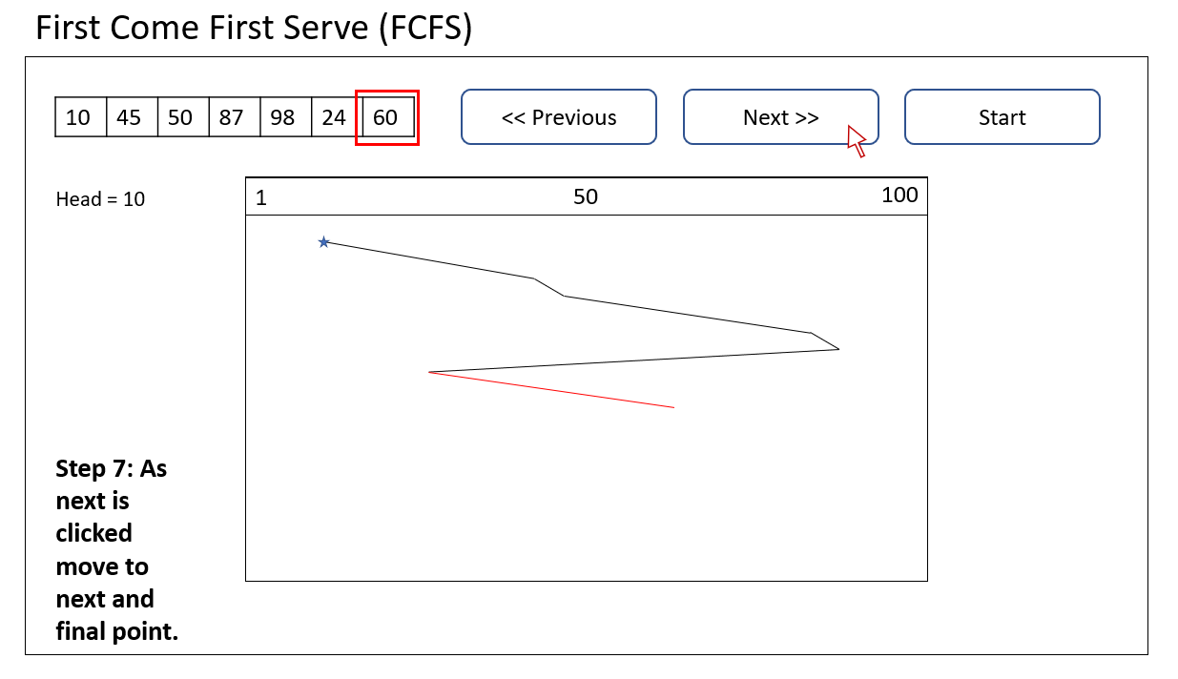

* Implementation:

I implemented the basic homepage of the web framework as well as some different beginner JavaScript code to understand how the implement the algorithms fully.

* Test:
* Documentation:
* Other (any other activities, such as talking to customers, attended a meeting, …):

Attended Weekly class meeting to discuss any updates we have found in research, design, and implementation. We focused mainly on talking about the design of the algorithms and getting an idea of how they should look when it comes time to implement them successfully. We also went over some goals and directions that we would like to have complete come time of midterm report.

b) Technology/Skills/Methods LEARNED or LEARNING:

Used previous knowledge to get a better understanding of Light web design of front-end applications, mainly through bootstrap, html, and CSS. Learning how to work with JavaScript focusing on animation. This included working with SVG, JavaScript DOM, JQUERY, and HTML Canvas techniques. Learning and practicing old and new skills.

c) PLAN for next week:

Next week, I plan to have more detailed designs for more algorithms finished. Also, more code to show as implementation of the algorithms as we approach the midterm report.