**CS Projects – Fall 2021**

**Weekly Updates**

(must fill-in your info with blue color or in CAPITAL LETTERS)

Student “Class Key”: __S21 – 20____ Weekly Update # ___05___ Date: __02__ /_25_ /2021

Student Name: ____________MATTHEW MORFEA___________________

Company/Unit internship site) ____________SUNY NEW PALTZ: CPS485-01 - PROJECTS___________________

Short Description of the Problem/Task _WEEK 5 DESIGN OF ARCHITECTURE, MIDTERM REPORT / PRESENTATION, AND START OF CODE IMPLEMENTATION_

a) PROGRESS during the week, what you have been working on and/or accomplished (by area, if applicable):

* Problem Study/Discovery:

This week we continued looking into the design of the algorithms and updated our old designs to fit instructors’ specifications. We were further doing research in JavaScript as well as other tools to aid in creating the visualizations of the algorithms. I further tied together my HTML / CSS knowledge to the new JavaScript and HTML DOM knowledge I had been learning in order to work on the main implementation of FCFS (First Come First Serve). We also focused heavily on the Midterm Report and Presentation as this is soon approaching.

* Design:

I made an update to the design of my main algorithm diagram, specifically FCFS. This included adding more buttons to fit the instructor’s specifications. I also plan to add more buttons above as a sort of menu in choosing different algorithms, relying less on the web framework approach to traversing algorithms. Furthermore, I put together designs for the Architecture of the main and my portions of the project, mainly how the Disk scheduling algorithms and page functions and how they connect with other portions of the project. This was done through flowcharts made with programs in the Microsoft office suite. Designs for the Flowchart, which were included in the Midterm Report as well as the updated algorithm diagram are shown below:

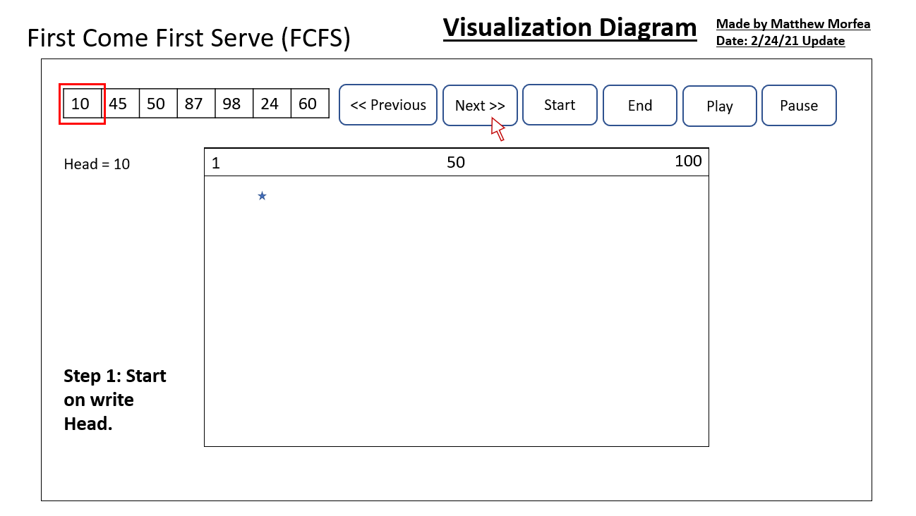 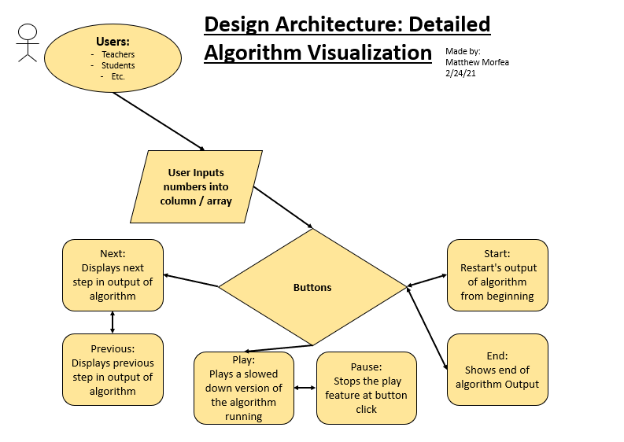 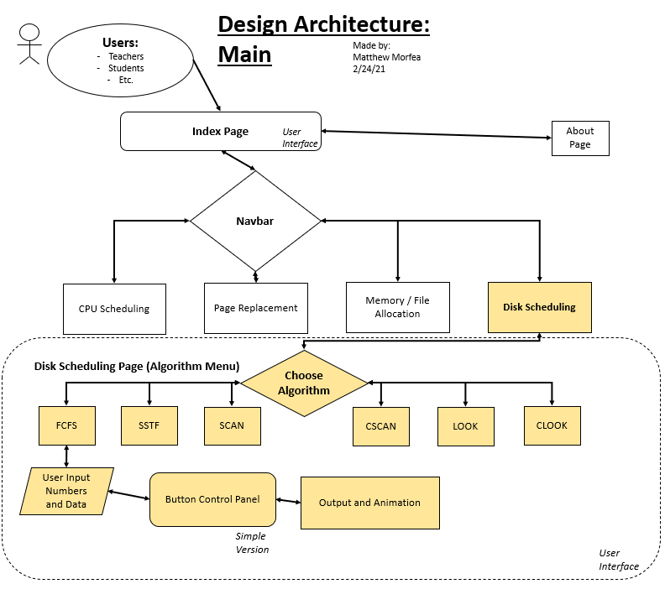

* Implementation:

Taking my known skills of HTML5 / CSS and my newly learned / learning skills of HTML Canvas and JavaScript DOM I have started to implement the visualization and user input portions of the FCFS (First Come First Serve) algorithm. This includes implementing a user input section for read / write head, as an array, buttons for user to control output, and a canvas to draw lines based on user’s controls. This is just the beginning of a production setting of implementation that will take place in the following weeks.

* Test:
* Documentation:

The main source of documentation created this week were my Midterm Report and my portions of the Midterm Presentation. This included the designs as well as sections explaining the designs and plans for future development of our software. The midterm report being based on what I have done and how it ties into the group and the presentation being an set of slides used to explain what we are doing as a whole.

* Other (any other activities, such as talking to customers, attended a meeting, …):

Attended Weekly class meeting to discuss updates we have made to our own portions of the code as well as any research we had found along the way on new discoveries. We spoke with the instructor to fit specifications of the design of algorithm diagrams and further ask questions about the Midterm Report and Midterm Presentation. We planned another meeting next week to practice and go over our presentation before presenting it in front of the class.

b) Technology/Skills/Methods LEARNED or LEARNING:

Used new knowledge of JavaScript DOM and HTML Canvas to start to create a base model for my FCFS algorithm, which will serve later algorithms in the future as well. Used Microsoft office suite to create flowcharts that we added to the Midterm Report. Continued working with old skills of HTML5, CSS, and Bootstrap to incorporate more updates between the framework and the newly developed FCFS algorithm model.

c) PLAN for next week:

Next week, my group and I plan to meet up prior to the midterm Presentations in order to do a mach version of our Oral Presentation as well as iron out any concerns for the Midterm Report and Presentation Slides. Continue to work on and update designs and Midterm Report. Also, add more features to the growing implementation of the algorithms.