**CS Projects – Fall 2021**

**Weekly Updates**

(must fill-in your info with blue color or in CAPITAL LETTERS)

Student “Class Key”: __S21 – 20____ Weekly Update # ___10___ Date: __04__ /_23_ /2021

Student Name: ____________MATTHEW MORFEA___________________

Company/Unit internship site) ____________SUNY NEW PALTZ: CPS485-01 - PROJECTS___________________

Short Description of the Problem/Task _WEEK 10 ANALYSIS, FINAL TESTING, FINAL DOCUMENTATION OF CODE

a) PROGRESS during the week, what you have been working on and/or accomplished (by area, if applicable):

* Problem Study/Discovery:

Over the final week of this projects working period, I have been working on the final report as well as final testing of different coding problems regarding the randomize and editing features of input.txt and output.txt files for each algorithm. This problem was discovered and is now relatively solved for a final product.

* Design:

I have designed and updated different diagrams to better display the software and data that I am using for my portions of the project. That includes the update to old architecture and protocols, new protocols for File I/O, a new sequence diagram, and an overall map of the code and data within it. This is mostly done because of the final presentation slides and final report that are due in the following weeks. Samples of these designs are shown below:

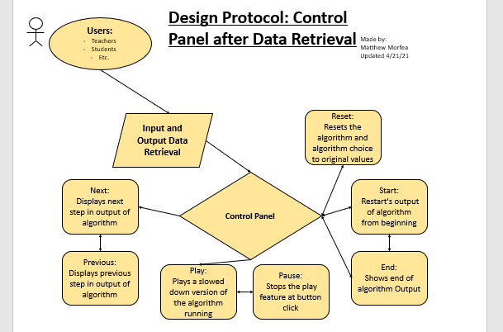 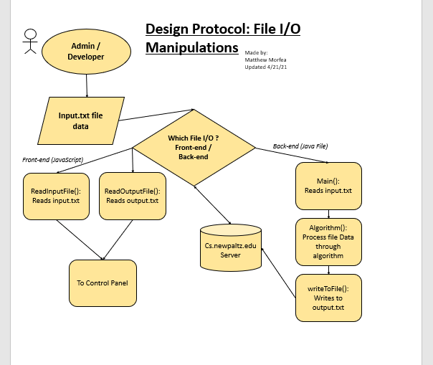 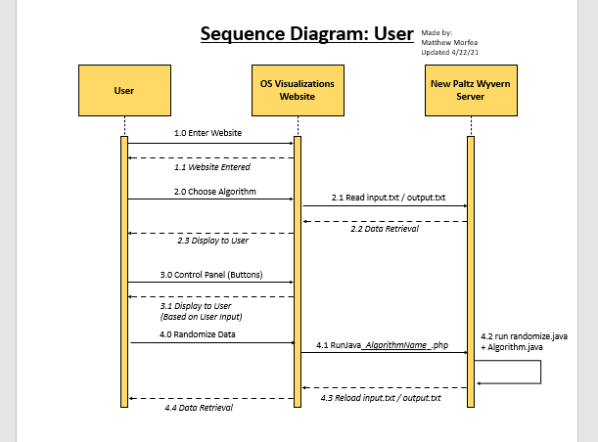

* Implementation:

Not many implementations of code made this week as we are wrapping up what we will have for the final presentation and video demonstration of what we have gotten thus far. I implemented some fixes to the php and java algorithms in order to incorporate better file connection between the front-end and back-end of the website / webserver. The php code now executes system commands to run java code on the back-end and acts as a connection to do this from the front-end via button. This includes an ajax connection on the front to call the php when the randomize button is pressed.

* Test:

Final testing was done this week on all portions of the website / webserver. I tested the ajax connections from the front-end to the php codes for each algorithm. These php codes were also testing to call java code on the back end. This was difficult test as to have the java codes write to files then update the website in real time weird, given the original setup of Disk Scheduling. However, the new implementations allowed this to work with little oversight on the developer’s side, so this feature could work for the user. Minimal testing was done on the old codes as they were tested last week and seemed to be running smoothly.

* Documentation:

Documentation of the final weekly update was completed as well as the final report being started were done this week. These documents required a lot of material from previous weekly updates and other information to come together for the correct results.

* Other (any other activities, such as talking to customers, attended a meeting, …):

Attended a weekly class meeting to discuss updates on our code and the testing and analysis we were doing on our different portions. Some of my groupmates seem to be behind in their implementation and testing so we urged them to show what they had and encouraged them to finish a presentable project for the upcoming final presentation and recording of the video demonstration. We have scheduled the recording time for the video demonstration as well as a time we can all come together to complete the presentations slides. This presentation will then be rehearsed later, before the presentation date.

b) Technology/Skills/Methods LEARNED or LEARNING:

Used the help of Charles in order to understand and test the updated php, ajax, and java code needed for the randomize features of Disk Scheduling. Php and Ajax connectivity was relatively new to me prior to this week so discovering and testing this problem made portions of my code much more connected and synergized.

c) PLAN for next week:

Next week, we are going to write up and practice / rehearse our project presentation as well as finish our final reports for the projects course. This is the final weekly update before the presentation and the end of the semester and class. Next week we will unveil what we have been working on for since the beginning of this semester.