Title: Task management app

Description: The high-level overview/statement of your idea
Details: Task management app

Description of background and problem that your idea is going to solve.
With the advent of covid-19, masses of people are required to be self-quarantined and many industries have been severely impacted causing loss of jobs and businesses. We're aiming to target these particularly vulnerable people who may now have large amounts of unstructured free time and find it difficult to get the motivation to complete tasks.

Description of how your idea works to solve this problem.
Our app will help users by rewarding them for consistent task completion. This is done through consistent reminders and tracking of progress. Our app will have gamification aspects such as streaks, experience points, rewards to help users to stick to good habits. In the future we aim to partner up with local companies and business to supply discounts and vouchers as rewards, this could be a way to encourage support for local businesses and also help generate revenue.

UI Design of your idea (i.e. paper prototypes (rough drawings of an interface, screen design)

Below is an example of wireframes that were made for the design of the home page and the sign up screen.

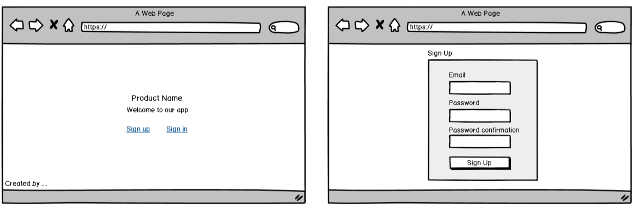

These are also another set of wireframes that were made for the Sign in box and the main
view of the tasks.
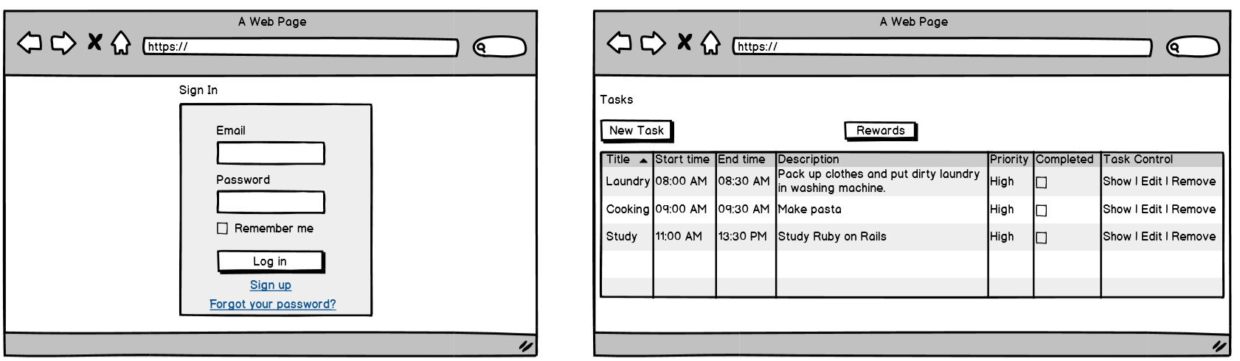
We’ve included a full set of the wireframes we’ve made including wireframes for how the flow of task creation should look, accessing rewards page and a full list of the pages of the website.

Displayed below is an example of the trello board we were using to assist us in collaboration and development of the entire process.
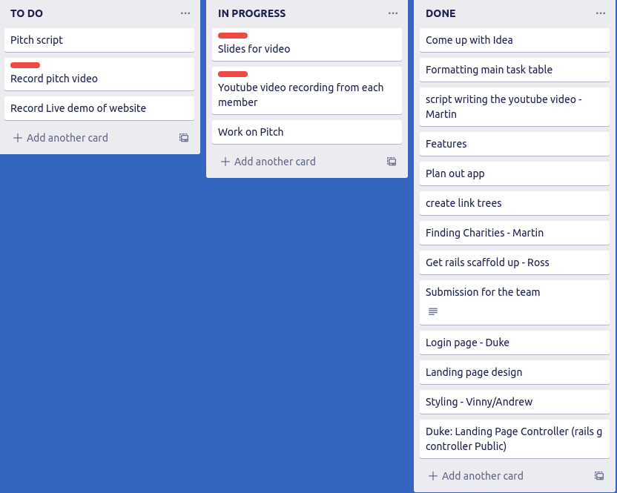

Advantages of your idea.
Priority levels - allow users to be able to easily distinguish which tasks are most important

Regular reminders - help users stay on track and remind them of their most important tasks

Reoccurring Tasks - allow users to set regularly occurring tasks instead of manually making them every time

Social Media encouragement – allow users to link their social media platforms and post tasks for accountability
Gamification - streaks, rewards, experience points - helps users stick to using the app

Web app and mobile app - allow users to easily access app from either computers or mobiles

Donation to charity/friends - users could set rewards/punishments for themselves as donations to charities or friends

Key scenarios:
In which scenarios will it help people?
Unmotivated workers affected by covid – our app will be useful in encouraging these particular people to continue scheduling their day and also feel connected through social media encouragement or tying tasks to donations/bets with charities and friends.

Students - looking for a task management app – students may find it difficult to stick to their tasks.

Potential difficulties:
What are the potential difficulties? Like how to get enough data?
How to get enough users etc?
Issues could be consistent usage of the app - may be difficult to encourage users to continue using app to be productive

Based on honesty - since users are making their own tasks and ticking them off for completion, it's completely up to them whether they're honest.

Competition from other apps such as Habitica and Google tasks - other task management apps such as Habitica also have fleshed out gamification aspects.

Video Link:
https://www.youtube.com/watch?v=ZQhmO8u-gXk
GitHub or other code repo link: https://github.com/MorganBat/FlattenTheCurve

Active Deployed Website:
https://habbit-motivator.herokuapp.com/

