Kanbanana
User Manuel
1.0 alpha

Table of Contents
What is kanban? 3
Sitemap 3
Getting started 4
Invite users to the board 4
User creating an account 4
Company account 4
User account 4
View a task 5
Create a task 5
Updating a task 5
Grabbing a new task 5
Assigning a task 5
Reporting a task 5
Commenting on a task 6
Creating a board 6
Parts of a board 6
Creating a column 6
Parts of a column 6
Create a task 7
Parts of a Task 7
Setting deadlines for boards and tasks 7
Automatic emails 7
Switching between boards 7
Administrator Controls 7
Setting user permissions 8
Change who has access to boards 8
Change a users edit permissions 8
Renaming 8
Rename a board 8
Rename a column 8
Rename a task 8

What is kanban?
{Insert image of Kanbanana}
Kanban is the Japanese word for board. It is a way to formalize a complex projects into tasks then organize them according to the state of being they are in. This allows a visual representation of how far along the project is.

Sitemap
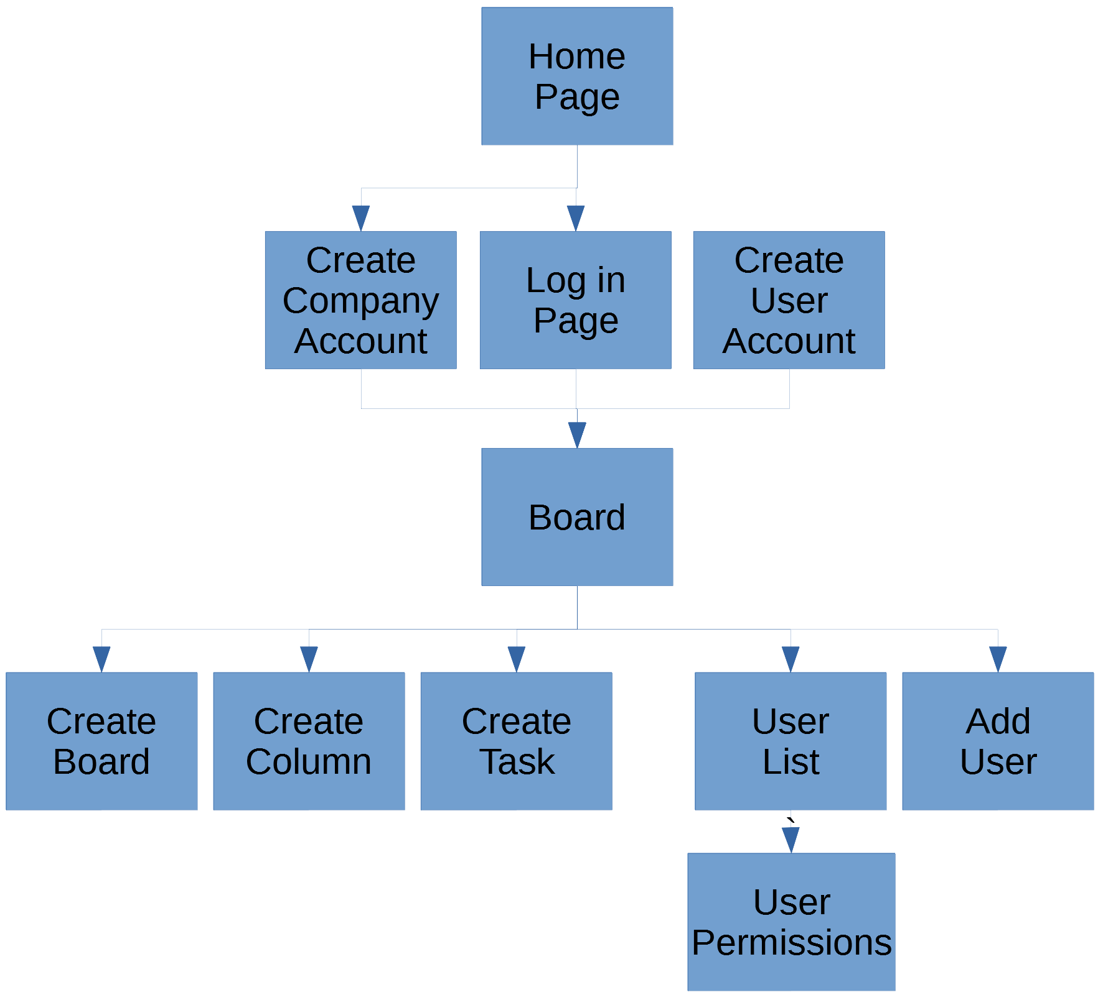

Getting started
{Image of Home Page}
To get started you’ll want to create a company account. To create a company account you’ll need to go to the home page at {Insert address here} then click ‘Create Company Account.’
{Highlight Create Company Account}
This will create an initial board for you. Then from here you can start inviting users to your boards.
This will give you access to several boards and the ability to add users to boards. From there you’ll want to start adding users and createing columns and tasks for them to work on.
{Give all first steps to getting started}

Invite users to the board
To invite users to join your boards you can navigate to ‘Invite Users’ on the tool bar.
{Image of invite users page}
Enter the users email to send them an invite, then click Send Emails.

User creating an account
Kanbanana uses two kinds of user accounts: company and user. In order to get started you’ll have to create a company account, then invite users to create a user account for your company.

Company account
To create a company account go to the home page at {address} then click Create Company Account. Fill out the information and click Create Account.

User account
To create a user account you’ll need an invite from a company account. As a Company account you’ll need to select Add a User.
{image of Invite users page}
Select the link in the email that you receive and fill out the needed information, then select Create Account. Once you receive an email follow the link to the sign up page.
{Show image of email}
Fill out the information and click sign up. This will create your account and take you to the boards you were invited to.

View a task
To view a task you’ll need to navigate a board that has tasks. From there you’ll be able to see the collection of tasks on that board. To see more details about a task or leave a comment you can click on any task to expand it.
{image of expanded task}

Create a task
To create a task you’ll need to navigate to a board that has columns. Click on Add a Task on the column you want to add a task to.
{image of create task page}
This will take you to the task create page; fill out the information and click Create Task. This will redirect you back to the board with your new task added to it.

Updating a task
Once a task has been picked up or finished you’ll need to update what column it is residing in. To do that you can select the task and drag it to the column you want to add it to, or you can click edit the task to open up the edit page and choose.
{image of update task page}
After changing details you can finalize the change by clicking Update Task.

Assigning a task
To assign a task to yourself you can click grab task to automatically assign it. Or to assign it to another user you can click edit, then select from the drop-down what user to assign to it.

Reporting a task
To automatically report a task to a superior you can add them to the reporting to section. To do this you need to click edit on a task and select the person to report to.

Commenting on a task
To comment on a task you can select the task to open it up and scroll to the bottom. There is a section where comments can be added. Fill in the box with the comment you wish to post, then click Send.

Creating a board
To create a board you’ll need to be the admin of the company. You can click the hamburger then click Create a board. You’ll be able to select users to add to the board then and a name. Then click add.
{Create a Board}
This will take you to the newly minted board.

Parts of a board
{image of board}
Name[required] – This is the displayed name of the board. When you are selecting what board to view or adding users to a board this is what you’ll see to know what board it is.
Deadline – If the board has a due date that all the tasks need to be completed by you have the option to add one. Any tasks created with a blank deadline on the board with a deadline will inherit the boards deadline.

Creating a column
{Create column button highlighted}
A column usally represents the stage of production that the task is in. You can group tasks however you want. To create a column you can click add a column on a board. This will bring up the new column creation window.
{image of Create Column page}
Give the column a name, then click Create Column. This will take you back to your board with the new column.

Parts of a column
{Insert picture of a column}
Name[required] – The name of the column that shows at the top of each column created. A column is usally named after the stage of production is is representing, etc. Backlog, Not Started, or Finished, however you can name it however you want.
Tasks – Each column can have as many tasks as needed. This is the list of tasks that are grouped together based on what the column represents.

Create a task
To create a task you’ll need a column available to add one to. At the top of the column you can click add Task. From here a new blank task will open up and you can start filling out the information. You must have a Name and a Description to submit it as a new task to be added to the column. Some optional information you can add is the deadline, assigned to, and the report to sections.

Parts of a Task
Name – What the task is referred to.
Description – An explanation to what the specifics of the task are.
Deadline – If the task has a deadline by when it needs to be finished a dead line can be added. If no deadline was given for a task on a board that has a deadline; the board’s deadline will be inherited.
Comments – Comments can be left on the task in the expanded view. This is to help discussion about the task.
Assigned To – The person who is responsible for the completion of the task.

Setting deadlines for boards and tasks
To set a deadline open up the board or task by selecting edit. Then from there you can add the deadline in the correct option.

Automatic emails
To receive emails when a task is completed or when the deadline has past. You can go into the option and turn that option on.

Switching between boards
To switch between board go up to the board name dropdown and view the complete list of all boards you have access to. From there select the one that you want to view.

Administrator Controls
There are a few different options that the one who controls the company account can do. They are able to add and remove users, update user permissions, create or remove boards, invite users, and so much more.

Setting user permissions
The admin account can view the list of users that are currently on their account. They can select the permission of the users. To do this they need to click on the hamburger button to drop down the menu. They can select User Settings and see the list of users. They then can check or uncheck user permissions as well as select the boards they have access to. To finalize the change they need to click submit.

Change who has access to boards
To change the accessibility permissions you can click on the correct thing. Then select a user then set their view permission for each board that has been created.

Change a users edit permissions
Each user can be set on who can create/edit/remove columns or tasks. To do this select one of your users then select the permissions they are allowed to have.

Renaming
At any time something can be renamed. The board, column, or task can be renamed at any point.

Rename a board
To rename a board go to the board options by clicking the edit button.
From there you can rename the board in the respectful window, then click submit to finalize the change.

Rename a column
To rename a column go to the column options by clicking on the edit button.
From there you can rename the board in the respectful window, then click submit to finalize the change.

Rename a task
To rename a task go to the column options by clicking on the edit button.
From there you can rename the board in the respectful window, then click submit to finalize the change.

