Paper: Mastering Atari, Go, Chess and Shogi by Planning with a Learned Model

CSM6420 Report by Morgan Jones (mwj7@aber.ac.uk)

# Overview of MuZero

The algorithm presented in this paper is MuZero [1]. It is an extension and generalisation of AlphaZero [2] a past state-of-the-art work by the same authors. MuZero is a model-based reinforcement learning (RL) [3] algorithm that uses deep neural networks [4] [5] to estimate transition reward, action-selection and state value quantities. The learning of these quantities enables the planning capabilities of the algorithm to achieve superhuman performance in Go, Chess, Shogi and 57 different Atari games implemented in the Arcade Learning Environment (ALE) [6].

MuZero is a model-based RL algorithm because it plans with respect to a learned model of the environment’s dynamics; that is actions, rewards, state transitions and (if stochastic) transition probabilities. Previous model-based algorithms have struggled in visually rich domains, such as Atari 2600, with the most successful methods based on model-free RL [3]. This is a significance of MuZero it is a model-based algorithm that achieves state-of-the-art performance in visually complex domains (Atari 2600) as well as maintaining superhuman performance in two player zero sum games.

The domain model has to be learned by MuZero from scratch. This is a generalisation of AlphaZero because AlphaZero was given knowledge of the game rules in the form of implementation in a simulator. AlphaZero made use of the provided model when performing the search required for its search-based policy iteration. The given model provided all legal actions, deterministic state transitions and terminal states to be used by the Monte-Carlo Tree Search (MCTS) [7] to traverse game simulations in the search tree. How MuZero does search without given model?

MuZero also extends AlphaZero to work in more environments including single agent domains and environments where actions yield non-zero immediate rewards. The AlphaZero algorithm was built for Chess, Go and Shogi where all state transitions were set to zero immediate reward except for terminal states where a Win, Loss or Draw was 1, -1 and 0 respectively.

# Algorithm Components

## Model

MuZero’s RL model is made possible by three components: a representation function , dynamics function and prediction function . All three functions are neural networks with denoting the network parameters (weights).

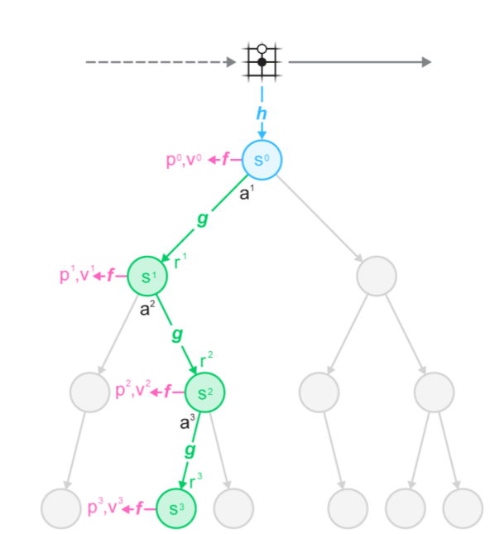

Figure - MuZero using its 3 component networks {h(), g(), f()} to perform internal planning for k hypothetical steps.

The **representation function**  is responsible for transforming observations of the environment into an initial hidden state used to initialise the root of the search tree for planning. This action is one-way because “There is no direct constraint or requirement for the hidden state to capture all information necessary to reconstruct the original observation”.

The **dynamics function** is responsible for thinking ahead at each hypothetical step k by transitioning between hidden states. The dynamics function takes an action from a hidden state and computes the next hidden state and the immediate reward for the transition.

The **prediction function** evaluates a hidden state by predicting the policy and value from it. This is the same as the joint policy & value predicting network of AlphaZero.

A **policy** is a mapping of states to actions. Here the policy is specifically a mapping of a sequence of observations (initial hidden state ) and a sequence of actions to the next action. Effectively saying what action to take given the currently considered hidden state .

The **value function** in reinforcement learning estimates the expected value of being in a state, that is the expected sum of discounted future rewards given we are in a state and continue to follow the current policy . In games this would be the predicted winner, in Atari the predicted final score. The discount factor is denoted by Discounting means rewards further into the future are valued lesser, the variation of this hyperparameter reflects the trade-off between short and long term planning.

The **immediate reward** is approximating the true observed reward of the environment.

The model predicts at each time step the three quantities described above: policy, value function and immediate reward. This mirrors the structure of the typical Markov-Decision Process (MDP) [8] model of the RL problem. A key difference being a hidden state has no semantics of the environment associated with it because hidden states exist solely to predict the quantities mentioned above.

## Search

Given the model above MuZero can iteratively apply a planning algorithm to learn the optimal policy by searching over hypothetical future trajectories when acting and learning. Monte Carlo Tree Search (MCTS) is used by the authors but they do state that any MDP planning algorithm may be used. The MCTS is used to output a recommended policy and a value for the current environment observation at time step . The agent then acts on the environment according to the policy’s recommended next action and receives an environment reward . The values of the actions in the search policy are proportional to their visit count during the MCTS. The value, search policy and environment reward as result of the MCTS are then used as improved targets for the training of the neural networks. MCTS is briefly described below.

MCTS runs simulations from the root state to leaf nodes and stores a set of statistics for each edge along the search tree that it visits. In our algorithm the set of statistics stored is

* is the visit count of an edge.
* is the average Q-value (expected total future return) of the edge, averaged over all simulations.
* is the prior probability of taking that action from that state according to the current policy.
* is the immediate transition reward of that edge.
* is the resulting state after traversing the edge.

There are 3 stages to MCTS:

1. **Selection**During selection nodes are expanded for k hypothetical time steps with actions being selected based on maximisation of an upper confidence bound. This is calculated using the stored statistics for each edge.
2. **Expansion**
3. **Backup**At the end of a simulation statistics along the trajectory are updated.

MuZero can be used for games or MDPs because MCTS approach to planning converges asymptotically to the optimal policy in single agent domains and to the minimax value function in zero sum games [8]. Note that authors used 800 simulations per search for board games and 50 for Atari because of the smaller branching factor in Atari.

## Networks

### Learning

MCTS is a relevant to the machine learning components of the solution because it results in targets that guide the learning of the neural networks. The three objectives of this learning are as follows:

* To minimise the error between predicted policy and search policy .
* To minimise the error between the predicted value and the value target .
* To minimise the error between the predicted reward and the observed reward

These objectives along with an L2 regularisation term lead to the overall loss function for the model.



The function refers to the linear combination of a real number through a combination of its adjacent integers. This is because the authors normalise values and rewards using an invertible transform, thereafter using a transformation to obtain equivalent categorical representations of the target values from a discrete set of 601 integers between 300 and -300. With each real value being a linear combination of its two adjacent integers in the set. The value and reward are predicted as a Softmax distribution over the set with a real value being obtained by computing the expected value from over the distribution and then inverting the transformation.

### Input

#### Encoding game state

For the board games the input to the representation function in MuZero is similar to the representation AlphaZero used for board states (shown in table below). With the exception that for chess the history has been increased to the last 100 states to better predict draws. Meaning total input depth for chess below would now be 8x8x1407 instead of 8x8x119.

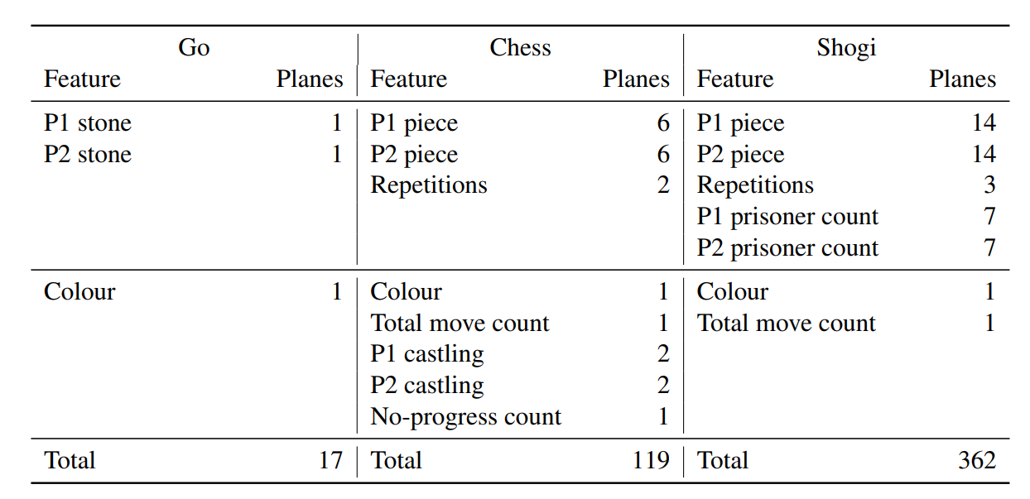

Figure - Input features used by AlphaZero in Go, Chess and Shogi. First row repeated for a T = 8-step history.

The representation input for Atari is the last 32 RGB frames at resolution 96x96 and the last 32 actions taken at each frame. Historical actions are needed because not all actions have immediate visible effect. RGB planes are encoded as 3 binary planes leaving the final input dimensions at 96x96x128.

#### Encoding transition action

The dynamics function takes the output of either the representation function or a previous application of the dynamics function as input along with a representation of an action. Actions are encoded as planes of the same resolution as the hidden state (6x6 for Atari & board size for board games).

A Go action is a single plane representing the position of stone placement or a pass. An action in chess is 8 planes: the start position, end position, a binary plane describing if the move was legal along with 5 binary planes representing the type of promotion {queen, knight, bishop, rook, none}. Shogi actions are encoded in 11 planes: 8 planes for where the piece was moved from, 2 planes for the target and legality of the move and a single binary plane denoting promotion. Atari actions are one hot vectors tiled appropriately into planes. UNDERSTAND THIS AND EXPAND?

### Architecture

The representation, prediction and dynamics functions in MuZero are approximated by deep residual <REF> convolutional <REF> neural networks.

TODO

### Training

At the end of an episode of gameplay trajectories are stored in a replay buffer. These sequences are sampled by selecting a state from any game stored in the replay buffer. The initial step receives the past observations up to that state and applies the representation function to attain a hidden state. Thereafter the sequence is unrolled for K=5 steps by passing each hidden state and the actual past action taken into the dynamics function.

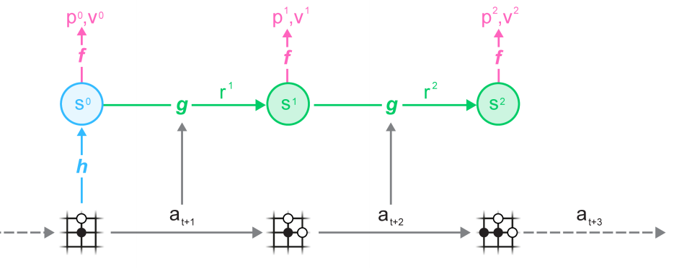

Figure 3 - MuZero training by unrolling from the replay buffer.

Prioritised replay [9] is used to draw samples from the replay buffer when learning Atari. With states being sampled uniformly for zero sum games. Prioritised replay focuses the algorithm to train on those past observations from which there is the most to learn.

When learning Atari samples are selected with the following priority , where is the search value (expected return) predicted and is the observed total return. The priority says that those states with a larger relative difference in correct & predicted value will have a higher chance of being sampled from the replay buffer.

At each unrolled step the network has losses to the target values (policy, value & environment reward) the summation of which produce the total loss for the network . The target value is the actual return of the sample which is bootstrapped until the end of the game for Chess/Go/Shogi or 10 steps into the future for Atari.

# Results

MuZero was trained for 1 million mini-batches with batch size being 2048 for board games and 1024 for Atari. The plots below show the progress of MuZero as it trains. It matches AlphaZero’s Elo rating in Chess and Shogi while exceeding it in Go. MuZero also exceeds R2D2 <REF>; the previous (model-free) state-of-the-art for Atari. MuZero achieved a new state-of-the-art for Atari as shown below in the table comparing previous Atari agents.

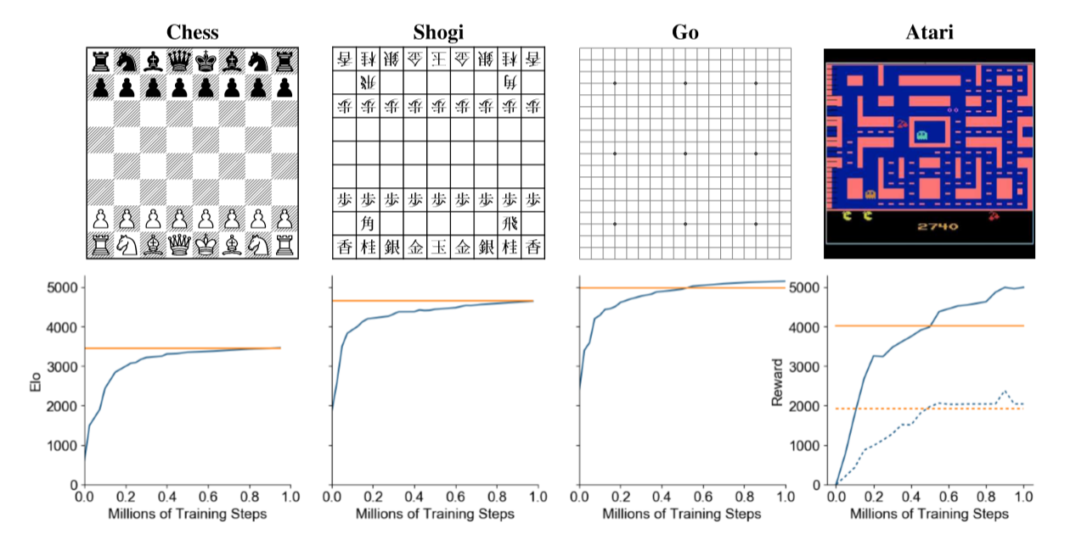

Figure 4 - MuZero evaluation throughout training.

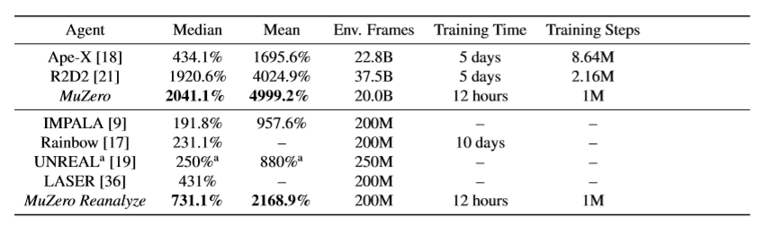

Figure 5 - Comparison of MuZero against previous agents in Atari.

In this table ‘*MuZero’* and ‘*MuZero Reanalyze’* are the best Atari agents. MuZero Reanalyze is …

MuZero was compared against a strong model-free algorithm to better understand the benefit of a model-based approach. MuZero was adapted into a Q-Learning algorithm <REF> by replacing its training objective, changing its output to a single Q-value and omitting search during training and evaluation.

Original MuZero and the Q-Learning alternative were trained to play Ms. Pacman. The performance of the Q-Learning version was similar to R2D2 but learned slower and performed worse than MuZero. The authors conjecture that this is due to the search-based policy improvement providing better learning targets with less bias and variance than those used by Q-Learning.

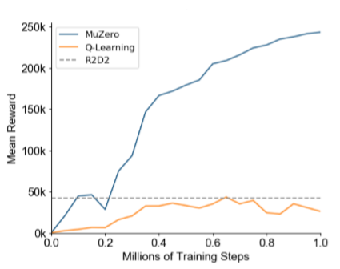

Figure 6 - Comparison of training on Ms. Pacman with MCTS and Q-Learning within the MuZero framework.

ASK CHUEN IF RESULTS SECTION SHOULD BE INCLUDED

# Proposed Alterations

(ALTERATION perhaps) Also, Atari has intermediate rewards which makes some samples can teach us a lot more than others i.e when something crashes and you lose loads of points from an intermediate reward that would probably INCLUDIGN IMMEDIATE REWARD INTO PRIORITISED REPLAY FOR ATARI???? PROBABLY NOT A GOOD IDEA

# Limitations & Future Directions

* The dynamics function is deterministic which means all state transistions succedd with a probability of 1. The authors mention that “extension to stochastic transitions is left for future work”. Expand this to show RL equation and how it could be done with their algorithm.
* Future real world domains with unknown environment dynamics.
* Imperfect info games like poker?? I know AlphaStar is imperfect info maybe its related?

# References

|  |  |
| --- | --- |
| [1] | J. Schrittwieser, I. Antonoglou, T. Hubert, K. Simonyan, L. Sifre, S. Schmitt, A. Gues, E. Lockhart, D. Hassabis, T. Graepel, T. Lillicrap and D. Silver, “Mastering Atari, Go, Chess and Shogi by Planning with a Learned Model,” *arXiv preprint arXiv: 1911.08265,* 2019. |
| [2] | D. Silver, T. Hubert, J. Schrittwieser, I. Antonoglou, M. Lai, A. Guez, M. Lanctot, L. Sifre, D. Kumaran, T. Graepel, T. Lillicrap, K. Simonyan and D. Hassabis, “A general reinforcement learning algorithm that masters chess, shogi and go through self-play,” *Science,* pp. 1140-1144, 2018. |
| [3] | R. S. Sutton and A. G. Barto, Reinforcement Learning: An Introduction, The MIT Press, 2018. |
| [4] | J. Schmidhuber, “Deep Learning in Neural Networks: An Overview,” *Neural Networks,* vol. 61, pp. 85-117, 2015. |
| [5] | A. Krizhevskym, I. Sutskever and G. E. Hinton, “ImageNet Classification with Deep Convolutional Neural Networks,” *In Advances in Neural Information Processing Systems,* no. 25, pp. 1106-1114, 2012. |
| [6] | M. G. Bellemare, Y. Naddaf, J. Veness and M. Bowling, “The arcade learning environment: An evaluation platform for general agents,” *Journal of Artificial Intelligence Research,* vol. 47, pp. 253-279, 2013. |
| [7] | C. B. Browne, E. Powley, D. Whitehouse, S. M. Lucas, P. I. Cowling, P. Rohlfshagen, S. Tavener, D. Perez, S. Samothrakis and S. Colton, “A survey of monte carlo tree search methods,” *IEEE Transactions on Computational Intelligence and AI in games,* vol. 4, pp. 1-43, 2012. |
| [8] | S. J. Russel and P. Norvig, Artifical Intelligence: a modern approach, Pearson Education, 2014. |
| [9] | T. Schaul, J. Quan, I. Antonoglou and D. Silver, “Prioritized experience replay,” in *International Conference on Learning Representations*, 2016. |