Reach GUI 0.0.0

Author: Qiao Liu

Time: 2018.10.13

**UI Guideline**

**Colors**

**Primary-UI color**

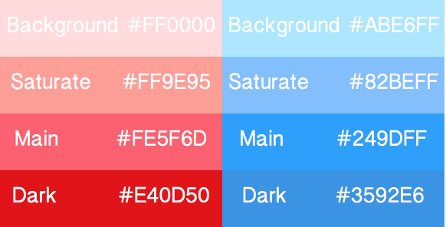

**Grey**

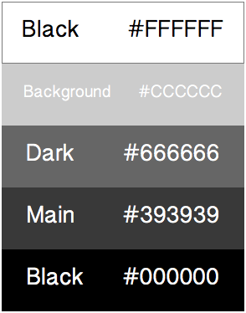

|  |  |
| --- | --- |
| **Color Columns** | **Function** |
| Background | Notifications background |
| Saturate | Button background |
| Main | Button highlight |
| Dark | Notifications text color/ button background pressed |
| Black | Text |

**Buttons**

**Condition**

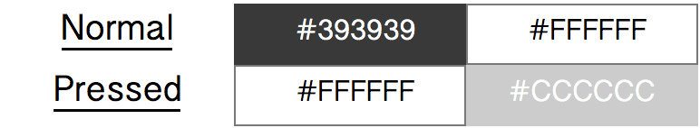

|  |  |
| --- | --- |
| **Condition** | **Function** |
| Normal | Static button connection |
| Pressed | Mouse moved color |

**Style**

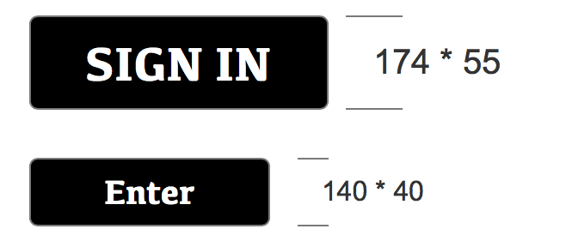

|  |  |  |  |
| --- | --- | --- | --- |
| **Size** | **Width** | **Height** | **Round corner** |
| Big | 174 | 55 | 2px |
| Small | 140 | 40 | 2px |

**Tooltips**

**Condition**



**Style**

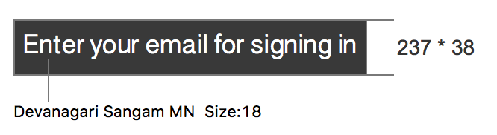

**Form**

**Input**

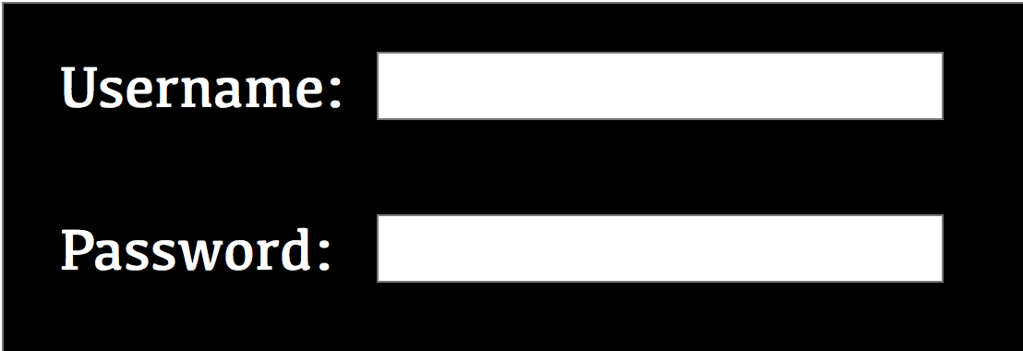

**Style**

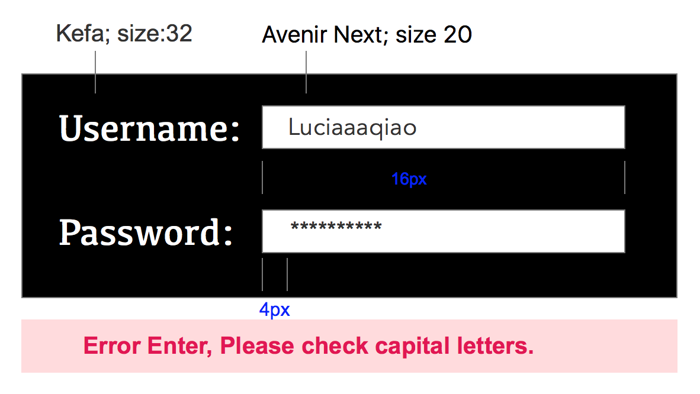

**Dropdown**

**Condition**

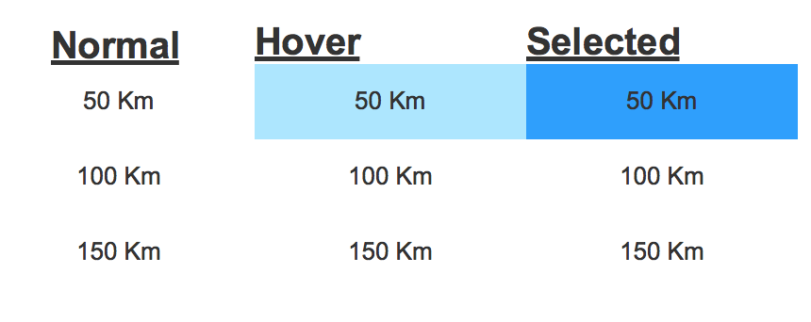

**Style**

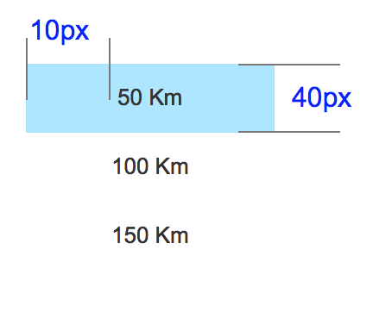

**Table**

**Condition**

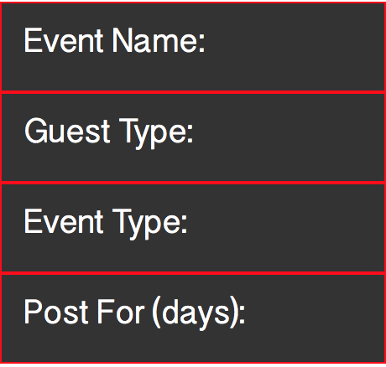

**Style**

