User Guide: Sigma M&V Engine Tool
A step-by-step workflow for analysts
This is the day-to-day how-to for operating the Sigma M&V Engine Tool. It does not cover how the engine works internally — see the technical documentation for that. Follow the track that matches your situation: a customer's first run, or every run after.

Before you begin — two things that shape every run

1. Your weather source
Heating and cooling degree days (HDD/CDD) come from one of two places. This is set once per workbook and rarely changes but confirm it before every run because it decides several later steps.
If your weather comes from... | Weather Source control | Input to run off of
Sigma (looked up automatically) | sigma | Input
Your own CSV (HDD/CDD already in the file) | csv | Uploaded File

2. First run vs. every run after
The very first run for a customer lets the M&V Engine choose the baseline period. After that run you lock that baseline and reuse it on every future run, so results stay consistent and defensible as new bills arrive. The two tracks below reflect this — the first run has extra steps to capture and lock the baseline; later runs simply append new records to the same file.
The key file: input_with_baseline
Of everything the tool produces, input_with_baseline matters most. It is your original upload plus a record of exactly which bills the tool chose as the baseline. Feeding it back in on future runs is what locks the baseline. Guard this export.

Track A — A customer's first run
Step 1 — Prepare your upload CSV
Build a CSV with one row per utility bill. Include these columns:
- Column Names: Site Name, Meter Number, Service Type (electricity or gas), Period Start Date, Period End Date, HDD, CDD, Consumption, Total Charges, Commission Date, Consumption Unit, Provider Classification, Individual Selected Baseline, Aggregated Selected Baseline
- Consumption Unit Requirements: kWh, MWh, Wh are acceptable for electricity. CCF, therms, MCF, and MMBtu are acceptable for gas. All electricity gets converted to kWh and all gas gets converted to therms for consistency. Do not preemptively convert gas units to kWh, this could cause errors in the KPI tiles on the Results & Analysis page
- Optional: Meter Number (only populate if available for all bills, this allows for multi-meter analysis)
- Leave the Selected Baseline columns blank — the tool fills them on this run (Individual Selected Baseline / Aggregated Selected Baseline).
If you use CSV weather
Include HDD and CDD for every bill — the tool reads them straight from the file.
If you use Sigma weather
Nothing extra needed — Sigma looks up the weather for each bill automatically.

Step 2 — Confirm weather source and input (Controls & Meta page)
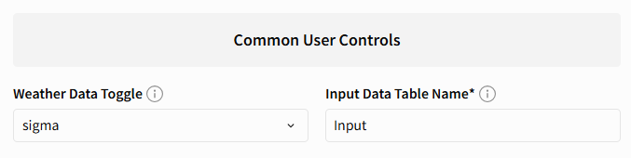
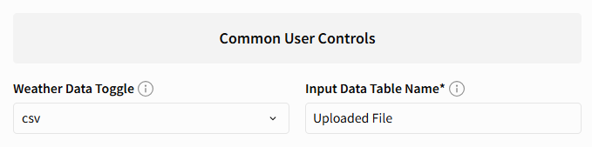
Check that the Weather Source control and the input element match your source, per the table above (sigma + Input, or csv + Uploaded File). The full list of controls on this page is explained in the Controls & Meta reference at the end of this guide.

If you use Sigma weather — also check the Input table
Open the Input table and scroll through it to confirm every row populated. The Input table is the middleman: it takes your uploaded bills and matches each one to Sigma weather. If a column name in your CSV is off or missing, rows won't match and the run will error. Fix the CSV and re-check before running.
Step 3 — Run the M&V Engine and wait

Start the run and let it finish. Runtime is driven far more by the total number of baseline combinations the engine evaluates than by site count alone: a portfolio where most sites have ~12 baseline bills has relatively few combinations to test, while one where sites carry 20+ bills can generate millions. For reference, a ~50–60 site portfolio with 20+ baseline bills at most sites and a million combinations tested in total finishes in roughly 30–40 minutes on the vectorized engine.
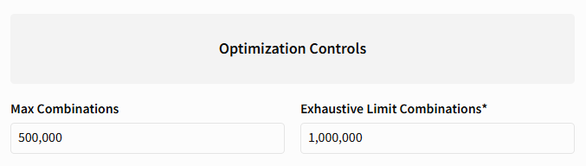

If a run risks timing out
Sigma will stop a run that exceeds its execution time limit. If you hit that limit — or just want a faster run — lower Max Combinations on the Controls & Meta page so the engine tests fewer samples per site. This trades a little baseline-search thoroughness for speed; the fit and gate logic are unchanged.
Step 4 — Review the results (Optimization & Models, Results & Analysis, and Summaries pages)
When it finishes, the detailed result tables populate on the Optimization & Models page. Give them a look before exporting — a few minutes here catches most problems. Check:
- Did every site get a model? Scan all_models table for skips. A handful (too few baseline bills, data issues) is normal; a large number usually means a data or column-mapping problem, not a modeling one.
- Do the recommended models look sound? Spot-check that Model Passes Quality is True and R² is reasonable for the models feeding your savings.
- Anything flagged for review? Glance at the Outliers and Cost-Only Review tables — sites appearing there need review before their numbers are trusted.
- Spot-check one or two sites against what you'd expect. If a familiar site looks wildly off, investigate before exporting rather than after.
- Review savings summaries as well. These are two tables found on the Summaries page and contain the same data pulled from the Optimization & Models tables but paired down to be more digestible for customer presentations.
- Do the KPI tiles reconcile? These are on the Results & Analysis page. The combined tiles should equal the electric + gas pieces. A tile showing null or an odd value usually means the page filters aren't applied — check them.
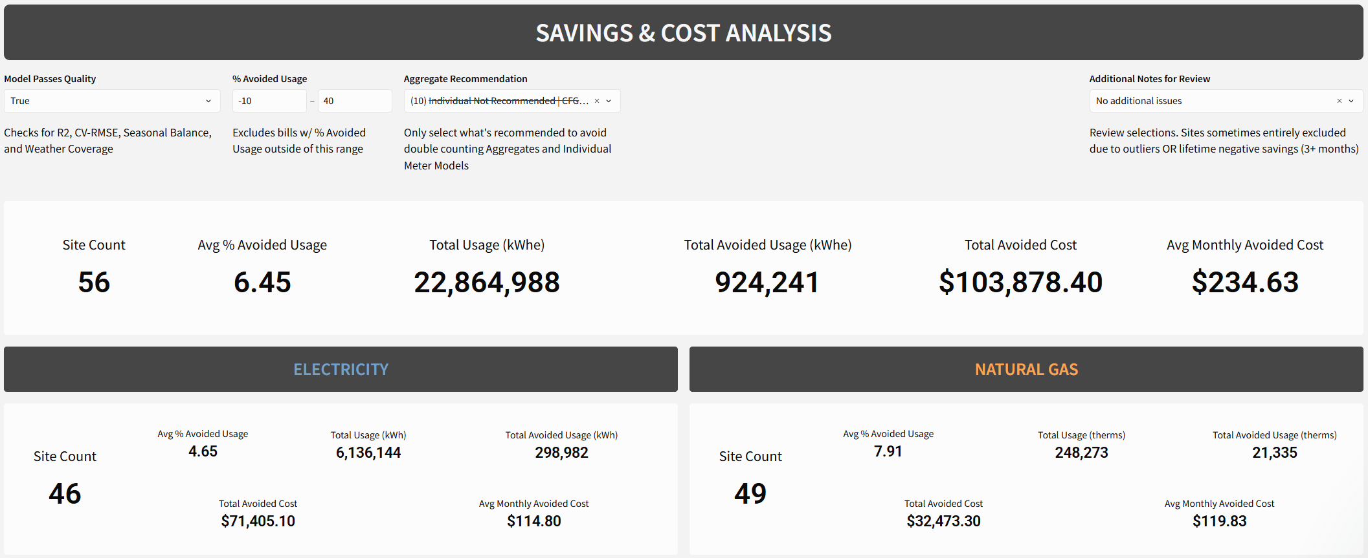
Step 5 — Export everything and save it
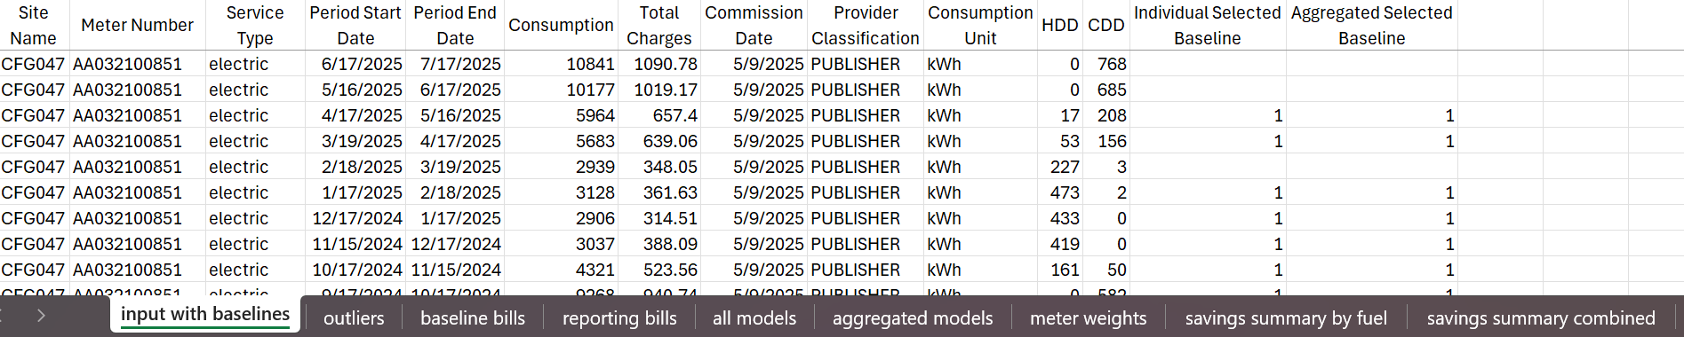
Export all result tables, combine them into a single Excel workbook, and save it to SharePoint and locally. This is your record of the run. If Meter Number was left out of the csv, aggregated models and meter weights would be empty.

Step 6 — Lock the baseline for next time
Export input_with_baseline a second time to turn it into your reusable upload file. Doing this now means that the moment new reporting bills arrive, your locked upload file is already in place and ready. Prepare it for re-upload based on your weather source:
If you use CSV weather
Save the export as-is as a fresh CSV. Then go to the Code & Input page and replace the Uploaded File with it.
If you use Sigma weather
The input_with_baseline export carries a WeatherStation column (Sigma added it during the run). Remove that column first, then save as a fresh CSV — Sigma re-adds the weather automatically on the next run, so the locked file should not carry it. Then go to the Code & Input page and replace the Uploaded File with it.
Step 7 — Publish the Sigma workbook
Publish so all results are saved for later review and for the next run.

Track B — Every run after (new reporting bills)
The baseline is already locked from Track A, so these runs are shorter — you simply append the new records to the same file.
Step 1 — Get your locked upload file
Export the current Uploaded File from the Code & Input page (or use the copy you saved locally). Its Selected Baseline columns are already filled — that is your locked baseline. Leave those columns exactly as they are.
Step 2 — Append the new bills
Add each new bill as a new row, filling the same columns as before.
If you use CSV weather
Add HDD and CDD for the new billing periods — you'll need to look those up, same as the first run.
If you use Sigma weather
Leave weather to the tool — it fills HDD/CDD for the new bills automatically. The upload file needs no WeatherStation column.
Step 3 — Reupload as the new Uploaded File (Code & Input page)
Replace the Uploaded File with your updated file (old bills + new bills, baseline still locked).
Step 4 — Run the M&V Engine and wait
If you use Sigma weather, re-check the Input table populated correctly first (same as Track A, Step 2), then run. Runtime scales the same way as Track A — see the guide there if it runs long.
Step 5 — Export and save all results again
Export the tables, combine into one Excel workbook, and save to SharePoint and locally, same as before.
You don't need to export input_with_baseline twice this time
The baseline is already locked, so input_with_baseline already matches the file you just ran off of. One export for your records is enough.
Step 6 — Publish the Sigma workbook
Publish again so all results are saved for next time and for review.
Reading the results & changing the display

The tables the M&V Engine produces
- all_models — one row per model (per meter, plus an aggregate for concurrent sites). Carries the fit (R², CV-RMSE, coefficients/model equation), whether it passes quality, and its avoided usage and cost.
- reporting_bills — one row per reporting-period bill, with predicted vs. actual usage, % avoided, and the columns the KPI tiles filter on.
- baseline_bills — the bills chosen for each model's baseline period.
- Savings Summaries (by fuel / combined) – per-site roll-ups; the combined one converts gas to kWh-equivalent so both fuels sit on one basis.
- meter_weights, outliers, cost_only_review — supporting and diagnostic tables; the last two flag sites that need manual review.
- input_with_baseline — your locked-baseline file (see the callout on page 1).

How the KPI tiles decide what counts
The tiles sum the reporting bills that pass four plain filters — the same ones an analyst applies by hand:
- Model Passes Quality = True — the model cleared all four gates (R², CV-RMSE, weather coverage, seasonal balance).
- % Avoided between -10 and 40 — drops outlier bills. (Gas summer non-heating bills are already left blank by the engine using the gas-nonheating-hdd cutoff in the Controls & Meta, so they fall outside this band automatically.)
- Aggregate Recommendation is a “…Recommended” unit — counts either the aggregate OR the individual meters for a concurrent site, never both, so nothing is double-counted.
- Additional Notes for Review = “No additional issues” — drops sites whose reporting periods are all negative (lifetime-negative savings, 3+ months required).

Changing what's displayed
The page filters at the top of the results page drive the tiles. Loosen or tighten them to explore — for example, include non-recommended models, or widen the % avoided band — but return them to the standard four above before you export the official numbers. Keep the distinction in mind: the Controls & Meta parameters (thresholds, combination caps, the non-heating HDD cutoff) change how the engine models; the page filters change only what you see.

Controls & Meta — parameter reference
A key to every control on the Controls & Meta page. These change how the engine models and searches — set them before a run.
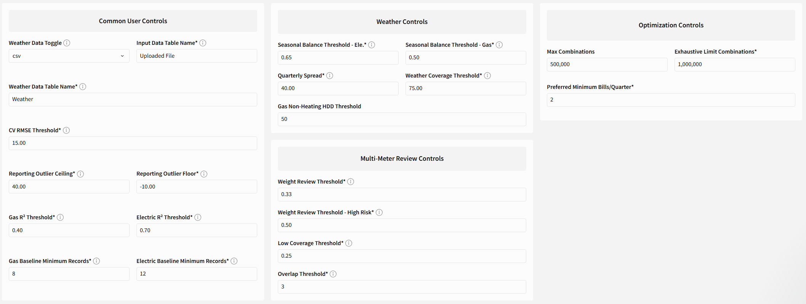

Common user controls
Control | What it does
Weather Data Toggle | Where HDD/CDD come from:  sigma  (auto lookup) or  csv  (from your file).
CV RMSE Threshold | Max CV-RMSE (%) a model may have and still pass quality. Lower = stricter.
Electric / Gas R² Threshold | Min R² a model needs to pass, per fuel (electric stricter than gas).
Reporting Outlier Floor / Ceiling | The % avoided band a reporting bill must fall in to count (default -10 to 40).
Electric / Gas Baseline Minimum Records | Fewest baseline bills a meter needs before the engine will model it (12 / 8).
Weather / Input Data Table Name | Names of the Sigma weather element and the input element the engine reads.

Weather controls
Control | What it does
Seasonal Balance Threshold (Ele. / Gas) | How evenly a baseline must span the seasons to pass (electric 0.65 / gas 0.50).
Quarterly Spread | Max allowed unevenness in bill counts across the four quarters.
Weather Coverage Threshold | Min % of the reporting weather range the baseline must cover (default 75%).
Gas Non-Heating HDD | Gas bills below this HDD are treated as non-heating and dropped from savings (default 50).

Optimization controls
Control | What it does
Preferred Minimum Bills/Quarter | Target number of baseline bills per quarter the search prefers.
Max Combinations | Cap on sampled baseline combinations per site when the total is too large to enumerate. Lower to speed up long runs.
Exhaustive Limit Combinations | If a site's possible combinations are at or below this, the engine tests them all; above it, it samples. Lower to speed up long runs.

Multi-meter review controls
Control | What it does
Weight Review Threshold / High Risk | Flags concurrent-meter sites where one meter carries a large share of load for a closer look.
Low Coverage Threshold | Flags aggregates where a meter contributes little coverage.
Overlap Threshold | How many billing periods two meters must overlap in time to be treated as concurrent (default 3).

Frequently Asked Questions & Common Errors
[WARNING] The following 39 site(s) could not have their PUBLISHER/PASS_THROUGH bills automatically consolidated (a billing period had more than one PUBLISHER bill, or a PASS_THROUGH bill with no matching PUBLISHER bill). They will be SKIPPED from optimization and savings calculations. See the 'cost_only_review' output table for details — these require manual review/correction of the source data before re-running
This could mean that there are duplicated bills in your upload file. Check and remove any duplicates, then try running again.

How do I know what weather source I should use?

Check the Weather Data Coverage page and select your customer from the Tenant drop down. If availability is less than 99.9-100%, click on the KPI tiles called Total Max Date Lag. This will automatically filter the Weather Data Coverage table to sites with missing weather data. If it’s a small impact, you can choose to still use Sigma weather. However, if several sites are impacted then you may want to consider sourcing HDD and CDD manually. In this case, you would fill out the HDD and CDD columns in your original Upload File and then change your controls from Sigma/Input to CSV/Uploaded File.

