Energy M&V Baseline Optimizer
Sigma Computing — Process Guide
How to upload data, run the analysis, and use the interactive workbook

1. Overview
The M&V Sigma workbook performs the same IPMVP Option C baseline optimization analysis as the VS Code tool (see other documentation) but runs entirely in your browser through Sigma Computing. You upload/replace your CSV file referencing the provided template, click Run at the top of Page 2, and the results appear as interactive tables and charts.

The workbook has three pages:

Page | Name | What it does
Page 1 | Data Intake | Upload your CSV file here. The workbook reads it and passes it to the analysis engine.
Page 2 | Optimization & Models | The Python engine runs here. Shows 7 output tables plus quality scatter charts.
Page 3 | Savings & Cost Analysis | KPI tiles, savings charts, cumulative trend, and outlier summary — interactive with site filter.

2. Preparing Your CSV File

2.1 Use the template
Download the blank templet at the top of Page 1 and use it as your starting point. This ensures all the data is in the appropriate order.

2.2 Required columns
The CSV must have exactly these column names. They are case-sensitive — do not rename them.

Column Name | Required | Notes
Site Name | Yes | Unique building identifier. All rows for the same building must use the same value.
Meter Number | No | Optional. Utility account or meter ID. If blank, the engine treats the whole site as a single meter.
Service Type | Yes | Must contain 'Electricity' or 'Natural Gas'. Case-insensitive — 'electric', 'gas' also work.
Period Start Date | Yes | Format: YYYY-MM-DD (e.g. 2023-01-01)
Period End Date | Yes | Format: YYYY-MM-DD
HDD | Yes | Heating Degree Days for the billing period.
CDD | Yes | Cooling Degree Days for the billing period.
Consumption | Yes | Energy usage. Standard units: kWh for electricity, Therms for gas.
Total Charges | Yes | Total dollar cost of the bill. Can include a $ sign and commas — the engine strips them automatically.
Commission Date | Yes | Date the energy efficiency project was commissioned. All rows for the same site use the same date. Bills before this date = baseline. Bills on/after = reporting.
Consumption Unit | No | Leave blank for kWh/Therms. Fill in for MWh, CCF, MCF, or MMBTU — the engine converts automatically.
Selected Baseline | No | Leave blank on first upload. After the first run, download the input_with_baseline output table as CSV — this file has “1” populated in this column for the selected baseline bills. Re-upload that file to run savings calculations without re-optimizing. See Section 4 for the full re-upload workflow.

2.3 Data requirements
- Minimum 12 electricity billing rows before Commission Date per meter
- Minimum 8 gas billing rows before Commission Date per meter
- At least 1 billing row per calendar quarter in the baseline period
- All sites can be in the same CSV file — the engine groups by Site Name automatically
- For multi-meter sites, include all meters in the CSV — the engine detects whether they are concurrent or sequential

2.4 What to watch out for
- Total Charges formatted as currency (e.g. $1,234) is handled — the engine strips $ and commas
- Commission Date with time zone information (e.g. 2024-01-15 00:00:00+00:00) is handled — time zone is stripped automatically
- Commission Date must be present for every row — do not leave it blank even for reporting period rows
- Site Name must match exactly across rows — 'SiteA' and 'Site_A' will be treated as different sites

3. Uploading Your Data (Page 1)
Step 1 Upload your CSV
Click the CSV Input Table element on the page. Select Upload CSV in the drop down and proceed with your upload.
* Note: whatever data is currently loaded will be overwritten.
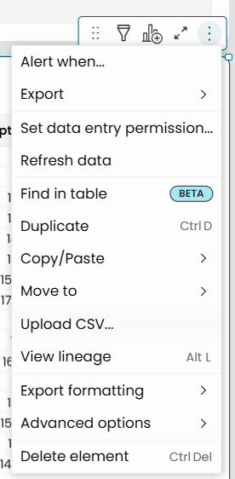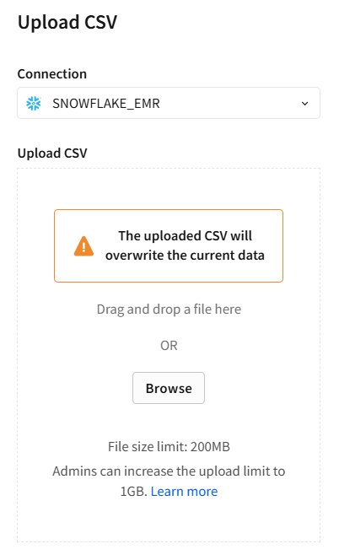

Step 2 Verify the data loaded correctly
After uploading, the table should show your data rows with the correct column headers. Quick checks:
- Row count matches your CSV (minus the header row)
- Site Name, Meter Number, and Commission Date columns are populated
- Period Start Date and Period End Date look like dates, not text
- Consumption and Total Charges look like numbers (dollar signs and commas are fine at this stage)

4. Running the Analysis (Page 2)
Step 1 Click Run
The engine will run. Expect:
- Small portfolios (1–5 sites): 5–15 seconds
- Medium portfolios (10–20 sites): 30–60 seconds
- Large portfolios (20+ sites): 60–120 seconds

Step 2 Review the 7 output tables
The Python element produces 7 output tables. Each is a child element wired to the Python output:

Table | What it shows
individual_models | One row per meter. Your primary results — R², CV-RMSE, savings, weight flags.
aggregated_models | One row per concurrent multi-meter site. Only populated if your data has multi-meter sites with overlapping billing periods.
baseline_bills | One row per baseline bill per meter. Status column shows Used in Model, or Excluded with reason.
reporting_bills | One row per reporting bill. Includes Predicted Consumption, Avoided Usage, Pct Avoided, and Bill Avoided Cost.
outliers | Bills removed from baseline or excluded from savings. Shows Outlier_Type and Outlier_Reason.
meter_weights | Load distribution per meter for concurrent multi-meter sites. Shows Meter Weight (%), Coverage Flag, and Aggregate Weight Flag.
input_with_baseline | Re-upload file. Your original input CSV with one extra column: Selected Baseline = “1” for each bill the optimizer chose. Download this after the first run and use it for all future uploads. See Section 4 — Re-upload Workflow.

4.1 Re-upload Workflow (adding new reporting bills)
After the first run, the baseline is locked. You do not need to re-optimize when new reporting bills come in — the engine detects the locked baseline automatically and skips optimization entirely.
- After the first run, download the input_with_baseline table as a CSV file.
- Open that CSV. It has the same columns as your original upload plus a Selected Baseline column with “1” marking the chosen baseline bills.
- Append your new reporting bill rows at the bottom of that CSV. Leave the Selected Baseline column blank for the new rows.
- Upload that CSV to the Input table on Page 1, replacing the previous input. Run the engine again on Page 2.
- The Optimization Mode column on individual_models will show “Locked” confirming the baseline was not changed. Savings results update to include the new reporting bills.
To re-optimize from scratch (e.g. for a rebaseline), start with a fresh CSV that has no Selected Baseline column and run as normal.

5. Using the Savings Dashboard (Page 3)
Page 3 is the interactive results dashboard. With no site selected, everything shows portfolio-level totals, but the results can be filtered down by site and service type for further investigation.

5.1 Filter controls
At the top of Page 3 there are five filter controls:
- Site Name (drop down) – select one or more sites to filter all elements on the page. Leave blank for the full portfolio view.
- Service Type (drop down) – filter to Electricity only, Natural Gas only, or both.
- Savings Status (drop down) – filter to Included or Excluded
- Model Passes Quality (drop down) – select true or false
- % Avoided Usage (slider) – adjust range to view sites with more or less % avoided usage

5.2 KPI tiles

All are shown at a comprehensive portfolio level as well as broken down by fuel type.

Tile | What it shows
Site Count | Total sites included in savings calculations
Total Avoided Cost ($) | Sum of avoided cost across all passing models. With a site selected: that site's total savings.
Avg % Avoided Usage | Average percent of predicted consumption that was avoided. Positive = savings. Negative = net usage increase.
Avg Monthly Avoided Cost | Average avoided cost per reporting bill — the expected ongoing monthly savings rate.

5.3 Charts

Chart | How to read it
Avoided Cost by Site and Fuel Type | Horizontal bars — length = total avoided cost. Color = service type. Negative bars = net usage increase. Sorted highest to lowest.
Avg % Avoided Usage by Site and Fuel Type | Same layout as avoided cost but normalized by size.
R² Distribution | Histogram showing how model quality is distributed across the portfolio. Most models should cluster to the right (high R²). Models near the threshold line are borderline and worth monitoring.
Savings Performance Scatter | Each dot = one model. X axis = % avoided, Y axis = avoided cost. Top-right = high savings in both dimensions. Bottom-left = underperforming. Negative X = using more than baseline.
Actual vs Predicted Consumption | Two lines per site/service type: actual consumption (what the meter measured) vs predicted consumption (what the baseline model says it should be). The gap between the lines is the avoided usage. Select a site and service type for the clearest view.

6. Output Column Reference

6.1 individual_models and aggregated_models

Column | Description
Site Name | Site identifier from input data
Meter Number | Meter identifier. 'AGGREGATED (N)' for aggregated rows.
Model Type | Individual or Aggregated
Service Type | Electricity or Natural Gas
Seasonal Strategy | Optimal = at least 2 bills per quarter selected. Acceptable = at least 1 per quarter (fallback used).
Baseline Count | Number of bills used to build the model
Reporting Count | Number of clean reporting bills used in savings calculation
Model Equation | Regression equation: Consumption = Intercept + HDD*coef + CDD*coef
R2 | R² score (0–1). Higher is better. Threshold: 0.70 electricity, 0.40 gas.
CV-RMSE | Average prediction error as % of mean consumption. Lower is better. Threshold: ≤15%.
Weather Coverage (%) | % of weather range covered by selected baseline bills. Threshold: ≥75%.
Model Passes Quality | True if R², CV-RMSE, and Weather Coverage all pass. Primary quality indicator.
Pct Avoided Usage | % of predicted consumption avoided in reporting period. Positive = savings.
Avoided Cost ($) | Dollar value: Modeled Cost minus Actual Cost
Avg Monthly Avoided Cost | Avoided Cost divided by number of reporting bills
Meter Weight (%) | This meter's share of total baseline consumption. Only populated for concurrent multi-meter sites.
Coverage Flag | LOW COVERAGE if a passing meter represents less than 25% of site baseline load
Weight Flag | OK / REVIEW / HIGH RISK based on failing meter load share (see Section 7.3)
Notes | Auto-generated observations: multi-meter quality comparisons, weight warnings, sequential meter notes

6.2 reporting_bills

Column | Description
Status | Used in Savings (included in calculations) or Excluded: reason (outlier removed)
Consumption | Actual metered consumption for this billing period
Predicted Consumption | What the baseline model predicted for this period given actual weather
Avoided Usage | Predicted minus Actual consumption
Pct Avoided | Avoided Usage / Predicted * 100%
Bill Avoided Cost | Bill-level avoided cost = Avoided Usage × measured rate for this bill. Used for the cumulative savings chart.

6.3 Weight flag thresholds

Flag | Condition and meaning
OK | Failing meters represent ≤33% of site baseline load. Aggregate is defensible for M&V reporting.
REVIEW | Failing meters represent 33–50% of load. A meaningful portion of site consumption is from unverified meters. Review before including in formal reports.
HIGH RISK | Failing meters represent >50% of load. More than half of site consumption cannot be individually verified. Consider excluding from savings totals or flagging explicitly.
LOW COVERAGE | On individual model rows: this passing meter represents less than 25% of site baseline load. Its contribution to the aggregate savings figure is small.

7. Updating the Engine Script
When a new version of sigma_mv_engine.py is released, update the workbook by replacing the Python element's code. The element can be found in the hidden sheet labeled “Code”

7.1 Tunable parameters
These constants are near the top of the engine script and can be adjusted without affecting anything else:

Parameter | Default | Effect
MAX_COMBINATIONS | 500 | Max baseline combinations tested per meter. Higher = better optimization, slower runtime. 500 gives ~60s for 20 sites.
ELEC_R2_THRESHOLD | 0.70 | Minimum R² for electricity models to pass.
GAS_R2_THRESHOLD | 0.40 | Minimum R² for gas models to pass.
CVRMSE_THRESHOLD | 15.0 | Maximum CV-RMSE (%) to pass. ASHRAE Guideline 14.
WEIGHT_REVIEW_THRESHOLD | 0.33 | Failing meter weight above which aggregate gets REVIEW flag.
WEIGHT_HIGH_RISK_THRESHOLD | 0.50 | Failing meter weight above which aggregate gets HIGH RISK flag.
LOW_COVERAGE_THRESHOLD | 0.25 | Meter weight below which a passing individual meter gets LOW COVERAGE flag.

