**PHYS 375; PS3**

**Joshua Issa; 20783023**

Code can be found at <https://github.com/Morhc/PHYS-375---Problem-Set-3>

**Declaration of Collaboration**

While working on this problem set, I discussed approaches to question 3 with Suhail Chander.

**Question 2**

**Question 3**

3a)

3b)

3c)

3d)

3e, f)

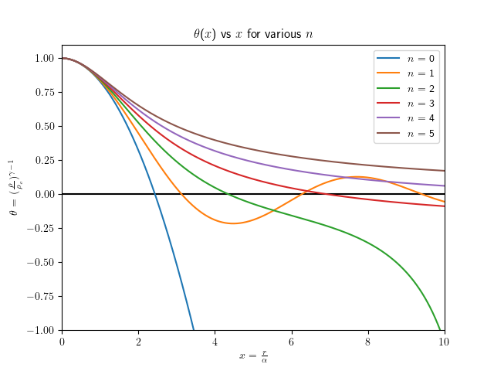

3g) The results for the variables are:

α = 1.00 * 108 m [assuming that x is dimension-less]

ρc = 7.80 * 104 kg/m3

K = 3.86 * 109 [dimension-less]

3h)

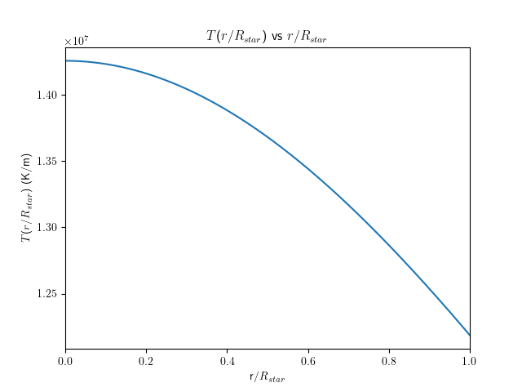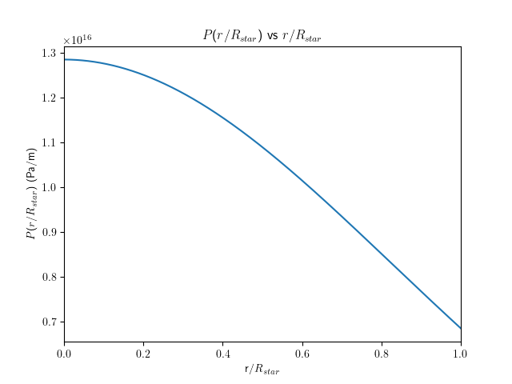

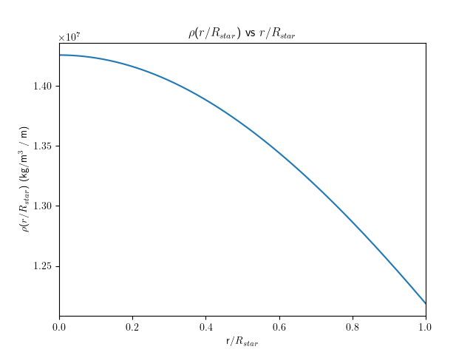

3i)

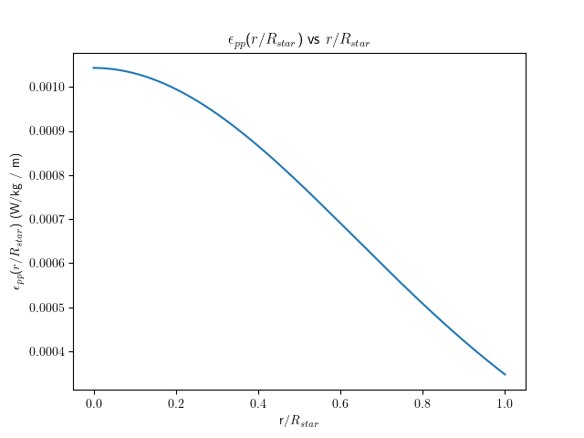

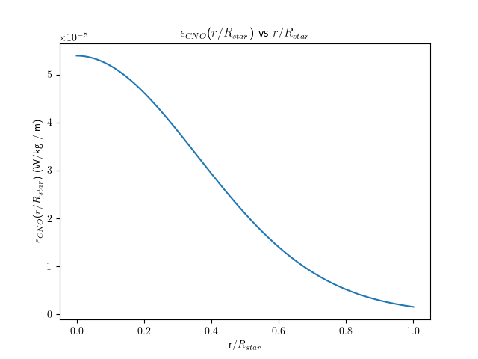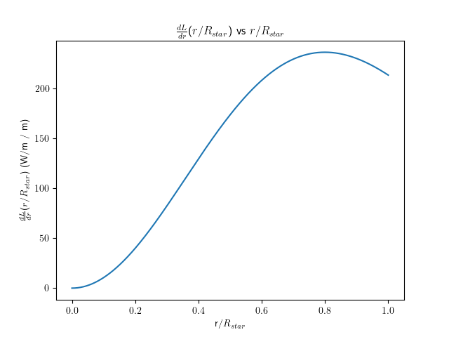

The total luminosity of the star is 4.88 * 1028 W.[1]

3j)

|  |  |  |  |  |
| --- | --- | --- | --- | --- |
| Mass/Msun | Radius/Rsun | ρc (kg/m3) | Tc (K) | Total L (W) |
| 1 | 1 | 7.80 * 104 | 2.85 * 107 | 4.88 * 1028 |
| 0.5 | 0.6 | 1.80 * 105 | 1.19 * 107 | 2.68 * 1028 |
| 20 | 10 | 1.56 * 103 | 1.43 * 107 | 3.44 * 1032 |

We can see that the lower mass star has a greater density, and the greater mass star has a lower density than the solar mass star; each differs by a factor of 10 from the next. The luminosities for the lower mass star and the solar mass are on the same order, but the higher mass star has a luminosity that is 10,000 times greater than the other two. Interestingly, all the core temperatures are the same order.

1. Yes, I know this is not in line with the expected 1026 W.