Grid

grid-template-columns:
200px 400px
repeat(2, 400px)
1fr 2fr
repeat(4, 1fr)
50px auto 100px 1fr

grid-template-rows:
200px
200px 200px 200px
repeat(3, 200px)
repeat(3, minmax(200px, auto))
repeat(3, 1fr)
gap:10px

grid-auto-rows:
200px
minmax(200px, auto)
grid-column-start / grid-column-end / grid-column
grid-column-start: 1
grid-column-start: 2
grid-column-end: 3
grid-column-end: span 2
grid-column-end: -1
grid-column: 1 / span 2

grid-row-start / grid-row-end / grid row
grid-row-start: 1
grid-row-start: 2
grid-row-end: 3
grid-row-end: span 2
grid-row-end: -1
grid-row: 1 / -1

body{
background-color: black;
font-family: 'Nunito Semibold';
text-align:center;
}
#content{
display:grid;
grid-template-columns:repeat(3, 1fr);
grid-auto-rows: minmax(200px, auto);
grid-gap:10px;
max-width:960px;
margin: 0 auto;
}
#content div{
background: #3bbced;
padding: 30px
}
#content div:nth-child(even){
background: #777;
}

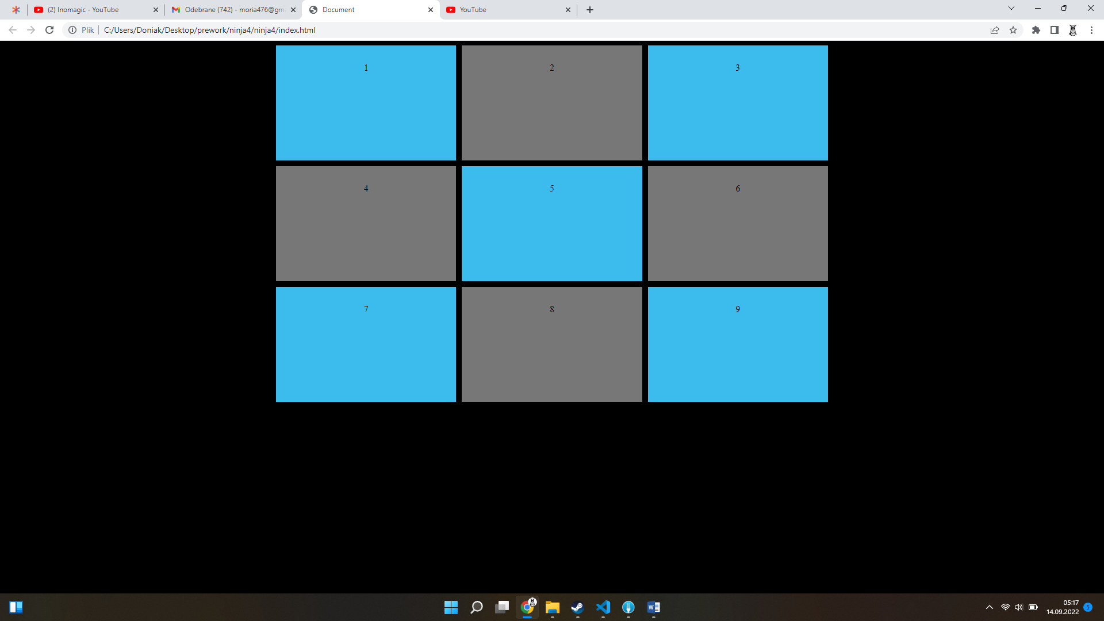

body{
background-color: black;
font-family: 'Nunito Semibold';
text-align:center;
}
#content{
display:grid;
grid-template-columns:repeat(6, 1fr);

grid-gap:10px;
grid-template-rows: repeat(4,minmax(150px,auto));
max-width:960px;
margin: 0 auto;
}
#content div{
background: #3bbced;
padding: 30px
}
#content div:nth-child(even){
background: #777;
}
.one{
grid-column:1/3;
}
.two{
grid-column:3/7;
}
.three{
grid-column: 1/4;
grid-row: 2/4;
}
.four{
grid-column: 4/7;
grid-row: 2/4;
}
.five{
grid-column:3/7;

}
.six{
grid-row:4;
grid-column:1/3;
}

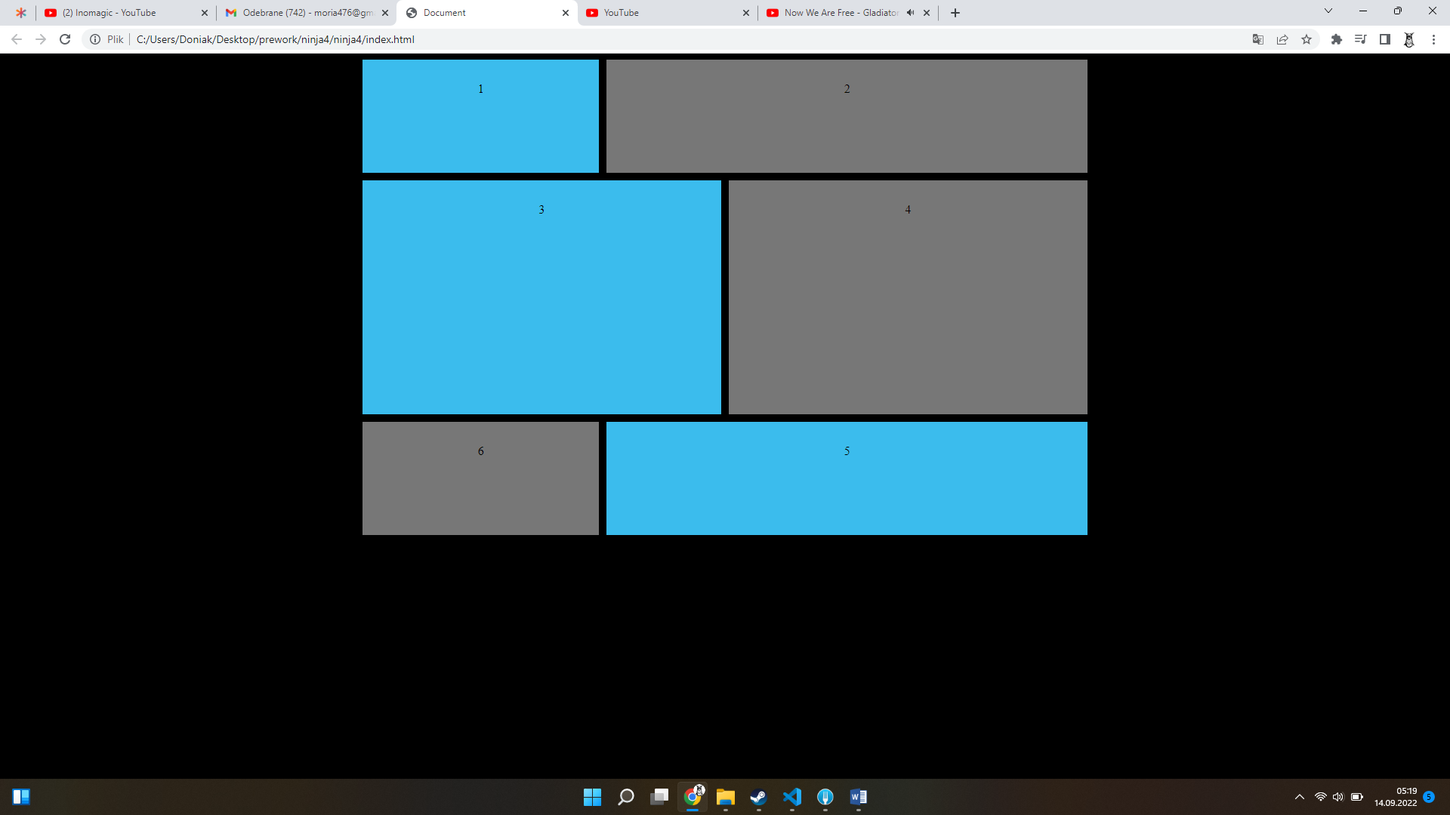
body{
background-color: black;
font-family: 'Nunito Semibold';
text-align:center;
}
#content{
display:grid;
grid-template-columns:repeat(3, 1fr);

grid-gap:10px;
grid-auto-rows: minmax(150px,auto);
max-width:960px;
margin: 0 auto;
}
#content div{
background: #3bbced;
padding: 30px
}
#content div:nth-child(even){
background: #777;
}
.one{
justify-self: end;
align-self: start;
}
.two{
justify-self: center;
align-self: center;
}

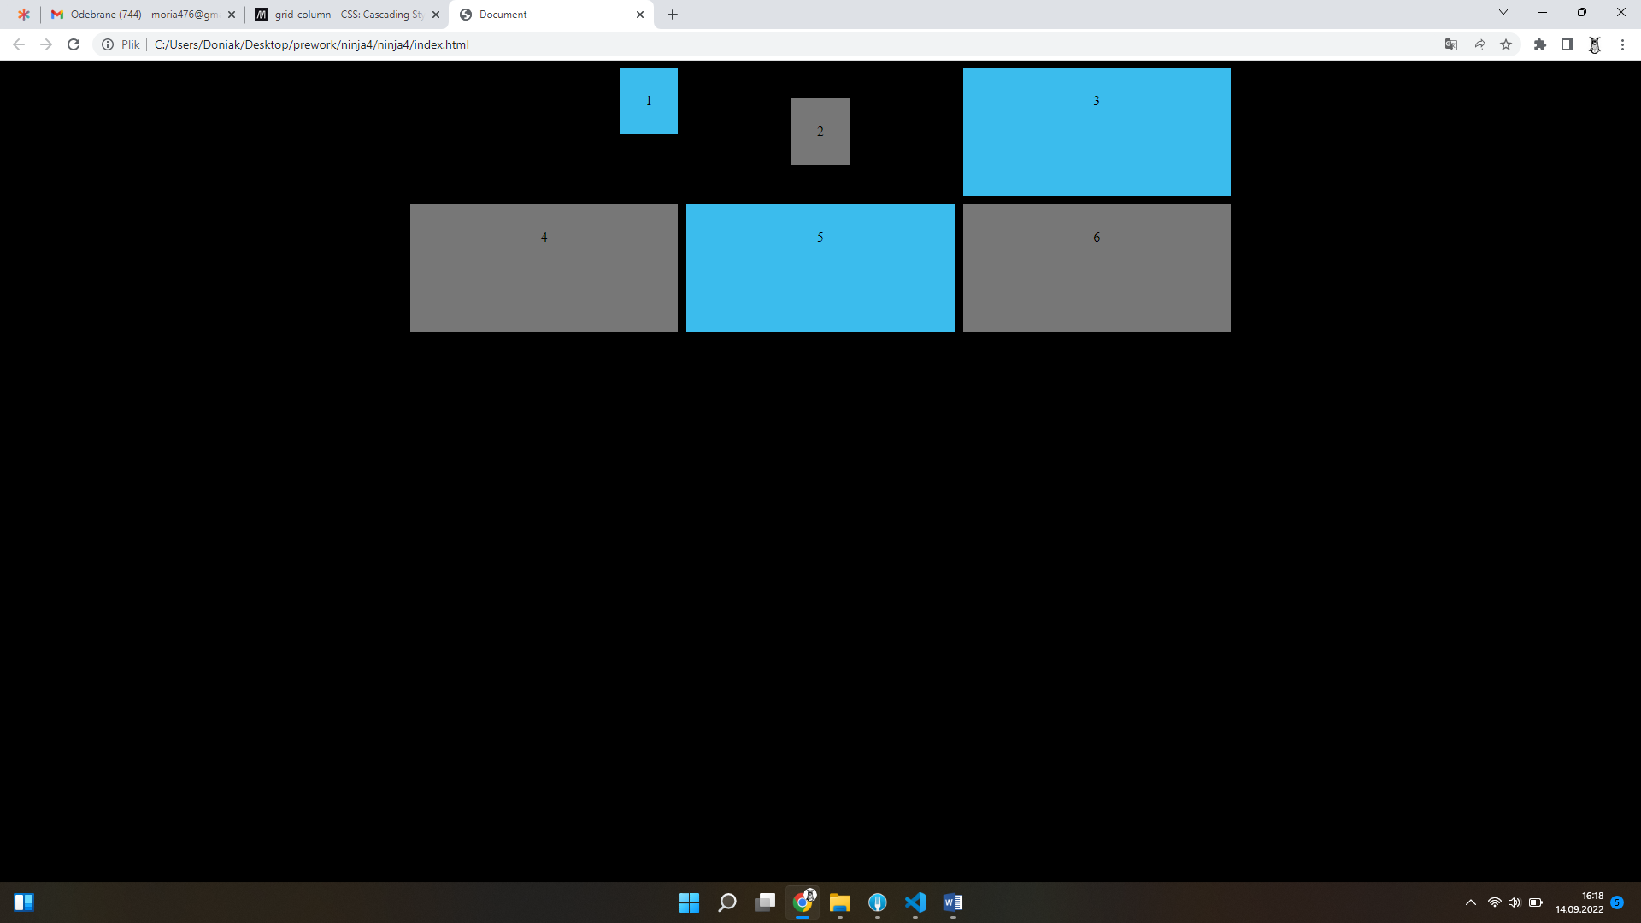

<div id="content">

<Header>Header</Header>
<Main>Main</Main>
<Section>section</Section>
<aside>aside</aside>
<nav>nav</nav>
<footer>footer</footer>

</div>

body{
color: #fff;
font-family: 'Nunito Semibold';
text-align: center;

}
#content{
grid-template-columns: repeat(4,1fr);
grid-auto-rows: minmax(100px,auto);
display:grid;
max-width:960px;
margin: 0 auto;
grid-gap:10px;
grid-template-areas:
"header header header header"
"footer footer footer footer"
"main main main main"
"main main main main"
"aside aside nav nav"
"section section section section"
"section section section section"
…ńćźż
;

}
@media screen and (min-width: 760px){
#content{
grid-template-columns: repeat(4,1fr);
grid-auto-rows: minmax(100px,auto);
display:grid;
max-width:960px;
margin: 0 auto;
grid-gap:10px;
grid-template-areas:
"header header header header"
"aside . main main"
"nav . main main"
"section section section section"
"section section section section"
"footer footer footer footer"
;

}
}
#content >*{
background-color: rgb(16, 43, 34);
padding: 30px;
}
header{
grid-area:header;
}
main{
grid-area: main;
}
section{
grid-area: section;
}
aside{
grid-area:aside;
}
nav{
grid-area: nav;
}
footer{
grid-area:footer;
}

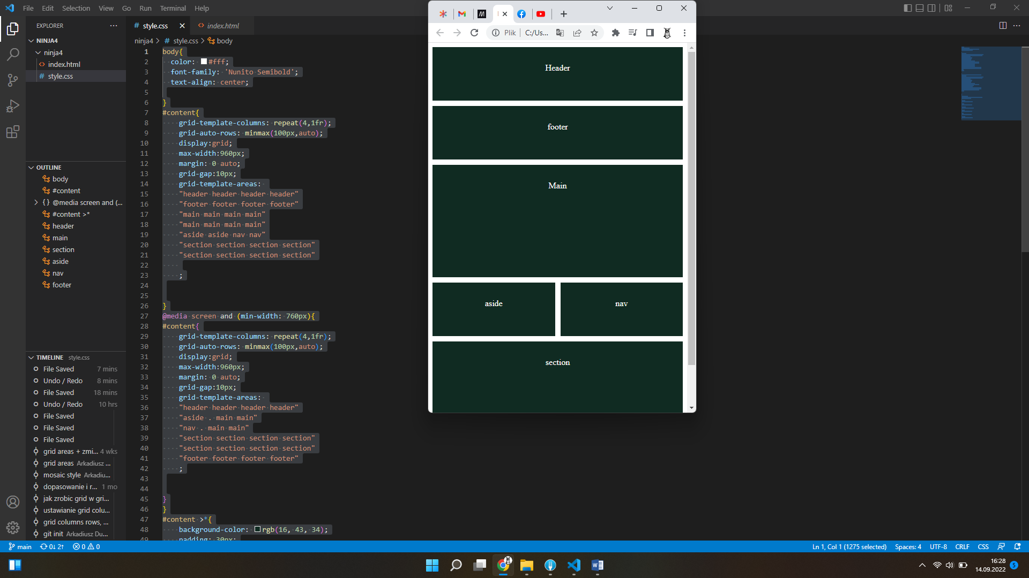
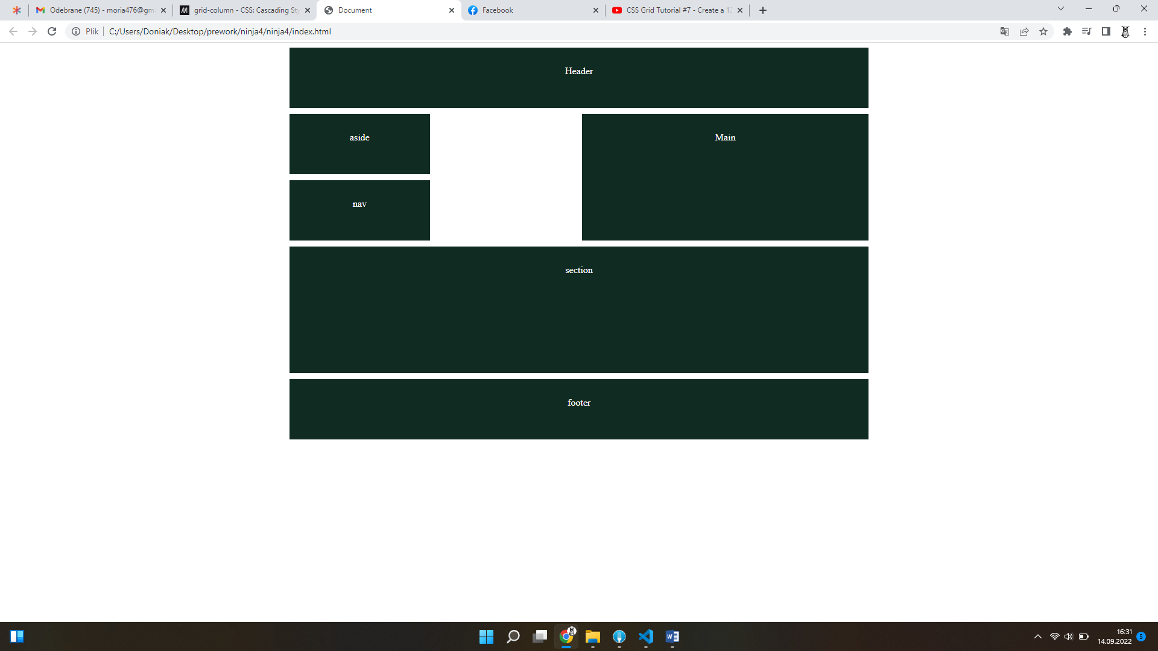
main {
height: 100vh;
display: grid;
grid-template-columns: 1fr 3fr 1fr;
grid-template-rows: 50px auto 50px;
grid-template-areas:

"topbar topbar topbar"
"content ads sidebar"
"footer footer footer";

gap: 10px 20px;
}

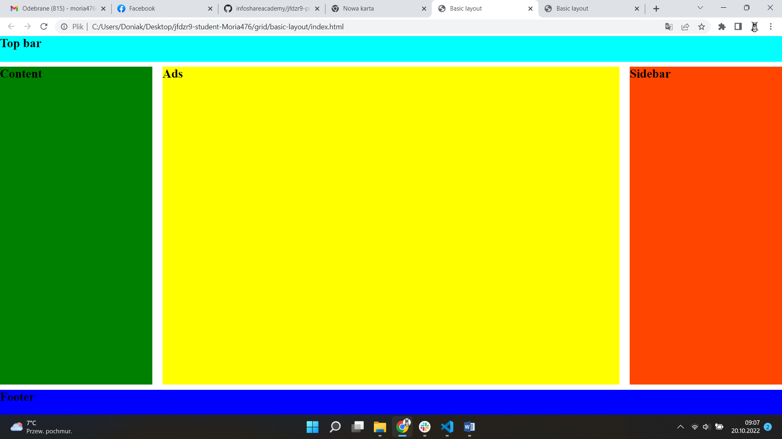

https://www.hongkiat.com/blog/css-grid-layout-minmax/

.grid-container--fill {
grid-template-columns: repeat(auto-fill, minmax(100px, 1fr));
}

.grid-container--fit {
grid-template-columns: repeat(auto-fit, minmax(100px, 1fr));
}
Min-content /Max-content
width: min-content;

grid-template-columns: 1fr max-content max-content;

fit-content()

min(maximum size, max(minimum size, argument))
grid-template-columns: fit-content(40%) fit-content(40%) 1fr;

grid-auto-flow
grid-auto-flow: row;
grid-auto-flow: column;

grid-auto-flow: row dense;

