1. Generating keystore for side A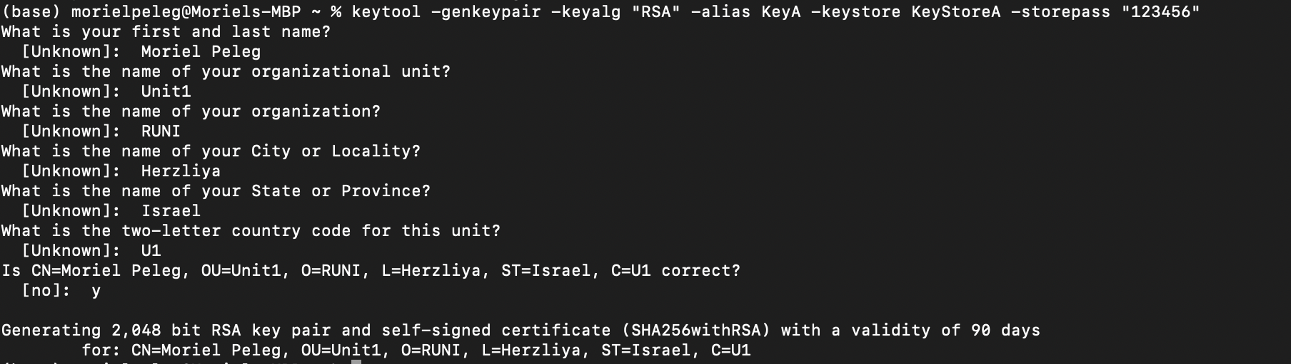
2. Generating keystore for side B 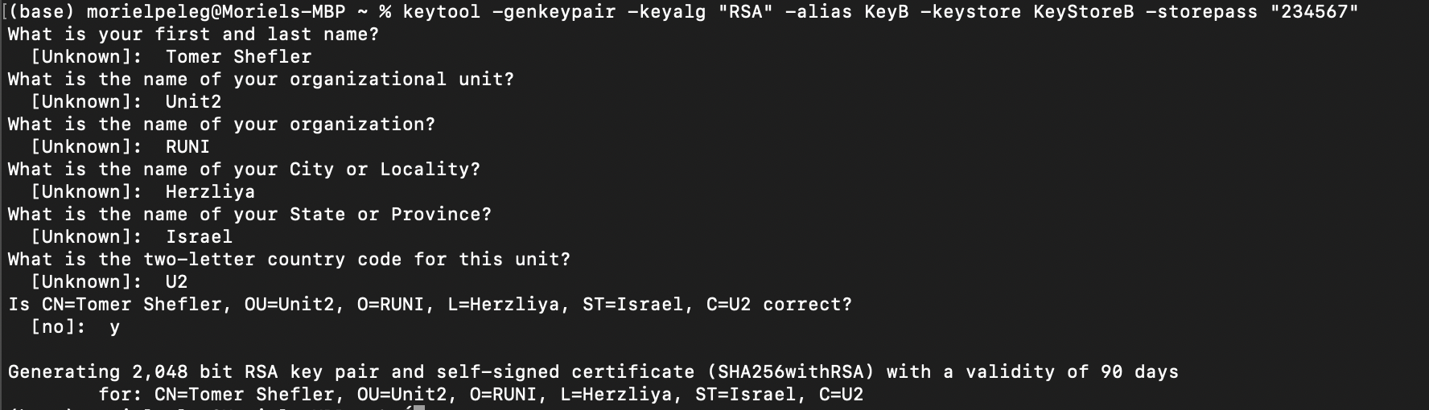
3. Exporting both certificates   
   Importing each certificate to the other keystore 