DD2427 – Exercice 2

Question 1

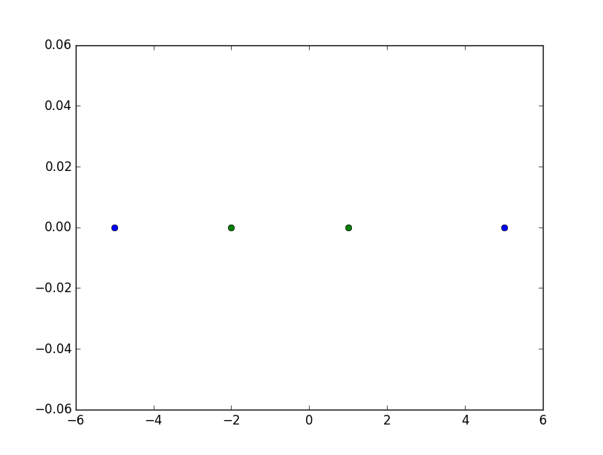
Illustration 1: Data in one dimension
The points from class 1 and class 2 are not linearly separable since class 1 surrounds class 2.

Question 2
In those two dimensions the two classes are linearly separable since a line can split the dimension in two parts with only class 1 in one side and only class 2 in the other side.
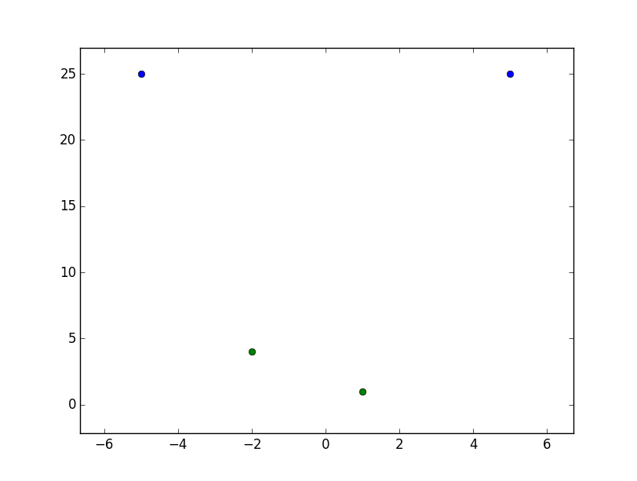
Illustration 2: Data in two dimensions

Question 3
The optimal hyper plan with SVM is :
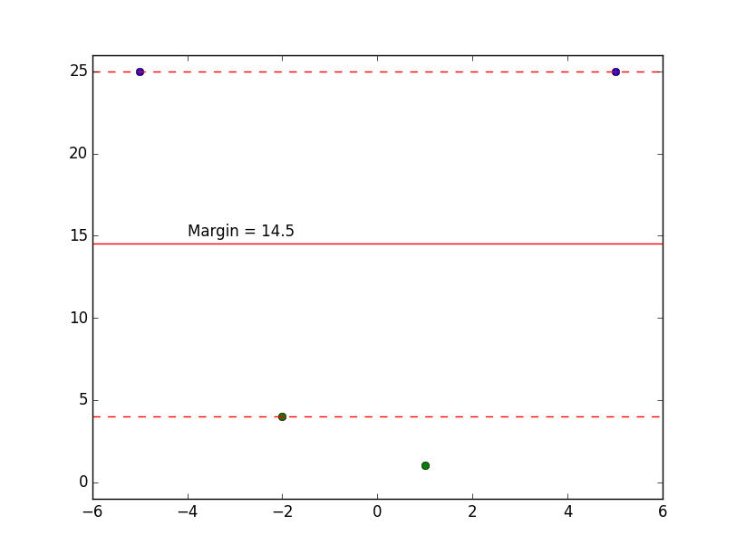
Illustration 3: Hyperplane with SVM in two dimensions
If we use the margin we have found before, we can find a non-linear discriminant function in the one dimension space.
The bounds are -3.8 and 3.8 since both squared are equal to 14.5
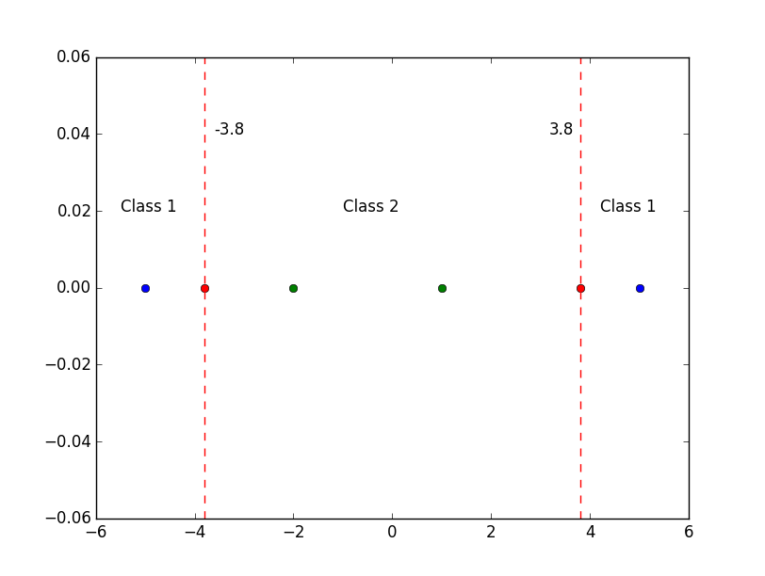
Illustration 4: Non-linear separation in original space
Thus, if x < 3.8 and x > -3.8 we are in class 2 and everything else is class 1.

