Lab 3A – Continuous Speech Recognition

Training and Testing

Prepare the Database

- Number of male /female in test/training set

cat train.lst| grep "/man"| cut -d "/" -f 6 | uniq -c| wc -l

Test set
4311 male sounds
4389 female sounds
77 sounds per male/female
56 males
57 females

Training set
4235 male sounds
4388 female sounds (Mrs ag has only 76 samples)
55 males
57 females

- Number of training and test utterances (shorter sound separated with silences)

Test
28584

Training
cat train_word.mlf |grep -v "\." | wc -l
28330

- Number of phonemes (with silence)
21 (phones0.lst)
22 (phones1.lst)

- Number of nodes and arcs in the recognition network

16 nodes and 36 arcs

Train and test G-HMMs with different features
In the file .cfg we find :
- TARGETKIND
The type of feature we want to use. (MFCC or variants)
- TARGETRATE (HTK uses units of 100ns)
The frame period (100000 ~ 10ms)
- SAVECOMPRESSED
Compress the output features (No)
- SAVEWITHCRC
Add a CRC (resistance to data alteration) to file features (No)
- WINDOWSIZE
The size of the window where we will extract a MFCC feature. (200000 ~ 20ms)
- USEHAMMING
Apply a hamming window on the window extracted for computing the MFCC (Yes)
- USEPOWER
Take absolute value of FFT (Yes)
- PREEMCOEF
Value of the coefficent that compensates the db dropped due to radiation at lips. (0.97)
- NUMCHANS
Number of coefficients takes in the FFT (40)
- LOFREQ
Lowest frequency analyze int FFT (133.33 Hz)
- HIFREQ
Highest frequency analyze in FFT (6835 Hz)
- CEPLIFTER
Number of filter applied during the step of Mel Filterbank (21)
- NUMCEPS
Number of coefficients kept after the DCT (12)
- ENORMALISE
Energy normalisation on recorded audio files (No)

In the proto .mmf file :
- Size of the Vector <> Number of MFCC coefficients
- Number of States of the HMM model
- For each state specified :
  - Tell Means (same size as Vector)
  - Tell variances (same size as Vector)
- Show transition matrix

Differences between all the types of MFCC :
- MFCC : basic one (size 12)
- MFCC_0 : Keep the energy of the DCT coeff (size 13)
- MFCC_0_D : Add delta vector (Delta is the derivative of the MFCC before and after) (size 26)
- MFCC_0_D_A : Add deltadelta vector (Delta² is the second derivative of the MFCC aka acceleration) (size 39)
- MFCC_0_D_A_Z : ... (size 39)

Globla Mean and Variance :
Compute it from the dataset (ex : training) and use it at inital value for all HMM

Training
Difference between hmm 1-3 and 5-7
The iterations 1 to 3 are contained 21 different HMM models since there are 21 phones.
The iterations 5 to 7 are containes 22 HMM models. The 22th one is called 'sp' and shared a state with the phone 'sil'.
Difference between hmm 4 and 5
In HMM 4 the HMM fot the phone 'sp' and 'sil' are not sharing a state. After using the command HHEd, in HMM 5 the phone 'sp' and 'sil' are sharing the state called 'silst'.

Testing
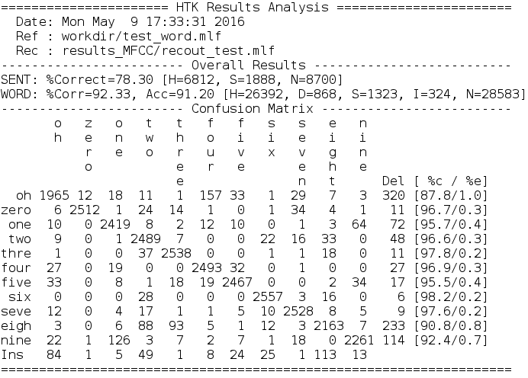
The average performance for finding a word is about 91.20 %. It's better to use this value since the Corr percentage are not removing the I value.

The performance for finding the good sentence of digits is about 78.3 %.

The worth case is the word oh. It generates one percent of the global error and only 87.8 % of the retrieving oh are really a oh.

The word six is really a word six with the highest probability : 98.2 %.

GMM-2

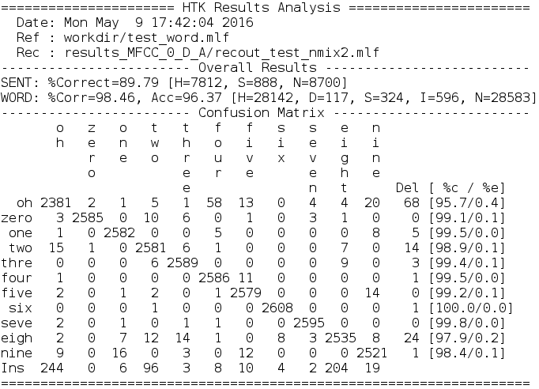
We gain 5 % accurancy for the words. Thus, the correct sentences increase of more than 10 %.

GMM-4

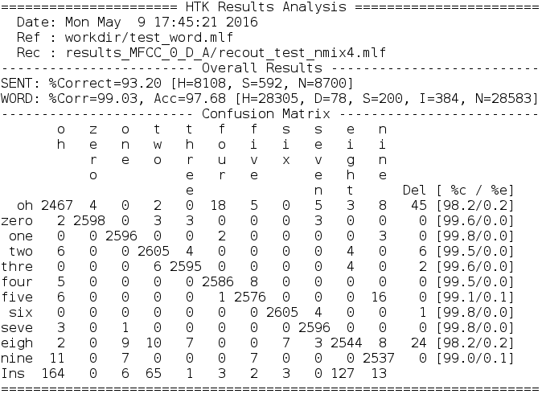
We gain 1.37 % accurancy for the words. We still gain 3.5 % for the correct sentences.

GMM-8

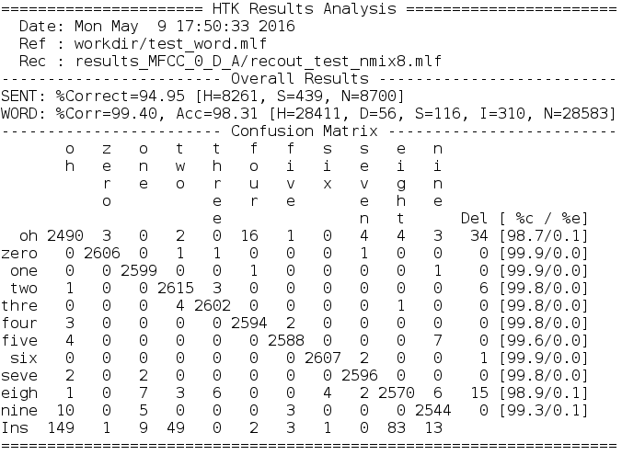
We gain 0.6 % accurancy for the words. There is still a gain of almost 3 % for the sentences.

GMM-16

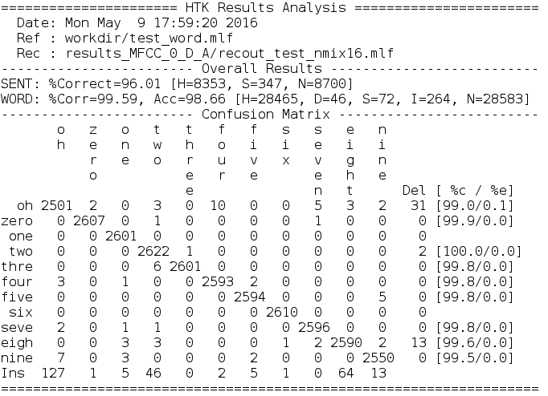
We gain 0.3 % accurancy for the words. Finally, the percentage of good sentence increase of 1 %.

Conclusion :
The more you add gaussians, the better are the results. However, the derivative of the percentage by the number of gaussians is decreasing.
Since the sentences are a mix between different words, a small increase in the word accuracy gives a bigger increase for the sentence accuracy. Thus, even the smaller increase in the word accuracy can be important.

Tune insertion penalty parameter
For the one gaussian model, we have a balance favorable for the deletions.
For the GMM model, we have always a balance favorable for the insertions.

The default value for the gaussion model is -20.
Test with value 0 :
We have more insertion and a lower accuracy.
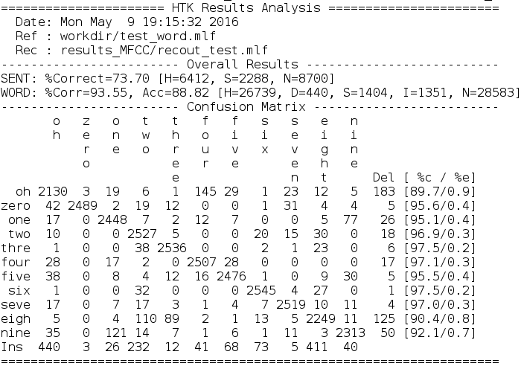
Test with value -60 :
Even worth, the deletion are bigger and the accuracy is smaller than with p = 0 that was already smaller.
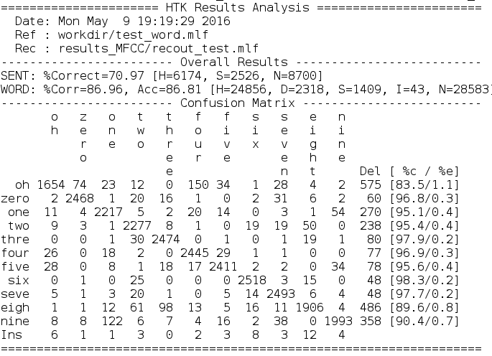

Forced Alignment
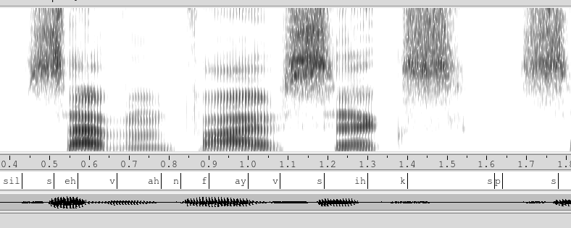
The s and the f are well aligned. A 'f' is a gray block in the bottom and a 's' is a gray block in the top. The big white gap is a 'sp' and I have heard a break.

Analysis

Parameter evolution at different iterations
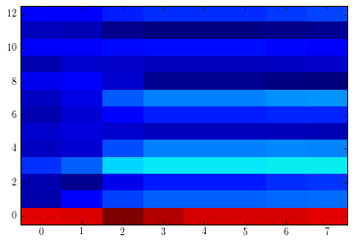
Illustration 1: Mean parameters evolution of state 2 in 'n' (MFFC0)
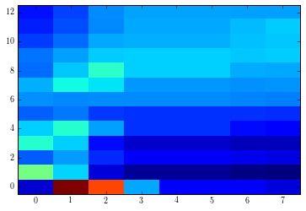
Illustration 2: Variance parameters evolution of state 2 in 'n' (MFCC0)

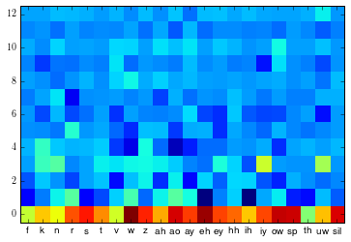
Illustration 3: Mean of state 0 for each phonemes in hmm7 in MFCC0

