Lab 3A – Continuous Speech Recognition

Prepare the Database
Number of male and female in training and test set
$> cat train.lst| grep "/man"| cut -d "/" -f 6 | uniq -c| wc -l

 | Male | Female
Training | 55 | 57
Test | 56 | 57

Number of utterances in training and test set
$> cat train_word.mlf |grep "\/" | wc -l

 | Utterances
Training | 8623
Test | 8700

Number of phonemes
21 (phones0.lst)
22 (phones1.lst)

Number of nodes and arcs in the recognition network
16 nodes and 36 arcs

Train and test G-HMMs with different features
In the file .cfg we find :
- TARGETKIND
The type of feature we want to use. (MFCC or variants)
- TARGETRATE (HTK uses units of 100ns)
The frame period (100000 ~ 10ms)
- SAVECOMPRESSED
Compress the output features (No)
- SAVEWITHCRC
Add a CRC (resistance to data alteration) to file features (No)
- WINDOWSIZE
The size of the window where we will extract the MFCC features. (200000 ~ 20ms)
- USEHAMMING
Apply a hamming window on the window extracted for computing the FFT (Yes)
- USEPOWER
Take absolute value of FFT (Yes)
- PREEMCOEF
Value of the coefficent that compensates the db dropped due to radiation at lips. (0.97)
- NUMCHANS
Number of coefficients takes in the FFT (40)
- LOFREQ
Lowest frequency analyze in FFT (133.33 Hz)
- HIFREQ
Highest frequency analyze in FFT (6835 Hz)
- CEPLIFTER
Number of filter applied during the step of Mel Filterbank (21)
- NUMCEPS
Number of coefficients kept after the DCT (12)
- ENORMALISE
Energy normalisation on recorded audio files (No)

In the proto .mmf file :
- Size of the Vector is equal to the number of MFCC coefficients
- Number of States of the HMM model
- For each state specified :
  - Tell Means (same size as Vector)
  - Tell variances (same size as Vector)
- Show transition matrix

Differences between all the types of MFCC :
- MFCC : Keep 12 coefficients from the DCT (size 12)
- MFCC_0 : Keep the energy of the DCT (size 13)
- MFCC_0_D : Add delta vector (Delta is the derivative of the MFCC before and after) (size 26)
- MFCC_0_D_A : Add deltadelta vector (Delta² is the second derivative of the MFCC thus acceleration) (size 39)
- MFCC_0_D_A_Z : Remove the cepstral mean to the coefficients (size 39)

Globla Mean and Variance :
Compute it from the dataset (ex : training) and use it at inital value for all HMMs

Training
Difference between hmm 1-3 and 5-7
The iterations 1 to 3 contain 21 different HMM models since there are 21 phones.
The iterations 5 to 7 contain 22 HMM models. The 22th one is called 'sp' and shared a state with the phone 'sil'.
Difference between hmm 4 and 5
In HMM 4 the specific HMM for the phone 'sp' and 'sil' are not sharing a state. After using the command HHEd, in HMM 5 the phone 'sp' and 'sil' are sharing the state called 'silst'.

Testing
Simple gaussian
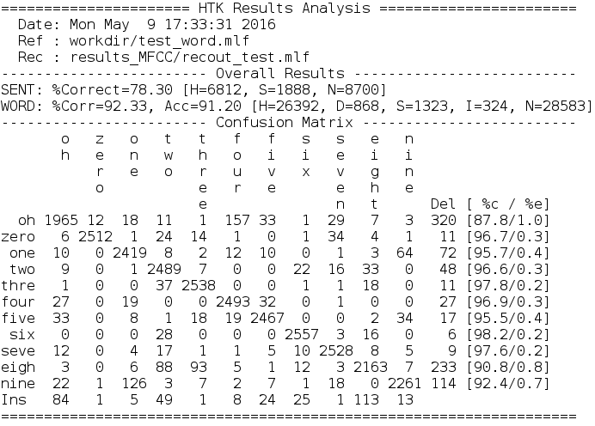
Illustration 1: Result on test set with single gaussian model
The average performance for finding a word is about 91.20 %. It's better to use this value since the Corr percentage are not removing the I (Insertion) value.

The performance for finding the good sentences of digits is about 78.3 %.

The worth case is the word « oh ». It generates 1 % of the global error and only 87.8 % of the retrieving « oh » are really a « oh ».
The word « six » is really a word « six » with the highest probability : 98.2 %.

GMM-2
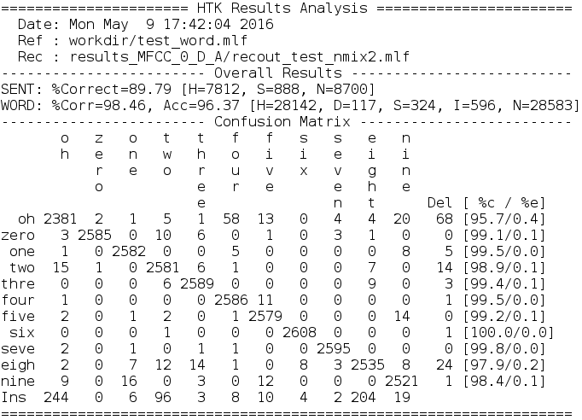
Illustration 2: Result on test set with 2 gaussians model
We gain 5 % of accurancy for the words. Thus, the correct sentences increases of more than 10 %.
GMM-4
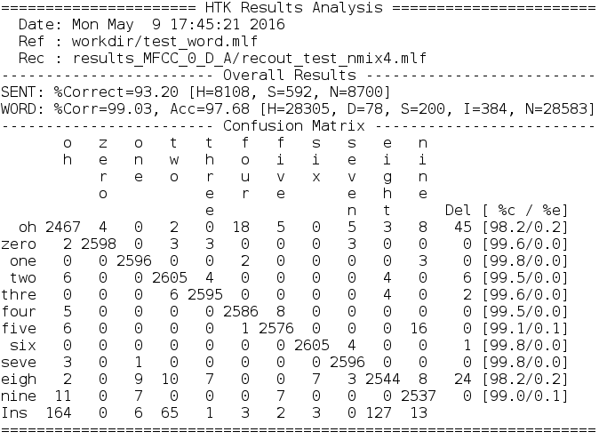
Illustration 3: Result on test set with 4 gaussians model
We gain 1.37 % of accurancy for the words. We still gain 3.5 % for the correct sentences.
GMM-8
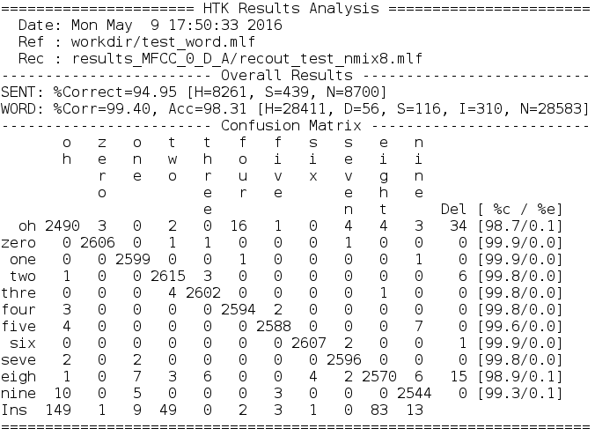
Illustration 4: Result on test set with 8 gaussians model
We gain 0.6 % of accurancy for the words. There is still a gain of almost 3 % for the sentences.
GMM-16
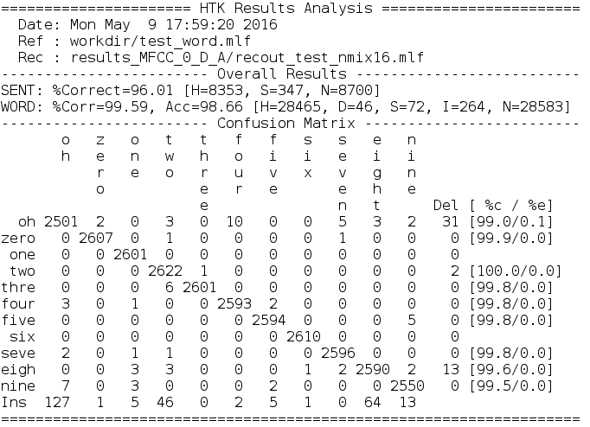
Illustration 5: Result on test set with 16 gaussians model
We gain 0.3 % of accurancy for the words. The percentage of good sentences increases of 1 %.

Conclusion :
The more you add gaussians, the better are the results. However, the derivative of the percentage by the number of gaussians is decreasing.
Since the sentences are a mix between different words, a small increase in the words accuracy gives a bigger increase for the sentences accuracy. Thus, even the smaller increase in the words accuracy can be important.

Tune insertion penalty parameter
For the one gaussian model, we have a balance favorable for the deletions.
For the GMM model, we have always a balance favorable for the insertions.

The default value for the gaussion model is -20.
Test with value 0 :
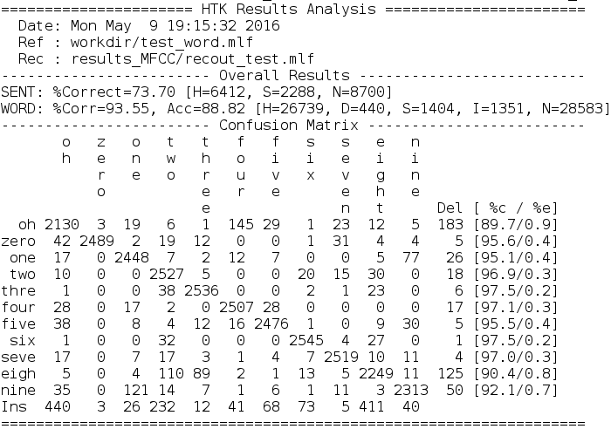
Illustration 6: Insertion penalty set to 0 for MFCC model

We have more insertion and a lower accuracy.
Test with value -60 :
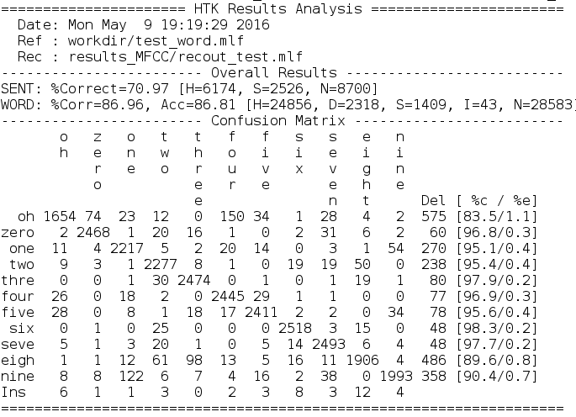
Illustration 7: Insertion penalty set to -60 for MFCC model

Even worth, the deletions are bigger and the accuracy is smaller than with p = 0 that was already smaller.

Forced Alignment
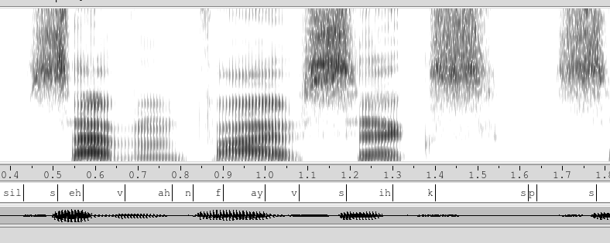
Illustration 8: An utterance where we see the frequencies and the phones associated
The 's' and the 'f' are well aligned. A 'f' is a gray block in the bottom and a 's' is a gray block in the top. The big white gap is a 'sp' and I have heard a break.

Analysis

Parameter evolution at different iterations
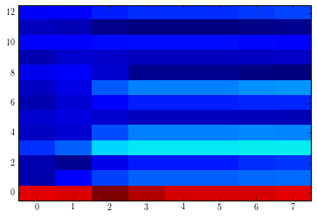
Illustration 9: Mean parameters evolution of state 2 in 'n' (MFFC0)
The mean parameters almost converge in the forth iteration and stop changing after the seventh. The convergence is reached. The coeffcient 0 that correspond to the DCT energy is really bigger than the other ones.
As for the mean, the variance parameters change a lot before the forth iteration and some minor changes are still visible in the last iteration.
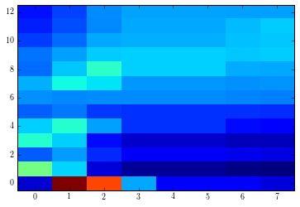
Illustration 10: Variance parameters evolution of state 2 in 'n' (MFCC0)

Parameters for different phonemes
A 's' and a 'sil' are very similar. The energy is really big and all the other coefficients are almost constant.
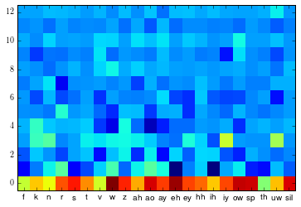
Illustration 11: Mean of state 0 for each phonemes in hmm7 in MFCC0
Usually the fricatives have a lower energy ('f', 'k', 'n'...).
The vowels have a biger energy and the lower coefficients (2-7) are more variable and sometimes very low.

