Report 1 – Feature extraction

Objective
During this lab, we will understand the different steps for extracting the features of the sound and how to differentiate the sounds.
Explanation of MFCC
http://practicalcryptography.com/miscellaneous/machine-learning/guide-mel-frequency-cepstral-coefficients-mfccs/
Cepstrum : sequence of numbers that characterise a frame of speech

Enframe
The purpose of this step is to cut the original sample in many smaller ones.
Here the shift is smaller (10ms) than the length of the window (20ms), part of the original will be in more than one window.
Calculation of the length and the shift in samples :
Sample rate (Sp) : 20 kHz
Time between two samples (Tp) :
Length of the window :
Length of the shift :
Short segment are quasi-stationary
If too short : not enough samples to get a reliable spectral estimate
If too long:signal is changing too much statisticaly not predictable

Pre-emphasis
This function compensate the 6db/octave that are dropped due to the radiation at the lips.
The function is like
The coefficents are A = 1 and B =
Accentuate the variation of signal : low frequencies change to slowly, so we focus more on high frequencies

Hamming Window
The hammig window will reduce the extremities of the window and keep emphasize the center of the window. This is really important for improving the values of the FFT. This will reduce the high level harmonics and focus on the main frequencies.
Reduced sidelobes
Without Hamming window, it's like using a rectangle window.
Rectangle –FFT--> Lot Important sidelobes
Hanning window : gaussian like shape that goes to 0
First side lobe are present but the attenuation is around 60db/lobes
Hamming window : Hanning window + rectangle(small)
First sidelobe disappear but the decreasing of the next one are just -20db/octave

Fast Fourier Transform
According to the sampling theorem :

Mel filterbank log spectrum
The filters is composed of 40 filters. The first triangle is only keeping low frequencies. The next filters are slowly shifting to the higher frequencies. However, the amplitude of the triangle is decreasing.
Reproduce the ear system : due to sampling limitation, bigger are the frequencies, more it is difficult to discern the difference
The filter sum the energy of a frame of the frequencies. When the frequencies increase, we take a bigger filter since the resolution is less precise
Take the log of the energy because of the log property of sound : for doubling the volume, you should put 8 times as much energy
Variation are less perceptable when the sound get louder
Since high frequencies imply more variation, we need to emphasize them for not losing information
--> Mspec : Really corellated
DCT : decorellates the signal
High coefficients represent fast change in filterbank energies and experiment show that they degrade the efficience of ASR.
Keep only the first coefficient

Result
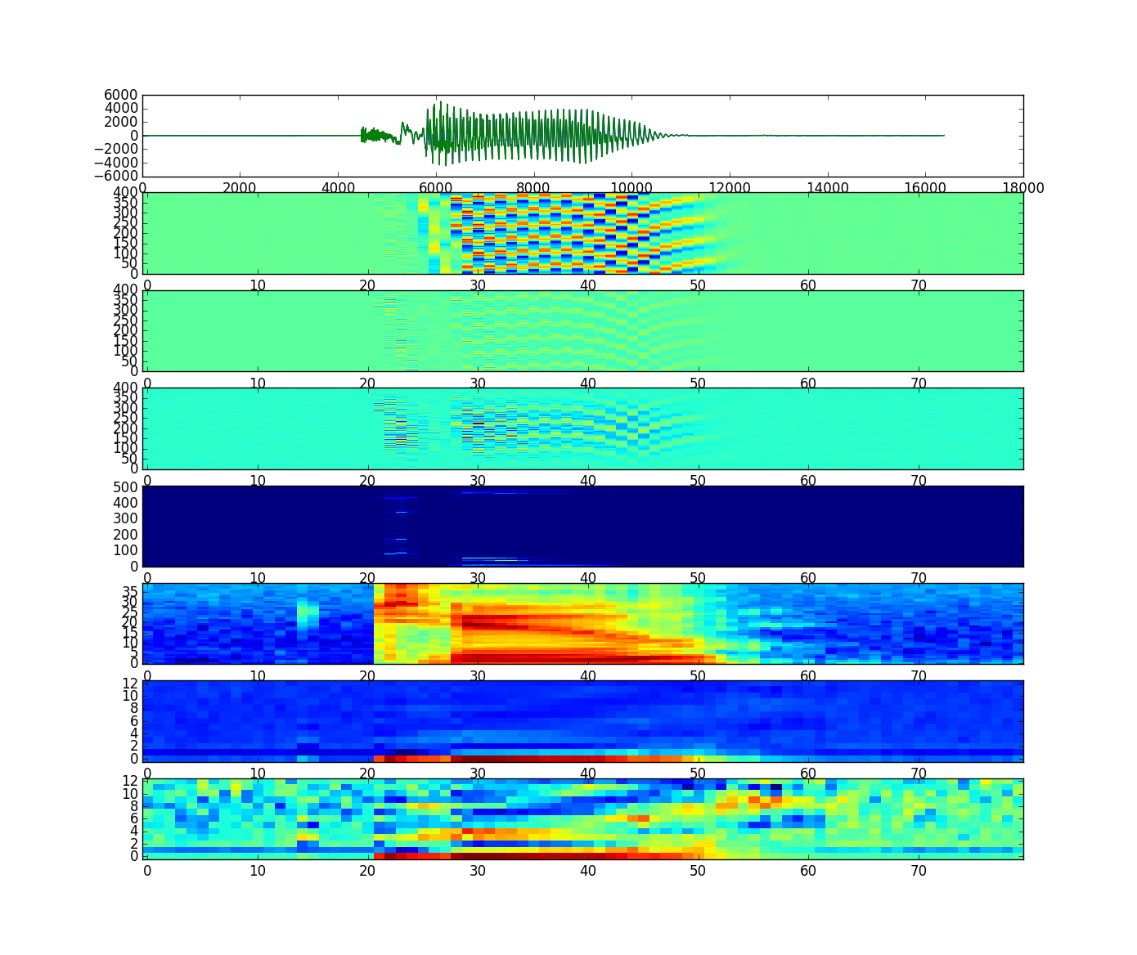
Illustration 1: Differents steps for extracting the features of the example

Feature Correlation
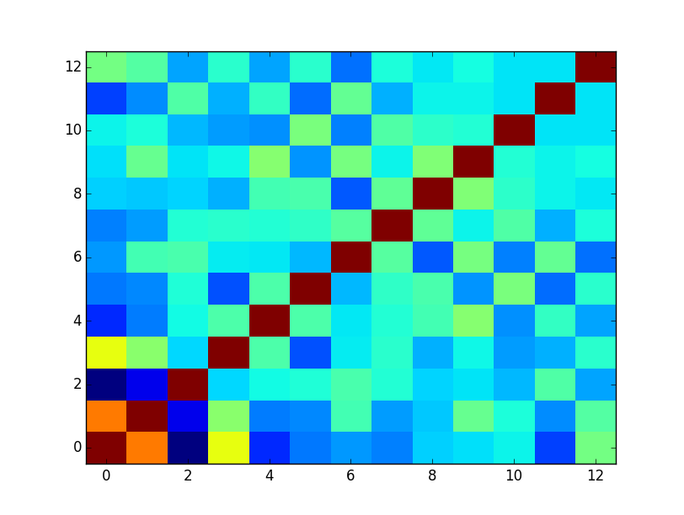
Illustration 2: Correlation between Mfcc features

We can see that the correlation is really strong on the diagonal and really weak elsewhere. Those features are really good to use because each vector is giving a lot of new information.

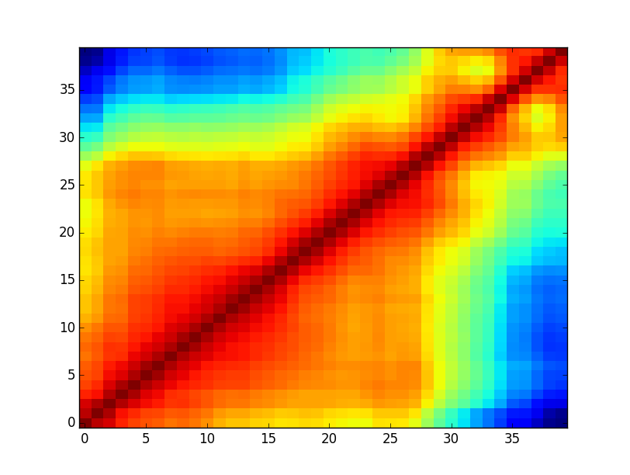
Illustration 3: Correlation between Mspec features

Using Mspec features is a really bad idea since the correlation is really strong between vectors that are neighboor.

Comparing Utterances
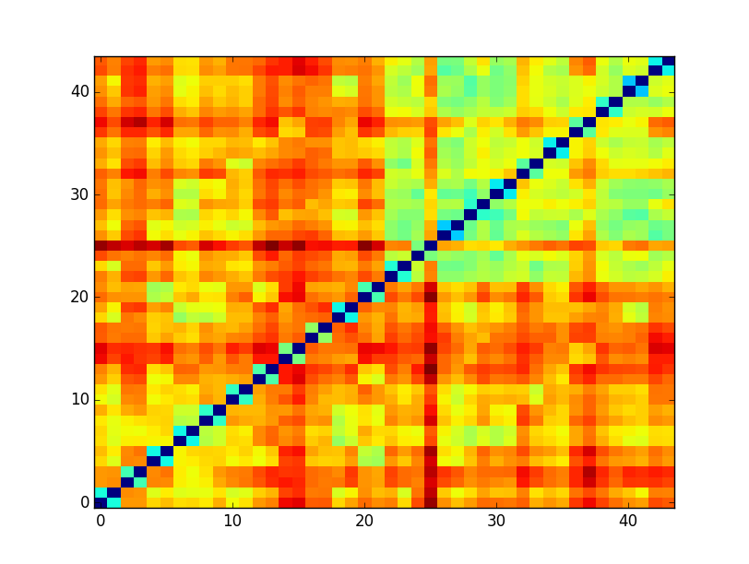
Illustration 4: Distance between samplings of tidigits
We can see that the distance is really small between a « digit » said from a girl and a man. Thus it will be harder to recognize them.
For the samples 0 to 22 to every other samples the distance is more emphasized so it will be easier to recognize them. The distance between the samples 22-44, that are mostly numbers, have a smaller distance between them. The system has more difficulties to differenciate numbers.

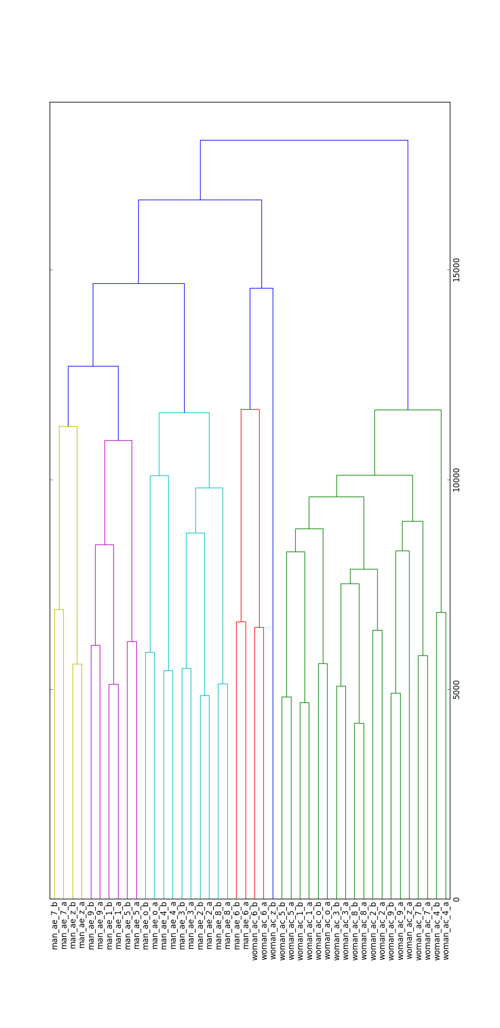
Dendrogram

