**Project Description**

PIAA, particularly the WPIAL, still schedule dual meets for their track & field schools. These meets are scored very different than an invitation or championship meet. As a result, these meets offer special challenges. First, these meets are often contested with limited resources. There are simply not enough staff to dedicate multiple people to storing results and calculating scores. Second, scoring takes time. There are many times when meet results don’t come out until the day after the meet. Could you imagine a football game being played, and not knowing who won until the next day? Third, human error is often involved in scoring. This happens anytime a human is in charge or doing math. Finally, complete results are usually unavailable after the meet, only scoring performances. This is usually due to time constraints.

The proposed of the proposed program will help elevate all of these issues. Users will have the opportunity to define the specifics of the meet (Date, Locations, Team Names, Etc.), and names/performances for all 18 events. The data can then be used to calculate scores for each dual meet instantly and accurately. Coaches can also benefit from having quick, accurate, and neat printouts for the entire meet. These printouts could be by event, by team, or a printout of an entire meets scores.

**Use Case Diagram**

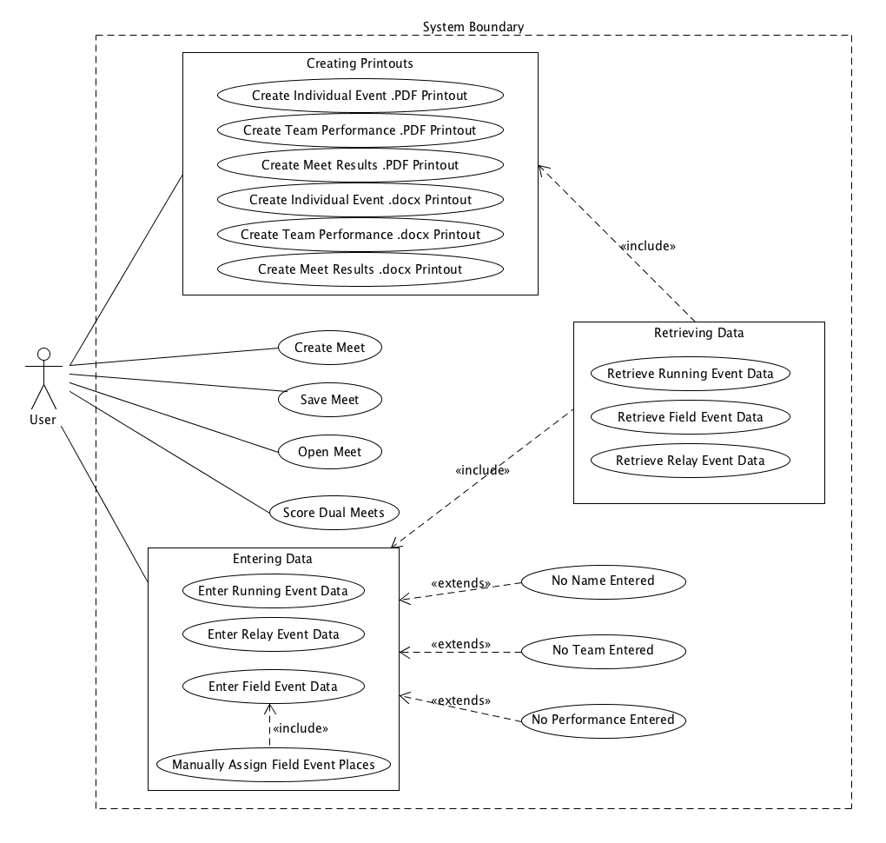

**Use Cases**

**Create New Meet**

User will enter information for a new meet. This will include the Date, Location, Weather conditions, Boy/Girl Team Names, and a 1-3 character abbreviation for each team name. Once entered, the user will be asked to confirm the data.

**Enter Running Event Data**

Success Scenario:

The user will have the option to enter running data by heat #. The user will be presented the option to select how many runners are in the heat, and the proper number of boxes will be displayed based on that information. The user will have the opportunity to enter each runner’s name (textbox), school (combobox), and performance (textbox). The user must enter data for each in order for the program to accept the results. For the performance, the user may enter the data in minutes and seconds (Minutes:Seconds, 1:01), or just seconds (61). If the user enters performances out of order, they will be reordered accordingly. Users will be able to scroll through each heat by clicking arrows located at the bottom.

Alternate Scenarios:

No name entered for a performance – A Message Box will pop up alerting the user to enter a name for every performance.

No team entered for a performance - A Message Box will pop up alerting the user to enter a team for every performance.

No performance enter for a name – A Message Box will pop up alerting the user to enter a performance for every name given.

**Enter Field Event Data**

Similar to the Enter Running Event Data Use case. Users instead will be able to enter data by feet and inches (Feet-Inches, 18-3), or just inches (219). Data will not be organized by flight, as this has no bearing on scoring guidelines.

Alternate Scenarios:

No name entered for a performance – A Message Box will pop up alerting the user to enter a name for every performance.

No team entered for a performance - A Message Box will pop up alerting the user to enter a team for every performance.

No performance enter for a name – A Message Box will pop up alerting the user to enter a performance for every name given.

**Enter Relay Event Data**

Similar to Running Event Data, but data is separated by scoring teams and non-scoring teams. This way, non-scoring teams can have their performances stored, but won’t count towards point calculations. The user will have the option to enter names of the 4 members of the relay teams, but it will be optional. Data will also not be separated by heat, as this has no bearing on scoring guidelines, and would add confusion to the separation of scoring vs non-scoring teams.

Alternate Scenarios:

No name entered for a performance – A Message Box will pop up alerting the user to enter a name for every performance.

No team entered for a performance - A Message Box will pop up alerting the user to enter a team for every performance.

No performance enter for a name – A Message Box will pop up alerting the user to enter a performance for every name given.

**Retrieve Running Event Data**

Previous running event data must be retrieved for several uses. This includes editing previous data, checking scores, or creating print outs. This data must convert raw data (seconds) to formatted data (minutes:seconds).

**Retrieve Field Event Data**

Previous throwing event data must be retrieved for several uses. This includes editing previous data, checking scores, or creating print outs. This data must convert raw data (inches) to formatted data (feet-inches).

**Retrieve Relay Event Data**

Previous relay event data must be retrieved for several uses. This includes editing previous data, checking scores, or creating print outs. This data must convert raw data (seconds) to formatted data (minutes:seconds).

**Score Dual Meets**

Primary Actor: User

Stakeholders:

* User – Wants results to calculate quickly and accurately without doing calculations themselves
* Coaches – Want accurate results instantly

Preconditions:

Results for all events that have taken place so far have been entered and are accurate

Success Guarantee: The current results of each dual meet taking place are displayed to the user

Main Success Scenario:

In a contest that has more than 2 teams, each set of two teams needs scored as separate meets. Therefore, every set of teams needs scored for first, second, and third place. Current PIAA rules must be applied:

1. First place is awarded 5 points, second is awarded 3 points, third is awarded 1 point
2. Winning relay teams receive 5 points, loser receives 0
3. Ties can occur under certain circumstances:
   1. For track events, runners have the same time in separate heats (They cannot tie in the same heat)
   2. For field events, other than High Jump and Pole Vault, all 3 jumps/throws are the exact same.
   3. For High Jump and Pole Vault, all jumps/misses are the same
4. Ties are calculated by dividing evenly (2 firsts are award 4-4 respectively)

Each of the 18 events must be scored separately, then added together for each team to come up with the totals. There are rules in place for if 2 teams have the same number of points, but the program does not need to concern itself with that.

Extensions:

Only one team: Scoring will not be available as there are no meets to score. This could happen if the program is used for an intrasquad type meet

No results have been added yet: The program will simply tally a 0 vs 0 for each set of teams. No special consideration for this scenario need to be accounted for.

Special Requirements: None

Technology & Data Variation List: How should the program handle running decimals?

Frequency of Occurrence: Whenever the user requests this information from the title screen

Open Issues:

Inaccurate Data – If the user enters inaccurate data somewhere in any event, this could produce an inaccurate score. These inaccuracies are not easily found during this process, each event must be looked at separately. Care must be taken by the user to enter data accurately when prompted to do so.

Decimal Places – It is possible for a score to handle decimal places, which isn’t usually a big deal. However, it is also possible for repeating decimals (.3333…..) to happen because of fractions. Special considerations need to be considered to counter the issues that could occur with this.

**Manually Assign Field Event Places**

The Field events score rules, particularly the High Jump and Pole Vault, pose a unique challenge to the creation of this program. These points are award based on the best performance, same as a running event. However, if the best performance is the same, it will go by the second, and maybe even the third best performance. The High Jump and Pole Vault is even more unique, as previous misses are factored in. Rather than have the program understand all of these rules and force the user to enter significantly more data, it would be far more efficient to have the user manually award field event places when these situation might occur. If the best performance is a tie, the user will be prompted to award a winner (or a tie if appropriate).

**Save Meet**

All data from the meet must be saved. The data will include All Meet specific data, as well as all event performances. This will, at first, be done via File IO, but later a database will be used.

**Open Meet**

Saved meet data needs to be retrieved. The data will include All Meet specific data, as well as all event performances. This will, at first, be done via File IO, but later a database will be used.

**Create Individual Event .PDF Printout**

A PDF file will be generated that contains all names, teams, and performances for a particular event. These results will be listed in a table(s). Data will be ordered by performance, from best to worst. When applicable, the data will be separated by heat #

**Create Individual Event .docx Printout**

A .docx file will be generated that contains all names, teams, and performances for a particular event. These results will be listed in a table(s). Data will be ordered by performance, from best to worst. When applicable, the data will be separated by heat #

**Create Team Performance .PDF Printout**

A PDF file will be generated that contains all names and performance for every event competed by a particular team. Performances will be separated by event and will be listed in order of performance, from best to worst.

**Create Team Performance .docx Printout**

A .docx file will be generated that contains all names and performance for every event competed by a particular team. Performances will be separated by event and will be listed in order of performance, from best to worst.

**Create Meet Results .PDF printout**

A PDF file will be generated containing the breakdown of each individual meet. See Score Dual Meets Use Case for specific scoring guidelines. Each set of teams needs an individual page dedicated to that meet. Each event will be broken down to show how the points were awarded. This will include name, schools, and performance. Performances that are not good enough to earn points (ex: 5th place) will not show up on this sheet. Ties will be marked as such, with the word “TIE” in place of a name, and possibly the school. All data will be arranged in one really big table, with the exception of the total points, which will be shown separately at the top of the page.

**Create Meet Results .docx printout**

A .docx file will be generated containing the breakdown of each individual meet. See Score Dual Meets Use Case for specific scoring guidelines. Each set of teams needs an individual page dedicated to that meet. Each event will be broken down to show how the points were awarded. This will include name, schools, and performance. Performances that are not good enough to earn points (ex: 5th place) will not show up on this sheet. Ties will be marked as such, with the word “TIE” in place of a name, and possibly the school. All data will be arranged in one really big table, with the exception of the total points, which will be shown separately at the top of the page.