SE Department


Software Engineering Department
ORT Braude College
Course 61771: Extended Project in Software Engineering
PV angle and spatial placement design using Genetic Algorithm

In Partial Fulfillment of the Requirements for
Final Project in Software Engineering (Course 61766)
Karmiel – Januar 2019

Students:
- Shahar Shani 303161590
- Mor Atias 307864009
Supervisor(s):
Dr. Miri Weiss-Cohen

Content

1. INTRODUCTION: 3
2.RELATED WORK:……………………………………………………………………...5
3. BACKGROUND: 7
3.1 Genetic Algorithem Overview: 7
3.1.1 Elitism: 8
3.1.2 Selection: 11
3.1.3 Crossover: 11
3.1.4Mutation12.........................................................................................................
3.1.5 Replacement:……………………....………………………………………..13
4. PROPOSED SOLUTION: 13
4.1 Evaluation Function 14
4.2 Selection 16
4.3 Crossover 16
4.4 Mutation 17
4.5 Replacement 18
5.SOFTWARE ENGINEERING DOCUMENTS…………….………………………..24
5.1 UML-diagrams 24
5.1.1 Use-Case diagram 24
5.1.2 Calss diagram 25
5.1.3 State chart diagram 26
5.2 GUI: 26
5.2.1 Main window: 26
5.2.2 GA-setting window: 27
5.2.3 Result window: 27
5.2.4 Confirm saving dialog: 28
6.TESTING PLANE…………………………….…………………………………….….28
7.RESULTS:………………………………………………………………………………29
8.PARAMETER ANALYSIS AND TESTS: 29
9.CONCLUSIONS:…………………………………………………………………….…30
10. REFERENCES:……………………………………………………………………..….30

ABSTRACT: In recent years solar energy has received worldwide attention in the field of renewable energy systems. The specifications of photovoltaic modules show performance under standard testing conditions (STC), but only limited information relating to performance at non-STC conditions. While performance is affected by irradiance, temperature, spectral composition of irradiance, angle-of-incidence (AOI) of the irradiance and other parameters, specifications only partly give detail to consumers or retailers about the effect of irradiance and temperature. We establish the effect of two parameters on array of modules performance: positioning and angle-of-incidence. We offer a solution by using Genetic Algorithm to optimize the position of each PV module and the irradiance angle of incidence. Furthermore, we characterize the operating conditions and contribution of the two parameters to energy losses or gains relative to operating conditions.
KEYWORDS
photovoltaics; spectral effects; irradiance; angle-of-incidence; positioning; PV array; Genetic Algorithm

1. INTRODUCTION:

The continuous and reliable supply of energy has been one of the most important issues for humankind, regardless of geographical position, race, religion, or economic and political conditions. The current global population of 7.6 billion is expected to grow to 8.8 billion by 2035, and consequently, the primary energy consumption could increase from 13,147 Mtoe (million tons oil equivalent) in 2017 to 17,157 Mtoe by 2035. Despite the growing environmental concerns with fossil and nuclear energy, the primary energy in 2014 was still based 86.31% on fossil fuel resources and 4.44% on radioactive resource [1]. The replacement of natural gas, crude oil, and coal with different types of renewable energy resources has become the overarching goal of sustainable development. The successful substitution of fossil fuel and nuclear resources probably will require the combination of different renewable resources including hydropower, photovoltaic, wind, geothermal, and biomass-based energies. The renewable energy portfolio is therefore highly dependent on geographical location and weather conditions, the latter of which could rapidly and unpredictably start to change in the near future [1].

In recent years, the substantial increase of research and development work in the area of photovoltaic (PV) systems have made the PV power generators a feasible alternative
energy resource that complements other energy sources in hybrid energy systems. The trend of fast increase of the PV energy use is related to the increasing efficiency of solar cells as well as the improvements of manufacturing technology of solar panels. The PV generators can either be grid connected (operate in distributed generation systems) or can operate in stand-alone (autonomous) systems. With the development of distributed generation systems, the renewable electricity from PV sources became a resource of energy in great demand [2]. Photovoltaic (PV) systems are an alternative to produce energy without the need of external fuel storage. Such a characteristic makes the PV systems a suitable alternative for mobile applications but also for stand-alone electricity generation in isolated locations . Moreover, PV systems have become an interesting alternative for co-generation in urban environments to supply non-critical loads such as office lighting (light-to-light) and residential comfort devices such as air-conditioned plants [3].

Photovoltaic modules use light energy (photons) from the Sun to generate electricity through the photovoltaic effect. The majority of modules use wafer-based crystalline silicon cells or thin-film cells. The structural (load carrying) member of a module can either be the top layer or the back layer. Cells must also be protected from mechanical damage and moisture. Most modules are rigid, but semi-flexible ones based on thin-film cells are also available. The cells must be connected electrically in series, one to another.

In (Fig 1) we can see a schematic of one diode model when $' I_{L}'$represents the light-generated current in the cell, $' I_{D}'$ represents the voltage-dependent current lost to recombination,$' I_{sh}'$ represents the current lost due to shunt resistances $' R_{s}'$ is the resistance offered by the solar cells in the path of the current flow and $' R_{sh}'$ is shunt resistances.

Fig.1. Schematic of One diode model.

Reconfigurable architectures are of great interest to system designers. This interest is gaining more momentum as technological advances and improvements to system components become more modular and allow for greater design flexibility and innovation. The utility interactive system, the simplest system in terms of design, is configured with added components to improve its efficiency[5].

The main challenge in configurate PV arrays concerns the large amount of possibilities that must be evaluated to find the best solution. There is a lot of issues that should be addressed like whether one photovoltaic cell is too close to the other and can make a shadow on him in some parts of the day, depends the angle to the sun. As it will be detailed in the following sections, differences in electric characteristics between solar cells composing a single PV module and between PV modules composing a PV string lead to a strong reduction of the output power of the whole PV array. All the above factors create a gap between the potential energy production and the actual energy extracted.
For grid-connected PV arrays a proper design of the architecture of the power conversion group is required. The choice of the number of inverters and their configuration affects significantly the performance , reliability , mismatch rejection and of course costs of the array. There are four, most commonly, architectures[7].:
- Central-inverter architecture - all the arrays are connected to the input of the common unique inverter. This solution is usually simpler and cheaper but has the disadvantage that mismatch losses are higher. the single inverter is usually stored in a proper housing providing more stable environmental conditions.
- String-inverter architecture - every string has its own inverter thus performances under partial shading condition are increased, how ever it is more expensive
- Multi-string inverter architecture – a DC/DC boost converter is installed in each string. All the DC/DC outputs insist on a common DC bus and this is finally connected to the DC/AC stage. This solution combines both the advantages of the cheaper central-inverter architecture and the better performances of the string-inverter architecture.
- Micro-inverter architecture - each module has its own inverter and all the micro-inverter outputs are connected to a unique AC bus. The disadvantages are essentially higher costs of each micro-inverter. More- over they may show a more limited reliability since they are exposed to varying weather conditions (i.e. rain, snow).

In this work, we will address the Central-inverter architechture because it is the most common and widley use one, and because it is the simpliest and the cheapest. We will compensate the mismatch condition in our algorithem by choosing the best performance configuration topology.

Furthermore, one of the most important affects on the utilization of photovoaltic technology, the electrical current generated by photovoltaic devices, is the spectral distribution (spectrum) of sunlight. It is also commonly understood that spectral distribution of sunlight varies during the day, being "redder" at sunrise and sunset and "bluer" at noon. The magnitude of the influence that changing spectrum has on performance can vary significantly, depending on the photovoltaic technology being considered. In any case, spectral variation introduces a systematic influence on performance that is time-of-day dependent. The influence of spectral variation on photovoltaic devices has been documented by several authors . Similarly, the optical characteristics of photovoltaic modules or pyranometers can result in a systematic influence on their performance related to the solar angle-of-incidence [4].

This work proposes the design of a reconfiguration system, position and AOI, based on a Genetic Algorithm (GA) aimed to provide the best configuration, with a much shorter processing time in comparison with the Bridge-link (BF) solution. Such a characteristic makes the proposed GA solution suitable for real-time applications. In such a way, the proposed solution is validated using detailed models, parameterized with experimental data.

RELATED WORK:

The main problem in configurate PV arrays is the amount of possibilities. Such a problem has been addressed in literature using multiple approaches. In [6] the author propose a programed configurations (PC), which select a given configuration depending on pre-defined rules. The algorithm change the configuration according to the device it connect with, what's make the solution unsuitable for large PV arrays. In [7] Nguyen offers a solution using sorting algorithms (SA), which search an acceptable solution that meets a given criterion, with two main approaches. The first one is the "Bubble sort" algorithm which switches the adaptive PV arrays one at a time. After each switching, the power of the total system is analyzed, and the next sort is implemented. The second one is a model reference approach that is able to predict power levels in each of the rows of the fixed solar arrays and uses this prediction to simultaneously switch the connections of the adaptive bank. In [1] the author present a solution using brute force (BF) algorithm, which tests every possible configuration at the cost of very long computation times. Among those approaches, only the BF solution ensures to find the configuration providing the highest power, but its excessive long processing times
make this solution impractical for real-time applications.

Fig. 2. Connection topologies of the PV array.(a)Series array,(b)parallel array,(c)series-parallel array,(d)total-cross tied array,(e)bridge-link array and(f)honey-combarra[7].

In literature , many alternative array interconnection topologies have been proposed for reducing mismatch losses [7]. Series and parallel topologies, Fig. 2 (a) and (b), are the basic configurations,with the main disadvantages that , respectively , the current and the voltage are below the practical desired values under mismatch condition. During partial shading ,parallel-connected PV elements produce higher power than series-connected ones , since in the parallel connection the overall current is the summation of all the currents and voltages do not vary very significantly. However, higher currents flow in parallel connected elements,so that power losses and voltage drops are generally higher and cabling is more expensive . In actual PV power arrays,the serial-parallel(SP) is the most common connection. It is obtained connecting solar modules in series to form a string(necessary to reach the voltage required by inverter input ranges);strings are then connected in parallel to increase the total current (as shown in Fig. 2c).
In Total- cross-tied(TCT) configurations (see Fig. 2d), modules are first parallel tied so that voltages are equal and currents are summed up; many of these groups are then connected in series. Though under uniform conditions SP and TCT modules connection provide the same power value, the TCT topology reduces the overall effect of mismatch.
In the Bridge-link(BL) topology,in Fig. 2e, about half of the interconnections of the TCT topology are avoided ,sot hat cable losses and wiring installation time are reduced. Though, in larger installations the TCT arrangement can be easier to wire because of the simplicity of the pattern. Advantages shown by both TCT and BL topologies have been combined in the Honey- Comb (HC) configuration (in Fig. 2f). However, it less immune to mismatch condition.

The power ratings of PV modules are performed with a beam of light that is perpendicular to the PV modules surface. From our perspective on Earth, the sun is always changing its position in the sky. It is pretty obvious that every day the sun moves from the east to the west between sunrise and sunset. The exact location of the sun in the sky depends on where you live, the day of the year, and, of course, the time of day. This effects the design decisions engineers make when they are installing photovoltaic (PV) panels.
We want to reach the best angle-of-incidence, which gives us the best uttiliztion of the photovolativ cell, and maximize the amount of electrical energy we produce from him throughout the day. This problem is addresed in literature in some different approaches.
In[4] the author offers a solution that takes into consideration the zenith angle to the sun and calculate the affect of solar spectral irradiance on the angle of incidence, but it requires a lot of pre-measured parameters, and empirically parameters, which make the solution not sutibale because it is much more complicated and expensive to use trial and error methods.

3. BACKGROUND:

3.1 Genetic Algorithm Overview:

Introduction
Genetic Algorithm is a search heuristic that mimics the process of evaluation which are used to search, optimize or learn. These types of algorithms were invented by John Holland at the University of Michigan in the 1970s. They are a part of Evolutionary Computing while using evolutionary analogy. Most compare them to the idea behind the theory “survival of the fittest”. The principle is similar to the natural selection concept: those who are the fittest survive. As an analogy to the world of algorithms, if we examine a group of solutions, we will only choose the best suited and dispose of the less suitable.
The methodology of Genetic Algorithms is to use a population of candidate solutions (usually referred to as individuals) to an optimization problem, which are then used to evolve in order to reach a better solution. Each candidate solution has a set of properties (chromosomes) which can be mutated, altered or discarded. These genes and their settings are usually referred to as an organism’s genotype – the encoded solution.
Overviewing the genetic algorithm process, you would first find that an empty population is created. The first solutions evolve and create better and enhanced solutions. Two individuals are selected from this population, copied and crossed with each other. On a predefined probability, the offspring will mutate and a possible better feasible solution will be reached. The new created solution will replace the existing solution, therefore leaving the existing population the size. This process will be expanded on in the following sections.

3.1.1 Elitism:
: Elitist strategy is used to preserve the best solution obtained against the selection, crossover and mutation operators. Elitism simply saves the best-so-far chromosome throughout generations, and replaces the worst chromosome with the elite after each generation. The use of this strategy is optional and not always used, it allows us to pass the best solution to the next generation. It can be also used as a method of Replacement/Insertion as we will discuss further in this overview.
In order to review and analyze a solution, a representable method is required. A possible candidate can be represented as a binary string of ‘1’s or ‘0’s, in which each trait either exists or not. For example, if we assume that the human being is represented as a string of 80 bits (see Fig 3), and that the 25th-26th bits represent eye color: blue, green, brown or gray, in addition to the 25th -26th bits being “10”, then it means that this person's eye color is brown.
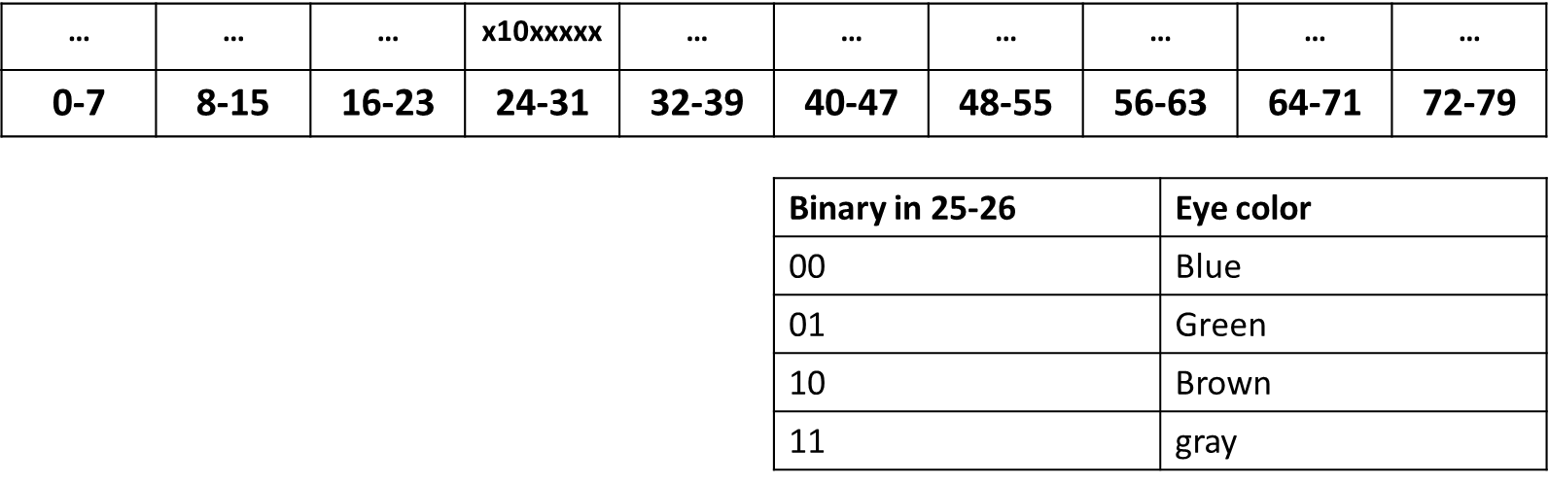
Fig3: Human representation in binary
Search space
Search Space (Fig 3.1) refers to the space that contains all possible solutions. Each point in the search space represents a feasible solution, which is marked by its value or “fitness”, meaning how good or compatible it is for the problem that is being solved. Each solution generated through this process is referred to or is treated as a Chromosome. In Biology terminology, all living organisms consist of cells, when each cell contains the same set of chromosomes. These chromosomes are strings of DNA and genes, which serve as a model for the complete organism, for example, each gene encodes a trait like eye color.
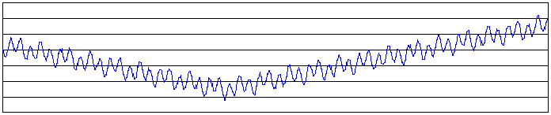
Fig 3.1: Search space of 1 dimension (one value was encoded into the chromosome)
The algorithm
The evolution usually starts from a random set of individuals, which are examined and evaluated in each generation. In programming terms this is called iteration. After the evaluation the individual will be altered or mutated. The fitness is usually the value of the objective function in the optimization problem being solved, or how close the individual is to the solution of the problem. After a known amount of generations has been produced, or a satisfactory fitness level has been reached, the production of generations is stopped and the best solution for the problem is chosen. This means that we will not always get an optimal solution. At some point of the algorithm a best solution may have been located, but as in some generation, an operator was used and therefore the individual had changed. This may lead to a less fitted offspring than the parent.
A basic genetic algorithm would run as follows:
- Start: Generate a random population of ‘n’ chromosomes (a suitable solution for the problem).
- Fitness: Evaluate the fitness f(x) of each chromosome ‘x’ in the population.
- New population: Create a new population by repeating following steps until the new population is complete:
- Selection: select two parent chromosomes from the population according to their fitness value.
- Crossover: with a crossover probability, cross over the parents to form a new offspring. If no crossover was performed, the offspring will be an exact copy of its parents.
- Mutation: with a mutation probability, mutate new offspring at each locus (the position of a gene in a chromosome).
- Replacement/Insertion: place new offspring in the new population.
- Replace: Use new generated population for a further iteration – a generation.
- Test: If the end condition is satisfying, stop, and return the best solution in the current population.
- Loop: Go to step 2.
After the algorithm ends it will return the fittest of the last iteration.
Encoding
The encoding of chromosomes (the feasible solutions) is of very high importance when trying to solve a problem with genetic algorithms. The encoding and the representation depend on the problem. Following are examples of encoding methods:
- Binary encoding: (Fig 3.2) in binary encoding, every chromosome is a string of bits: ‘0’ or ‘1’.
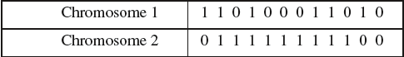
Fig 3.2: Binary encoding

- Permutation encoding: (Fig 3.3) can be used in ordering problems such as Travelling Salesman’s problem or task ordering problems. In permutation encoding, every chromosome is a string of numbers, which represent numbers in a sequence. For example, the encoding of TLS problem would be that the chromosomes would be shown the order of the cities that the salesman is to visit.
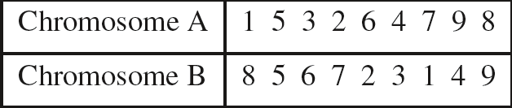
Fig 3.3: Permutation encoding

- Value encoding: (Fig 3.4) direct value encoding can be used in problems with complicated values, such as real numbers. In value encoding every chromosome consists of a string of values. These can be any values connected to the problem, starting from numbers, real numbers or chars and up to high complicated objects.
One of the biggest disadvantages of this method is that it often needs to develop new crossovers and mutation techniques specifically for the problem.
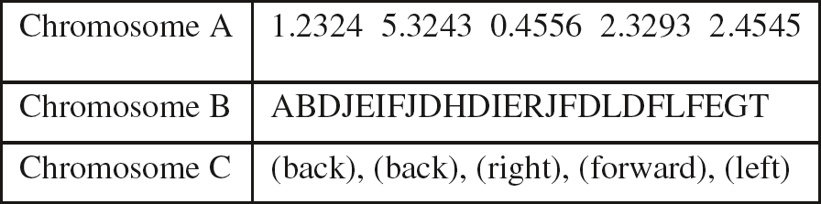
Fig 3.4: Value encoding

- Tree encoding: (Fig 3.5) is used mainly for evolving programs or expressions for genetic programming. In tree encoding every chromosome is a tree of objects, such as functions or commands in the programming language (Scheme, LISP etc.).
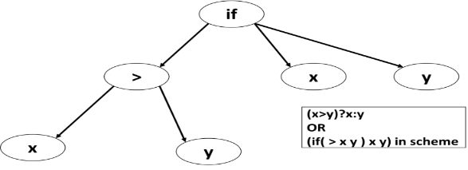
Fig 3.5: Tree encoding
Genetic operators
After reviewing the different types of encodings, the next step of the algorithm is creating the new population. There are several operators:

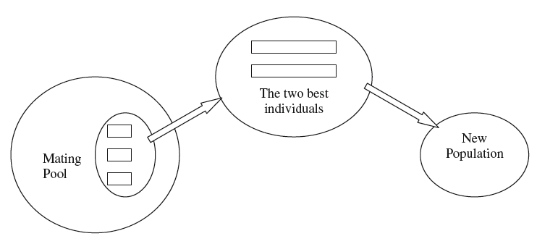
3.1.2 Selection: selection also known as Reproduction: (Fig 3.6) Chromosomes (parents) are selected from the population - the Mating pool. These Chromosomes crossover to the next stage. This operator is required in order to choose the fittest chromosomes that are most suitable to solve the problem. In most cases, the children, who are traditionally better suited to solve the problem, will replace their parents in the new population.
Fig 3.6: Selection

The original technique for selection in the GA is Fitness-Proportionate Selection, also known as Roulette Selection (Fig. 3.7). The guideline for this operator is: survival of the fittest. The selection operator can be used as a roulette wheel in which two random chromosomes will be chosen, and can be used as a random selection, or a ranking selection, in which the best two chromosomes will be chosen.
In the Roulette Selection algorithm, the future parents are selected in accordance to their fitness, the better the fitness, the better chance it will have to be selected. The probability for selecting the i^{th} chromosomes in the Roulette-Wheel selection is:
$$p_{i}=\frac{f_{i}}{\sum_{j=1}^{n}{f_{j}}} (1)$$
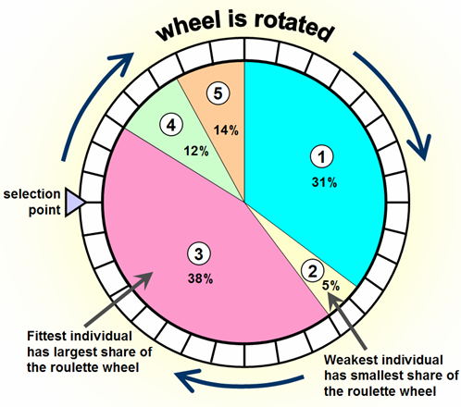
n being the population size and f is the fitness of a solution.
Fig 3.7: Roulette Selection

3.1.3 Crossover: (Fig 3.8) a crossover operator is used to recombine two strings to get a better string, where string is the chromosome. Practically crossover is the process of taking two chromosomes and producing a child, or two, in some cases, from them. Once the process is finished, the population is enriched with better individuals. The process starts in the Mating Pool, when two suited solutions are chosen and one possible crossover operator will initiate.
Possible operators for the Crossover process are: single point, two point, multi point or uniform crossover. These operators can yield one or two offspring. A block of bits from the first chromosome is chosen and altered with a block of bits from the second chromosome.
the basic cross-over procedure is as follows:
- A pair of parents is randomly selected from the mating pool.
- A point, called the crossover site, along their common length is randomly selected
- The information after the crossover site of the two parent strings are swapped
- Two new children are created.
Fig 3.8 shows that from a certain point, both children are bit-crossed starting from the 6th bit.
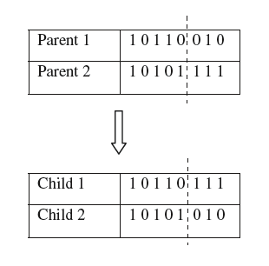
Fig 3.8: Crossover single point

Mutation: mutate (Fig 3.9) the two individuals (children) resulting from each crossover operation will now be subjected to the mutation operator in the final step of forming the new generation. After crossover, mutations prevent the algorithm to be trapped in a local minimum. This plays the role of recovering the lost genetic material and makes sure that if, at some point, a bit was lost and doomed to be set at ‘0’, it will have the chance of turning back into a ‘1’ – SET. It operates on one chromosome that produces an offspring that is slightly different from his parent by one or more bits. Each bit has the same probability to mutate. There are several methods to do this, such as flipping, set/reset a bit, interchanging reversing, etc.
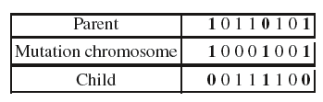
Fig 3.9: Mutation - Flipping

in the reverse sequence mutation operator, we take a sequence S limited by two positions i and j randomly chosen, such that i < j. The gene order in this sequence will be reversed (Fig. 3.10).
This method will always create feasible solutions, even in the cases of a mismatch between two PV modules as it is possible to use a transition module that can be used as a "bridge" between them. Due to this characteristic, we intend on using the Mutation method: Reverse Sequence Mutation (RSM) in our proposed solution.
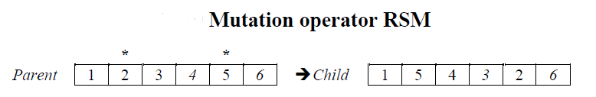
Fig 3.10: Mutation – RSM

3.1.5 Replacement: : The last operator and also the last stage of any generation is that two parents are drawn from the population and they breed two offspring, however, not all will be returned to the population. The technique used to decide who stays in the population and who will be replaced with the new offspring are:
  - Both parents: In this method both parents will be replaced and their offspring will take their place.
  - Random replacement: In this method the Replacement routine will randomly choose two chromosomes and replace them with the candidate.
  - Elitism: In this method a routine scouts the population, discards of the weakest candidates and inserts the new offspring instead.
All or some of these methods will be used by us in our suggested solution. At this stage we are not sure which one of these methods suits our solution best. We believe that when start the implementation, we will probably implement all of them, or at least two. Only after thoroughly examining them, will we know which best suits our suggested solution.

Fitness function
The fitness of an individual in a genetic algorithm is the value of an objective function for its attributes – the phenotypes. In order for a chromosome to be calculated and given a fitness value, it first has to be decoded and evaluated by the fitness function. The evaluation indicates how good the solution is. In multi criterion optimization problems, there is often a dilemma as how to determine if one solution is better than another. The fitness functions’ main objective is to summarize and give a value that can be compared, usually the higher the value, the better the solution is.

4. PROPOSED SOLUTION:

In order to solve our problem, we will use a Genetic Algorithm (GA), that first will create the PV arrays, that contains 9 PV cells, under pre given values by the user, for example for each cell we will save its charachestics, i.e. cell length and width, the latitude and longtitude angels of the location we wheeling to position the PV array, which will later influence the calculation of the zenith angle that necessary to calculate the AOI. After creating a list of PV cells and their attributes, we will create a population, PV arrays, of candidate solutions, each of them is based on the configuration of SP ,shown if Fig 2, because we found out that it is the best configuration under mismatch condition's like shade. Randomly, each will be given a values of the PV cells from the available options. These solutions are the chromosomes in our GA. Then we will begin iterate Y times, when Y represents the number of generations which will be predefined. In each generation, we will select via the Roulette Selection method two chromosomes which will be the parents for the offspring to come. These two chromosomes will be used to create two sequences by using crossover. Under a predefined probability, these new offspring will mutate and be replaced with two chromosomes that are in the population.
After Y generation, we will return the best solution with the least penalty, and present it as the fittest. This means that this sequence is the best that the algorithm found.
In order to examine each solution, we need to quantify a value that represents how good it is. In order to do so, we created a penalty system that will help us assess the fitness of the solutions. We will evaluate each solution by the power it is generating, depending on the cell angle, the solution total shade, and the total amount of cable that are calculated depend on the distance between cells, and the best angle-of-incidence. Using this logic we will evaluate how good a solution. Each attribute is given a weight value for the penalty by its importance, we will be assisted by an electricity expert. The idea is to reach a total value of 100% fitness while each attribute is assigned a weight value in the penalty calculation. We found out that the best solutions produced when we use this weight's:

Cable sidtance = 0.5

Shade = 0.2

Angle = 0.3

In Fig 4 we can see our propose chromosome structure that compose of 9 cells as sequence.
Every Cell of this structure include the optimization parameters: cell slope angle , cable distance to the next cell and shade percentage. Those parameters helps us to evaluate each solution.



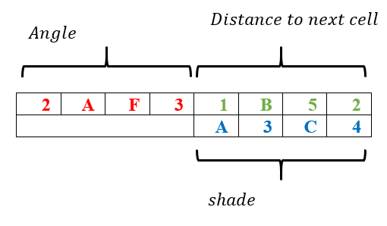

Fig 4. Chromosome structer

4.1 Evaluation Function

In order to quantify each solution, we calculated the total amount of cable distance between cells, and we normalizing it to a number between 0-1 by dividing it with the maximum range possible(Eq 2). For each solution, genome, we calculate the amount of shading that each cell make's on the other cells, using the distance between cell's, the azimuth to the sun, the angle-of-incidence (AOI), and the cell's length/width, depends on the direction the sun come's from. Than we normalize it by dividing the shade lenth with the cell length, so we can get a number that represents how many percentage of the cell are shaded(Eq 4).

For each population, we calculate the best angle for the cell slope to be, in order to produce maximum amount of energy. The angle of the cell is important, because it affects the shade one cell is making on the other, and therefor we try to find the angle that will be as close as possible to the best angle, but make the minimum amount of shade on others, and damage there performance(Eq 3).

By summing up each solution penalty, a value between 0-1 will be given, this value is the penalty of the solution.

$$\sum_{Each cell}{\frac{cell cable length}{MaxValue-MinValue} (2)}$$

$$\sum_{Each cell}{\frac{abs(cell angle-best angle)}{MaxValue-MinValue}} (3)$$

$$\sum_{Each cell}{\frac{cell shade}{MaxValue-MinValue}} (4)$$

The next step requires calculating the total penalty for each attribute. In order to do so, we need to divide the total amount of distance in a solution by the sequence length, to normalize it to a number between 0-1 again:

$${distance}_{penalty}=\frac{Total distance}{Sequence length}*distance penalty (5)$$

After calculating the distance penalty, we need to calculate the other penalties. The angle penalty is calculated in the same method, normalize it to a 0-1 number:

$${angle}_{penalty}=\frac{Total angle diff's}{Sequence length}*angle penalty (6)$$

And the same method is for the shade penalty:

$${shade}_{penalty}=\frac{Total shade}{Sequence length}*shade penalty (7)$$

Than the solution penalty is the sum of all:

$${chromosome}_{penalty}=distance penalty+angle penalty + shade penalty (8)$$

The fitness of a solution is proportional to its penalty, this meaning that the lower the penalty, the better the fit. The highest possible penalty of each transition is 1: $\frac{\max_{penalty}}{\max_{penalty}}=1$, so if we divide the total ${chromosome}_{penalty}$ by the sequence length, we will get a penalty in the ranges of [0, 1], so the fitness will be:

$${chromosome}_{fitness}= 1- {chromosome}_{penalty}(9)$$

def evaluate(self):
"""
This method evaluate the whole sequence fitness based on each cell attributes
:return: NONE
"""
angle_penalty = 0
dist_penalty = 0
shade_penalty = 0
self.calculate_shade_in_solution(self.azimuth)
for i in range(GAutils.CONST_SEQUENCE_LENGTH):
temp_angle = numpy.fabs(self.sequence[i].angle - self.best_angle)
temp_angle_penalty = temp_angle / GAutils.CONST_ANGLE_DIF
angle_penalty += temp_angle_penalty
temp_shade = self.sequence[i].shade
shade_penalty += temp_shade
for i in range(GAutils.CONST_SEQUENCE_LENGTH - 1):
temp_dist = self.sequence[i].distance_to_next / GAutils.CONST_DISTANCE_DIF
dist_penalty += temp_dist
total_dist_penalty = (dist_penalty / (GAutils.CONST_SEQUENCE_LENGTH - 1)) * CONST_DISTANCE_PENALTY
total_angle_penalty = (angle_penalty / GAutils.CONST_SEQUENCE_LENGTH) * CONST_ANGLE_PENALTY
total_shade_penalty = (shade_penalty / GAutils.CONST_SEQUENCE_LENGTH) * CONST_SHADE_PENALTY
self.fitness = 1 - (total_angle_penalty + total_dist_penalty + total_shade_penalty)
self.penalty = total_dist_penalty + total_shade_penalty + total_angle_penalty

4.2 Selection

We chose Roulette Selection as it will prefer better solutions, but not enforce it to be the best ones. Using this method allows us to use and cross a variety of chromosomes, even the “weakest”. This avoids getting trapped in a local maximum. In order to calculate the probabilities and the range of each chromosome to be selected, we used their fitness. The calculation of the total fitness is:

$${Total}_{fitness}= \sum_{i=0}^{populationSize-1}{{chromosome(i)}_{fitness}} (10)$$

The probability to choose a specific chromosome is:

$$p\left(chromosome\left(i\right)\right)=\frac{{chromosome\left(i\right)}_{fitness}}{{Total}_{fitness}} (11)$$

We then chose a random value between [0, 1] and checked between the ranges of the chromosomes.

4.3 Crossover

We think that the best crossover function for us is the single point crossover, because the order of the cells is important and we would like to keep the distances between cells as close as possible so the wiring and installation costs will be minimize.
The single point crossover operator selects at random position in both of the parent sequences, and the order of the cells until the selected point in the first parent is transfer on the first children, and the order of the cells from the second parent until the position is transfer on the the second children. The other cells from the position chosen to the end are than transfer from first parent to second children and from second parent to first children, in Fig 5 we can see an example.

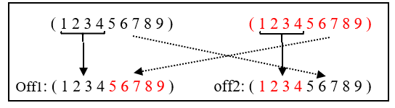

Fig 5. An example of order based crossover

4.4 Mutation

After creating two new chromosomes, like in nature, our GA acts the same. One or both of them can mutate and therefore create a different sequence. We used in our research the Reverse Sequence Mutation (RSM). This works by creating two random integers $i, j$ such as:
$$i=random\left(0, sequenceLength-1\right) \\ j=random\left(i, sequenceLenth-1\right)$$
This enables us to get two points in the sequence, and then reverse the order of the subsequence that has been chosen(Fig 5.1).
Fig 5.1: Reverse Sequence Mutation

Mutation would not always be used, but only under a certain probability. In our research we compare different mutation rate to find out which is the best rate that give us the best results.
At first we thought that high mutation rate will help us to discover more solutions and therefore will increase our population fitness. In Fig 5.2 we can see the comparison that we made with different mutation rates, with the same data set(azimuth – 120, lat – 31, long – 35, cell length – 5, cel width – 3, area size – 20), to decide which is the best one for our problem. We can see that the best rate is 0.1 and this rate provide us the higher population fitness.
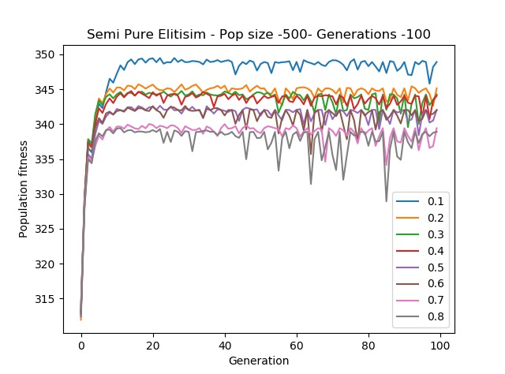
Fig 5.2: Comparison between different mutation rates

4.5 Replacement

After the mutation has finished, we now have two offspring. These need to be returned to the population in order to continue to the next generation. In order to do this, we tried to us Elitism first place. Elitism means that for two new offsprings, new children's , we search for the two solutions with the lowest fitness and replace them with the new children's. thus going through all of the population, tossing the least fitted solution and inserting new offspring instead of them. We learned that at a certain point, the population gets fixed on a local maximum. In Fig 6 we can see the results of the algorithm with Elitsm in each cycle, with a low amount of population size. In each test we used the same dataset (azimuth – 120, lat – 31, long – 35, cell length – 5, cel width – 3, area size – 20).

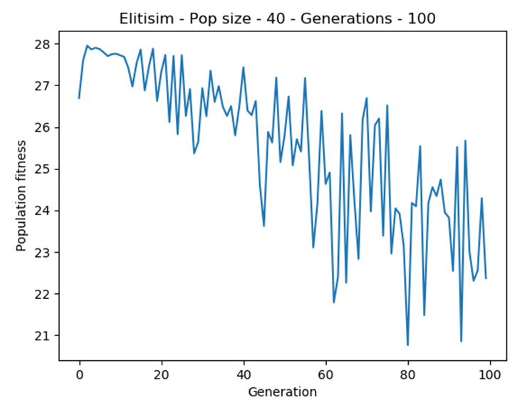

Fig 6. Elitism result Population = 40

We can see that the level of solutions is degraded as long as the generations keep going up.
Than we tried it with bigger population size, which should give us more possibilities and therefore increase our solutions fitnesses.
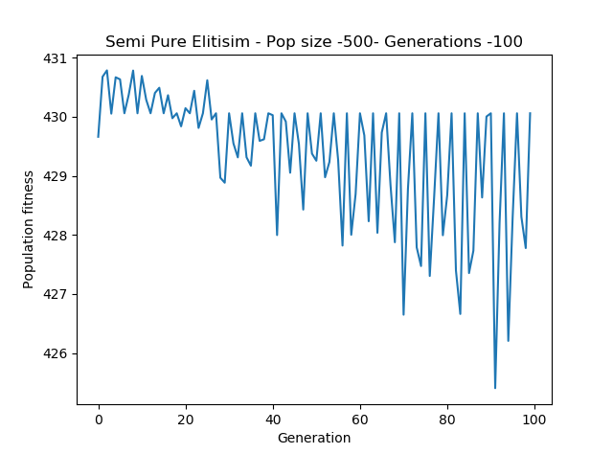
As we can see in Fig 6.1, the population fitness is degraded significantly as the generation go on, and that shows us that this method is not working for us in any condition.
Fig 6.1 Elitism result Population = 500

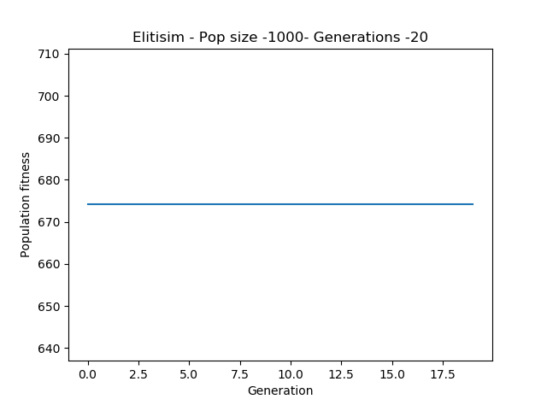The next method we tried is called semi-pure elitism. In this method we compare the new children that was created, with the two best solutions out of the population. If the fitness of the new children is higher, than they will be inserted instead of the weakest solutions, otherwise we will insert the best solutions. In Fig 6.2 we can see that the population fitness is linear and it is stuck in the same number throw the generations.
Fig 6.2 Semi-Pure Elitism
Semi Pure Elitism

Fig 6. Elitism result Pop 500

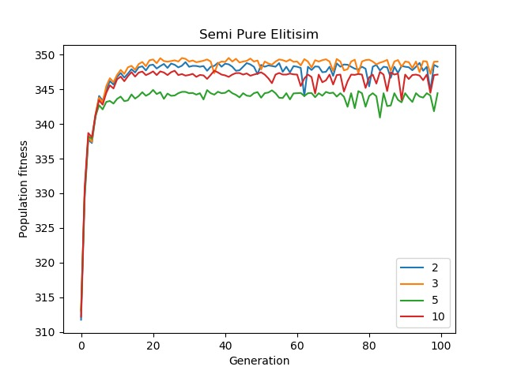
We understand that the semi-pure elitism is going too fast for the local maximum so we thought on a way that combine semi-pure elitism and random replacement, which means to insert the new born children into the population and take the least fittest out. So we determine that every certain number of generations we will use semi-pure elitism and the other generations we will random replace. First we tried with every second generation, and we can see in Fig 6.3, that the difference between 2,3,5, or 10. We can see that when we use semi-pure elitism every third generation, we get better population fitness. It is also the most stable one, as you can see the up and down movement is lower than the others. That is why decided to go with every third generation.
Fig 6.3 Semi-Pure Elitism with different modulo rates

First we tried with small amount of population. In Fig 6.4 we can see that the population fitness is going up in general, and maintain it until we get to a maximum point and we keep the same fitness until the end.
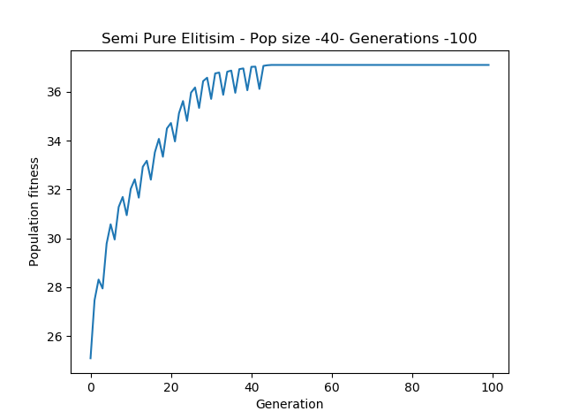

Fig 6.4 Semi-Pure elitism population = 40
When we apply the semi-pure elitism with a bigger population size (Fig 6.5) and more generations, we can see the results are the same, and we can see the orientation of the population fitness is to go up or maintain the same.

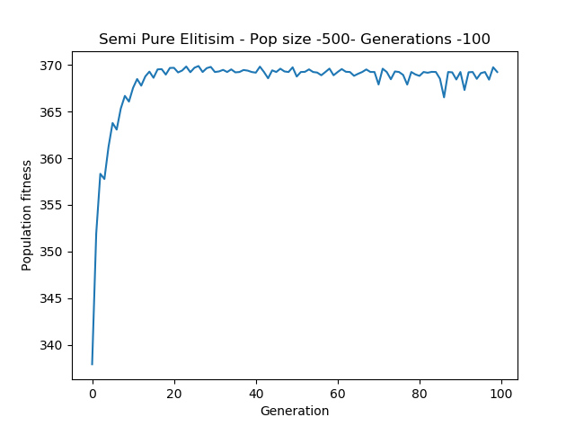

Fig 6.5 Semi-Pure elitism population = 500
The results we got are unambiguous, and therefore we decided to go on with the combination of semi-pure elitism and random replacement for every third generation.

SOFTWARE ENGINEERING DOCUMENTS

5.1 UML-diagrams

5.1.1 Use-Case diagram

In this section we will present our software documentation, start with our main use cases:
a. Insert_Relevant_Details: the user insert relevant values for the algorithm, for the calculation of the best PV configuration, the system than begin to calculate for higher fitness solution.
b. Chang_GA_stting: in this case the user can change the properties of the GA algorithem, the user can change the population size, generation size and mutation rate.
c. View Results: this case shown when the calculation of the GA algorithem is finished, this window include the best PV array, best fitness , Average fitness and gives us the option to save the result .
As shown in Fig 7:

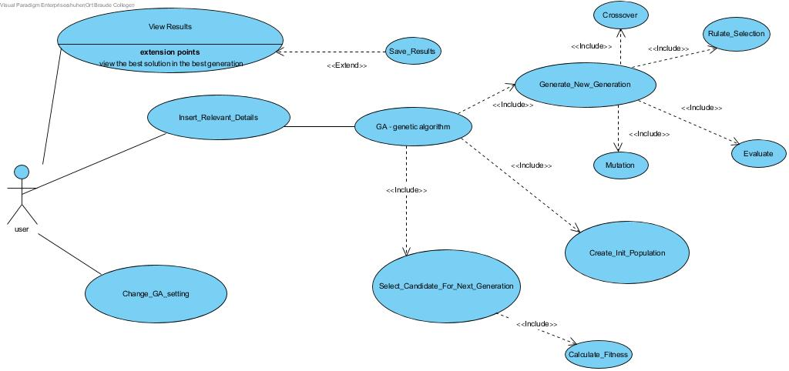
Fig 7. The Use case diagram

5.1.2 Calss diagram

This diagram (fig. 7.1) represents the GA related data and behavioral objects that perform the requests coming from the user through the main screen.
Genetic Algorithem Logic – in this part we have all the components that compose our genetic algorithem.
GUI – in this part we have the windows and the controlers that response for the input and output display.

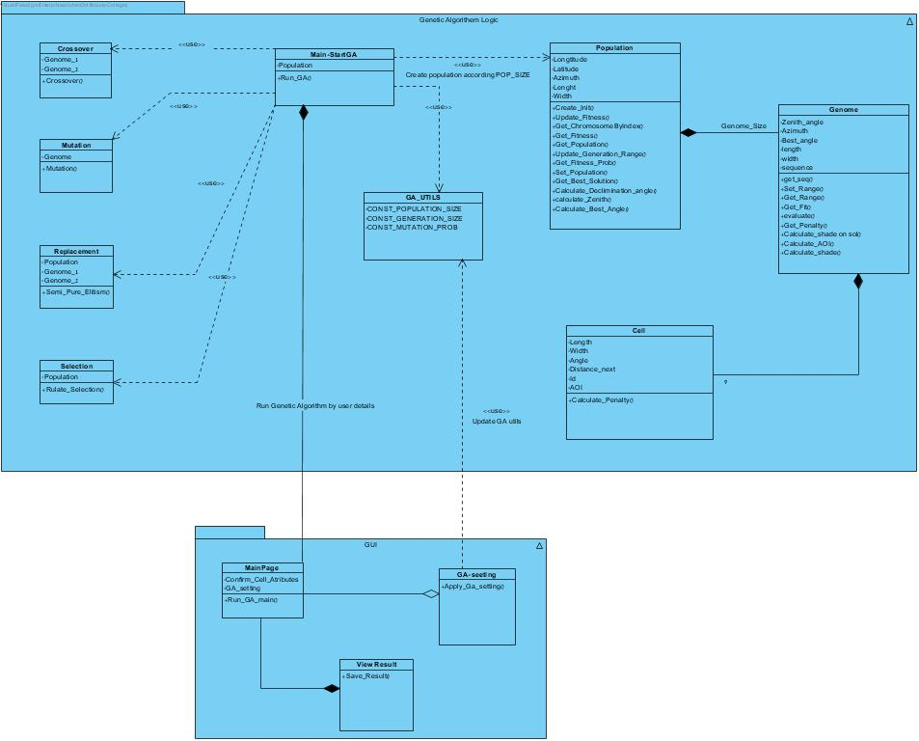

Fig 7.1. GA class diagram

5.1.3 State chart diagram

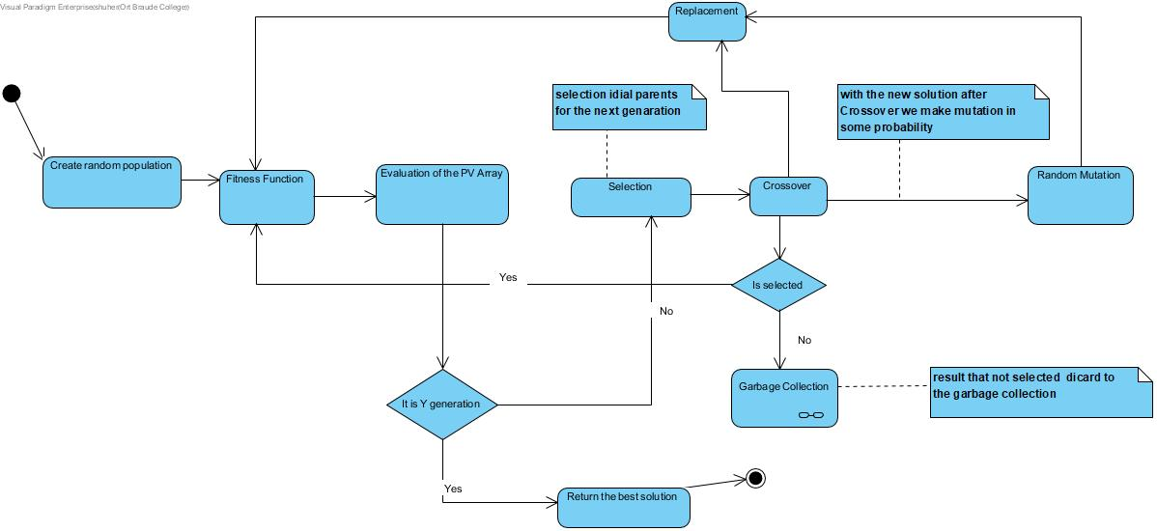
This diagram(Fig 7.2) shows the GA states and flow of control from one state to another state.

Fig 7.2. State chart diagram

5.2 GUI:

5.2.1 Main window:
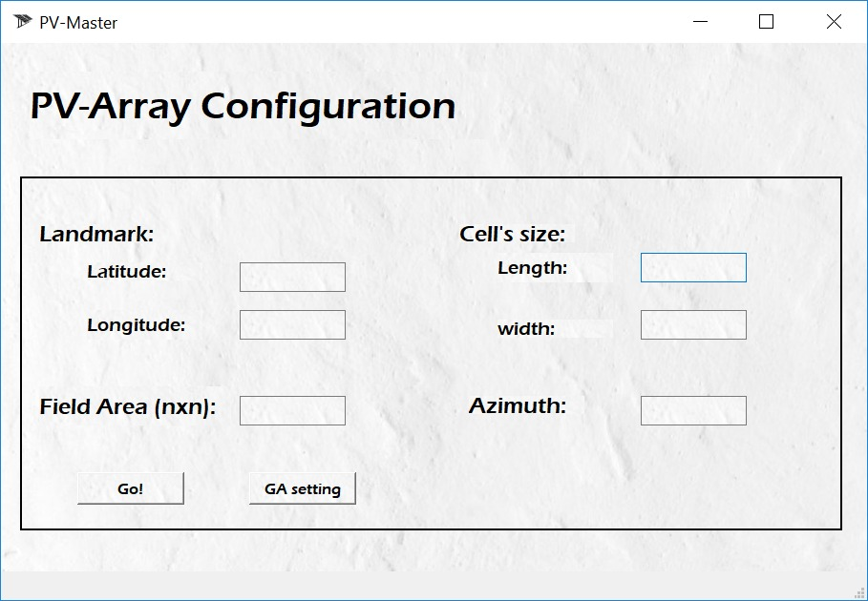
The main menu shown when opening the application. This page include all the relevant details that the user need to insert to the application.

Fig 7.3. main page screen- insert relevant details

5.2.2 GA-setting window:

The window shown by clicking "GA-setting" button in Fig 7.3. This window allow to change the Genetic Algoritem properties.

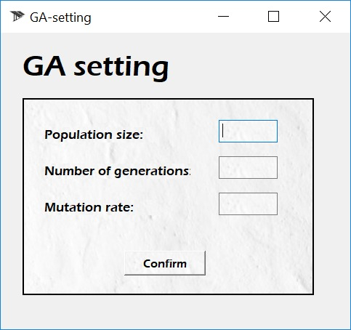

Fig 7.4. GA-setting window

5.2.3 Result window:
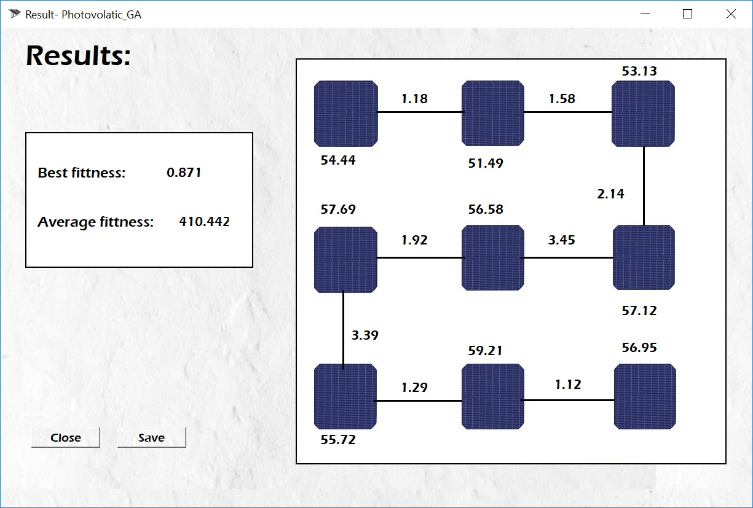
window shown when the calculate is finished. This window show the best fitness , average fitness and the best solution

5.2.4 Confirm saving dialog:
A dialog that appears when the user want to save the result after clicking "save" button in the result page (Fig 7.5)
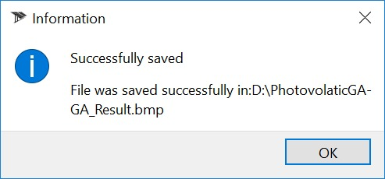

Fig 7.5. Confirm saving dialog

TESTING PLANE

Table 1 shows the unit test we will perform for each class and what will be tested

Class | Test created | Description
PV cell | Maximum penalty | We will check that the maximum penalty function is accurate.
PV cell | Transition penalty between two cells | We will check that the function that calculated the penalty between two cells is accurate.
Population  (PV array) | Get a specific chromosome | During the algorithm we need to choose a specific chromosome, this test makes sure that it will choose the correct one.
Population  (PV array) | Fitness probability for roulette | The roulette selection function relies on the pie created by the probabilities of the chromosomes.
Population  (PV array) | Get and set population | During the algorithm, we need the population for many calculations, for example, gets the penalty between two cells. We want to make sure this function is fully operative and that the population cannot be changed during a specific run.
Population  (PV array) | Get the best solution out of the population | For the output result we will check the best solution alone, this is what will help us do it.
Genome | Checks the solution evaluation | In order to check how good the solution is, we need to evaluate it. We therefore check the fitness and penalty boundaries and check if they complete each other.
Genome | Check the chromosome range in the roulette | The ranges are float numbers between 0-1 that are based on the actual fitness of the solution.
Genome | Test the chromosome sequence | We tested the sequence length and that there are no repeats, meaning that a cell will not appear twice in a sequence.
Utility | Test attributes boundaries | Once we got an input that includes a list of attributes, we need to make sure that the user inserted the attributes within the boundaries, for example, latitude can not be more then 90 degrees.
Utility | Checks the input | In order to run the algorithm we need to make sure that the input exists and contains a list of attributes.

RESULTS:
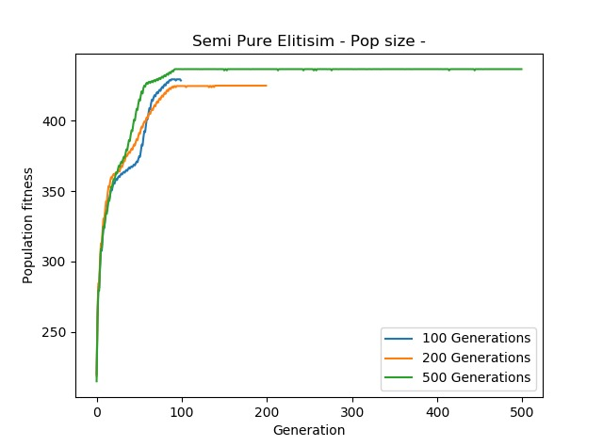
In order to compare the results and to find the optimize parameter that give us the best solution we work with the same dataset that has been used and multiple different tests were done. This dataset include same initial parameters (azimuth – 120, lat – 31, long – 35, cell length – 5, cel width – 3, area size – 70). Below are the final accumulated results whilst using different parameters at each test. Since we have found that using a mutation rate of 0.1, gives the best results, we have used those parameters and what differs between each test are only the population size and the number of generations. Below are the results of those tests.
Fig 8.1 Different generation size test

We can see in Fig 8.1 that we try to calculate different results with differernt generation size, and we conclude from this test that the fitness is increases until the 100 th generation, and than maintain the same level of fitness, same local maximum. Therefore our tests use with generation size of 100 and different population size . This conclusion helped us to reduce the complexity run time of the system.

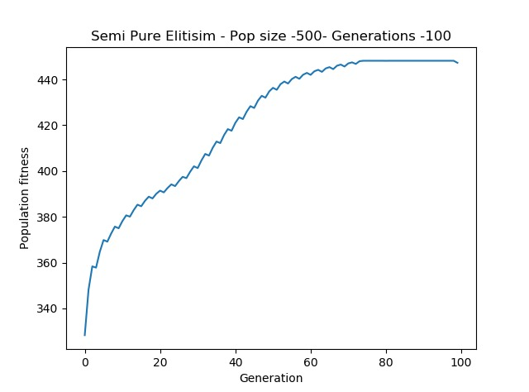
Fig 8.2 Test of –
Population size = 500
Generation size=100

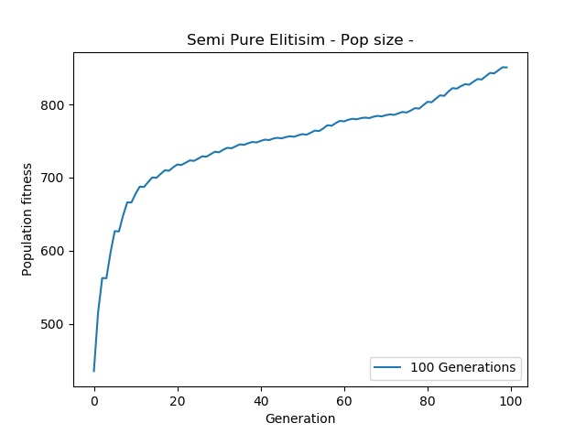
1000
Fig 8.3 Test of –
Population size = 1000
Generation size=100 test

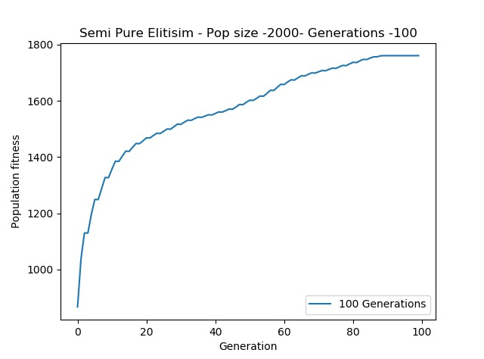
Fig 8.4 Test of –
Population size = 2000
Generation size=100 test

PARAMETER ANALYSIS AND TESTS:

As a consequence of the (apparent) movement of the sun across the Earth’s sky, the sun’s light hits the PV modules at different angles throughout the day, as solar zenith and azimuth change. Because of the Earth’s inclination, there is also a strong seasonal variation in the course of zenith and azimuth throughout the day. It is important for us to know where the sun will be throughout the year so we can configurate PV arrays at the ideal angle to absorb the maximum amount of sunlight during the course of a year, to improve PV efficiency. Combining the solar zenith, azimuth, and the slope and orientation of the PV module, we can calculate the AOI between the beam component of solar irradiance and the PV module surface. In [9] they suggest Eq(11) to calculate the AOI.

$$cos θ = cos θz* cos β+ sin θz* sin β* cos \left(Фs – Ф\right) (11)$$

where $'θ'$ is the AOI, $'θz$' is the solar zenith, $'β'$ is the PV module slope, $'Фs'$ is the solar azimuth and $'Ф$' is the orientation of the PV modules (by definition '$Ф'$ = 0 for a panel oriented to the south in the northern hemisphere). A higher AOI results in a decrease of light coupled into the PV cells, which directly affect on the utilization of the pv cell.
To calculate the zenith angle, all we need is the latitude and declimination angle(Eq(12)).
latitude is a geographic coordinate that specifies the north–south position of a point on the Earth's surface. Latitude is an angle (defined below) which ranges from 0° at the Equator to 90° (North or South) at the poles.

$$*zenith angle = latitude – declination(12)$$

declination (abbreviated dec; symbol δ) is one of the two angles that locate a point on the celestial sphere in the equatorial coordinate system, the other being hour angle. Declination's angle is measured north or south of the celestial equator, in Eq(13) we can see the calculation of the declination angle, when N is the number of days since January 1.

$$sinδ=0.39795*\cos\left[0.98563*\left(N-173\right)\right] (13)$$

In our solution we calculate that total shade on a solution, by going on every cell in the solution sequence and calculate the shade he makes or not, on the other cells in the sequence. In order to do so, we use the slope angle of the cell, the Angle-of-incidence (AOI), the distance to the cell and the cell length or width, depend on the azimuth angle to the sun. As we can see in Fig 5, the shade that one cell influence on another. For checking the shade function we try to initial the system with differen cabel distances. We saw that for 2 meter cabel, which consider close range, we have 20% shade on the solution sequence and for 10 meter cable, which consider far range, we got 0% shading on the cells.

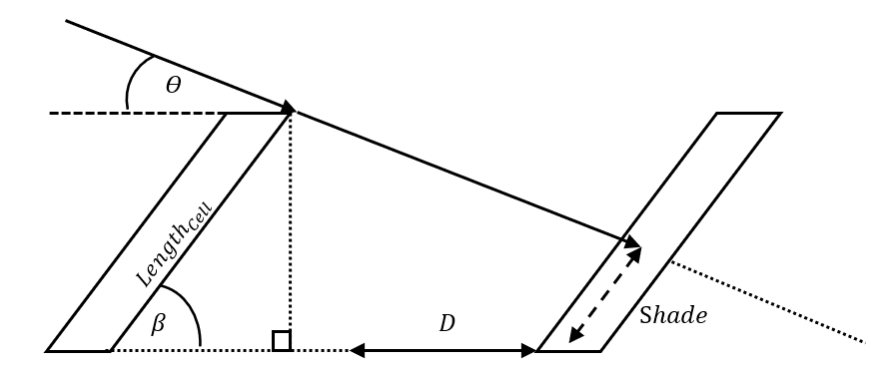

Fig 5. Example of shade calculation

In Eq(14) we can see the function that calculate the shade between cells, where ' ϴ' is the AOI, 'β' is the slope angle of the cell, ' D' is the distance between the cells and '$Le{ngth}_{Cell}'$ which is the cell length or width, depend on the azimuth to the sun.
$$Shade=cosβ*\left[ sinβ*{Length}_{Cell}*\tan\left(90-ϴ\right)-D-\left(Le{ngth}_{Cell}-Le{ngth}_{Cell}*cosβ\right)\right] (14)$$

CONCLUSIONS:
In this section we would like to present the conclusions for our solution and implementation. In our project we wanted to create a new and more efficient solution for the arrangement of pv arrays in limited area problem which manifests in each cells’ characteristics incompatibility to the next cell. We presented a GA algorithm which receives a batch of values, creates a random result population and optimizes this solution until we reached 100 generations. We hypothesized that we would receive improved results. Due to the connection between fitness and the penalties in our solution we expected the fitness to increase throughout the generation while the penalty would decrease. The fitness improved up to 30% and more in some occasions. Our solution is based on the penalty system and therefore this improvement is more important than the fitness itself. We start the improvement calculations by assessing them from 100%. As the population is randomly created, there is a possibility that the initial best solution is already good. The algorithm optimizes the penalty evaluation, so we see a much higher improvement compared to the initial best fitted solution. We conclude that our solution always provides a better solution. After a certain amount of generations, we can see continues improvement in fitness. In our evaluation, 100 generations are enough generations to create a vast improvement, but will not expand unnecessary complexity. From the graphs shown in this work, we can see that the deltas between each cell for each characteristic changes according to their weight values, thus meaning that the highest valued characteristic will be the most important one and have the lowest amount of changes between cells. This will also contribute the most to the passing of the next generations. We created our solution in such a way that we will receive results right away, in a fast manner, instead going to the field and do the testing 'by hands'. This results in saving time and money which is our main goal - to maximize the profit the array can achieve by using our solution. In case of an unfeasible solution the application will not allow the user to start the algorithm. For example if you try to enter an area number(nXn) that is smaller than cell width three times, the application will show an error and will not start. Due to the simplicity of our solution, it does not require a large amount of resources. At each given moment, our space complexity is O(N*M) – while N is the number of cells in a sequence, M is the number of solutions or in other words the size of our population. In conclusion, our suggested solution handles the major issues of arrangement of pv arrays in limited area, in terms of cable cost, best angle and minimum shade. Our complexity run time level is O(P*G), when P is the population size, and G is the amount of generations. Our project saves work and time for the handling engineers as these tasks are usually prepared by them.

REFERENCES:

- Edit Csefalvay ́and Istvan T. Horva ́ " Sustainability Assessment of Renewable Energy in the United States, Canada, the European Union, China, and the Russian Federation"
Department of Energy Engineering, Faculty of Mechanical Engineering, Budapest University of Technology and Economics, Műegyetem Rakpart 3, H-1111 Budapest, Hungary
- Jan T. Bialasiewicz, Senior Member , "Renewable Energy Systems With Photovoltaic" , IEEE TRANSACTIONS ON INDUSTRIAL ELECTRONICS, VOL. 55, NO. 7, JULY 2008.
- Juan Ramón Camarillo-Peñaranda, Fabio Andrés Ramírez-Quiroz, Daniel
González-Montoya, Freddy Bolaños-Martínez, Carlos Andrés Ramos-Paja- " Reconfiguration of photovoltaic arrays based on genetic algorithm", Departamento de Energía Eléctrica y Automática Universidad Nacional de Colombia (Sede Medellín). Carrera 80 N.° 65-223, Núcleo Robledo. A.A. 568. Medellín, Colombia.
- King DL, Kratochvil JA, Boyson WE. Measuring solar spectral and angle-of-incidence effects on photovoltaic modules and solar irradiance sensors, In Conference Record of the Twenty-Sixth IEEE Photovoltaic Specialists Conference, 1997, Anaheim, CA, USA, 1997;1113–1116.
- (] M. Alahmad, M.A. Chaaban, S.K. Lau, J. Shi, J. Neal, An adaptive utility interactive photovoltaic system based on a flexible switch matrix to optimize performance in real-time, Solar Energy 86 (3) (2012) 951–963)
- Numerical method for angle-of-incidence correction factors for diffuse
radiation incident photovoltaic modules
Bill Marion ⇑National Renewable Energy Laboratory, Golden, CO 80401, USA
- "Reconﬁgurable electrical interconnection strategies for photovoltaic arrays: A review" Damiano La Manna, Vincenzo Li Vigni, Eleonora Riva Sanseverinon, Vincenzo Di Dio, Pietro Romano DEIM, University of Palermo, Palermo, Italy
- " Solar PV array reconfiguration using the concept of Standard deviation and Genetic Algorithm"; Naik Aashay Rajan1, Kulkarni Devendra Shrikant2, B.Dhanalakshmi2 and N.Rajasekar 2* 1Colorado State University,USA. 2Solar Energy Research Cell,School of Electrical Engineering,VIT University,Vellore-632401,India.
- Comprehensive characterisation and analysis of PV module performance under real operating conditions. Atse Louwen1*, Arjen C. de Waal1, Ruud E. I. Schropp2, Andrי P. C. Faaij3 and Wilfried G. J. H. M. van Sark1 Copernicus Institute of Sustainable Development, Utrecht University, Heidelberglaan 2, 3584CS Utrecht, The Netherlands

