**Lab Course: Hardware/Software Co-Design with a LEGO**

Abdallah Attawia, Moritz, Heiko, Berkay

Technische Universität München, Garching, Department of Informatics  
Boltzmannstr. 3, 85748 Garching, Germany

Please do briefly summarize the topic of your review, the main findings and your conclusions (max. 200 words)

**Keywords:** maximum 5 keywords

1. Introduction

Describe your topic and your expectations, e.g. a hypothesis you might have about the topic, questions you think are relevant. Briefly describe your search strategy (e.g. keywords, search engines you used, number of results)

1. Literature review

Summarize key statements of relevant articles you found with citations (Newton, 1704).

1. Discussion

How do the statements you found matching your expectation. Are they contradicting each other or confirming each other? Are there rivaling approaches? What are the main findings, what are open questions?

1. Conlusion

State the three most important findings of your review.

Figures

In case your manuscript contains figures, they are typically placed in one column inside the respective section. A large figure might span two columns. As you most likely take a figure from another paper, do not forget to state your source!

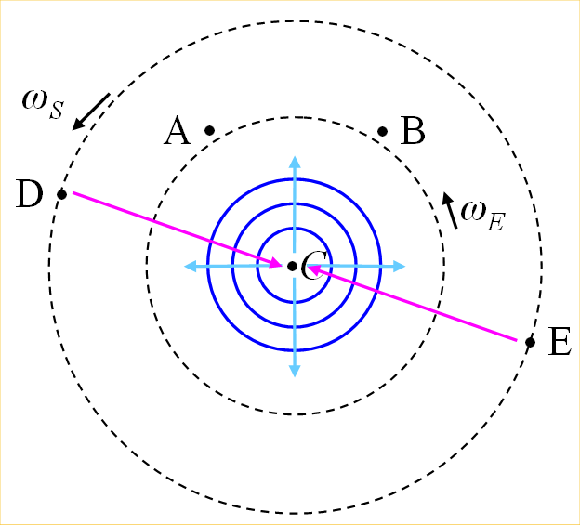

FIG. 1. (Color online) A central clock, orbited by one or more clocks. Figure captions use *Figure* style. The figure image itself uses *picture* style.

acknowledgements

If somebody did substantially help you with this review, e.g. discuss with you or point you to relevant sources, acknowledge him here.

Bibliography

Newton, I. (1704). *Opticks: or a treatise of the reflexions, refractions, inflexions and colours of light.*