Retrospective - Sprint 3 (and 2)

What went well?
- Achieved big progress on the map.
- Planning was very well executed.
- Project boards were well set up.

What could be improved?
- Improving time boarders in which should be worked.
- Estimated workloads for all tasks

What will we improve in the next Sprint?
- The time management and estimation.

Burndown chart
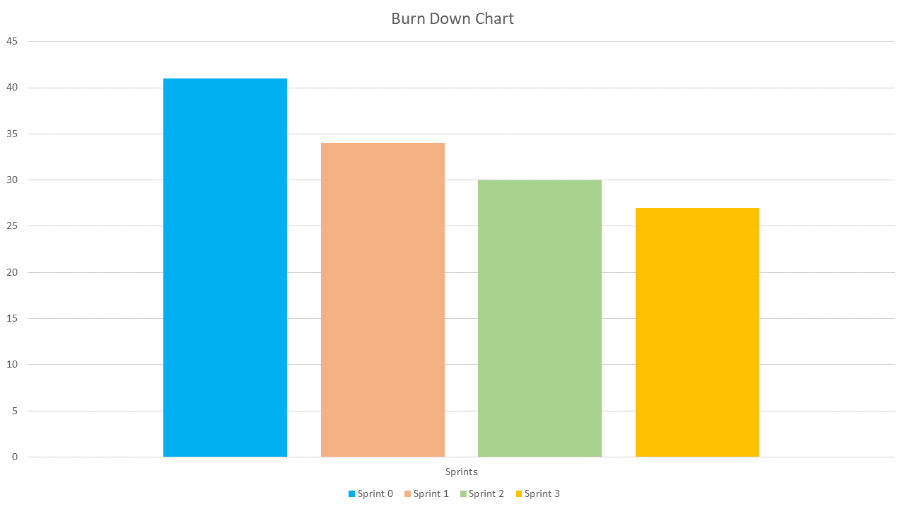

Team velocity
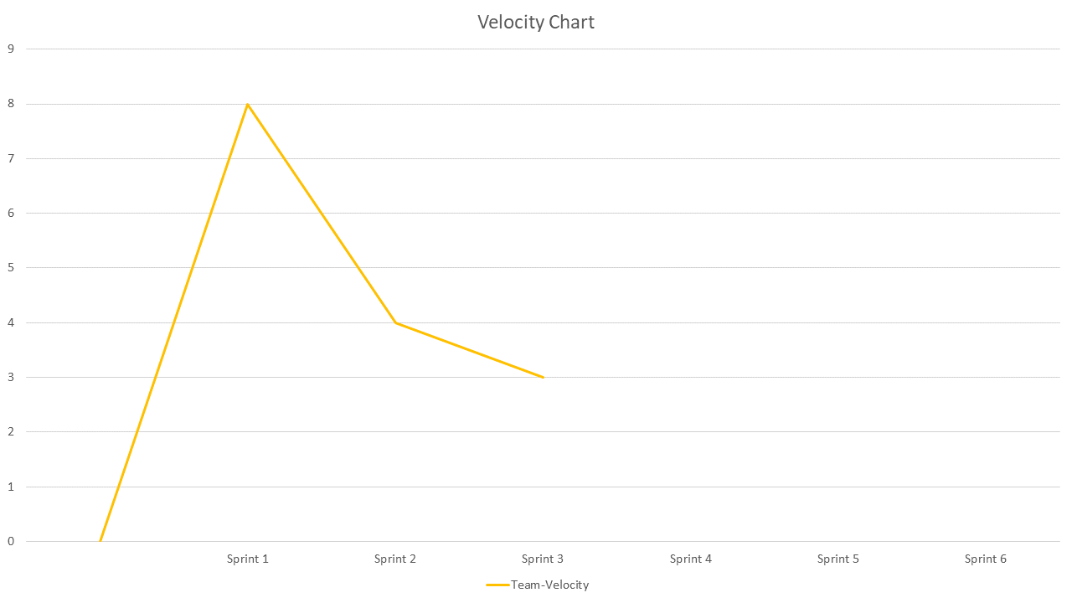

Updated Product backlog
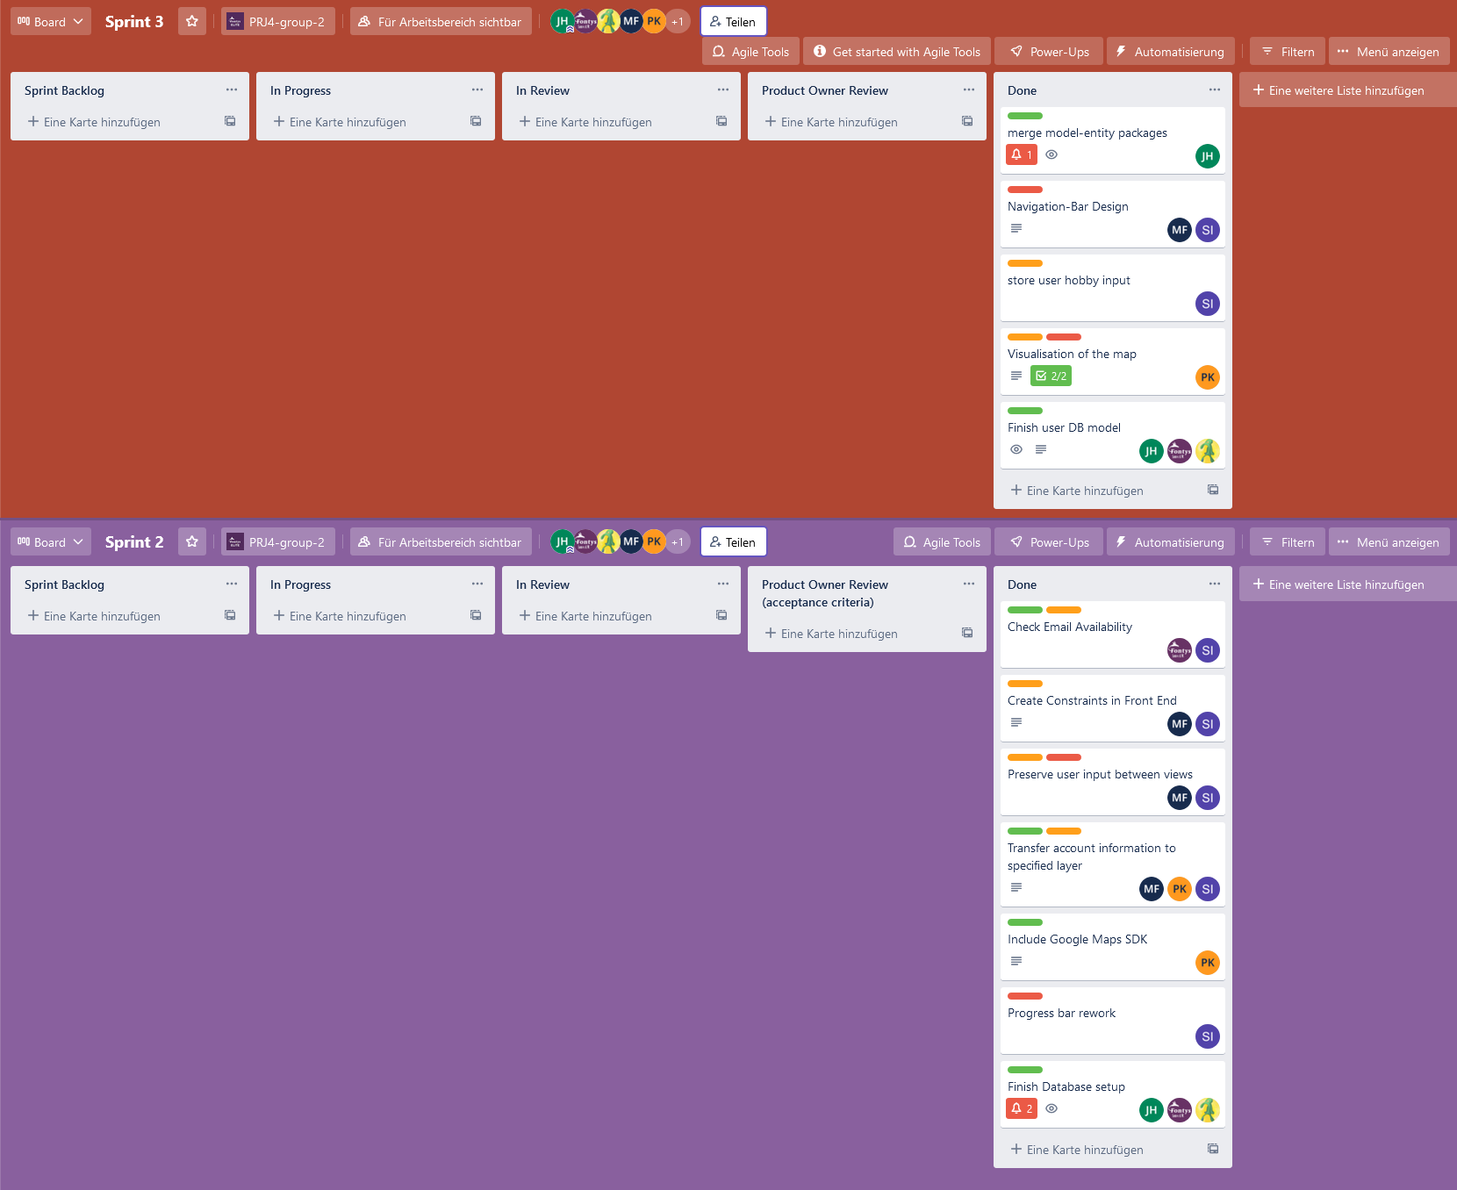

Fourth Sprint backlog
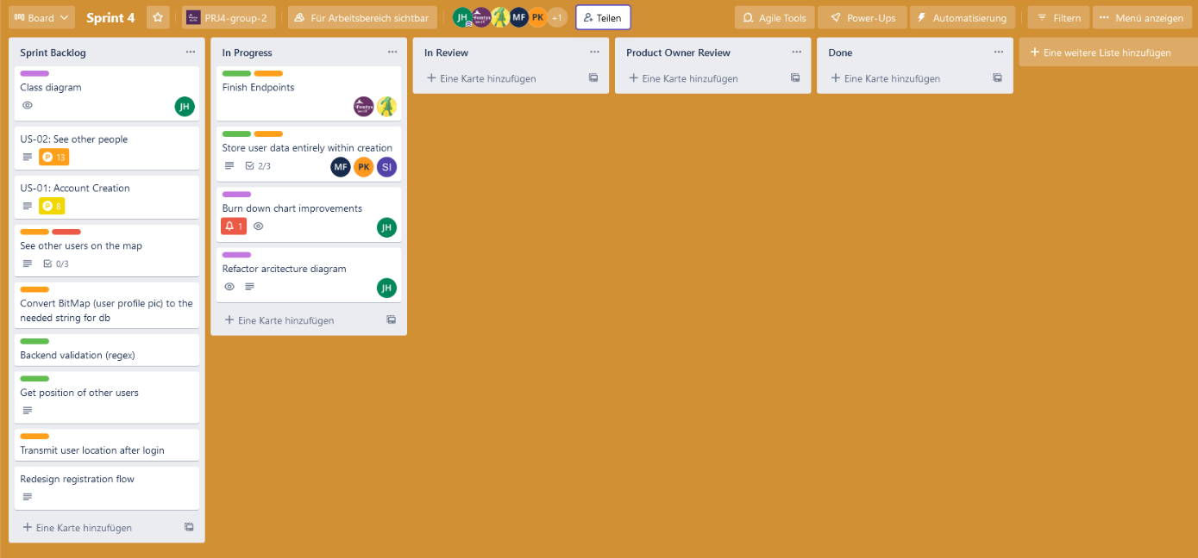

Goal of the fourth Sprint
Finishing the Sprint 2,3 leftovers and working the map related tasks.

