Retrospective - Sprint 1

What went well?
- Achieved most of our goals, although the user story has a very large workload.
- Planning was very well executed.
- Project board is well set up.

What could be improved?
- Improving time boarders in which should be worked.

What will we improve in the next Sprint?
- The time management.

Burndown chart
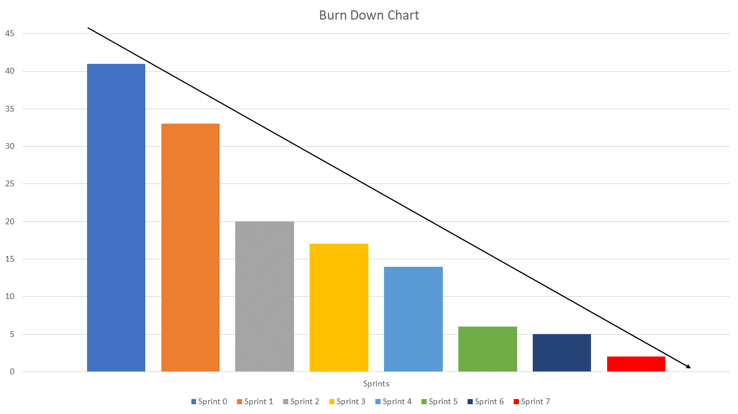

Team velocity
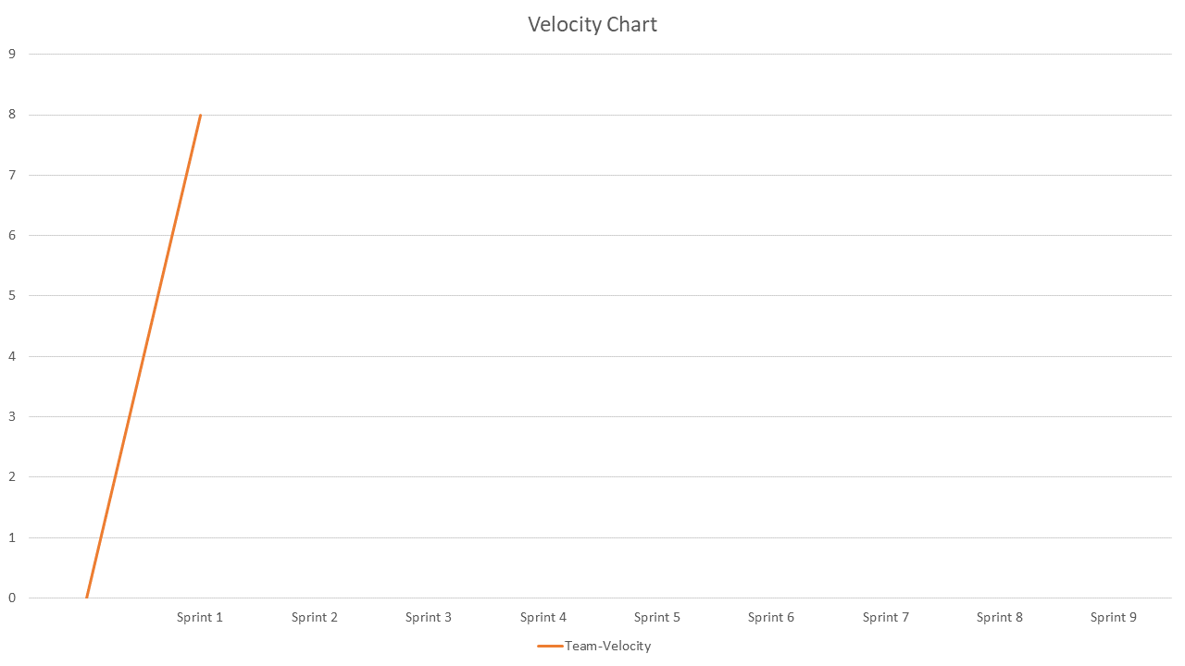

Updated Product backlog
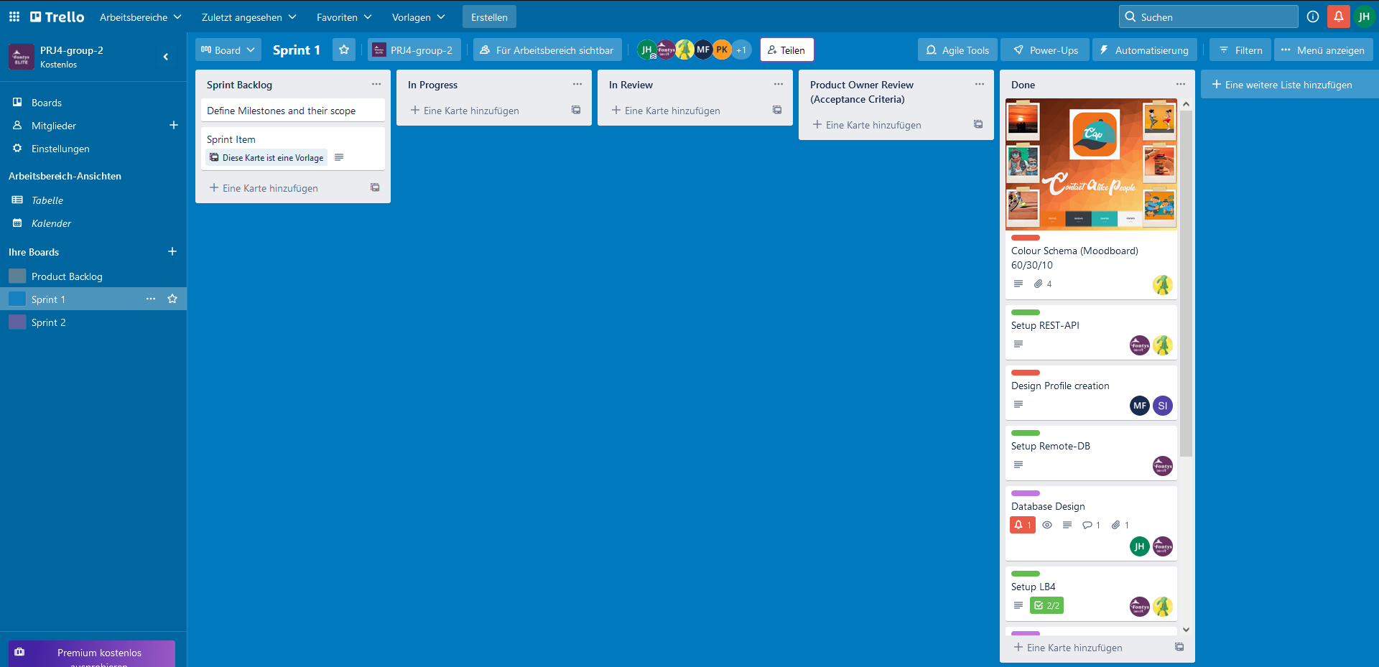

Second Sprint backlog
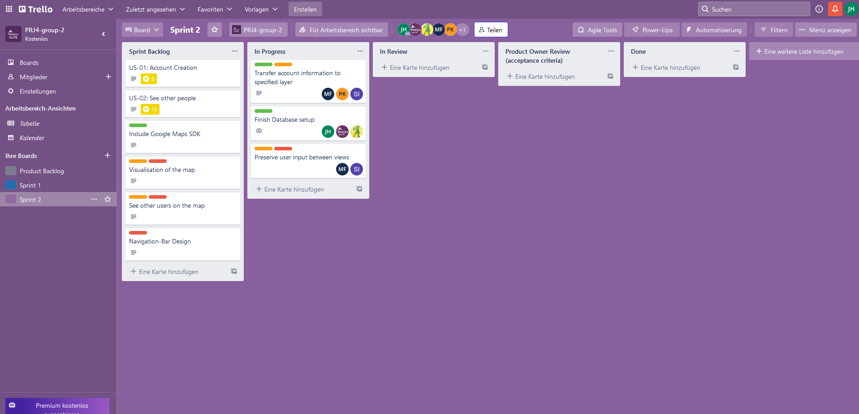

Goal of the second Sprint
Finishing the Sprint 1 leftovers and starting to work on the second user story

