Retrospective – Sprint 4

What went well?
- Major process gain
- Time framing
- Workload estimation

What could be improved?
-

What will we improve in the next Sprint?
- We will try to stay at the current level of productivity

Burndown chart
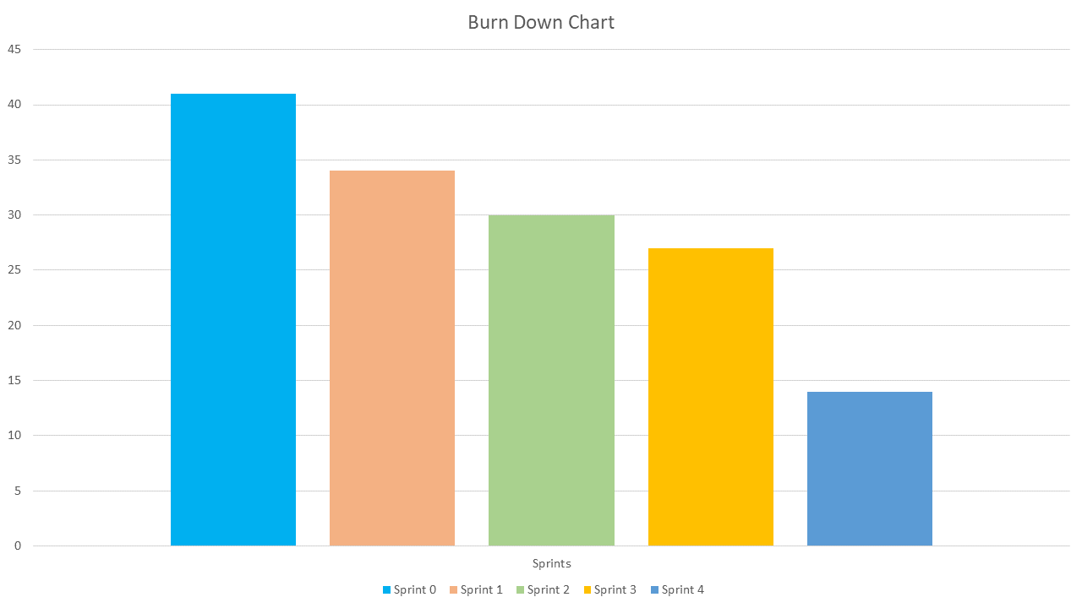

Team velocity
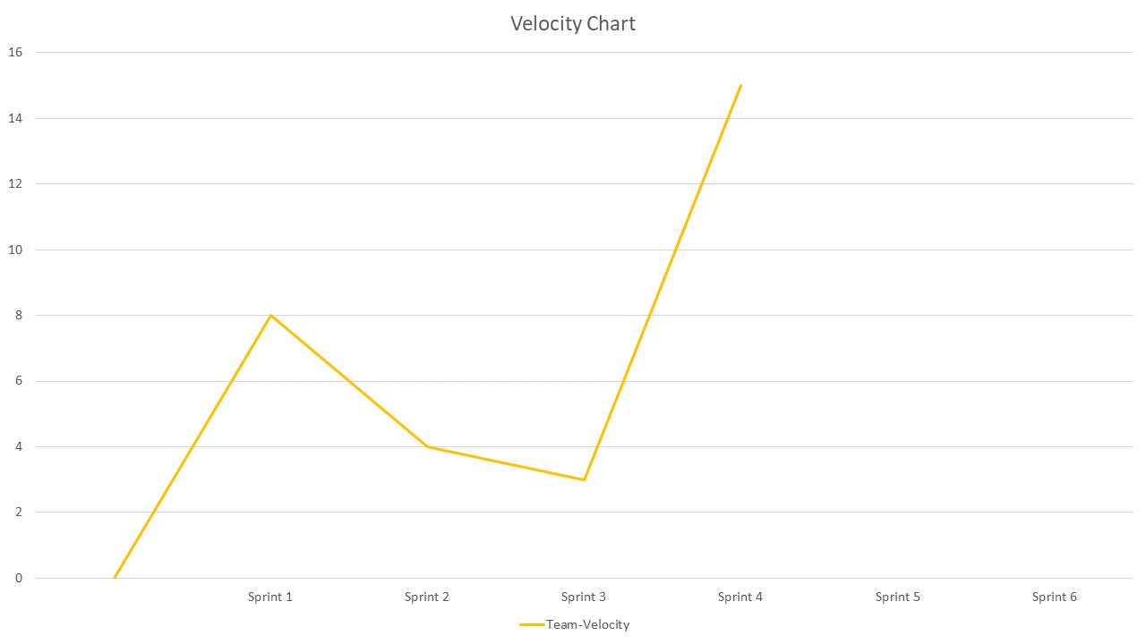

Updated Product backlog
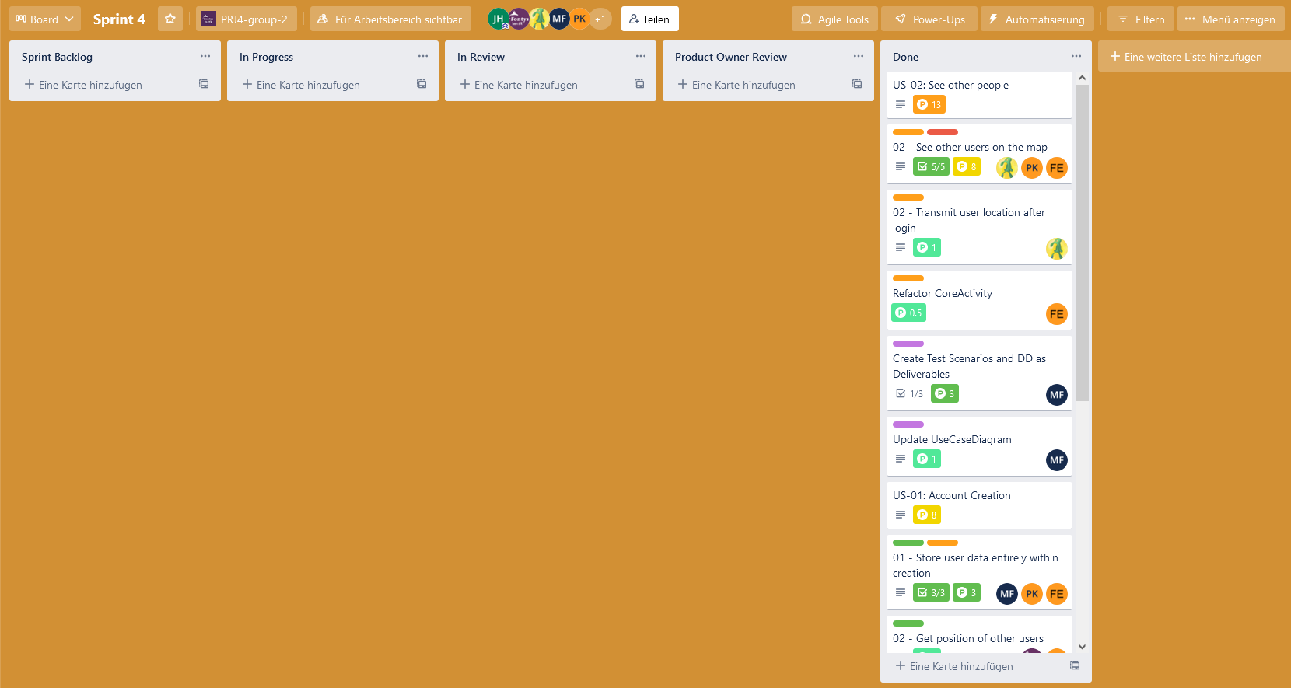

Fifth Sprint backlog
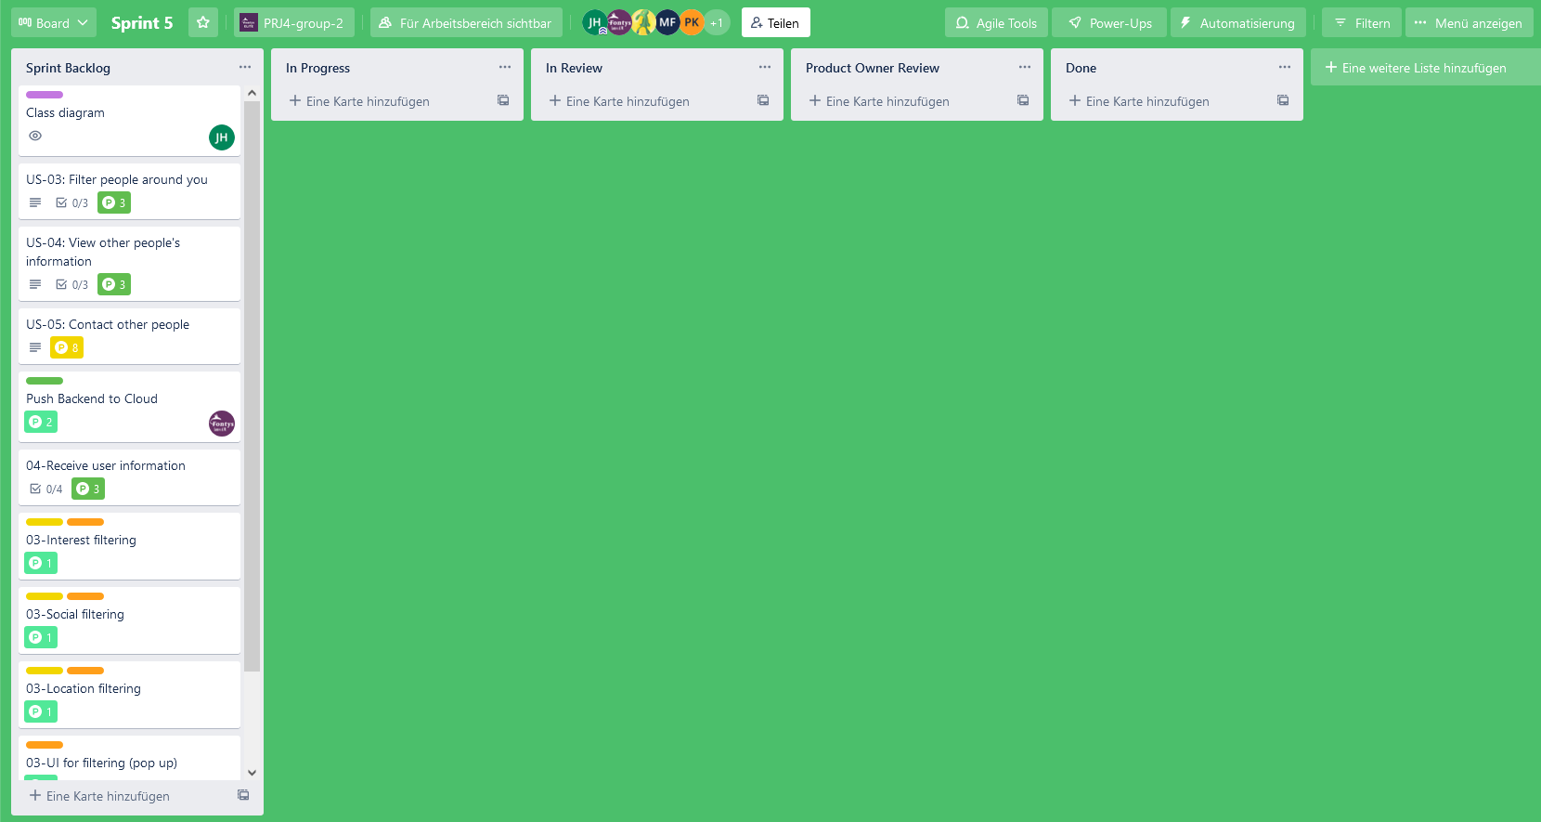

Goal of the fifth Sprint
Start working on Use Case 3,4 and 5.

