Retrospective – Sprint 5

What went well?
- Backend to Cloud success
- Filtering done

What could be improved?
- A bit more story points

What will we improve in the next Sprint?
- Reach more story points

Burndown chart
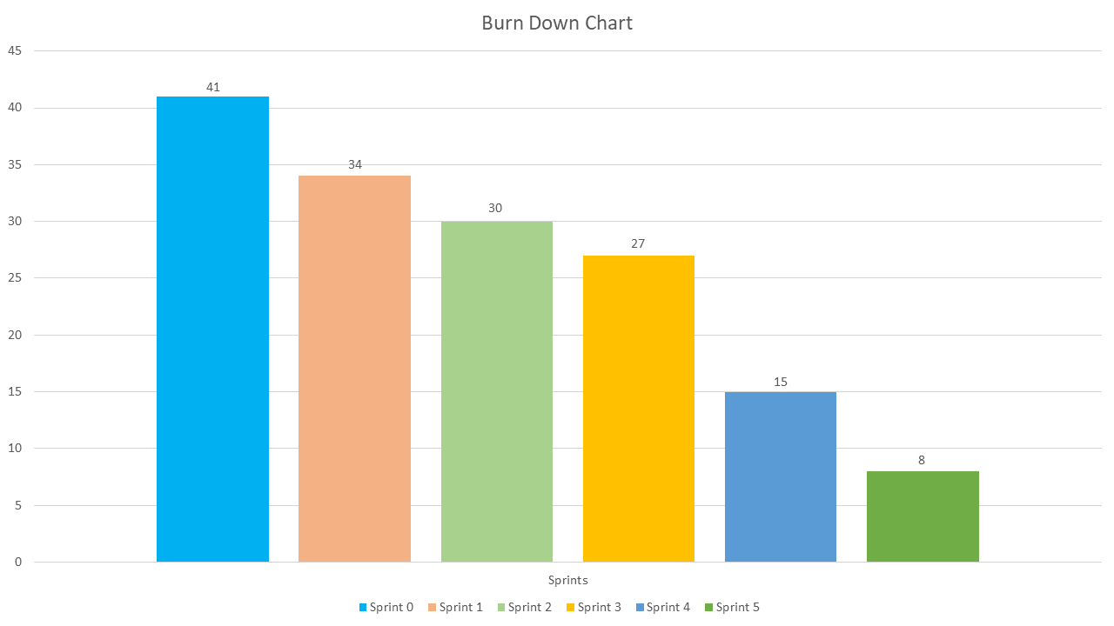
- The Burndown chart shows how much work is left from our original Story points we set for our 8 different use cases. That’s why we burned 8 story points here and 9 on the velocity chart.

Team velocity
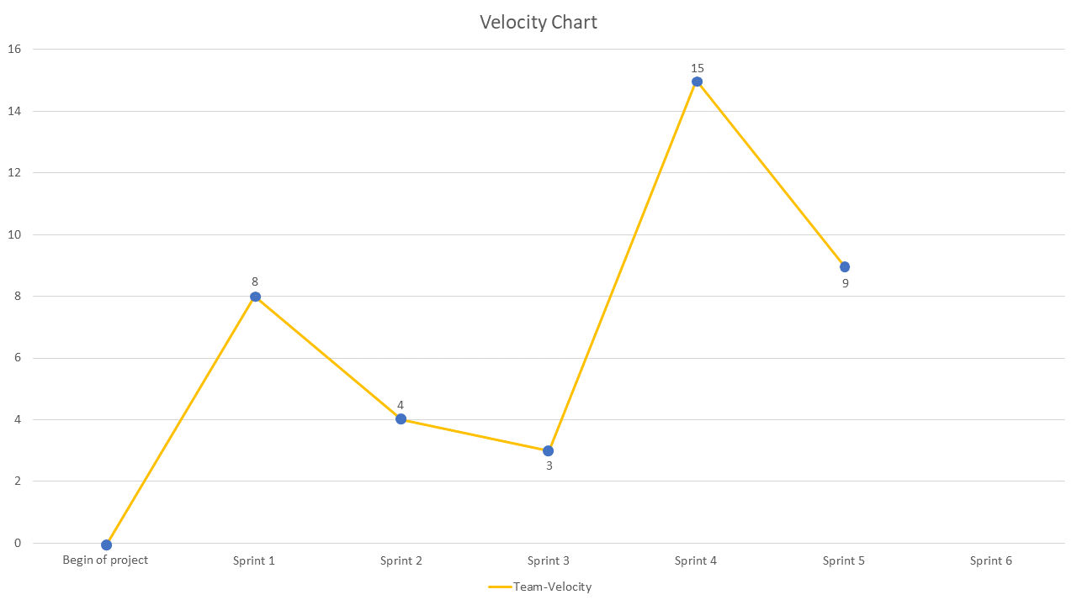
- On average we do 7,8 Story points per Sprint, this sprint we did 9. The variation comes from the different Sprints having various hours that we are able to spend on the project.

Updated Product backlog
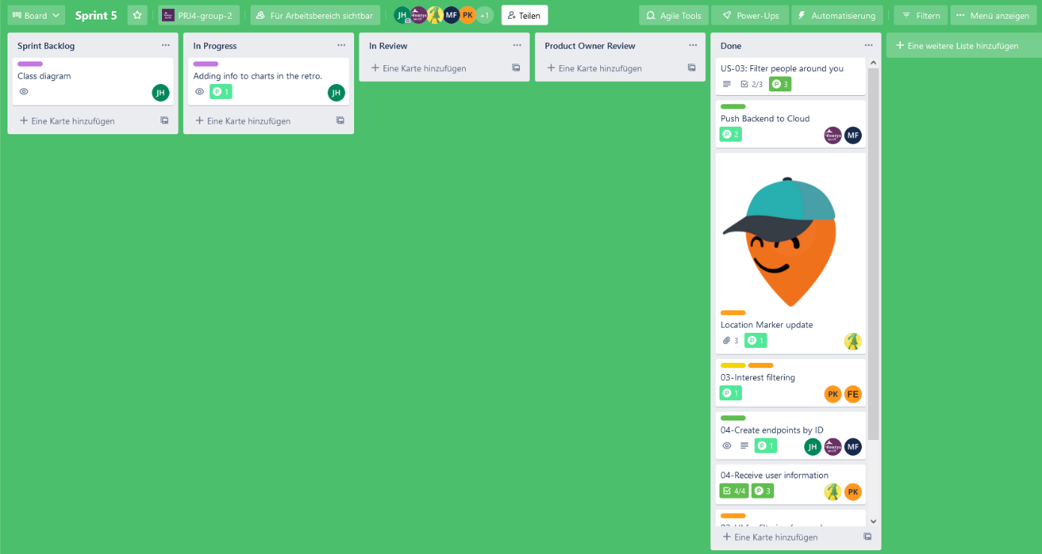

Sixth Sprint backlog
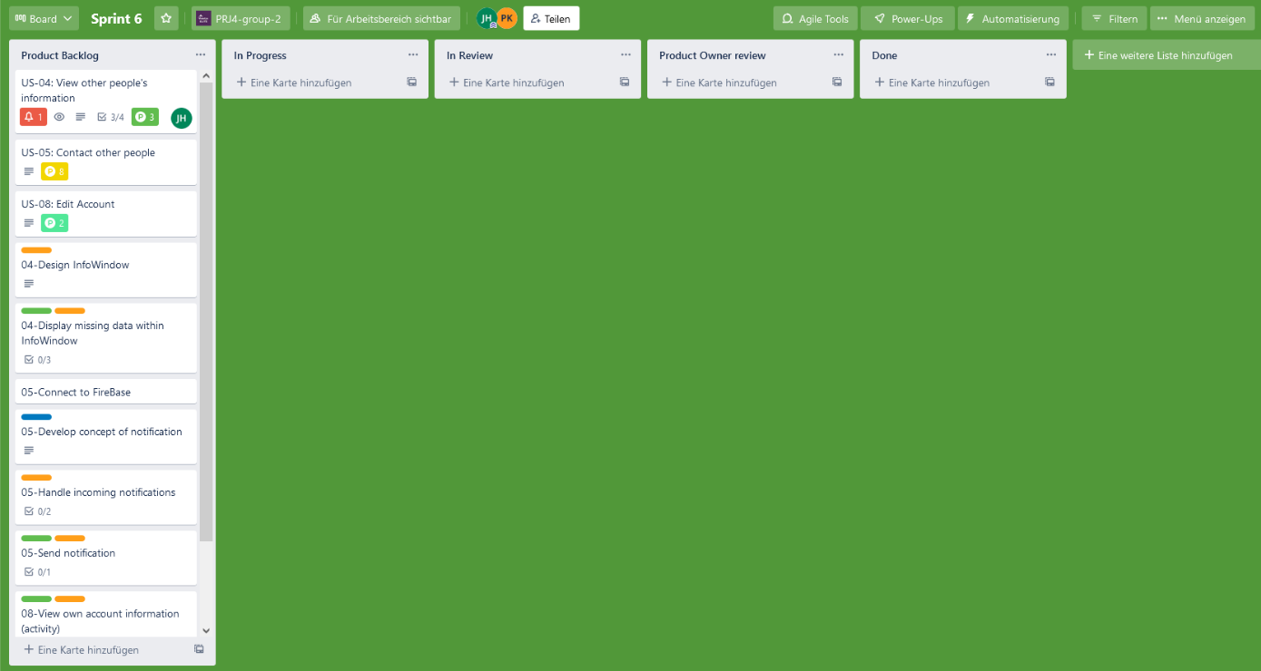

Goal of the Sixth Sprint
Start working on contacting and editing the account. Maybe some UI refactors

