Retrospective – Sprint 6

What went well?
- Refactor core activity
- App deployed on mobile phone
- First steps with Firebase

What could be improved?
- Consistency on story points

What will we improve in the next Sprint?
- Estimation of workload

Burndown chart
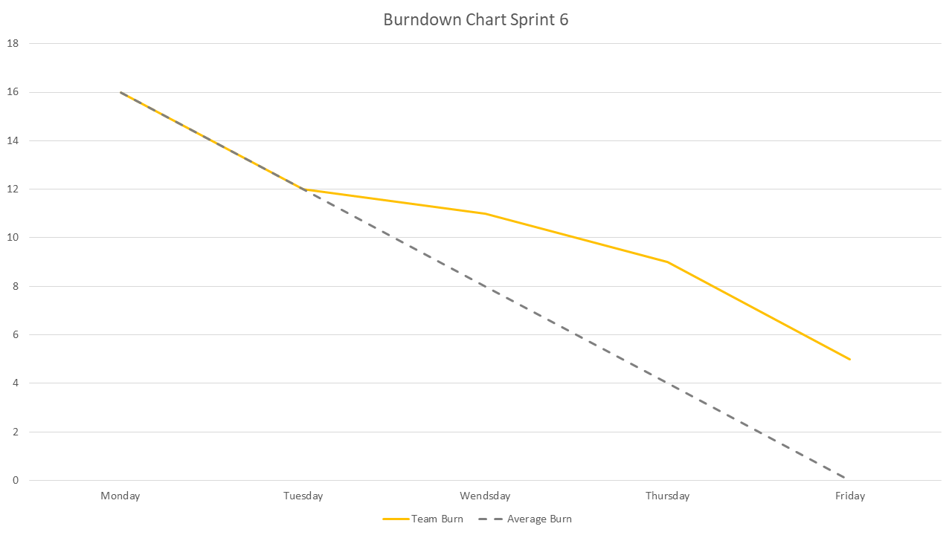
- We had 16 points to burn this Sprint. We burned 11 out of them so 5 Story points are going to the backlog of Sprint 7.

Team velocity
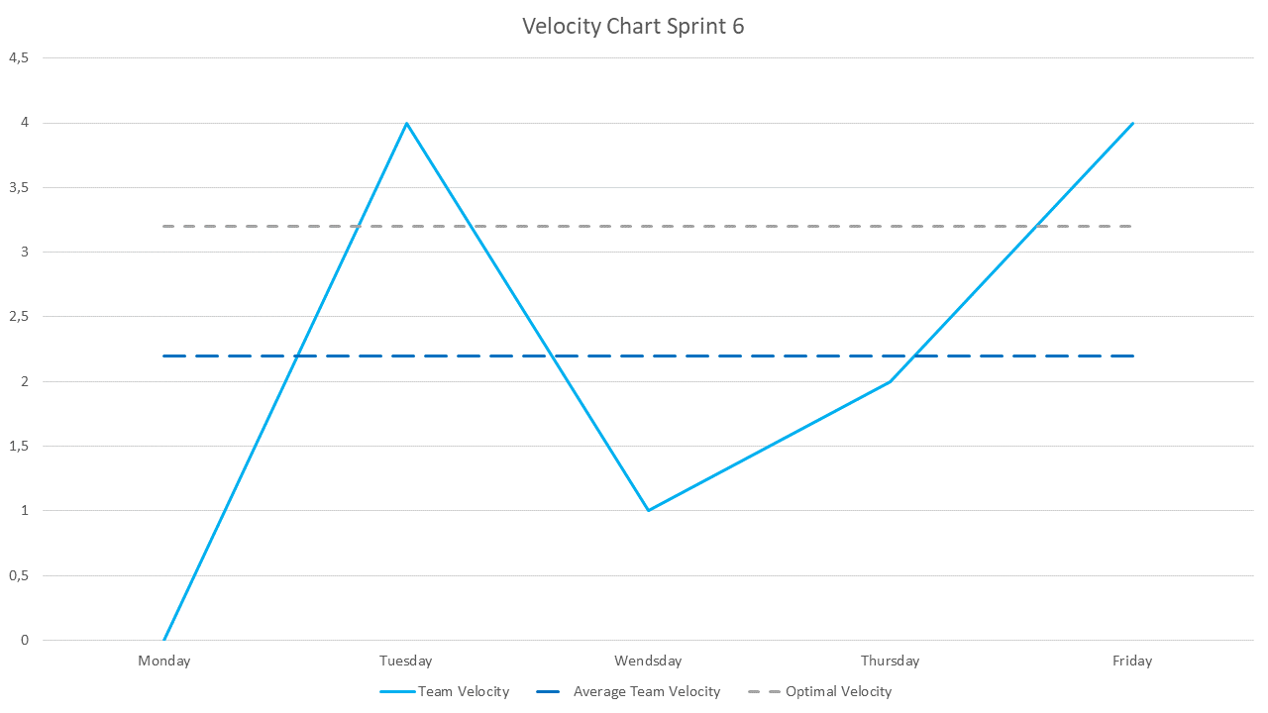
- The average Story points for this Sprint should have been 3,2 per day. We did 2,2 and were left with 5.

Updated Product backlog
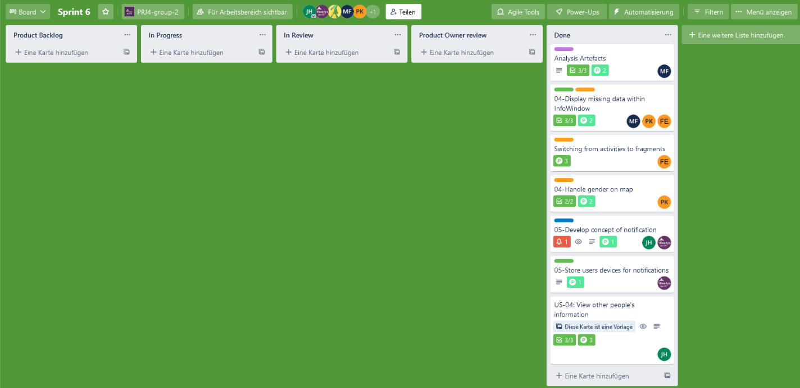

Sixth Sprint backlog
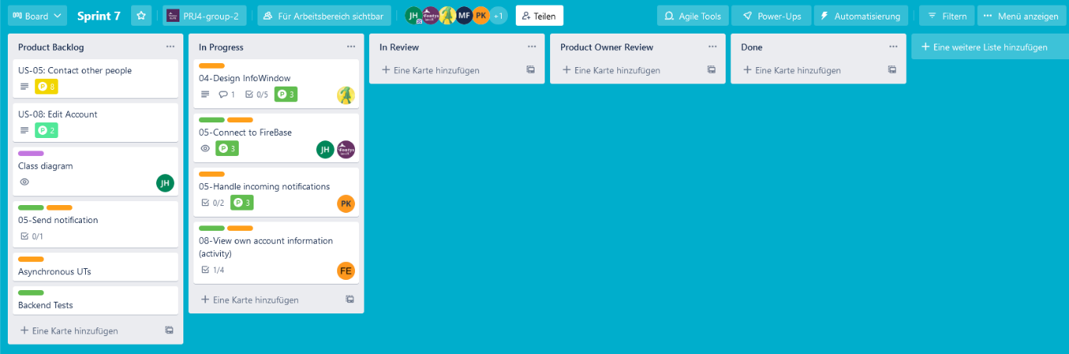

Goal of the seventh Sprint
- Continue working on contacting.

