Retrospective – Sprint 7

What went well?
- Successfully connected to firebase

What could be improved?
- Consistency on story points

What will we improve in the next Sprint?
- Estimation of workload

Burndown chart
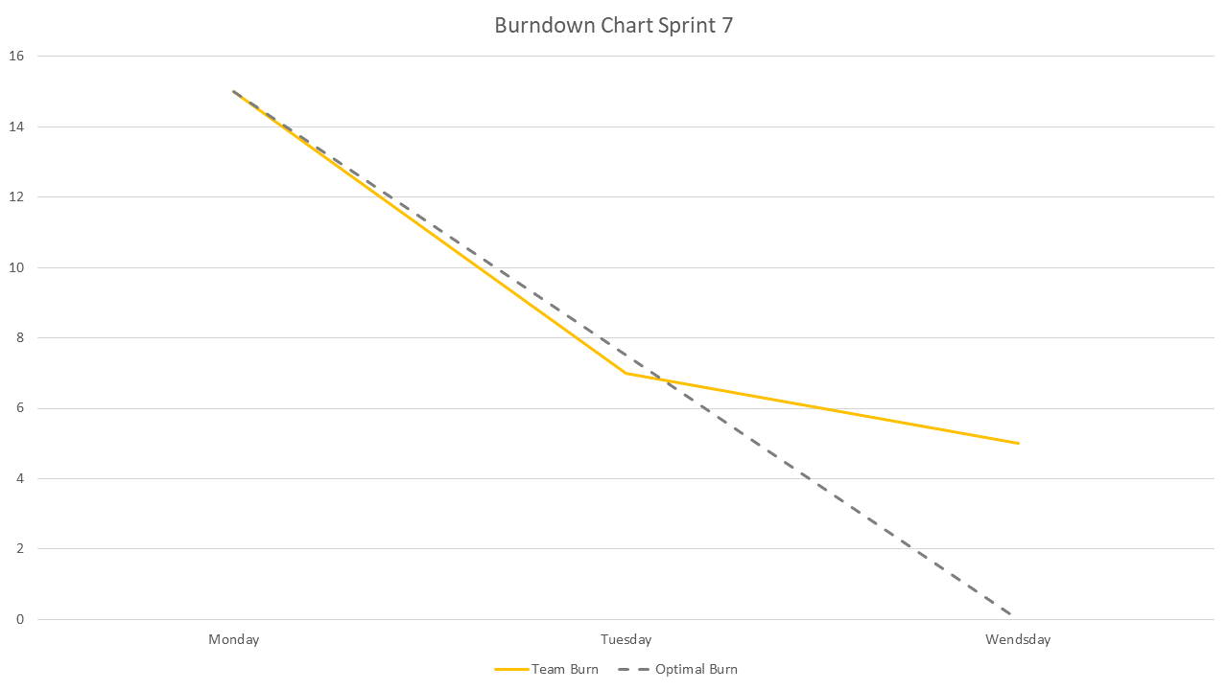
- We had 15 points to burn this Sprint. We burned 10 out of them so 5 Story points are going to the backlog of Sprint 8.

Team velocity
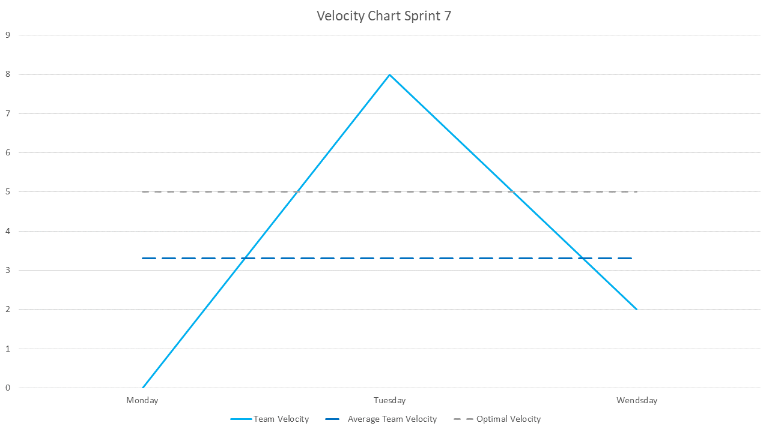
- The average Story points for this Sprint should have been 5 per day. We did 3,3 and were left with 5.

Updated Product backlog
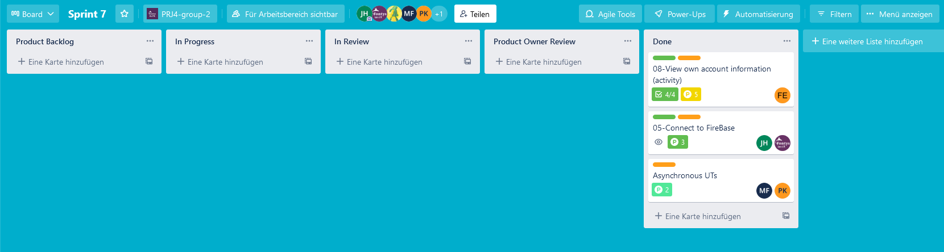

Seventh Sprint backlog
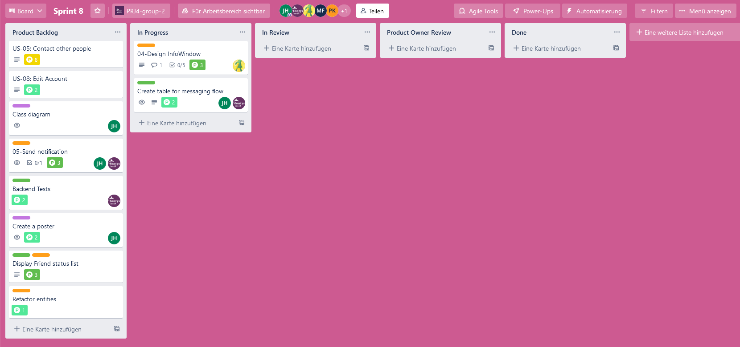

Goal of the seventh Sprint
- Finishing all that is left before the presentation

