Retrospective – Sprint 8

What went well?
- Fixed many issues
- Closed the requirements
- Finalized requesting

What could be improved?
- UI improvements
- Smaller bugs need to be addressed

Burndown chart
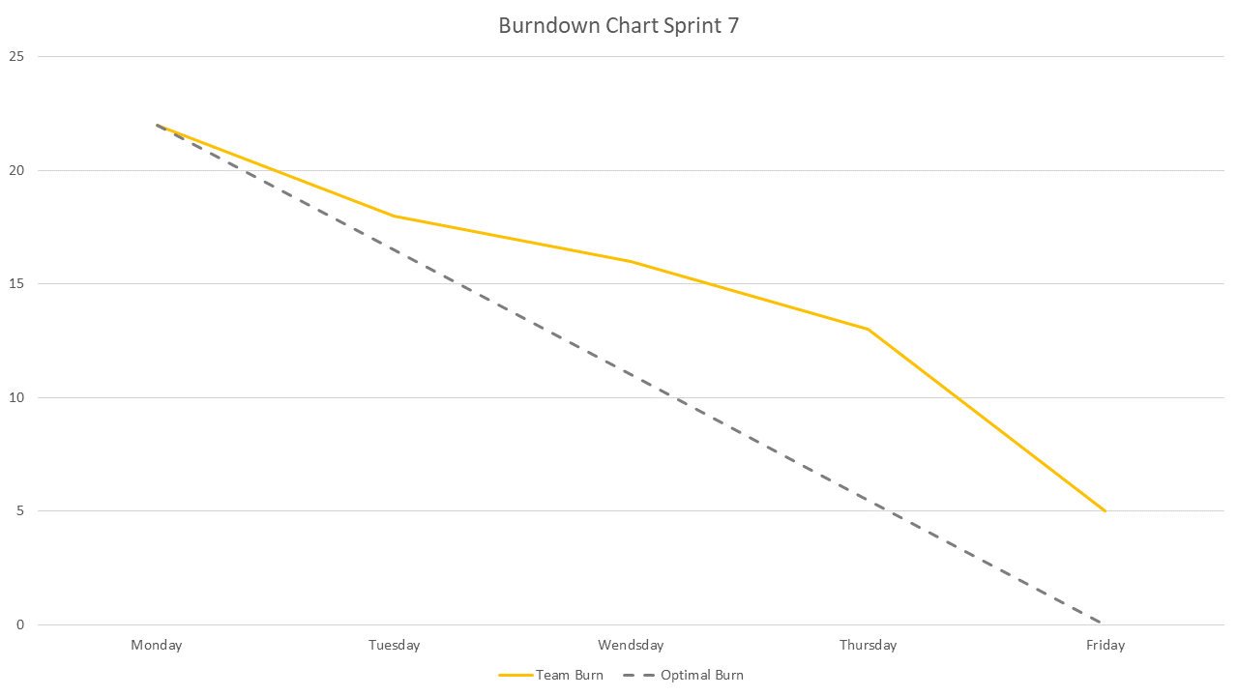
- We had 22 points to burn this Sprint. We burned 17 out of them so 5 Story points are left.

Team velocity
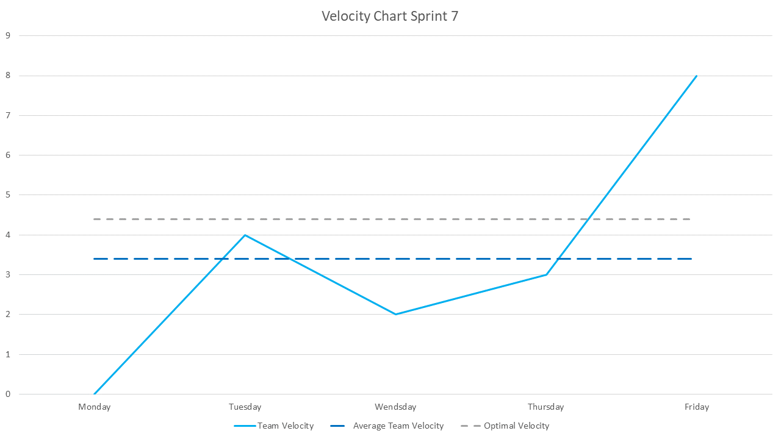
- The average Story points for this Sprint should have been 4,4 per day. We did 3,4 and were left with 5.

Updated Product backlog
