Process Characterization Master Report
  - A-Mab Drug Substance — PCMR-001
Process Development / Manufacturing Science & Technology (MSAT)
2026-07-24
Table of contents

Field | Value
Document ID | PCMR-001
Document class | Process Characterization Master Report
Title | Process Characterization Master Report: A-Mab Drug Substance
Product | A-Mab
Version | 1.0
Effective date | 2026-07-24
Status | Approved (synthetic)
Document owner | Manufacturing Science & Technology (MSAT)
Sponsor / sites | Novacyte Biologics; Novacyte Biologics — Cambridge, MA (Development) → Novacyte Biologics — Grafton, WI (Commercial DS)
SYNTHETIC DOCUMENT — NOT A REAL RECORD. Illustrative content generated from a seeded model of the A-Mab case study (CMC Biotech Working Group, 2009). Novacyte Biologics and all sites, SOP/AMV numbers and signatories are fictional. For NLP corpus development only; not for any regulated use.

Approvals
Table 1: Approval record (synthetic; signatures not applied).
Role | Function | Name (synthetic) | Signature | Date
Author | Process Development / MSAT | — | — | —
Reviewer | Analytical Development | — | — | —
Reviewer | Manufacturing Science | — | — | —
Reviewer | Statistics | — | — | —
Approver | Quality Assurance | — | — | —

Abbreviations
AEX, anion exchange chromatography; ADCC, antibody-dependent cell-mediated cytotoxicity; AMV, analytical method validation; BLA, Biologics License Application; CEX, cation exchange chromatography; CPP, critical process parameter; CQA, critical quality attribute; Cpk, process capability index (one-sided); DCS, distributed control system; DoE, design of experiments; DS, drug substance; ELISA, enzyme-linked immunosorbent assay; GPP, general process parameter; HCP, host cell protein; HMW, high molecular weight; ICH, International Council for Harmonisation; icIEF, imaged capillary isoelectric focusing; KPP, key process parameter; LRF, log reduction factor; MSAT, Manufacturing Science and Technology; MVM, minute virus of mice; NOR, normal operating range; PAR, proven acceptable range; PPQ, process performance qualification; qPCR, quantitative polymerase chain reaction; RSM, response-surface methodology; SDM, scale-down model; SEC, size-exclusion chromatography; SOP, standard operating procedure; TCID50, 50 % tissue-culture infectious dose; TFF, tangential-flow filtration; TMP, transmembrane pressure; UF/DF, ultrafiltration and diafiltration; WC-CPP, well-controlled critical process parameter; XMuLV, xenotropic murine leukaemia virus.

Executive summary
Stage 1 characterization of the A-Mab drug substance process is complete and the process is ready for Stage 2. The 8 unit operations of the train were studied on qualified scale-down models under the master plan PCMP-001, with the scope of each study set by the pre-characterization risk assessment RA-001. Each step has its own report, PCR-003 through PCR-010, and this document consolidates those reports without repeating their analyses. Each number quoted here is taken from the report named beside it.
All 10 drug substance quality attributes meet their acceptance criteria at commercial scale, where capability was estimated by Monte-Carlo simulation of 2,000 batches in which every classified parameter varied independently inside its normal operating range and the fitted step models carried that variation through to the drug substance. The lowest capability index in the process is 1.51, for the cumulative MVM clearance, whose simulated mean of 10.38 log₁₀ lies 1.78 log₁₀ above the requirement of 8.6 log₁₀. Of the product quality attributes the tightest is high mannose, at 1.94. High mannose is formed in the production bioreactor and is not modified by any later step (PCR-003).
Cumulative viral clearance is 18.87 log₁₀ for XMuLV against a requirement of 16.7 log₁₀, and 10.03 log₁₀ for MVM against 8.6 log₁₀. 3 steps carry the claim and their mechanisms are independent of one another. They are the low-pH hold (PCR-006), anion exchange (PCR-008) and virus filtration (PCR-009). No viral clearance is claimed for Protein A capture or for cation exchange, although both steps are known to remove virus.
The campaign classified 37 process parameters, and only the inactivation pH of the low-pH hold is classified as a critical process parameter, because its acceptable range is narrow and the consequence of leaving it is severe in both directions (PCR-006). 20 parameters are well-controlled critical process parameters, 10 are key process parameters and 6 are general process parameters.
The campaign recorded 17 deviations across 8 reports, and one of them invalidated a complete designed experiment. The first anion exchange execution was run on a non-representative load, so its screening and response-surface designs were invalidated and re-executed in full on requalified material (DEV-008-01, PCR-008). A second anion exchange deviation was closed by modelling the effect and confirming the correction in verification runs (DEV-008-02, PCR-008). The remaining 15 deviations were retained with a bounded impact assessment. No deviation changed a parameter classification, an operating range or a viral clearance claim.
Every claim made here is bounded, and none of the bounds is closed by Stage 1. The design spaces are not confirmed at commercial scale at the edges of their ranges. Capability is a model estimate from qualified scale-down models operated with every parameter inside its normal operating range. Viral clearance is measured in small-scale spiking studies and not on production material. Stage 2 process performance qualification has not been executed, and this report makes no claim about commercial-scale reproducibility.

1. Introduction

1.1 Purpose and scope
This report is the roll-up of the A-Mab drug substance characterization campaign, and its purpose is to present the outcome of that campaign as one argument. It summarizes the individual reports and cites them, and it does not re-derive their models, their effect estimates or their design spaces, so where a conclusion in this report rests on such an analysis, the report that carries it is named. The scope is the drug substance process, Steps 3 to 10, at the 15,000 L commercial scale. Drug product manufacture, the validation of the analytical methods themselves and the Stage 2 qualification batches lie outside it.
The campaign supports the transfer of the process from the sending site to the receiving site, which is framed by the transfer plan PTP-001 (International Council for Harmonisation 2008). Characterization was executed at the sending site on scale-down models qualified against commercial-equivalent operation, so the conclusions hold for the commercial process only to the extent that those models represent it, and §9.2 states where that assumption carries the most weight.

1.2 The characterization package
The campaign is documented in 20 controlled documents, and the dependency between them is fixed. RA-001 sets the scope, PCMP-001 sets the common approach, each PCP-00N plans one step, each PCR-00N reports it, and this document consolidates the reports.
Table 2: The A-Mab characterization document package, excluding this report.
Document ID | Document class | Subject
PTP-001 | Process Transfer Plan | A-Mab Drug Substance
RA-001 | Pre-Characterization Process Risk Assessment | A-Mab Drug Substance
PCMP-001 | Process Characterization Master Plan | A-Mab Drug Substance
PCP-003 | Process Characterization Plan | Production Bioreactor (Step 3)
PCR-003 | Process Characterization Report | Production Bioreactor (Step 3)
PCP-004 | Process Characterization Plan | Harvest and Clarification (Step 4)
PCR-004 | Process Characterization Report | Harvest and Clarification (Step 4)
PCP-005 | Process Characterization Plan | Protein A Chromatography (Step 5)
PCR-005 | Process Characterization Report | Protein A Chromatography (Step 5)
PCP-006 | Process Characterization Plan | Low-pH Viral Inactivation (Step 6)
PCR-006 | Process Characterization Report | Low-pH Viral Inactivation (Step 6)
PCP-007 | Process Characterization Plan | Cation Exchange Chromatography (Step 7)
PCR-007 | Process Characterization Report | Cation Exchange Chromatography (Step 7)
PCP-008 | Process Characterization Plan | Anion Exchange Chromatography (Step 8)
PCR-008 | Process Characterization Report | Anion Exchange Chromatography (Step 8)
PCP-009 | Process Characterization Plan | Small-Virus Retentive Filtration (Step 9)
PCR-009 | Process Characterization Report | Small-Virus Retentive Filtration (Step 9)
PCP-010 | Process Characterization Plan | Ultrafiltration / Diafiltration (Step 10)
PCR-010 | Process Characterization Report | Ultrafiltration / Diafiltration (Step 10)

PTP-001, RA-001 and PCMP-001 are the parents of the whole set, and PTP-001 states what is being transferred and why the package exists. RA-001 was written before any study was executed, and its output is the study scope and not a classification. PCMP-001 states once what the 8 plans would otherwise each repeat, which is the quality attribute framework, the common scale-down approach and the shared statistical method.

1.3 Study inventory
Multivariate designed experiments were used at 6 of the 8 steps. Harvest and clarification, and ultrafiltration and diafiltration, neither form nor clear a product quality attribute, so both were characterized univariately. No designed experiment was executed at either step, and none is claimed for them.
Table 3: Characterization studies by unit operation, with the fitted response-surface coefficient of determination for the responses that map to a drug substance quality attribute.
Step | Unit operation | Design | Screening runs | RSM runs | R² (quality-linked responses) | Report
3 | Production Bioreactor | Screening + response surface | 19 | 28 | 0.94 to 1.00 | PCR-003
4 | Harvest and Clarification | Univariate | n/a | n/a | n/a | PCR-004
5 | Protein A Chromatography | Screening + response surface | 19 | 28 | 0.37 to 0.97 | PCR-005
6 | Low-pH Viral Inactivation | Screening + response surface | 11 | 18 | 0.98 to 1.00 | PCR-006
7 | Cation Exchange Chromatography | Screening + response surface | 19 | 28 | 0.94 to 0.97 | PCR-007
8 | Anion Exchange Chromatography | Screening + response surface | 19 | 28 | 0.84 to 0.97 | PCR-008
9 | Small-Virus Retentive Filtration | Screening + response surface | 7 | 12 | 0.71 to 0.85 | PCR-009
10 | Ultrafiltration / Diafiltration | Univariate | n/a | n/a | n/a | PCR-010

The reported campaign comprises 236 characterization runs across 12 designs, as given in Table 3. A further 47 runs were executed at anion exchange and then superseded, for the reason given in §8.2. Every design used a screening stage followed by a response-surface stage. The screening stage identifies which factors matter. The response-surface model is the predictive model and the basis of each step’s design space, and no design space in this package rests on a screening fit, because a near-saturated screening design cannot resolve all of the interactions between the parameters it screens.
Response-surface models were fitted for 21 responses, of which 17 map to a drug substance quality attribute. One of those responses, leached Protein A at the capture step, has no active factor over the ranges studied, so PCR-005 reports it as robust and claims no predictive model for it, and its coefficient of determination is correspondingly low at 0.37. For the remaining quality-linked responses the coefficient of determination ranged from 0.71 to 1.00, and the model adequacy of each is assessed in its own report against lack-of-fit and pure error.

1.4 Regulatory and scientific basis
The campaign follows the lifecycle approach to process validation, in which characterization is the Stage 1 process design activity that produces the commercial control strategy (U.S. Food and Drug Administration 2011). The enhanced development approach of ICH Q8(R2) and ICH Q11 provides the design space and control strategy framework (International Council for Harmonisation 2009, 2012). Criticality is treated as a continuum and not as a binary, following ICH Q9(R1) and the A-Mab case study, so quality attributes carry a level of criticality and process parameters carry a class that reflects both the demonstrated impact on quality and the risk of leaving the design space (International Council for Harmonisation 2023b; CMC Biotech Working Group 2009). Viral safety is evaluated under ICH Q5A(R2) as a modular claim built from independent steps (International Council for Harmonisation 2023a). The process model, the attribute framework and the risk method are those of the A-Mab case study (CMC Biotech Working Group 2009).

2. Process description and performance
The A-Mab drug substance process is a fed-batch cell culture followed by a platform purification train (capture, low-pH inactivation, two polishing steps, virus filtration and formulation). The bioreactor forms the product and its quality attributes. Everything downstream recovers the product and removes impurities, and only the low-pH hold and cation exchange alter an attribute that the bioreactor formed. Table 4 gives the train with each step’s principal role in the control strategy.
Table 4: The A-Mab drug substance process train, with each step’s principal role in the control strategy.
Step | Unit operation | Principal role
3 | Production Bioreactor | Forms the glycan, charge-variant and aggregate CQAs (design-space step)
4 | Harvest and Clarification | Primary recovery and clarification; forms no product-quality CQA
5 | Protein A Chromatography | Capture; sets leached Protein A; principal HCP and DNA clearance
6 | Low-pH Viral Inactivation | Low-pH hold; sets the cumulative XMuLV (enveloped) clearance
7 | Cation Exchange Chromatography | Polish; principal aggregate reduction; major HCP/DNA/leached-PA clearance
8 | Anion Exchange Chromatography | Flow-through polish; sets the cumulative MVM clearance; clears XMuLV/HCP/DNA
9 | Small-Virus Retentive Filtration | Dedicated small-virus removal; principal MVM clearance
10 | Ultrafiltration / Diafiltration | Formulation / mass balance; delivers drug substance at target concentration

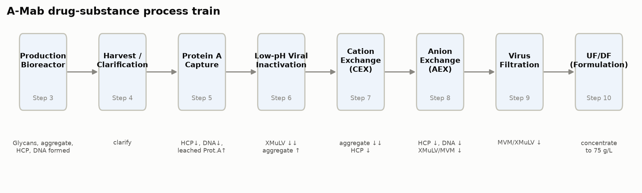
Figure 1: The A-Mab drug substance process train. The annotation under each step names the attributes it forms or clears.
Two steps in Table 4 deserve emphasis, because the whole quality argument turns on them. The production bioreactor forms the glycan, charge-variant and aggregate attributes, and it is the only step at which those attributes are set. Anion exchange is the last purification step, so the impurity levels leaving it are the drug substance levels, subject only to the concentration change across ultrafiltration and diafiltration, which alters the volume the product sits in and not the amount of protein impurity carried with it. The remaining steps recover product, clear impurities, or inactivate and remove virus.

2.1 Process performance
Product yield across the train is 83.2%. At the 15,000 L commercial scale and a nominal harvest titre of 4.37 g/L, this delivers 54.6 kg of drug substance at 75 g/L. No step yield is unusually low, and the lowest is 95.2% at Cation Exchange Chromatography, which is consistent with a bind and elute polishing step operated with a deliberately conservative elution collection window (PCR-007).
Table 5: Step and cumulative product yield across the drug substance train. The bioreactor is the basis of the cumulative yield.
Step | Unit operation | Step yield | Cumulative yield
3 | Production Bioreactor | 100.0% | 100.0%
4 | Harvest / Clarification | 97.7% | 97.7%
5 | Protein A Chromatography | 97.2% | 95.0%
6 | Low-pH Viral Inactivation | 99.0% | 94.0%
7 | Cation Exchange Chromatography | 95.2% | 89.5%
8 | Anion Exchange Chromatography | 97.3% | 87.1%
9 | Small Virus Retentive Filtration | 98.4% | 85.7%
10 | Ultrafiltration / Diafiltration (formulation) | 97.1% | 83.2%

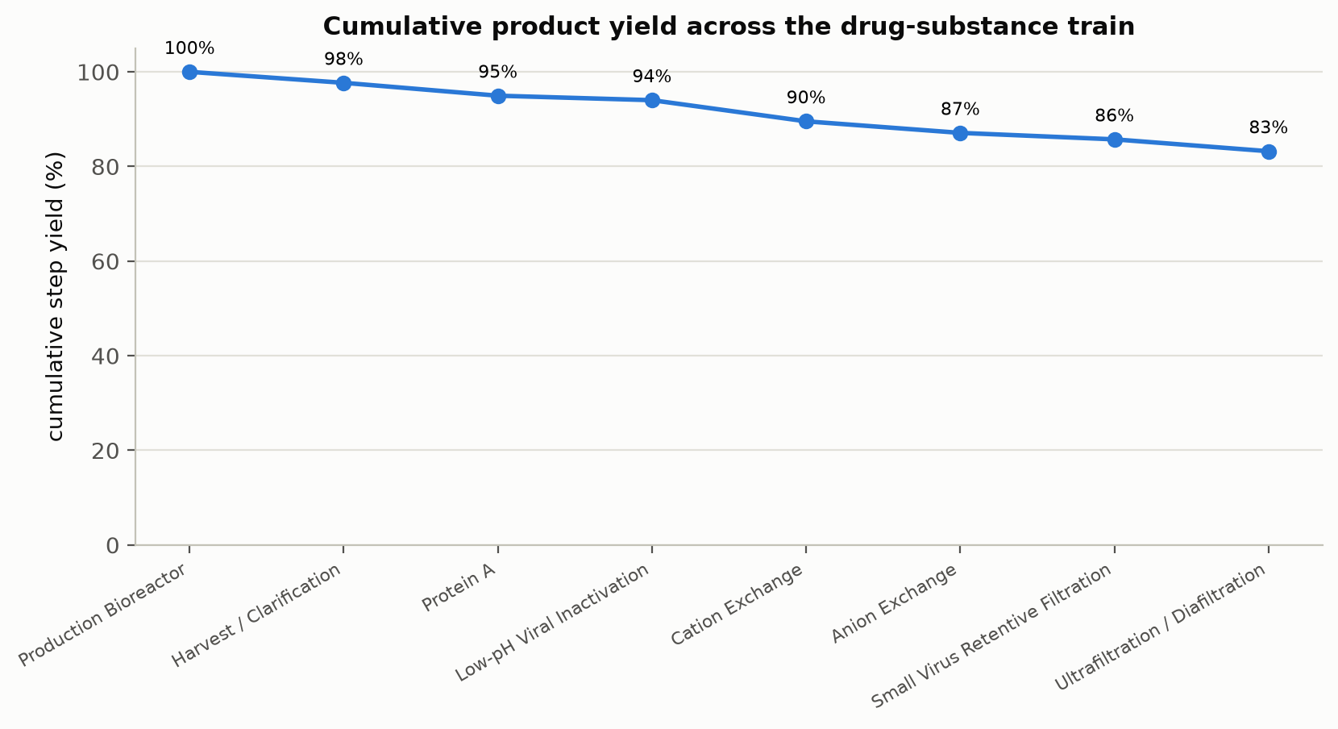
Figure 2: Cumulative product yield across the eight modelled unit operations.
Yield is a process performance attribute and not a quality attribute, and no yield value constrains a design space in this package. It is reported here because a characterized process that cannot meet its mass requirement is not transferable, and because the step yields are the basis of the key process parameter classifications at harvest and at ultrafiltration and diafiltration (PCR-004, PCR-010).

3. Consolidated quality attribute outcomes
Every drug substance quality attribute meets its acceptance criterion, and Table 6 gives the outcome for each. The table names the step that the attribute register assigns to each attribute, which for the impurities and product variants is the step that forms it and for the two clearance attributes is the step that completes the cumulative claim. In neither case is that necessarily the step that controls the outcome, and the difference is the subject of the subsections below.
Table 6: Consolidated drug substance quality attribute outcomes. The drug substance column is the mean and standard deviation of the simulated commercial-scale distribution.
CQA | Criticality | Acceptance | Set by | Drug substance | Cpk
Afucosylation | H | 2–13 % of glycans | Production Bioreactor | 7.98 ± 0.58 | 2.89
Galactosylation (total %Gal) | H | 10–40 % (G1+G2 equiv.) | Production Bioreactor | 26 ± 1.6 | 2.86
High Mannose | VH | 3–10 % of glycans | Production Bioreactor | 5.99 ± 0.51 | 1.94
Aggregates (HMW) | H | 0–5 % HMW (SEC) | Production Bioreactor | 0.753 ± 0.088 | 16.11
Acidic charge variants (deamidation) | VL | 18–40 % (CEX/icIEF) | Production Bioreactor | 22.3 ± 1.4 | 4.26
Host Cell Protein (HCP) | M-H | 0–100 ng/mg | Production Bioreactor | 15.2 ± 4.6 | 6.14
Residual DNA | VL | 0–0.001 ng/dose | Production Bioreactor | 0.0001 ± 0 | 10.81
Leached Protein A | L-M | 0–5 ppm | Protein A Chromatography | 0.003 ± 0.0006 | 2785.30
Viral clearance — XMuLV (enveloped) | VH | 16.7–30 log10 (cumulative) | Low-pH Viral Inactivation | 19.5 ± 0.61 | 1.53
Viral clearance — MVM (parvovirus) | VH | 8.6–20 log10 (cumulative) | Anion Exchange Chromatography | 10.4 ± 0.4 | 1.51

3.1 Glycan and charge-variant attributes
The three glycan attributes and the acidic charge variants are formed in the production bioreactor and are not modified downstream. Afucosylation and galactosylation are linked to potency through the antibody-dependent cell-mediated cytotoxicity (ADCC) mechanism, which is why both carry a high criticality despite comfortable capability. High mannose carries very high criticality because it is linked to clearance as well as to potency, and its acceptance range of 3 to 10 % of glycans is the tightest two-sided range in the register.
None of the chromatography steps discriminates between glycosylation variants when operated under platform conditions, which is the mechanistic reason the downstream process cannot correct a glycan excursion (CMC Biotech Working Group 2009). Control of the glycan attributes therefore rests entirely on the bioreactor, on culture pH, temperature, dissolved carbon dioxide, osmolality and duration, and PCR-003 defines the multivariate region over which all three glycan attributes remain inside their limits across the ranges characterized. Acidic charge variants behave in the same way, with one addition. The low-pH hold and the neutralized hold that follows it can promote deamidation, and PCR-006 quantified that contribution over the characterized hold time.

3.2 Aggregates
Aggregate is formed in the bioreactor, increased slightly by the low-pH hold, and reduced by cation exchange. The low-pH hold raises the aggregate content by 0.35 percentage points to 1.91 % at the characterized set-point, which is the expected consequence of holding an antibody at pH 3.5 (PCR-006). Cation exchange then reduces the pool aggregate 2.61-fold to 0.73 %, against a drug substance limit of 5 % (PCR-007). Cation exchange is the only aggregate clearance step in the train, and there is no step after it that would remove aggregate formed later, so its performance is the reason the drug substance capability for aggregate is as large as Table 6 shows.

3.3 Host cell protein
Host cell protein (HCP) is cleared to specification only after the last purification step. The clarified harvest carries 500,000 ng/mg, and Protein A capture reduces this about 55-fold to 9,125 ng/mg in the capture pool (PCR-005). Cation exchange reduces it a further 78.0-fold to 117.0 ng/mg (PCR-007), and anion exchange reduces it 6.19-fold to 18.9 ng/mg (PCR-008). Only the last of these figures is below the drug substance limit of 100 ng/mg.
The intermediate values are in-process results and not failed acceptance criteria. No acceptance criterion for host cell protein applies to the Protein A pool or to the cation exchange pool, because neither is drug substance. Each of those pools carries its own in-process limit, defined in the report for that step, and the limits are set from what the downstream steps can be relied on to remove. The total clearance across the chromatography steps is about 26,444-fold.
Credit for host cell protein clearance is therefore shared, and no single step can be described as the host cell protein control. Protein A does the bulk of the removal in absolute terms, cation exchange contributes the largest single fold reduction, and anion exchange sets the level that reaches the drug substance. A change to the load conditions of any one of them shifts the burden onto the others, which is why the three steps are classified together in the control strategy of §7 and why the design space of each is defined against an in-process limit and not against the drug substance specification.

3.4 Residual DNA and leached Protein A
Residual DNA and leached Protein A both reach the drug substance far below their limits. Residual DNA is 0.0001 ng per dose against a limit of 0.001 ng per dose, and it is cleared by every chromatography step in the train. Leached Protein A enters the process at the capture step at 3.63 ppm and is cleared by the two polishing steps to 0.003 ppm, against a limit of 5 ppm (PCR-005, PCR-007, PCR-008).
Leached Protein A is the one attribute in the register whose level depends on a consumable rather than on a set-point. It rises with resin age and with elution pH, and PCR-005 found no significant effect of any characterized parameter on it over the ranges studied. Its control is therefore a life-cycle control on the capture resin and not a parameter range, and §7.4 describes it.

3.5 Viral clearance
Cumulative XMuLV and MVM clearance are drug substance quality attributes in this register, and both are of very high criticality. They are treated separately in §6 because their acceptance criteria apply to the sum of several steps and not to an output of any one step.

4. Parameter classification summary
All 37 process parameters carried into the campaign are classified. Table 7 gives the counts by class and Table 8 gives them by unit operation. 21 parameters are linked to a quality attribute and are controlled within the design space of their step. The remainder are controlled for process consistency or are not controlled beyond their normal operating range.
Table 7: Parameter classification across the whole drug substance train.
Class | Parameters | Basis for the class
CPP | 1 | Impact on a CQA demonstrated; appreciable risk of leaving the design space
WC-CPP | 20 | Impact on a CQA demonstrated; low risk of leaving the design space
KPP | 10 | No CQA impact; controlled to keep process performance consistent
GPP | 6 | No CQA or performance impact over the ranges studied

Table 8: Parameter classification by unit operation.
Step | Unit operation | CPP | WC-CPP | KPP | GPP | Total
3 | Production Bioreactor | 0 | 5 | 3 | 1 | 9
4 | Harvest / Clarification | 0 | 0 | 2 | 1 | 3
5 | Protein A Chromatography | 0 | 2 | 2 | 2 | 6
6 | Low-pH Viral Inactivation | 1 | 2 | 0 | 1 | 4
7 | Cation Exchange Chromatography | 0 | 4 | 0 | 1 | 5
8 | Anion Exchange Chromatography | 0 | 5 | 0 | 0 | 5
9 | Small Virus Retentive Filtration | 0 | 2 | 0 | 0 | 2
10 | Ultrafiltration / Diafiltration (formulation) | 0 | 0 | 3 | 0 | 3

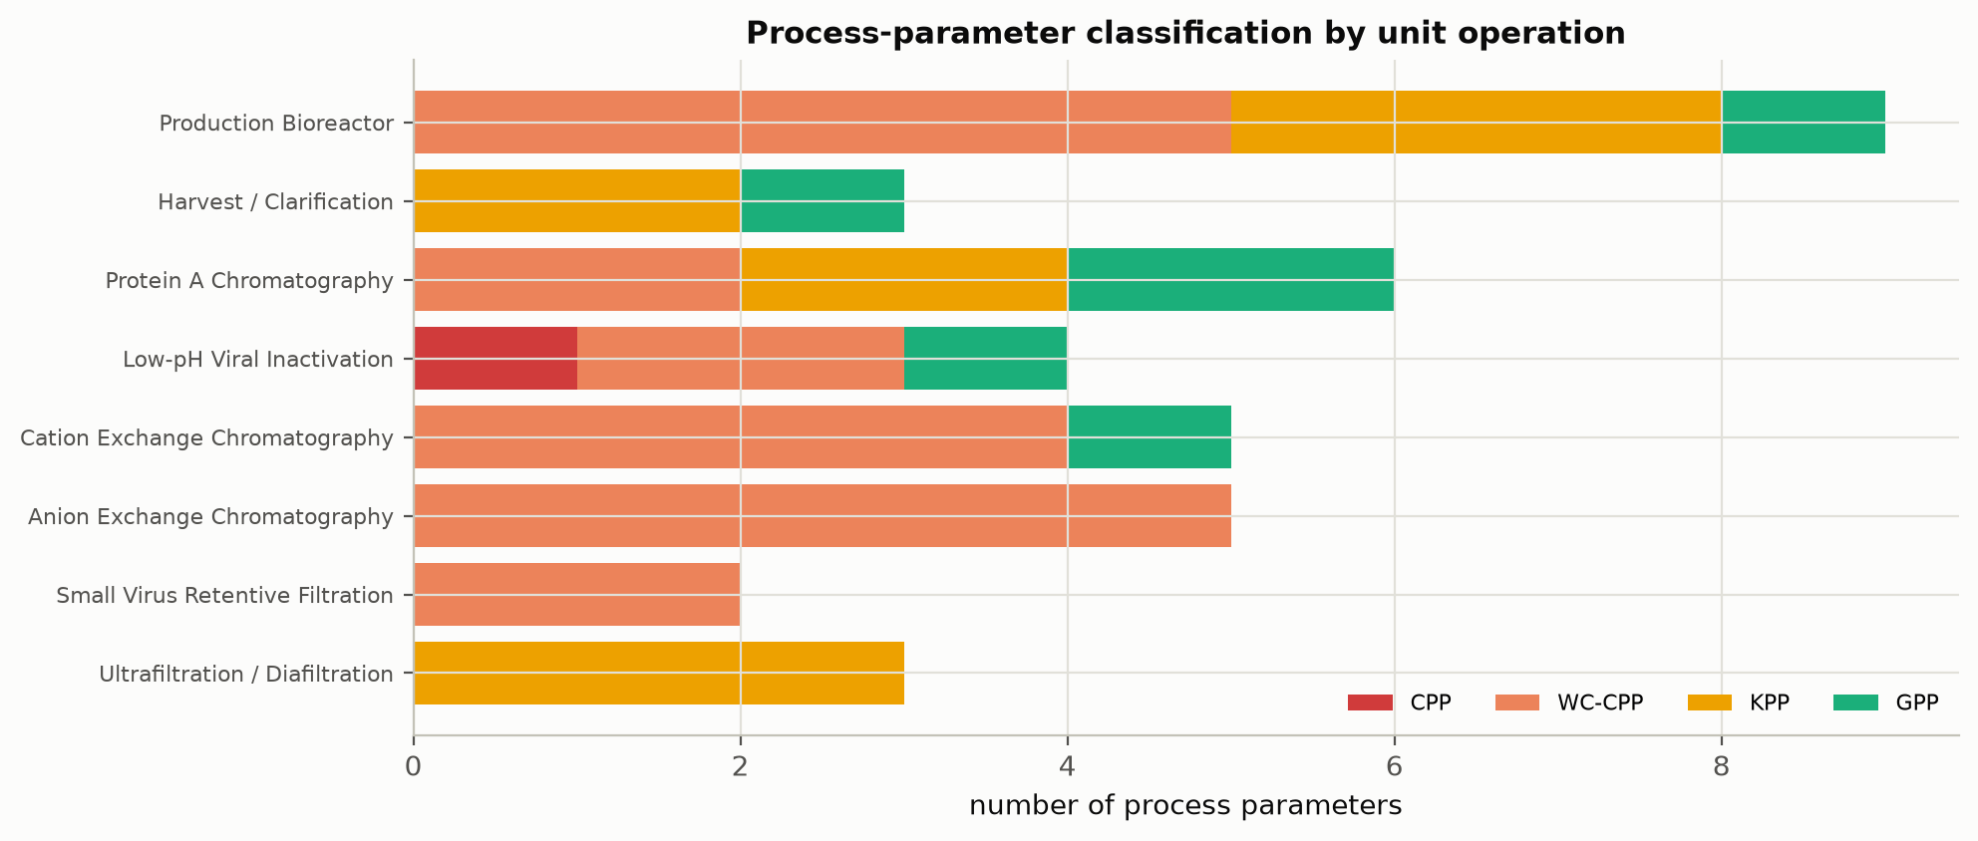
Figure 3: Post-characterization classification of process parameters by unit operation.
The single critical process parameter is the inactivation pH of the low-pH hold, with a normal operating range of 3.4 to 3.6 and a characterized range of 3.2 to 4. It is critical and not well-controlled critical for the reason PCR-006 gives. The consequence of leaving the range is severe in both directions, because inactivation of XMuLV is incomplete above the upper edge and the antibody aggregates below the lower edge, and the width of the acceptable range is small relative to the control capability of a pH loop on a large hold vessel. Every other quality-linked parameter in the process is held in a range wide enough, relative to the control capability of its loop, that the risk of leaving the design space is low.
Table 9: Parameters linked to a quality attribute, with their set-points and normal operating ranges.
Unit operation | Parameter | Unit | Set-point | NOR | Class
Production Bioreactor | Culture pH | pH | 6.85 | 6.75–6.95 | WC-CPP
Production Bioreactor | Culture temperature | °C | 35 | 34.5–35.5 | WC-CPP
Production Bioreactor | Dissolved CO2 (pCO2) | mmHg | 100 | 70–130 | WC-CPP
Production Bioreactor | Osmolality | mOsm | 400 | 375–425 | WC-CPP
Production Bioreactor | Culture duration | days | 17 | 16–18 | WC-CPP
Protein A Chromatography | Protein load | g/L resin | 30 | 20–40 | WC-CPP
Protein A Chromatography | Elution buffer pH | pH | 3.55 | 3.4–3.7 | WC-CPP
Low-pH Viral Inactivation | Inactivation pH | pH | 3.5 | 3.4–3.6 | CPP
Low-pH Viral Inactivation | Hold time | min | 90 | 60–120 | WC-CPP
Low-pH Viral Inactivation | Temperature | °C | 21 | 19–23 | WC-CPP
Cation Exchange Chromatography | Protein load | g/L resin | 25 | 18–32 | WC-CPP
Cation Exchange Chromatography | Load/Wash conductivity | mS/cm | 5 | 4–6 | WC-CPP
Cation Exchange Chromatography | Elution buffer pH | pH | 6 | 5.85–6.15 | WC-CPP
Cation Exchange Chromatography | Elution stop collect | OD desc. | 1 | 0.7–1.3 | WC-CPP
Anion Exchange Chromatography | Load pH | pH | 7.5 | 7.35–7.65 | WC-CPP
Anion Exchange Chromatography | Equil/Wash-1 conductivity | mS/cm | 2.6 | 2.1–3.1 | WC-CPP
Anion Exchange Chromatography | Load conductivity | mS/cm | 5.5 | 4–7 | WC-CPP
Anion Exchange Chromatography | Protein load | g/L resin | 200 | 120–280 | WC-CPP
Anion Exchange Chromatography | Operating flow rate | cm/hr | 300 | 200–400 | WC-CPP
Small Virus Retentive Filtration | Filtration volume (load) | L/m2 | 90 | 50–105 | WC-CPP
Small Virus Retentive Filtration | Filtration pressure | psi | 13 | 10–20 | WC-CPP

The parameters that the control strategy must hold inside a design space are listed in Table 9. The production bioreactor and anion exchange contribute 5 each, more than any other step. At the bioreactor they are culture conditions acting on the glycan and charge-variant attributes (PCR-003). At anion exchange the flow-through mode makes the load and the buffer conditions jointly determine both impurity clearance and virus removal, so all 5 parameters of the step are quality-linked (PCR-008). Cation exchange contributes 4 and Protein A capture 2.
One classification in Table 9 rests on a bounding argument rather than on a measured effect. The anion exchange operating flow rate was assessed univariately and was not a factor in either multivariate design, so no interaction between flow and the buffer conditions was estimated. PCR-008 classifies it as well-controlled critical on the basis that residence time is mechanistically linked to virus removal in a flow-through step, and that the safe course where an interaction has not been estimated is the more stringent class. It is the only quality-linked parameter in the campaign assessed this way.
Null results account for a large part of Table 7. Several parameters showed no significant effect on any response over the ranges characterized, and each of them was classified on that evidence and kept in the record, because a factor that does nothing over a wide range is evidence of robustness and not an absence of information. Basal medium concentration, Protein A operating temperature and bed height, cation exchange elution flow rate, harvest post-clarification turbidity and the A-Mab concentration at the low-pH hold are all general process parameters (GPP) for that reason. Their ranges remain in the knowledge space as evidence that the attributes they might have affected are robust to them.

5. Process capability
Capability at commercial scale was estimated for every drug substance quality attribute by Monte-Carlo simulation of 2,000 batches. In each simulated batch every classified parameter was drawn independently within its normal operating range and propagated through the fitted step models, so the simulated distribution reflects parameter variation, the analytical variation of the methods (Table 12) and the residual variation of each model. Capability is reported as a one-sided index against the acceptance limit that applies, following the practice described in the process validation literature for judging whether a process can meet a specification (U.S. Food and Drug Administration 2011).
Table 10: Commercial-scale process capability for every drug substance quality attribute.
CQA | Crit. | Spec | Acceptance | Mean ± SD | Cpk
Afucosylation | H | two-sided | 2–13 | 7.98 ± 0.58 | 2.89
Galactosylation (total %Gal) | H | two-sided | 10–40 | 26 ± 1.6 | 2.86
High Mannose | VH | two-sided | 3–10 | 5.99 ± 0.51 | 1.94
Aggregates (HMW) | H | upper | 0–5 | 0.753 ± 0.088 | 16.11
Acidic charge variants (deamidation) | VL | upper | 18–40 | 22.3 ± 1.4 | 4.26
Host Cell Protein (HCP) | M-H | upper | 0–100 | 15.2 ± 4.6 | 6.14
Residual DNA | VL | upper | 0–0.001 | 0.0001 ± 0 | 10.81
Leached Protein A | L-M | upper | 0–5 | 0.003 ± 0.0006 | 2785.30
Viral clearance — XMuLV (enveloped) | VH | lower | 16.7–30 | 19.5 ± 0.61 | 1.53
Viral clearance — MVM (parvovirus) | VH | lower | 8.6–20 | 10.4 ± 0.4 | 1.51

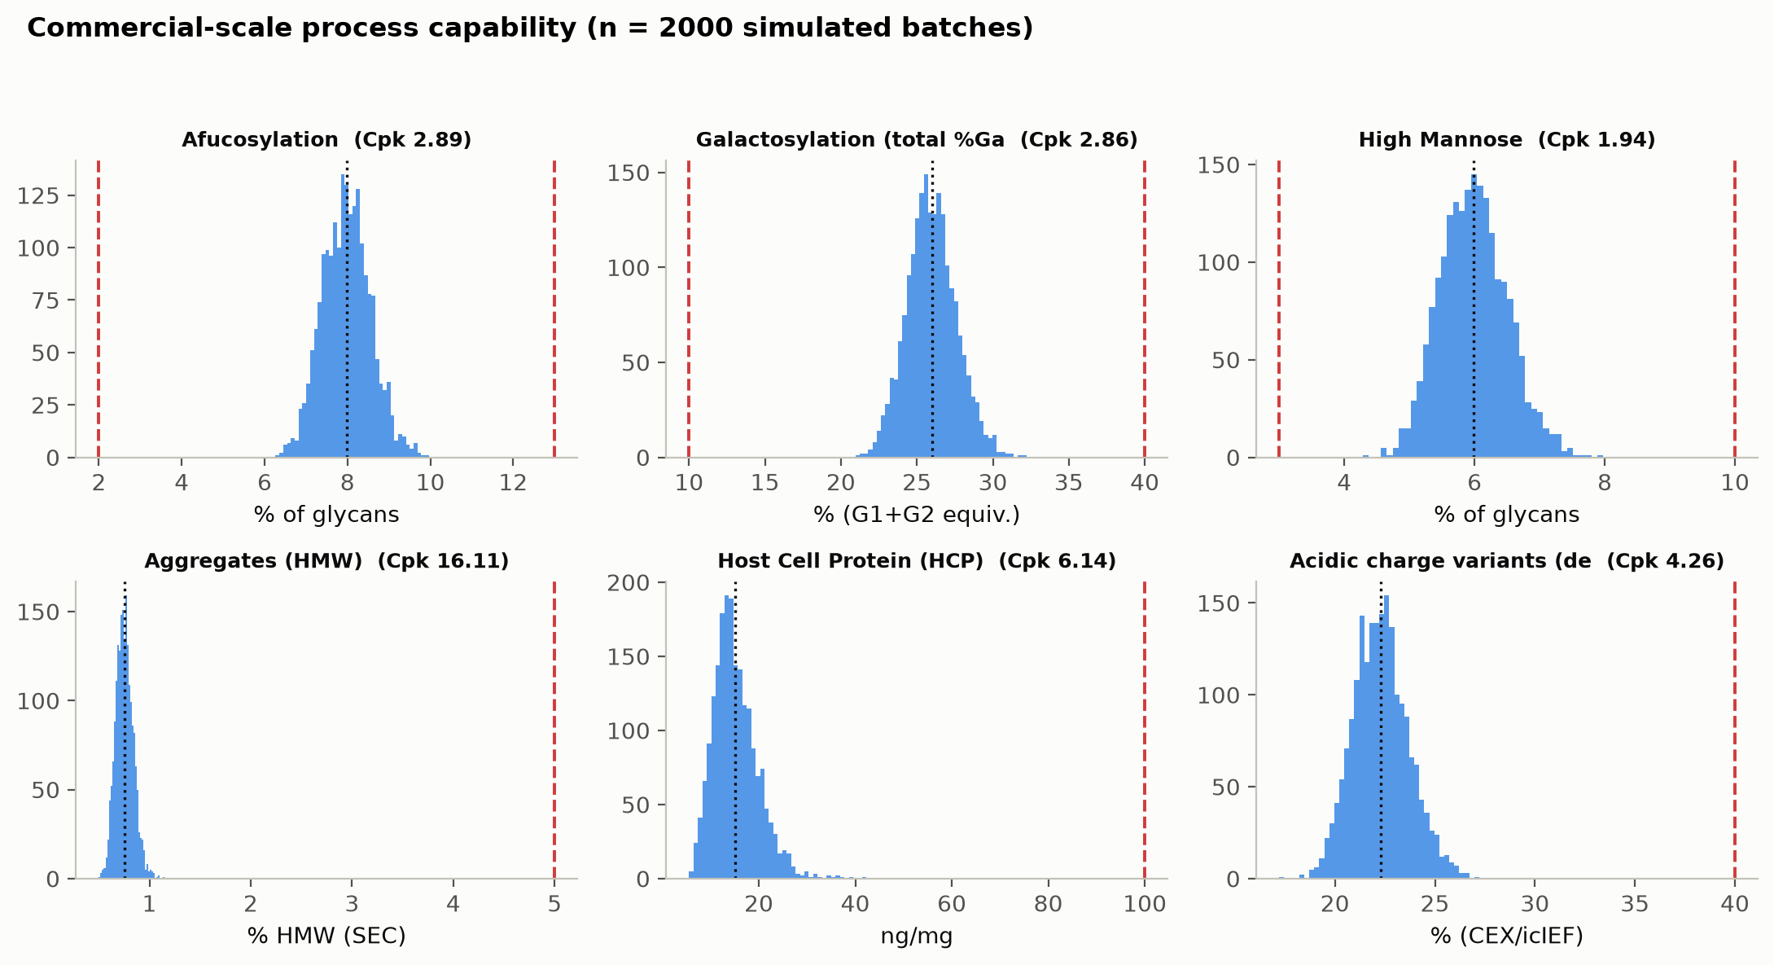
Figure 4: Simulated commercial-scale distributions of the product quality attributes against their acceptance limits, annotated with the capability index.
The tightest capability in the process is the cumulative MVM clearance, at 1.51. Its simulated mean of 10.38 log₁₀ sits 1.78 log₁₀ above the requirement of 8.6 log₁₀, with a standard deviation of 0.40 log₁₀. The cumulative XMuLV clearance is next at 1.53, and both are lower than any product quality attribute because a clearance requirement is a floor and not a window, and because the variation of 3 independent spiking studies combines in the sum.
Of the product quality attributes the tightest is high mannose at 1.94, with a simulated mean of 5.99 % of glycans in a range of 3 to 10 %. The binding side is the lower limit, and PCR-003 identifies culture pH and temperature as the parameters that move it. Afucosylation and galactosylation are next, at 2.89 and 2.86. The remaining attributes sit far from their limits, and their indices should be read as showing that the attribute does not constrain the process, and not as meaningful precision. Leached Protein A is the extreme case, at 1,667-fold below its limit, and its index is reported in Table 10 for completeness only.
Two bounds apply to every value in Table 10. The simulation propagates parameter variation within the normal operating ranges and does not extrapolate to the edges of the characterized ranges, so it describes routine operation and not the whole design space, where the reliability of a model that predicts mean levels is lower than it is at the centre. The step models it propagates were fitted on qualified scale-down models, so the capability is inherited from the scale-down qualification of each step. Commercial-scale capability is confirmed in Stage 2, on the 5 process performance qualification batches and the continued process verification that follows them.

6. Viral clearance summary
Cumulative clearance exceeds the requirement for both model viruses. XMuLV clearance is 18.87 log₁₀ against a requirement of 16.7 log₁₀, a margin of 2.17 log₁₀. MVM clearance is 10.03 log₁₀ against 8.6 log₁₀, a margin of 1.43 log₁₀. The claim is modular in the sense of ICH Q5A(R2), which means each step was spiked and assayed independently of the others and the increments are summed (International Council for Harmonisation 2023a).
Table 11: Modular viral clearance by step, with the mechanism claimed for each and the report that establishes it.
Step | Mechanism | XMuLV (log₁₀) | MVM (log₁₀) | Report
Low-pH Viral Inactivation | Chemical inactivation of the viral envelope | 7.10 | 0.00 | PCR-006
Anion Exchange (AEX) | Charge-based partition in flow-through mode | 5.95 | 4.71 | PCR-008
Virus Filtration | Size-based retention by the membrane | 5.82 | 5.32 | PCR-009
Cumulative |  | 18.87 | 10.03

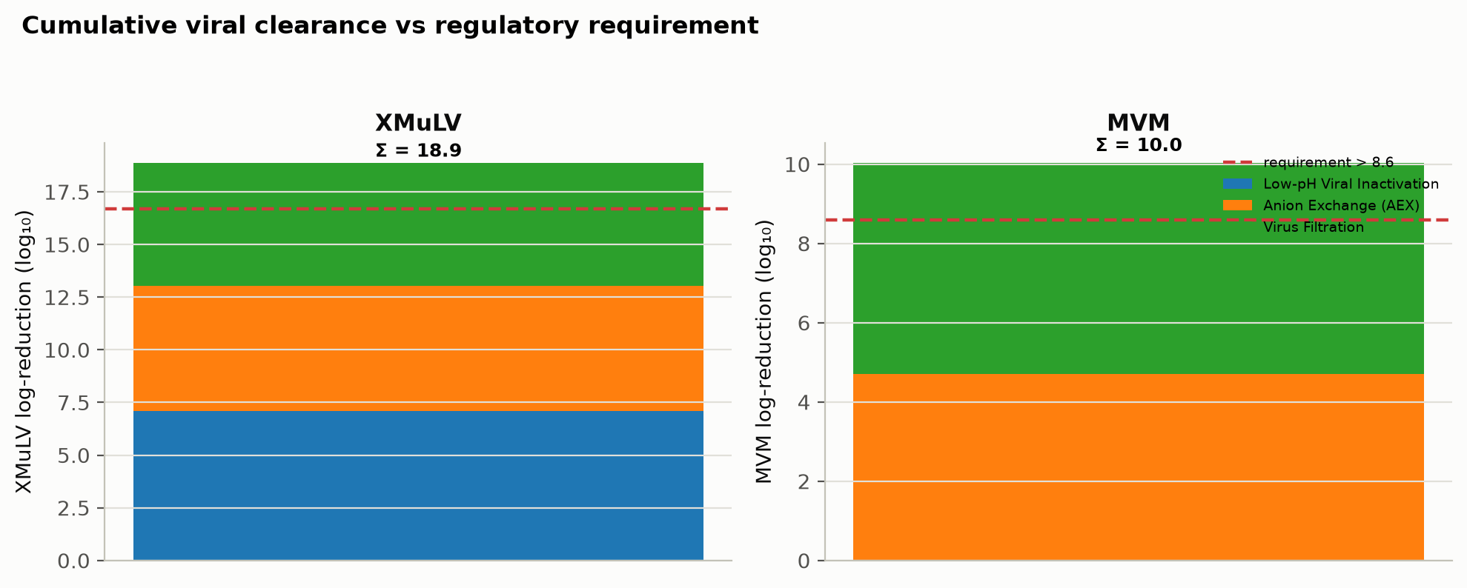
Figure 5: Modular viral clearance by step for XMuLV and MVM against the cumulative requirement.
The mechanisms in Table 11 are orthogonal, which is what allows the increments to be added. Low-pH inactivation disrupts the lipid envelope of an enveloped virus, anion exchange partitions virus from antibody on charge in flow-through mode, and the virus filter retains virus on size, so a condition that defeats one of them does not defeat the others. No single step carries the cumulative claim.
Each step contributes differently to the two viruses, and the difference is mechanistic. The low-pH hold gives 7.10 log₁₀ against XMuLV and nothing at all against MVM, because minute virus of mice is a non-enveloped parvovirus with no envelope to disrupt (PCR-006). Anion exchange gives 5.95 log₁₀ against XMuLV and 4.71 log₁₀ against MVM, and PCR-008 shows both to depend on load pH and on load conductivity. Virus filtration gives 5.32 log₁₀ against MVM and 5.82 log₁₀ against XMuLV, and it is the largest single contributor to the parvovirus claim (PCR-009).
The MVM claim rests on 2 steps only, which is why it carries the tightest capability in the process. Anion exchange and virus filtration are both credited, and PCR-008 and PCR-009 each define the operating region over which their contribution holds. For anion exchange the region validated for viral clearance is wider than the region required for control of the other quality attributes, so the narrower region governs routine operation. For virus filtration the binding constraint is the volumetric load, and the normal operating range of 50 to 105 L/m² is set inside the characterized range of 50 to 140 L/m² for that reason.
No viral clearance is claimed for Protein A capture or for cation exchange. Both steps are expected to remove virus, and platform experience with related antibodies supports that expectation, but neither was spiked in this campaign and neither appears in Table 11. The margins quoted above are therefore conservative. Clearance is measured at small scale on spiked material, so the claim is bounded by the qualification of the small-scale spiking models described in PCR-006, PCR-008 and PCR-009, and by the assumption that the model viruses represent the relevant classes of adventitious agent.

7. Overall control strategy
The control strategy has two purposes, and the elements described below serve them. Product quality and safety are assured by holding every quality-linked parameter inside the design space of its step. Process consistency is assured by holding the key process parameters within their established limits and by monitoring the process attributes that report on them (CMC Biotech Working Group 2009). Nothing in the strategy relies on end-product testing to detect a quality failure that the process controls should have prevented.

7.1 Parameter control
Every parameter in Table 9 is held within the normal operating range given there, each of those ranges lies inside the design space or proven acceptable range established by the step’s report, and the relationship between the ranges is the same at every step. The normal operating range is the routine control range, the design space is the multivariate region within which the attributes stay in limit, and the characterized range is the wider knowledge space over which the models were fitted, so each of the three is nested inside the one that follows it. Movement within a design space is not a change in the regulatory sense, although it remains subject to the pharmaceutical quality system (International Council for Harmonisation 2009, 2008). Movement outside one is a change and requires the study that supports it.

7.2 In-process control
Each purification step is sampled at its pool and tested by the validated methods listed in Table 12. The in-process limits that apply to those pools are defined step by step, and the host cell protein limits in particular are set from what the downstream steps are relied on to remove, as §3.3 describes. Two in-process controls arose from the campaign itself. The charge-variant verification of the anion exchange load introduced during the investigation of DEV-008-01 is retained as a routine input control on that step. The trailing-edge collection set-point at anion exchange (the ultraviolet absorbance at which pool collection stops) was reduced from 180 mAU to 120 mAU, and confirmed in 3 verification runs (PCR-008).
Table 12: Controlled procedures and validated analytical methods referenced across the campaign. All numbers are placeholders.
Reference | Title | Type
SOP-1001 | Qualification of Scale-Down Models | SOP
SOP-1002 | Design, Execution and Statistical Analysis of DoE Studies | SOP
SOP-2003 | Operation of the Production Bioreactor (Fed-Batch) | SOP
SOP-2004 | Cell-Culture Media and Feed Preparation | SOP
SOP-2005 | Harvest by Continuous Disk-Stack Centrifugation | SOP
SOP-2006 | Clarification by Depth and Sterile Filtration | SOP
SOP-2007 | Operation of the Protein A Capture Chromatography Step | SOP
SOP-2008 | Chromatography Resin Life-Cycle, Packing and Sanitization | SOP
SOP-2009 | Operation of the Low-pH Viral Inactivation Step | SOP
SOP-2010 | Operation of the Cation-Exchange Polishing Chromatography Step | SOP
SOP-2011 | Operation of the Anion-Exchange Polishing Chromatography Step | SOP
SOP-2012 | Operation and Post-Use Integrity Testing of the Small-Virus Retentive Filtration Step | SOP
SOP-2013 | Operation of the Ultrafiltration / Diafiltration (Formulation) Step | SOP
SOP-3010 | Released N-Glycan Mapping by 2-AB HILIC-UPLC | SOP
SOP-3011 | Size-Variant Analysis by SEC-HPLC | SOP
SOP-3012 | Host-Cell-Protein Quantitation by ELISA | SOP
SOP-3013 | Charge-Variant Analysis by icIEF | SOP
SOP-3014 | Residual Host-Cell DNA by qPCR | SOP
SOP-4001 | Process-Parameter Classification and Control- Strategy Definition | SOP
AMV-3010 | N-Glycan Map (2-AB HILIC-UPLC) | Method validation
AMV-3011 | Size-Variants (SEC-HPLC) | Method validation
AMV-3012 | Host-Cell Protein ELISA | Method validation
AMV-3013 | Charge Variants (icIEF) | Method validation
AMV-3014 | Residual DNA (qPCR) | Method validation
AMV-3015 | Turbidity by Nephelometry (NTU) | Method validation
AMV-3016 | Leached Protein A by ELISA (ppm) | Method validation
AMV-3017 | XMuLV Infectivity Titre (TCID50) | Method validation
AMV-3018 | MVM Infectivity Titre (TCID50/qPCR) | Method validation
AMV-3019 | Protein Concentration by A280 (UV) | Method validation

7.3 Release control
The drug substance is released against the acceptance criteria in Table 6. Release testing confirms the outcome of the control strategy and is not the means by which the outcome is achieved, which is the distinction the lifecycle approach draws between a controlled process and a tested one (U.S. Food and Drug Administration 2011). Viral safety is not a release test at all. It is assured by the cleared log reduction of §6 together with the testing of the cell banks and the unprocessed bulk, and no release assay could substitute for it.

7.4 Life-cycle control
Part of the strategy consists of life-cycle controls and not of parameter ranges. The capture resin carries a validated life-cycle in cycles, because leached Protein A rises with resin age and no set-point controls it (PCR-005). The virus filter is single-use and is integrity-tested after every batch, because the clearance claim depends on membrane integrity and not on an operating parameter that can be monitored during the run (PCR-009). The polishing resins carry sanitization and storage requirements under the same procedure.

7.5 What the control strategy does not cover
The strategy covers the drug substance process at the receiving site and nothing beyond it. It does not cover drug product manufacture, the shipping and storage of drug substance, or the qualification of the commercial equipment train, each of which is addressed in its own package. It does not establish commercial-scale reproducibility, which is the object of Stage 2. It also assumes that the raw materials and the cell bank remain those characterized here, and a change to either requires the comparability assessment described in PTP-001.

8. Deviations across the campaign
One deviation in this campaign invalidated a complete designed experiment. The first anion exchange execution, 47 runs across a screening design and a response-surface design, was found to have been run on a non-representative load and was discarded for the purpose of defining an operating region. The whole study was executed again on requalified material, and it is the second execution that PCR-008 reports and that this document consolidates. 17 deviations were recorded in total across 8 reports, and each was investigated, dispositioned and impact-assessed in the report for its step. None of them is reinvestigated here.

8.1 The register
Table 13: The complete deviation register for the characterization campaign. The document named beside each identifier is the report that investigated it.
Deviation | Step | What happened | Root cause | Disposition
DEV-003-01 (PCR-003) | Bioreactor | Dissolved-CO2 probe drift during screening run 4 | probe drift between calibrations | retained
DEV-003-02 (PCR-003) | Bioreactor | Nutrient feed-1 under-delivery on a centre-point batch | feed pump calibration offset | retained
DEV-004-01 (PCR-004) | Harvest | Depth-filter lot pre-use flush turbidity above alert | insufficient initial flush volume | retained
DEV-004-02 (PCR-004) | Harvest | Post-clarification turbidity excursion above NOR on one run | depth filter loading near maximum | retained
DEV-005-01 (PCR-005) | Protein A | Elution-buffer pH prepared below target on an RSM run | titration endpoint error | retained
DEV-005-02 (PCR-005) | Protein A | Leached Protein A result initially out-of-trend; re- assayed | assay carryover suspected | retained
DEV-006-01 (PCR-006) | Low-pH hold | Hold-time record discrepancy between DCS and manual log | clock synchronisation offset | retained
DEV-006-02 (PCR-006) | Low-pH hold | XMuLV infectivity assay cytotoxicity at low dilution | sample matrix cytotoxicity | retained
DEV-007-01 (PCR-007) | CEX | Expired Tris load/wash buffer lot used in screening run 6 | material expiry not checked at preparation | retained
DEV-007-02 (PCR-007) | CEX | Column inlet temperature excursion during RSM run 14 | controller setpoint drift | retained
DEV-008-01 (PCR-008) | AEX | Non-representative (deamidated) load in the first DoE execution; designs invalidated and re-executed | extended neutralized hold promoted asparagine deamidation | invalidated and re-executed
DEV-008-02 (PCR-008) | AEX | Trailing-edge UV pool- collection set-point slightly permissive in both executions | permissive UV pool stop setpoint | corrected by modelling and verification runs
DEV-008-03 (PCR-008) | AEX | Equilibration/Wash-1 buffer released below its pH acceptance range on one screening run | titration endpoint error at buffer preparation | retained
DEV-009-01 (PCR-009) | Virus filtration | Transient filtration-pressure excursion above NOR | pump ramp overshoot | retained
DEV-009-02 (PCR-009) | Virus filtration | Filter membrane lot flux below vendor-typical value | membrane lot permeability variation | retained
DEV-010-01 (PCR-010) | UF/DF | Transmembrane-pressure excursion above NOR during concentration | membrane fouling transient | retained
DEV-010-02 (PCR-010) | UF/DF | Final DS concentration below target on one run; topped up | residual hold up volume | retained

The register is given in full in Table 13, because the dispositions are not uniform. 15 deviations were retained, which means the affected data were used as executed with a documented impact assessment. One was invalidated and re-executed, and one was corrected by modelling and verification runs. Both of the latter occurred at anion exchange and both are described in §8.2.

8.2 The anion exchange deviations
The load used for the first anion exchange execution was not representative of a routine cation exchange pool. Its acidic charge-variant content was 33.5 %, against 21.0 % in the requalified material used for the second execution. The cause was an extended neutralized hold of 36 hours before loading, which promoted asparagine deamidation (verified by icIEF under AMV-3013). The deamidated load altered the charge the antibody presented to the resin and produced an anomalous interaction between protein load and wash conductivity, and at the corner where both were high the flow-through pool left its in-process limit, which is the observation that prompted the investigation. PCR-008 documents that investigation and the root cause.
Both affected designs were invalidated for the purpose of defining an operating region and were re-executed in full. The re-executed screening and response-surface studies are the ones analysed in PCR-008 and summarized in Table 3. The first execution is retained as a controlled record and is referenced there to confirm the root cause, since the anomalous interaction is statistically absent from the requalified data, and it is not analysed further, so no conclusion in this package rests on it. The load-material verification introduced during the investigation is now a routine input control on the step, as §7.2 records.
The second anion exchange deviation is smaller and was present in both executions. The trailing-edge collection set-point was permissive, so pool collection continued further down the descending edge of the peak than intended, at 180 mAU against the 120 mAU the process requires. The effect on the pool was quantified from the fitted model and the corrected set-point was confirmed experimentally in 3 verification runs (PCR-008). The data were not discarded, because the fitted model covers the collection range that was actually used.

8.3 The retained deviations
The retained deviations divide into parameter excursions, material and buffer findings, instrument findings, and analytical or record findings, and none of them changed a conclusion. Excursions of a process parameter beyond its normal operating range were recorded at harvest, at the cation exchange column, at the virus filter and at the ultrafiltration skid (DEV-004-02, DEV-007-02, DEV-009-01, DEV-010-01). Buffer preparation, material expiry and consumable variation account for the largest group (DEV-004-01, DEV-005-01, DEV-007-01, DEV-008-03, DEV-009-02). Two were instrument findings, a drifting dissolved carbon dioxide probe and a feed pump calibration offset (DEV-003-01, DEV-003-02). The remainder were analytical or record findings raised after execution (DEV-005-02, DEV-006-01, DEV-006-02, DEV-010-02).
The parameter excursions share a bounding argument, and it is the same argument in each case. The excursion took the parameter outside its normal operating range but left it inside the range over which that parameter was characterized, so the fitted model already covers the condition that occurred. Filtration pressure reached 22 psi against a normal operating range of 10 to 20 psi and a characterized range of 8 to 30 psi (DEV-009-01). Transmembrane pressure at ultrafiltration reached 14.6 psi against a normal range of 10 to 14 psi and a characterized range of 10 to 15 psi (DEV-010-01). The Protein A elution buffer prepared below target at 3.38 fell below the normal range of 3.4 to 3.7 but inside the characterized range of 3.2 to 3.9 (DEV-005-01).
Two of the retained deviations produced a result worse than expected before they were dispositioned. Post-clarification turbidity reached 12.5 NTU on one harvest run, against a normal operating range of 1 to 10 NTU and a characterized range of 1 to 20 NTU, with depth filter loading near its maximum as the cause (DEV-004-02, PCR-004). A virus filter membrane lot delivered flux 12 % below the vendor-typical value, and PCR-009 assessed it against the retention claim before the affected run was retained (DEV-009-02). Neither finding moved the associated attribute outside its limit.

8.4 Campaign-level impact
No deviation changed a parameter classification, an operating region or a viral clearance claim, and the classifications in Table 9 and Table 7 are those the re-executed and retained data support. No design space was widened or narrowed as a result of a deviation, and the clearance increments in Table 11 come from studies that no deviation touched.
One control-strategy element did change. The trailing-edge collection set-point at anion exchange was tightened, as §8.2 describes, and the load-material verification became a routine input control. Both are improvements to the control strategy and neither reflects a defect in the data reported here. The campaign also carries one enduring consequence in its records, which is that a complete designed experiment at anion exchange exists in superseded form and is retained as such.

9. Conclusions and Stage 2 readiness

9.1 What the campaign established
The A-Mab drug substance process is characterized across all 8 unit operations and its control strategy is defined. Every drug substance quality attribute meets its acceptance criterion at commercial scale, with a lowest capability index of 1.51 on the cumulative MVM clearance. Cumulative viral clearance exceeds its requirement by 2.17 log₁₀ for XMuLV and 1.43 log₁₀ for MVM, from 3 steps whose mechanisms are independent. All 37 process parameters are classified, and only the inactivation pH of the low-pH hold requires the most stringent control.
The process understanding behind those statements is multivariate where it needs to be. 22 parameters were studied in designed experiments and 15 univariately, the assignment follows the risk basis in RA-001 and not convenience, and interactions were estimated wherever two parameters could plausibly act together on the same attribute. The significant interactions are reported in the step reports, and the one quality-linked parameter assessed univariately is identified in §4.

9.2 Limitations
Design spaces are not confirmed at commercial scale at the edges of their ranges. The response-surface models predict mean levels over the characterized ranges, and the reliability of a mean-level model at the edge of its own region is lower than at its centre.
Capability is estimated and not observed. The values in Table 10 come from simulation of qualified scale-down models with every parameter inside its normal operating range, so they describe routine operation of a model of the process and not the process itself.
Viral clearance is measured in small-scale spiking studies. No production material is spiked, the model viruses stand in for classes of adventitious agent, and the cumulative figure is a sum of independent studies rather than a measurement of the whole train.
The campaign ran a limited number of batches at each condition. A characterization study cannot capture the batch-to-batch variability that commercial manufacture will show, and the scale-down models cannot reproduce every scale-dependent effect of a 15,000 L vessel or a commercial column.
One designed experiment exists in superseded form. The anion exchange conclusions rest entirely on the re-executed studies, and the superseded dataset is retained as a record and referenced only for root-cause confirmation.

9.3 Stage 2 readiness
The characterization package supports entry into Stage 2. The process description, the parameter ranges, the in-process controls and the analytical methods are defined, and the receiving site can execute the process as described. The deliverables that Stage 2 requires from Stage 1 are complete, and the gaps that remain are the ones Stage 2 exists to close.
Stage 2 will qualify the process at commercial scale on 5 process performance qualification batches, confirm that the capability estimated here is realised, and begin the continued process verification (Stage 3) that carries the control strategy through the product life-cycle. Until those batches are executed no claim in this report about commercial-scale performance is confirmed. This report should be read as the evidence that the process is understood well enough to be qualified, and not as evidence that it has been.

References
CMC Biotech Working Group. 2009. A-Mab: A Case Study in Bioprocess Development. CASSS.
International Council for Harmonisation. 2008. ICH Q10: Pharmaceutical Quality System. ICH.
International Council for Harmonisation. 2009. ICH Q8(R2): Pharmaceutical Development. ICH.
International Council for Harmonisation. 2012. ICH Q11: Development and Manufacture of Drug Substances. ICH.
International Council for Harmonisation. 2023a. ICH Q5A(R2): Viral Safety Evaluation of Biotechnology Products Derived from Cell Lines of Human or Animal Origin. ICH.
International Council for Harmonisation. 2023b. ICH Q9(R1): Quality Risk Management. ICH.
U.S. Food and Drug Administration. 2011. Guidance for Industry: Process Validation — General Principles and Practices. FDA.

