Process Characterization Report
  - A-Mab Drug Substance — Production Bioreactor (Step 3) — PCR-003
Process Development / Manufacturing Science & Technology (MSAT)
2026-07-24
Table of contents

Field | Value
Document ID | PCR-003
Document class | Process Characterization Report
Title | Process Characterization Report: Production Bioreactor (Step 3)
Product | A-Mab
Version | 1.0
Effective date | 2026-07-24
Status | Approved (synthetic)
Document owner | Manufacturing Science & Technology (MSAT)
Sponsor / sites | Novacyte Biologics; Novacyte Biologics — Cambridge, MA (Development) → Novacyte Biologics — Grafton, WI (Commercial DS)
SYNTHETIC DOCUMENT — NOT A REAL RECORD. Illustrative content generated from a seeded model of the A-Mab case study (CMC Biotech Working Group, 2009). Novacyte Biologics and all sites, SOP/AMV numbers and signatories are fictional. For NLP corpus development only; not for any regulated use.

Approvals
Table 1: Approval record (synthetic; signatures not applied).
Role | Function | Name (synthetic) | Signature | Date
Author | Process Development / MSAT | — | — | —
Reviewer | Analytical Development | — | — | —
Reviewer | Manufacturing Science | — | — | —
Reviewer | Statistics | — | — | —
Approver | Quality Assurance | — | — | —

Abbreviations
ADCC, antibody-dependent cell-mediated cytotoxicity; AMV, analytical method validation; Cpk, one-sided process capability index; CPP, critical process parameter; CV, coefficient of variation; ELISA, enzyme-linked immunosorbent assay; GPP, general process parameter; HCP, host cell protein; HILIC, hydrophilic interaction liquid chromatography; HMW, high molecular weight; icIEF, imaged capillary isoelectric focusing; KPP, key process parameter; MSAT, Manufacturing Science and Technology; NOR, normal operating range; PAR, proven acceptable range; pCO₂, dissolved carbon dioxide partial pressure; qPCR, quantitative polymerase chain reaction; RMSE, root mean square error; RSD, relative standard deviation; SEC, size exclusion chromatography; SOP, standard operating procedure; UPLC, ultra-high performance liquid chromatography; WC-CPP, well-controlled critical process parameter.

Executive summary
The production bioreactor is the step at which the design space for the A-Mab drug substance is defined, since it forms the glycan, charge variant and aggregate quality attributes and sets the impurity burden that the purification train has to clear. This report presents the executed characterization of the step against its plan (PCP-003), and all studies were run on a qualified scale-down model of the commercial 15,000 L fed-batch culture. The work follows the lifecycle approach to process validation (U.S. Food and Drug Administration 2011) and the enhanced development approach of ICH Q8 and ICH Q11 (International Council for Harmonisation 2009, 2012), and criticality is treated as a continuum (International Council for Harmonisation 2023b) using the attribute assessment of the A-Mab case study (CMC Biotech Working Group 2009).
The step is well understood. 9 process parameters were characterized and classified, of which 5 are well-controlled critical process parameters (WC-CPP), 3 are key process parameters (KPP) and 1 is a general process parameter (GPP). No parameter at this step required the most stringent (CPP) control. Of the 7 quality attributes set here, 5 were measured as responses in the designed experiments. A screening design of 19 runs identified the active factors, and a face-centred central composite design of 28 runs in the 4 active factors is the predictive model and the basis of the design space. Its coefficients of determination range from 0.91 to 0.97, and no response shows significant lack of fit against the centre-point pure error.
One corner of the characterized region is excluded from the design space. Where culture pH, dissolved CO₂ and culture duration are all at their lower characterization edges and culture temperature is at or above 35.8 °C, the model predicts galactosylation above its upper acceptance limit. The largest predicted exceedance anywhere in the region is 0.27 percentage points. Everywhere else in the characterized region all 5 attributes are predicted within acceptance. Within the normal operating ranges (NOR) the highest predicted galactosylation is 31.8 %, which leaves 8.2 percentage points of headroom to the limit.
Commercial-scale capability was estimated from 2,000 simulated batches operated within the normal operating ranges. The tightest of the five is High Mannose at a one-sided capability index of 1.94, with a simulated mean sitting 2.99 percentage points above its lower limit and 4.01 percentage points below its upper limit, and the widest is Aggregates (HMW) at 16.1. Since the tightest capability of the whole drug substance process is 1.51 and arises at a viral clearance step, nothing formed here limits the process.
2 deviations were recorded during execution (§13). Both were investigated, impact-assessed and retained, and neither changed a parameter classification or the boundary of the operating region.
No viral clearance is claimed for this step. Host cell protein (HCP) and residual DNA are generated here and cleared downstream, so their drug substance capability is credited to Protein A chromatography, cation exchange and anion exchange, and the aggregate formed here is polished at cation exchange. What the step guarantees on its own is the glycan and charge variant profile, over the operating region defined in §6 and the proven acceptable ranges (PAR) given in §7. These results roll up into the master report (PCMR-001).

1. Introduction

1.1 Product and unit operation
A-Mab is a humanized immunoglobulin G monoclonal antibody whose principal mechanism of action is antibody-dependent cell-mediated cytotoxicity (ADCC). Because effector function depends on the N-linked glycan profile, afucosylation and galactosylation are efficacy-linked quality attributes, and both are formed in cell culture. The drug substance process is a platform process, and its train is given in Table 2.
Table 2: The A-Mab drug substance process train and the principal role of each step.
Step | Unit operation | Principal role
3 | Production Bioreactor | Forms the glycan, charge-variant and aggregate CQAs (design-space step)
4 | Harvest and Clarification | Primary recovery and clarification; forms no product-quality CQA
5 | Protein A Chromatography | Capture; sets leached Protein A; principal HCP and DNA clearance
6 | Low-pH Viral Inactivation | Low-pH hold; sets the cumulative XMuLV (enveloped) clearance
7 | Cation Exchange Chromatography | Polish; principal aggregate reduction; major HCP/DNA/leached-PA clearance
8 | Anion Exchange Chromatography | Flow-through polish; sets the cumulative MVM clearance; clears XMuLV/HCP/DNA
9 | Small-Virus Retentive Filtration | Dedicated small-virus removal; principal MVM clearance
10 | Ultrafiltration / Diafiltration | Formulation / mass balance; delivers drug substance at target concentration

The production bioreactor is a fed-batch culture operated at 15,000 L working volume, with the culture environment (pH, temperature, dissolved oxygen and dissolved CO₂) held under closed-loop control throughout. A basal medium supports growth to a peak viable cell density of about 13.5 million cells/mL, and a nutrient feed sustains productivity through the production phase until the culture is harvested at a nominal titre of 4.37 g/L and a viability of 67 %. Harvest and clarification follow as Step 4 and are reported in PCR-004.
This is the only step of the drug substance process at which product quality attributes are formed. The glycosylation and charge variant distributions are established inside the cell and in the culture fluid, and neither is modified by the platform purification train. Aggregate is formed here and is reduced later at cation exchange, while host cell protein and residual DNA enter the process as the impurity burden of the clarified harvest and are cleared by the three chromatography steps (Protein A, cation exchange and anion exchange). The step makes no contribution to the viral safety claim, which rests on low-pH inactivation, anion exchange and virus filtration (International Council for Harmonisation 2023a).

1.2 Objectives
This characterization had five objectives.
- To quantify the relationship between each prioritized process parameter and each quality attribute formed at the step, over ranges wider than the routine control ranges.
- To define a multivariate operating region within which those attributes remain inside their acceptance limits.
- To establish proven acceptable ranges for each parameter, both with the remaining parameters at set-point and with them varying within their normal operating ranges.
- To assign a final classification to every process parameter of the step, with the evidence for that classification.
- To justify the Stage 2 operating ranges and the step’s contribution to the control strategy.

1.3 Regulatory and scientific basis
This report is the Stage 1 process design record for the step, in the sense of the lifecycle approach to process validation (U.S. Food and Drug Administration 2011). The development approach is the enhanced approach of ICH Q8 and ICH Q11 (International Council for Harmonisation 2009, 2012): prior knowledge and risk assessment scope the studies, designed experiments quantify the parameter to attribute relationships, and the resulting understanding is expressed as a design space and a control strategy. Attribute criticality is treated as a continuum of impact and uncertainty (International Council for Harmonisation 2023b) and not as a binary split, and attributes of high and very high criticality are called critical. The criticality assessment, the process model and the factor ranges follow the A-Mab case study (CMC Biotech Working Group 2009).
Viral safety is evaluated modularly across the process, in the sense of ICH Q5A (International Council for Harmonisation 2023a). Since no clearance is claimed at the production bioreactor, the cumulative claim is consolidated in the master report (PCMR-001) from the steps that do claim it.

1.4 Related documents
The document set that frames this report is listed in Table 3. The controlled procedures under which the studies were executed and analysed are listed in Table 4.
Table 3: Documents related to this report.
Document ID | Title | Relationship
PTP-001 | Process Transfer Plan (A-Mab Drug Substance) | Parent — transfer scope
RA-001 | Pre-Characterization Process Risk Assessment (A-Mab Drug Substance) | Parent — risk basis for study scope
PCMP-001 | Process Characterization Master Plan (A-Mab Drug Substance) | Parent — master plan
PCP-003 | Process Characterization Plan (Production Bioreactor (Step 3)) | Sibling — paired document
PCMR-001 | Process Characterization Master Report (A-Mab Drug Substance) | Rolls up into

Table 4: Controlled procedures applied to the execution and analysis of the studies.
Reference | Title | Type
SOP-1001 | Qualification of Scale-Down Models | SOP
SOP-1002 | Design, Execution and Statistical Analysis of DoE Studies | SOP
SOP-2003 | Operation of the Production Bioreactor (Fed-Batch) | SOP
SOP-2004 | Cell-Culture Media and Feed Preparation | SOP
SOP-3010 | Released N-Glycan Mapping by 2-AB HILIC-UPLC | SOP
SOP-3011 | Size-Variant Analysis by SEC-HPLC | SOP
SOP-3012 | Host-Cell-Protein Quantitation by ELISA | SOP
SOP-3013 | Charge-Variant Analysis by icIEF | SOP
SOP-3014 | Residual Host-Cell DNA by qPCR | SOP
SOP-4001 | Process-Parameter Classification and Control-Strategy Definition | SOP

2. Prior knowledge and quality risk basis
Prior knowledge and the pre-characterization risk assessment (RA-001) fixed the scope of this study. Together they determined which parameters entered a designed experiment, which were assessed one at a time, and which carried their ranges forward from the platform knowledge space, and they also fixed the mechanistic expectation against which the results below are read.

2.1 Platform and prior-product knowledge
The upstream platform is well established. The same fed-batch platform, the same host cell line lineage and the same basal medium and feed strategy have supported three previous licensed antibodies (X-Mab, Y-Mab and Z-Mab) as well as the A-Mab clinical and engineering campaigns. That body of experience shows which culture parameters move the glycan and charge variant profile, and it also shows the direction of each effect. Characterization at this step confirms and bounds known relationships. It is not a search for unknown ones.
Four mechanistic expectations were carried into the study. First, galactosylation tracks the activity of the Golgi galactosyltransferase and the availability of its nucleotide sugar donor, both of which decline as a culture ages and as ammonium accumulates. Second, high mannose reflects the completeness of mannosidase trimming in the Golgi, which is an enzymatic step and is therefore sensitive to lumenal pH and to temperature. Third, afucosylation reflects the competition between core fucosyltransferase activity and the rate of antibody transit, so it was expected to fall as the culture progresses. Fourth, aggregate formed in culture reflects the residence of secreted antibody in an ageing broth, so it was expected to rise with culture duration and with any condition that lowers colloidal stability (principally a culture pH close to the isoelectric window of the molecule).
Prior knowledge also fixed the acceptance criteria that the study had to satisfy. The aggregate and host cell protein limits are carried from X-Mab clinical experience, and the glycan limits are set from the exposure to efficacy relationship for A-Mab itself. These are drug substance criteria (see Table 5), and they are applied here unchanged.

2.2 Quality attributes in scope
The attributes set or generated at this step are given in Table 5 with their acceptance criterion, criticality level and Tool #1 score, the last being the product of impact and uncertainty (CMC Biotech Working Group 2009). Attributes scoring high or very high are treated as critical.
Table 5: Quality attributes set or generated at the production bioreactor.
CQA | Category | Acceptance | Criticality | Tool #1
Afucosylation | glycosylation | 2–13 % of glycans | H | 60
Galactosylation (total %Gal) | glycosylation | 10–40 % (G1+G2 equiv.) | H | 48
High Mannose | glycosylation | 3–10 % of glycans | VH | 80
Aggregates (HMW) | size variant | 0–5 % HMW (SEC) | H | 60
Acidic charge variants (deamidation) | charge variant | 18–40 % (CEX/icIEF) | VL | 4
Host Cell Protein (HCP) | process impurity | 0–100 ng/mg | M-H | 36
Residual DNA | process impurity | 0–0.001 ng/dose | VL | 6

High mannose carries the highest score of the set. Its impact is comparable to that of the other glycan attributes, but its uncertainty is higher, and it is that uncertainty which raises it to very high criticality. Afucosylation and galactosylation follow, both driven by the efficacy link through effector function, and aggregate is of high criticality because of its immunogenicity risk. Acidic charge variants score very low, which reflects a small measured impact and low uncertainty for this molecule.
5 of these attributes were measured as responses in the designed experiments (afucosylation, galactosylation, high mannose, acidic charge variants and aggregate), and the remaining two were not. Host cell protein and residual DNA are impurities of the clarified harvest and not product attributes formed by a parameter setting, so their drug substance levels are determined by downstream clearance. Their burden at harvest nonetheless rises with culture duration, which is one of the reasons duration was carried into the multivariate design, and their clearance is characterized in PCR-005, PCR-007 and PCR-008.

2.3 Risk-based prioritization and parameter selection
RA-001 ranked every parameter of the step on its potential impact on quality attributes and on its potential to interact with other parameters, and the parameters were then placed in three groups following the approach of the case study (CMC Biotech Working Group 2009). The first group holds the parameters warranting multivariate evaluation, the second holds secondary parameters whose ranges could be supported by a univariate study, and the third holds parameters that needed no new study because their ranges are already supported by the platform knowledge space.
The first group has 5 members (culture pH, culture temperature, dissolved CO₂, osmolality and culture duration), each of which is linked by prior knowledge to at least one glycan or charge variant attribute. Each is also a plausible interaction partner for the others, because they all act on the same intracellular chemistry. The second group holds initial viable cell concentration, which governs the integral of viable cell concentration and hence titre; since prior knowledge does not link it to the glycan profile, a univariate assessment was judged sufficient. The third group holds dissolved oxygen, basal medium concentration and nutrient feed volume, all of which were characterized on the prior products rather than in the A-Mab designs. Their A-Mab ranges are carried from that knowledge space, and they were held at their set-points in the designs reported here.
The characterized ranges were widened deliberately beyond the routine control ranges, with culture pH studied over 2.5 times its normal operating range, dissolved CO₂ over 2.0 times and culture duration over 2.0 times. Widening serves two purposes, because it exposes curvature and interaction that a narrow range would hide and it leaves room to move within the design space later without a new study. The width was bounded by process feasibility in both directions. Culture pH was not taken below 6.60, because base addition and lactate accumulation become unrepresentative of the commercial vessel below that point. Culture duration was not extended beyond 19 days, because harvest viability then falls to a level at which the clarification step (Step 4) is no longer representative.

3. Materials and methods

3.1 Scale-down model and its qualification
The scale-down model is a bench-scale stirred-tank bioreactor system of the same design family as the commercial vessel. Both are stirred tanks with equivalent design characteristics (mixing, aeration and mass transfer) and both control the culture environment (pH, temperature, dissolved oxygen and dissolved CO₂) through the same control strategy. The model and its qualification are described in SOP-1001, and the operation of the step in SOP-2003.
Scale-independent parameters were set at the proposed commercial values. Culture pH, culture temperature, initial viable cell concentration, dissolved oxygen and culture duration fall in this group, and each was operated at the set-point given in Table 7 for the qualification runs. Scale-dependent parameters (agitation, gas flow rates, headspace pressure and working volume) were instead set so that the small-scale culture matched commercial performance. Dissolved CO₂ is the parameter that most obviously does not scale, because stripping is governed by the gas flow per unit volume and by liquid height. It was therefore controlled to the commercial profile as an independent input, and it was carried into the designed experiments as a factor in its own right.
Qualification compared the small-scale culture with the commercial-equivalent process at target conditions, and agreement was assessed on growth, viability, titre and on the 5 quality attributes measured in this study. The centre-point runs of the two designs are the operational form of that comparison, and their reproducibility is reported below (§5.1). The same centre-point variance is the pure-error term against which lack of fit is tested (§5.3). The qualification record itself is held with the study documentation for PCP-003.
The scale-down warrant for this report is therefore narrow and explicit. The model supports claims about how the 5 measured attributes respond to the 5 characterized parameters, over the ranges studied, at the commercial target for every other input. It does not support claims about the absolute titre of a commercial batch, and it does not support extrapolation outside the characterized ranges.

3.2 Cell line, media and culture operation
The culture is inoculated from the N-1 seed bioreactor at the initial viable cell concentration given in Table 7, and the basal medium and nutrient feed are prepared under SOP-2004 and released against their own specifications. Medium and feed lots are identity-controlled and quality-controlled inputs, and they were not varied as factors in these studies because the platform experience (§2.1) already bounds their contribution.
The culture is operated under pH and temperature control from inoculation to harvest, with the nutrient feed delivered as a fixed percentage of working volume on a fixed schedule and dissolved oxygen maintained by sparge control. Dissolved CO₂ is measured in process and is controlled by the sparge and overlay strategy. The culture is terminated at the scheduled duration and is transferred to Step 4 for harvest and clarification.

3.3 Analytical methods
Every response was measured with a validated method. The methods and their validation reports are listed in Table 6, and their performance is summarized in Appendix D.
Table 6: Validated analytical methods used for the responses of this study.
Reference | Title | Type
AMV-3010 | N-Glycan Map (2-AB HILIC-UPLC) | Method validation
AMV-3011 | Size-Variants (SEC-HPLC) | Method validation
AMV-3012 | Host-Cell Protein ELISA | Method validation
AMV-3013 | Charge Variants (icIEF) | Method validation
AMV-3014 | Residual DNA (qPCR) | Method validation

The three glycan responses (afucosylation, galactosylation and high mannose) are reported from a single released N-glycan map by HILIC-UPLC under AMV-3010, so they are not independent measurements. They are three summaries of one chromatogram, and a shift in the assay affects all three together. Aggregate is measured by size exclusion chromatography (SEC) under AMV-3011 and reported as the high molecular weight percentage, and acidic charge variants are measured by imaged capillary isoelectric focusing (icIEF) under AMV-3013. Host cell protein is measured by ELISA under AMV-3012 and residual DNA by qPCR under AMV-3014. Neither is a response of the designed experiments, and both are reported at the drug substance stage.
Assay precision is not negligible relative to the effects reported below, since the N-glycan map has an intermediate precision of 2.5 % RSD and the host cell protein assay 9.5 % RSD. Where a statistically significant effect is small, the assay contribution to it is stated explicitly (§5.2 and §5.4).

3.4 Sampling plan
Each run was sampled at harvest, after the culture had reached its scheduled duration and before transfer to clarification, and that harvest sample is the basis of every quality attribute reported here. Growth and metabolite samples were drawn daily for process monitoring and are not analysed in this report.
Replication is carried at the centre point of each design, with 3 centre points in the screening design and 4 in the response-surface design. Since the centre point of both designs is the commercial target condition, the replicate set does double duty: it estimates pure error for the model checks, and it shows the reproducibility of the scale-down model at target.

3.5 Statistical methods
Factors were coded so that the set-point is 0 and the edges of the characterization range are the coded levels −1 and +1. Coding puts the factors on a common scale, so that a coefficient measures the change in the response over a half-range and coefficients can be compared directly (CMC Biotech Working Group 2009). All models were fitted by ordinary least squares under SOP-1002.
The screening design was analysed with a model containing all main effects and all two-factor interactions. The reported effect is twice the coded coefficient, which is the change in the response across the full characterized range of that factor. The response-surface design was analysed with the full quadratic model in the 4 factors carried forward (main effects, two-factor interactions and pure quadratic terms). Terms were judged significant at α = 0.05.
Model adequacy was judged on four measures. The coefficient of determination and its adjusted form measure fit, while the predicted coefficient of determination (computed from the prediction error sum of squares) measures how well the model predicts a run that was not used to fit it. The overall F test measures whether the model explains more than noise. Lack of fit was tested by partitioning the residual sum of squares into a lack-of-fit component and the pure error of the centre-point replicates. A response with no significant lack of fit and a positive predicted coefficient of determination is treated as predictive, whereas a response with a significant model but a poor predicted coefficient of determination is treated as adequate for identifying active factors only.
Proven acceptable ranges were computed from the fitted response-surface model in two ways (§7). Commercial-scale capability was estimated by Monte-Carlo simulation of 2,000 batches with every parameter drawn within its normal operating range, and is reported as a one-sided capability index (Cpk) against the binding acceptance limit. All simulations use a fixed seed, so every figure in this report is reproducible from the same inputs.

4. Study design
The design has two stages. The screening stage resolves which of the 5 prioritized factors are active, and it does so over the full characterized ranges, while the response-surface stage takes the active factors forward and adds the curvature needed to predict inside the region. The screening design identifies the factors. The response-surface model is the predictive model and the basis of the design space.

4.1 Factors, ranges and the knowledge space
Table 7 gives every parameter of the step with its set-point, its normal operating range, its characterized range, its final classification and the study that supports it. The characterized range is the edge of the knowledge space explored in this campaign, and it is not itself a proven acceptable range, which is a per-attribute quantity computed in §7.
Table 7: Process parameters of the production bioreactor, with set-points, ranges, final classification and supporting study type.
Parameter | Unit | Set-point | NOR | Char. range | Class | Study
Culture pH | pH | 6.85 | 6.75–6.95 | 6.6–7.1 | WC-CPP | multivariate
Culture temperature | °C | 35 | 34.5–35.5 | 34–36 | WC-CPP | multivariate
Dissolved CO2 (pCO2) | mmHg | 100 | 70–130 | 40–160 | WC-CPP | multivariate
Osmolality | mOsm | 400 | 375–425 | 360–440 | WC-CPP | multivariate
Culture duration | days | 17 | 16–18 | 15–19 | WC-CPP | multivariate
Dissolved oxygen | % sat | 50 | 40–60 | 30–70 | KPP | univariate
Initial viable cell conc. | e6 cells/mL | 1 | 0.8–1.2 | 0.5–1.5 | KPP | univariate
Basal medium concentration | X | 1.2 | 1–1.4 | 0.8–1.6 | GPP | univariate
Nutrient feed-1 volume | % WV | 12 | 10–14 | 9–15 | KPP | univariate

The coded letters used in the effect and coefficient tables are given in Table 8. The same letter denotes the same factor in the screening and response-surface analyses.
Table 8: Coded factor legend for the designed experiments.
Code | Factor | Unit | Studied in
A | Culture pH | pH | screening + RSM
B | Culture temperature | °C | screening + RSM
C | Dissolved CO2 (pCO2) | mmHg | screening + RSM
D | Osmolality | mOsm | screening
E | Culture duration | days | screening + RSM

Each range was justified separately against prior knowledge. Culture pH spans 6.60 to 7.10, which brackets the control range the commercial vessel can hold and reaches the points at which base demand and lactate accumulation change character. Culture temperature spans 34 to 36 °C, which covers the shift band used across the platform. Dissolved CO₂ spans 40 to 160 mmHg, reaching both the accumulation seen at the largest scale and the low values obtained under aggressive stripping. Osmolality spans 360 to 440 mOsm, which covers the feed-driven rise over a full production phase. Culture duration spans 15 to 19 days, which brackets the scheduled harvest by a full day in each direction.

4.2 Screening design
The screening design is a two-level fractional factorial in the 5 prioritized factors, augmented with 3 centre points, for 19 runs in total. The fraction is a half-fraction, so the factorial part carries 16 runs, and it is of Resolution V, which means that no main effect is aliased with a two-factor interaction and that two-factor interactions are aliased only with three-factor interactions. Three-factor and higher interactions are assumed negligible, and the runs were executed in randomized order.
The design supports a model with 16 terms (all main effects and all two-factor interactions), leaving 3 residual degrees of freedom. Since the model is close to saturated, effect estimates from this design are reliable in sign and in rank while their absolute magnitudes and the model’s predictions are not, and neither is used to define the design space. The point is revisited against the fit statistics (§5.2), and the full coded design matrix and the measured responses are given in Appendix A.

4.3 Response-surface design
The response-surface design is a face-centred central composite design in the 4 factors carried forward from screening (culture pH, culture temperature, culture duration and dissolved CO₂). Osmolality was not carried forward, because its main effects were smaller than those of the four retained factors on every response for which it was active and its only appreciable interaction was with culture temperature on galactosylation. Osmolality nonetheless remains in the knowledge space, and its range is supported by the screening result and by the classification rationale (§9).
The design comprises 16 factorial runs at the corners of the coded cube, 8 axial runs on the faces and 4 centre points, for 28 runs in total. Since the axial points sit on the faces of the cube, no run is required outside the characterized range of any factor. The design supports the full quadratic model of 15 terms with 13 residual degrees of freedom, which is enough to test lack of fit against the centre-point pure error. The full coded design matrix and the measured responses are in Appendix B.

4.4 Univariate assessment
Initial viable cell concentration was assessed one at a time over its characterized range of 0.5 to 1.5 million cells/mL, with every other parameter at its set-point. It was excluded from the multivariate design because it acts on the growth trajectory and on the integral of viable cell concentration, and not on the intracellular chemistry that sets the glycan and charge variant profile. Its measured effect is on titre and on the timing of the production phase. The supporting data are held in the study record for PCP-003 and are summarized in the classification rationale (§9).

5. Results

5.1 Centre-point performance and reproducibility
The scale-down model reproduces the target condition well enough to resolve the effects reported below. Table 9 gives the mean, standard deviation and coefficient of variation of the 4 response-surface centre points, and Table 10 the same for the 3 screening centre points.
Table 9: Centre-point reproducibility of the response-surface design.
Response | n | Mean | SD | %CV
Afucosylation | 4 | 7.61 | 0.355 | 4.66
Galactosylation | 4 | 25.9 | 2.34 | 9.02
High mannose | 4 | 5.66 | 0.559 | 9.88
Acidic variants | 4 | 21.5 | 0.877 | 4.08
Aggregates (HMW) | 4 | 1.51 | 0.0985 | 6.53

Table 10: Centre-point reproducibility of the screening design.
Response | n | Mean | SD | %CV
Afucosylation | 3 | 7.93 | 0.502 | 6.33
Galactosylation | 3 | 26.9 | 0.484 | 1.8
High mannose | 3 | 6.28 | 0.721 | 11.5
Acidic variants | 3 | 21.3 | 1.09 | 5.1
Aggregates (HMW) | 3 | 1.59 | 0.0753 | 4.74

Coefficients of variation (%CV) at the response-surface centre point range from 4.1 % for Acidic variants to 9.9 % for High mannose, so high mannose is the least precise of the five and it is also the attribute of highest criticality. Part of that variability is analytical, since the N-glycan map carries an intermediate precision of 2.5 % RSD and high mannose is the smallest of the three glycan summaries reported from it, which gives it the largest relative assay contribution. The remainder is biological variation between nominally identical cultures.
The screening centre points behave consistently with the response-surface centre points, in that the largest screening coefficient of variation is 11.5 % for High mannose against 9.9 % for the same response in the response-surface design. One screening centre-point batch was affected by a nutrient feed deviation (§13.2), and its retention does not inflate the screening centre-point variability relative to the response-surface centre points.
The practical consequence is a resolution floor, because an effect smaller than about the centre-point standard deviation of its response cannot be separated from run-to-run noise whatever its p-value. That floor is applied in the interpretation below.

5.2 Screening: factor effects
The screening design resolved the active factors for all 5 responses, and the fitted screening models are summarized in Table 11.
Table 11: Screening model summary for each response.
Response | N | R² | Adj. R² | Pred. R² | F | p-value | RMSE
Afucosylation | 19 | 0.965 | 0.79 | -47.4 | 5.51 | 0.0926 | 1.06
Galactosylation | 19 | 0.998 | 0.988 | -1.33 | 103 | 0.00138 | 0.773
High mannose | 19 | 0.942 | 0.65 | -7.99 | 3.23 | 0.182 | 0.619
Acidic variants | 19 | 0.994 | 0.963 | -0.442 | 32.2 | 0.00766 | 0.957
Aggregates (HMW) | 19 | 0.995 | 0.972 | -2.44 | 42.2 | 0.00515 | 0.0829

The fit statistics show why this design identifies but does not predict. Coefficients of determination run from 0.942 to 0.998, which looks excellent, but the predicted coefficient of determination is negative for every response and falls as low as -47. A model with 16 terms fitted to 19 runs has only 3 residual degrees of freedom, so it absorbs almost all of the variation in the data and then predicts a held-out run worse than the response mean does. The screening results below are read as a ranking of active factors and as evidence of their direction, while the magnitudes used for prediction and for the design space come from the response-surface model (§5.3).
Afucosylation is governed by culture duration and by its interaction with culture pH, and the largest effects are given in Table 12.
Table 12: Largest screening effects on afucosylation.
Term | Effect | Coef. | Std. err. | t | p-value | Sig.
AE | 2.46 | 1.23 | 0.266 | 4.62 | 0.0191 | *
E | -2.37 | -1.19 | 0.266 | -4.46 | 0.0209 | *
AC | -1.76 | -0.88 | 0.266 | -3.31 | 0.0455 | *
A | -1.57 | -0.785 | 0.266 | -2.95 | 0.06
B | -1.34 | -0.671 | 0.266 | -2.53 | 0.0858
D | -1.33 | -0.664 | 0.266 | -2.5 | 0.0878

Extending the culture across its full range lowers afucosylation by 2.37 percentage points, and the pH by duration interaction is of similar size and opposite sign at +2.46 percentage points, so the duration effect is weaker at high culture pH than at low. 3 terms reach significance at α = 0.05, and the main effects of culture temperature and osmolality do not, although both are of the same order as the significant terms. That is a consequence of the residual degrees of freedom available in this design and not evidence that the two factors are inactive.
Galactosylation is the most responsive of the 5 attributes, and it is active in every factor (Table 13).
Table 13: Largest screening effects on galactosylation.
Term | Effect | Coef. | Std. err. | t | p-value | Sig.
E | -7.82 | -3.91 | 0.193 | -20.2 | 0.000264 | ***
AE | 6.9 | 3.45 | 0.193 | 17.9 | 0.000382 | ***
C | -5.79 | -2.9 | 0.193 | -15 | 0.000644 | ***
A | -4.56 | -2.28 | 0.193 | -11.8 | 0.00131 | **
BD | 3.7 | 1.85 | 0.193 | 9.57 | 0.00242 | **
AC | 3.6 | 1.8 | 0.193 | 9.32 | 0.00261 | **
B | 3.54 | 1.77 | 0.193 | 9.17 | 0.00274 | **
AB | 3.28 | 1.64 | 0.193 | 8.49 | 0.00343 | **

Extending the culture lowers galactosylation by 7.8 percentage points across the characterized range, which is the largest single effect measured in this study, and raising dissolved CO₂ lowers it by 5.8 points and raising culture pH by 4.6 points. Raising culture temperature acts in the opposite direction and raises it by 3.5 points. 12 terms are significant, including the pH by duration interaction at +6.9 points and the temperature by osmolality interaction at +3.7 points. Since the interaction structure is as large as the main-effect structure, a response-surface model was needed for this attribute.
High mannose depends on the fewest factors of the 5 responses (Table 14).
Table 14: Largest screening effects on high mannose.
Term | Effect | Coef. | Std. err. | t | p-value | Sig.
A | 1.51 | 0.756 | 0.155 | 4.89 | 0.0164 | *
B | -1.39 | -0.696 | 0.155 | -4.5 | 0.0205 | *
C | -0.446 | -0.223 | 0.155 | -1.44 | 0.245
BC | 0.369 | 0.185 | 0.155 | 1.19 | 0.318
E | 0.158 | 0.0791 | 0.155 | 0.511 | 0.645
D | -0.139 | -0.0693 | 0.155 | -0.448 | 0.685

Only 2 terms are significant and both are main effects, with culture pH raising high mannose by 1.51 percentage points across the characterized range and culture temperature lowering it by 1.39 points. The remaining three factors (dissolved CO₂, osmolality and culture duration) show no significant effect. That null result is informative for the control strategy, because it means the attribute of highest criticality is governed by the two parameters the commercial vessel controls most tightly. The three inactive factors were retained in the knowledge space as evidence that the attribute is robust to them over the ranges screened.
Acidic charge variants respond most strongly to dissolved CO₂ (Table 15).
Table 15: Largest screening effects on acidic charge variants.
Term | Effect | Coef. | Std. err. | t | p-value | Sig.
C | -8.15 | -4.08 | 0.239 | -17 | 0.000441 | ***
A | -4.17 | -2.08 | 0.239 | -8.7 | 0.00319 | **
B | 2.97 | 1.48 | 0.239 | 6.19 | 0.00848 | **
D | -2.55 | -1.28 | 0.239 | -5.34 | 0.0129 | *
AB | 1.98 | 0.992 | 0.239 | 4.15 | 0.0255 | *
AC | -1.93 | -0.964 | 0.239 | -4.03 | 0.0275 | *
BE | 1.73 | 0.865 | 0.239 | 3.61 | 0.0364 | *

Raising dissolved CO₂ across its characterized range lowers acidic variants by 8.2 percentage points, raising culture pH lowers them by 4.2 points and raising culture temperature raises them by 3.0 points, with 7 terms significant in total. These are large and well-resolved effects of limited practical consequence, because the attribute is of very low criticality and its acceptance criterion is applied as an upper limit that lies far above the observed range. The point is quantified as a capability index (§8).
Aggregate is governed by culture pH and culture duration (Table 16).
Table 16: Largest screening effects on aggregate.
Term | Effect | Coef. | Std. err. | t | p-value | Sig.
A | 0.834 | 0.417 | 0.0207 | 20.1 | 0.000268 | ***
E | 0.578 | 0.289 | 0.0207 | 13.9 | 0.0008 | ***
BE | -0.141 | -0.0705 | 0.0207 | -3.4 | 0.0424 | *
C | 0.116 | 0.058 | 0.0207 | 2.8 | 0.0678
CD | -0.0742 | -0.0371 | 0.0207 | -1.79 | 0.171
AD | -0.0666 | -0.0333 | 0.0207 | -1.61 | 0.206

Raising culture pH across its range raises harvest aggregate by 0.83 percentage points and extending the culture raises it by 0.58 points, and both effects are highly significant. The temperature by duration interaction is also significant at -0.141 percentage points, which is below the centre-point standard deviation of 0.075 percentage points for this response, so it is a real term in the model that is too small to matter to the control strategy.

5.3 Response-surface models
The response-surface models are adequate for all 5 responses and predictive for four of them, and the fits are summarized in Table 17.
Table 17: Response-surface model summary for each response.
Response | N | R² | Adj. R² | Pred. R² | F | p-value | RMSE
Afucosylation | 28 | 0.963 | 0.923 | 0.795 | 24.3 | 5.05e-07 | 0.584
Galactosylation | 28 | 0.971 | 0.94 | 0.915 | 31.3 | 1.06e-07 | 1.36
High mannose | 28 | 0.911 | 0.815 | 0.65 | 9.48 | 0.000118 | 0.472
Acidic variants | 28 | 0.938 | 0.872 | 0.598 | 14.1 | 1.27e-05 | 1.57
Aggregates (HMW) | 28 | 0.969 | 0.936 | 0.835 | 29.3 | 1.58e-07 | 0.0985

Coefficients of determination run from 0.911 to 0.971, adjusted values do not fall below 0.815, and every model is significant with a p-value at or below 1.2e-04. The predicted coefficient of determination is the measure that matters for a design space, because it is computed by leaving each run out in turn, and it runs from 0.60 for Acidic variants to 0.92. Four of the five models therefore predict a held-out run well, and the model for Acidic variants is the weakest of the set; its predictions are used with the reservation stated at the end of this subsection.
Lack of fit is not significant for any response. Table 18 and Table 19 give the partition for galactosylation and for high mannose, which are the two attributes that carry the design space (§6).
Table 18: Analysis of variance with lack-of-fit partition, galactosylation.
Source | Sum sq. | df | Mean sq. | F | p-value
Model | 810.8 | 14 | 57.92 | 31.3 | 1.059e-07
Residual | 24.06 | 13 | 1.85 | nan | nan
Lack of fit | 7.685 | 10 | 0.7685 | 0.1408 | 0.9923
Pure error | 16.37 | 3 | 5.457 | nan | nan

Table 19: Analysis of variance with lack-of-fit partition, high mannose.
Source | Sum sq. | df | Mean sq. | F | p-value
Model | 29.61 | 14 | 2.115 | 9.477 | 0.0001184
Residual | 2.901 | 13 | 0.2231 | nan | nan
Lack of fit | 1.963 | 10 | 0.1963 | 0.6277 | 0.7479
Pure error | 0.938 | 3 | 0.3127 | nan | nan

The smallest lack-of-fit p-value across the 5 responses is 0.15 for Acidic variants, and since all of them exceed α = 0.05 the quadratic model form is not rejected against the centre-point pure error in any case. The test is a weak one here, because the pure error carries only 3 degrees of freedom, and it is reported as one check among four and not as the sole basis of model acceptance.
The fitted coefficients for the two design-space attributes are given in Table 20 and Table 21, on the coded scale, so that each measures the change in the response for a move from the set-point to the edge of the characterized range.
Table 20: Response-surface coefficients, galactosylation.
Term | Coef. | Std. err. | t | p-value | Sig.
Intercept | 25.79 | 0.4704 | 54.82 | 9.112e-17 | ***
A | -2.211 | 0.3206 | -6.895 | 1.094e-05 | ***
B | 2.303 | 0.3206 | 7.183 | 7.126e-06 | ***
E | -3.82 | 0.3206 | -11.92 | 2.274e-08 | ***
C | -2.425 | 0.3206 | -7.564 | 4.11e-06 | ***
AB | 1.674 | 0.3401 | 4.923 | 0.0002787 | ***
AE | 2.716 | 0.3401 | 7.987 | 2.276e-06 | ***
AC | 2.346 | 0.3401 | 6.899 | 1.086e-05 | ***
BE | -0.2173 | 0.3401 | -0.6389 | 0.534
BC | 0.3155 | 0.3401 | 0.9277 | 0.3705
EC | 0.3317 | 0.3401 | 0.9754 | 0.3471
A² | -0.8369 | 0.847 | -0.9882 | 0.3411
B² | 0.3781 | 0.847 | 0.4464 | 0.6627
E² | 0.9372 | 0.847 | 1.107 | 0.2885
C² | -0.3732 | 0.847 | -0.4406 | 0.6667

Table 21: Response-surface coefficients, high mannose.
Term | Coef. | Std. err. | t | p-value | Sig.
Intercept | 5.886 | 0.1633 | 36.04 | 2.056e-14 | ***
A | 1.088 | 0.1113 | 9.768 | 2.361e-07 | ***
B | -0.4213 | 0.1113 | -3.784 | 0.002274 | **
E | -0.1881 | 0.1113 | -1.689 | 0.115
C | 0.2124 | 0.1113 | 1.908 | 0.07878
AB | 0.1484 | 0.1181 | 1.257 | 0.2309
AE | -0.29 | 0.1181 | -2.455 | 0.02892 | *
AC | 0.2928 | 0.1181 | 2.479 | 0.02764 | *
BE | 0.08745 | 0.1181 | 0.7405 | 0.4722
BC | -0.1177 | 0.1181 | -0.9965 | 0.3372
EC | -0.04023 | 0.1181 | -0.3406 | 0.7388
A² | 0.1156 | 0.2941 | 0.3929 | 0.7008
B² | 0.09397 | 0.2941 | 0.3195 | 0.7544
E² | -0.2151 | 0.2941 | -0.7312 | 0.4776
C² | 0.1265 | 0.2941 | 0.4301 | 0.6742

For galactosylation the four main effects and three of the six interactions are significant and none of the quadratic terms is, so the surface is close to a plane with a twist in it. Culture duration carries the largest coefficient at -3.82, followed by dissolved CO₂ at -2.43 and culture pH at -2.21, while the pH by duration interaction of +2.72 is larger than two of those main effects. For high mannose only 4 terms are significant, with culture pH dominating at +1.09, culture temperature at -0.42 and two small interactions. No quadratic term is significant for either attribute. Coefficient tables for the remaining three responses are in Appendix C.
Figure 1 shows the fitted surfaces over culture pH and culture duration with the other two factors held at their set-points, and Figure 2 shows the same responses over culture temperature and dissolved CO₂.
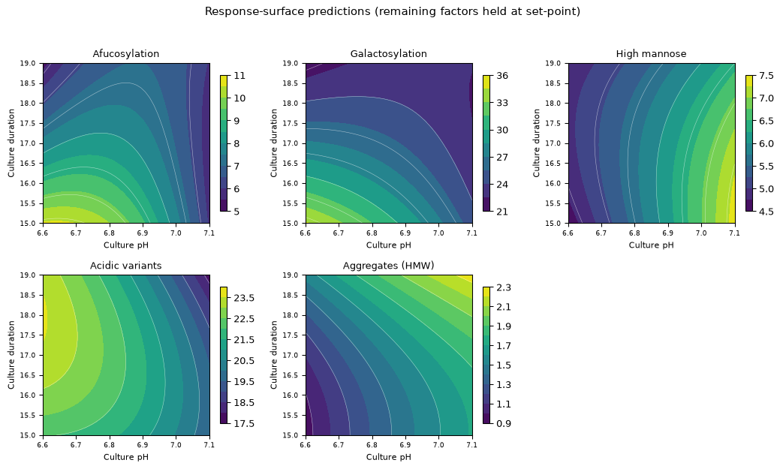
Figure 1: Response-surface predictions over culture pH and culture duration, with culture temperature and dissolved CO2 held at their set-points.
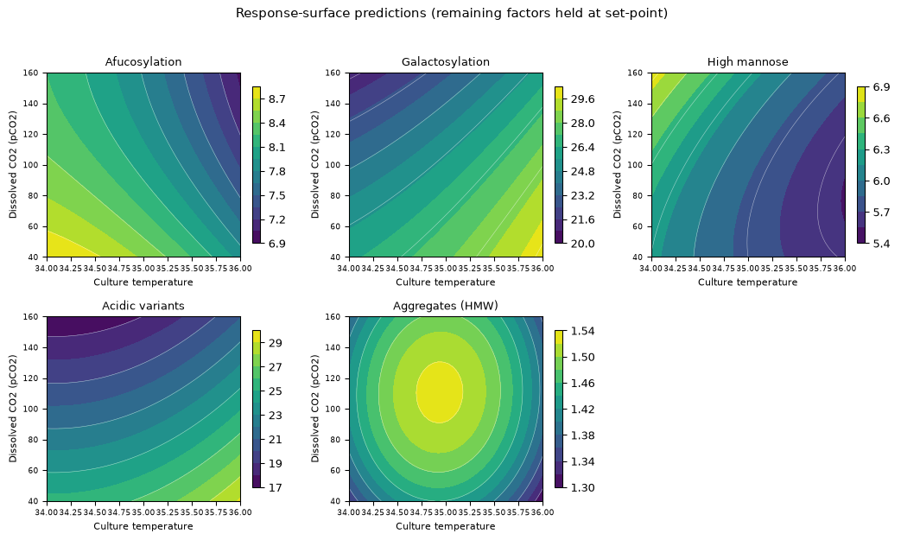
Figure 2: Response-surface predictions over culture temperature and dissolved CO2, with culture pH and culture duration held at their set-points.
The galactosylation panel of Figure 1 shows the twist directly, since the contours are not parallel to either axis and their slope with respect to duration changes with pH. The high mannose panel is close to a set of vertical bands, which is what a surface dominated by a single main effect (culture pH) looks like, and the aggregate panel rises monotonically towards high pH and long duration with no interior optimum.
Diagnostics for the two design-space attributes are given in Figure 3 and Figure 4.
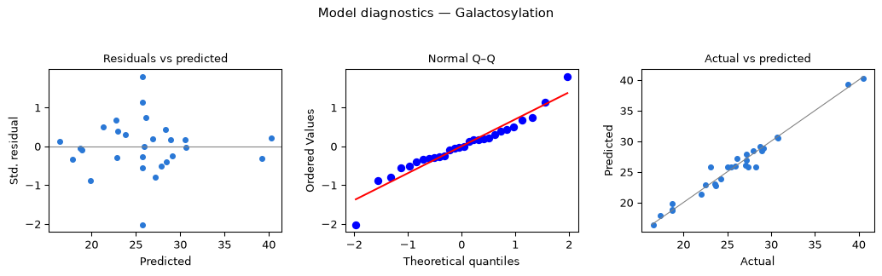
Figure 3: Model diagnostics for galactosylation: standardized residuals against predicted values, normal quantile plot, and actual against predicted.
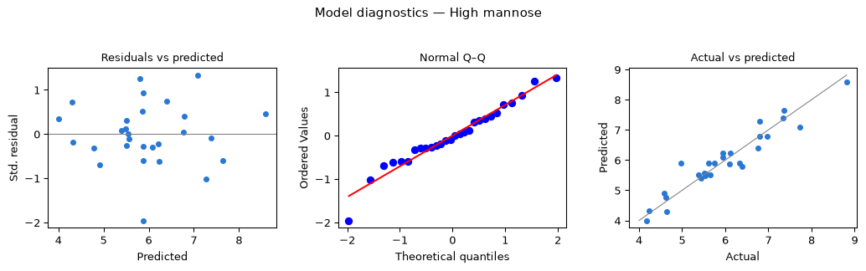
Figure 4: Model diagnostics for high mannose: standardized residuals against predicted values, normal quantile plot, and actual against predicted.
The residual plots show no structure against the predicted value and no funnel, the normal quantile plots are close to linear over the body of the distribution, and the actual against predicted plots scatter about the identity line without curvature. Taken with the lack-of-fit tests, this supports the quadratic model form for both attributes.
One reservation applies to Acidic variants, whose predicted coefficient of determination of 0.60 is the lowest of the 5 and whose residual standard error is 1.57 percentage points against a centre-point standard deviation of 0.88. That model is used in this report to describe the direction and approximate size of the effects on the attribute and to support its capability estimate, and it is not used to set a boundary of the operating region. It does not need to be, because the attribute stays far inside its acceptance limit everywhere in the characterized region.

5.4 Mechanistic interpretation
The surfaces are consistent with the mechanistic expectations set out earlier (§2.1), and the interactions have a common origin.
Galactosylation falls as the culture ages, as dissolved CO₂ rises and as culture pH rises, and all three act on the same enzymatic step, since galactose transfer in the Golgi requires both an active transferase and an adequate supply of its nucleotide sugar donor. Late in a fed-batch culture, viability falls, the donor pool contracts and ammonium accumulates. Elevated dissolved CO₂ lowers the pH of the Golgi lumen and moves the transferase away from its optimum, and a higher culture pH shifts the ammonium equilibrium towards free ammonia, which crosses membranes readily and raises lumenal pH with the same consequence. Raising temperature acts in the opposite direction by raising the transfer rate itself.
The strong pH by duration interaction follows from that shared mechanism, because two conditions that both restrict the same limited galactosylation capacity cannot each remove it in full. The effects are therefore sub-additive, and the fitted interaction coefficient of +2.72 has the sign that sub-additivity predicts, as does the pH by dissolved CO₂ interaction of +2.35. This is why the operating region for this attribute has to be defined multivariately: a set of one-dimensional ranges, each established with the other parameters at their set-points, would understate the joint effect at the corners of the region.
High mannose behaves differently, and its simplicity has the same explanation. It measures glycans that have escaped mannosidase trimming in the Golgi, and trimming is an enzymatic step whose rate depends on lumenal pH and on temperature but does not compete for a nucleotide sugar donor. Raising culture pH raises lumenal pH, slows trimming and leaves more untrimmed glycan, which is the positive pH coefficient of +1.09, while raising temperature raises the trimming rate and lowers the attribute. Neither culture duration nor dissolved CO₂ has a significant effect, which is consistent with a step limited by enzyme kinetics and not by substrate supply.
Afucosylation falls with culture duration because core fucosylation competes with secretion, so that as the culture progresses the intracellular donor pool for fucose builds up and a smaller fraction of antibody escapes the transferase. The pH by duration interaction of +1.32 is the same sub-additivity seen for galactosylation, acting on a different transferase.
Acidic charge variants respond most strongly to dissolved CO₂ and to culture pH, and both act on the extent of sialylation (the largest contributor to the acidic peak group in this platform) in the direction that a lower lumenal pH predicts for sialyltransferase activity. The temperature effect is of opposite sign and is consistent with a chemical contribution from deamidation, whose rate rises with temperature. The mechanistic reading of this attribute is provisional, and it is of little practical consequence for the reasons given in §5.2.
Aggregate rises with culture pH and with culture duration and with nothing else, and both effects act on the residence of secreted antibody in an ageing broth. A longer culture means a longer exposure of product to proteases and to the products of cell lysis. A higher culture pH moves the broth closer to the region where the net charge on the antibody, and hence the colloidal repulsion between molecules, is reduced. The absence of a dissolved CO₂ effect and of an osmolality effect is consistent with an assembly process governed by exposure time and by surface charge.

6. Design space
The design space for this step is the characterized region in the four response-surface factors (culture pH, culture temperature, culture duration and dissolved CO₂), with one corner excluded. Osmolality is held within its characterized range, and every other parameter of the step within the range given in Table 7. Within that region the fitted response-surface models predict mean attribute levels inside acceptance for all 5 responses.
The excluded corner is a galactosylation edge of failure, and it bounds the claim made above. Where culture pH is at 6.60, dissolved CO₂ at 40 mmHg and culture duration at 15 days, all three at their lower characterization edges, the model predicts galactosylation above its upper limit of 40 % once culture temperature reaches 35.8 °C. The exceedance grows to 0.27 percentage points at the extreme corner. The affected volume is small, since it requires three factors at an edge simultaneously and then occupies only the top 0.2 °C of the temperature range at that corner. The corner is nevertheless excluded, and movement into it would be a change requiring prior assessment.
The principal planes of the region are culture pH against culture duration and culture temperature against dissolved CO₂. The first plane carries the galactosylation and afucosylation twist described earlier (§5.4) as well as the aggregate gradient, and the second carries the acidic variant gradient and the temperature dependence of high mannose. Figure 1 and Figure 2 are the graphical form of the region on these two planes.
The worst case that the region must satisfy is not the same corner for every attribute. For galactosylation it is low pH with high temperature, short duration and low dissolved CO₂, which is the excluded corner, and for high mannose it is high pH with low temperature, where the predicted level reaches 8.60 % against an upper limit of 10 %. For aggregate it is high pH with long duration, where the predicted level reaches 2.26 % against a limit of 5 %. For afucosylation the binding case is the lower limit, and the minimum predicted level anywhere in the region is 2.93 % against a lower limit of 2 %. Each of these worst cases sits inside acceptance.
The normal operating ranges sit well inside the region, since over the whole normal operating box the model predicts galactosylation between 21.5 % and 31.8 % and high mannose between 5.18 % and 6.90 %. The nesting is the usual one, in that the normal operating range lies inside the design space, which in turn lies inside the characterized knowledge space (CMC Biotech Working Group 2009). Operation anywhere within the design space is not a change in the regulatory sense (International Council for Harmonisation 2009), although any planned move within it is still assessed and approved under the pharmaceutical quality system (International Council for Harmonisation 2008). Operation outside it requires a change to the filed process.
Three bounds apply to this claim. First, it holds only over the characterized ranges in Table 7, and the edges of failure outside those ranges were not located. Second, the surfaces predict mean levels, so at the boundary of the region the predicted mean sits on the limit and about half of the batches operated exactly there would be expected to exceed it. The assurance available for routine operation comes from the normal operating ranges and from the capability estimate (§8). It does not come from the boundary itself. Third, the claim rests on the scale-down model, whose warrant is stated above (§3.1), and it assumes that every parameter not carried into the design is held at the value stated in Table 7 and that medium and feed lots meet their release specifications.

7. Proven acceptable ranges
Every characterized range is a proven acceptable range for every attribute this step governs, under both of the analyses described below. This section states the acceptance basis, gives the computed ranges, and explains why that outcome does not make the design space redundant.
The acceptance criteria are the drug substance specifications for the attributes formed at this step, taken directly from the attribute register (Table 5), so no back-calculation is involved. A viral clearance attribute would require one, because its step-level criterion is the cumulative requirement less the clearance credited to the other steps, but this step claims no viral clearance and that case does not arise here.
Two analyses were run for each attribute and parameter pair. The first holds every other response-surface factor at its set-point and finds the contiguous range of the parameter over which the predicted level stays within acceptance. The second is a robustness analysis. It varies the other factors within their normal operating ranges by Monte-Carlo sampling of the fitted model, adds the model residual variation, and requires the 95 % predictive interval to stay within acceptance across the parameter range. The Monte-Carlo uses 2,000 draws at each of 81 grid points, with a fixed seed. The second analysis is the stricter of the two, and it is the reproducible default.
Table 22: Proven acceptable ranges for each governed quality attribute and each response-surface parameter, with the characterization range for comparison.
CQA | Parameter | Char. range | Unit | PAR (set-point) | PAR (NOR)
Afucosylation | Culture pH | 6.6–7.1 | pH | 6.6–7.1 | 6.6–7.1
Afucosylation | Culture temperature | 34–36 | °C | 34–36 | 34–36
Afucosylation | Culture duration | 15–19 | days | 15–19 | 15–19
Afucosylation | Dissolved CO2 (pCO2) | 40–160 | mmHg | 40–160 | 40–160
Galactosylation | Culture pH | 6.6–7.1 | pH | 6.6–7.1 | 6.6–7.1
Galactosylation | Culture temperature | 34–36 | °C | 34–36 | 34–36
Galactosylation | Culture duration | 15–19 | days | 15–19 | 15–19
Galactosylation | Dissolved CO2 (pCO2) | 40–160 | mmHg | 40–160 | 40–160
High mannose | Culture pH | 6.6–7.1 | pH | 6.6–7.1 | 6.6–7.1
High mannose | Culture temperature | 34–36 | °C | 34–36 | 34–36
High mannose | Culture duration | 15–19 | days | 15–19 | 15–19
High mannose | Dissolved CO2 (pCO2) | 40–160 | mmHg | 40–160 | 40–160
Acidic variants | Culture pH | 6.6–7.1 | pH | 6.6–7.1 | 6.6–7.1
Acidic variants | Culture temperature | 34–36 | °C | 34–36 | 34–36
Acidic variants | Culture duration | 15–19 | days | 15–19 | 15–19
Acidic variants | Dissolved CO2 (pCO2) | 40–160 | mmHg | 40–160 | 40–160
Aggregates (HMW) | Culture pH | 6.6–7.1 | pH | 6.6–7.1 | 6.6–7.1
Aggregates (HMW) | Culture temperature | 34–36 | °C | 34–36 | 34–36
Aggregates (HMW) | Culture duration | 15–19 | days | 15–19 | 15–19
Aggregates (HMW) | Dissolved CO2 (pCO2) | 40–160 | mmHg | 40–160 | 40–160

Table 22 gives all 20 combinations of the 5 governed attributes and the 4 response-surface parameters, and in every row the proven acceptable range equals the characterization range. That holds for all 20 rows under the at set-point analysis and for all 20 rows under the NOR-propagated analysis. No parameter has a narrower proven acceptable range than the range over which it was studied, and no attribute binds a parameter before the edge of the knowledge space is reached.
Figures Figure 5 to Figure 9 give the representative plot for each governed attribute against its governing parameter, which is the response-surface factor with the largest main effect on that attribute. Each figure has two panels, the left being the at set-point analysis and the right the NOR-propagated analysis, with the acceptable region shaded and the set-point and normal operating range marked.
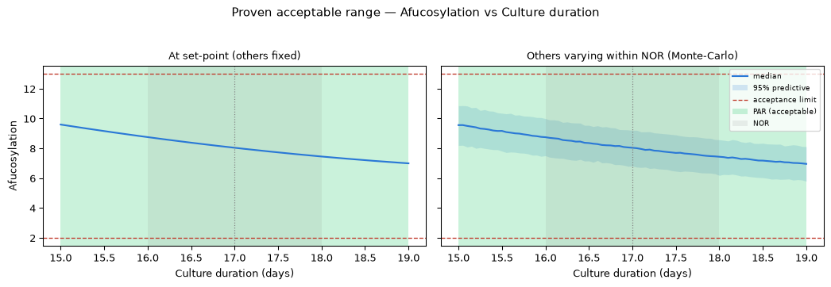
Figure 5: Proven acceptable range for afucosylation against its governing parameter.
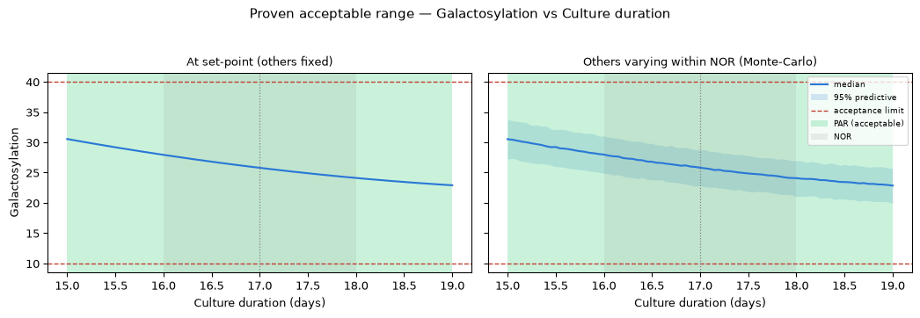
Figure 6: Proven acceptable range for galactosylation against its governing parameter.
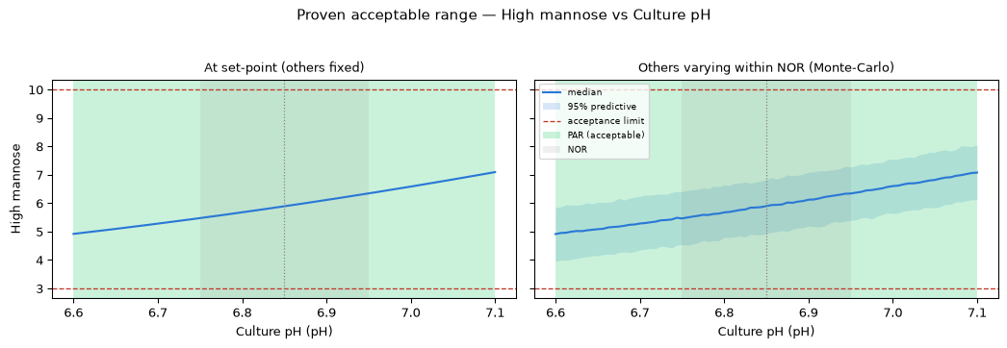
Figure 7: Proven acceptable range for high mannose against its governing parameter.
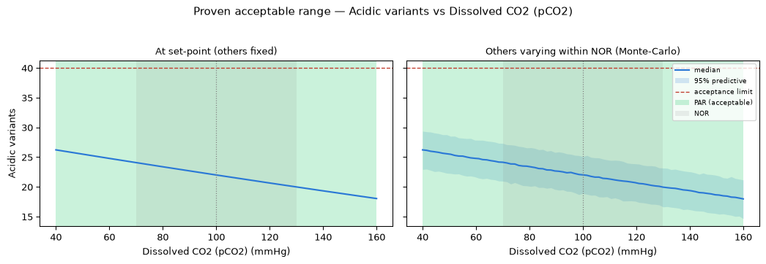
Figure 8: Proven acceptable range for acidic charge variants against its governing parameter.
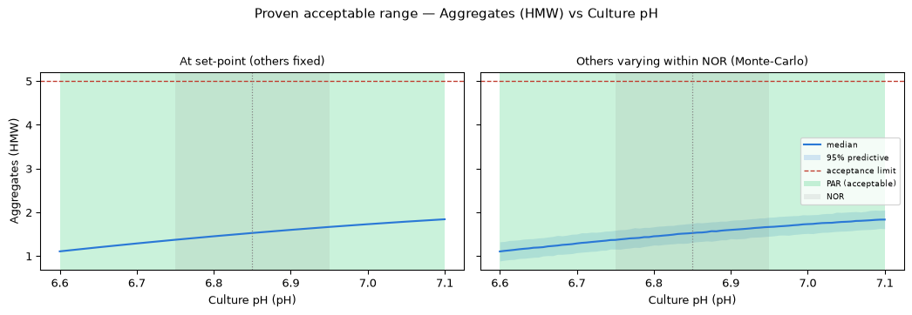
Figure 9: Proven acceptable range for aggregate against its governing parameter.
The plots show how much margin sits behind that result. For high mannose against culture pH the predicted level stays between 3.99 % and 8.60 % across the whole characterized region, against limits of 3 % and 10 %. For aggregate against culture pH the predicted level does not exceed 2.26 % anywhere, against a limit of 5 %. The predictive interval in the right-hand panels widens the band but does not reach a limit in any case.
The relationship between these ranges and the design space needs to be explicit. A proven acceptable range is a statement about one parameter, with the at set-point form holding the others fixed and the NOR-propagated form letting them move only within their normal operating ranges. The design space is a statement about all 4 parameters at once, and it allows each of them to reach its characterization edge. The galactosylation corner identified above (§6) therefore lies outside the reach of either proven acceptable range analysis, because it requires three parameters at an edge simultaneously. Where the whole characterization range is a proven acceptable range, as it is here, the binding constraint on the operating region is the multivariate corner and not any univariate range. Both statements are bounded by the characterization ranges in Table 7 and by the fitted model, and neither extends beyond them.

8. Process capability and robustness
The step meets its acceptance criteria at commercial scale with margin on every attribute it forms. Capability was estimated by simulating 2,000 batches with each parameter drawn independently within its normal operating range and propagating the fitted response-surface models and their residual variation, and the outcome is given in Table 23.
Table 23: Simulated commercial-scale capability for the attributes formed at this step.
CQA | Crit. | Spec | Acceptance | Mean ± SD | Cpk
Afucosylation | H | two_sided | 2–13 | 7.98 ± 0.58 | 2.89
Galactosylation (total %Gal) | H | two_sided | 10–40 | 26 ± 1.6 | 2.86
High Mannose | VH | two_sided | 3–10 | 5.99 ± 0.51 | 1.94
Aggregates (HMW) | H | upper | 0–5 | 0.753 ± 0.088 | 16.1
Acidic charge variants (deamidation) | VL | upper | 18–40 | 22.3 ± 1.4 | 4.26

High Mannose is the tightest of the 5 at 1.94, with a simulated mean of 5.99 % that sits 2.99 percentage points above the lower limit (the binding one) and 4.01 points below the upper limit. The highest simulated batch reached 7.98 % and the lowest 4.28 %, so no simulated batch came within a percentage point of either limit. Afucosylation and galactosylation follow at 2.89 and 2.86, and Aggregates (HMW) is the widest at 16.1, which reflects an upper limit of 5 % against a simulated mean of only 0.75 %. Acidic charge variants reach 4.26 against their upper limit, which is the practical-significance point made in §5.2 expressed as a capability.
Two of these capabilities are not this step’s alone. The aggregate figure is a drug substance figure, and the drug substance mean of 0.75 % is well below the harvest centre-point mean of 1.51 % measured here, the difference being the cation exchange polish characterized in PCR-007. This step supplies a low and stable aggregate input, and it does not on its own deliver the drug substance figure. The glycan and charge variant attributes are different, because they are not modified by the platform purification train, so their drug substance capability is set at this step. The agreement between the harvest centre-point means in Table 9 and the simulated drug substance means in Table 23 is the evidence for that.
Host cell protein and residual DNA are generated here and reach specification only after downstream clearance, and their capability is given in Table 24 for completeness.
Table 24: Simulated commercial-scale capability for the impurities generated at this step and cleared downstream.
CQA | Crit. | Spec | Acceptance | Mean ± SD | Cpk
Host Cell Protein (HCP) | M-H | upper | 0–100 | 15.2 ± 4.6 | 6.14
Residual DNA | VL | upper | 0–0.001 | 0.0001 ± 0 | 10.8

The credit for those two figures belongs to Protein A chromatography, cation exchange and anion exchange, and it is claimed in PCR-005, PCR-007 and PCR-008. What this step contributes is a bounded and predictable input, since culture duration is the parameter that raises the harvest burden of both impurities and it is controlled within the range given in Table 7.
The tightest capability of the drug substance process as a whole is 1.51 and belongs to a viral clearance attribute set at another step, so nothing formed at the production bioreactor is the limiting capability of the process. All capability figures here are bounded in two ways: they assume operation within the normal operating ranges of Table 7, and they inherit the scale-down warrant of §3.1. They are model-based estimates and not a substitute for the process performance qualification campaign of 5 batches.

9. Parameter classification
Every parameter of the step is classified in Table 7, and the evidence for each classification is given below. A parameter whose variability affects a critical quality attribute is a critical process parameter (CPP). Where the risk of leaving the design space is low, because the parameter is easy to control and the region around it is wide, it is classified as well controlled (WC-CPP) (CMC Biotech Working Group 2009). A parameter that affects process performance but not product quality is a key process parameter (KPP), and a parameter that affects neither is a general process parameter (GPP).
Culture pH is a WC-CPP, since it is the dominant parameter for high mannose and for aggregate and is active for every other response. It is classified as well controlled because the commercial vessel holds it within a normal operating range of 6.75 to 6.95 (a small part of the characterized range) and because every attribute is in specification across the whole of that range.
Culture temperature is a WC-CPP, since it is active for high mannose, galactosylation and acidic variants and it participates in the galactosylation corner identified in §6. It is classified as well controlled because jacket control holds it within 34.5 to 35.5 °C without difficulty.
Dissolved CO₂ is a WC-CPP, since it carries the largest effect on acidic variants and a large effect on galactosylation. It is the least directly controlled of the quality-linked parameters, because it is governed by the sparge and overlay strategy and by scale, and its characterized range is correspondingly wide at 2.0 times its normal operating range. Since the whole of that range is a proven acceptable range for every attribute (§7), it is classified as well controlled on that basis and not on ease of control alone.
Osmolality is a WC-CPP, since it showed a significant effect on acidic variants and on galactosylation in screening. It was not carried into the response-surface design because those effects were smaller than those of the four retained factors, and its range is supported by the screening result over 360 to 440 mOsm. It is classified as quality-linked and well controlled, because the feed strategy holds it within 375 to 425 mOsm.
Culture duration is a WC-CPP, since it carries the largest single effect measured in this study (on galactosylation), is also active for afucosylation and aggregate, and raises the harvest impurity burden. It is classified as well controlled because harvest is a scheduled event and the operating range of 16 to 18 days is held by the batch record.
Dissolved oxygen is a KPP, because prior platform work links it to specific productivity and to titre and not to any attribute formed here, and it was held at set-point in the designs reported above. It is monitored and controlled because process consistency depends on it.
Initial viable cell concentration is a KPP, because the univariate assessment described in §4.4 found its effect to be on the growth trajectory, on the integral of viable cell concentration and on titre, and not on any quality attribute of this step. The supporting data are held in the study record for PCP-003.
Nutrient feed volume is a KPP, because it governs nutrient sufficiency through the production phase and hence titre, and its quality-relevant effect is indirect, through osmolality and culture duration, both of which are controlled parameters in their own right. The deviation reported in §13.2 provides direct evidence that a small under-delivery does not move the attributes formed here.
Basal medium concentration is a GPP, because platform multivariate work found no link to a quality attribute of this step and no appreciable link to process performance within the range carried forward. It is controlled as a released material attribute under SOP-2004.
5 of the 9 parameters are quality-linked, and all 5 are well controlled. No parameter of this step is classified CPP. The process as a whole carries 1 CPP, and it is not at this step. The classification rules and the decision logic are given in SOP-4001.

10. Contribution to the control strategy
The production bioreactor contributes four things to the control strategy for A-Mab drug substance.
The first is parameter control. The 5 quality-linked parameters are held within the normal operating ranges of Table 7, all of which lie inside the design space of §6 and inside the proven acceptable ranges of §7. Culture pH, temperature and dissolved oxygen are held by closed-loop control, and dissolved CO₂ is held by the sparge and overlay strategy and monitored in process. Osmolality is held by the feed strategy and verified on the harvest sample, and culture duration is held by the batch record.
The second is in-process monitoring. Viable cell density, viability, metabolites and dissolved CO₂ are trended through the culture, and the harvest sample is tested for the attributes formed at the step. Trending gives early detection of a culture drifting towards an edge of the region, which is the practical use of the mechanistic interpretation in §5.4.
The third is input control. Basal medium and nutrient feed are released against their own specifications under SOP-2004, and the nutrient feed deviation reported in §13.2 led to a tightened verification of feed pump calibration before each characterization campaign, which is carried forward as a routine control.
The fourth is lifecycle control. The ranges justified here are the input to the process performance qualification campaign of 5 batches, the attributes formed here are on the continued process verification plan, and movement within the design space is assessed under the quality system before it is made (International Council for Harmonisation 2008).
Two limits on this contribution need stating. The step does not control host cell protein or residual DNA at drug substance level; it sets their input burden, and the three chromatography steps clear them, as reported in PCR-005, PCR-007 and PCR-008. The step also makes no contribution to viral safety, since clearance of enveloped and non-enveloped virus is claimed at low-pH inactivation, anion exchange and virus filtration, and the cumulative claim is consolidated in PCMR-001.

11. Discussion
The step is understood well enough to support a design space claim, and the evidence for that statement is the combination of a resolved factor set, a predictive model and a wide capability margin. The screening design separated active from inactive factors over ranges two to three times the routine control ranges. The response-surface design then gave models with adjusted coefficients of determination at or above 0.81, no significant lack of fit and predicted coefficients of determination above 0.60. The capability simulation puts the tightest attribute at 1.94.
The mechanistic picture is coherent, and it is what gives confidence that the model will hold at scale. Three of the 5 attributes are governed by the pH and temperature of the Golgi lumen, and their interactions are the sub-additivity expected when two conditions restrict the same enzymatic capacity, while the two remaining attributes are governed by residence time in an ageing broth. Neither picture requires an effect that the scale-down model cannot reproduce, because both depend on the controlled culture environment and not on vessel geometry.
Confidence in the scale-down model is nonetheless bounded. The model was qualified against commercial-equivalent performance at target conditions, and its centre points reproduce that condition with coefficients of variation between 4.1 % and 9.9 %, but it was not qualified at the edges of the characterized ranges. That is a general limitation of design space claims and is stated as such here. Dissolved CO₂ is the parameter where the limitation bites hardest, because stripping does not scale, and that is why it was carried as an independent factor and not allowed to float.
Two deviations occurred and both were retained. Their combined effect on the reported analysis is smaller than the centre-point variability of the affected responses, and neither changed a classification, a range or a boundary; §13 gives the argument in full. The more instructive of the two is the nutrient feed under-delivery, because it produced a direct experimental check of a parameter that had been assigned to the knowledge space rather than to the designed experiment.
Three limitations remain, and each has a forward control. First, the design space is not confirmed at scale at the edges of the ranges, and the process performance qualification campaign will operate at target. Second, the model for acidic charge variants is the weakest of the 5, with a predicted coefficient of determination of 0.60, and it is used descriptively and not as a boundary. Third, the study assumes medium and feed lots that meet their release specifications, so lot-to-lot variability is controlled by material specification and not by this design space.
No parameter of this step required the most stringent control. All 5 quality-linked parameters are well controlled, because each is held by an established control loop or by the batch record and because every attribute stays in specification across the whole of each characterized range.

12. Conclusions
The production bioreactor is well characterized and robust over the ranges studied. A response-surface model in culture pH, culture temperature, culture duration and dissolved CO₂ defines an operating region within which afucosylation, galactosylation, high mannose, acidic charge variants and aggregate all remain within their acceptance limits. One corner of the characterized region is excluded, where three factors sit at a lower edge and culture temperature is at or above 35.8 °C, and the maximum predicted exceedance there is 0.27 percentage points of galactosylation.
Every characterized range is a proven acceptable range for every attribute the step governs, under both the at set-point and the NOR-propagated analyses, so the binding constraint on the operating region is the multivariate corner and not any univariate range.
9 parameters were classified, of which 5 are WC-CPP, 3 are KPP and 1 is a GPP, and no parameter required CPP control. At commercial scale, simulated over 2,000 batches within the normal operating ranges, the tightest capability at this step is High Mannose at 1.94, which is above the tightest capability of the drug substance process as a whole (1.51).
2 deviations were recorded, investigated and retained, and neither altered a parameter classification, a range or the boundary of the operating region.
The step claims no viral clearance and does not by itself deliver the drug substance specification for host cell protein, residual DNA or aggregate, since those attributes depend on downstream clearance and polishing. The results of this report roll up into the master report (PCMR-001).

13. Deviations from the plan
2 deviations from PCP-003 were recorded during execution, and each was investigated, assigned a root cause, impact-assessed and dispositioned. Both were retained, which means that the affected run and its data were kept in the reported analysis, and the register is given in Table 25.
Table 25: Deviation register for this report.
Deviation | Summary | Detected during | Disposition
DEV-003-01 | Dissolved-CO2 probe drift during screening run 4 | in-process monitoring vs offline reference | retained
DEV-003-02 | Nutrient feed-1 under-delivery on a centre-point batch | post-execution mass reconciliation | retained

Both deviations were detected by a routine control and not by inspection of the results, the first by comparing the in-process probe against an offline reference and the second by mass reconciliation after execution. Neither was found because a result looked wrong, which is what allows the impact to be assessed independently of the analysis.

13.1 DEV-003-01: dissolved CO₂ probe drift during a screening run
The dissolved CO₂ probe on the scale-down bioreactor read 6.5 mmHg below the offline reference during screening run 4. The offset is 11 % of the width of the normal operating range for the parameter, so the actual culture pCO₂ during that run was above its intended set-point by that amount.
The investigation traced the offset to drift of the probe between scheduled calibrations. The equipment record for EQ-BRX-205 shows the unit in calibration at execution, with the next calibration due 2026-06-14, and the offline reference method (the qualified comparator) was used to establish the magnitude of the offset. No other run in either design used the affected probe outside its calibration interval.
The impact assessment is bounded by the size of the offset in coded units. Since the characterized range for dissolved CO₂ spans 40 to 160 mmHg, the offset is 0.108 in coded units, and multiplying that displacement by the screening coefficient for dissolved CO₂ gives the largest bias the offset can introduce. For acidic charge variants, the response most sensitive to dissolved CO₂, the bias is 0.44 percentage points against a screening centre-point standard deviation of 1.09 points, and for galactosylation it is 0.31 points against a centre-point standard deviation of 0.48 points. In both cases the bias is below the reproducibility of the measurement it would perturb.
The run was retained on that basis, since the actual pCO₂ during the run remained inside the characterized range and the run therefore remains a valid point of the knowledge space. The screening design is used in this report to rank active factors and not to predict (§5.2), and a displacement of this size does not change the rank order of any effect. Dissolved CO₂ was carried into the response-surface design, which was executed after the probe was recalibrated, and the design space rests on that model.

13.2 DEV-003-02: nutrient feed under-delivery on a centre-point batch
The nutrient feed was under-delivered by 4.2 % of the scheduled volume on one screening centre-point batch, so that the delivered volume was 11.50 % of working volume against a set-point of 12 %. This is a deviation from the planned centre-point condition, and it affects a replicate that contributes to the pure-error estimate.
The investigation traced the shortfall to a calibration offset on the feed pump. The feed material was LOT-FED-3120, within its expiry of 2026-09-30, and the lot itself met its release specification, and the pump was recalibrated before the response-surface design was executed.
The delivered volume remains inside the normal operating range of 10 to 14 % of working volume, so the batch remains a valid centre point and it was retained. The glycan attributes of the affected batch were re-assayed in 3 replicates under AMV-3010, whose intermediate precision is 2.5 % RSD, and the relative half-width of the 95 % confidence interval on that verification set is 6.21 %. The verification mean agreed with the other centre points within that interval.
Two consequences follow. The screening centre-point variability is not inflated relative to the response-surface centre points, as Table 10 and Table 9 show and as §5.1 discusses, and the design space rests on the response-surface model, whose 4 centre points were executed after the pump was recalibrated and were unaffected. The deviation also produced useful evidence, because nutrient feed volume had been assigned to the knowledge space rather than to the designed experiment, and a shortfall of this size produced no detectable movement in the attributes formed at the step. That supports its classification as a key process parameter (§9).

14. Appendices A–D
The appendices carry the executed design matrices, the complete effect and coefficient tables, and the analytical method summary. Each table is emitted from the same data set as the corresponding section of the report.

14.1 Appendix A — Screening design matrix and responses
The coded screening design and the measured responses are given in Table 26. Factor letters are as defined in Table 8. The coded settings of −1 and +1 denote the edges of the characterized range and 0 denotes the set-point.
Table 26: Executed screening design in coded units, with measured responses.
Run | Type | A | B | C | D | E | Afucosylation | Galactosylation | High mannose | Acidic variants | Aggregates (HMW)
1 | factorial | -1 | -1 | -1 | -1 | 1 | 5.182 | 27.91 | 6.605 | 26.4 | 1.297
2 | factorial | -1 | -1 | -1 | 1 | -1 | 8.929 | 36.11 | 6.436 | 26.46 | 0.7833
3 | factorial | -1 | -1 | 1 | -1 | -1 | 11.76 | 34.61 | 5.629 | 22.27 | 0.7852
4 | factorial | -1 | -1 | 1 | 1 | 1 | 4.825 | 14.74 | 5.459 | 17.89 | 1.477
5 | factorial | -1 | 1 | -1 | -1 | -1 | 9.718 | 41.37 | 4.605 | 26.98 | 0.8589
6 | factorial | -1 | 1 | -1 | 1 | 1 | 4.683 | 27.29 | 4.683 | 27.6 | 1.263
7 | factorial | -1 | 1 | 1 | -1 | 1 | 6.218 | 14.52 | 4.649 | 23.1 | 1.483
8 | factorial | -1 | 1 | 1 | 1 | -1 | 9.827 | 31.24 | 4.451 | 19.27 | 0.9484
9 | factorial | 1 | -1 | -1 | -1 | -1 | 9.611 | 28.02 | 7.769 | 24.09 | 1.512
10 | factorial | 1 | -1 | -1 | 1 | 1 | 7.513 | 16.97 | 7.887 | 20.38 | 2.257
11 | factorial | 1 | -1 | 1 | -1 | 1 | 7.127 | 19.45 | 7.34 | 12.63 | 2.535
12 | factorial | 1 | -1 | 1 | 1 | -1 | 5.29 | 17.57 | 7.009 | 11.31 | 1.611
13 | factorial | 1 | 1 | -1 | -1 | 1 | 6.743 | 28.32 | 6.426 | 29.61 | 2.176
14 | factorial | 1 | 1 | -1 | 1 | -1 | 5.405 | 26.73 | 5.937 | 24.39 | 1.619
15 | factorial | 1 | 1 | 1 | -1 | -1 | 3.82 | 25.17 | 6.097 | 18.43 | 1.803
16 | factorial | 1 | 1 | 1 | 1 | 1 | 3.079 | 29.09 | 6.149 | 15.78 | 2.053
17 | center | 0 | 0 | 0 | 0 | 0 | 7.796 | 26.41 | 5.884 | 21.95 | 1.639
18 | center | 0 | 0 | 0 | 0 | 0 | 7.505 | 27.37 | 5.84 | 20.01 | 1.626
19 | center | 0 | 0 | 0 | 0 | 0 | 8.482 | 26.98 | 7.11 | 21.84 | 1.503

14.2 Appendix B — Response-surface design matrix and responses
The coded response-surface design and the measured responses are given in Table 27.
Table 27: Executed response-surface design in coded units, with measured responses.
Run | Type | A | B | E | C | Afucosylation | Galactosylation | High mannose | Acidic variants | Aggregates (HMW)
1 | factorial | -1 | -1 | -1 | -1 | 9.431 | 38.79 | 5.439 | 29.83 | 0.8269
2 | factorial | -1 | -1 | -1 | 1 | 11.78 | 28.95 | 5.552 | 17.64 | 0.7906
3 | factorial | -1 | -1 | 1 | -1 | 4.496 | 25.89 | 5.653 | 25.13 | 1.329
4 | factorial | -1 | -1 | 1 | 1 | 5.382 | 16.56 | 5.378 | 20.04 | 1.372
5 | factorial | -1 | 1 | -1 | -1 | 10.39 | 40.54 | 4.228 | 25.59 | 0.8029
6 | factorial | -1 | 1 | -1 | 1 | 10.14 | 30.66 | 4.17 | 19.77 | 0.7071
7 | factorial | -1 | 1 | 1 | -1 | 5.118 | 27.12 | 4.627 | 30.28 | 1.242
8 | factorial | -1 | 1 | 1 | 1 | 6.134 | 17.38 | 4.641 | 21.75 | 1.414
9 | factorial | 1 | -1 | -1 | -1 | 8.924 | 22 | 6.792 | 22.91 | 1.503
10 | factorial | 1 | -1 | -1 | 1 | 5.886 | 18.67 | 8.81 | 13.6 | 1.528
11 | factorial | 1 | -1 | 1 | -1 | 8.051 | 18.74 | 6.115 | 19.27 | 1.993
12 | factorial | 1 | -1 | 1 | 1 | 5.165 | 18.7 | 7.338 | 12.34 | 2.155
13 | factorial | 1 | 1 | -1 | -1 | 5.41 | 28.74 | 6.971 | 28.53 | 1.45
14 | factorial | 1 | 1 | -1 | 1 | 2.836 | 29.12 | 7.356 | 18.52 | 1.699
15 | factorial | 1 | 1 | 1 | -1 | 6.203 | 25.4 | 5.947 | 26.49 | 2.079
16 | factorial | 1 | 1 | 1 | 1 | 4.19 | 27.15 | 6.8 | 17.15 | 2.012
17 | axial | -1 | 0 | 0 | 0 | 7.82 | 26.08 | 4.585 | 24.2 | 1.148
18 | axial | 1 | 0 | 0 | 0 | 6.073 | 23.66 | 7.719 | 19.27 | 1.816
19 | axial | 0 | -1 | 0 | 0 | 8.771 | 24.26 | 6.754 | 19.94 | 1.512
20 | axial | 0 | 1 | 0 | 0 | 7.551 | 27.91 | 5.506 | 26.75 | 1.321
21 | axial | 0 | 0 | -1 | 0 | 10.26 | 30.77 | 6.106 | 20.75 | 1.298
22 | axial | 0 | 0 | 1 | 0 | 6.891 | 22.52 | 5.537 | 22.45 | 2.059
23 | axial | 0 | 0 | 0 | -1 | 8.482 | 27.14 | 6.389 | 25.66 | 1.496
24 | axial | 0 | 0 | 0 | 1 | 8.388 | 23.53 | 5.937 | 19.23 | 1.449
25 | center | 0 | 0 | 0 | 0 | 7.878 | 23.04 | 5.753 | 20.48 | 1.516
26 | center | 0 | 0 | 0 | 0 | 7.954 | 27.33 | 6.324 | 22.04 | 1.6
27 | center | 0 | 0 | 0 | 0 | 7.347 | 25.03 | 5.605 | 22.39 | 1.547
28 | center | 0 | 0 | 0 | 0 | 7.267 | 28.23 | 4.963 | 21.08 | 1.37

14.3 Appendix C — Full effect and coefficient tables
The complete screening effect tables for all five responses are given in Table 28 to Table 32. Each lists every main effect and every two-factor interaction in order of absolute effect size.
Table 28: Complete screening effects, afucosylation.
Term | Effect | Coef. | Std. err. | t | p-value | Sig.
AE | 2.458 | 1.229 | 0.2659 | 4.621 | 0.01907 | *
E | -2.374 | -1.187 | 0.2659 | -4.464 | 0.02094 | *
AC | -1.759 | -0.8796 | 0.2659 | -3.308 | 0.04545 | *
A | -1.569 | -0.7847 | 0.2659 | -2.951 | 0.05997
B | -1.343 | -0.6715 | 0.2659 | -2.525 | 0.08578
D | -1.329 | -0.6643 | 0.2659 | -2.498 | 0.08783
AB | -1.28 | -0.6402 | 0.2659 | -2.408 | 0.09522
C | -0.7296 | -0.3648 | 0.2659 | -1.372 | 0.2637
BD | 0.4521 | 0.2261 | 0.2659 | 0.8502 | 0.4577
BE | 0.362 | 0.181 | 0.2659 | 0.6807 | 0.5449
AD | -0.1751 | -0.08757 | 0.2659 | -0.3294 | 0.7635
BC | -0.1713 | -0.08565 | 0.2659 | -0.3221 | 0.7685
CD | -0.1472 | -0.0736 | 0.2659 | -0.2768 | 0.7999
DE | 0.03583 | 0.01791 | 0.2659 | 0.06737 | 0.9505
CE | 0.01181 | 0.005907 | 0.2659 | 0.02222 | 0.9837

Table 29: Complete screening effects, galactosylation.
Term | Effect | Coef. | Std. err. | t | p-value | Sig.
E | -7.816 | -3.908 | 0.1932 | -20.23 | 0.0002641 | ***
AE | 6.903 | 3.451 | 0.1932 | 17.87 | 0.0003824 | ***
C | -5.793 | -2.897 | 0.1932 | -14.99 | 0.0006438 | ***
A | -4.556 | -2.278 | 0.1932 | -11.79 | 0.001311 | **
BD | 3.696 | 1.848 | 0.1932 | 9.567 | 0.002423 | **
AC | 3.601 | 1.801 | 0.1932 | 9.321 | 0.002615 | **
B | 3.544 | 1.772 | 0.1932 | 9.173 | 0.002739 | **
AB | 3.279 | 1.64 | 0.1932 | 8.488 | 0.003434 | **
D | -2.454 | -1.227 | 0.1932 | -6.351 | 0.007896 | **
CD | 2.178 | 1.089 | 0.1932 | 5.638 | 0.01104 | *
DE | 1.926 | 0.9629 | 0.1932 | 4.984 | 0.01553 | *
BE | 1.494 | 0.7471 | 0.1932 | 3.867 | 0.03058 | *
AD | -0.1947 | -0.09737 | 0.1932 | -0.5041 | 0.6489
BC | -0.1313 | -0.06566 | 0.1932 | -0.3399 | 0.7564
CE | 0.1192 | 0.0596 | 0.1932 | 0.3085 | 0.7779

Table 30: Complete screening effects, high mannose.
Term | Effect | Coef. | Std. err. | t | p-value | Sig.
A | 1.512 | 0.756 | 0.1547 | 4.887 | 0.01638 | *
B | -1.392 | -0.696 | 0.1547 | -4.499 | 0.0205 | *
C | -0.4459 | -0.2229 | 0.1547 | -1.441 | 0.2452
BC | 0.3693 | 0.1847 | 0.1547 | 1.194 | 0.3184
E | 0.1581 | 0.07907 | 0.1547 | 0.5111 | 0.6445
D | -0.1386 | -0.06929 | 0.1547 | -0.4479 | 0.6846
AC | 0.08973 | 0.04487 | 0.1547 | 0.29 | 0.7907
AE | 0.08935 | 0.04468 | 0.1547 | 0.2888 | 0.7915
DE | -0.0718 | -0.0359 | 0.1547 | -0.2321 | 0.8314
CE | -0.05525 | -0.02762 | 0.1547 | -0.1786 | 0.8697
BE | 0.04598 | 0.02299 | 0.1547 | 0.1486 | 0.8913
AB | 0.04317 | 0.02159 | 0.1547 | 0.1395 | 0.8979
AD | -0.02395 | -0.01197 | 0.1547 | -0.0774 | 0.9432
CD | -0.02321 | -0.01161 | 0.1547 | -0.07503 | 0.9449
BD | -0.0005759 | -0.000288 | 0.1547 | -0.001861 | 0.9986

Table 31: Complete screening effects, acidic charge variants.
Term | Effect | Coef. | Std. err. | t | p-value | Sig.
C | -8.154 | -4.077 | 0.2394 | -17.03 | 0.0004408 | ***
A | -4.166 | -2.083 | 0.2394 | -8.702 | 0.003194 | **
B | 2.965 | 1.483 | 0.2394 | 6.194 | 0.008478 | **
D | -2.555 | -1.277 | 0.2394 | -5.337 | 0.01286 | *
AB | 1.985 | 0.9924 | 0.2394 | 4.146 | 0.02549 | *
AC | -1.927 | -0.9636 | 0.2394 | -4.026 | 0.02754 | *
BE | 1.73 | 0.8649 | 0.2394 | 3.613 | 0.03642 | *
AD | -0.6694 | -0.3347 | 0.2394 | -1.398 | 0.2565
CE | -0.4935 | -0.2468 | 0.2394 | -1.031 | 0.3784
CD | -0.4923 | -0.2462 | 0.2394 | -1.028 | 0.3794
BD | -0.2152 | -0.1076 | 0.2394 | -0.4495 | 0.6836
BC | 0.1514 | 0.07569 | 0.2394 | 0.3162 | 0.7726
DE | 0.03237 | 0.01619 | 0.2394 | 0.06762 | 0.9503
E | 0.02345 | 0.01173 | 0.2394 | 0.04899 | 0.964
AE | 0.02259 | 0.01129 | 0.2394 | 0.04718 | 0.9653

Table 32: Complete screening effects, aggregate.
Term | Effect | Coef. | Std. err. | t | p-value | Sig.
A | 0.8339 | 0.4169 | 0.02072 | 20.12 | 0.0002683 | ***
E | 0.5776 | 0.2888 | 0.02072 | 13.94 | 0.0007997 | ***
BE | -0.141 | -0.07048 | 0.02072 | -3.401 | 0.04242 | *
C | 0.116 | 0.05802 | 0.02072 | 2.8 | 0.06784
CD | -0.07417 | -0.03709 | 0.02072 | -1.79 | 0.1714
AD | -0.06662 | -0.03331 | 0.02072 | -1.608 | 0.2063
AB | -0.05933 | -0.02967 | 0.02072 | -1.432 | 0.2476
DE | -0.05539 | -0.0277 | 0.02072 | -1.337 | 0.2737
D | -0.05479 | -0.0274 | 0.02072 | -1.322 | 0.2779
BD | -0.05474 | -0.02737 | 0.02072 | -1.321 | 0.2782
AE | 0.04159 | 0.02079 | 0.02072 | 1.004 | 0.3896
BC | -0.02351 | -0.01175 | 0.02072 | -0.5672 | 0.6102
CE | 0.02224 | 0.01112 | 0.02072 | 0.5366 | 0.6288
B | -0.006713 | -0.003356 | 0.02072 | -0.162 | 0.8816
AC | -0.006631 | -0.003315 | 0.02072 | -0.16 | 0.883

The response-surface coefficient tables for the three responses not shown in §5.3 are given in Table 33 to Table 35, and the corresponding analysis of variance partitions in Table 36 to Table 38.
Table 33: Response-surface coefficients, afucosylation.
Term | Coef. | Std. err. | t | p-value | Sig.
Intercept | 8.035 | 0.202 | 39.79 | 5.742e-15 | ***
A | -0.9971 | 0.1377 | -7.243 | 6.522e-06 | ***
B | -0.5507 | 0.1377 | -4 | 0.001512 | **
E | -1.301 | 0.1377 | -9.452 | 3.446e-07 | ***
C | -0.3669 | 0.1377 | -2.665 | 0.01944 | *
AB | -0.6303 | 0.146 | -4.317 | 0.0008373 | ***
AE | 1.323 | 0.146 | 9.058 | 5.602e-07 | ***
AC | -0.907 | 0.146 | -6.211 | 3.161e-05 | ***
BE | 0.362 | 0.146 | 2.479 | 0.02766 | *
BC | -0.0703 | 0.146 | -0.4815 | 0.6382
EC | 0.0322 | 0.146 | 0.2205 | 0.8289
A² | -1.371 | 0.3637 | -3.771 | 0.002334 | **
B² | -0.1569 | 0.3637 | -0.4314 | 0.6732
E² | 0.2565 | 0.3637 | 0.7054 | 0.493
C² | 0.1173 | 0.3637 | 0.3226 | 0.7522

Table 34: Response-surface coefficients, acidic charge variants.
Term | Coef. | Std. err. | t | p-value | Sig.
Intercept | 21.99 | 0.5416 | 40.6 | 4.427e-15 | ***
A | -2.008 | 0.3692 | -5.439 | 0.0001133 | ***
B | 1.896 | 0.3692 | 5.136 | 0.0001914 | ***
E | -0.1235 | 0.3692 | -0.3346 | 0.7433
C | -4.091 | 0.3692 | -11.08 | 5.399e-08 | ***
AB | 1.113 | 0.3916 | 2.841 | 0.01389 | *
AE | -0.7933 | 0.3916 | -2.026 | 0.06381
AC | -0.2477 | 0.3916 | -0.6326 | 0.5379
BE | 0.6546 | 0.3916 | 1.672 | 0.1185
BC | -0.01107 | 0.3916 | -0.02827 | 0.9779
EC | 0.465 | 0.3916 | 1.187 | 0.2563
A² | -0.5859 | 0.9753 | -0.6008 | 0.5583
B² | 1.029 | 0.9753 | 1.055 | 0.3106
E² | -0.7179 | 0.9753 | -0.7361 | 0.4748
C² | 0.1301 | 0.9753 | 0.1334 | 0.8959

Table 35: Response-surface coefficients, aggregate.
Term | Coef. | Std. err. | t | p-value | Sig.
Intercept | 1.524 | 0.03405 | 44.76 | 1.253e-15 | ***
A | 0.3668 | 0.02321 | 15.8 | 7.263e-10 | ***
B | -0.01566 | 0.02321 | -0.6746 | 0.5117
E | 0.2806 | 0.02321 | 12.09 | 1.914e-08 | ***
C | 0.02253 | 0.02321 | 0.9708 | 0.3494
AB | 0.01347 | 0.02462 | 0.5473 | 0.5935
AE | -0.0106 | 0.02462 | -0.4305 | 0.6739
AC | 0.01789 | 0.02462 | 0.7266 | 0.4804
BE | -0.007128 | 0.02462 | -0.2895 | 0.7768
BC | 0.004145 | 0.02462 | 0.1683 | 0.8689
EC | 0.01049 | 0.02462 | 0.4262 | 0.6769
A² | -0.05335 | 0.06132 | -0.87 | 0.4001
B² | -0.1186 | 0.06132 | -1.934 | 0.0752
E² | 0.1428 | 0.06132 | 2.329 | 0.03661 | *
C² | -0.06255 | 0.06132 | -1.02 | 0.3263

Table 36: Analysis of variance with lack-of-fit partition, afucosylation.
Source | Sum sq. | df | Mean sq. | F | p-value
Model | 115.8 | 14 | 8.273 | 24.25 | 5.048e-07
Residual | 4.435 | 13 | 0.3411 | nan | nan
Lack of fit | 4.057 | 10 | 0.4057 | 3.226 | 0.1822
Pure error | 0.3773 | 3 | 0.1258 | nan | nan

Table 37: Analysis of variance with lack-of-fit partition, acidic charge variants.
Source | Sum sq. | df | Mean sq. | F | p-value
Model | 484 | 14 | 34.57 | 14.09 | 1.268e-05
Residual | 31.9 | 13 | 2.454 | nan | nan
Lack of fit | 29.59 | 10 | 2.959 | 3.851 | 0.1472
Pure error | 2.305 | 3 | 0.7684 | nan | nan

Table 38: Analysis of variance with lack-of-fit partition, aggregate.
Source | Sum sq. | df | Mean sq. | F | p-value
Model | 3.984 | 14 | 0.2846 | 29.34 | 1.577e-07
Residual | 0.1261 | 13 | 0.009699 | nan | nan
Lack of fit | 0.097 | 10 | 0.0097 | 1 | 0.5675
Pure error | 0.02909 | 3 | 0.009697 | nan | nan

14.4 Appendix D — Analytical methods summary
The validated methods used for the responses of this study are summarized in Table 39. Method performance is reported in full in the referenced validation reports.
Table 39: Analytical methods, the attributes they report and their validation references.
Method validation | Method | Reportable attribute | Procedure | Intermediate precision (%RSD)
AMV-3010 | N-Glycan Map (2-AB HILIC-UPLC) | Afucosylation, galactosylation, high mannose | SOP-3010 | 2.5
AMV-3011 | Size-Variants (SEC-HPLC) | Aggregates (HMW) | SOP-3011 | see AMV report
AMV-3012 | Host-Cell Protein ELISA | Host cell protein | SOP-3012 | 9.5
AMV-3013 | Charge Variants (icIEF) | Acidic charge variants | SOP-3013 | see AMV report
AMV-3014 | Residual DNA (qPCR) | Residual DNA | SOP-3014 | see AMV report

References
CMC Biotech Working Group. 2009. A-Mab: A Case Study in Bioprocess Development. CASSS.
International Council for Harmonisation. 2008. ICH Q10: Pharmaceutical Quality System. ICH.
International Council for Harmonisation. 2009. ICH Q8(R2): Pharmaceutical Development. ICH.
International Council for Harmonisation. 2012. ICH Q11: Development and Manufacture of Drug Substances. ICH.
International Council for Harmonisation. 2023a. ICH Q5A(R2): Viral Safety Evaluation of Biotechnology Products Derived from Cell Lines of Human or Animal Origin. ICH.
International Council for Harmonisation. 2023b. ICH Q9(R1): Quality Risk Management. ICH.
U.S. Food and Drug Administration. 2011. Guidance for Industry: Process Validation — General Principles and Practices. FDA.

