Process Characterization Report
  - A-Mab Drug Substance — Production Bioreactor through Ultrafiltration/Diafiltration
Process Development / Manufacturing Science & Technology (MSAT)
2026-07-24
Table of contents

Executive summary
This report documents the process characterization (Stage 1, Process Design) of the A-Mab drug-substance manufacturing process, a humanized IgG1 monoclonal antibody whose principal mechanism of action is antibody-dependent cell-mediated cytotoxicity (ADCC). The work follows the lifecycle approach to process validation of the FDA 2011 guidance, PDA Technical Report 60 (Parenteral Drug Association 2013) and the ISPE Good Practice Guide (International Society for Pharmaceutical Engineering 2023), and applies the Quality-by-Design principles of ICH Q8, Q9 and Q11 (International Council for Harmonisation 2009, 2023, 2012). The methodology and quality-attribute framework are those of the A-Mab case study (CMC Biotech Working Group 2009).
Eight unit operations were modelled and characterized — production bioreactor, harvest, Protein A capture, low-pH viral inactivation, cation-exchange (CEX) and anion-exchange (AEX) chromatography, small-virus retentive filtration, and ultrafiltration/diafiltration (UF/DF). Scale-down models were used to execute screening and response-surface designs of experiments (DoE) that relate process parameters to critical quality attributes (CQAs) and to define proven acceptable ranges (PARs), design spaces and the control strategy.
Key outcomes
- 37 process parameters were classified. 21 are critical (CPP or well-controlled CPP, WC-CPP); the remainder are key (KPP) or general (GPP) process parameters.
- All drug-substance CQAs meet their acceptance criteria at set-point, and a Monte-Carlo simulation of 2,000 commercial-scale batches gives a minimum process-capability index of Cpk = 1.51 across all CQAs.
- Cumulative viral clearance is 18.87 log₁₀ (XMuLV, requirement > 16.7) and 10.03 log₁₀ (MVM, requirement > 8.6).
- Overall product step-yield is 83.2%, giving 54.6 kg of drug substance per 15,000 L batch at 75.0 g/L.
- The accompanying post-characterization FMEA shows the median risk priority number falling by ~85% once the characterized ranges and control strategy are in place — the quantitative demonstration of enhanced process understanding.
The process is demonstrated to be well understood and robust, and is considered ready to proceed to Stage 2 (Process Performance Qualification).

1. Purpose and scope
Purpose. This report is the Process Design Report for A-Mab drug substance as defined in PDA TR 60 §3.11 (Parenteral Drug Association 2013). It consolidates the critical quality attributes and their supporting risk assessments, the process description and parameter ranges, the classification of each parameter for its risk of impact to CQAs and process performance, the design spaces established by multivariate experimentation, and the justification and data supporting every parameter range. It is the repository that links the risk assessments, characterization studies and control strategy, and it provides the justification for the Stage 2 (PPQ) ranges and acceptance criteria.
Scope. The drug-substance process, Steps 3–10 (production bioreactor through UF/DF), operated at the 15,000-L commercial scale. Seed-train expansion (Steps 1–2) is addressed only where it was shown capable of affecting the production bioreactor (Section 4). UF/DF is included for mass balance; its formulation characterization is reported separately with the drug product. Analytical method validation, facility/equipment qualification and drug-product processing are out of scope.
Raw materials and critical material attributes (CMAs). Consistent with the A-Mab platform approach, raw-material and cell-culture-medium attributes are controlled to established platform specifications and are treated as identity/quality-controlled inputs rather than characterized variables in this study; where a material attribute was a potential CQA driver (e.g. medium concentration) it was included in the bioreactor characterization (Section 6.1). Formal CMA characterization and supplier controls are managed under the raw-material control programme and are out of scope of this report.
Basis. The process model, quality-attribute framework and risk methodology follow the A-Mab case study (CMC Biotech Working Group 2009); the report structure and statistical approach follow PDA TR 60 (Parenteral Drug Association 2013) and the ISPE Good Practice Guide (International Society for Pharmaceutical Engineering 2023); the QbD framework follows ICH Q8/Q9/Q11 (International Council for Harmonisation 2009, 2023, 2012).

2. Product and process background

2.1 Quality target product profile (QTPP)
Table 1: Quality target product profile for A-Mab.
Attribute | Target
Dosage form | Sterile liquid for intravenous infusion
Drug substance | Humanized IgG1 mAb, 75.0 g/L, iso-osmolar formulation
Mechanism of action | Antibody-dependent cell-mediated cytotoxicity (ADCC); CDC contributory
Manufacturing scale | 15,000 L fed-batch production bioreactor
Purity / safety | Aggregates, HCP, DNA, leached Protein A within acceptance; validated viral clearance
Potency | ADCC 70–130% of reference; governed by Fc glycosylation

2.2 Process description and flow
The A-Mab drug substance is produced by a platform monoclonal-antibody process (Figure 1). Product quality is established in the production bioreactor (glycosylation, charge variants and the initial size-variant and impurity load) and is subsequently purified: Protein A captures the antibody and clears the bulk of host-cell protein (HCP) and DNA; low-pH viral inactivation provides enveloped-virus safety; CEX is the principal aggregate- and HCP-polishing step; AEX in flow-through mode removes residual HCP, DNA and leached Protein A and provides an orthogonal viral-clearance claim; small-virus retentive filtration provides a size-based, modular viral-clearance claim; and UF/DF concentrates and formulates the drug substance.
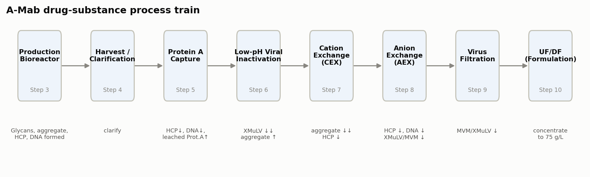
Figure 1: A-Mab drug-substance process flow (Steps 3–10) with the principal quality impact of each unit operation.

2.3 Process description, in-process controls and outputs
Each unit operation is summarized in Table 2 (mode/scale, estimated step yield and the principal hold time/condition). The inputs to each step are the process parameters and their ranges (Section 6); the step outputs — in-process tests, limits and in-process specifications — are given in Table 3. Final drug-substance acceptance criteria and the statistically-justified PPQ sampling plans are established in Stage 2 (Section 8).
Table 2: Process description and estimated per-step performance.
Step | Unit operation | Mode / scale | Est. step yield | Principal hold / condition
3 | Production Bioreactor | Fed-batch cell culture, 15,000 L | 100% | 15–19 day culture; harvest on viability/titer/quality
4 | Harvest / Clarification | Centrifugation + depth/sterile filtration | 98% | ≤ 24 h post-harvest hold, 2–8 °C
5 | Protein A Chromatography | Protein A affinity, bind–elute, multi-cycle | 97% | Low-pH eluate held for viral inactivation
6 | Low-pH Viral Inactivation | Low-pH batch incubation | 99% | pH 3.5, 60–120 min, 15–25 °C
7 | Cation Exchange Chromatography | Cation exchange, bind–elute | 95% | Eluate pool hold ≤ 24 h, 2–8 °C
8 | Anion Exchange Chromatography | Anion exchange, flow-through | 97% | Single-cycle flow-through
9 | Small Virus Retentive Filtration | Small-virus retentive filtration | 98% | Volumetric load ≤ 105 L/m²
10 | Ultrafiltration / Diafiltration | Ultrafiltration/diafiltration (TFF) | 97% | Formulate to 75 g/L; DS hold 2–8 °C

Table 3: In-process controls, tests and outputs by unit operation (representative alert/action limits; final specifications set in Stage 2).
Unit operation | In-process test / output | Alert / action limit or in-process specification
Production Bioreactor | Culture viability & titer at harvest | Harvest criteria on viability, titer and quality
Harvest | Post-clarification turbidity; bioburden | Turbidity trended; bioburden action limit per programme
Protein A | Step yield (A280); pool HCP (trend) | Yield ≥ 75%; HCP trended
Low-pH Viral Inactivation | Inactivation pH; hold time | pH 3.4–3.6; hold ≥ 60 min (action)
Low-pH Viral Inactivation | Pool aggregate (SEC) | ≤ 3.1% (action)
CEX | Step yield; pool aggregate (SEC) | Yield ≥ target; aggregate ≤ release-linked limit
AEX | Eluate endotoxin | Alert ≥ 5 EU/mL; action ≥ 10 EU/mL
AEX | Eluate bioburden | Alert ≥ 10 CFU/10 mL; action ≥ 50 CFU/10 mL
AEX | Pool HCP; residual DNA | HCP trended to release limit; DNA < LOQ
Virus Filtration | Pre/post-use filter integrity test; volumetric load | Integrity test: pass; load ≤ 105 L/m²
UF/DF | Drug-substance concentration; endotoxin/bioburden | 70–80 g/L; per DS specification

3. Critical quality attributes and criticality
CQAs were identified and their criticality assessed on a continuum (ICH Q9) using the A-Mab Tool #1 risk score = Impact × Uncertainty, where impact is scored on efficacy/biological activity, PK/PD, immunogenicity and safety, and uncertainty reflects the strength of the supporting knowledge (CMC Biotech Working Group 2009). Attributes rated High (H) or Very High (VH) are treated as Critical. Table 4 summarizes the CQAs, their acceptance criteria and criticality; Figure 1 indicates where each is set or controlled.
Table 4: A-Mab critical quality attributes and criticality (Tool #1 = Impact × Uncertainty; H/VH = Critical).
CQA | Category | Acceptance | Criticality | Tool#1 score | Set/controlled by
Afucosylation | glycosylation | 2–13 % of glycans | H | 60 | bioreactor
Galactosylation (total %Gal) | glycosylation | 10–40 % (G1+G2 equiv.) | H | 48 | bioreactor
High Mannose | glycosylation | 3–10 % of glycans | VH | 80 | bioreactor
Aggregates (HMW) | size variant | 0–5 % HMW (SEC) | H | 60 | bioreactor
Acidic charge variants (deamidation) | charge variant | 18–40 % (CEX/icIEF) | VL | 4 | bioreactor
Host Cell Protein (HCP) | process impurity | 0–100 ng/mg | M-H | 36 | bioreactor
Residual DNA | process impurity | 0–0.001 ng/dose | VL | 6 | bioreactor
Leached Protein A | process impurity | 0–5 ppm | L-M | 16 | protein_a
Viral clearance — XMuLV (enveloped) | viral safety | 16.7–30 log10 (cumulative) | VH | 20 | viral_inactivation
Viral clearance — MVM (parvovirus) | viral safety | 8.6–20 log10 (cumulative) | VH | 20 | aex

The glycosylation attributes (afucosylation, high mannose, non-glycosylated heavy chain, galactosylation) are the most critical because they govern ADCC and CDC potency; they are determined in cell culture and are not modified by downstream processing. Aggregates and HCP are managed by the purification train. Viral safety is assured by process design (three orthogonal clearance steps) because it cannot be measured in the final product.

4. Risk-assessment strategy
Process characterization was directed by a lifecycle of iterative quality risk assessments (ICH Q9), consistent with A-Mab Risk Assessments #1–#4 (CMC Biotech Working Group 2009) and the Stage-1 risk flow of PDA TR 60 (Parenteral Drug Association 2013):
- Initial risk assessment (RA#1–#2) — prior platform knowledge and early development experience prioritized the process steps and parameters carrying the greatest potential impact to CQAs, and set the characterization scope (which parameters, which ranges, which interactions).
- Process characterization — screening DoE (two-level factorial / resolution-V fractional factorial) identified the significant parameters; response-surface designs (face-centred central-composite) quantified main effects, interactions and curvature and defined the design space.
- Post-characterization risk assessment (RA#3–#4) — the study results re-scored the process risk and fixed the parameter classification and control strategy. This is the subject of the accompanying post-PC FMEA (RPN = Severity × Occurrence × Detection). CPP status is set by the pre-control risk of impacting a CQA — a parameter that affects a CQA with Severity ≥ 8 or an initial (pre-mitigation) RPN > 72 is a CPP. The control strategy then determines whether that CPP is a well-controlled CPP (WC-CPP, low risk of leaving the design space) or remains a CPP requiring the most stringent control. The residual RPN reflects the post-control Occurrence and Detection; a high-severity attribute retains an elevated residual RPN even when well controlled — which is precisely why it is designated (WC-)CPP and enhanced-controlled.
Parameter designations follow the A-Mab continuum: CPP (variability impacts a CQA; high risk of leaving the design space), WC-CPP (impacts a CQA but well controlled, low risk), KPP (impacts process performance/consistency, not product quality), and GPP (general parameter, no meaningful impact over a wide range).
Prior knowledge and manufacturing history. The characterization ranges are supported not only by the scale-down studies reported here but by prior platform knowledge from related antibodies (X-Mab, Y-Mab, Z-Mab) and by A-Mab clinical and engineering manufacturing experience — the basis for the CQA acceptance ranges (Section 3), the modular viral-clearance claims (Sections 6.4, 6.6, 6.8) and the set-point selection. For a regulatory filing this section would summarize the clinical, engineering and process-evaluation batch history (batch records, campaign summaries and comparability data) that corroborates each proven acceptable range; that history is referenced here and maintained in the development report set.

5. Scale-down model qualification
All characterization studies were performed on qualified scale-down models (SDMs): a 2 L bioreactor for the production culture and bench-scale columns/devices for the downstream steps, each operated at the commercial bed height, linear velocity and load/wash/elution column-volumes (or membrane device equivalents). SDM qualification compared operational parameters and, critically, the input and output quality attributes (titer, viability, HCP, DNA, aggregate, charge and glycan profiles, and log-reduction values) against at-scale reference data, confirming the models are representative and suitable to support design-space and PAR claims (Parenteral Drug Association 2013). Viral-clearance claims additionally leverage the A-Mab modular approach across related antibodies.

6. Process characterization studies
Each unit operation was characterized against the CQAs and performance attributes it affects. For each step the following subsections give the study design, the parameters and ranges studied, the significant effects, the resulting design space, and the parameter classification.

6.1 Production bioreactor (Step 3)
The production bioreactor establishes the glycosylation, charge-variant and initial size-variant/impurity profile of A-Mab and is the sole upstream step used to define the upstream design space. A five-factor resolution-V screening design followed by a face-centred central-composite response-surface design characterized culture pH, temperature, dissolved CO₂, osmolality and culture duration (dissolved oxygen, inoculation density, medium concentration and feed volume were assessed for process performance).
Table 5: Production-bioreactor process parameters, ranges and classification.
Parameter | Unit | Set-point | NOR | PAR | Class | Study
Culture pH | pH | 6.85 | 6.75–6.95 | 6.6–7.1 | WC-CPP | multivariate
Culture temperature | °C | 35 | 34.5–35.5 | 34–36 | WC-CPP | multivariate
Dissolved CO2 (pCO2) | mmHg | 100 | 70–130 | 40–160 | WC-CPP | multivariate
Osmolality | mOsm | 400 | 375–425 | 360–440 | WC-CPP | multivariate
Culture duration | days | 17 | 16–18 | 15–19 | WC-CPP | multivariate
Dissolved oxygen | % sat | 50 | 40–60 | 30–70 | KPP | multivariate
Initial viable cell conc. | e6 cells/mL | 1 | 0.8–1.2 | 0.5–1.5 | KPP | univariate
Basal medium concentration | X | 1.2 | 1–1.4 | 0.8–1.6 | GPP | multivariate
Nutrient feed-1 volume | % WV | 12 | 10–14 | 9–15 | KPP | multivariate

The nominal fed-batch profile (Figure 2) reaches a peak viable cell density of 13.48 ×10⁶ cells/mL and a harvest titer of 4.37 g/L at 67.1% final viability. Screening identified culture pH, temperature, CO₂, osmolality and duration as significant for the glycosylation and charge-variant CQAs (Figure 3, Table 6); the response-surface model reproduces the multivariate, interacting behaviour of the A-Mab design space (CMC Biotech Working Group 2009).
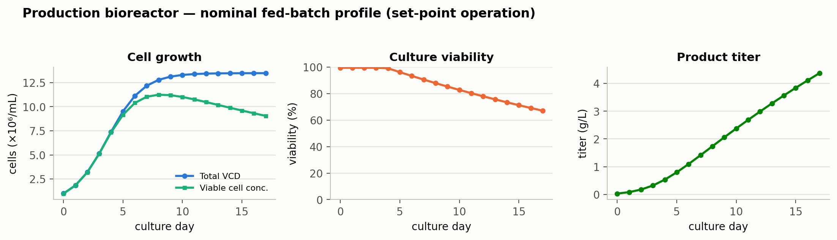
Figure 2: Nominal production-bioreactor time course: viable cell density, viability and titer.

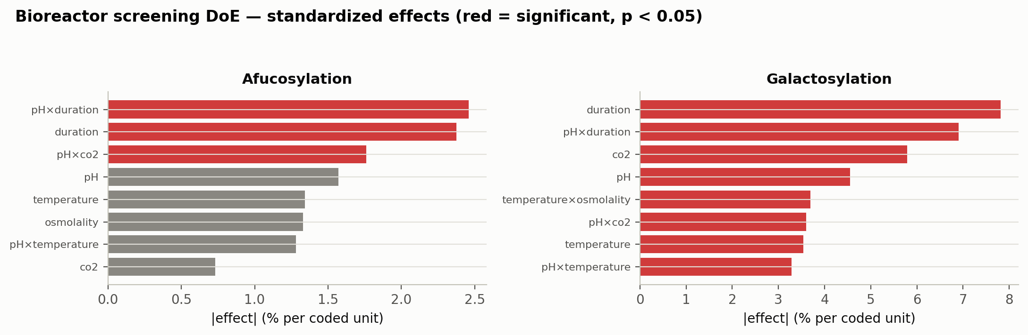
Figure 3: Standardized effects (screening DoE) for afucosylation and galactosylation; red bars are significant (p < 0.05).

Table 6: Largest standardized effects on afucosylation (bioreactor screening DoE).
Term | Effect | p-value | signif.
pH × duration | 2.46 | 0.0191 | yes
duration | -2.37 | 0.0209 | yes
pH × co2 | -1.76 | 0.0455 | yes
pH | -1.57 | 0.06
temperature | -1.34 | 0.0858
osmolality | -1.33 | 0.0878

Lower pH and lower temperature increase specific productivity, culture duration and titer, with a modest increase in afucosylation and a decrease in galactosylation; extended culture duration lowers afucosylation and galactosylation and raises the harvest HCP and DNA load as viability declines. Within the characterized ranges all cell-culture CQAs remain within acceptance simultaneously, defining a robust multivariate design space (Figure 4). Culture pH, temperature, CO₂, osmolality and duration are classified WC-CPP (significant CQA effects, but reliably controlled within the design space); dissolved oxygen, inoculation density and feed volume are KPP; medium concentration is GPP.
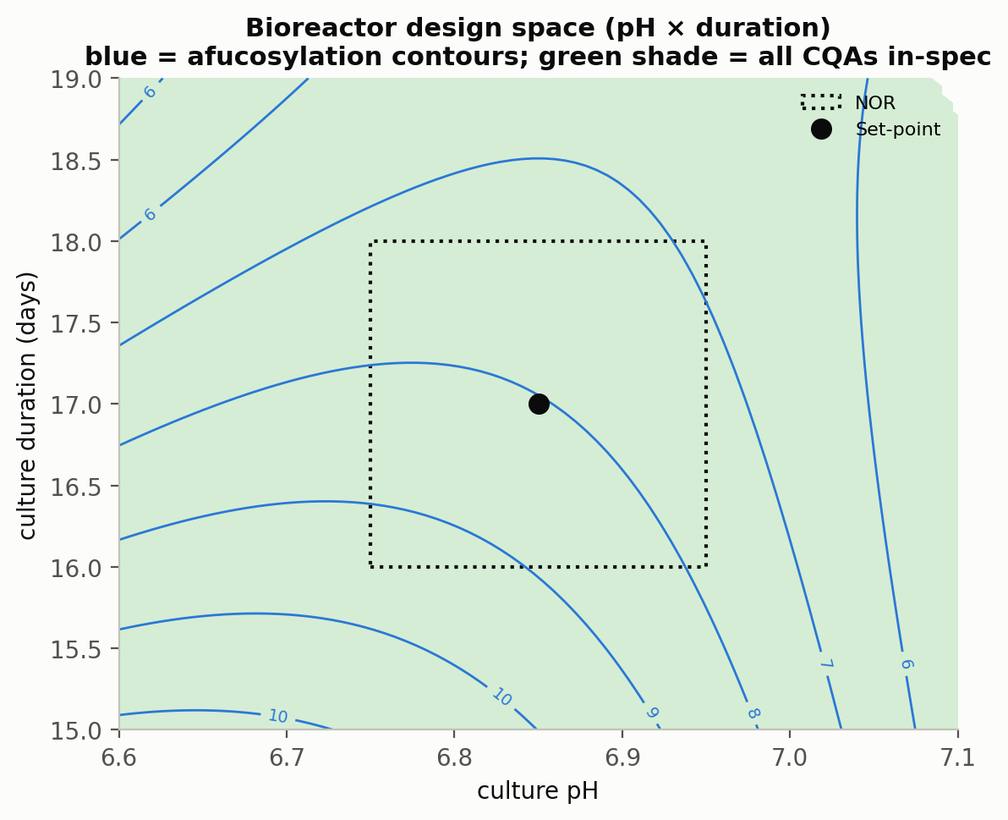
Figure 4: Production-bioreactor design space (pH × culture duration); the shaded region satisfies all cell-culture CQAs simultaneously. Blue contours are afucosylation (%).

6.2 Harvest and clarification (Step 4)
Harvest (centrifugation followed by depth and sterile filtration) clarifies the culture and defines the feed to Protein A. No product-quality impact was demonstrated; the step parameters (centrifugation g-force, depth-filter load, post-clarification turbidity) are KPP/GPP controlled for process performance and feed consistency (CMC Biotech Working Group 2009).

6.3 Protein A affinity chromatography (Step 5)
Protein A captures the antibody and clears the bulk of HCP and DNA. A six-factor resolution-IV screening design and a response-surface design characterized protein load, elution pH, load flow rate and end-of-pool collection.
Table 7: Protein A process parameters, ranges and classification.
Parameter | Unit | Set-point | NOR | PAR | Class | Study
Protein load | g/L resin | 30 | 20–40 | 10–50 | WC-CPP | multivariate
Elution buffer pH | pH | 3.55 | 3.4–3.7 | 3.2–3.9 | WC-CPP | multivariate
Load flow rate | cm/hr | 200 | 150–250 | 100–300 | KPP | multivariate
End of pool collect | CV | 2.6 | 2.3–2.9 | 2–3.2 | KPP | multivariate
Operating temperature | °C | 22 | 18–26 | 15–30 | GPP | multivariate
Bed height | cm | 20 | 15–25 | 10–30 | GPP | univariate

Pool HCP is the quality-determining response: it increases with higher protein load and lower elution pH (Figure 5), reproducing A-Mab Figure 4.2, while remaining well below the levels the CEX and AEX steps subsequently clear. Load flow rate and end-of-pool collection affect product yield (high load × high flow reduces recovery) but not quality. Protein load and elution pH are therefore WC-CPP (impact HCP, controlled within the design space); flow rate and end-collection are KPP; the remaining parameters are GPP.
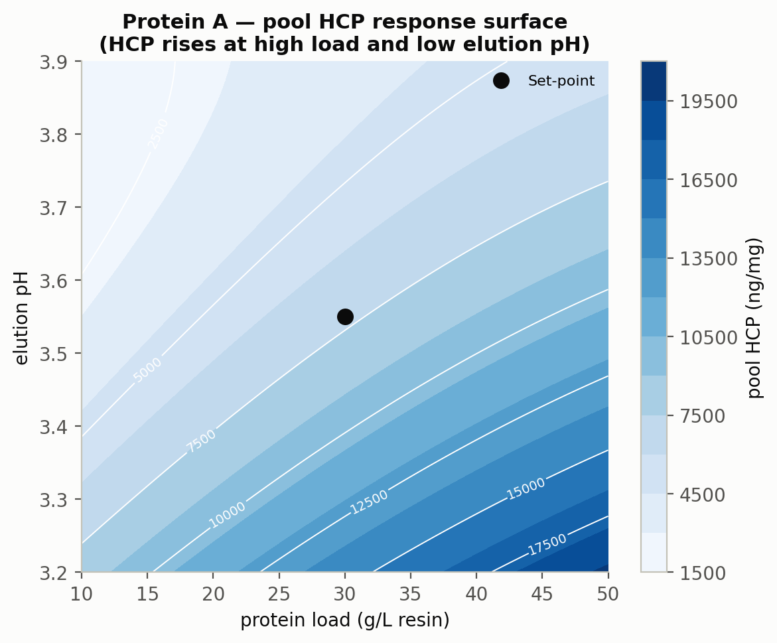
Figure 5: Protein A pool-HCP response surface (load × elution pH): HCP rises at high load and low elution pH.

6.4 Low-pH viral inactivation (Step 6)
Low-pH incubation inactivates enveloped virus (XMuLV). pH, hold time, temperature and protein concentration were characterized against XMuLV log-reduction and product quality (aggregation).
Table 8: Low-pH viral inactivation process parameters, ranges and classification.
Parameter | Unit | Set-point | NOR | PAR | Class | Study
Inactivation pH | pH | 3.5 | 3.4–3.6 | 3.2–4 | CPP | multivariate
Hold time | min | 90 | 60–120 | 60–180 | WC-CPP | multivariate
Temperature | °C | 21 | 19–23 | 15–25 | WC-CPP | multivariate
A-Mab concentration | g/L | 20 | 5–35 | 5–35 | GPP | univariate

pH is the defining parameter: above pH 4.0 inactivation of XMuLV within the hold is not assured, while below pH 3.2 the antibody may aggregate or precipitate — a narrow, high-consequence range that makes pH a CPP. Aggregate increases modestly with hold time and temperature (Figure 6, left) but remains below acceptance across the range, and is further polished by CEX; the XMuLV log-reduction surface (Figure 6, right) exceeds the required clearance throughout the acceptable pH × time region. Hold time and temperature are WC-CPP; protein concentration (≤ 35 g/L) is GPP.
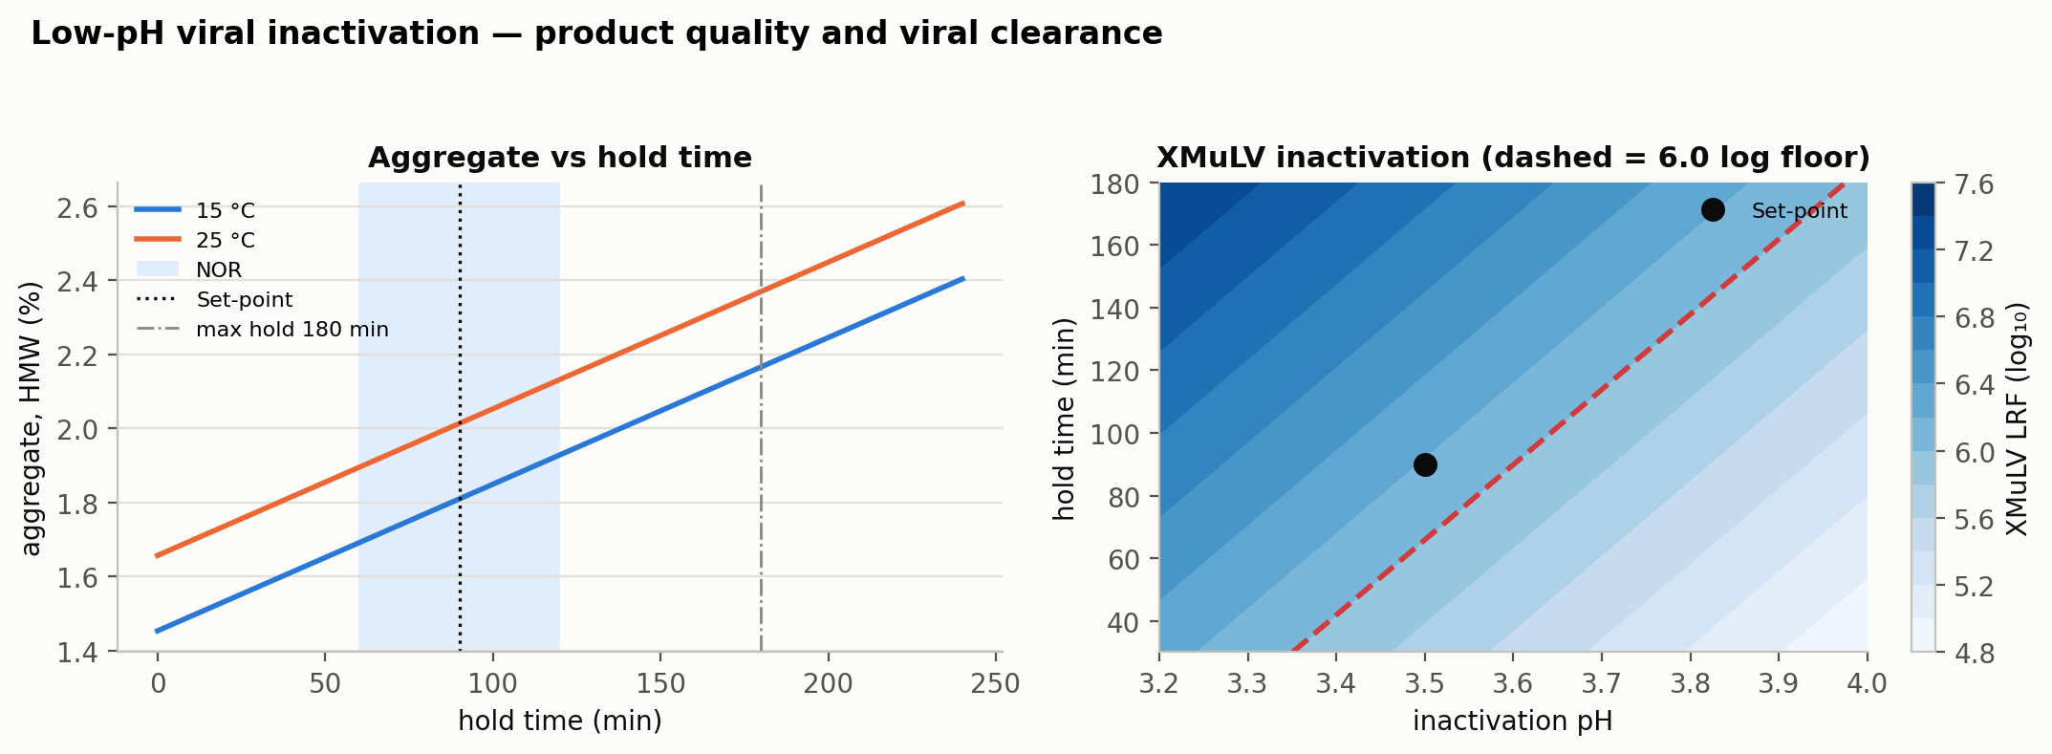
Figure 6: Low-pH viral inactivation: aggregate vs hold time at 15/25 °C (left) and the XMuLV log-reduction surface over pH × hold time (right).

6.5 Cation exchange chromatography — CEX (Step 7)
CEX operates in bind-and-elute mode and is the principal aggregate-polishing step; it also reduces HCP and clears DNA and leached Protein A. A fractional-factorial screen and a response-surface design characterized protein load, load/wash conductivity, elution pH and elution stop-collect.
Table 9: CEX process parameters, ranges and classification.
Parameter | Unit | Set-point | NOR | PAR | Class | Study
Protein load | g/L resin | 25 | 18–32 | 10–40 | WC-CPP | multivariate
Load/Wash conductivity | mS/cm | 5 | 4–6 | 3–7 | WC-CPP | multivariate
Elution buffer pH | pH | 6 | 5.85–6.15 | 5.8–6.2 | WC-CPP | multivariate
Elution stop collect | OD desc. | 1 | 0.7–1.3 | 0.5–1.5 | WC-CPP | multivariate
Elution flow rate | cm/hr | 200 | 150–250 | 100–300 | GPP | multivariate

Aggregate clearance (2–3×) weakens at higher protein load and wider elution stop-collect, and HCP clearance (50–100×) weakens at higher load and lower load/wash conductivity, with a significant load × conductivity interaction (Figure 7). Because there is no downstream aggregate-reduction step, a worst-case aggregate feed (linked to the low-pH hold) confirmed that CEX reduces aggregate below acceptance across all conditions. Protein load, load/wash conductivity, elution pH and stop-collect are WC-CPP; elution flow rate is GPP.
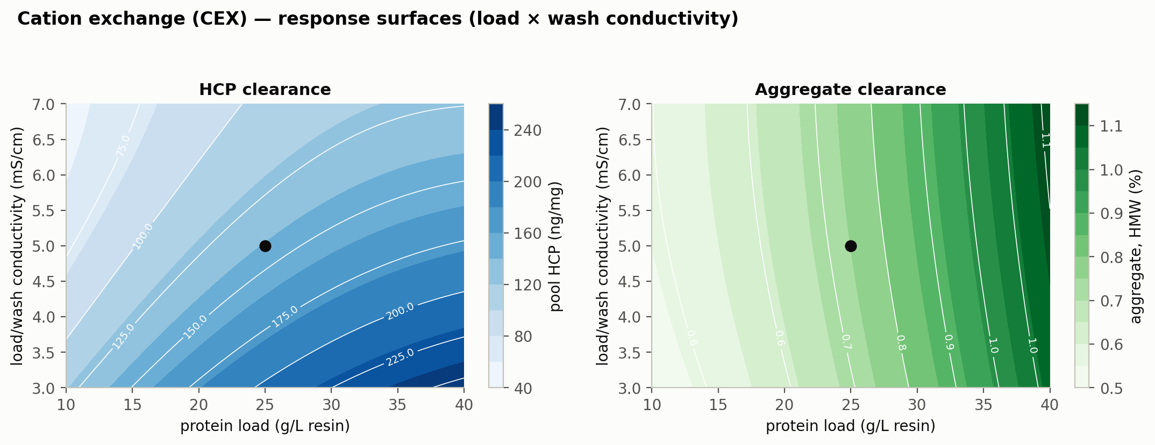
Figure 7: CEX response surfaces for pool HCP and aggregate over protein load × load/wash conductivity.

6.6 Anion exchange chromatography — AEX (Step 8)
AEX operates in flow-through mode: the antibody passes through while HCP, DNA, leached Protein A and endotoxin bind. AEX also provides an orthogonal viral-clearance claim (XMuLV and MVM). Load pH, Equilibration/Wash-1 conductivity, load conductivity and protein load were characterized.
Table 10: AEX process parameters, ranges and classification.
Parameter | Unit | Set-point | NOR | PAR | Class | Study
Load pH | pH | 7.5 | 7.35–7.65 | 7.2–7.8 | WC-CPP | multivariate
Equil/Wash-1 conductivity | mS/cm | 2.6 | 2.1–3.1 | 1.6–3.6 | WC-CPP | multivariate
Load conductivity | mS/cm | 5.5 | 4–7 | 3–8 | WC-CPP | multivariate
Protein load | g/L resin | 200 | 120–280 | 50–300 | WC-CPP | multivariate
Operating flow rate | cm/hr | 300 | 200–400 | 150–450 | WC-CPP | multivariate

HCP removal and viral clearance both decline as load pH decreases and conductivity increases (Figure 8); the quality design space (pH 7.2–7.8, Equil/Wash-1 conductivity 1.6–3.6 mS/cm) is narrower than the validated viral-clearance ranges, so operation is constrained by the quality requirement. Load pH, both conductivities, protein load and flow rate are WC-CPP.
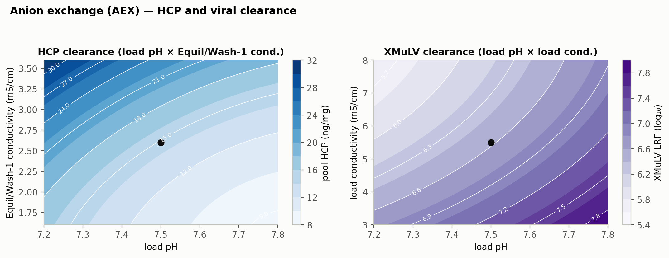
Figure 8: AEX response surfaces: HCP clearance and XMuLV log-reduction both fall as load pH decreases and Equil/Wash-1 conductivity increases.

6.7 Small-virus retentive filtration (Step 9)
Size-based filtration provides an orthogonal, modular clearance claim for small non-enveloped virus (MVM) and larger enveloped virus (XMuLV). MVM log-reduction declines with volumetric load; a load limit of 105 L/m² preserves LRV ≥ 4.62 (Figure 9). Filtration volume and pressure are WC-CPP; the pre/post-use integrity test is a procedural control.
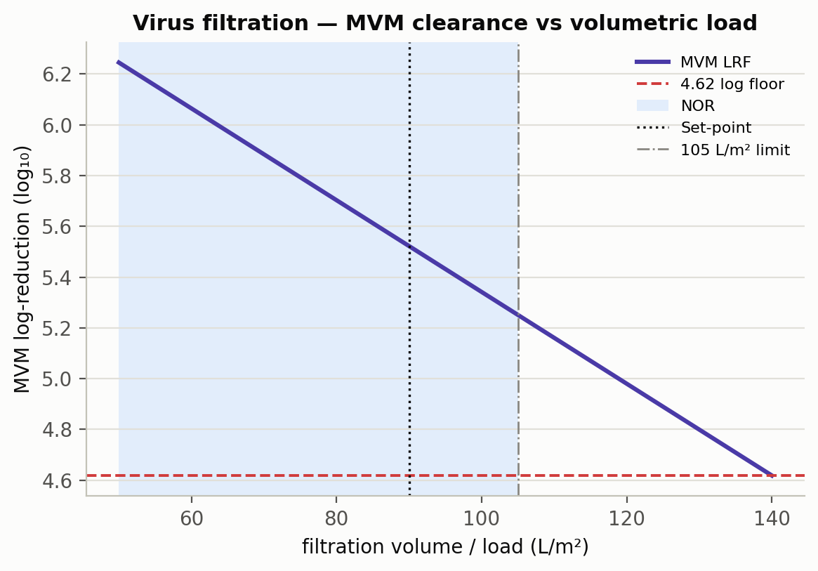
Figure 9: Small-virus filtration: MVM log-reduction vs volumetric load; the 105 L/m² limit preserves LRF ≥ 4.62.

6.8 Ultrafiltration / diafiltration (Step 10)
UF/DF concentrates and buffer-exchanges the antibody to the drug-substance target of 75.0 g/L. Consistent with the A-Mab case study, formulation characterization is reported with the drug product; the step is included here for mass balance only, and its parameters (diavolumes, transmembrane pressure, final concentration) are controlled as KPP.

7. Parameter classification summary
Across the drug-substance train, 37 process parameters were classified (Figure 10, Table 11). 21 are critical (CPP or WC-CPP), concentrated in the bioreactor (glycosylation and charge control), the chromatography steps (aggregate and HCP control) and the viral-safety steps.
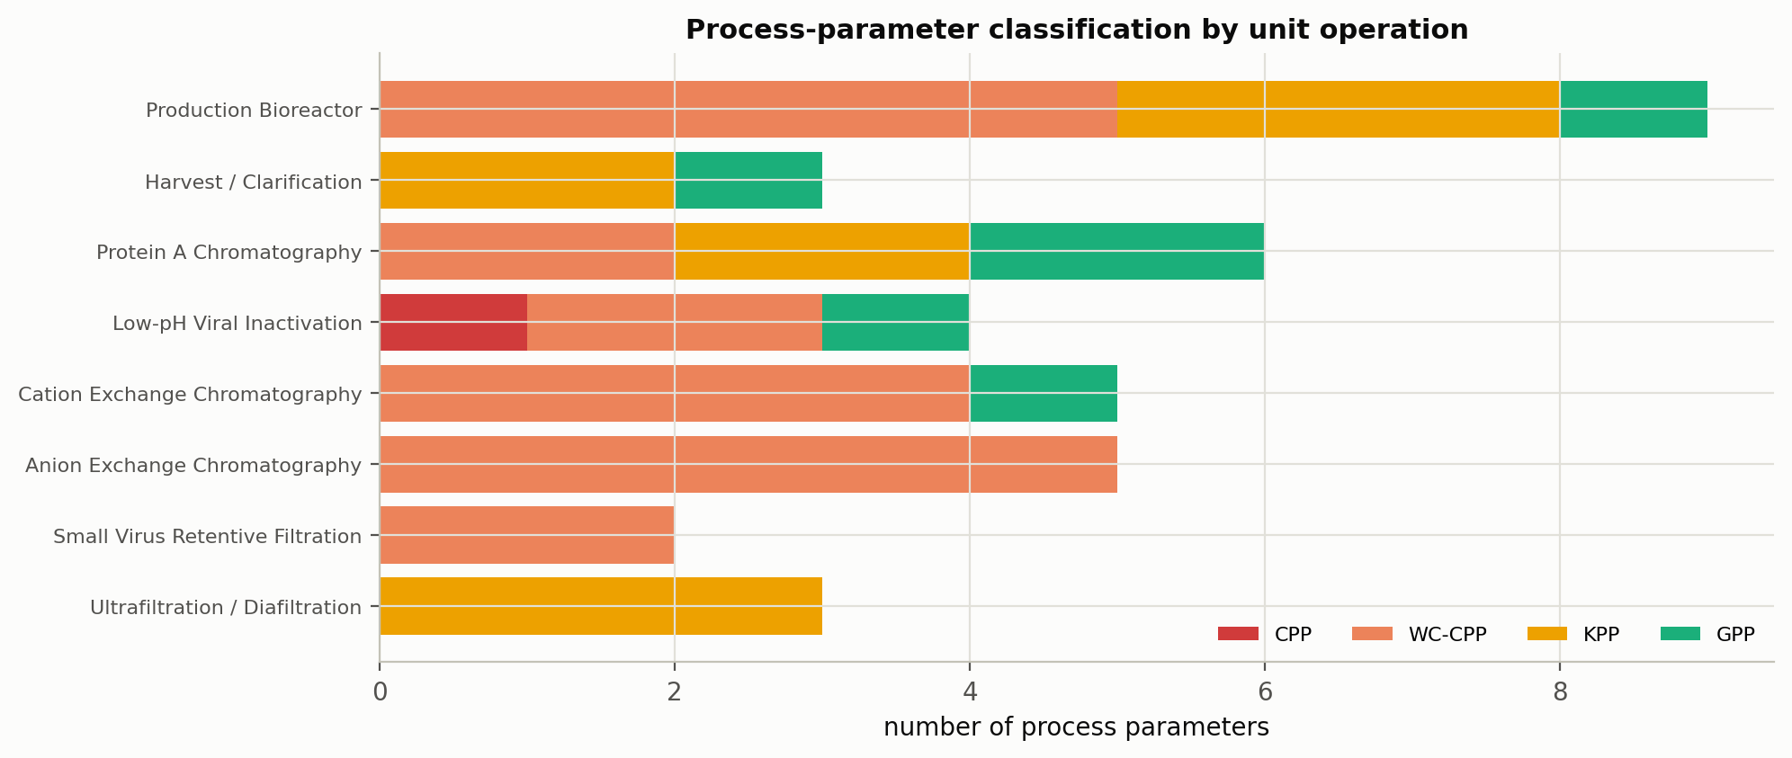
Figure 10: Post-characterization classification of process parameters by unit operation.

Table 11: Process-parameter classification summary.
Classification | Number of parameters
CPP | 1
WC-CPP | 20
KPP | 10
GPP | 6
Total | 37

The complete post-characterization FMEA — one row per parameter with failure mode, severity/occurrence/detection scores, RPN before and after characterization, designation, control strategy and residual risk — is provided as the accompanying workbook, A-Mab_Post-PC_Process_Risk_Assessment.xlsx.

8. Process capability and Stage-2 readiness
A Monte-Carlo simulation of 2,000 commercial-scale batches, with every parameter varied within its normal operating range, was used to estimate the drug-substance quality distribution and process capability (Figure 11, Table 12). Capability is evaluated one-sided for impurities (upper limit) and for viral clearance (lower requirement), and two-sided for target-range attributes.
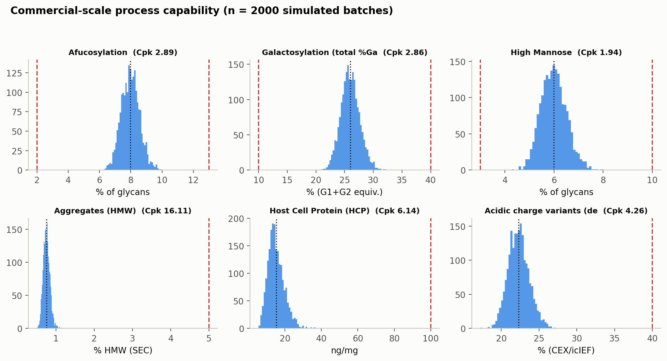
Figure 11: Commercial-scale drug-substance CQA distributions vs acceptance limits, annotated with process capability (Cpk).

Table 12: Commercial-scale process capability by CQA (n = simulated batches).
CQA | Crit. | Spec | Acceptance | Mean ± SD | Cpk
Afucosylation | H | two_sided | 2–13 | 7.98 ± 0.58 | 2.89
Galactosylation (total %Gal) | H | two_sided | 10–40 | 26 ± 1.6 | 2.86
High Mannose | VH | two_sided | 3–10 | 5.99 ± 0.51 | 1.94
Aggregates (HMW) | H | upper | 0–5 | 0.753 ± 0.088 | 16.11
Acidic charge variants (deamidation) | VL | upper | 18–40 | 22.3 ± 1.4 | 4.26
Host Cell Protein (HCP) | M-H | upper | 0–100 | 15.2 ± 4.6 | 6.14
Residual DNA | VL | upper | 0–0.001 | 0.0001 ± 0 | 10.81
Leached Protein A | L-M | upper | 0–5 | 0.003 ± 0.0006 | 2785.30
Viral clearance — XMuLV (enveloped) | VH | lower | 16.7–30 | 19.5 ± 0.61 | 1.53
Viral clearance — MVM (parvovirus) | VH | lower | 8.6–20 | 10.4 ± 0.4 | 1.51

The minimum capability across all CQAs is Cpk = 1.51 (all CQAs ≥ 1.33). A representative PPQ campaign of 5 batches (Table 13) meets all acceptance criteria.
Table 13: Representative PPQ-campaign drug-substance results.
Batch | Yield | aFuc % | Gal % | HMW % | HCP (ng/mg) | XMuLV LRV | MVM LRV
PPQ-001 | 0.782 | 7.44 | 26.6 | 0.817 | 17.2 | 19.7 | 9.9
PPQ-002 | 0.754 | 8.51 | 28 | 0.614 | 14.5 | 19.5 | 9.87
PPQ-003 | 0.732 | 7.42 | 24.3 | 0.596 | 15.9 | 19.7 | 10.6
PPQ-004 | 0.763 | 7.94 | 25.1 | 0.927 | 14.2 | 20.1 | 10.4
PPQ-005 | 0.838 | 6.8 | 25.8 | 0.664 | 7.96 | 19.9 | 9.93

Viral clearance is delivered by three orthogonal steps (Figure 12, Table 14): cumulative clearance of 18.87 log₁₀ (XMuLV) and 10.03 log₁₀ (MVM) exceeds the requirements of > 16.7 and > 8.6 with margin. Product step-yield across the train is 83.2% (Figure 13).
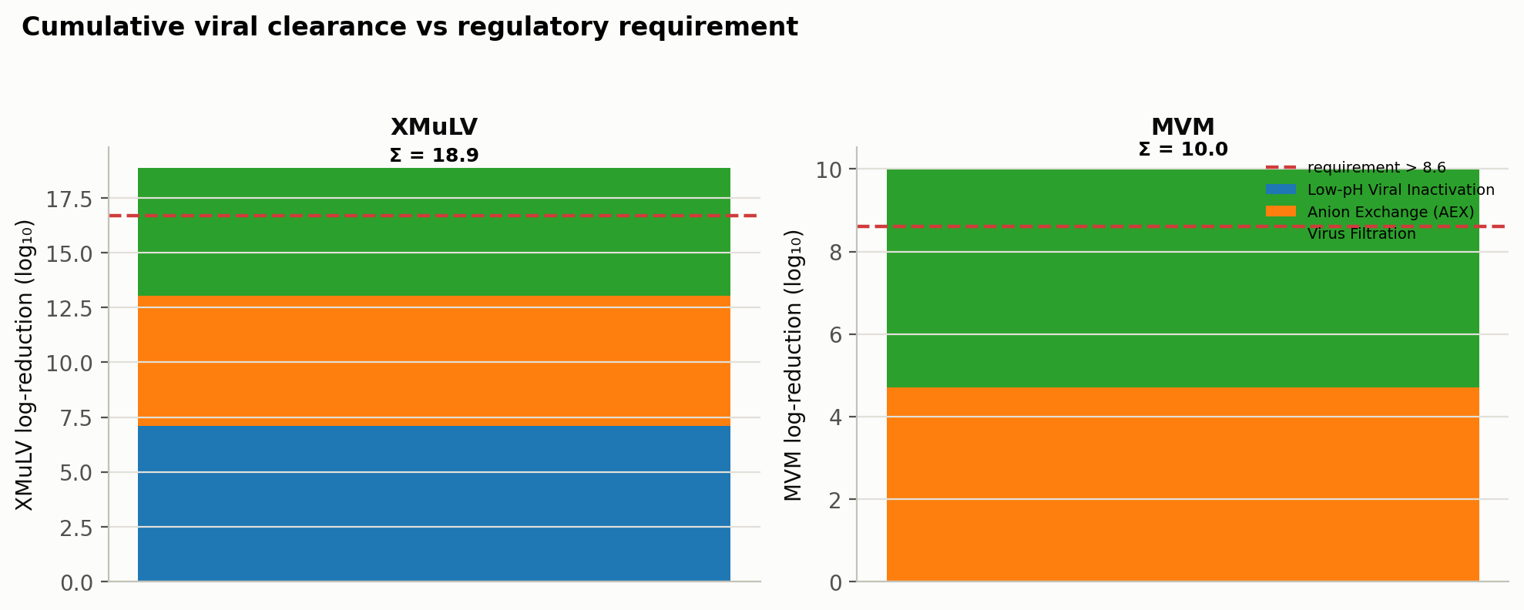
Figure 12: Modular viral clearance by step for XMuLV and MVM; cumulative clearance exceeds the total requirement.

Table 14: Viral log-reduction by step and cumulative total.
Step | XMuLV | MVM
Low-pH Viral Inactivation | 7.10 | 0.00
Anion Exchange (AEX) | 5.95 | 4.71
Virus Filtration | 5.82 | 5.32
Cumulative | 18.87 | 10.03

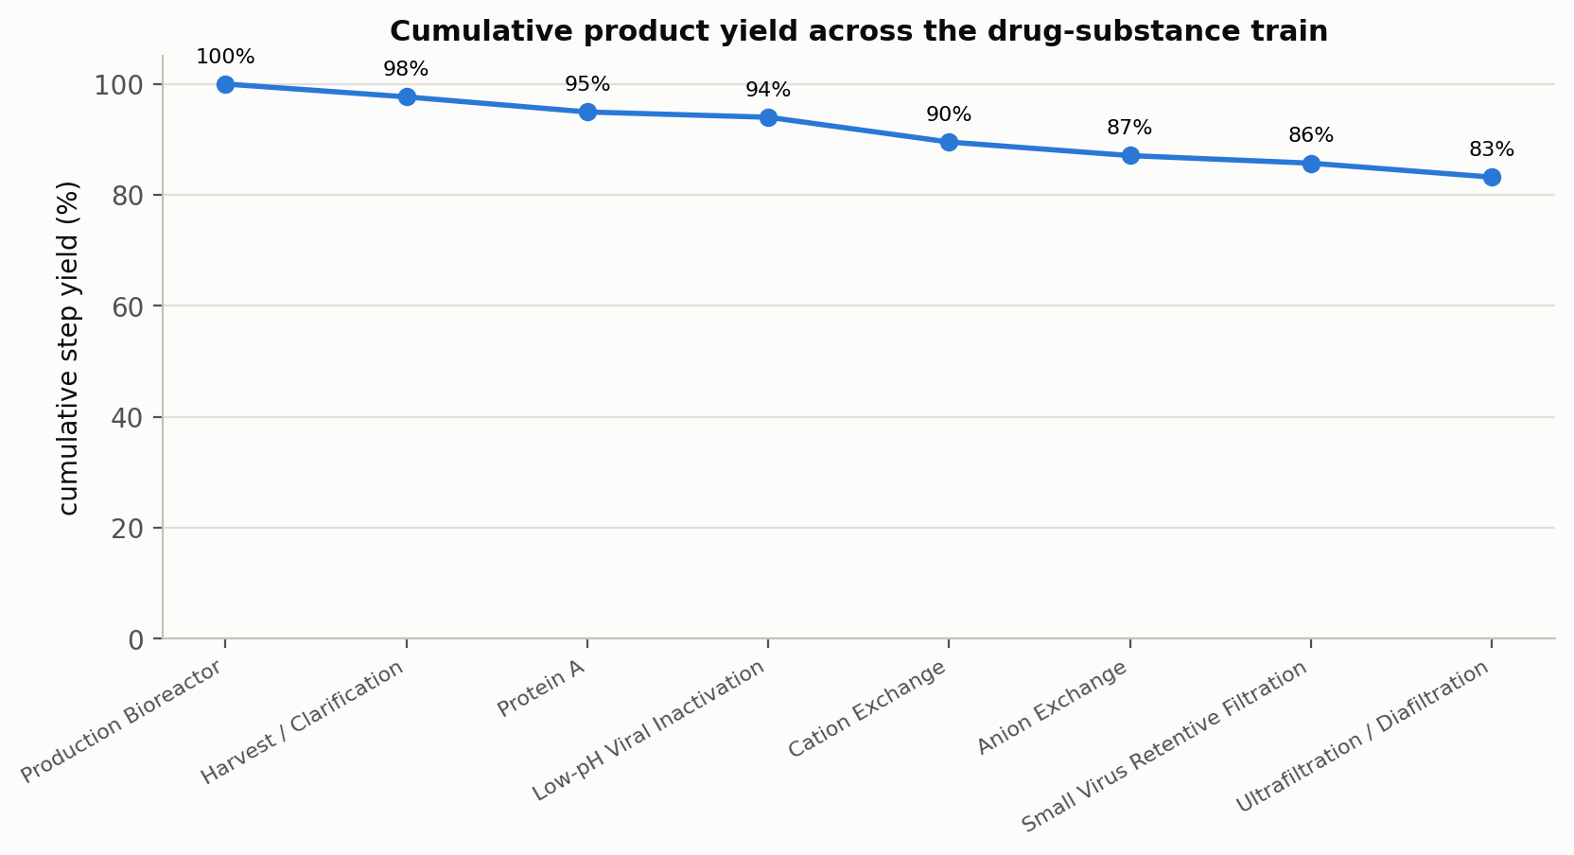
Figure 13: Cumulative product step-yield across the drug-substance train.

9. Control strategy
The control strategy is the sum of the individual CQA control strategies (ICH Q10), built from the characterization understanding above. Each CQA is controlled by a defined combination of input-material controls, procedural controls, process-parameter set-points and proven acceptable ranges, in-process controls and release testing (Table 15). Glycan CQAs are controlled predominantly at the bioreactor; aggregate at CEX (with the low-pH hold bounded); HCP across Protein A, CEX and AEX; and viral safety by three orthogonal clearance steps plus the low-pH inactivation.
Table 15: Overall control strategy — principal controls per CQA.
CQA | Principal process controls | Testing
Afucosylation / high mannose / galactosylation | Bioreactor pH, temperature, CO₂, osmolality, duration (design space) | Released glycan map; in-process culture control
Aggregates (HMW) | CEX (load, conductivity, elution pH, stop-collect); low-pH hold bounded | SEC at CEX pool and release
Acidic charge variants | Bioreactor set-points; CEX/AEX collection | Charge-variant assay at release
Host cell protein (HCP) | Protein A (load, elution pH); CEX; AEX (load pH, conductivity) | HCP ELISA at AEX pool and release
Residual DNA | Protein A + AEX clearance (modular) | qPCR at release
Leached Protein A | CEX + AEX clearance | Leached Protein A assay at release
Viral safety (XMuLV / MVM) | Low-pH inactivation; AEX; virus filtration (validated ranges) | Validated clearance; in-process bioburden/endotoxin

10. Conclusions and readiness for Stage 2
The A-Mab drug-substance process is well understood and robust:
- Every CQA meets its acceptance criterion at set-point, with a minimum capability of Cpk = 1.51 across 2,000 simulated commercial batches.
- The relationships between process parameters and CQAs are quantified by DoE, design spaces are established for the bioreactor and the chromatography and viral-safety steps, and every parameter range is justified by data.
- 37 parameters are classified; 21 are critical (CPP/WC-CPP) with a defined control strategy, and the post-characterization FMEA shows the median risk priority number falling by ~85% relative to the initial assessment.
- Viral clearance exceeds requirements with margin (18.87 / 10.03 log₁₀ for XMuLV/MVM).
The process design (Stage 1) is complete. The characterized ranges, design spaces and control strategy provide the basis for the Stage 2 Process Performance Qualification protocol, acceptance criteria and sampling plans. The process is recommended for progression to PPQ.

Reproducibility
Every figure, table and number in this report is generated from a seeded process model (master seed 20240724). The report is regenerated end-to-end with make all (see the repository README): the model produces the datasets (outputs/data/) and figures (outputs/figures/), and Quarto renders this document to Word and PDF from the same sources.

References
CMC Biotech Working Group. 2009. “A-Mab: A Case Study in Bioprocess Development.” CASSS.
International Council for Harmonisation. 2009. “ICH Q8(R2): Pharmaceutical Development.” ICH.
———. 2012. “ICH Q11: Development and Manufacture of Drug Substances.” ICH.
———. 2023. “ICH Q9(R1): Quality Risk Management.” ICH.
International Society for Pharmaceutical Engineering. 2023. “Good Practice Guide: Practical Implementation of the Lifecycle Approach to Process Validation.” ISPE.
Parenteral Drug Association. 2013. “Technical Report No. 60: Process Validation — a Lifecycle Approach.” PDA.

