Process Characterization Report
  - A-Mab Drug Substance — Production Bioreactor (Step 3) — PCR-003
Process Development / Manufacturing Science & Technology (MSAT)
2026-07-24
Table of contents

Field | Value
Document ID | PCR-003
Document class | Process Characterization Report
Title | Process Characterization Report: Production Bioreactor (Step 3)
Product | A-Mab
Version | 1.0
Effective date | 2026-07-24
Status | Approved (synthetic)
Document owner | Manufacturing Science & Technology (MSAT)
Sponsor / sites | Novacyte Biologics; Novacyte Biologics — Cambridge, MA (Development) → Novacyte Biologics — Grafton, WI (Commercial DS)
SYNTHETIC DOCUMENT — NOT A REAL RECORD. Illustrative content generated from a seeded model of the A-Mab case study (CMC Biotech Working Group, 2009). Novacyte Biologics and all sites, SOP/AMV numbers and signatories are fictional. For NLP corpus development only; not for any regulated use.

Approvals
Table 1: Approval record (synthetic; signatures not applied).
Role | Function | Name (synthetic) | Signature | Date
Author | Process Development / MSAT | — | — | —
Reviewer | Analytical Development | — | — | —
Reviewer | Manufacturing Science | — | — | —
Reviewer | Statistics | — | — | —
Approver | Quality Assurance | — | — | —

Abbreviations
2-AB, 2-aminobenzamide; ADCC, antibody dependent cell mediated cytotoxicity; AMV, analytical method validation; ANOVA, analysis of variance; BLA, Biologics License Application; CCD, central composite design; CDC, complement dependent cytotoxicity; CEX, cation exchange chromatography; CQA, critical quality attribute; CPP, critical process parameter; Cpk, process capability index; DoE, design of experiments; DS, drug substance; GPP, general process parameter; HCP, host cell protein; HILIC, hydrophilic interaction liquid chromatography; HMW, high molecular weight; icIEF, imaged capillary isoelectric focusing; iVCC, initial viable cell concentration; KPP, key process parameter; MSAT, Manufacturing Science and Technology; NOR, normal operating range; OLS, ordinary least squares; PAR, proven acceptable range; pCO2, dissolved carbon dioxide partial pressure; PPQ, process performance qualification; PRESS, prediction error sum of squares; qPCR, quantitative polymerase chain reaction; RMSE, root mean square error; RSM, response surface methodology; SD, standard deviation; SDM, scale-down model; SEC, size exclusion chromatography; SOP, standard operating procedure; UPLC, ultra performance liquid chromatography; WC-CPP, well controlled critical process parameter.

Executive summary
The production bioreactor forms the glycan, charge variant and aggregate quality attributes of A-Mab, which places the widest part of the drug substance control strategy at this one step. The characterization of that step is recorded here against the approved plan PCP-003. Although the characterization studies were executed at small scale, they were run on a scale-down model qualified against the commercial 15,000 L vessel under SOP-1001, within the lifecycle approach to process validation (U.S. Food and Drug Administration 2011) and the enhanced development approach of ICH Q8, Q9 and Q11 (International Council for Harmonisation 2009, 2023, 2012). The attribute framework and the risk ranking approach were taken from the A-Mab case study (CMC Biotech Working Group 2009). The scope of the study was fixed in advance by the pre-characterization risk assessment RA-001.
9 process parameters were characterized over ranges 1.5 to 2.5 times as wide as the intended commercial control ranges, which puts the edge of the knowledge space well outside the region the commercial process is expected to occupy under routine operation (Table 6). 5 of those parameters were varied together in a multivariate design, while 4 were assessed one at a time. The 5 parameters studied together entered a resolution V screening design of 19 runs, in which every main effect is estimated clear of every two-factor interaction. The 4 factors retained from screening were then studied in a face centred central composite design of 28 runs, which supports a full quadratic model over three levels of every factor it carries. On every run of both designs the same 5 quality attributes were measured at harvest: afucosylation, galactosylation, high mannose, acidic variants and aggregates.
Over the ranges studied, the response surface models fitted to those runs describe the data adequately, with R² between 0.911 and 0.971, a lowest adjusted R² of 0.815, and no lack of fit test reaching significance against the pure error measured on the 4 centre-point replicates (Table 16). Predicted R² separates the five responses more sharply than R² does. The weakest response on that measure is acidic variants, at 0.598. In this report both the predictive claim for those responses and the basis of the design space in §6 rest on the response surface models, whereas the factors that matter were identified by screening.
Culture pH, the first of those factors, moves more attributes than any other parameter, at +1.09 percentage points per coded unit on high mannose and +0.37 on aggregates, while afucosylation runs the other way at -1.00. Because the same parameter pushes different attributes in opposite directions, the operating region is defined multivariately in §6 instead of as a set of independent one-dimensional ranges. Over the characterized space, 57 % of the region meets every in-process limit the step governs. The region is bound most tightly by galactosylation (§6).
Commercial-scale capability of the seven attributes was estimated by Monte-Carlo simulation of 2,000 batches, with every parameter drawn independently from inside its own normal operating range. On that basis all 7 attributes the step sets are shown to meet the drug substance acceptance criteria at commercial scale (Table 22). Among the seven, the tightest of those indices reaches 1.94 for High Mannose, which sits 2.99 percentage points inside the nearer acceptance limit on a simulated standard deviation of 0.51. Two deviations were recorded during execution of the two designs (Table 23). Both of them were investigated, root caused and retained, and neither altered a fitted effect, a proven acceptable range or a parameter classification (§12).
Of the 9 parameters characterized, 5 were classified WC-CPP, 3 KPP and 1 GPP, while none required classification as a CPP (§9). The step does not control host cell protein or residual DNA on its own, because both are formed in the culture and cleared downstream, with the clearance credited in PCR-005, PCR-007 and PCR-008. Throughout this report, every claim made about those parameters rests on a qualified scale-down model with each of them held inside the normal operating range. Confirmation at commercial scale is the work of Stage 2. Once that confirmation is complete, this report rolls up into PCMR-001 alongside the reports covering the other seven steps of the train.

1. Introduction

1.1 Product and unit operation
A-Mab is a humanized IgG1 monoclonal antibody produced by fed-batch mammalian cell culture and purified on a platform train. The primary mechanism of action of that antibody is antibody dependent cell mediated cytotoxicity, which makes the N-linked glycan attributes efficacy linked and places them among the attributes of highest criticality in the drug substance (CMC Biotech Working Group 2009). Downstream of the culture, the purification train for that antibody runs Protein A capture (PCR-005), low-pH viral inactivation (PCR-006), cation exchange (PCR-007), anion exchange (PCR-008), small virus retentive filtration (PCR-009) and ultrafiltration with diafiltration (PCR-010), each of them covered by a characterization plan and report pair of its own (Table 2).
The production bioreactor occupies Step 3 of that drug substance process. Within the drug substance train, that step opens the characterization campaign this package documents. The culture in that bioreactor is grown at a working volume of 15,000 L, fed on a defined schedule, and harvested after about 17 days at a nominal titer of 4.37 g/L. The production bioreactor is the only step of the drug substance process at which product quality attributes are formed. Those quality attributes, the glycosylation and charge variant distributions, are established inside the cell and in the culture fluid. Neither distribution is modified by the platform purification train, which separates on affinity, charge and size without discriminating between glycoforms of the same antibody.
Five of the attributes formed in that culture were measured as responses of the characterization studies: afucosylation, galactosylation, high mannose, acidic variants and aggregates. Two further attributes, host cell protein and residual DNA, are also formed in the culture. Because the purification train clears both by several orders of magnitude, neither was carried as a response of this study; the clearance is characterized in PCR-005, PCR-007 and PCR-008, while the commercial-scale outcome for both attributes appears in the capability table of §8 (Table 22).

1.2 Objectives
The characterization studies were performed to meet the five objectives listed below, each of which is answered in a section of this report.
- Quantify the relationship between each process parameter and each quality attribute the step forms, over ranges wider than the intended commercial control ranges.
- Define the multivariate operating region within which every attribute the step governs stays inside its acceptance criterion.
- Establish a proven acceptable range for each response surface factor against each governed attribute, both at the set-point and under normal operating range variation of the remaining factors.
- Classify each parameter from the demonstrated effect on quality and from the risk of operating outside the region.
- Justify the Stage 2 ranges and the control strategy contribution of the step, for roll-up into PCMR-001.

1.3 Regulatory and scientific basis
The characterization of the step was performed as Stage 1 process design work under the lifecycle approach to process validation (U.S. Food and Drug Administration 2011). The enhanced development approach of ICH Q8 supplies the design space concept, ICH Q9 supplies the risk methodology, while ICH Q11 supplies the expectation that a process parameter be linked both to the quality attribute it moves and to the range over which that link was demonstrated (International Council for Harmonisation 2009, 2023, 2012). Attribute criticality was treated throughout as a continuum instead of a binary label, consistent with ICH Q9 and with the assessment tools of the case study (CMC Biotech Working Group 2009). Attributes scoring high or very high on those tools were called critical.
No viral clearance claim is made for this step, which places the viral safety framework of ICH Q5A outside the scope of this report. The modular clearance claims belong to low-pH viral inactivation (PCR-006), anion exchange (PCR-008) and small virus retentive filtration (PCR-009), and each of them is consolidated in PCMR-001. At the procedural level, qualification of the scale-down model followed SOP-1001, while the design, execution and statistical analysis of the designed experiments followed SOP-1002.

1.4 Related documents
As a set, the documents that scope, plan and consolidate this work appear in Table 2. RA-001 set the study scope and PCP-003 is the approved plan this report executes. That plan and this report both roll up into PCMR-001, in which the outcome of the step is consolidated with the outcome of the other seven steps of the drug substance train before Stage 2 begins.
Table 2: Related documents.
Document ID | Title | Relationship
PTP-001 | Process Transfer Plan (A-Mab Drug Substance) | Parent — transfer scope
RA-001 | Pre-Characterization Process Risk Assessment (A-Mab Drug Substance) | Parent — risk basis for study scope
PCMP-001 | Process Characterization Master Plan (A-Mab Drug Substance) | Parent — master plan
PCP-003 | Process Characterization Plan (Production Bioreactor (Step 3)) | Sibling — paired document
PCMR-001 | Process Characterization Master Report (A-Mab Drug Substance) | Rolls up into

The controlled procedures governing the studies are listed in Table 3, while the analytical method validations supporting the four assays are listed separately in Table 5.
Table 3: Controlled procedures governing the characterization of Step 3.
Reference | Title | Type
SOP-1001 | Qualification of Scale-Down Models | SOP
SOP-1002 | Design, Execution and Statistical Analysis of DoE Studies | SOP
SOP-2003 | Operation of the Production Bioreactor (Fed-Batch) | SOP
SOP-2004 | Cell-Culture Media and Feed Preparation | SOP
SOP-3010 | Released N-Glycan Mapping by 2-AB HILIC-UPLC | SOP
SOP-3011 | Size-Variant Analysis by SEC-HPLC | SOP
SOP-3012 | Host-Cell-Protein Quantitation by ELISA | SOP
SOP-3013 | Charge-Variant Analysis by icIEF | SOP
SOP-3014 | Residual Host-Cell DNA by qPCR | SOP
SOP-4001 | Process-Parameter Classification and Control-Strategy Definition | SOP

2. Prior knowledge and quality risk basis

2.1 Platform and prior-product knowledge
Novacyte operates a single humanized IgG1 platform, on which A-Mab is the fourth product to be developed. In development order, three products preceded A-Mab on that platform: X-Mab, Y-Mab and Z-Mab, all of them humanized IgG1 antibodies expressed in the same host cell line. The cell line lineage, the basal medium, the feed strategy and the control scheme of the production bioreactor run common to all four products, which means the mechanisms by which culture conditions move the glycan and charge variant distributions were established well before this study began. What the platform does not supply is the size of each effect for this molecule, or the shape of the region over which all five of the measured attributes stay simultaneously acceptable at commercial scale under normal operating range variation. For that reason, characterization of those mechanisms at this step confirms and bounds what the platform already establishes. It was not expected to discover a mechanism that the platform had not already established.
Of the seven attributes, several acceptance limits carried into this study come from X-Mab clinical experience, which the attribute register records as such (Table 4). Y-Mab and Z-Mab, the other two products of the X-Mab lineage, contribute platform process history without contributing clinical data of their own. Because the three prior products share the expression system, the medium and the control scheme, the mechanistic expectations below were treated as established knowledge and were used to set both the direction and the width of each of the factor ranges studied here (Table 6).
Among the glycan attributes, galactosylation tracks the activity of the Golgi galactosyltransferase and the supply of its nucleotide sugar donor, both of which decline as a culture ages, which made a lower galactosylation the expectation for a longer culture with every other condition held constant. High mannose behaves enzymatically in the same way and reflects how far mannosidase trimming has run, which makes the attribute sensitive both to lumenal pH and to the temperature at which the culture is held over the whole of the production stage. Unlike the other two glycans, afucosylation depends on a competition, between core fucosyltransferase activity and the rate at which antibody transits the Golgi. Afucosylation was expected on that basis to fall as the culture progresses. Aggregate in the same culture follows the one expectation of the five that is not enzymatic, because antibody that sits longer in an ageing broth aggregates more through simple physical association of the secreted material. Acidic variants in the same broth arise mainly by deamidation of the secreted antibody in the culture fluid, where the carbonate system sets the local proton activity, which made dissolved CO2 the parameter expected to dominate that response over the ranges characterized here.

2.2 Quality attributes in scope
In all, 7 attributes of the drug substance are set at the bioreactor step, listed with acceptance criteria, criticality level and Tool #1 score in Table 4.
Table 4: Quality attributes formed at the production bioreactor, with acceptance criteria, criticality and the Tool #1 score.
CQA | Category | Acceptance | Criticality | Tool #1
Afucosylation | glycosylation | 2–13 % of glycans | H | 60
Galactosylation (total %Gal) | glycosylation | 10–40 % (G1+G2 equiv.) | H | 48
High Mannose | glycosylation | 3–10 % of glycans | VH | 80
Aggregates (HMW) | size variant | 0–5 % HMW (SEC) | H | 60
Acidic charge variants (deamidation) | charge variant | 18–40 % (CEX/icIEF) | VL | 4
Host Cell Protein (HCP) | process impurity | 0–100 ng/mg | M-H | 36
Residual DNA | process impurity | 0–0.001 ng/dose | VL | 6

High mannose ranks as the most consequential of those seven attributes, at a Tool #1 score of 80, because both the potential impact on clearance and the residual uncertainty about that impact are scored high. The second of the seven attributes, afucosylation, carries high criticality for a different reason. Through the same glycan route, it drives effector function directly, which means a shift in either direction changes potency. Galactosylation and aggregate follow those two attributes, both of high criticality and both scoring 60 or below on the same tool. On the same tool, the remaining three attributes sit far lower, with acidic variants at 4, the lowest score anywhere in the register, and residual DNA at 6.
Five of those seven attributes were measured as responses of the designed experiments. The other two attributes, host cell protein and residual DNA, were not measured as responses, for the reason given in §1.1: neither of them reaches the drug substance at a level the culture governs. Despite that exclusion, both attributes carry a drug substance acceptance criterion of their own. Both attributes are reported in the capability analysis of §8 on that basis, with the clearance credited to the steps that deliver it.

2.3 Risk-based prioritization and parameter selection
Before any run was executed, every bioreactor parameter was ranked in RA-001 on two axes, the potential impact on a quality attribute and the potential to interact with other parameters. The ranked list was then filtered into study groups. 5 parameters were assigned to the multivariate design, on the ground that each of them acts on the enzymatic and physicochemical environment that sets a glycan or a charge variant. The remaining 4 parameters were assigned to univariate assessment instead, on the ground that each of them acts on the culture through growth and productivity rather than through that chemistry. No parameter was excluded from study altogether, which is the conservative default RA-001 applies wherever the supporting rationale is judged incomplete.
The studied ranges of those parameters were widened well beyond the intended commercial control ranges, by a factor of 1.5 to 2.5 across the nine parameters, in order that the characterized space would bound the operating region at every edge instead of coinciding with it (Table 6). Culture pH, the first of those parameters, was studied across 6.6–7.1 against a normal operating range of 6.75–6.95, culture temperature across 34–36 °C against 34.5–35.5 °C, and dissolved CO2 across 40–160 mmHg against 70–130 mmHg. Culture duration was studied across 15–19 days, which brackets the scheduled harvest day by 2 days on each side. In addition, widening the ranges in this way supports later movement within the design space, since the knowledge space then extends beyond the region the commercial process is expected to occupy.

3. Materials and methods

3.1 Scale-down model and its qualification
The characterization studies were executed in stirred tank scale-down bioreactors qualified against the commercial vessel under SOP-1001. Although the scale-down bioreactors reproduce the geometry class, the mixing and mass transfer behaviour and the control capability of the 15,000 L vessel, the qualification rests on measured comparability of the input and output attributes at set-point operation instead of on equipment similarity alone. Scale-independent parameters, among them culture pH, temperature, dissolved oxygen, initial viable cell concentration and culture duration, were operated at the target values of commercial operation. Scale-dependent parameters, among them agitation, gas flow rates, headspace pressure and the dissolved CO2 that follows from them, were set at small scale to match the process performance of the full-scale system instead of its equipment settings, which is the convention SOP-1001 requires.
At the qualification stage, the two scales were compared at set-point operation on growth, viability and titer trajectories, and on the five quality attributes measured at harvest. For the set-point condition, the nominal profile of the qualified scale-down model appears in Figure 1, in which peak viable cell density reaches 13.5 × 10⁶ cells/mL and viability at harvest is 67 %. Because the conclusions of this report are applied directly to the commercial process at 15,000 L, that qualification is the warrant standing behind every operating range claim made in the sections below. Instead of reproducing them here, the comparability data supporting that qualification are held under SOP-1001.
The 4 centre-point replicates of the response surface design were distributed across the execution campaign instead of being run consecutively, which means the spread between them carries culture-to-culture variation as well as assay variation. That spread is the pure error term against which the lack of fit tests of §5.3 are measured. The pure error term is reported per response in Table 8.
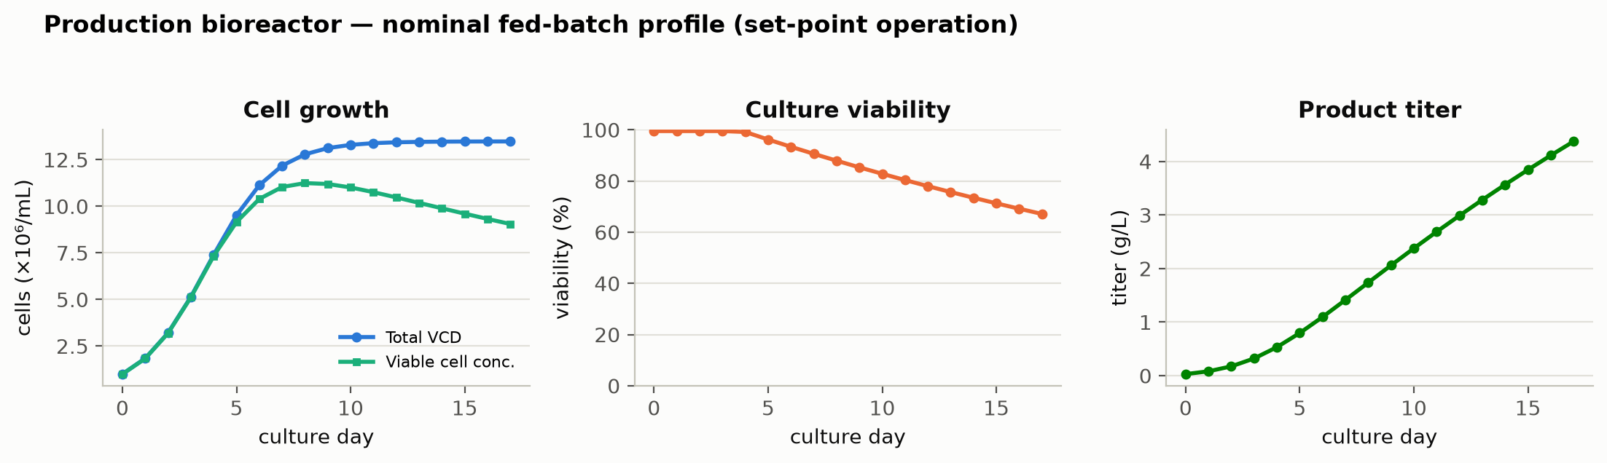
Figure 1: Nominal fed-batch profile of the qualified scale-down model at set-point operation: viable cell density, culture viability and product titer.

3.2 Cell line, media and culture operation
The production culture of every run was inoculated from an N-1 seed bioreactor at an initial viable cell concentration of 1 × 10⁶ cells/mL and operated under SOP-2003. Chemically defined culture medium and nutrient feeds were prepared under SOP-2004 at a basal medium concentration of 1.2 X, with nutrient feed-1 delivered at 12 % of working volume on the platform schedule. Culture pH during the feed was held at 6.85 by carbon dioxide sparging and base addition, temperature at 35 °C by jacket control, and dissolved oxygen at 50 % of air saturation by cascaded gassing.
Raw materials controlled to the platform specification were treated as identity and quality controlled inputs, and none of those materials was characterized as a variable of this study. The one exception among those inputs is nutrient feed-1, whose delivered volume is a settable parameter and was assessed univariately for that reason (§4.4). The cell bank, the medium formulation and the nutrient feed formulation were held constant across every run of both designs, which is the assumption under which every fitted effect reported in §5 is attributed to a studied parameter rather than to a change in the raw materials.

3.3 Analytical methods
Each of the five responses was measured by a validated method on the harvest sample. Of the four methods, the released N-glycan map by 2-AB HILIC-UPLC reports three responses from a single injection, namely afucosylation, galactosylation and high mannose, which removes any between-assay component from a comparison among the three glycan responses. The charge variant response was measured on the same sample by imaged capillary isoelectric focusing (icIEF), with the acidic variant group reported as the summed area of the peaks eluting ahead of the main peak. The aggregate peak was measured as the high molecular weight fraction by SEC-HPLC, and the result was reported as a percentage of the total integrated peak area. The two process impurities were measured separately, host cell protein by ELISA and residual DNA by qPCR, both on the clarified harvest instead of on the bioreactor broth.
Table 5: Validated analytical methods supporting the study.
Reference | Title | Type
AMV-3010 | N-Glycan Map (2-AB HILIC-UPLC) | Method validation
AMV-3011 | Size-Variants (SEC-HPLC) | Method validation
AMV-3012 | Host-Cell Protein ELISA | Method validation
AMV-3013 | Charge Variants (icIEF) | Method validation
AMV-3014 | Residual DNA (qPCR) | Method validation

The attribute to method assignment is given in Table 36 and the recorded method performance in Table 37, both of them in Appendix D. Method performance is not restated in the body of this report, because the validation reports listed in Table 5 hold the full data for each method.

3.4 Sampling plan
Every run of both designs was sampled once, at harvest, and each harvest sample was then split between the four validated methods listed in Table 5. Sampling at harvest matches the point at which the attributes leave the step, which is also the point the scale-down model was qualified against (§3.1). In-process samples were drawn from the same cultures daily, for growth, viability, titer, pH, dissolved oxygen and dissolved CO2. In this report those daily in-process results are held with the operating record and are kept out of the response models.
Between them, the two designs were given 3 and 4 centre-point replicates respectively, with the centre-point runs distributed through the execution sequence in each case. Run order within each design was randomized under SOP-1002, which protects the effect estimates against any drift in the analytical methods or in the culture system over the campaign.

3.5 Statistical methods
Factors were coded so that the set-point maps to 0 and the edges of the characterization range map to −1 and +1. By coding the factors in that way, the estimates are placed on a common scale, on which a coefficient is the change in the response over half the characterized range of that factor. The screening data for each response were fitted on that coded scale by ordinary least squares, with all main effects and all two-factor interactions, which gives 16 terms on 19 runs and leaves 3 residual degrees of freedom. An effect is reported as twice the coefficient on the coded factor, which is the change across the full characterized range. The response surface data were fitted with a full quadratic model of 15 terms on 28 runs, leaving 13 residual degrees of freedom.
Significance of every term was assessed at α = 0.05 throughout both designs. That significance threshold was not adjusted for the number of terms estimated. Model adequacy was judged on R², adjusted R², predicted R² from the PRESS statistic, the overall F test, and an analysis of variance partitioning the residual into lack of fit and pure error against the centre-point replicates of each design (Table 16). A factor whose terms reach no significance in that analysis is reported as inactive over the range screened. Such a null result is retained in the knowledge space as evidence of robustness, because a parameter shown to be inactive over a wide range would otherwise have to be established again later in the lifecycle, at greater cost and with less supporting data behind it.
Commercial-scale capability was estimated on the same fitted models, by simulating 2,000 batches with every parameter drawn from inside its normal operating range and with the fitted models propagated through the train to the drug substance. Capability is reported as a one-sided Cpk against the drug substance criterion, taken on the binding side of the specification. No numerical acceptance threshold for Cpk is defined in this package. Each Cpk index is accordingly reported alongside the margin to the limit, which is what a reviewer needs in order to judge it directly.

4. Study design

4.1 Factors, ranges and the knowledge space
The 9 parameters carried into the study are listed in Table 6 with the set-point, the normal operating range, the characterization range and the classification reached in §9. For each parameter, the characterization range given there marks the knowledge-space edge. That edge is not a proven acceptable range, because the proven acceptable ranges are computed per attribute in §7 and run narrower than the characterization range in several cases.
Table 6: Production bioreactor parameters, ranges, study type and final classification.
Parameter | Unit | Set-point | NOR | Char. range | Class | Study
Culture pH | pH | 6.85 | 6.75–6.95 | 6.6–7.1 | WC-CPP | multivariate
Culture temperature | °C | 35 | 34.5–35.5 | 34–36 | WC-CPP | multivariate
Dissolved CO2 (pCO2) | mmHg | 100 | 70–130 | 40–160 | WC-CPP | multivariate
Osmolality | mOsm | 400 | 375–425 | 360–440 | WC-CPP | multivariate
Culture duration | days | 17 | 16–18 | 15–19 | WC-CPP | multivariate
Dissolved oxygen | % sat | 50 | 40–60 | 30–70 | KPP | univariate
Initial viable cell conc. | e6 cells/mL | 1 | 0.8–1.2 | 0.5–1.5 | KPP | univariate
Basal medium concentration | X | 1.2 | 1–1.4 | 0.8–1.6 | GPP | univariate
Nutrient feed-1 volume | % WV | 12 | 10–14 | 9–15 | KPP | univariate

5 of the 9 parameters were varied together. The coded letters used for those parameters throughout this report are given in Table 7. The letters follow the screening order and are reused for the response surface terms, which means term AE denotes the same factor pair in both designs and in the appendix tables that carry the full matrices (Appendices A and B).
Table 7: Coded factor legend for the screening and response-surface designs.
Code | Factor | Unit | Studied in
A | Culture pH | pH | screening + RSM
B | Culture temperature | °C | screening + RSM
C | Dissolved CO2 (pCO2) | mmHg | screening + RSM
D | Osmolality | mOsm | screening
E | Culture duration | days | screening + RSM

4.2 Screening design
As executed, a two-level fractional factorial in 5 factors at resolution V was used for screening, augmented with 3 centre points, which gives 16 factorial runs and 19 runs in total. At that resolution every main effect of the five factors stays clear of every two-factor interaction, while each two-factor interaction is aliased only with interactions of three factors or more, which platform experience does not support as active in this expression system at the ranges studied. In a campaign of this kind, a screening experiment is run to identify the parameters with the largest effect on the quality attributes. A screening design of this kind supports no predictive claim. By construction, this type of design cannot resolve curvature. It has to be augmented on the subset of factors shown to move an attribute, which is the purpose of the response surface stage described below. The full coded matrix of that design and the measured responses are given in Appendix A.

4.3 Response-surface design
At the second stage, a face centred central composite layout was used in the 4 factors retained from screening: culture pH, culture temperature, culture duration and dissolved CO2. In total that layout is built from 16 factorial runs, 8 axial runs and 4 centre points, on 28 runs. Face centred axial points were chosen so that no run falls outside the characterization range of any factor, which keeps every run of the design inside the space the scale-down model of §3.1 was qualified over, with no extrapolation involved. The design supports a full quadratic model, in which curvature and two-factor interaction are estimated together over three levels of each factor.
Osmolality was screened but was not carried into the response surface stage. The largest significant screening main effect of osmolality reached 2.55 percentage points across the characterized range, against 3.54 for the smallest of the four factors that were carried forward. Because osmolality was left out of the response surface model, any interaction involving it is represented in this report by the screening estimate alone. That bound is stated again in §11, where it also explains why osmolality keeps a WC-CPP classification on screening evidence (§9).

4.4 Univariate assessment
The remaining 4 parameters were assessed one at a time across the ranges in Table 6: dissolved oxygen, initial viable cell conc., basal medium concentration and nutrient feed-1 volume. Each of them acts on the culture through growth and productivity instead of through the enzymatic chemistry that sets a glycan, which is why a multivariate design would have spent runs resolving interactions that platform experience does not support at this step. Dissolved oxygen and initial viable cell concentration were varied to both edges of the characterization range given in Table 6, with every other parameter held at its set-point throughout. Across a further set of runs, basal medium concentration and nutrient feed-1 volume were varied over their own ranges in the same way. However, neither of them was combined with another parameter in a factorial run.
Over the ranges assessed, no univariate variation of those four parameters moved a quality attribute outside its acceptance criterion. The classification consequences of that univariate work appear in §9, where dissolved oxygen, initial viable cell concentration and nutrient feed-1 volume are classified KPP on process performance grounds, while basal medium concentration is classified GPP.

5. Results

5.1 Centre-point performance and reproducibility
Taken together, the centre-point replicates of both designs reproduce well enough to support the model adequacy tests that follow. The mean, the standard deviation and the coefficient of variation of each response across the 4 centre points of the response surface design are given in Table 8.
Table 8: Centre-point reproducibility of the response-surface design: mean, standard deviation and coefficient of variation per response.
Response | n | Mean | SD | %CV
Afucosylation | 4 | 7.61 | 0.355 | 4.66
Galactosylation | 4 | 25.9 | 2.34 | 9.02
High mannose | 4 | 5.66 | 0.559 | 9.88
Acidic variants | 4 | 21.5 | 0.877 | 4.08
Aggregates (HMW) | 4 | 1.51 | 0.0985 | 6.53

The least precise of those responses is high mannose, at 9.9 % of the mean, while the most precise is acidic variants at 4.1 %. At the screening centre points, the same responses give a similar picture, with high mannose least precise there at 11.5 %. Because the scale-down runs were executed across the whole campaign, these figures carry culture-to-culture variation as well as assay variation, which makes them an upper bound on the assay contribution taken alone. Against those figures, the recorded intermediate precision of the glycan assay reaches 2.5 % relative standard deviation. The validation summary for that method attributes 30 % of the observed variance on those responses to the assay itself (Table 37). The remainder of that variance is culture variation, which is the quantity the lack of fit tests of §5.3 are measured against.

5.2 Screening: factor effects
Across the five responses, only a small number of large effects was resolved by screening. The model summaries for all five responses are given in Table 9. The adjusted R² of those summaries runs high throughout, but the near-saturated design leaves only 3 residual degrees of freedom, which drives the predicted R² negative for every response and leaves the overall F test short of significance on 2 of the 5 responses. Consequently the fits from that design are read as effect estimates and never as predictive models of the step. Those magnitudes are refined by the response surface stage in §5.3, which is where the predictive claim of this report is made.
Table 9: Screening model summaries. Predicted R² is negative throughout, which is the expected behaviour of a near-saturated design.
Response | N | R² | Adj. R² | Pred. R² | F | p-value | RMSE
Afucosylation | 19 | 0.965 | 0.79 | -47.4 | 5.51 | 0.0926 | 1.06
Galactosylation | 19 | 0.998 | 0.988 | -1.33 | 103 | 0.00138 | 0.773
High mannose | 19 | 0.942 | 0.65 | -7.99 | 3.23 | 0.182 | 0.619
Acidic variants | 19 | 0.994 | 0.963 | -0.442 | 32.2 | 0.00766 | 0.957
Aggregates (HMW) | 19 | 0.995 | 0.972 | -2.44 | 42.2 | 0.00515 | 0.0829

Of those five, galactosylation was found to be the most responsive attribute measured. 12 of the 15 terms estimable on that response reach significance at α = 0.05. The largest of them is culture duration at -7.82 percentage points across the characterized range (p = 0.0003). Behind that term, dissolved CO2 follows at -5.79 and culture pH at -4.56, both in the same direction as duration. The pH by duration interaction is larger than either of those main effects at +6.90, which is the first indication in the study that the two factors cannot be ranged independently of one another within the operating region defined in §6 (Table 10).
Table 10: Screening effects on galactosylation, six largest by magnitude.
Term | Effect | Coef. | Std. err. | t | p-value | Sig.
E | -7.82 | -3.91 | 0.193 | -20.2 | 0.000264 | ***
AE | 6.9 | 3.45 | 0.193 | 17.9 | 0.000382 | ***
C | -5.79 | -2.9 | 0.193 | -15 | 0.000644 | ***
A | -4.56 | -2.28 | 0.193 | -11.8 | 0.00131 | **
BD | 3.7 | 1.85 | 0.193 | 9.57 | 0.00242 | **
AC | 3.6 | 1.8 | 0.193 | 9.32 | 0.00261 | **

Acidic variants are governed by dissolved CO2 above every other factor screened. That main effect reaches -8.15 percentage points across the characterized range (p = 0.0004), which is roughly twice the next largest term in the table. Behind that effect, culture pH and culture temperature follow with opposite signs, at -4.17 and +2.97 respectively. Where a culture runs both warm and acidic, the two effects partly cancel.
Table 11: Screening effects on acidic variants, six largest by magnitude.
Term | Effect | Coef. | Std. err. | t | p-value | Sig.
C | -8.15 | -4.08 | 0.239 | -17 | 0.000441 | ***
A | -4.17 | -2.08 | 0.239 | -8.7 | 0.00319 | **
B | 2.97 | 1.48 | 0.239 | 6.19 | 0.00848 | **
D | -2.55 | -1.28 | 0.239 | -5.34 | 0.0129 | *
AB | 1.98 | 0.992 | 0.239 | 4.15 | 0.0255 | *
AC | -1.93 | -0.964 | 0.239 | -4.03 | 0.0275 | *

Afucosylation and aggregate each rest on 3 significant terms of their own. For afucosylation the largest of them is the pH by duration interaction at +2.46 percentage points, ahead of the culture duration main effect at -2.37 (Table 12). For aggregate the ranking is simpler, with culture pH at +0.83 and culture duration at +0.58 well ahead of one small interaction, both of them in the direction the prior expectation of §2.1 predicts (Table 13).
Table 12: Screening effects on afucosylation, six largest by magnitude.
Term | Effect | Coef. | Std. err. | t | p-value | Sig.
AE | 2.46 | 1.23 | 0.266 | 4.62 | 0.0191 | *
E | -2.37 | -1.19 | 0.266 | -4.46 | 0.0209 | *
AC | -1.76 | -0.88 | 0.266 | -3.31 | 0.0455 | *
A | -1.57 | -0.785 | 0.266 | -2.95 | 0.06
B | -1.34 | -0.671 | 0.266 | -2.53 | 0.0858
D | -1.33 | -0.664 | 0.266 | -2.5 | 0.0878

Table 13: Screening effects on aggregates (HMW), six largest by magnitude.
Term | Effect | Coef. | Std. err. | t | p-value | Sig.
A | 0.834 | 0.417 | 0.0207 | 20.1 | 0.000268 | ***
E | 0.578 | 0.289 | 0.0207 | 13.9 | 0.0008 | ***
BE | -0.141 | -0.0705 | 0.0207 | -3.4 | 0.0424 | *
C | 0.116 | 0.058 | 0.0207 | 2.8 | 0.0678
CD | -0.0742 | -0.0371 | 0.0207 | -1.79 | 0.171
AD | -0.0666 | -0.0333 | 0.0207 | -1.61 | 0.206

Of the five responses, high mannose was resolved on the fewest terms. Only 2 terms reach significance, both of them main effects: culture pH at +1.51 percentage points and culture temperature at -1.39. Over the ranges screened, dissolved CO2, osmolality and culture duration stay inactive on this response. That null result was retained in the knowledge space, because it establishes that the attribute of highest criticality among the seven depends on the two parameters held under continuous closed-loop control (Table 14).
Table 14: Screening effects on high mannose, six largest by magnitude.
Term | Effect | Coef. | Std. err. | t | p-value | Sig.
A | 1.51 | 0.756 | 0.155 | 4.89 | 0.0164 | *
B | -1.39 | -0.696 | 0.155 | -4.5 | 0.0205 | *
C | -0.446 | -0.223 | 0.155 | -1.44 | 0.245
BC | 0.369 | 0.185 | 0.155 | 1.19 | 0.318
E | 0.158 | 0.0791 | 0.155 | 0.511 | 0.645
D | -0.139 | -0.0693 | 0.155 | -0.448 | 0.685

The standardized effects for the two glycan responses carrying the most terms are ranked in Figure 2. The contrast between the two panels makes the argument for the design that follows, since galactosylation is moved by four factors and by several of their interactions, whereas afucosylation is dominated by a single interaction and a single main effect of comparable size.
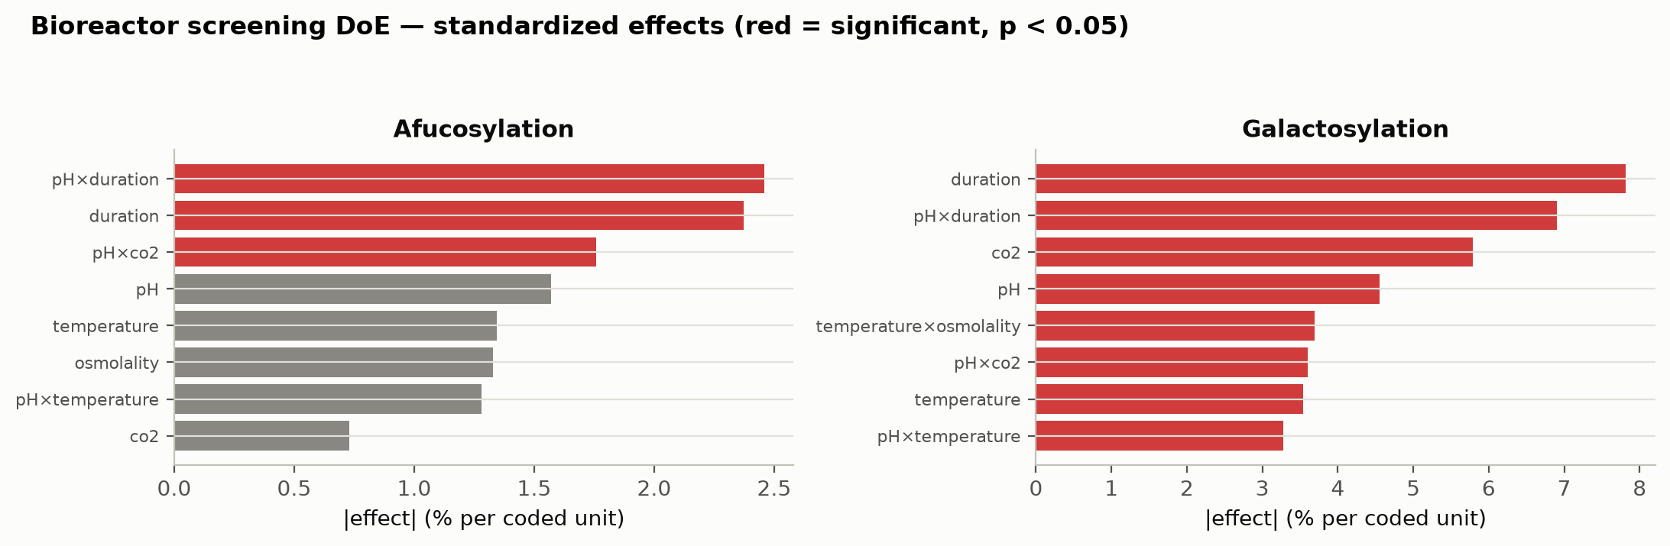
Figure 2: Standardized screening effects on afucosylation and galactosylation. Significant terms are shown in red.

5.3 Response-surface models
The response surface models describe the characterized region adequately. Within that region, those models carry the predictive claim of this report. The model summaries for all five responses are given in Table 15. R² runs from 0.911 to 0.971, at a lowest adjusted R² of 0.815. Across the five responses, every overall F test reaches significance, the weakest of them at p = 0.00012.
Table 15: Response-surface model summaries.
Response | N | R² | Adj. R² | Pred. R² | F | p-value | RMSE
Afucosylation | 28 | 0.963 | 0.923 | 0.795 | 24.3 | 5.05e-07 | 0.584
Galactosylation | 28 | 0.971 | 0.94 | 0.915 | 31.3 | 1.06e-07 | 1.36
High mannose | 28 | 0.911 | 0.815 | 0.65 | 9.48 | 0.000118 | 0.472
Acidic variants | 28 | 0.938 | 0.872 | 0.598 | 14.1 | 1.27e-05 | 1.57
Aggregates (HMW) | 28 | 0.969 | 0.936 | 0.835 | 29.3 | 1.58e-07 | 0.0985

Predicted R² is computed from the PRESS statistic and thus measures how a model behaves at a point it was not fitted to, which separates the five responses more sharply than R² does. The strongest of the five on that measure is galactosylation, at 0.915, well clear of the rest. The weakest is acidic variants at 0.598, a value that still supports interpolation inside the design while leaving less assurance behind a claim made at the edge of it. The same bound is carried by every prediction made for that response below.
No lack of fit test reaches significance against the centre-point pure error. The lack of fit partition for all five responses is set side by side in Table 16. The smallest lack of fit p-value belongs to acidic variants, at 0.15.
Table 16: Lack-of-fit summary for the response-surface models, against the centre-point pure error.
Response | F (lack of fit) | p-value | df (lack of fit) | df (pure error) | RMSE
Afucosylation | 3.23 | 0.182 | 10 | 3 | 0.584
Galactosylation | 0.141 | 0.992 | 10 | 3 | 1.36
High mannose | 0.628 | 0.748 | 10 | 3 | 0.472
Acidic variants | 3.85 | 0.147 | 10 | 3 | 1.57
Aggregates | 1 | 0.568 | 10 | 3 | 0.0985

The lack of fit tests rest on 4 centre-point replicates. Therefore a non-significant result bounds the evidence for the model form without establishing it. For the response with the least margin, the full partition is given in Table 17.
Table 17: Analysis of variance for acidic variants, partitioning the residual into lack of fit and pure error.
Source | Sum sq. | df | Mean sq. | F | p-value
Model | 484 | 14 | 34.6 | 14.1 | 1.27e-05
Residual | 31.9 | 13 | 2.45 | nan | nan
Lack of fit | 29.6 | 10 | 2.96 | 3.85 | 0.147
Pure error | 2.31 | 3 | 0.768 | nan | nan

Coefficient tables for the two glycan responses that drive the operating region are given in Table 18 and Table 19, with the remaining three in Appendix C. For galactosylation, 7 of the 14 model terms reach significance. On that response, culture duration carries the largest coefficient at -3.82 percentage points per coded unit, followed by dissolved CO2 at -2.43 and culture pH at -2.21, while culture temperature runs the other way at +2.30. Three of those interactions reach significance and none of the quadratic terms does, which describes a surface tilted and twisted across this region without being curved within it.
Table 18: Response-surface coefficients for galactosylation.
Term | Coef. | Std. err. | t | p-value | Sig.
Intercept | 25.8 | 0.47 | 54.8 | 9.11e-17 | ***
A | -2.21 | 0.321 | -6.89 | 1.09e-05 | ***
B | 2.3 | 0.321 | 7.18 | 7.13e-06 | ***
E | -3.82 | 0.321 | -11.9 | 2.27e-08 | ***
C | -2.43 | 0.321 | -7.56 | 4.11e-06 | ***
AB | 1.67 | 0.34 | 4.92 | 0.000279 | ***
AE | 2.72 | 0.34 | 7.99 | 2.28e-06 | ***
AC | 2.35 | 0.34 | 6.9 | 1.09e-05 | ***
BE | -0.217 | 0.34 | -0.639 | 0.534
BC | 0.315 | 0.34 | 0.928 | 0.37
EC | 0.332 | 0.34 | 0.975 | 0.347
A² | -0.837 | 0.847 | -0.988 | 0.341
B² | 0.378 | 0.847 | 0.446 | 0.663
E² | 0.937 | 0.847 | 1.11 | 0.289
C² | -0.373 | 0.847 | -0.441 | 0.667

High mannose behaves differently from galactosylation. 4 terms are significant, and culture pH dominates them at +1.09 percentage points per coded unit (p = 2.4e-07). Culture temperature is the only other significant main effect, at -0.42. Because the attribute of highest criticality depends on the two parameters under continuous closed-loop control, the control burden it places on the step is correspondingly light.
Table 19: Response-surface coefficients for high mannose.
Term | Coef. | Std. err. | t | p-value | Sig.
Intercept | 5.89 | 0.163 | 36 | 2.06e-14 | ***
A | 1.09 | 0.111 | 9.77 | 2.36e-07 | ***
B | -0.421 | 0.111 | -3.78 | 0.00227 | **
E | -0.188 | 0.111 | -1.69 | 0.115
C | 0.212 | 0.111 | 1.91 | 0.0788
AB | 0.148 | 0.118 | 1.26 | 0.231
AE | -0.29 | 0.118 | -2.46 | 0.0289 | *
AC | 0.293 | 0.118 | 2.48 | 0.0276 | *
BE | 0.0874 | 0.118 | 0.74 | 0.472
BC | -0.118 | 0.118 | -0.996 | 0.337
EC | -0.0402 | 0.118 | -0.341 | 0.739
A² | 0.116 | 0.294 | 0.393 | 0.701
B² | 0.094 | 0.294 | 0.32 | 0.754
E² | -0.215 | 0.294 | -0.731 | 0.478
C² | 0.126 | 0.294 | 0.43 | 0.674

Among the five responses, afucosylation is the only one on which a quadratic term was resolved. That quadratic term reaches -1.37 per coded unit (p = 0.002), acting together with a pH by duration interaction of +1.32 to give a ridged surface whose maximum sits away from the corners of the design and inside the characterized region. By comparison, the simplest surface of the five was fitted for aggregate, on two significant main effects, culture pH at +0.37 and culture duration at +0.28, alongside a small duration square (Appendix C).
The fitted surfaces over culture pH and culture duration are shown in Figure 3, with culture temperature and dissolved CO2 held at their set-points. The same five responses are shown over culture temperature and dissolved CO2 in Figure 4, with the remaining two factors held at the same values. Read together, the two panels show that no single plane contains the operating problem: high mannose and aggregate are steepest along pH, whereas galactosylation and acidic variants are steepest along duration and dissolved CO2.
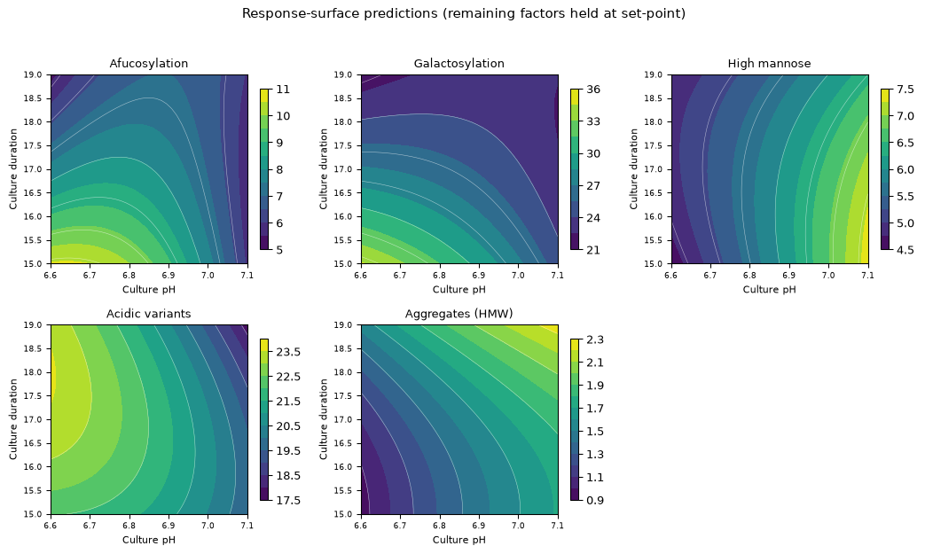
Figure 3: Response-surface predictions over culture pH and culture duration, with culture temperature and dissolved CO2 at their set-points.
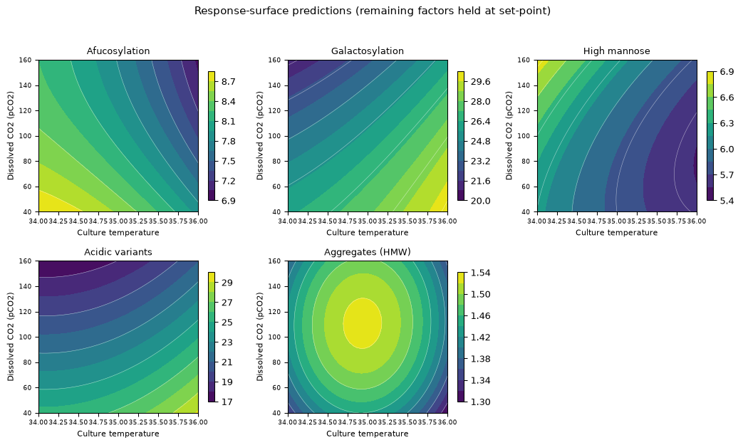
Figure 4: Response-surface predictions over culture temperature and dissolved CO2, with culture pH and culture duration at their set-points.
Model diagnostics for three of those responses are given in Figure 5, Figure 6 and Figure 7. The standardized residuals show no structure against the predicted value, the normal quantile plots are close to linear and the actual against predicted plots sit on the identity line. Furthermore, diagnostics for the remaining two responses were reviewed to the same standard and show the same behaviour.
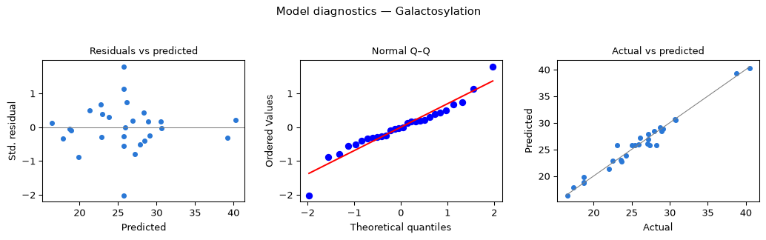
Figure 5: Model diagnostics for galactosylation: standardized residuals against predicted value, normal quantile plot, and actual against predicted.
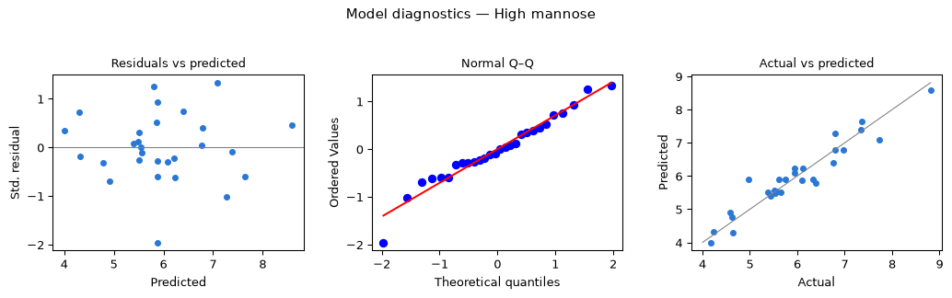
Figure 6: Model diagnostics for high mannose.
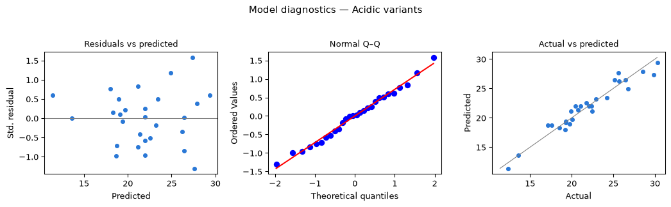
Figure 7: Model diagnostics for acidic variants.

5.4 Mechanistic interpretation
On four of the five responses measured, the fitted surfaces follow the mechanisms set out in §2.1. Galactosylation falls as the culture lengthens, which is what a declining galactosyltransferase activity and a depleting nucleotide sugar pool together predict. Dissolved CO2 acts in the same direction, consistent with the acidification of the Golgi lumen that accompanies a rising carbonate load in the culture. Afucosylation also falls with culture duration, at -1.30 percentage points per coded unit, which matches the platform observation that longer cultures give lower afucosylation. In the same cultures, aggregate rises with both culture pH and culture duration, as expected for a species that accumulates while secreted antibody sits in an ageing broth.
Of the five, high mannose confirms the mechanistic expectation of §2.1 more directly than any other response. The attribute rises with culture pH and falls with culture temperature, which is the signature of incomplete mannosidase trimming, because a higher lumenal pH and a lower temperature both slow the trimming enzymes and leave more of the high-mannose precursor intact at secretion. Neither dissolved CO2 nor culture duration is significant on this response in either design, a null result that localizes the control of the attribute of highest criticality onto two of the nine parameters characterized.
Acidic variants are the exception to that pattern. Dissolved CO2 dominates the response as expected, at -4.09 percentage points per coded unit, but the sign of the culture pH term runs against a simple base-catalysed deamidation argument. Raising culture pH lowers acidic variants by 2.01 percentage points per coded unit. However, the attribute is of very low criticality, at a Tool #1 score of 4, with an acceptance criterion applied as an upper limit of 40 %. The highest value any response surface run reached was 30.3 %. That observation is recorded as an empirical result of the study and is not used to support a mechanism.
Read together, the significant interactions of the model carry the same message as the main effects do. The pH by duration term is significant on afucosylation and on galactosylation, at a magnitude that is large in both. What it means physically is that the consequence of harvesting a day later depends on the pH the culture was held at, because pH sets both the enzyme environment and the growth trajectory that determines how much antibody is made late in the culture. An operating region assembled from independent one-dimensional ranges would miss that dependence entirely, which is why §6 defines a multivariate region instead.

6. Design space
The design space of the step is defined as the multivariate region of the characterized space over which every attribute the step governs stays inside its in-process limit. That region is defined in the 4 well-controlled parameters carried into the response surface design: culture pH, culture temperature, culture duration and dissolved CO2. The principal planes of the region are drawn as culture pH against culture duration (Figure 3) and culture temperature against dissolved CO2 (Figure 4), because those two pairs carry the significant interactions found in §5.3.
Evaluated on a grid of 14,641 points across the coded cube, 57.3 % of the characterized region meets every criterion simultaneously. The region is bound most tightly by galactosylation, which alone rejects 14.3 % of the grid, while the least binding of the five is high mannose at 5.3 %. Since no single attribute rejects more than a sixth of the characterized region while the five of them together reject over two fifths of it, the constraints must act in different directions, which is the interaction argument of §5.4 expressed as a volume.
Geometrically, the corners of the characterized cube are the worst case the region has to survive. All 16 of those corners are evaluated against the in-process limits in Table 20. 3 of them meet every in-process limit at once. The worst of those corners sits at culture pH 6.6, culture temperature 34 °C, culture duration 15 days and dissolved CO2 40 mmHg, where 3 limits are breached at once: afucosylation, galactosylation and acidic variants. At that corner galactosylation is predicted at 39.2 % against an in-process limit of 30.1 %.
Table 20: Predicted performance at the 16 corners of the characterized region, against the in-process limits of §7.
Culture pH | Culture temperature (°C) | Culture duration (days) | Dissolved CO2 (mmHg) | Limits breached | Attribute
6.6 | 34 | 15 | 40 | 3 | Afucosylation, Galactosylation and Acidic variants
6.6 | 34 | 15 | 160 | 1 | Afucosylation
6.6 | 34 | 19 | 40 | 1 | Acidic variants
6.6 | 34 | 19 | 160 | 0 | none
6.6 | 36 | 15 | 40 | 3 | Afucosylation, Galactosylation and Acidic variants
6.6 | 36 | 15 | 160 | 2 | Afucosylation and Galactosylation
6.6 | 36 | 19 | 40 | 1 | Acidic variants
6.6 | 36 | 19 | 160 | 0 | none
7.1 | 34 | 15 | 40 | 0 | none
7.1 | 34 | 15 | 160 | 1 | High mannose
7.1 | 34 | 19 | 40 | 1 | Aggregates
7.1 | 34 | 19 | 160 | 2 | High mannose and Aggregates
7.1 | 36 | 15 | 40 | 1 | Acidic variants
7.1 | 36 | 15 | 160 | 1 | High mannose
7.1 | 36 | 19 | 40 | 2 | Acidic variants and Aggregates
7.1 | 36 | 19 | 160 | 1 | Aggregates

Against the drug substance specifications those corners fare much better. Only 1 corner of the cube fails that criterion. At culture pH 6.6, culture temperature 36 °C, culture duration 15 days and dissolved CO2 40 mmHg, galactosylation is predicted at 40.3 % against a specification of 10 to 40 %. That corner marks the edge of failure of the knowledge space. It lies well outside the operating region defined here.
The region is shown in the culture pH against culture duration plane in Figure 8, with the drug substance acceptance boundaries drawn and the normal operating range marked. In that plane the normal operating range sits inside the characterized region, which in turn sits inside the knowledge space bounded by Table 6. As stated in ICH Q8, working within the design space is not considered a change from a regulatory filing perspective, although every planned move is still assessed prospectively under the pharmaceutical quality system before it is made (International Council for Harmonisation 2009, 2008). Movement outside that region is handled under change control, with supporting data and a prospective assessment of the effect on each governed attribute.
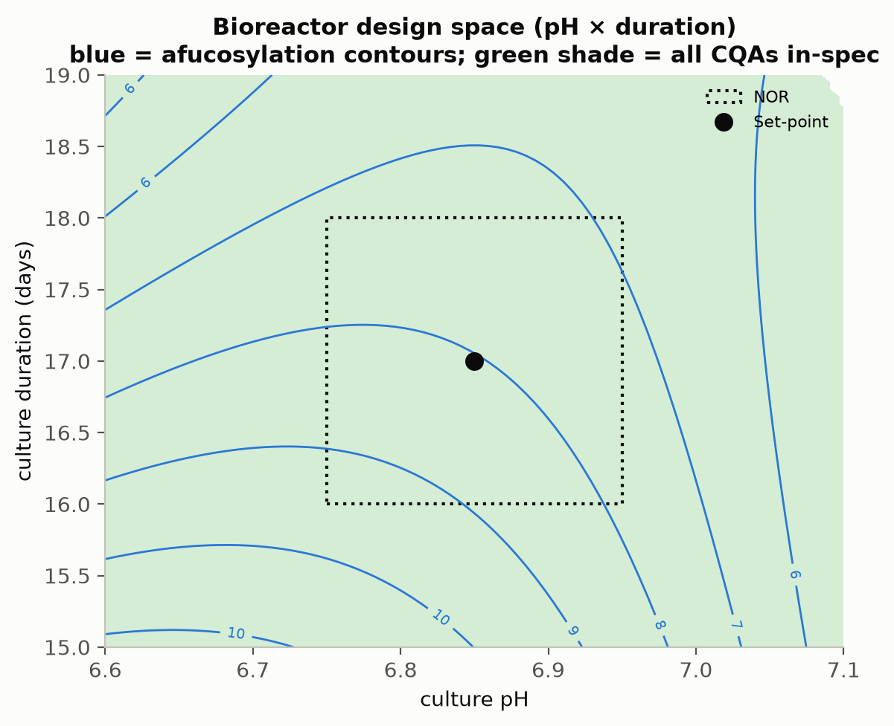
Figure 8: Production-bioreactor operating region in the culture pH and culture duration plane. The shaded region meets every drug substance criterion, dashed lines are the acceptance boundaries and the dotted rectangle is the normal operating range.
Three bounds are attached to the design space claim made above. The region is defined only over the characterized ranges of Table 6. Nothing at all is claimed beyond those ranges. The models behind it were fitted as mean-response models on 28 runs, which makes the reliability at the edge of the shaded region lower than at its centre. Routine operation at the centre of that region is accordingly supported by the capability statement of §8 instead of by the boundary itself. Beyond those two bounds, the whole region rests on the qualified scale-down model of §3.1. Design spaces of this kind are not confirmed at commercial scale at the edges of the ranges.

7. Proven acceptable ranges
The proven acceptable ranges are reported alongside the multivariate region, as a view taken one attribute and one parameter at a time. Each range was measured against the in-process limit of the step instead of the drug substance specification, because an intermediate has to be judged against a criterion that applies to it. For 4 of the 5 responses the in-process limit is derived from the demonstrated commercial-scale capability, as an alert limit 2.5 standard deviations from the simulated mean (§8). For aggregates the limit is carried back instead from the drug substance criterion, through the clearance the downstream train delivers, then divided by an assurance margin of 6.8. The resulting limits appear in the Criterion column of Table 21, against which both proven acceptable range columns were computed.
Two analyses were run against those limits, one for each combination of governed attribute and response surface factor. In the first of those analyses the other factors are held at their set-points, while the parameter of interest is scanned across its characterization range on the fitted response surface model. In the second analysis the other factors are varied within their normal operating ranges by Monte-Carlo of the same model. The proven acceptable range is then taken as the span over which the 95 % predictive interval stays inside the criterion. The second analysis serves as the reproducible default of this package. By construction it bounds the parameter more tightly than the first.
Table 21: Proven acceptable ranges per governed attribute and response-surface factor, at set-point and under normal operating range variation.
CQA | Parameter | Char. range | Unit | Criterion | PAR (set-point) | PAR (NOR)
Afucosylation | Culture pH | 6.6–7.1 | pH | ≤ 9.43 | 6.6–7.1 | 6.82–7.1
Afucosylation | Culture temperature | 34–36 | °C | ≤ 9.43 | 34–36 | 34.7–36
Afucosylation | Culture duration | 15–19 | days | ≤ 9.43 | 15.2–19 | 16.8–19
Afucosylation | Dissolved CO2 (pCO2) | 40–160 | mmHg | ≤ 9.43 | 40–160 | 82–160
Galactosylation | Culture pH | 6.6–7.1 | pH | ≤ 30.1 | 6.6–7.1 | 6.74–7.1
Galactosylation | Culture temperature | 34–36 | °C | ≤ 30.1 | 34–36 | 34–35.5
Galactosylation | Culture duration | 15–19 | days | ≤ 30.1 | 15.2–19 | 16.4–19
Galactosylation | Dissolved CO2 (pCO2) | 40–160 | mmHg | ≤ 30.1 | 40–160 | 74.5–160
High mannose | Culture pH | 6.6–7.1 | pH | ≤ 7.28 | 6.6–7.1 | 6.6–6.94
High mannose | Culture temperature | 34–36 | °C | ≤ 7.28 | 34–36 | 34.1–36
High mannose | Culture duration | 15–19 | days | ≤ 7.28 | 15–19 | 15–19
High mannose | Dissolved CO2 (pCO2) | 40–160 | mmHg | ≤ 7.28 | 40–160 | 40–156
Acidic variants | Culture pH | 6.6–7.1 | pH | ≤ 25.8 | 6.6–7.1 | 6.82–7.1
Acidic variants | Culture temperature | 34–36 | °C | ≤ 25.8 | 34–36 | 34–35.2
Acidic variants | Culture duration | 15–19 | days | ≤ 25.8 | 15–19 | 15–19
Acidic variants | Dissolved CO2 (pCO2) | 40–160 | mmHg | ≤ 25.8 | 46.6–160 | 92.5–160
Aggregates (HMW) | Culture pH | 6.6–7.1 | pH | ≤ 1.86 | 6.6–7.1 | 6.6–6.93
Aggregates (HMW) | Culture temperature | 34–36 | °C | ≤ 1.86 | 34–36 | 34–36
Aggregates (HMW) | Culture duration | 15–19 | days | ≤ 1.86 | 15–18.7 | 15–17.7
Aggregates (HMW) | Dissolved CO2 (pCO2) | 40–160 | mmHg | ≤ 1.86 | 40–160 | 40–160

At set-point, 16 of the 20 attribute and parameter combinations stay acceptable across the whole characterization range, whereas under normal operating range variation that count falls to 4. Under that propagation, the narrowest of those combinations is formed by afucosylation against culture pH. It retains 55 % of the characterized range, running from 6.82 to 7.10 under variation of the other three factors. Four rows are left unaffected by the propagation: high mannose and acidic variants against culture duration, and aggregate against culture temperature and dissolved CO2.
For the operating region, the rows that matter most in that table are the ones that pull in opposite directions. On culture pH the proven acceptable range is bounded below by afucosylation at 6.82 and bounded above by aggregates at 6.93. Because the two bounds come from different attributes, the intersection of the univariate ranges on pH is narrower than any one of them taken alone. The same two-sided squeeze holds on culture duration, where the lower bound comes from afucosylation at 16.8 days while the upper bound comes from aggregates at 17.7 days.
That intersection is narrower than the normal operating range itself on every one of the 4 response surface factors. 3 of the 16 corners of the normal operating range box are predicted to exceed an in-process limit on the mean response. The attributes involved in those corners are afucosylation and galactosylation. That finding is bounded by three considerations. The limits concerned act as alert limits, set 2.5 standard deviations from the demonstrated commercial-scale mean, which means a small fraction of normal operation is expected to reach them by construction. On top of that construction, the Monte-Carlo analysis requires a 95 % predictive interval to sit wholly inside the alert limit, compounding the conservatism a second time. Measured against the drug substance specifications instead, 16 of the 16 corners of the normal operating range box meet every criterion. Those corners are also covered by the capability indices of §8, which carry the margins reported there.
A representative plot is given for each governed attribute, taken against the parameter with the largest response surface main effect on it. In each of those figures the acceptance limit is drawn, the acceptable region is shaded green and the set-point and normal operating range are marked. In every figure the left panel carries the at set-point analysis and the right panel carries the Monte-Carlo analysis.
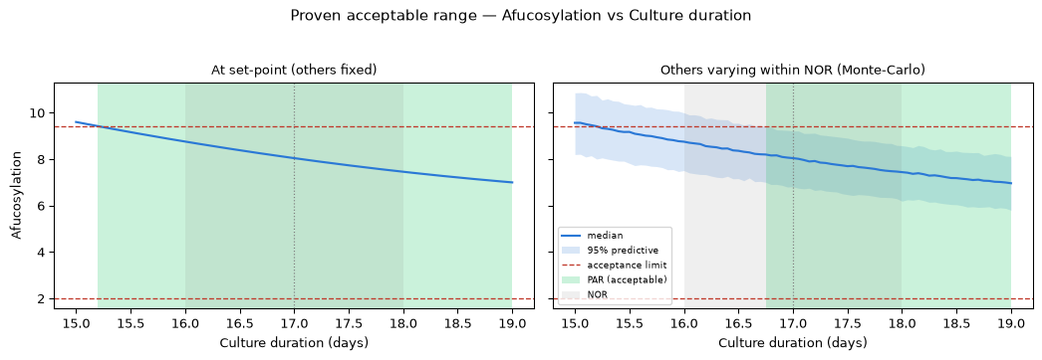
Figure 9: Proven acceptable range for afucosylation against its governing parameter.
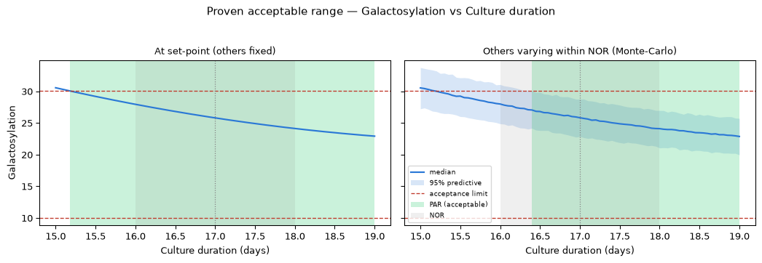
Figure 10: Proven acceptable range for galactosylation against its governing parameter.
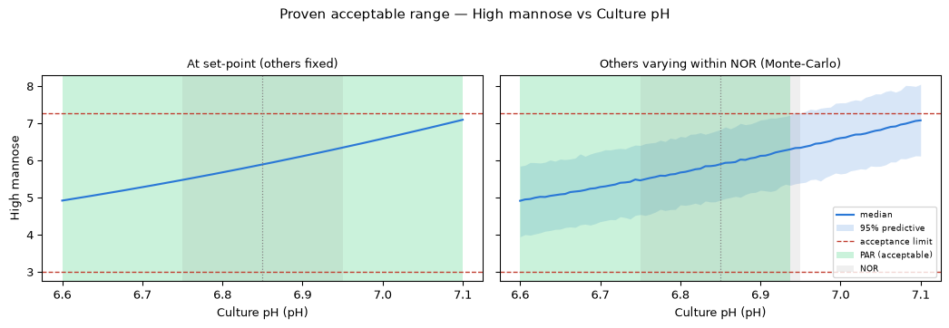
Figure 11: Proven acceptable range for high mannose against its governing parameter.
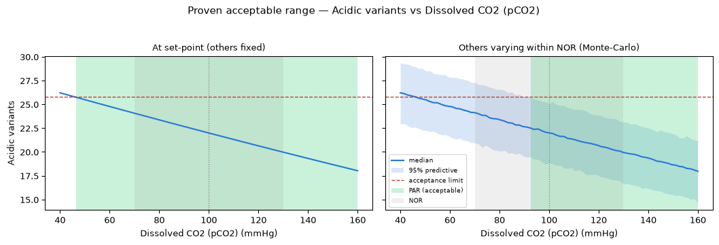
Figure 12: Proven acceptable range for acidic variants against its governing parameter.
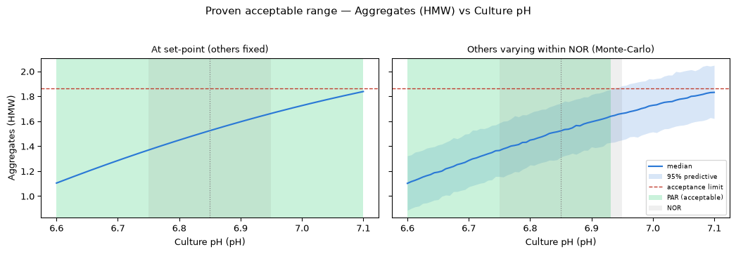
Figure 13: Proven acceptable range for aggregates (HMW) against its governing parameter.
The relationship between these ranges and the region of §6 runs as follows. A proven acceptable range is univariate. It therefore holds only under the conditions of the analysis that produced it. The design space covers the multivariate region instead. Where a whole characterization range is proven acceptable, the binding constraint on operation falls at a multivariate corner instead of on any univariate range. Every range in Table 21 is bounded by the characterization ranges of Table 6 and by the fitted response surface models. None of them is claimed outside those bounds.

8. Process capability and robustness
Commercial-scale capability was estimated from 2,000 simulated batches, with every process parameter drawn from within its normal operating range. The capability outcome for the 7 attributes the step sets is given in Table 22.
Table 22: Commercial-scale capability for the attributes formed at the production bioreactor, from 2,000 simulated batches.
CQA | Crit. | Spec | Acceptance | Mean ± SD | Cpk
Afucosylation | H | two_sided | 2–13 | 7.98 ± 0.58 | 2.89
Galactosylation (total %Gal) | H | two_sided | 10–40 | 26 ± 1.6 | 2.86
High Mannose | VH | two_sided | 3–10 | 5.99 ± 0.51 | 1.94
Aggregates (HMW) | H | upper | 0–5 | 0.753 ± 0.088 | 16.1
Acidic charge variants (deamidation) | VL | upper | 18–40 | 22.3 ± 1.4 | 4.26
Host Cell Protein (HCP) | M-H | upper | 0–100 | 15.2 ± 4.6 | 6.14
Residual DNA | VL | upper | 0–0.001 | 0.0001 ± 0 | 10.8

The tightest capability among those seven attributes belongs to High Mannose, at 1.94. The simulated mean of that attribute sits at 5.99 % against a specification of 3 to 10 %, leaving a margin of 2.99 percentage points to the nearer limit on a standard deviation of 0.51. The binding side of that specification is the lower limit, which follows directly from §5.4: the parameters that lower high mannose are the ones the step holds most closely, which settles the distribution nearer the floor than the ceiling.
The second tightest capability belongs to Galactosylation (total %Gal), at 2.86. By contrast, the remaining attributes sit far from their limits. Their capability indices therefore show only that none of them constrains the process. The furthest of those attributes from a limit is Aggregates (HMW), at 16.1. The capability index of that attribute is reported in Table 22 for completeness.
Host cell protein and residual DNA are listed in Table 22 with indices of 6.1 and 10.8. Neither of those two figures records an achievement of the production bioreactor alone. Both attributes leave the bioreactor far above the drug substance criterion. The clearance that brings both attributes down is credited to Protein A capture (PCR-005), cation exchange (PCR-007) and anion exchange (PCR-008). The contribution of the production bioreactor amounts to the input burden it hands on, which is the quantity those three steps were characterized against.
Two bounds are attached to the capability statement made above. The simulation behind it draws parameters from within the normal operating range, which makes it a description of routine operation instead of the edges of the design space. The models it propagates were fitted on the qualified scale-down model of §3.1. Confirmation of the figures at commercial scale is delivered by the process performance qualification batches of Stage 2.

9. Parameter classification
Every parameter characterized was given a classification, whether or not a significant effect was found for it. The classifications appear in Table 6 and the rationale for each is given below. The classification convention is taken from SOP-4001 and from the decision logic of the case study (CMC Biotech Working Group 2009). A parameter whose variability affects a critical quality attribute becomes a CPP or a WC-CPP, and what separates the two classes is the risk of falling outside the design space instead of the size of the effect.
- Culture pH was classified WC-CPP in Table 6. It carries a significant response surface main effect on 5 of the 5 responses, including the attribute of highest criticality. Because the parameter is measured continuously and controlled to well within its normal operating range (6.75–6.95), the risk of leaving the design space is low.
- Culture temperature was classified WC-CPP on the same control argument, together with a significant response surface effect on 4 responses. The culture is held by jacket control well inside the normal operating range of 34.5–35.5 °C.
- Culture duration was classified WC-CPP. The largest single coefficient anywhere in the study belongs to the duration term on galactosylation, at -3.82 percentage points per coded unit (Table 18). Harvest day remains a scheduled decision instead of a controlled variable, which makes the operating risk procedural and places it under the batch record.
- Dissolved CO2 was classified WC-CPP. It governs acidic variants and carries significant terms on galactosylation as well (Table 18). The range needed to hold that parameter runs wide (70–130 mmHg). The parameter is measured in line against an offline reference, which is the control that detected DEV-003-01 in §12.
- Osmolality was classified WC-CPP on screening evidence alone, which makes it the only parameter in the register classified that way. It reached significance on 2 responses in screening, with a largest effect of 2.55 percentage points, the smallest of the 5 factors. Because the response surface model does not carry it, the classification rests on the screening estimate and on the conservative default RA-001 applies to an attribute-linked parameter.
- Dissolved oxygen was classified KPP. No effect on any quality attribute was found across 30–70 % of air saturation. Because the parameter governs cell growth and titer, it is controlled and monitored for process consistency.
- Initial viable cell concentration was classified KPP on the same basis. It sets the growth trajectory of the culture and with it the productivity of the run, without moving a quality attribute across 0.5–1.5 × 10⁶ cells/mL.
- Nutrient feed-1 volume was classified KPP. The delivered volume drives titer and the late-culture nutrient environment, without moving any quality attribute across the characterized range of 9–15 % of working volume.
- Basal medium concentration was classified GPP. Nothing was detected on any quality attribute or on process performance across 0.8–1.6 X, which allows the parameter to be held to the platform specification without process monitoring.
Finally, no parameter at this step was classified as a CPP. Every quality-linked parameter here is held by instrumented control within a band that is a small fraction of the characterized space, which keeps the risk of an excursion outside the design space low in each of the five cases considered. The null results of those parameters are retained in the knowledge space, because a parameter shown to be inactive over a wide range is evidence of robustness in exactly the way §3.5 describes.

10. Contribution to the control strategy
Four elements are contributed by the step to the control strategy of the drug substance. The first element is the set of parameter ranges in Table 6, in which the 5 WC-CPPs are controlled to normal operating ranges lying inside the design space of §6, while the 3 KPPs are controlled for process consistency rather than for a quality outcome. The second element is in-process monitoring, since culture pH, temperature, dissolved oxygen and dissolved CO2 are recorded continuously, while the in-process limits of §7 give the alert levels against which the performance of a running culture is judged in real time.
The third element the step contributes is analytical control of the harvest material. The five attributes of Table 8 are measured on the harvest material of every batch by the validated methods of Table 5, which links the operating record to the attribute outcome batch by batch. The fourth element is the input control arising from DEV-003-02, under which nutrient feed-1 delivery is verified by mass reconciliation after execution and the feed pump calibration interval has been shortened (§12).
Cross-step credit is owed for three of the seven attributes the step sets. Aggregate formed in the bioreactor is polished principally at cation exchange, which is characterized in PCR-007. Host cell protein and residual DNA are cleared across Protein A capture (PCR-005), cation exchange and anion exchange (PCR-008). The bioreactor controls the burden handed to those steps, without delivering the drug substance figures of Table 22 by itself. The glycan and charge variant attributes remain the ones for which this step is solely responsible, because no downstream step modifies them.
What the step does not control matters equally to the control strategy. It contributes nothing to the viral safety claim, which rests on low-pH viral inactivation (PCR-006), anion exchange (PCR-008) and small virus retentive filtration (PCR-009), and which is consolidated in PCMR-001. It does not set the drug substance concentration, which is delivered at ultrafiltration and diafiltration (PCR-010). Every control element above holds only while the culture is operated within the ranges characterized here, on the cell bank and the medium formulation held constant throughout this study.

11. Discussion
The bioreactor step is now understood well enough to support the Stage 2 ranges. The 5 factors of that step were ranked in a screening design. The four factors retained from screening are modelled by a response surface design: culture pH, culture temperature, culture duration and dissolved CO2. Across the five responses those models explain between 91 % and 97 % of the observed variation, while the operating region they define covers 57 % of the characterized space (§6). Overall, what the study adds to platform knowledge is the size of each effect for this molecule and the geometry of the acceptable region, neither of which the three prior products could supply.
Confidence in the scale-down model behind those figures rests on the qualification of §3.1 and on the centre-point behaviour of §5.1. The centre points were run across the campaign, at a largest coefficient of variation of 9.9 % on high mannose. Because that figure carries culture variation as well as assay variation, it is the natural yardstick for the lack of fit tests, all of which the models passed (Table 16).
The conclusions drawn above are bounded by three limitations. The first limitation is the response surface factor set, which carries 4 of the 5 screened factors, leaving the temperature by osmolality interaction that screening resolved on galactosylation (Table 10) represented in this report by the screening estimate alone, as stated in §4.3. The second limitation is predictive strength at the edge of the region, where predicted R² is weakest for acidic variants at 0.598, which leaves a prediction made for that response near the boundary with correspondingly less assurance behind it than one made near the centre. The third limitation is scale, since every claim in this report is made on a qualified scale-down model and the design space is not confirmed at commercial scale at the edges of the ranges.
The lack of fit tests rest on 4 centre-point replicates. Therefore a non-significant result bounds the evidence for the model form without establishing it. For this reason the weakest case to watch at scale is acidic variants (p = 0.15).
Two deviations from the plan were recorded during execution and both of them were retained. Neither of them changed a fitted effect, a proven acceptable range or a classification, for the reasons set out in §12. The one deviation that reaches the control strategy is DEV-003-02, whose corrective action added the feed verification step described in §10.
No parameter at this step required the most stringent classification available under SOP-4001. Every quality-linked parameter was classified WC-CPP instead of CPP, because each of them is held by instrumented control well inside the characterized space. Should the control capability at the receiving site prove looser than the capability assumed here, culture pH is the parameter to re-examine first, since it carries significant terms on more responses than any other.

12. Conclusions
The production bioreactor is well characterized and robust over the ranges studied. A multivariate operating region for that step is defined in culture pH, culture temperature, culture duration and dissolved CO2, covering 57 % of the characterized space. Proven acceptable ranges are established for every governed attribute against every response surface factor, at set-point and under normal operating range variation (Table 21).
All 7 attributes formed at the step meet the drug substance acceptance criteria at commercial scale. The tightest of those capabilities reaches 1.94 for High Mannose, with a margin of 2.99 percentage points to the nearer limit. Of the 9 parameters classified, 5 are WC-CPP, 3 are KPP and 1 is GPP, while none is a CPP. The two deviations recorded during execution were resolved without impact on the region, on the ranges or on the classifications.
The claims above hold over the characterized ranges of Table 6, on the qualified scale-down model of §3.1, and for the cell bank and medium formulation used throughout this study. The step does not deliver the drug substance host cell protein and residual DNA outcomes on its own. It makes no viral clearance claim of any kind. Confirmation at commercial scale is the work of Stage 2. On completion of that work, this report rolls up into PCMR-001.

13. Deviations from the plan
Two deviations from PCP-003 were recorded during execution. Each of them was investigated, root caused, impact assessed and dispositioned before the data were analysed. Both of them were retained, which means the affected runs stayed in the reported analysis. Table 23 holds the register of those two events.
Table 23: Deviation register for the production-bioreactor characterization.
Deviation | Summary | Detected during | Disposition
DEV-003-01 | Dissolved-CO2 probe drift during screening run 4 | in-process monitoring vs offline reference | retained
DEV-003-02 | Nutrient feed-1 under-delivery on a centre-point batch | post-execution mass reconciliation | retained

13.1 DEV-003-01 — dissolved CO2 probe drift
The first of those events began when the in-line dissolved CO2 probe on the scale-down bioreactor read 6.5 mmHg away from the offline reference during screening run 4. That discrepancy was found by the routine comparison of the in-line reading against the offline blood-gas measurement, by which time the run had already completed. Because the control loop held the culture to the in-line reading, the culture experienced a dissolved CO2 level differing from the design level of that run by the same amount.
That discrepancy was attributed by the investigation to drift of probe EQ-BRX-205 between scheduled calibrations. The equipment record confirms that the probe was inside its calibration interval at execution. The probe was recalibrated and re-verified against the offline reference before the response surface design was executed. In addition, the calibration interval for that probe class was shortened as a corrective action.
The impact of the drift is bounded by the size of the offset relative to the design. Since the characterization range of dissolved CO2 spans 40–160 mmHg, an offset of 6.5 mmHg is 0.11 of a coded unit on one of 16 factorial runs. The screening estimates are used to rank factors and never to predict. A perturbation of that size on a single run does not change the ranking from which the response surface factors were selected. The response surface design was executed after recalibration and estimates the dissolved CO2 terms on 28 runs at three levels, which leaves the predictive model of §5.3 and every proven acceptable range derived from it unaffected by this deviation. The deviation was therefore retained.

13.2 DEV-003-02 — nutrient feed-1 under-delivery
The second event was found when post-execution mass reconciliation showed that one centre-point batch of the screening design had received 4.2 % less nutrient feed-1 than the batch record specified, from lot LOT-FED-3120. That shortfall stayed invisible during the run itself, because the feed was delivered on schedule and only the cumulative mass fell short.
The root cause of the shortfall was traced to a calibration offset on the feed pump, confirmed against the pump verification record. The pump was recalibrated and the verification frequency was increased, as described in §10. Moreover, the reconciliation step that detected the shortfall is now performed before the analytical results are released.
The delivered feed volume reached 11.5 % of working volume against a set-point of 12 %, which places it inside the normal operating range of 10–14 % assessed univariately in §4.4. The glycan results for that batch were verified against 3 further determinations by AMV-3010. However, the 95 % confidence half-width of that verification set is 6.21 % of the reported value, which is wider than the shift a 4.2 % feed deficit could produce. No shift attributable to the deviation was resolvable against it. Because the affected batch is a centre point, the consequence of retaining it is a small addition to the pure error term instead of a change to any effect estimate. As a result the lack of fit tests of §5.3 are made more conservative by retaining the batch than they would be by excluding it. The second deviation was retained on that basis.

14. Appendices A-D
The complete design matrices, the full effect and coefficient tables and the analytical method summary are collected in the appendices below. They carry the data behind §5 and §7, without adding any claim that is not already made in the body of this report.

14.1 Appendix A — Screening design matrix and responses
Table 24 gives the coded settings of the screening design and Table 25 the measured responses, both by run number.
Table 24: Screening design, coded factor settings by run.
Run | Type | A | B | C | D | E
1 | factorial | -1 | -1 | -1 | -1 | 1
2 | factorial | -1 | -1 | -1 | 1 | -1
3 | factorial | -1 | -1 | 1 | -1 | -1
4 | factorial | -1 | -1 | 1 | 1 | 1
5 | factorial | -1 | 1 | -1 | -1 | -1
6 | factorial | -1 | 1 | -1 | 1 | 1
7 | factorial | -1 | 1 | 1 | -1 | 1
8 | factorial | -1 | 1 | 1 | 1 | -1
9 | factorial | 1 | -1 | -1 | -1 | -1
10 | factorial | 1 | -1 | -1 | 1 | 1
11 | factorial | 1 | -1 | 1 | -1 | 1
12 | factorial | 1 | -1 | 1 | 1 | -1
13 | factorial | 1 | 1 | -1 | -1 | 1
14 | factorial | 1 | 1 | -1 | 1 | -1
15 | factorial | 1 | 1 | 1 | -1 | -1
16 | factorial | 1 | 1 | 1 | 1 | 1
17 | center | 0 | 0 | 0 | 0 | 0
18 | center | 0 | 0 | 0 | 0 | 0
19 | center | 0 | 0 | 0 | 0 | 0

Table 25: Screening design, measured responses by run.
Run | Afucosylation | Galactosylation | High mannose | Acidic variants | Aggregates (HMW)
1 | 5.18 | 27.9 | 6.61 | 26.4 | 1.3
2 | 8.93 | 36.1 | 6.44 | 26.5 | 0.783
3 | 11.8 | 34.6 | 5.63 | 22.3 | 0.785
4 | 4.83 | 14.7 | 5.46 | 17.9 | 1.48
5 | 9.72 | 41.4 | 4.61 | 27 | 0.859
6 | 4.68 | 27.3 | 4.68 | 27.6 | 1.26
7 | 6.22 | 14.5 | 4.65 | 23.1 | 1.48
8 | 9.83 | 31.2 | 4.45 | 19.3 | 0.948
9 | 9.61 | 28 | 7.77 | 24.1 | 1.51
10 | 7.51 | 17 | 7.89 | 20.4 | 2.26
11 | 7.13 | 19.5 | 7.34 | 12.6 | 2.53
12 | 5.29 | 17.6 | 7.01 | 11.3 | 1.61
13 | 6.74 | 28.3 | 6.43 | 29.6 | 2.18
14 | 5.4 | 26.7 | 5.94 | 24.4 | 1.62
15 | 3.82 | 25.2 | 6.1 | 18.4 | 1.8
16 | 3.08 | 29.1 | 6.15 | 15.8 | 2.05
17 | 7.8 | 26.4 | 5.88 | 21.9 | 1.64
18 | 7.51 | 27.4 | 5.84 | 20 | 1.63
19 | 8.48 | 27 | 7.11 | 21.8 | 1.5

14.2 Appendix B — Response-surface design matrix and responses
Table 26 gives the coded settings of the face centred central composite design and Table 27 the measured responses.
Table 26: Response-surface design, coded factor settings by run.
Run | Type | A | B | E | C
1 | factorial | -1 | -1 | -1 | -1
2 | factorial | -1 | -1 | -1 | 1
3 | factorial | -1 | -1 | 1 | -1
4 | factorial | -1 | -1 | 1 | 1
5 | factorial | -1 | 1 | -1 | -1
6 | factorial | -1 | 1 | -1 | 1
7 | factorial | -1 | 1 | 1 | -1
8 | factorial | -1 | 1 | 1 | 1
9 | factorial | 1 | -1 | -1 | -1
10 | factorial | 1 | -1 | -1 | 1
11 | factorial | 1 | -1 | 1 | -1
12 | factorial | 1 | -1 | 1 | 1
13 | factorial | 1 | 1 | -1 | -1
14 | factorial | 1 | 1 | -1 | 1
15 | factorial | 1 | 1 | 1 | -1
16 | factorial | 1 | 1 | 1 | 1
17 | axial | -1 | 0 | 0 | 0
18 | axial | 1 | 0 | 0 | 0
19 | axial | 0 | -1 | 0 | 0
20 | axial | 0 | 1 | 0 | 0
21 | axial | 0 | 0 | -1 | 0
22 | axial | 0 | 0 | 1 | 0
23 | axial | 0 | 0 | 0 | -1
24 | axial | 0 | 0 | 0 | 1
25 | center | 0 | 0 | 0 | 0
26 | center | 0 | 0 | 0 | 0
27 | center | 0 | 0 | 0 | 0
28 | center | 0 | 0 | 0 | 0

Table 27: Response-surface design, measured responses by run.
Run | Afucosylation | Galactosylation | High mannose | Acidic variants | Aggregates (HMW)
1 | 9.43 | 38.8 | 5.44 | 29.8 | 0.827
2 | 11.8 | 29 | 5.55 | 17.6 | 0.791
3 | 4.5 | 25.9 | 5.65 | 25.1 | 1.33
4 | 5.38 | 16.6 | 5.38 | 20 | 1.37
5 | 10.4 | 40.5 | 4.23 | 25.6 | 0.803
6 | 10.1 | 30.7 | 4.17 | 19.8 | 0.707
7 | 5.12 | 27.1 | 4.63 | 30.3 | 1.24
8 | 6.13 | 17.4 | 4.64 | 21.8 | 1.41
9 | 8.92 | 22 | 6.79 | 22.9 | 1.5
10 | 5.89 | 18.7 | 8.81 | 13.6 | 1.53
11 | 8.05 | 18.7 | 6.11 | 19.3 | 1.99
12 | 5.17 | 18.7 | 7.34 | 12.3 | 2.15
13 | 5.41 | 28.7 | 6.97 | 28.5 | 1.45
14 | 2.84 | 29.1 | 7.36 | 18.5 | 1.7
15 | 6.2 | 25.4 | 5.95 | 26.5 | 2.08
16 | 4.19 | 27.2 | 6.8 | 17.2 | 2.01
17 | 7.82 | 26.1 | 4.59 | 24.2 | 1.15
18 | 6.07 | 23.7 | 7.72 | 19.3 | 1.82
19 | 8.77 | 24.3 | 6.75 | 19.9 | 1.51
20 | 7.55 | 27.9 | 5.51 | 26.8 | 1.32
21 | 10.3 | 30.8 | 6.11 | 20.8 | 1.3
22 | 6.89 | 22.5 | 5.54 | 22.4 | 2.06
23 | 8.48 | 27.1 | 6.39 | 25.7 | 1.5
24 | 8.39 | 23.5 | 5.94 | 19.2 | 1.45
25 | 7.88 | 23 | 5.75 | 20.5 | 1.52
26 | 7.95 | 27.3 | 6.32 | 22 | 1.6
27 | 7.35 | 25 | 5.6 | 22.4 | 1.55
28 | 7.27 | 28.2 | 4.96 | 21.1 | 1.37

14.3 Appendix C — Full effect and coefficient tables
The complete screening effect tables for all five responses follow, then the response-surface coefficient tables for the three responses not shown in §5.3.
Table 28: Complete screening effect table for afucosylation.
Term | Effect | Coef. | Std. err. | t | p-value | Sig.
AE | 2.46 | 1.23 | 0.266 | 4.62 | 0.0191 | *
E | -2.37 | -1.19 | 0.266 | -4.46 | 0.0209 | *
AC | -1.76 | -0.88 | 0.266 | -3.31 | 0.0455 | *
A | -1.57 | -0.785 | 0.266 | -2.95 | 0.06
B | -1.34 | -0.671 | 0.266 | -2.53 | 0.0858
D | -1.33 | -0.664 | 0.266 | -2.5 | 0.0878
AB | -1.28 | -0.64 | 0.266 | -2.41 | 0.0952
C | -0.73 | -0.365 | 0.266 | -1.37 | 0.264
BD | 0.452 | 0.226 | 0.266 | 0.85 | 0.458
BE | 0.362 | 0.181 | 0.266 | 0.681 | 0.545
AD | -0.175 | -0.0876 | 0.266 | -0.329 | 0.764
BC | -0.171 | -0.0856 | 0.266 | -0.322 | 0.769
CD | -0.147 | -0.0736 | 0.266 | -0.277 | 0.8
DE | 0.0358 | 0.0179 | 0.266 | 0.0674 | 0.951
CE | 0.0118 | 0.00591 | 0.266 | 0.0222 | 0.984

Table 29: Complete screening effect table for galactosylation.
Term | Effect | Coef. | Std. err. | t | p-value | Sig.
E | -7.82 | -3.91 | 0.193 | -20.2 | 0.000264 | ***
AE | 6.9 | 3.45 | 0.193 | 17.9 | 0.000382 | ***
C | -5.79 | -2.9 | 0.193 | -15 | 0.000644 | ***
A | -4.56 | -2.28 | 0.193 | -11.8 | 0.00131 | **
BD | 3.7 | 1.85 | 0.193 | 9.57 | 0.00242 | **
AC | 3.6 | 1.8 | 0.193 | 9.32 | 0.00261 | **
B | 3.54 | 1.77 | 0.193 | 9.17 | 0.00274 | **
AB | 3.28 | 1.64 | 0.193 | 8.49 | 0.00343 | **
D | -2.45 | -1.23 | 0.193 | -6.35 | 0.0079 | **
CD | 2.18 | 1.09 | 0.193 | 5.64 | 0.011 | *
DE | 1.93 | 0.963 | 0.193 | 4.98 | 0.0155 | *
BE | 1.49 | 0.747 | 0.193 | 3.87 | 0.0306 | *
AD | -0.195 | -0.0974 | 0.193 | -0.504 | 0.649
BC | -0.131 | -0.0657 | 0.193 | -0.34 | 0.756
CE | 0.119 | 0.0596 | 0.193 | 0.309 | 0.778

Table 30: Complete screening effect table for high mannose.
Term | Effect | Coef. | Std. err. | t | p-value | Sig.
A | 1.51 | 0.756 | 0.155 | 4.89 | 0.0164 | *
B | -1.39 | -0.696 | 0.155 | -4.5 | 0.0205 | *
C | -0.446 | -0.223 | 0.155 | -1.44 | 0.245
BC | 0.369 | 0.185 | 0.155 | 1.19 | 0.318
E | 0.158 | 0.0791 | 0.155 | 0.511 | 0.645
D | -0.139 | -0.0693 | 0.155 | -0.448 | 0.685
AC | 0.0897 | 0.0449 | 0.155 | 0.29 | 0.791
AE | 0.0894 | 0.0447 | 0.155 | 0.289 | 0.792
DE | -0.0718 | -0.0359 | 0.155 | -0.232 | 0.831
CE | -0.0552 | -0.0276 | 0.155 | -0.179 | 0.87
BE | 0.046 | 0.023 | 0.155 | 0.149 | 0.891
AB | 0.0432 | 0.0216 | 0.155 | 0.14 | 0.898
AD | -0.0239 | -0.012 | 0.155 | -0.0774 | 0.943
CD | -0.0232 | -0.0116 | 0.155 | -0.075 | 0.945
BD | -0.000576 | -0.000288 | 0.155 | -0.00186 | 0.999

Table 31: Complete screening effect table for acidic variants.
Term | Effect | Coef. | Std. err. | t | p-value | Sig.
C | -8.15 | -4.08 | 0.239 | -17 | 0.000441 | ***
A | -4.17 | -2.08 | 0.239 | -8.7 | 0.00319 | **
B | 2.97 | 1.48 | 0.239 | 6.19 | 0.00848 | **
D | -2.55 | -1.28 | 0.239 | -5.34 | 0.0129 | *
AB | 1.98 | 0.992 | 0.239 | 4.15 | 0.0255 | *
AC | -1.93 | -0.964 | 0.239 | -4.03 | 0.0275 | *
BE | 1.73 | 0.865 | 0.239 | 3.61 | 0.0364 | *
AD | -0.669 | -0.335 | 0.239 | -1.4 | 0.256
CE | -0.494 | -0.247 | 0.239 | -1.03 | 0.378
CD | -0.492 | -0.246 | 0.239 | -1.03 | 0.379
BD | -0.215 | -0.108 | 0.239 | -0.449 | 0.684
BC | 0.151 | 0.0757 | 0.239 | 0.316 | 0.773
DE | 0.0324 | 0.0162 | 0.239 | 0.0676 | 0.95
E | 0.0235 | 0.0117 | 0.239 | 0.049 | 0.964
AE | 0.0226 | 0.0113 | 0.239 | 0.0472 | 0.965

Table 32: Complete screening effect table for aggregates.
Term | Effect | Coef. | Std. err. | t | p-value | Sig.
A | 0.834 | 0.417 | 0.0207 | 20.1 | 0.000268 | ***
E | 0.578 | 0.289 | 0.0207 | 13.9 | 0.0008 | ***
BE | -0.141 | -0.0705 | 0.0207 | -3.4 | 0.0424 | *
C | 0.116 | 0.058 | 0.0207 | 2.8 | 0.0678
CD | -0.0742 | -0.0371 | 0.0207 | -1.79 | 0.171
AD | -0.0666 | -0.0333 | 0.0207 | -1.61 | 0.206
AB | -0.0593 | -0.0297 | 0.0207 | -1.43 | 0.248
DE | -0.0554 | -0.0277 | 0.0207 | -1.34 | 0.274
D | -0.0548 | -0.0274 | 0.0207 | -1.32 | 0.278
BD | -0.0547 | -0.0274 | 0.0207 | -1.32 | 0.278
AE | 0.0416 | 0.0208 | 0.0207 | 1 | 0.39
BC | -0.0235 | -0.0118 | 0.0207 | -0.567 | 0.61
CE | 0.0222 | 0.0111 | 0.0207 | 0.537 | 0.629
B | -0.00671 | -0.00336 | 0.0207 | -0.162 | 0.882
AC | -0.00663 | -0.00332 | 0.0207 | -0.16 | 0.883

Table 33: Complete response-surface coefficient table for afucosylation.
Term | Coef. | Std. err. | t | p-value | Sig.
Intercept | 8.04 | 0.202 | 39.8 | 5.74e-15 | ***
A | -0.997 | 0.138 | -7.24 | 6.52e-06 | ***
B | -0.551 | 0.138 | -4 | 0.00151 | **
E | -1.3 | 0.138 | -9.45 | 3.45e-07 | ***
C | -0.367 | 0.138 | -2.67 | 0.0194 | *
AB | -0.63 | 0.146 | -4.32 | 0.000837 | ***
AE | 1.32 | 0.146 | 9.06 | 5.6e-07 | ***
AC | -0.907 | 0.146 | -6.21 | 3.16e-05 | ***
BE | 0.362 | 0.146 | 2.48 | 0.0277 | *
BC | -0.0703 | 0.146 | -0.481 | 0.638
EC | 0.0322 | 0.146 | 0.221 | 0.829
A² | -1.37 | 0.364 | -3.77 | 0.00233 | **
B² | -0.157 | 0.364 | -0.431 | 0.673
E² | 0.257 | 0.364 | 0.705 | 0.493
C² | 0.117 | 0.364 | 0.323 | 0.752

Table 34: Complete response-surface coefficient table for acidic variants.
Term | Coef. | Std. err. | t | p-value | Sig.
Intercept | 22 | 0.542 | 40.6 | 4.43e-15 | ***
A | -2.01 | 0.369 | -5.44 | 0.000113 | ***
B | 1.9 | 0.369 | 5.14 | 0.000191 | ***
E | -0.124 | 0.369 | -0.335 | 0.743
C | -4.09 | 0.369 | -11.1 | 5.4e-08 | ***
AB | 1.11 | 0.392 | 2.84 | 0.0139 | *
AE | -0.793 | 0.392 | -2.03 | 0.0638
AC | -0.248 | 0.392 | -0.633 | 0.538
BE | 0.655 | 0.392 | 1.67 | 0.118
BC | -0.0111 | 0.392 | -0.0283 | 0.978
EC | 0.465 | 0.392 | 1.19 | 0.256
A² | -0.586 | 0.975 | -0.601 | 0.558
B² | 1.03 | 0.975 | 1.06 | 0.311
E² | -0.718 | 0.975 | -0.736 | 0.475
C² | 0.13 | 0.975 | 0.133 | 0.896

Table 35: Complete response-surface coefficient table for aggregates.
Term | Coef. | Std. err. | t | p-value | Sig.
Intercept | 1.52 | 0.0341 | 44.8 | 1.25e-15 | ***
A | 0.367 | 0.0232 | 15.8 | 7.26e-10 | ***
B | -0.0157 | 0.0232 | -0.675 | 0.512
E | 0.281 | 0.0232 | 12.1 | 1.91e-08 | ***
C | 0.0225 | 0.0232 | 0.971 | 0.349
AB | 0.0135 | 0.0246 | 0.547 | 0.593
AE | -0.0106 | 0.0246 | -0.43 | 0.674
AC | 0.0179 | 0.0246 | 0.727 | 0.48
BE | -0.00713 | 0.0246 | -0.29 | 0.777
BC | 0.00414 | 0.0246 | 0.168 | 0.869
EC | 0.0105 | 0.0246 | 0.426 | 0.677
A² | -0.0533 | 0.0613 | -0.87 | 0.4
B² | -0.119 | 0.0613 | -1.93 | 0.0752
E² | 0.143 | 0.0613 | 2.33 | 0.0366 | *
C² | -0.0626 | 0.0613 | -1.02 | 0.326

14.4 Appendix D — Analytical methods summary
Table 36 maps each quality attribute to the validated method that reports it, while Table 37 gives the recorded performance for the methods whose validation summary is held in this package. The remaining validations are cited in Table 5.
Table 36: Attribute to method assignment.
Quality attribute | Method validation | Technique | Reportable unit
Afucosylation | AMV-3010 | N-Glycan Map (2-AB HILIC-UPLC) | % of glycans
Galactosylation (total %Gal) | AMV-3010 | N-Glycan Map (2-AB HILIC-UPLC) | % (G1+G2 equiv.)
High Mannose | AMV-3010 | N-Glycan Map (2-AB HILIC-UPLC) | % of glycans
Aggregates (HMW) | AMV-3011 | Size-Variants (SEC-HPLC) | % HMW (SEC)
Acidic charge variants (deamidation) | AMV-3013 | Charge Variants (icIEF) | % (CEX/icIEF)
Host Cell Protein (HCP) | AMV-3012 | Host-Cell Protein ELISA | ng/mg
Residual DNA | AMV-3014 | Residual DNA (qPCR) | ng/dose

Table 37: Recorded analytical method performance.
Method validation | Method | Precision (%RSD) | LOQ | LOQ unit | Accuracy (%) | Assay share of variance
AMV-3010 | Released N-Glycan Map (2-AB HILIC-UPLC) | 2.5 | 0.5 | % glycan | 99 | 0.3
AMV-3012 | Host-Cell Protein by ELISA | 9.5 | 1 | ng/mg | 95 | 0.4

References
CMC Biotech Working Group. 2009. A-Mab: A Case Study in Bioprocess Development. CASSS.
International Council for Harmonisation. 2008. ICH Q10: Pharmaceutical Quality System. ICH.
International Council for Harmonisation. 2009. ICH Q8(R2): Pharmaceutical Development. ICH.
International Council for Harmonisation. 2012. ICH Q11: Development and Manufacture of Drug Substances. ICH.
International Council for Harmonisation. 2023. ICH Q9(R1): Quality Risk Management. ICH.
U.S. Food and Drug Administration. 2011. Guidance for Industry: Process Validation — General Principles and Practices. FDA.

