Process Characterization Master Report
  - A-Mab Drug Substance — Stage 1 Process Characterization — PCMR-001
Manufacturing Science & Technology (MSAT) / Process Development
2026-07-24
Table of contents

Field | Value
Document ID | PCMR-001
Document class | Process Characterization Master Report
Title | Process Characterization Master Report — A-Mab Drug Substance
Product | A-Mab
Version | 1.0
Effective date | 2026-07-24
Status | Approved (synthetic)
Document owner | Manufacturing Science & Technology (MSAT)
Sponsor / sites | Novacyte Biologics; Novacyte Biologics — Cambridge, MA (Development) → Novacyte Biologics — Grafton, WI (Commercial DS)
SYNTHETIC DOCUMENT — NOT A REAL RECORD. Illustrative content generated from a seeded model of the A-Mab case study (CMC Biotech Working Group, 2009). Novacyte Biologics and all sites, SOP/AMV numbers and signatories are fictional. For NLP corpus development only; not for any regulated use.

Approvals
Table 1: Approval record (synthetic; signatures not applied).
Role | Function | Name (synthetic) | Signature | Date
Author | Process Development / MSAT | — | — | —
Reviewer | Analytical Development | — | — | —
Reviewer | Manufacturing Science | — | — | —
Reviewer | Statistics | — | — | —
Approver | Quality Assurance | — | — | —

Abbreviations
BLA, Biologics License Application · CPP, critical process parameter · CQA, critical quality attribute · Cpk, process-capability index · DoE, design of experiments · DS, drug substance · GPP, general process parameter · HCP, host-cell protein · ICH, International Council for Harmonisation · KPP, key process parameter · LRV, log-reduction value · MVM, minute virus of mice · MSAT, Manufacturing Science and Technology · NOR, normal operating range · PPQ, process performance qualification · QbD, Quality by Design · WC-CPP, well-controlled CPP · XMuLV, xenotropic murine leukaemia virus.

Executive summary
This Process Characterization Master Report (PCMR-001) consolidates the Stage 1 (Process Design) characterization of the A-Mab drug-substance (DS) process, rolling up the 8 per-unit-operation reports (PCR-003 … PCR-010) into an integrated statement of process understanding, parameter classification, process capability, viral clearance and the overall control strategy. The characterization was executed under the Process Characterization Master Plan (PCMP-001) and the per-unit-operation plans, on qualified scale-down models, following the lifecycle approach to process validation (U.S. Food and Drug Administration 2011; Parenteral Drug Association 2013; International Society for Pharmaceutical Engineering 2023), the Quality-by-Design principles of ICH Q8, Q9, Q10 and Q11 (International Council for Harmonisation 2009, 2023b, 2008, 2012) and the viral-safety expectations of ICH Q5A(R2) (International Council for Harmonisation 2023a), with the process model and quality-attribute framework of the A-Mab case study (CMC Biotech Working Group 2009).
Headline outcomes
- All 37 process parameters across the 8 unit operations were classified on the A-Mab continuum: 1 CPP, 20 WC-CPP, 10 KPP and 6 GPP (21 critical parameters in total). Every classification is supported by data from the characterization studies.
- All 10 drug-substance CQAs meet their acceptance criteria at commercial scale with a process capability of Cpk ≥ 1.51 (all CQAs Cpk ≥ 1.33), the minimum being the cumulative Viral clearance — MVM (parvovirus) clearance.
- The modular viral clearance meets its requirements with margin: cumulative 18.87 log₁₀ (XMuLV) and 10.03 log₁₀ (MVM), delivered orthogonally across the low-pH inactivation, anion-exchange and virus-filtration steps.
- The integrated process delivers an overall DS yield of 83.2% (~54.6 kg of drug substance at 75 g/L) from the 15,000-L production culture.
- Multivariate design spaces were established for the DoE unit operations; the production bioreactor forms the glycan, charge-variant and aggregate CQAs, and the purification train clears the process-related impurities and provides the viral clearance.
The A-Mab drug-substance process is demonstrated to be well understood, robust and in control across its 8 unit operations. The parameter classifications, design spaces, proven acceptable ranges and per-CQA control strategy support the Stage 2 operating ranges and the receiving-site validation (PTP-001); the process is ready for Stage 2 (Process Performance Qualification).

1. Introduction

1.1 Purpose
This master report consolidates the per-unit-operation characterization reports into a single statement of the drug-substance process understanding and control strategy suitable to support a Biologics License Application. It summarizes, across the whole train, the process description and performance, the CQA outcomes, the parameter classification, the process capability, the viral clearance and the overall control strategy, and it establishes Stage-2 readiness. The detailed studies, effects, models and design spaces are in the per-unit-operation reports cited herein.

1.2 Regulatory and scientific basis
The characterization follows the lifecycle approach to process validation (U.S. Food and Drug Administration 2011; Parenteral Drug Association 2013; International Society for Pharmaceutical Engineering 2023) and the enhanced (QbD) approach of ICH Q8, Q9, Q10 and Q11 (International Council for Harmonisation 2009, 2023b, 2008, 2012); viral clearance is credited per ICH Q5A(R2) (International Council for Harmonisation 2023a). Criticality is treated as a continuum (ICH Q9). The report consolidates the Stage 1 Process Design outputs of PDA TR 60 §3.11 across the unit operations.

2. Process description and performance
The A-Mab DS process comprises the 8 unit operations of Table 2, operated at 15,000 L with a nominal titre of 4.37 g/L. The process flow and the principal quality impact of each step are shown in Figure 1.
Table 2: The A-Mab drug-substance process train (Steps 3–10) and each step’s principal role in the control strategy.
Step | Unit operation | Principal role
3 | Production Bioreactor | Forms the glycan, charge-variant and aggregate CQAs (design-space step)
4 | Harvest and Clarification | Primary recovery and clarification; forms no product-quality CQA
5 | Protein A Chromatography | Capture; sets leached Protein A; principal HCP and DNA clearance
6 | Low-pH Viral Inactivation | Low-pH hold; sets the cumulative XMuLV (enveloped) clearance
7 | Cation Exchange Chromatography | Polish; principal aggregate reduction; major HCP/DNA/leached-PA clearance
8 | Anion Exchange Chromatography | Flow-through polish; sets the cumulative MVM clearance; clears XMuLV/HCP/DNA
9 | Small-Virus Retentive Filtration | Dedicated small-virus removal; principal MVM clearance
10 | Ultrafiltration / Diafiltration | Formulation / mass balance; delivers drug substance at target concentration

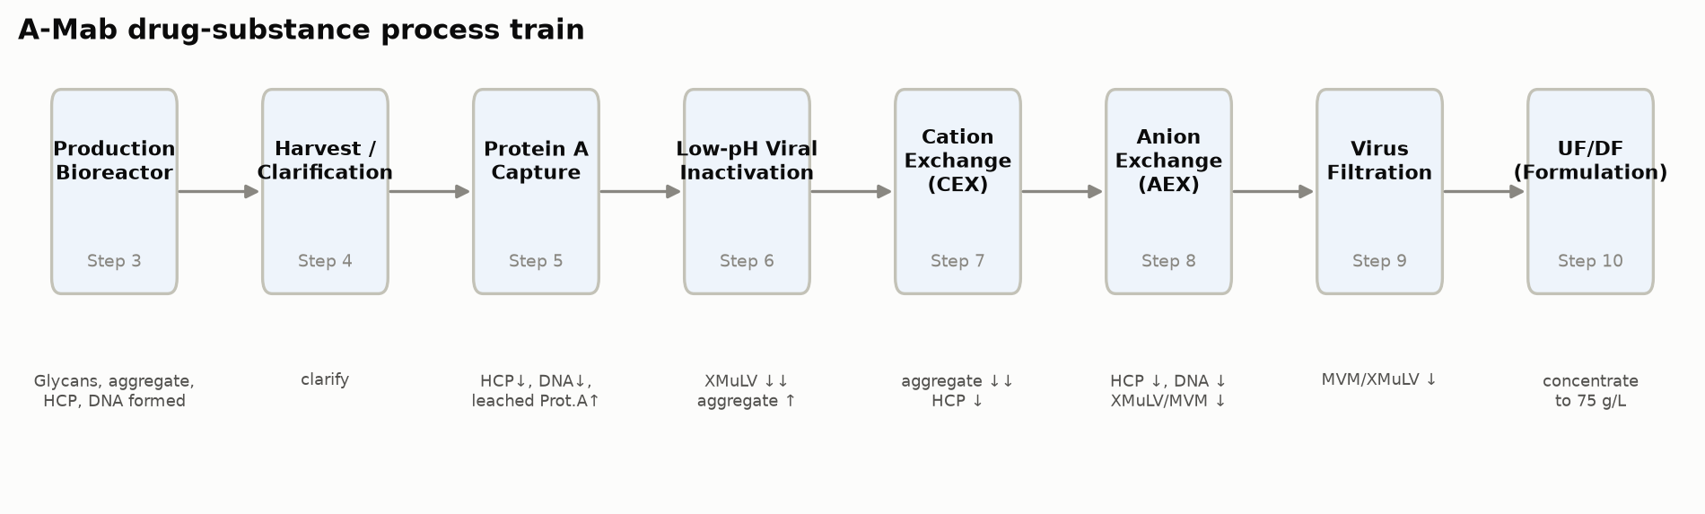
Figure 1: A-Mab drug-substance process flow (Steps 3–10) with the principal quality impact of each unit operation.
The integrated process delivers an overall DS yield of 83.2%, approximately 54.6 kg of drug substance at 75 g/L. The cumulative step-yield across the train is shown in Figure 2.
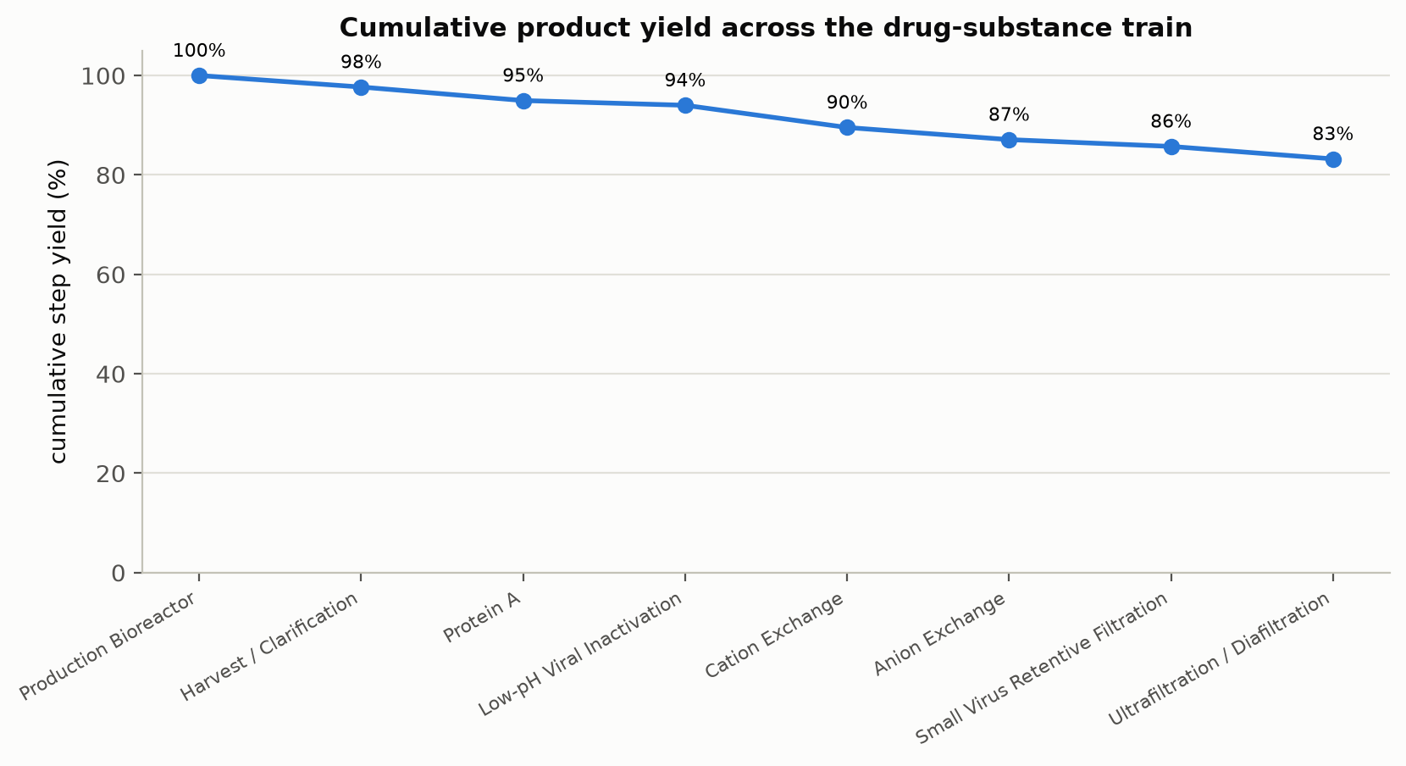
Figure 2: Cumulative product step-yield across the eight modelled unit operations.

3. Consolidated CQA outcomes
The 10 drug-substance CQAs, the unit operation that primarily sets or controls each, and the commercial-scale outcome (mean ± SD and capability against the acceptance criterion) are consolidated in Table 3. Every CQA meets its acceptance criterion with a capability of Cpk ≥ 1.51.
Table 3: Consolidated drug-substance CQA outcomes — the step that primarily sets/controls each CQA and the commercial-scale capability.
CQA | Crit. | Set/controlled by | Acceptance | Mean ± SD | Cpk
Afucosylation | H | Production Bioreactor | 2–13 | 7.98 ± 0.58 | 2.89
Galactosylation (total %Gal) | H | Production Bioreactor | 10–40 | 26 ± 1.6 | 2.86
High Mannose | VH | Production Bioreactor | 3–10 | 5.99 ± 0.51 | 1.94
Aggregates (HMW) | H | Production Bioreactor | 0–5 | 0.753 ± 0.088 | 16.11
Acidic charge variants (deamidation) | VL | Production Bioreactor | 18–40 | 22.3 ± 1.4 | 4.26
Host Cell Protein (HCP) | M-H | Production Bioreactor | 0–100 | 15.2 ± 4.6 | 6.14
Residual DNA | VL | Production Bioreactor | 0–0.001 | 0.0001 ± 0 | 10.81
Leached Protein A | L-M | Protein A Chromatography | 0–5 | 0.003 ± 0.0006 | 2785.30
Viral clearance — XMuLV (enveloped) | VH | Low-pH Viral Inactivation | 16.7–30 | 19.5 ± 0.61 | 1.53
Viral clearance — MVM (parvovirus) | VH | Anion Exchange Chromatography | 8.6–20 | 10.4 ± 0.4 | 1.51

The glycan and charge-variant CQAs (afucosylation, galactosylation, high mannose, acidic variants) are formed and controlled in the production bioreactor within its multivariate design space; the aggregate is formed upstream, can rise during the low-pH hold, and is polished at cation exchange; the process-related impurities (HCP, residual DNA, leached Protein A) are formed upstream and cleared modularly across Protein A, cation exchange and anion exchange; and the viral clearance is delivered orthogonally across the low-pH inactivation, anion-exchange and virus-filtration steps.

4. Parameter classification summary
All 37 process parameters were classified on the A-Mab continuum (Table 4, Figure 3). Of these, 21 are critical (1 CPP and 20 WC-CPP), 10 are KPP and 6 are GPP. The single true CPP is the low-pH viral-inactivation pH — a narrow, high-consequence parameter — while the remaining critical parameters are well-controlled CPPs whose impact is reliably controlled within the operating region.
Table 4: Parameter-classification summary across the train (detail in the per-unit-operation reports).
Classification | Parameters
CPP | 1
WC-CPP | 20
KPP | 10
GPP | 6

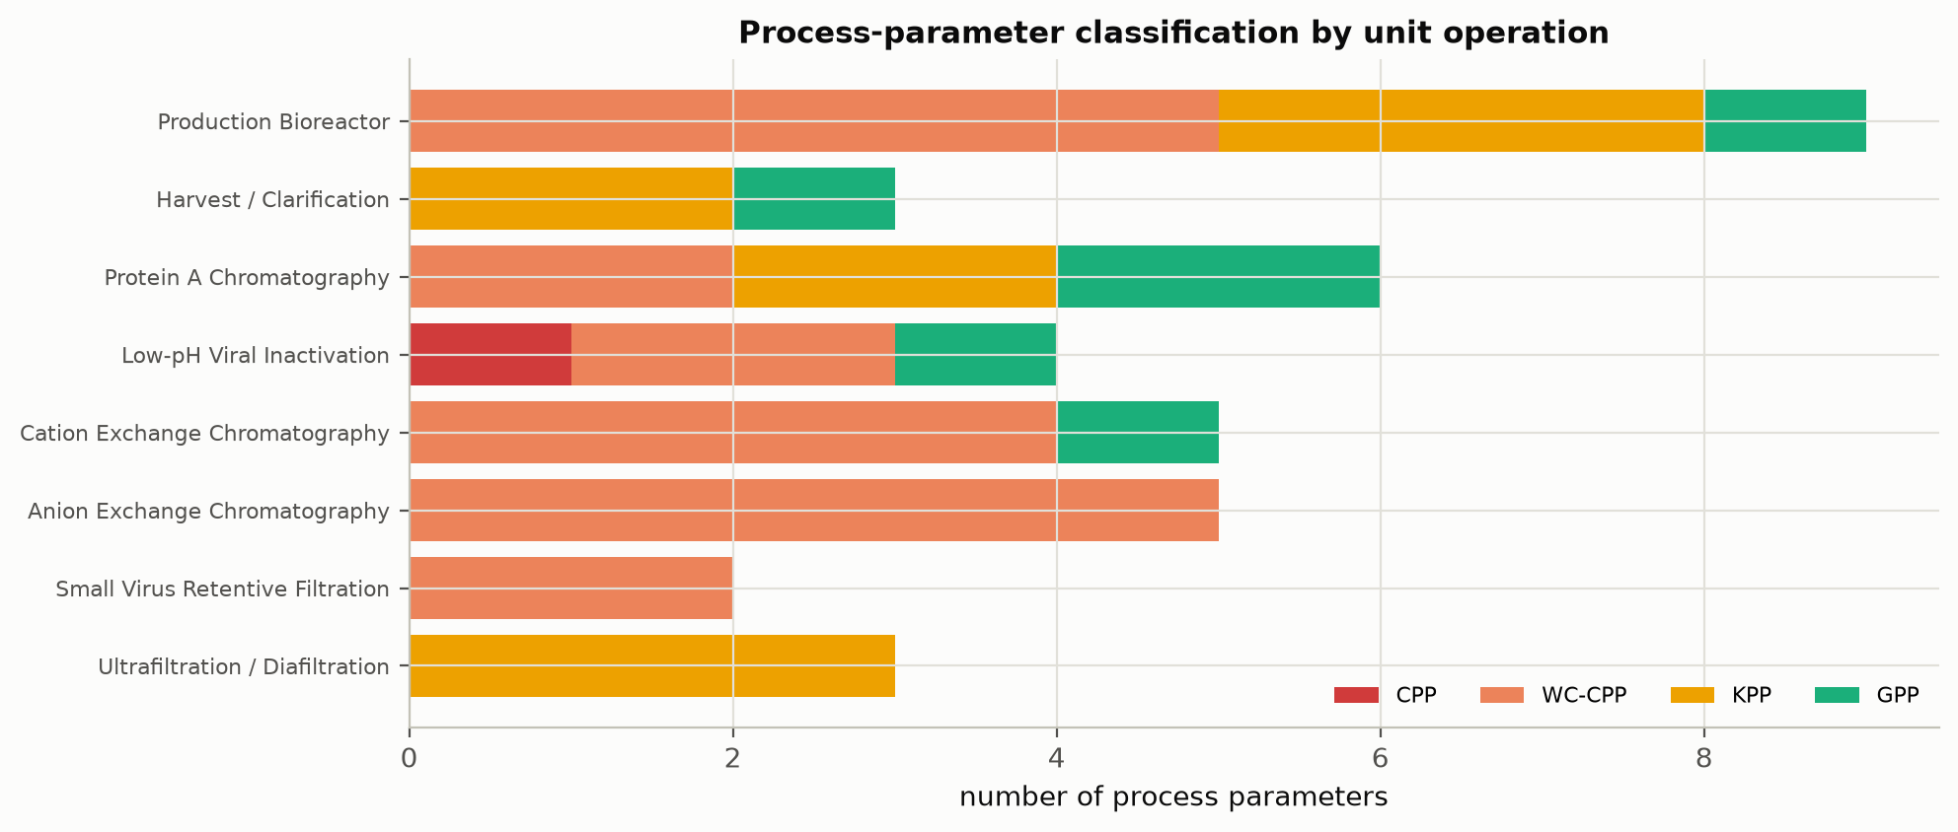
Figure 3: Post-characterization classification of process parameters (CPP / WC-CPP / KPP / GPP) by unit operation.

5. Process capability
Commercial-scale process capability was estimated by Monte-Carlo simulation of 2,000 batches with every parameter varied within its NOR (Figure 4). Every CQA meets its acceptance criterion, with the minimum capability at the cumulative Viral clearance — MVM (parvovirus) clearance (Cpk = 1.51); all CQAs achieve Cpk ≥ 1.33. The capability is confirmed at commercial scale by the Stage-2 PPQ campaign (5 qualification batches as the capability basis).
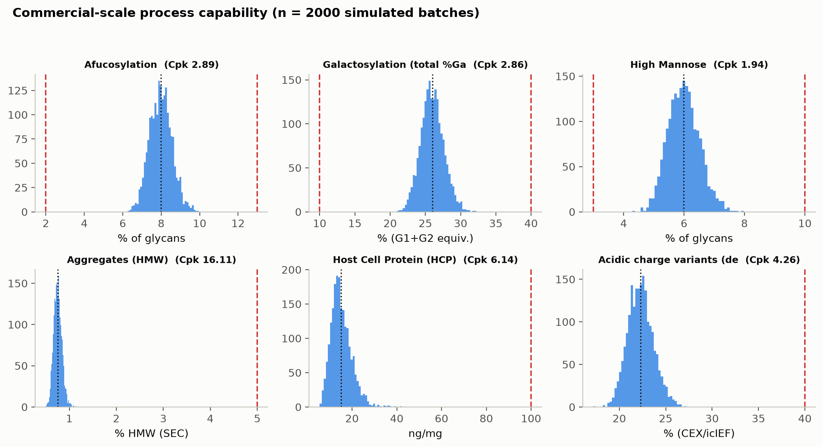
Figure 4: Monte-Carlo drug-substance CQA distributions vs acceptance limits, annotated with process capability (Cpk).

6. Viral clearance summary
The modular viral clearance is delivered by three orthogonal mechanisms — low-pH inactivation, anion-exchange adsorption and small-virus size-exclusion filtration — and credited per ICH Q5A(R2) (International Council for Harmonisation 2023a). The per-step and cumulative log-reductions are consolidated in Table 5 and Figure 5. The cumulative clearance is 18.87 log₁₀ for XMuLV (enveloped retrovirus) and 10.03 log₁₀ for MVM (small non-enveloped parvovirus), both above their cumulative requirements with margin.
Table 5: Modular viral clearance by step and cumulative (log₁₀), for XMuLV and MVM.
step | XMuLV | MVM
Low-pH Viral Inactivation | 7.10 | 0.00
Anion Exchange (AEX) | 5.95 | 4.71
Virus Filtration | 5.82 | 5.32
Cumulative | 18.87 | 10.03

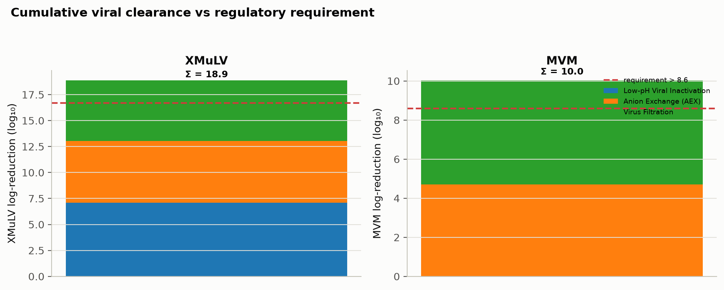
Figure 5: Modular viral clearance by step for XMuLV and MVM; cumulative clearance exceeds the total requirement with margin.

7. Overall control strategy
The overall control strategy is the sum of the individual per-CQA control strategies established across the unit operations. It comprises: control of the 1 CPP and 20 WC-CPPs to their NORs within the established design spaces, with enhanced control of the low-pH-inactivation pH; control of the 10 KPPs for process performance and of the 6 GPPs as general parameters; in-process controls and monitoring at each step; resin and membrane life-cycle control; the modular, orthogonal viral-clearance strategy; and the release and characterization testing of the 10 CQAs. The per-unit-operation contributions are detailed in the reports of Table 6 and are the basis of the drug-substance control strategy transferred to the commercial site (PTP-001).
Table 6: The per-unit-operation Process Characterization Reports consolidated in this master report.
Report | Step | Unit operation
PCR-003 | 3 | Production Bioreactor
PCR-004 | 4 | Harvest and Clarification
PCR-005 | 5 | Protein A Chromatography
PCR-006 | 6 | Low-pH Viral Inactivation
PCR-007 | 7 | Cation Exchange Chromatography
PCR-008 | 8 | Anion Exchange Chromatography
PCR-009 | 9 | Small-Virus Retentive Filtration
PCR-010 | 10 | Ultrafiltration / Diafiltration

8. Conclusions and Stage-2 readiness
The Stage 1 characterization demonstrates that the A-Mab drug-substance process is well understood, robust and in control across its 8 unit operations. All 37 parameters are classified with a data-supported rationale; multivariate design spaces are established for the DoE unit operations; all 10 CQAs meet their acceptance criteria at commercial scale with Cpk ≥ 1.51; and the modular viral clearance meets its requirements with margin (18.87 / 10.03 log₁₀ for XMuLV / MVM). The parameter classifications, design spaces, proven acceptable ranges and per-CQA control strategy support the Stage 2 operating ranges and the receiving-site validation. The process is ready for Stage 2 (Process Performance Qualification); the post-characterization process risk assessment finalizes the CPP selection and the residual-risk position from these outcomes.

References
CMC Biotech Working Group. 2009. A-Mab: A Case Study in Bioprocess Development. CASSS.
International Council for Harmonisation. 2008. ICH Q10: Pharmaceutical Quality System. ICH.
International Council for Harmonisation. 2009. ICH Q8(R2): Pharmaceutical Development. ICH.
International Council for Harmonisation. 2012. ICH Q11: Development and Manufacture of Drug Substances. ICH.
International Council for Harmonisation. 2023a. ICH Q5A(R2): Viral Safety Evaluation of Biotechnology Products Derived from Cell Lines of Human or Animal Origin. ICH.
International Council for Harmonisation. 2023b. ICH Q9(R1): Quality Risk Management. ICH.
International Society for Pharmaceutical Engineering. 2023. Good Practice Guide: Practical Implementation of the Lifecycle Approach to Process Validation. ISPE.
Parenteral Drug Association. 2013. Technical Report No. 60: Process Validation — a Lifecycle Approach. PDA.
U.S. Food and Drug Administration. 2011. Guidance for Industry: Process Validation — General Principles and Practices. FDA.

