Process Characterization Report
  - A-Mab Drug Substance — Protein A Chromatography (Step 5) — PCR-005
Process Development / Manufacturing Science & Technology (MSAT)
2026-07-24
Table of contents

Field | Value
Document ID | PCR-005
Document class | Process Characterization Report
Title | Process Characterization Report: Protein A Chromatography (Step 5)
Product | A-Mab
Version | 1.0
Effective date | 2026-07-24
Status | Approved (synthetic)
Document owner | Manufacturing Science & Technology (MSAT)
Sponsor / sites | Novacyte Biologics; Novacyte Biologics — Cambridge, MA (Development) → Novacyte Biologics — Grafton, WI (Commercial DS)
SYNTHETIC DOCUMENT — NOT A REAL RECORD. Illustrative content generated from a seeded model of the A-Mab case study (CMC Biotech Working Group, 2009). Novacyte Biologics and all sites, SOP/AMV numbers and signatories are fictional. For NLP corpus development only; not for any regulated use.

Approvals
Table 1: Approval record (synthetic; signatures not applied).
Role | Function | Name (synthetic) | Signature | Date
Author | Process Development / MSAT | — | — | —
Reviewer | Analytical Development | — | — | —
Reviewer | Manufacturing Science | — | — | —
Reviewer | Statistics | — | — | —
Approver | Quality Assurance | — | — | —

Abbreviations
ANOVA, analysis of variance · BLA, Biologics License Application · CCD, central-composite design · CEX, cation-exchange chromatography · CPP, critical process parameter · CQA, critical quality attribute · CV, column volume · DoE, design of experiments · DS, drug substance · ELISA, enzyme-linked immunosorbent assay · GPP, general process parameter · HCP, host-cell protein · ICH, International Council for Harmonisation · IPC, in-process control · KPP, key process parameter · MSAT, Manufacturing Science and Technology · NOR, normal operating range · PAR, proven acceptable range · PPQ, process performance qualification · QbD, Quality by Design · RSM, response-surface methodology · SDM, scale-down model · SEC, size-exclusion chromatography · WC-CPP, well-controlled CPP.

Executive summary
This report documents the Stage 1 (Process Design) characterization of the A-Mab Protein A capture chromatography step (Step 5), the affinity-capture operation that binds and concentrates the product from the clarified harvest and is the first and principal purification step for host-cell protein (HCP) and residual DNA. The study was executed under the Process Characterization Plan PCP-005 on a qualified scale-down chromatography column, following the lifecycle approach to process validation (U.S. Food and Drug Administration 2011; Parenteral Drug Association 2013; International Society for Pharmaceutical Engineering 2023) and the Quality-by-Design principles of ICH Q8, Q9 and Q11 (International Council for Harmonisation 2009, 2023, 2012), with the process model, quality-attribute framework and risk methodology of the A-Mab case study (CMC Biotech Working Group 2009).
Six process parameters were evaluated. A 19-run two-level full factorial screening design identified the significant factors and two-factor interactions for the eluate-pool HCP, the step yield and the leached Protein A; a 28-run face-centred central-composite response-surface design then quantified main effects, interactions and curvature and defined the multivariate operating region in the two well-controlled CPPs. The pool-HCP and step-yield response-surface models are adequate and predictive (R² = 0.91–0.99, adjusted R² ≥ 0.82, predicted R² ≥ 0.59); leached Protein A showed no significant parameter effect over the ranges studied and is characterized as robust.
Key outcomes
- Protein load and elution-buffer pH significantly affect the eluate-pool HCP — pool HCP rises at high load and low elution pH, with a significant load × elution-pH interaction (reproducing A-Mab Figure 4.2) — and are classified well-controlled CPP (WC-CPP). Load flow rate and end-of-pool-collect govern the step yield without a product-quality impact and are KPP; operating temperature and bed height are GPP.
- Leached Protein A is introduced at approximately 2.9 ppm at the nominal condition and shows no significant dependence on the studied parameters over their ranges; it is reliably cleared downstream to well below its 5 ppm drug-substance limit.
- The nominal step recovers 97.2% of the loaded product and delivers an eluate-pool HCP of approximately 7,564 ng/mg, which the cation- and anion-exchange polishing steps further reduce to the ≤ 100 ng/mg drug-substance limit.
- A multivariate operating region (design space) in protein load and elution pH was established over which the eluate-pool HCP is controlled so that the integrated control strategy delivers in-specification drug substance, with a commercial-scale HCP capability of Cpk = 6.14.
The Protein A step is demonstrated to be well understood and robust. The operating region, parameter classifications and proven acceptable ranges support the Stage 2 operating ranges and the drug-substance control strategy, and this report rolls up into the Process Characterization Master Report (PCMR-001).

1. Introduction

1.1 Product and unit operation
A-Mab is a humanized IgG1 monoclonal antibody purified by a platform Protein A → low-pH viral-inactivation → cation-exchange → anion-exchange → virus-filtration → UF/DF train (CMC Biotech Working Group 2009). Protein A chromatography is the capture step: the clarified harvest is loaded onto a Protein A affinity resin that binds the Fc region of the antibody, contaminants are removed in the wash, and the product is recovered by a low-pH elution. The step does not form or modify the product-quality CQAs established in cell culture (glycosylation, charge variants, aggregate); its role in the control strategy is to capture and concentrate the product, to provide the first and largest reduction of HCP and residual DNA, and to introduce a single process-related impurity — leached Protein A — that is subsequently cleared. This characterization quantifies how the capture parameters govern the eluate-pool HCP, the step yield and the leached Protein A.

1.2 Objectives
The objectives of the study were to (i) establish the quantitative relationships between the Protein A process parameters and the eluate-pool HCP, the step yield and the leached Protein A; (ii) define the multivariate operating region over which the HCP presented to the polishing steps is controlled; (iii) establish proven acceptable ranges (PARs) and normal operating ranges (NORs) for each parameter; (iv) classify each parameter for its risk of impact to CQAs and to process performance; and (v) provide the process understanding and ranges that justify the Stage 2 operating conditions and the control strategy.

1.3 Regulatory and scientific basis
The work follows the lifecycle approach to process validation of the FDA 2011 guidance (U.S. Food and Drug Administration 2011), PDA Technical Report 60 (Parenteral Drug Association 2013) and the ISPE Good Practice Guide (International Society for Pharmaceutical Engineering 2023), and applies the enhanced (QbD) development approach of ICH Q8, Q9 and Q11 (International Council for Harmonisation 2009, 2023, 2012). Criticality is treated as a continuum (ICH Q9). The report structure corresponds to the Stage 1 Process Design Report of PDA TR 60 §3.11 and provides development-report content suitable to support a Biologics License Application.

2. Prior knowledge and quality risk basis

2.1 Platform and prior-product knowledge
Protein A capture is a platform operation whose behaviour is well established from related humanized IgG1 antibodies (X-Mab, Y-Mab and Z-Mab) and from A-Mab clinical and engineering experience (CMC Biotech Working Group 2009). Prior knowledge established that the eluate HCP burden increases with column loading and with lower elution pH, that the two covary through a load × elution-pH interaction (A-Mab Figure 4.2), that the step recovery is governed by the load flow rate and the extent of the elution pool collected, and that a small, characteristic amount of Protein A leaches from the resin during low-pH elution. This knowledge framed the attributes in scope and the prioritization of parameters for characterization.

2.2 Quality attributes in scope
Protein A introduces one CQA — leached Protein A (Table 2) — and is the principal clearance step for two impurity CQAs that are formed upstream and specified at the drug substance: host-cell protein and residual DNA. Criticality is scored on the A-Mab continuum using Tool #1 (Risk Score = Impact × Uncertainty); attributes rated High (H) or Very High (VH) are treated as Critical (CMC Biotech Working Group 2009).
Table 2: CQA introduced by the Protein A step, with acceptance criterion and criticality (Tool #1 = Impact × Uncertainty).
CQA | Category | Acceptance | Criticality | Tool #1
Leached Protein A | process impurity | 0–5 ppm | L-M | 16

The eluate-pool HCP is not itself a released specification; it is an in-process attribute whose control at this step determines the impurity load presented to the cation- and anion-exchange steps and therefore the margin to the ≤ 100 ng/mg drug-substance HCP limit. It is characterized here as the primary response of the study.

2.3 Risk-based prioritization and parameter selection
Consistent with the A-Mab lifecycle of iterative risk assessments, the characterization scope was set by the Pre-Characterization Process Risk Assessment (RA-001), which used prior knowledge and a risk-ranking-and-filtering screen to prioritize parameters and to assign the study type. Protein load and elution pH, which carry a credible main-effect and interaction risk to the eluate-pool HCP, and the load flow rate and end-of-pool-collect, which govern recovery, were assigned to the multivariate DoE; operating temperature and bed height, expected to affect only process performance over a wide range, were assigned to univariate assessment (CMC Biotech Working Group 2009; Parenteral Drug Association 2013). The parameters and ranges carried into this study are given in Table 4 (§5.1).

3. Materials and methods

3.1 Scale-down model and its qualification
All characterization runs were performed on a qualified scale-down Protein A column operated at the commercial-process equivalents for resin, bed height, residence time, buffer system, load ratio and elution strategy (SOP-2007, SOP-2008). The SDM was qualified against at-scale reference data (SOP-1001) by comparing the operational parameters and, critically, the input and output attributes — step yield, eluate-pool HCP and residual DNA, and leached Protein A — confirming that the model is representative and suitable to support operating-range and PAR claims (Parenteral Drug Association 2013). The between-run reproducibility of the centre-point condition (§6.1) provides a direct estimate of model precision and is used as the pure-error term in the lack-of-fit assessment of every response-surface model.

3.2 Operation
The clarified harvest is loaded onto the equilibrated Protein A column to the target load ratio; the column is washed to remove weakly bound host-cell protein, DNA and media components; and the product is recovered by a low-pH elution, with the eluate pool collected between defined start and end criteria (the end-of-pool-collect, expressed in column volumes). Buffers, resin lot and column packing are controlled to platform specifications (SOP-2008) and are treated as identity/quality-controlled inputs rather than characterized variables, consistent with the A-Mab platform approach (CMC Biotech Working Group 2009).

3.3 Analytical methods
The step responses were measured by validated methods (Table 3). Leached Protein A was determined by ELISA (AMV-3016); host-cell protein by ELISA (AMV-3012); residual host-cell DNA by qPCR (AMV-3014); and aggregate by SEC-HPLC (AMV-3011). Step yield was determined from the load and eluate product mass by protein A₂₈₀. Method performance characteristics are summarized in Appendix D.
Table 3: Validated analytical methods used in the characterization.
Reference | Title | Type
AMV-3016 | Leached Protein A by ELISA (ppm) | Method validation
AMV-3012 | Host-Cell Protein ELISA | Method validation
AMV-3014 | Residual DNA (qPCR) | Method validation
AMV-3011 | Size-Variants (SEC-HPLC) | Method validation

3.4 Sampling plan
Each DoE run was sampled at the eluate pool for HCP, residual DNA and leached Protein A, and the load and pool product mass were recorded for the step-yield determination; in-process readings (pH, conductivity, UV) confirmed the chromatographic profile. Centre-point runs were replicated within each design (three in screening, four in the response-surface design) to quantify reproducibility and pure error.

3.5 Statistical methods
Designs were constructed and analyzed in coded factors, with each parameter’s characterization range mapped so that the set-point is 0 and the range edges are ±1 (SOP-1002). Screening data were analyzed by ordinary-least-squares regression of each response on the main effects and all two-factor interactions; factor effects are reported as twice the coded coefficient. Response-surface data were analyzed with the full quadratic model (main effects, two-factor interactions and pure-quadratic terms). Statistical significance was assessed at α = 0.05. Model adequacy was judged by the coefficient of determination (R²), the adjusted R², the predicted R² (computed from the PRESS statistic by leave-one-out), the overall model F-test, and an analysis of variance partitioning the residual into lack of fit and pure error, the latter estimated from the replicated centre points; a non-significant lack-of-fit F-test (p > 0.05) indicates an adequate model. A response with no significant parameter effect is reported as robust rather than modelled predictively. The operating region was defined as the multivariate region of protein load and elution pH over which the eluate-pool HCP is controlled. Commercial-scale process capability for the drug-substance CQAs governed by the step was estimated by Monte-Carlo simulation of 2,000 batches with each parameter varied within its NOR, reporting the one-sided process-capability index (Cpk) for the impurity CQAs.

4. Study design

4.1 Factors, ranges and the knowledge space
Six parameters were studied (Table 4). The characterization range of each factor (“PAR” column) defines the edges of the explored knowledge space and the basis of the proven acceptable range; the NOR is the tighter range at which the parameter is controlled routinely. The DoE factor coding for the four multivariate factors is given in Table 5.
Table 4: Protein A process parameters, set-points, ranges and post-characterization classification.
Parameter | Unit | Set-point | NOR | PAR | Class | Study
Protein load | g/L resin | 30 | 20–40 | 10–50 | WC-CPP | multivariate
Elution buffer pH | pH | 3.55 | 3.4–3.7 | 3.2–3.9 | WC-CPP | multivariate
Load flow rate | cm/hr | 200 | 150–250 | 100–300 | KPP | multivariate
End of pool collect | CV | 2.6 | 2.3–2.9 | 2–3.2 | KPP | multivariate
Operating temperature | °C | 22 | 18–26 | 15–30 | GPP | univariate
Bed height | cm | 20 | 15–25 | 10–30 | GPP | univariate

Table 5: Design-of-experiments factor legend (coded A–D).
Code | Factor | Unit | Studied in
A | Protein load | g/L resin | screening + RSM
B | Elution buffer pH | pH | screening + RSM
C | Load flow rate | cm/hr | screening + RSM
D | End of pool collect | CV | screening + RSM

4.2 Screening design
Factor screening used a two-level full factorial in the four multivariate factors (A–D) with three centre-point replicates, 19 runs in total. The full factorial estimates all four main effects and all six two-factor interactions without confounding. The three responses recorded for each run were the eluate-pool HCP, the step yield and the leached Protein A. The complete coded design matrix and run responses are given in Appendix A.

4.3 Response-surface design
The four multivariate factors were carried into a face-centred central-composite design (cube points, axial points at the face centres, and four centre-point replicates), 28 runs in total, enabling estimation of curvature in addition to main effects and interactions. The complete coded design matrix and responses are given in Appendix B.

4.4 Univariate assessment
Operating temperature and bed height were evaluated one factor at a time across their characterization ranges for their effect on step yield, eluate-pool HCP and the chromatographic profile; they were not carried into the multivariate design because prior knowledge indicated no credible impact to a product-quality CQA.

5. Results

5.1 Centre-point performance and reproducibility
At the nominal (centre-point) condition the step recovers 97.2% of the loaded product and delivers an eluate-pool HCP of approximately 7,564 ng/mg and a leached Protein A of approximately 2.9 ppm. The between-replicate reproducibility of the centre point (Table 6) is the pure-error estimate used in the lack-of-fit assessment; the coefficients of variation reflect the combined analytical and process variability of the scale-down model.
Table 6: Centre-point reproducibility (response-surface design; n = 4 replicates).
Response | n | Mean | SD | %CV
Pool HCP (ng/mg) | 4 | 7.56e+03 | 357 | 4.72
Step yield | 4 | 0.946 | 0.0187 | 1.97
Leached Protein A (ppm) | 4 | 2.86 | 0.967 | 33.8

5.2 Screening: factor effects
The screening models resolve the active factors and interactions for the eluate-pool HCP and the step yield, and confirm the absence of a significant effect on leached Protein A (Table 7). Consistent with a screening analysis, the magnitudes are refined by the response-surface models (§6.3).
Table 7: Screening-design model summary by response (main effects + two-factor interactions).
Response | N | R² | Adj. R² | Pred. R² | F | p-value | RMSE
Pool HCP (ng/mg) | 19 | 0.973 | 0.939 | 0.886 | 28.6 | 3.49e-05 | 1.4e+03
Step yield | 19 | 0.976 | 0.945 | 0.798 | 32 | 2.28e-05 | 0.00833
Leached Protein A (ppm) | 19 | 0.371 | -0.414 | -2.98 | 0.473 | 0.867 | 0.513

The largest effects are tabulated for the eluate-pool HCP (Table 8) and the step yield (Table 9). Full effect tables for all three responses are given in Appendix C.
Table 8: Largest standardized effects on eluate-pool HCP (screening; effect = 2 × coded coefficient; A = load, B = elution pH, C = flow, D = end-of-collect).
Term | Effect | Coef. | Std. err. | t | p-value | Sig.
B | -8.84e+03 | -4.42e+03 | 350 | -12.6 | 1.45e-06 | ***
A | 7.27e+03 | 3.63e+03 | 350 | 10.4 | 6.4e-06 | ***
AB | -2.59e+03 | -1.29e+03 | 350 | -3.7 | 0.00608 | **
AD | 1.13e+03 | 566 | 350 | 1.62 | 0.144
AC | 830 | 415 | 350 | 1.19 | 0.27
D | 708 | 354 | 350 | 1.01 | 0.341
BD | -433 | -217 | 350 | -0.619 | 0.553
C | 167 | 83.7 | 350 | 0.239 | 0.817

Table 9: Largest standardized effects on step yield (screening).
Term | Effect | Coef. | Std. err. | t | p-value | Sig.
D | 0.0604 | 0.0302 | 0.00208 | 14.5 | 5.01e-07 | ***
A | -0.0255 | -0.0128 | 0.00208 | -6.13 | 0.00028 | ***
C | -0.0237 | -0.0118 | 0.00208 | -5.68 | 0.000463 | ***
AC | -0.0209 | -0.0104 | 0.00208 | -5.01 | 0.00104 | **
CD | -0.0107 | -0.00537 | 0.00208 | -2.58 | 0.0326 | *
BD | -0.00981 | -0.0049 | 0.00208 | -2.36 | 0.0463 | *
AB | 0.00443 | 0.00221 | 0.00208 | 1.06 | 0.319
AD | 0.0037 | 0.00185 | 0.00208 | 0.889 | 0.4

Protein load and elution pH are the active factors for the eluate-pool HCP, with a significant load × elution-pH interaction: the HCP burden in the pool rises steeply when a high load is combined with a low elution pH. The step yield is governed by the end-of-pool-collect (more column volumes collected increases recovery), the load flow rate and the protein load, with a significant load × flow interaction. Leached Protein A shows no significant dependence on any factor over the ranges studied.

5.3 Response-surface models
The full quadratic response-surface models for the eluate-pool HCP and the step yield are adequate and predictive (Table 10): R² = 0.91–0.99, adjusted R² ≥ 0.82, and predicted R² ≥ 0.59, indicating good predictive capability rather than overfitting. For both modelled responses the lack-of-fit F-test was not significant (p > 0.05) relative to the centre-point pure error, confirming model adequacy. The leached-Protein-A response has a low coefficient of determination because it has no systematic parameter effect over the ranges studied — the variation is dominated by run-to-run reproducibility — and the response is therefore reported as robust rather than as a predictive surface.
Table 10: Response-surface model summary by response (full quadratic model).
Response | N | R² | Adj. R² | Pred. R² | F | p-value | RMSE
Pool HCP (ng/mg) | 28 | 0.989 | 0.976 | 0.932 | 80.9 | 2.71e-10 | 895
Step yield | 28 | 0.913 | 0.818 | 0.586 | 9.69 | 0.000105 | 0.016
Leached Protein A (ppm) | 28 | 0.567 | 0.101 | -0.714 | 1.22 | 0.365 | 0.637

The fitted coefficients for the eluate-pool HCP and the step yield are given in Table 11 and Table 12, and the analysis of variance for the eluate-pool HCP — including the lack-of-fit/pure-error partition — in Table 13.
Table 11: Response-surface coefficients for eluate-pool HCP (coded factors A = load, B = elution pH, C = flow, D = end-of-collect).
Term | Coef. | Std. err. | t | p-value | Sig.
Intercept | 7.22e+03 | 309 | 23.3 | 5.44e-12 | ***
A | 3.87e+03 | 211 | 18.4 | 1.12e-10 | ***
B | -5.24e+03 | 211 | -24.9 | 2.4e-12 | ***
C | -435 | 211 | -2.06 | 0.0596
D | -1.06e+03 | 211 | -5 | 0.000242 | ***
AB | -1.9e+03 | 224 | -8.49 | 1.16e-06 | ***
AC | -429 | 224 | -1.92 | 0.0774
AD | -518 | 224 | -2.32 | 0.0376 | *
BC | 348 | 224 | 1.56 | 0.144
BD | 727 | 224 | 3.25 | 0.00632 | **
CD | -129 | 224 | -0.575 | 0.575
A² | -344 | 557 | -0.618 | 0.547
B² | 1.94e+03 | 557 | 3.49 | 0.00401 | **
C² | 851 | 557 | 1.53 | 0.151
D² | 330 | 557 | 0.593 | 0.563

Table 12: Response-surface coefficients for step yield.
Term | Coef. | Std. err. | t | p-value | Sig.
Intercept | 0.947 | 0.00554 | 171 | 3.5e-23 | ***
A | -0.0165 | 0.00377 | -4.36 | 0.000767 | ***
B | -0.00243 | 0.00377 | -0.643 | 0.531
C | -0.00891 | 0.00377 | -2.36 | 0.0346 | *
D | 0.0365 | 0.00377 | 9.68 | 2.62e-07 | ***
AB | 0.00266 | 0.004 | 0.665 | 0.517
AC | -0.00914 | 0.004 | -2.28 | 0.0399 | *
AD | 0.00629 | 0.004 | 1.57 | 0.14
BC | 0.00243 | 0.004 | 0.606 | 0.555
BD | 0.00291 | 0.004 | 0.727 | 0.48
CD | 0.00219 | 0.004 | 0.547 | 0.594
A² | -0.0128 | 0.00997 | -1.29 | 0.221
B² | 0.012 | 0.00997 | 1.2 | 0.252
C² | 0.00681 | 0.00997 | 0.683 | 0.507
D² | -0.0178 | 0.00997 | -1.78 | 0.0976

Table 13: Analysis of variance for the eluate-pool HCP response-surface model, with lack-of-fit and pure-error partition.
Source | Sum sq. | df | Mean sq. | F | p-value
Model | 9.08e+08 | 14 | 6.48e+07 | 80.9 | 2.71e-10
Residual | 1.04e+07 | 13 | 8.01e+05 | nan | nan
Lack of fit | 1e+07 | 10 | 1e+06 | 7.88 | 0.058
Pure error | 3.82e+05 | 3 | 1.27e+05 | nan | nan

The eluate-pool HCP response surface over the two dominant factors (protein load and elution pH) is shown in Figure 1; the response surfaces for all three responses are shown in Figure 2, and the model diagnostics for the pool-HCP and step-yield models in Figure 3 and Figure 4. The residual-versus-predicted and normal-quantile plots show no systematic structure or departure from normality, and the actual-versus-predicted plots lie on the identity line, supporting the use of the models for the operating-region definition.
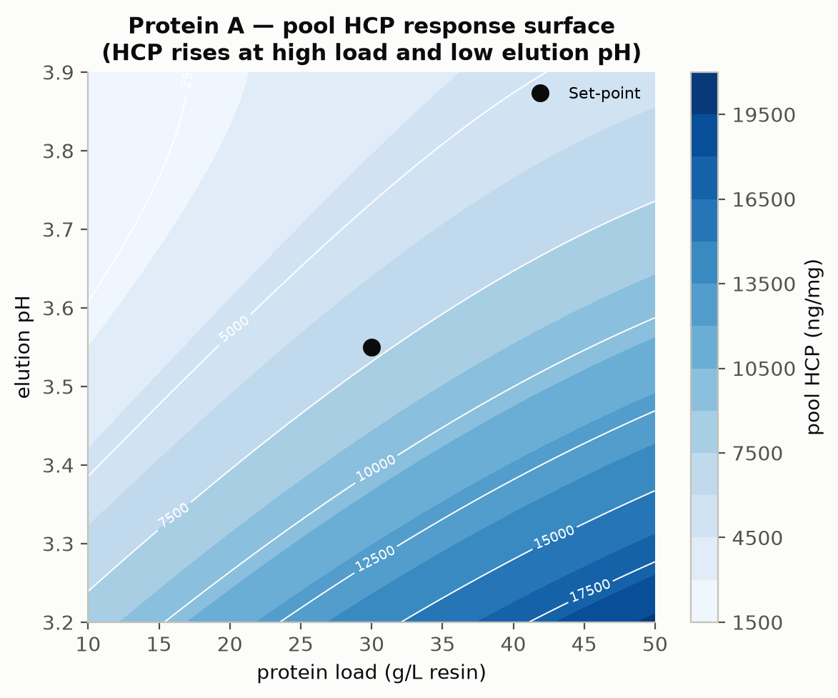
Figure 1: Protein A eluate-pool HCP response surface (protein load × elution pH); HCP increases at high load and low elution pH, reproducing A-Mab Figure 4.2. The set-point is marked.
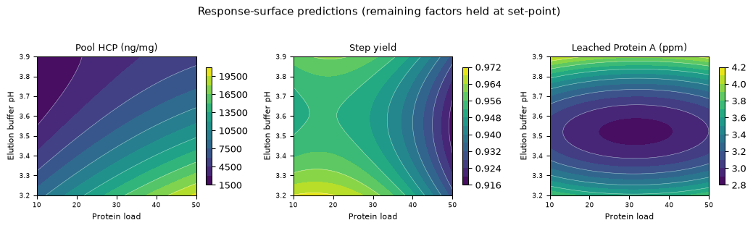
Figure 2: Response-surface predictions for the eluate-pool HCP, step yield and leached Protein A over protein load × elution pH (remaining factors at set-point).
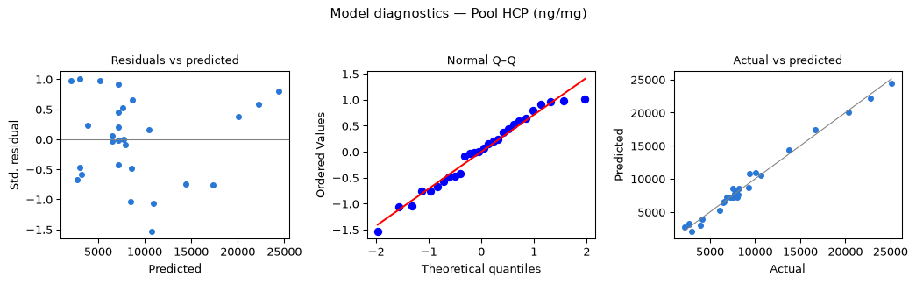
Figure 3: Model diagnostics for the eluate-pool HCP response-surface model.
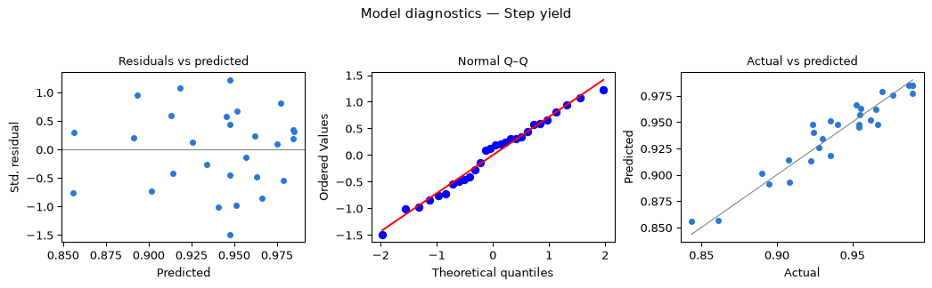
Figure 4: Model diagnostics for the step-yield response-surface model.

5.4 Mechanistic interpretation
The response-surface models reproduce the established behaviour of Protein A capture. The eluate-pool HCP rises with protein load because a more heavily loaded column retains and co-elutes a larger host-cell-protein burden, and rises as the elution pH is lowered because a lower pH strips more weakly associated impurity into the product pool; the two act together through the significant load × elution-pH interaction, so the worst case for pool HCP is a high load at a low elution pH. This is the relationship depicted in A-Mab Figure 4.2 and is the reason a multivariate operating region — rather than independent one-dimensional ranges — is used to assure the HCP presented downstream. The step yield increases as more of the elution peak is collected (higher end-of-pool-collect) and decreases at high load and high flow, where breakthrough and reduced residence time cost recovery. Leached Protein A, which originates from the resin under the low-pH elution, is essentially constant across the studied ranges and at a level that the downstream polishing steps clear with large margin.

6. Design space
The operating region (design space) is the multivariate region of protein load and elution pH over which the eluate-pool HCP is held low enough that the cation- and anion-exchange polishing steps clear the drug-substance HCP to its ≤ 100 ng/mg limit, while the step yield and leached Protein A remain acceptable. Figure 1 shows the pool-HCP surface over this plane with the set-point marked; the NOR of each parameter (Table 4) — protein load 20–40 g/L resin and elution pH 3.4–3.7 — lies well inside the characterized region, which in turn lies within the broader knowledge space bounded by the proven acceptable ranges. Movement within the operating region is not a change, whereas movement outside it would require assessment under the quality system (CMC Biotech Working Group 2009; International Council for Harmonisation 2009). Because leached Protein A and the step yield are robust across the region, the region is set by the eluate-pool HCP constraint alone.

7. Process capability and robustness
Protein A is the principal clearance step for host-cell protein and residual DNA and is the sole source of leached Protein A. A Monte-Carlo simulation of 2,000 commercial-scale batches, with every parameter varied within its NOR, was used to estimate the commercial-scale distributions and process capability of the drug-substance impurity CQAs to which this step is the primary contributor (Table 14). Capability is evaluated one-sided against the upper acceptance limit.
Table 14: Commercial-scale process capability for the impurity CQAs governed by the Protein A step.
CQA | Crit. | Spec | Acceptance | Mean ± SD | Cpk
Host Cell Protein (HCP) | M-H | upper | 0–100 | 15.2 ± 4.6 | 6.14
Leached Protein A | L-M | upper | 0–5 | 0.003 ± 0.0006 | 2785.30

The drug-substance HCP meets its ≤ 100 ng/mg limit with a capability of Cpk = 6.14, confirming that the eluate-pool HCP delivered by Protein A within its NOR is reliably polished to specification by the downstream train. Leached Protein A is cleared to far below its 5 ppm limit, giving a very high capability (Cpk = 2785). The capability margins confirm that the NOR-bounded step contributes robustly to in-specification drug substance at commercial scale.

8. Parameter classification
Each parameter was classified on the A-Mab continuum from the demonstrated effects and the operating-region risk (Table 15). The rationale is as follows.
- Protein load, elution-buffer pH — WC-CPP. Each significantly affects the eluate-pool HCP (§6.2–6.3) and the two participate in a significant interaction; the pool HCP determines the impurity load presented to the polishing steps. They are, however, reliably held within the operating region by controlled load ratio and buffer preparation with in-process pH and conductivity verification, giving a low risk of leaving the region; they are therefore well-controlled CPPs rather than CPPs.
- Load flow rate, end-of-pool-collect — KPP. These govern the step yield and the chromatographic profile but do not significantly affect a product-quality CQA; they are controlled for process performance.
- Operating temperature, bed height — GPP. No meaningful impact on the CQAs or on performance was observed over the wide ranges studied.
Table 15: Post-characterization parameter classification.
Parameter | Class | Study
Protein load | WC-CPP | multivariate
Elution buffer pH | WC-CPP | multivariate
Load flow rate | KPP | multivariate
End of pool collect | KPP | multivariate
Operating temperature | GPP | univariate
Bed height | GPP | univariate

9. Contribution to the control strategy
The Protein A step is the primary control point for the process-related impurity load: it provides the first and largest reduction of host-cell protein and residual DNA and introduces the leached Protein A that the polishing steps subsequently clear. Its contribution to the overall control strategy comprises: control of the two WC-CPPs (protein load and elution pH) to their NORs within the established operating region; control of the load flow rate and end-of-pool-collect for recovery; in-process monitoring of the load ratio, pH, conductivity and UV profile; resin life-cycle control (SOP-2008); and release testing of the eluate-pool HCP, residual DNA and leached Protein A. The host-cell protein and residual DNA established upstream are reduced here and further polished by cation exchange and anion exchange, and the leached Protein A introduced here is cleared by the same steps (reported in the paired unit-operation reports and consolidated in PCMR-001).

10. Discussion
The characterization quantifies the parameter–response relationships for the Protein A capture step, defines a robust multivariate operating region in the two well-controlled CPPs, and classifies every parameter with a data-supported rationale. The pool-HCP and step-yield response-surface models are adequate and predictive, and their behaviour is consistent with established Protein A chromatography and with the A-Mab prior knowledge (A-Mab Figure 4.2), increasing confidence that the SDM is representative of commercial scale. Leached Protein A is robust and immaterial to the ranges studied. The principal limitation is inherent to scale-down characterization: the absolute eluate-pool HCP and the resin-age contribution to leached Protein A may shift modestly at scale and over the resin life-cycle, which is why the operating region is defined on the qualified SDM and confirmed at commercial scale during Stage 2, and why the WC-CPP ranges are carried forward with in-process monitoring and resin life-cycle control. The characterization did not identify any parameter requiring the most stringent (CPP, as opposed to WC-CPP) control within the studied ranges.

11. Conclusions
The A-Mab Protein A capture step is well understood and robust. The relationships between the capture parameters and the eluate-pool HCP and step yield are quantified by DoE; a multivariate operating region in protein load and elution pH is established; every parameter range is justified by data; and the drug-substance impurity CQAs governed by the step meet acceptance at commercial scale, with a host-cell-protein capability of Cpk = 6.14. The operating region, parameter classifications and proven acceptable ranges provide the basis for the Stage 2 operating ranges and the drug-substance control strategy. This report rolls up into the Process Characterization Master Report (PCMR-001) and provides the parameter risk basis for the post-characterization process risk assessment.

Deviations from the plan
No deviations from PCP-005 were recorded. All planned runs were executed and all planned responses were measured on the qualified scale-down model.

References
CMC Biotech Working Group. 2009. A-Mab: A Case Study in Bioprocess Development. CASSS.
International Council for Harmonisation. 2009. ICH Q8(R2): Pharmaceutical Development. ICH.
International Council for Harmonisation. 2012. ICH Q11: Development and Manufacture of Drug Substances. ICH.
International Council for Harmonisation. 2023. ICH Q9(R1): Quality Risk Management. ICH.
International Society for Pharmaceutical Engineering. 2023. Good Practice Guide: Practical Implementation of the Lifecycle Approach to Process Validation. ISPE.
Parenteral Drug Association. 2013. Technical Report No. 60: Process Validation — a Lifecycle Approach. PDA.
U.S. Food and Drug Administration. 2011. Guidance for Industry: Process Validation — General Principles and Practices. FDA.

Appendix A — Screening design matrix and responses
The coded two-level full-factorial design (factors A–D per Table 5; coded levels −1/0/+1) and the measured responses for each run.
Table 16: Appendix A1 — screening design (coded factor settings).
Run | Type | A | B | C | D
1 | factorial | -1 | -1 | -1 | -1
2 | factorial | -1 | -1 | -1 | 1
3 | factorial | -1 | -1 | 1 | -1
4 | factorial | -1 | -1 | 1 | 1
5 | factorial | -1 | 1 | -1 | -1
6 | factorial | -1 | 1 | -1 | 1
7 | factorial | -1 | 1 | 1 | -1
8 | factorial | -1 | 1 | 1 | 1
9 | factorial | 1 | -1 | -1 | -1
10 | factorial | 1 | -1 | -1 | 1
11 | factorial | 1 | -1 | 1 | -1
12 | factorial | 1 | -1 | 1 | 1
13 | factorial | 1 | 1 | -1 | -1
14 | factorial | 1 | 1 | -1 | 1
15 | factorial | 1 | 1 | 1 | -1
16 | factorial | 1 | 1 | 1 | 1
17 | center | 0 | 0 | 0 | 0
18 | center | 0 | 0 | 0 | 0
19 | center | 0 | 0 | 0 | 0

Table 17: Appendix A2 — screening run responses.
Run | Pool HCP (ng/mg) | Step yield | Leached Protein A (ppm)
1 | 9966 | 0.918 | 2.643
2 | 9515 | 0.99 | 2.995
3 | 9023 | 0.9278 | 3.028
4 | 7894 | 0.9805 | 2.979
5 | 3212 | 0.9146 | 2.88
6 | 2523 | 0.9857 | 3.822
7 | 2540 | 0.9289 | 3.301
8 | 3108 | 0.9599 | 2.434
9 | 1.657e+04 | 0.9127 | 2.471
10 | 1.974e+04 | 0.99 | 2.661
11 | 1.827e+04 | 0.8575 | 2.671
12 | 2.124e+04 | 0.9363 | 3.54
13 | 6792 | 0.9114 | 2.771
14 | 7875 | 0.9755 | 2.288
15 | 7655 | 0.8908 | 2.878
16 | 7792 | 0.9269 | 3.136
17 | 6436 | 0.9307 | 2.911
18 | 9652 | 0.9331 | 3.069
19 | 8222 | 0.9421 | 3.859

Appendix B — Response-surface design matrix and responses
The coded face-centred central-composite design (factors A–D; coded levels −1/0/+1) and the measured responses for each run.
Table 18: Appendix B1 — response-surface design (coded factor settings).
Run | Type | A | B | C | D
1 | factorial | -1 | -1 | -1 | -1
2 | factorial | -1 | -1 | -1 | 1
3 | factorial | -1 | -1 | 1 | -1
4 | factorial | -1 | -1 | 1 | 1
5 | factorial | -1 | 1 | -1 | -1
6 | factorial | -1 | 1 | -1 | 1
7 | factorial | -1 | 1 | 1 | -1
8 | factorial | -1 | 1 | 1 | 1
9 | factorial | 1 | -1 | -1 | -1
10 | factorial | 1 | -1 | -1 | 1
11 | factorial | 1 | -1 | 1 | -1
12 | factorial | 1 | -1 | 1 | 1
13 | factorial | 1 | 1 | -1 | -1
14 | factorial | 1 | 1 | -1 | 1
15 | factorial | 1 | 1 | 1 | -1
16 | factorial | 1 | 1 | 1 | 1
17 | axial | -1 | 0 | 0 | 0
18 | axial | 1 | 0 | 0 | 0
19 | axial | 0 | -1 | 0 | 0
20 | axial | 0 | 1 | 0 | 0
21 | axial | 0 | 0 | -1 | 0
22 | axial | 0 | 0 | 1 | 0
23 | axial | 0 | 0 | 0 | -1
24 | axial | 0 | 0 | 0 | 1
25 | center | 0 | 0 | 0 | 0
26 | center | 0 | 0 | 0 | 0
27 | center | 0 | 0 | 0 | 0
28 | center | 0 | 0 | 0 | 0

Table 19: Appendix B2 — response-surface run responses.
Run | Pool HCP (ng/mg) | Step yield | Leached Protein A (ppm)
1 | 1.001e+04 | 0.9299 | 3.417
2 | 9269 | 0.99 | 3.064
3 | 1.065e+04 | 0.9275 | 2.527
4 | 7715 | 0.9875 | 2.481
5 | 2993 | 0.9228 | 3.272
6 | 2149 | 0.9768 | 1.891
7 | 2643 | 0.9077 | 4.611
8 | 2663 | 0.99 | 3.133
9 | 2.511e+04 | 0.8899 | 3.381
10 | 2.039e+04 | 0.99 | 2.486
11 | 2.276e+04 | 0.8611 | 2.125
12 | 1.669e+04 | 0.9244 | 3.027
13 | 7882 | 0.8947 | 3.627
14 | 6578 | 0.9697 | 2.724
15 | 6799 | 0.8436 | 3.065
16 | 6100 | 0.9623 | 2.819
17 | 3900 | 0.9354 | 2.714
18 | 9377 | 0.9353 | 3.37
19 | 1.373e+04 | 0.9656 | 3.769
20 | 4122 | 0.9547 | 3.804
21 | 7571 | 0.9554 | 2.303
22 | 8098 | 0.9546 | 2.542
23 | 8167 | 0.9083 | 2.069
24 | 6461 | 0.9525 | 2.687
25 | 8036 | 0.9402 | 2.749
26 | 7617 | 0.967 | 1.703
27 | 7206 | 0.9236 | 4.064
28 | 7396 | 0.9544 | 2.914

Appendix C — Full effect and coefficient tables

11.1 Screening effects — all responses
Pool HCP (ng/mg)
Term | Effect | Coef. | Std. err. | t | p-value | Sig.
B | -8.84e+03 | -4.42e+03 | 350 | -12.6 | 1.45e-06 | ***
A | 7.27e+03 | 3.63e+03 | 350 | 10.4 | 6.4e-06 | ***
AB | -2.59e+03 | -1.29e+03 | 350 | -3.7 | 0.00608 | **
AD | 1.13e+03 | 566 | 350 | 1.62 | 0.144
AC | 830 | 415 | 350 | 1.19 | 0.27
D | 708 | 354 | 350 | 1.01 | 0.341
BD | -433 | -217 | 350 | -0.619 | 0.553
C | 167 | 83.7 | 350 | 0.239 | 0.817
CD | -70.6 | -35.3 | 350 | -0.101 | 0.922
BC | 6.08 | 3.04 | 350 | 0.00868 | 0.993
Step yield
Term | Effect | Coef. | Std. err. | t | p-value | Sig.
D | 0.0604 | 0.0302 | 0.00208 | 14.5 | 5.01e-07 | ***
A | -0.0255 | -0.0128 | 0.00208 | -6.13 | 0.00028 | ***
C | -0.0237 | -0.0118 | 0.00208 | -5.68 | 0.000463 | ***
AC | -0.0209 | -0.0104 | 0.00208 | -5.01 | 0.00104 | **
CD | -0.0107 | -0.00537 | 0.00208 | -2.58 | 0.0326 | *
BD | -0.00981 | -0.0049 | 0.00208 | -2.36 | 0.0463 | *
AB | 0.00443 | 0.00221 | 0.00208 | 1.06 | 0.319
AD | 0.0037 | 0.00185 | 0.00208 | 0.889 | 0.4
BC | 0.0035 | 0.00175 | 0.00208 | 0.84 | 0.425
B | -0.00236 | -0.00118 | 0.00208 | -0.568 | 0.586
Leached Protein A (ppm)
Term | Effect | Coef. | Std. err. | t | p-value | Sig.
AC | 0.329 | 0.165 | 0.128 | 1.28 | 0.235
A | -0.208 | -0.104 | 0.128 | -0.811 | 0.441
BD | -0.189 | -0.0944 | 0.128 | -0.736 | 0.482
BC | -0.182 | -0.0912 | 0.128 | -0.712 | 0.497
C | 0.18 | 0.0898 | 0.128 | 0.701 | 0.503
D | 0.152 | 0.0758 | 0.128 | 0.591 | 0.571
AB | -0.133 | -0.0664 | 0.128 | -0.518 | 0.618
CD | -0.0987 | -0.0494 | 0.128 | -0.385 | 0.71
B | 0.0652 | 0.0326 | 0.128 | 0.254 | 0.806
AD | 0.0567 | 0.0284 | 0.128 | 0.221 | 0.83

11.2 Response-surface coefficients — leached Protein A
Term | Coef. | Std. err. | t | p-value | Sig.
Intercept | 2.87 | 0.22 | 13 | 7.67e-09 | ***
A | -0.027 | 0.15 | -0.18 | 0.86
B | 0.148 | 0.15 | 0.989 | 0.341
C | 0.00918 | 0.15 | 0.0612 | 0.952
D | -0.21 | 0.15 | -1.4 | 0.185
AB | -0.0127 | 0.159 | -0.0796 | 0.938
AC | -0.143 | 0.159 | -0.899 | 0.385
AD | 0.132 | 0.159 | 0.831 | 0.421
BC | 0.269 | 0.159 | 1.69 | 0.115
BD | -0.226 | 0.159 | -1.42 | 0.179
CD | 0.167 | 0.159 | 1.05 | 0.314
A² | 0.162 | 0.397 | 0.408 | 0.69
B² | 0.906 | 0.397 | 2.29 | 0.0397 | *
C² | -0.458 | 0.397 | -1.15 | 0.269
D² | -0.502 | 0.397 | -1.27 | 0.228

Appendix D — Analytical methods summary
Table 20: Analytical methods, techniques and validation references (performance characteristics per the cited method validation reports).
Method | Technique | Analytes / attributes | Validation ref. | Reportable
Leached Protein A | ELISA | Leached Protein A | AMV-3016 | ppm
Host-cell protein | ELISA | HCP | AMV-3012 | ng/mg
Residual DNA | qPCR | Host-cell DNA | AMV-3014 | ng/dose
Size variants | SEC-HPLC | Aggregate (HMW), monomer | AMV-3011 | % HMW

