Process Characterization Report
  - A-Mab Drug Substance — Low-pH Viral Inactivation (Step 6) — PCR-006
Process Development / Manufacturing Science & Technology (MSAT)
2026-07-24
Table of contents

Field | Value
Document ID | PCR-006
Document class | Process Characterization Report
Title | Process Characterization Report: Low-pH Viral Inactivation (Step 6)
Product | A-Mab
Version | 1.0
Effective date | 2026-07-24
Status | Approved (synthetic)
Document owner | Manufacturing Science & Technology (MSAT)
Sponsor / sites | Novacyte Biologics; Novacyte Biologics — Cambridge, MA (Development) → Novacyte Biologics — Grafton, WI (Commercial DS)
SYNTHETIC DOCUMENT — NOT A REAL RECORD. Illustrative content generated from a seeded model of the A-Mab case study (CMC Biotech Working Group, 2009). Novacyte Biologics and all sites, SOP/AMV numbers and signatories are fictional. For NLP corpus development only; not for any regulated use.

Approvals
Table 1: Approval record (synthetic; signatures not applied).
Role | Function | Name (synthetic) | Signature | Date
Author | Process Development / MSAT | — | — | —
Reviewer | Analytical Development | — | — | —
Reviewer | Virology / Viral Safety | — | — | —
Reviewer | Statistics | — | — | —
Approver | Quality Assurance | — | — | —

Abbreviations
ANOVA, analysis of variance · BLA, Biologics License Application · CCD, central-composite design · CPP, critical process parameter · CQA, critical quality attribute · DoE, design of experiments · DS, drug substance · GPP, general process parameter · HMW, high-molecular-weight (aggregate) · ICH, International Council for Harmonisation · icIEF, imaged capillary isoelectric focusing · IPC, in-process control · LRF, log-reduction factor · LRV, log-reduction value · MSAT, Manufacturing Science and Technology · MVM, minute virus of mice · NOR, normal operating range · PAR, proven acceptable range · PPQ, process performance qualification · QbD, Quality by Design · RSM, response-surface methodology · SDM, scale-down model · SEC, size-exclusion chromatography · TCID50, 50% tissue-culture infectious dose · WC-CPP, well-controlled CPP · XMuLV, xenotropic murine leukemia virus.

Executive summary
This report documents the Stage 1 (Process Design) characterization of the A-Mab low-pH viral inactivation step (Step 6), the dedicated viral-clearance operation in which the Protein A eluate is held at low pH to inactivate enveloped viruses. The study was executed under the Process Characterization Plan PCP-006 on a qualified scale-down inactivation model, following the lifecycle approach to process validation (U.S. Food and Drug Administration 2011; Parenteral Drug Association 2013; International Society for Pharmaceutical Engineering 2023), the Quality-by-Design principles of ICH Q8, Q9 and Q11 (International Council for Harmonisation 2009, 2023b, 2012), and the viral-safety framework of ICH Q5A (International Council for Harmonisation 2023a), with the process model and risk methodology of the A-Mab case study (CMC Biotech Working Group 2009).
Four process parameters were evaluated. A 11-run two-level full factorial screening design identified the significant factors and interactions for the XMuLV log-reduction, the aggregate and the acidic charge variants; a 18-run face-centred central-composite response-surface design then quantified main effects, interactions and curvature and defined the multivariate design space in inactivation pH and hold time.
Key outcomes
- Inactivation pH is the dominant factor for enveloped-virus inactivation and is classified CPP — the only true critical process parameter in the drug-substance process. Hold time and temperature significantly affect both the inactivation and the aggregate and are well-controlled CPP (WC-CPP); A-Mab concentration is GPP.
- At the nominal condition the step delivers an XMuLV log-reduction of approximately 6.7 log₁₀ and holds aggregate at 2.0%, well below the 5% drug-substance limit. Because low-pH inactivation is effective only against enveloped viruses, the step provides no clearance of the non-enveloped model virus MVM (0 log₁₀), which is cleared orthogonally by anion exchange and virus filtration.
- The aggregate response-surface model is excellent (R² = 0.997); the XMuLV log-reduction model is adequate (R² = 0.90) with no significant lack of fit, the residual scatter reflecting the inherent variability of the viral-infectivity assay. The viral-clearance claim is taken conservatively rather than from the model.
- A design space in inactivation pH and hold time was established over which the XMuLV log-reduction is assured and aggregate remains within its limit. Across the drug-substance process the cumulative XMuLV clearance is 18.9 log₁₀ against the ≥ 16.7 log₁₀ requirement, with a commercial-scale capability of Cpk = 1.53 — the process-minimum capability, reflecting the conservative viral-safety margin.
The low-pH viral inactivation step is demonstrated to be well understood and robust. The design space, parameter classifications and proven acceptable ranges support the Stage 2 operating ranges and the viral-safety control strategy, and this report rolls up into the Process Characterization Master Report (PCMR-001).

1. Introduction

1.1 Product and unit operation
A-Mab viral safety is assured by a combination of testing and by the demonstrated capacity of the purification process to clear adventitious and endogenous viruses (International Council for Harmonisation 2023a; CMC Biotech Working Group 2009). Low-pH viral inactivation is the dedicated inactivation step: the Protein A eluate, already at low pH from the acidic elution, is titrated to the target inactivation pH, held for a defined time at controlled temperature, and then neutralized before the next step. Low pH disrupts the lipid envelope of enveloped viruses and is a robust, well-characterized clearance mechanism for the endogenous retrovirus-like particles modelled by xenotropic murine leukemia virus (XMuLV); it is ineffective against non-enveloped viruses such as the parvovirus model MVM, whose clearance is provided orthogonally by anion exchange and small-virus filtration. This characterization quantifies how the inactivation parameters govern the XMuLV log-reduction and the associated product-quality risk of aggregate formation during the low-pH hold.

1.2 Objectives
The objectives of the study were to (i) establish the quantitative relationships between the inactivation parameters and the XMuLV log-reduction, the aggregate and the acidic charge variants; (ii) define the multivariate design space over which the enveloped-virus inactivation is assured while aggregate remains within its limit; (iii) establish proven acceptable ranges (PARs) and normal operating ranges (NORs) for each parameter; (iv) classify each parameter for its risk of impact to CQAs and to process performance; and (v) provide the process understanding and ranges that justify the Stage 2 operating conditions and the viral-safety control strategy.

1.3 Regulatory and scientific basis
The work follows the lifecycle approach to process validation of the FDA 2011 guidance (U.S. Food and Drug Administration 2011), PDA Technical Report 60 (Parenteral Drug Association 2013) and the ISPE Good Practice Guide (International Society for Pharmaceutical Engineering 2023), applies the enhanced (QbD) development approach of ICH Q8, Q9 and Q11 (International Council for Harmonisation 2009, 2023b, 2012), and addresses viral clearance under ICH Q5A (International Council for Harmonisation 2023a). Criticality is treated as a continuum (ICH Q9). The report structure corresponds to the Stage 1 Process Design Report of PDA TR 60 §3.11 and provides development-report content suitable to support a Biologics License Application.

2. Prior knowledge and quality risk basis

2.1 Platform and prior-product knowledge
Low-pH inactivation is a platform viral-clearance operation whose behaviour is well established from related humanized IgG1 antibodies and A-Mab experience (CMC Biotech Working Group 2009). Prior knowledge established that enveloped-virus inactivation increases as the pH is lowered and as the hold time and temperature increase; that the acceptable pH window is narrow and high-consequence — above approximately 4.0 the inactivation is incomplete, while below approximately 3.2 the product is at risk of acid-induced aggregation; and that aggregate can also form during a prolonged or warm hold. This knowledge framed the attributes in scope and the prioritization of parameters for characterization.

2.2 Quality attributes in scope
The step sets the (cumulative) enveloped-virus clearance CQA (Table 2) and carries a product-quality risk of aggregate formation during the low-pH hold; the acidic charge variants are followed as they can shift slightly during the hold. Criticality is scored on the A-Mab continuum using Tool #1 (Risk Score = Impact × Uncertainty); attributes rated High (H) or Very High (VH) are treated as Critical (CMC Biotech Working Group 2009).
Table 2: Viral-clearance CQA set by the low-pH inactivation step, with acceptance criterion and criticality (Tool #1 = Impact × Uncertainty).
CQA | Category | Acceptance | Criticality | Tool #1
Viral clearance — XMuLV (enveloped) | viral safety | 16.7–30 log10 (cumulative) | VH | 20

The XMuLV clearance CQA is expressed as the cumulative log-reduction across the process (≥ 16.7 log₁₀); this step is the single largest contributor. The aggregate is a High-criticality size-variant CQA (limit 5% HMW) that this step can increase and that the cation-exchange step subsequently polishes.

2.3 Risk-based prioritization and parameter selection
Consistent with the A-Mab lifecycle of iterative risk assessments, the characterization scope was set by the Pre-Characterization Process Risk Assessment (RA-001), which used prior knowledge and a risk-ranking-and-filtering screen to prioritize parameters and to assign the study type. Inactivation pH, hold time and temperature, which carry a credible risk to the enveloped-virus inactivation and to aggregate, were assigned to the multivariate DoE; A-Mab concentration, expected to affect neither over a wide range, was assigned to univariate assessment (CMC Biotech Working Group 2009; Parenteral Drug Association 2013). The parameters and ranges carried into this study are given in Table 4 (§5.1).

3. Materials and methods

3.1 Scale-down model and its qualification
All characterization runs were performed on a qualified small-scale inactivation model operated at the commercial-process equivalents for the acidification, mixing, hold vessel geometry and temperature control (SOP-2009). Viral log-reduction was determined in spiking studies in which a characterized XMuLV stock was added to the starting material and the infectious titre measured before and after the hold. The SDM was qualified against at-scale reference data (SOP-1001) by comparing the operational parameters and the output attributes — XMuLV log-reduction, aggregate and charge variants — confirming that the model is representative and suitable to support design-space and PAR claims (Parenteral Drug Association 2013; International Council for Harmonisation 2023a). The between-run reproducibility of the centre-point condition (§6.1) provides the pure-error term in the lack-of-fit assessment.

3.2 Operation
The Protein A eluate is titrated with acid to the target inactivation pH, mixed, and held for the defined hold time at controlled temperature; the solution is then neutralized to the load condition of the next step. Inactivation pH and temperature are controlled to set-point and the hold time is timed from the attainment of the target pH. Buffers and the A-Mab concentration of the incoming pool are controlled to platform specifications and are treated as quality-controlled inputs rather than characterized variables, except for the concentration range assessed univariately (CMC Biotech Working Group 2009).

3.3 Analytical methods
The step responses were measured by validated methods (Table 3). XMuLV infectious titre was determined by a TCID50 infectivity assay (AMV-3017) and the log-reduction computed from the pre- and post-hold titres; aggregate by SEC-HPLC (AMV-3011); and acidic charge variants by icIEF (AMV-3013). Method performance characteristics are summarized in Appendix D.
Table 3: Validated analytical methods used in the characterization.
Reference | Title | Type
AMV-3017 | XMuLV Infectivity Titre (TCID50) | Method validation
AMV-3011 | Size-Variants (SEC-HPLC) | Method validation
AMV-3013 | Charge Variants (icIEF) | Method validation

3.4 Sampling plan
Each DoE run was sampled before and after the hold for the XMuLV infectious titre and sampled at the end of the hold for aggregate and acidic charge variants; in-process pH, temperature and hold-time records confirmed the run conditions. Centre-point runs were replicated within each design (three in screening, four in the response-surface design) to quantify reproducibility and pure error.

3.5 Statistical methods
Designs were constructed and analyzed in coded factors, with each parameter’s characterization range mapped so that the set-point is 0 and the range edges are ±1 (SOP-1002). Screening data were analyzed by ordinary-least-squares regression of each response on the main effects and all two-factor interactions; factor effects are reported as twice the coded coefficient. Response-surface data were analyzed with the full quadratic model. Statistical significance was assessed at α = 0.05. Model adequacy was judged by R², the adjusted and predicted R², the overall model F-test, and an analysis of variance partitioning the residual into lack of fit and pure error; a non-significant lack-of-fit F-test (p > 0.05) indicates an adequate model. Consistent with the conservative treatment of viral clearance (International Council for Harmonisation 2023a), the enveloped-virus clearance claim is taken from the demonstrated log-reduction rather than from an extrapolated model. The design space was defined as the region of inactivation pH and hold time over which the XMuLV log-reduction is assured and aggregate remains within its limit. Commercial-scale capability of the cumulative XMuLV clearance was estimated by Monte-Carlo simulation of 2,000 batches with each parameter varied within its NOR, reporting the one-sided (lower) capability index.

4. Study design

4.1 Factors, ranges and the knowledge space
Four parameters were studied (Table 4). The characterization range of each factor (“PAR” column) defines the edges of the explored knowledge space and the basis of the proven acceptable range; the NOR is the tighter routine-control range. The DoE factor coding for the three multivariate factors is given in Table 5.
Table 4: Low-pH inactivation process parameters, set-points, ranges and post-characterization classification.
Parameter | Unit | Set-point | NOR | PAR | Class | Study
Inactivation pH | pH | 3.5 | 3.4–3.6 | 3.2–4 | CPP | multivariate
Hold time | min | 90 | 60–120 | 60–180 | WC-CPP | multivariate
Temperature | °C | 21 | 19–23 | 15–25 | WC-CPP | multivariate
A-Mab concentration | g/L | 20 | 5–35 | 5–35 | GPP | univariate

Table 5: Design-of-experiments factor legend (coded A–C).
Code | Factor | Unit | Studied in
A | Inactivation pH | pH | screening + RSM
B | Hold time | min | screening + RSM
C | Temperature | °C | screening + RSM

4.2 Screening design
Factor screening used a two-level full factorial in the three multivariate factors (A–C) with three centre-point replicates, 11 runs in total. The full factorial estimates all three main effects and all three two-factor interactions without confounding. The three responses recorded for each run were the XMuLV log-reduction, the aggregate and the acidic charge variants. The complete coded design matrix and run responses are given in Appendix A.

4.3 Response-surface design
The three multivariate factors were carried into a face-centred central-composite design (cube points, axial points at the face centres, and four centre-point replicates), 18 runs in total, enabling estimation of curvature in addition to main effects and interactions. The complete coded design matrix and responses are given in Appendix B.

4.4 Univariate assessment
A-Mab concentration was evaluated one factor at a time across its characterization range for its effect on the XMuLV log-reduction and aggregate; it was not carried into the multivariate design because prior knowledge indicated no credible impact over the range studied.

5. Results

5.1 Centre-point performance and reproducibility
At the nominal (centre-point) condition the step delivers an XMuLV log-reduction of 6.7 log₁₀ and an aggregate of 2.0% HMW. The between-replicate reproducibility of the centre point (Table 6) is the pure-error estimate used in the lack-of-fit assessment; the higher coefficient of variation of the XMuLV response reflects the inherent variability of the infectious-titre assay, whereas the aggregate and charge-variant measurements are highly reproducible.
Table 6: Centre-point reproducibility (response-surface design; n = 4 replicates).
Response | n | Mean | SD | %CV
Aggregates (HMW, %) | 4 | 2.01 | 0.0169 | 0.845
XMuLV LRF (log₁₀) | 4 | 6.71 | 0.381 | 5.67
Acidic variants | 4 | 20.7 | 0 | 0

5.2 Screening: factor effects
The screening models resolve the active factors and interactions for the three responses (Table 7). Consistent with a screening analysis, the magnitudes are refined by the response-surface models (§6.3).
Table 7: Screening-design model summary by response (main effects + two-factor interactions).
Response | N | R² | Adj. R² | Pred. R² | F | p-value | RMSE
Aggregates (HMW, %) | 11 | 0.992 | 0.98 | 0.828 | 82 | 0.000386 | 0.0333
XMuLV LRF (log₁₀) | 11 | 0.982 | 0.956 | 0.819 | 37.2 | 0.00182 | 0.265
Acidic variants | 11 | 1 | 1 | 1 | 3.93e+26 | 1.73e-53 | 1.16e-14

The largest effects are tabulated for the XMuLV log-reduction (Table 8) and the aggregate (Table 9). Full effect tables for all three responses are given in Appendix C.
Table 8: Largest standardized effects on the XMuLV log-reduction (screening; effect = 2 × coded coefficient; A = pH, B = hold time, C = temperature).
Term | Effect | Coef. | Std. err. | t | p-value | Sig.
A | -2.08 | -1.04 | 0.0936 | -11.1 | 0.000376 | ***
B | 1.72 | 0.862 | 0.0936 | 9.2 | 0.000774 | ***
C | 0.636 | 0.318 | 0.0936 | 3.4 | 0.0274 | *
BC | 0.238 | 0.119 | 0.0936 | 1.27 | 0.272
AB | 0.203 | 0.101 | 0.0936 | 1.08 | 0.34
AC | -0.194 | -0.097 | 0.0936 | -1.04 | 0.359

Table 9: Largest standardized effects on aggregate (screening).
Term | Effect | Coef. | Std. err. | t | p-value | Sig.
B | 0.471 | 0.236 | 0.0118 | 20 | 3.69e-05 | ***
C | 0.221 | 0.11 | 0.0118 | 9.37 | 0.000723 | ***
AC | 0.035 | 0.0175 | 0.0118 | 1.48 | 0.212
AB | 0.0285 | 0.0142 | 0.0118 | 1.21 | 0.294
A | 0.0221 | 0.011 | 0.0118 | 0.937 | 0.402
BC | 0.0107 | 0.00535 | 0.0118 | 0.453 | 0.674

Inactivation pH is the dominant factor for the XMuLV log-reduction — the log-reduction increases as the pH is lowered — followed by hold time and temperature, which also increase the inactivation. Aggregate, by contrast, is driven principally by hold time and temperature and is comparatively insensitive to pH over the range studied. The enveloped-virus inactivation and the aggregate risk therefore respond to a shared set of factors, which is why a multivariate design space — rather than independent one-dimensional ranges — is required to assure clearance while limiting aggregate.

5.3 Response-surface models
The full quadratic response-surface models are summarized in Table 10. The aggregate model is excellent (R² = 0.997), and the acidic-charge-variant response is an essentially deterministic, minor shift over the hold. The XMuLV log-reduction model is adequate (R² = 0.90, adjusted R² = 0.78); its lower coefficient of determination reflects the inherent variability of the infectivity assay rather than an inadequate functional form. For every response the lack-of-fit F-test was not significant (p > 0.05) relative to the centre-point pure error, confirming that the models are adequate. Consistent with ICH Q5A, the enveloped-virus clearance claim is taken conservatively from the demonstrated log-reduction and not extrapolated from the model.
Table 10: Response-surface model summary by response (full quadratic model).
Response | N | R² | Adj. R² | Pred. R² | F | p-value | RMSE
Aggregates (HMW, %) | 18 | 0.997 | 0.993 | 0.961 | 261 | 6.57e-09 | 0.0169
XMuLV LRF (log₁₀) | 18 | 0.896 | 0.779 | 0.579 | 7.67 | 0.00433 | 0.367
Acidic variants | 18 | 1 | 1 | 1 | 5.99e+26 | 2.43e-106 | 8.61e-15

The fitted coefficients for the XMuLV log-reduction and the aggregate are given in Table 11 and Table 12, and the analysis of variance for the XMuLV log-reduction — including the lack-of-fit/pure-error partition — in Table 13.
Table 11: Response-surface coefficients for the XMuLV log-reduction (coded factors A = pH, B = hold time, C = temperature).
Term | Coef. | Std. err. | t | p-value | Sig.
Intercept | 6.91 | 0.144 | 47.9 | 3.99e-11 | ***
A | -0.612 | 0.116 | -5.28 | 0.000747 | ***
B | 0.605 | 0.116 | 5.22 | 0.000806 | ***
C | 0.286 | 0.116 | 2.46 | 0.0391 | *
AB | 0.162 | 0.13 | 1.25 | 0.246
AC | 0.0691 | 0.13 | 0.533 | 0.608
BC | -0.105 | 0.13 | -0.812 | 0.44
A² | -0.513 | 0.223 | -2.31 | 0.0501
B² | 0.202 | 0.223 | 0.907 | 0.391
C² | 0.152 | 0.223 | 0.684 | 0.513

Table 12: Response-surface coefficients for aggregate.
Term | Coef. | Std. err. | t | p-value | Sig.
Intercept | 2.01 | 0.00667 | 301 | 1.64e-17 | ***
A | -0.00244 | 0.00536 | -0.455 | 0.661
B | 0.236 | 0.00536 | 44.1 | 7.76e-11 | ***
C | 0.107 | 0.00536 | 20 | 4.01e-08 | ***
AB | -0.00133 | 0.00599 | -0.221 | 0.83
AC | 0.0133 | 0.00599 | 2.21 | 0.0578
BC | 0.00837 | 0.00599 | 1.4 | 0.2
A² | -0.00247 | 0.0103 | -0.24 | 0.816
B² | 0.000627 | 0.0103 | 0.0609 | 0.953
C² | 0.0125 | 0.0103 | 1.21 | 0.261

Table 13: Analysis of variance for the XMuLV log-reduction response-surface model, with lack-of-fit and pure-error partition.
Source | Sum sq. | df | Mean sq. | F | p-value
Model | 9.27 | 9 | 1.03 | 7.67 | 0.00433
Residual | 1.07 | 8 | 0.134 | nan | nan
Lack of fit | 0.64 | 5 | 0.128 | 0.884 | 0.58
Pure error | 0.435 | 3 | 0.145 | nan | nan

The response surfaces over the two dominant factors (inactivation pH and hold time) are shown for all three responses in Figure 2, and the aggregate and XMuLV behaviour is summarized in Figure 1. The model diagnostics for the XMuLV and aggregate models are in Figure 3 and Figure 4; the residual and quantile plots show no systematic structure, supporting the use of the aggregate model for design-space definition and the conservative use of the XMuLV model.
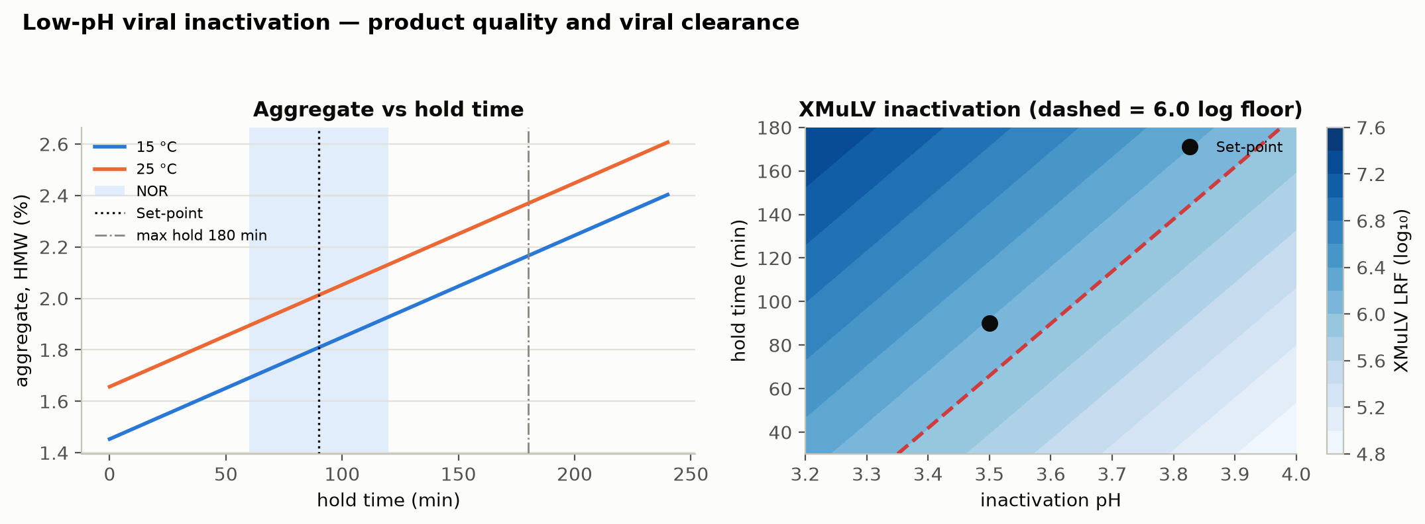
Figure 1: Low-pH viral inactivation: aggregate formation versus hold time at 15/25 °C (left) and the XMuLV log-reduction surface over inactivation pH × hold time with the required per-step floor (right).
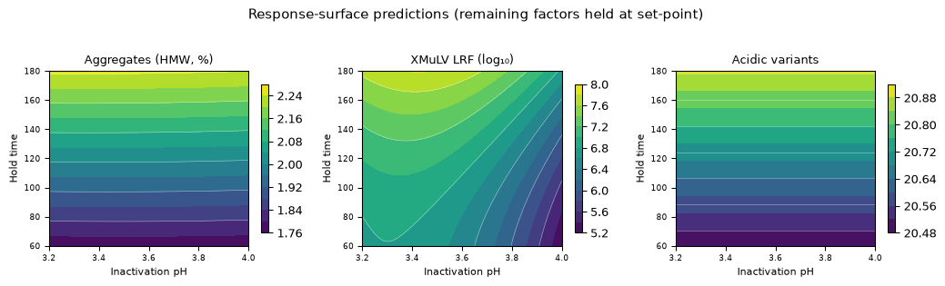
Figure 2: Response-surface predictions for the XMuLV log-reduction, aggregate and acidic charge variants over inactivation pH × hold time (temperature at set-point).
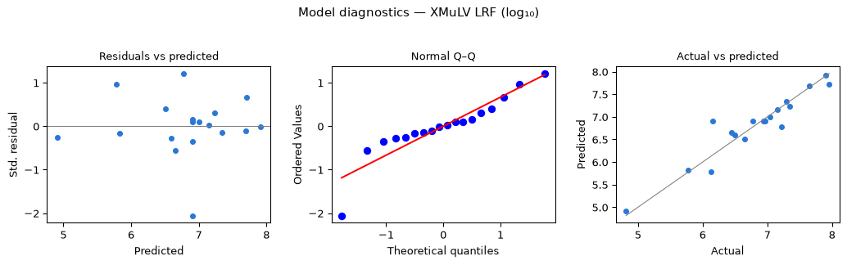
Figure 3: Model diagnostics for the XMuLV log-reduction response-surface model.
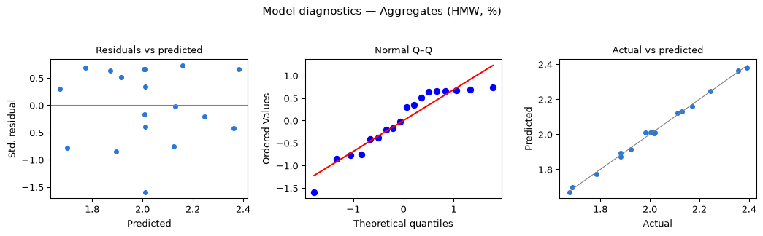
Figure 4: Model diagnostics for the aggregate response-surface model.

5.4 Mechanistic interpretation
The response-surface models reproduce the established behaviour of low-pH inactivation. Enveloped-virus inactivation is driven primarily by hydrogen-ion concentration: lowering the inactivation pH accelerates the disruption of the viral lipid envelope and increases the log-reduction, with additional inactivation from a longer hold and a warmer temperature. Aggregate formation, in contrast, is a time- and temperature-dependent process and is comparatively insensitive to pH over the studied window, so the practical constraint on the hold is the aggregate that accrues at long hold times and high temperature rather than at low pH. The acceptable pH window is nonetheless narrow and high-consequence — bounded above by incomplete inactivation and below by the prior-knowledge risk of acid-induced aggregation — which is why inactivation pH is controlled to a tight range and treated as the process’s only true CPP. Because the mechanism acts on the lipid envelope, the step provides no clearance of the non-enveloped parvovirus model MVM.

6. Design space
The design space is the region of inactivation pH and hold time (at the controlled temperature) over which the XMuLV log-reduction is assured with margin and the aggregate remains within its 5% limit, computed by overlaying the clearance and aggregate constraints on the fitted models. Figure 1 (right) shows the XMuLV log-reduction surface with the required per-step floor; the NOR of each parameter (Table 4) — inactivation pH 3.4–3.6 and hold time 60–120 min — lies well inside the region over which clearance is assured, which in turn lies within the broader knowledge space bounded by the proven acceptable ranges. Movement within the design space is not a change, whereas movement outside it would require assessment under the quality system (CMC Biotech Working Group 2009; International Council for Harmonisation 2009). Aggregate remains well below its limit across the entire region, so the binding constraint is the assurance of the enveloped-virus log-reduction.

7. Process capability and robustness
The low-pH inactivation step is the largest single contributor to the enveloped-virus clearance, providing 7.1 log₁₀ of the cumulative 18.9 log₁₀ XMuLV clearance; it provides 0 log₁₀ of MVM clearance, the non-enveloped parvovirus being cleared orthogonally by anion exchange and virus filtration. A Monte-Carlo simulation of 2,000 commercial-scale batches, with every parameter varied within its NOR, was used to estimate the commercial-scale distributions and process capability of the CQAs governed by the step (Table 14). Capability is evaluated one-sided against the lower requirement for viral clearance and the upper limit for aggregate.
Table 14: Commercial-scale process capability for the CQAs governed by the low-pH inactivation step.
CQA | Crit. | Spec | Acceptance | Mean ± SD | Cpk
Aggregates (HMW) | H | upper | 0–5 | 0.753 ± 0.088 | 16.11
Viral clearance — XMuLV (enveloped) | VH | lower | 16.7–30 | 19.5 ± 0.61 | 1.53

The cumulative XMuLV clearance meets its ≥ 16.7 log₁₀ requirement with a capability of Cpk = 1.53. This is the minimum capability in the drug-substance process and is deliberately conservative: the viral-clearance requirement is set with a large safety margin, and the demonstrated clearance exceeds it robustly. Aggregate is held well within its limit with high capability. The margins confirm that the NOR-bounded step reliably assures viral safety and product quality at commercial scale.

8. Parameter classification
Each parameter was classified on the A-Mab continuum from the demonstrated effects and the design-space risk (Table 15). The rationale is as follows.
- Inactivation pH — CPP. pH is the dominant factor for the enveloped-virus log-reduction (§6.2–6.3), which is a Very-High-criticality viral-safety CQA (Severity ≥ 8), and its acceptable window is narrow and high-consequence in both directions. It is therefore a full critical process parameter — the only one in the drug-substance process — controlled to a tight NOR with in-process pH verification.
- Hold time, temperature — WC-CPP. Each significantly affects both the log-reduction and the aggregate, but both are reliably held within the design space by timed, temperature-controlled operation, giving a low risk of leaving the space.
- A-Mab concentration — GPP. No meaningful impact on the log-reduction or aggregate was observed over the wide range studied.
Table 15: Post-characterization parameter classification.
Parameter | Class | Study
Inactivation pH | CPP | multivariate
Hold time | WC-CPP | multivariate
Temperature | WC-CPP | multivariate
A-Mab concentration | GPP | univariate

9. Contribution to the control strategy
The low-pH viral inactivation step is the primary control point for enveloped-virus safety: it provides the dominant, robust XMuLV log-reduction and, with the orthogonal non-enveloped clearance of anion exchange and virus filtration, establishes the total viral-clearance claim consolidated in PCMR-001. Its contribution to the overall control strategy comprises: control of the CPP (inactivation pH) to a tight NOR with in-process pH verification; control of the hold time and temperature (WC-CPP) by timed, temperature-controlled operation; in-process monitoring of pH, temperature and hold time; and end-of-hold testing of aggregate and charge variants. The aggregate that can form during the hold is subsequently polished by cation exchange, and the enveloped-virus clearance is claimed conservatively per ICH Q5A (International Council for Harmonisation 2023a).

10. Discussion
The characterization quantifies the parameter–response relationships for the low-pH inactivation step, defines a robust multivariate design space, and classifies every parameter with a data-supported rationale, identifying inactivation pH as the process’s only true CPP. The aggregate model is excellent and predictive; the XMuLV model is adequate with no significant lack of fit, and its residual variability — inherent to the infectivity assay — is handled by taking the clearance claim conservatively rather than by extrapolation, consistent with ICH Q5A. The principal limitation is inherent to scale-down viral-clearance characterization: absolute log-reduction values are validated in dedicated spiking studies on the qualified model and confirmed as part of the viral-clearance validation, and the design space is defined on that model and carried forward with in-process control. The characterization confirms that inactivation pH requires the most stringent (CPP) control, whereas hold time and temperature are well-controlled CPPs.

11. Conclusions
The A-Mab low-pH viral inactivation step is well understood and robust. The relationships between the inactivation parameters and the XMuLV log-reduction, aggregate and charge variants are quantified by DoE; a multivariate design space in inactivation pH and hold time is established; every parameter range is justified by data; and the cumulative XMuLV clearance meets its requirement at commercial scale with a capability of Cpk = 1.53. Inactivation pH is identified as the sole critical process parameter. The design space, parameter classifications and proven acceptable ranges provide the basis for the Stage 2 operating ranges and the viral-safety control strategy. This report rolls up into the Process Characterization Master Report (PCMR-001) and provides the parameter risk basis for the post-characterization process risk assessment.

Deviations from the plan
No deviations from PCP-006 were recorded. All planned runs were executed and all planned responses were measured on the qualified scale-down model.

References
CMC Biotech Working Group. 2009. A-Mab: A Case Study in Bioprocess Development. CASSS.
International Council for Harmonisation. 2009. ICH Q8(R2): Pharmaceutical Development. ICH.
International Council for Harmonisation. 2012. ICH Q11: Development and Manufacture of Drug Substances. ICH.
International Council for Harmonisation. 2023a. ICH Q5A(R2): Viral Safety Evaluation of Biotechnology Products Derived from Cell Lines of Human or Animal Origin. ICH.
International Council for Harmonisation. 2023b. ICH Q9(R1): Quality Risk Management. ICH.
International Society for Pharmaceutical Engineering. 2023. Good Practice Guide: Practical Implementation of the Lifecycle Approach to Process Validation. ISPE.
Parenteral Drug Association. 2013. Technical Report No. 60: Process Validation — a Lifecycle Approach. PDA.
U.S. Food and Drug Administration. 2011. Guidance for Industry: Process Validation — General Principles and Practices. FDA.

Appendix A — Screening design matrix and responses
The coded two-level full-factorial design (factors A–C per Table 5; coded levels −1/0/+1) and the measured responses for each run.
Table 16: Appendix A1 — screening design (coded factor settings).
Run | Type | A | B | C
1 | factorial | -1 | -1 | -1
2 | factorial | -1 | -1 | 1
3 | factorial | -1 | 1 | -1
4 | factorial | -1 | 1 | 1
5 | factorial | 1 | -1 | -1
6 | factorial | 1 | -1 | 1
7 | factorial | 1 | 1 | -1
8 | factorial | 1 | 1 | 1
9 | center | 0 | 0 | 0
10 | center | 0 | 0 | 0
11 | center | 0 | 0 | 0

Table 17: Appendix A2 — screening run responses.
Run | Aggregates (HMW, %) | XMuLV LRF (log₁₀) | Acidic variants
1 | 1.694 | 7.023 | 20.49
2 | 1.903 | 7.483 | 20.49
3 | 2.16 | 8.174 | 20.89
4 | 2.323 | 9.373 | 20.89
5 | 1.687 | 4.806 | 20.49
6 | 1.898 | 5.141 | 20.49
7 | 2.142 | 6.625 | 20.89
8 | 2.443 | 7.174 | 20.89
9 | 2.01 | 7.351 | 20.69
10 | 2.066 | 6.916 | 20.69
11 | 2.01 | 7.356 | 20.69

Appendix B — Response-surface design matrix and responses
The coded face-centred central-composite design (factors A–C; coded levels −1/0/+1) and the measured responses for each run.
Table 18: Appendix B1 — response-surface design (coded factor settings).
Run | Type | A | B | C
1 | factorial | -1 | -1 | -1
2 | factorial | -1 | -1 | 1
3 | factorial | -1 | 1 | -1
4 | factorial | -1 | 1 | 1
5 | factorial | 1 | -1 | -1
6 | factorial | 1 | -1 | 1
7 | factorial | 1 | 1 | -1
8 | factorial | 1 | 1 | 1
9 | axial | -1 | 0 | 0
10 | axial | 1 | 0 | 0
11 | axial | 0 | -1 | 0
12 | axial | 0 | 1 | 0
13 | axial | 0 | 0 | -1
14 | axial | 0 | 0 | 1
15 | center | 0 | 0 | 0
16 | center | 0 | 0 | 0
17 | center | 0 | 0 | 0
18 | center | 0 | 0 | 0

Table 19: Appendix B2 — response-surface run responses.
Run | Aggregates (HMW, %) | XMuLV LRF (log₁₀) | Acidic variants
1 | 1.687 | 6.491 | 20.49
2 | 1.882 | 7.348 | 20.49
3 | 2.17 | 7.651 | 20.89
4 | 2.356 | 7.908 | 20.89
5 | 1.676 | 4.816 | 20.49
6 | 1.881 | 5.77 | 20.49
7 | 2.111 | 6.446 | 20.89
8 | 2.393 | 7.158 | 20.89
9 | 2.007 | 7.044 | 20.69
10 | 2.016 | 6.134 | 20.69
11 | 1.786 | 6.65 | 20.49
12 | 2.243 | 7.958 | 20.89
13 | 1.924 | 7.217 | 20.69
14 | 2.129 | 7.292 | 20.69
15 | 2.021 | 6.942 | 20.69
16 | 1.983 | 6.153 | 20.69
17 | 2.016 | 6.967 | 20.69
18 | 2.003 | 6.781 | 20.69

Appendix C — Full effect and coefficient tables

11.1 Screening effects — all responses
Aggregates (HMW, %)
Term | Effect | Coef. | Std. err. | t | p-value | Sig.
B | 0.471 | 0.236 | 0.0118 | 20 | 3.69e-05 | ***
C | 0.221 | 0.11 | 0.0118 | 9.37 | 0.000723 | ***
AC | 0.035 | 0.0175 | 0.0118 | 1.48 | 0.212
AB | 0.0285 | 0.0142 | 0.0118 | 1.21 | 0.294
A | 0.0221 | 0.011 | 0.0118 | 0.937 | 0.402
BC | 0.0107 | 0.00535 | 0.0118 | 0.453 | 0.674
XMuLV LRF (log₁₀)
Term | Effect | Coef. | Std. err. | t | p-value | Sig.
A | -2.08 | -1.04 | 0.0936 | -11.1 | 0.000376 | ***
B | 1.72 | 0.862 | 0.0936 | 9.2 | 0.000774 | ***
C | 0.636 | 0.318 | 0.0936 | 3.4 | 0.0274 | *
BC | 0.238 | 0.119 | 0.0936 | 1.27 | 0.272
AB | 0.203 | 0.101 | 0.0936 | 1.08 | 0.34
AC | -0.194 | -0.097 | 0.0936 | -1.04 | 0.359
Acidic variants
Term | Effect | Coef. | Std. err. | t | p-value | Sig.
B | 0.4 | 0.2 | 4.12e-15 | 4.86e+13 | 1.08e-54 | ***
BC | -6.19e-15 | -3.09e-15 | 4.12e-15 | -0.751 | 0.494
C | -5.35e-15 | -2.67e-15 | 4.12e-15 | -0.649 | 0.551
AB | -4.57e-15 | -2.29e-15 | 4.12e-15 | -0.555 | 0.608
AC | -2.6e-15 | -1.3e-15 | 4.12e-15 | -0.316 | 0.768
A | 6.69e-16 | 3.35e-16 | 4.12e-15 | 0.0812 | 0.939

11.2 Response-surface coefficients — acidic charge variants
Term | Coef. | Std. err. | t | p-value | Sig.
Intercept | 20.7 | 3.39e-15 | 6.11e+15 | 5.79e-124 | ***
A | 2.63e-15 | 2.72e-15 | 0.964 | 0.363
B | 0.2 | 2.72e-15 | 7.34e+13 | 1.32e-108 | ***
C | 2.28e-15 | 2.72e-15 | 0.838 | 0.426
AB | -1.19e-15 | 3.04e-15 | -0.391 | 0.706
AC | -2.19e-15 | 3.04e-15 | -0.719 | 0.493
BC | -3.12e-15 | 3.04e-15 | -1.02 | 0.335
A² | -4e-15 | 5.23e-15 | -0.764 | 0.467
B² | 2.22e-15 | 5.23e-15 | 0.424 | 0.682
C² | -1.78e-15 | 5.23e-15 | -0.34 | 0.743

Appendix D — Analytical methods summary
Table 20: Analytical methods, techniques and validation references (performance characteristics per the cited method validation reports).
Method | Technique | Analytes / attributes | Validation ref. | Reportable
XMuLV infectivity | TCID50 infectivity assay | XMuLV infectious titre | AMV-3017 | log₁₀ reduction
Size variants | SEC-HPLC | Aggregate (HMW), monomer | AMV-3011 | % HMW
Charge variants | icIEF | Acidic / main / basic variants | AMV-3013 | % acidic

