Process Characterization Report
  - A-Mab Drug Substance — Small-Virus Retentive Filtration (Step 9) — PCR-009
Process Development / Manufacturing Science & Technology (MSAT)
2026-07-24
Table of contents

Field | Value
Document ID | PCR-009
Document class | Process Characterization Report
Title | Process Characterization Report: Small-Virus Retentive Filtration (Step 9)
Product | A-Mab
Version | 1.0
Effective date | 2026-07-24
Status | Approved (synthetic)
Document owner | Manufacturing Science & Technology (MSAT)
Sponsor / sites | Novacyte Biologics; Novacyte Biologics — Cambridge, MA (Development) → Novacyte Biologics — Grafton, WI (Commercial DS)
SYNTHETIC DOCUMENT — NOT A REAL RECORD. Illustrative content generated from a seeded model of the A-Mab case study (CMC Biotech Working Group, 2009). Novacyte Biologics and all sites, SOP/AMV numbers and signatories are fictional. For NLP corpus development only; not for any regulated use.

Approvals
Table 1: Approval record (synthetic; signatures not applied).
Role | Function | Name (synthetic) | Signature | Date
Author | Process Development / MSAT | — | — | —
Reviewer | Analytical Development / Virology | — | — | —
Reviewer | Manufacturing Science | — | — | —
Reviewer | Statistics | — | — | —
Approver | Quality Assurance | — | — | —

Abbreviations
AEX, anion-exchange chromatography · ANOVA, analysis of variance · BLA, Biologics License Application · CCD, central-composite design · CPP, critical process parameter · CQA, critical quality attribute · DoE, design of experiments · DS, drug substance · GPP, general process parameter · HCP, host-cell protein · ICH, International Council for Harmonisation · KPP, key process parameter · LRF, log-reduction factor · LRV, log-reduction value · MSAT, Manufacturing Science and Technology · MVM, minute virus of mice (a parvovirus) · NOR, normal operating range · PAR, proven acceptable range · PPQ, process performance qualification · QbD, Quality by Design · RSM, response-surface methodology · SDM, scale-down model · TCID₅₀, 50 % tissue-culture infectious dose · WC-CPP, well-controlled CPP · XMuLV, xenotropic murine leukaemia virus (an enveloped retrovirus).

Executive summary
This report documents the Stage 1 (Process Design) characterization of the A-Mab small-virus retentive filtration step (Step 9), the dedicated size-based virus-removal operation that follows the anion-exchange polish and precedes final ultrafiltration / diafiltration. Virus filtration removes small non-enveloped virus by a mechanistic, size-exclusion mechanism that is orthogonal to the low-pH inactivation (Step 6) and the charge-based anion-exchange clearance (Step 8); it is the principal contributor to the cumulative minute-virus-of-mice (MVM, parvovirus) log-reduction and a major contributor to the enveloped-virus (XMuLV) log-reduction, and it sets no product-quality CQA of its own. The study was executed under the Process Characterization Plan PCP-009 on a qualified scale-down filtration model, following the lifecycle approach to process validation (U.S. Food and Drug Administration 2011; Parenteral Drug Association 2013; International Society for Pharmaceutical Engineering 2023), the Quality-by-Design principles of ICH Q8, Q9 and Q11 (International Council for Harmonisation 2009, 2023b, 2012), and the viral-safety expectations of ICH Q5A(R2) (International Council for Harmonisation 2023a), with the process model and quality-attribute framework of the A-Mab case study (CMC Biotech Working Group 2009).
Two process parameters — the volumetric load (filtration volume, L/m²) and the filtration pressure — were evaluated in a compact two-factor design: a 7-run two-level full factorial screen with centre points and a 12-run face-centred central-composite response-surface design, with the MVM and XMuLV log-reduction and the step yield measured for each run. The MVM log-reduction response-surface model is adequate (R² = 0.95, adjusted R² = 0.90) and identifies the volumetric load as the single significant factor; the enveloped-virus log-reduction and the step yield showed no significant factor dependence over the ranges studied and are reported as robust. Consistent with ICH Q5A(R2), the credited log-reduction is substantiated conservatively at the worst-case (maximum-load) condition rather than read off the response surface.
Key outcomes
- The MVM (parvovirus) log-reduction declines with increasing volumetric load and is insensitive to filtration pressure over the range studied; the load is therefore capped at 105 L/m² (the upper normal-operating-range bound) to preserve the credited small-virus clearance with margin. The enveloped-virus (XMuLV) is retained essentially completely across the whole design, with no breakthrough.
- Virus filtration contributes an XMuLV log-reduction of 5.82 and an MVM log-reduction of 5.32 at the nominal condition — the largest single MVM contribution of the process — bringing the cumulative, modular clearance to 18.87 log₁₀ (XMuLV) and 10.03 log₁₀ (MVM), both above the cumulative requirements (≥ 16.7 and ≥ 8.6 log₁₀).
- The nominal step recovers 98.4% of the loaded product; yield is high and robust across both parameters.
- Both parameters are classified well-controlled CPP (WC-CPP): the volumetric load because it governs the credited MVM clearance, and the filtration pressure because it is controlled within a defined range to preserve filter performance and the validated retention (supported by a post-use filter-integrity test). There are no KPP or GPP at this step.
- The drug-substance viral-clearance capability is Cpk = 1.51 for MVM (the process-minimum capability) and Cpk = 1.53 for XMuLV, confirming the integrated, modular clearance meets its requirements at commercial scale.
The small-virus retentive filtration step is demonstrated to be well understood and robust. The load limit, parameter classifications and proven acceptable ranges support the Stage 2 operating ranges and the drug-substance viral-safety control strategy, and this report rolls up into the Process Characterization Master Report (PCMR-001).

1. Introduction

1.1 Product and unit operation
A-Mab is a humanized IgG1 monoclonal antibody purified by a platform Protein A → low-pH viral-inactivation → cation-exchange → anion-exchange → virus-filtration → UF/DF train (CMC Biotech Working Group 2009). Small-virus retentive filtration is the dedicated virus-removal step of the purification train: the anion-exchange flow-through pool is passed through a small-virus retentive (nanometre-rated) filter under controlled pressure, so that virus particles larger than the membrane rating are retained by size exclusion while the antibody monomer transmits. The step forms no new product-quality CQA; its role in the control strategy is to provide robust, size-based removal of small non-enveloped virus (MVM, a parvovirus surrogate) together with substantial removal of larger enveloped virus (XMuLV), as an orthogonal contribution to the overall viral-safety assurance of the drug substance. This characterization quantifies how the filtration parameters govern the MVM and XMuLV log-reduction and the step yield, and establishes the volumetric-load limit that preserves the credited clearance.

1.2 Objectives
The objectives of the study were to (i) establish the quantitative relationship between the filtration parameters (volumetric load and pressure) and the MVM and XMuLV log-reduction and the step yield; (ii) establish the volumetric-load limit over which the credited small-virus log-reduction is preserved; (iii) establish proven acceptable ranges (PARs) and normal operating ranges (NORs) for each parameter; (iv) classify each parameter for its risk of impact to the credited viral clearance and to process performance; and (v) provide the process understanding and ranges that justify the Stage 2 operating conditions and the viral-safety control strategy.

1.3 Regulatory and scientific basis
The work follows the lifecycle approach to process validation of the FDA 2011 guidance (U.S. Food and Drug Administration 2011), PDA Technical Report 60 (Parenteral Drug Association 2013) and the ISPE Good Practice Guide (International Society for Pharmaceutical Engineering 2023), and applies the enhanced (QbD) development approach of ICH Q8, Q9 and Q11 (International Council for Harmonisation 2009, 2023b, 2012). Viral clearance is evaluated and credited in accordance with ICH Q5A(R2) (International Council for Harmonisation 2023a), including the principle of orthogonal (modular) clearance across mechanistically independent steps and the substantiation of the credited log-reduction at the worst-case operating condition. Criticality is treated as a continuum (ICH Q9). The report structure corresponds to the Stage 1 Process Design Report of PDA TR 60 §3.11 and provides development-report content suitable to support a Biologics License Application.

2. Prior knowledge and quality risk basis

2.1 Platform and prior-product knowledge
Small-virus retentive filtration is a platform operation whose behaviour is well established from related humanized IgG1 antibodies and from A-Mab development and virus-spiking studies (CMC Biotech Working Group 2009). Prior knowledge established that removal is governed by size exclusion at the membrane rating: enveloped virus (XMuLV), being substantially larger than the membrane rating, is retained essentially completely and robustly, whereas the small non-enveloped parvovirus (MVM), whose size is closer to the membrane rating, is retained with a log-reduction that is high but declines as the membrane is progressively loaded — so the credited MVM clearance is a function of the volumetric load (throughput) presented to the filter. Prior knowledge further established that filtration pressure, within a controlled range, does not materially change retention but must be controlled to preserve filter performance and integrity. This knowledge framed the attributes in scope and the prioritization of parameters for characterization, and set the MVM log-reduction under worst-case (maximum) load as the primary response.

2.2 Quality attributes in scope
Virus filtration introduces no CQA. It is a principal clearance step for the two model viruses whose cumulative, cross-step log-reduction is specified at the drug substance (Table 2): the enveloped retrovirus XMuLV and the small non-enveloped parvovirus MVM. Criticality is scored on the A-Mab continuum using Tool #1 (Risk Score = Impact × Uncertainty); both viral-clearance attributes are rated Very High (VH) and are treated as Critical (CMC Biotech Working Group 2009; International Council for Harmonisation 2023a).
Table 2: Viral-clearance CQAs to which the virus-filtration step contributes (expressed as the cumulative, cross-step log-reduction), with acceptance criterion and criticality (Tool #1 = Impact × Uncertainty).
CQA | Category | Acceptance | Criticality | Tool #1
Viral clearance — MVM (parvovirus) | viral safety | 8.6–20 log10 (cumulative) | VH | 20
Viral clearance — XMuLV (enveloped) | viral safety | 16.7–30 log10 (cumulative) | VH | 20

The per-step MVM and XMuLV log-reductions are not themselves released specifications; they are the modular contributions whose sum, across the low-pH inactivation, anion-exchange and virus-filtration steps, must meet the cumulative log-reduction requirements at the drug substance. Because virus filtration is the principal MVM-removal mechanism, the study was designed to demonstrate the MVM-clearance capacity of the step at and beyond the maximum routine load, and the MVM log-reduction is characterized here as the primary response of the study.

2.3 Risk-based prioritization and parameter selection
Consistent with the A-Mab lifecycle of iterative risk assessments, the characterization scope was set by the Pre-Characterization Process Risk Assessment (RA-001), which used prior knowledge and a risk-ranking-and-filtering screen to prioritize parameters and to assign the study type. The volumetric load and the filtration pressure, which carry a credible risk to the credited viral log-reduction or must be controlled to preserve filter performance, were both assigned to the multivariate DoE; no parameter at this step was assigned to univariate assessment. The parameters and ranges carried into this study are given in Table 4 (§5.1).

3. Materials and methods

3.1 Scale-down model and its qualification
All characterization runs were performed on a qualified scale-down virus-filtration model operated at the commercial-process equivalents for membrane type and rating, area-normalized load, filtration pressure, buffer matrix and product concentration (SOP-2012). The SDM was qualified against at-scale reference data (SOP-1001) by comparing the operational parameters and, critically, the input and output attributes — volumetric throughput, MVM and XMuLV log-reduction and step yield — confirming that the model is representative and suitable to support the load limit and PAR claims (Parenteral Drug Association 2013; International Council for Harmonisation 2023a). Viral log-reduction was determined by validated live-virus spiking studies on the qualified SDM. The between-run reproducibility of the centre-point condition (§6.1) provides a direct estimate of model precision and is used as the pure-error term in the lack-of-fit assessment of the response-surface model.

3.2 Operation
The anion-exchange flow-through pool is filtered through a small-virus retentive membrane of the platform type and rating under controlled filtration pressure, to a defined area-normalized volumetric load, with the filtrate collected as the virus-filtration pool. Product transmits through the membrane while virus larger than the membrane rating is retained by size exclusion. Membrane lot, pre-use flush and buffer matrix are controlled to platform specifications and treated as identity/quality-controlled inputs rather than characterized variables, consistent with the A-Mab platform approach (CMC Biotech Working Group 2009). A post-use filter-integrity test (SOP-2012) confirms membrane integrity after each run and is a release-linked control for the credited retention.

3.3 Analytical methods
The step responses were measured by validated methods (Table 3). The MVM (parvovirus) infectious titre was determined by TCID₅₀ / qPCR infectivity assay (AMV-3018) and the XMuLV (enveloped) infectious titre by TCID₅₀ infectivity assay (AMV-3017), each on the filter load and filtrate of the spiking studies to derive the log-reduction; step yield was determined from the load and filtrate product mass by protein A₂₈₀. Method performance characteristics are summarized in Appendix D.
Table 3: Validated analytical methods used in the characterization.
Reference | Title | Type
AMV-3018 | MVM Infectivity Titre (TCID50/qPCR) | Method validation
AMV-3017 | XMuLV Infectivity Titre (TCID50) | Method validation

3.4 Sampling plan
Each DoE run was sampled at the filter load and the virus-filtration pool for the MVM and XMuLV infectious titre (spiking studies) and for the step-yield determination; in-process readings (pressure, flux/throughput and the post-use integrity result) confirmed the filtration profile and membrane integrity. Centre-point runs were replicated within each design (three in screening, four in the response-surface design) to quantify reproducibility and pure error.

3.5 Statistical methods
Designs were constructed and analyzed in coded factors, with each parameter’s characterization range mapped so that the set-point is 0 and the range edges are ±1 (SOP-1002). Screening data were analyzed by ordinary-least-squares regression of each response on the main effects and the two-factor interaction; factor effects are reported as twice the coded coefficient. Response-surface data were analyzed with the full quadratic model (main effects, the two-factor interaction and pure-quadratic terms). Statistical significance was assessed at α = 0.05. Model adequacy was judged by the coefficient of determination (R²), the adjusted R², the predicted R² (computed from the PRESS statistic by leave-one-out), the overall model F-test, and an analysis of variance partitioning the residual into lack of fit and pure error, the latter estimated from the replicated centre points; a non-significant lack-of-fit F-test (p > 0.05) indicates an adequate model. A response with no significant factor dependence over the ranges studied is reported as robust rather than as a predictive surface. The credited viral log-reduction was substantiated conservatively at the worst-case (maximum-load) condition per ICH Q5A(R2), not read from the response surface. Commercial-scale process capability for the cumulative viral-clearance CQAs to which this step contributes was estimated by Monte-Carlo simulation of 2,000 batches with each parameter varied within its NOR, reporting the one-sided process-capability index (Cpk) against the cumulative lower requirement.

4. Study design

4.1 Factors, ranges and the knowledge space
Two parameters were studied (Table 4). The characterization range of each factor (“PAR” column) defines the edges of the explored knowledge space and the basis of the proven acceptable range; the NOR is the tighter range at which the parameter is controlled routinely. The DoE factor coding is given in Table 5.
Table 4: Virus-filtration process parameters, set-points, ranges and post-characterization classification.
Parameter | Unit | Set-point | NOR | PAR | Class | Study
Filtration volume (load) | L/m2 | 90 | 50–105 | 50–140 | WC-CPP | multivariate
Filtration pressure | psi | 13 | 10–20 | 8–30 | WC-CPP | multivariate

Table 5: Design-of-experiments factor legend (coded A–B).
Code | Factor | Unit | Studied in
A | Filtration volume (load) | L/m2 | screening + RSM
B | Filtration pressure | psi | screening + RSM

4.2 Screening design
Factor screening used a two-level full factorial in the two factors (A = volumetric load, B = filtration pressure) with three centre-point replicates, 7 runs in total. The full factorial estimates both main effects and the two-factor interaction without confounding. The three responses recorded for each run were the MVM log-reduction, the XMuLV log-reduction and the step yield. The complete coded design matrix and run responses are given in Appendix A.

4.3 Response-surface design
The two factors were carried into a face-centred central-composite design (cube points, axial points at the face centres, and four centre-point replicates), 12 runs in total, enabling estimation of curvature in addition to the main effects and interaction. The complete coded design matrix and responses are given in Appendix B.

4.4 Univariate assessment
No parameter at this step was assigned to univariate assessment: both the volumetric load and the filtration pressure were carried into the multivariate design, the load because it governs the credited MVM clearance and the pressure so that its (expected small) effect on retention could be quantified jointly with the load rather than assumed.

5. Results

5.1 Centre-point performance and reproducibility
At the nominal (centre-point) condition the step recovers 98.4% of the loaded product and delivers an MVM log-reduction of approximately 5.54 log₁₀ and an XMuLV log-reduction of approximately 6.13 log₁₀. The between-replicate reproducibility of the centre point (Table 6) is the pure-error estimate used in the lack-of-fit assessment; the coefficients of variation reflect the combined analytical (infectivity-assay) and process variability of the scale-down model, with the infectivity-based log-reduction measurements inherently the least precise of the responses.
Table 6: Centre-point reproducibility (response-surface design; n = 4 replicates).
Response | n | Mean | SD | %CV
MVM LRF (log₁₀) | 4 | 5.54 | 0.116 | 2.1
XMuLV LRF (log₁₀) | 4 | 6.13 | 0.176 | 2.87
Step yield | 4 | 0.983 | 0.00839 | 0.854

5.2 Screening: factor effects
The screening models resolve the active factors for each response (Table 7). The MVM log-reduction is governed by the volumetric load; the XMuLV log-reduction and the step yield show no significant factor dependence over the ranges studied. Consistent with a screening analysis, the magnitudes are refined by the response-surface model (§6.3).
Table 7: Screening-design model summary by response (main effects + two-factor interaction).
Response | N | R² | Adj. R² | Pred. R² | F | p-value | RMSE
MVM LRF (log₁₀) | 7 | 0.848 | 0.695 | 0.769 | 5.56 | 0.0962 | 0.4
XMuLV LRF (log₁₀) | 7 | 0.714 | 0.428 | 0.364 | 2.5 | 0.236 | 0.122
Step yield | 7 | 0.709 | 0.418 | -2.23 | 2.43 | 0.242 | 0.0073

The largest effects on the MVM log-reduction are tabulated in Table 8. Full effect tables for all three responses are given in Appendix C.
Table 8: Standardized effects on the MVM log-reduction (screening; effect = 2 × coded coefficient; A = volumetric load, B = filtration pressure).
Term | Effect | Coef. | Std. err. | t | p-value | Sig.
A | -1.61 | -0.807 | 0.2 | -4.04 | 0.0273 | *
B | -0.246 | -0.123 | 0.2 | -0.617 | 0.581
AB | 0.0192 | 0.00962 | 0.2 | 0.0482 | 0.965

The volumetric load is the single active factor for the MVM log-reduction — the MVM clearance falls as the load increases — while the filtration pressure and the load × pressure interaction are not significant. The XMuLV log-reduction is essentially constant across the design (complete size-based retention of the larger enveloped virus, with no breakthrough), and the step yield is high and constant; neither shows a significant dependence on either parameter. The MVM log-reduction is therefore the response that defines the operating region, through the volumetric-load limit.

5.3 Response-surface model
The full quadratic response-surface model for the MVM log-reduction is adequate (Table 9): R² = 0.95, adjusted R² = 0.90. The lack-of-fit F-test was not significant (p > 0.05) relative to the centre-point pure error, confirming model adequacy. The predicted R² (0.53) is more modest than R², as expected for a compact two-factor design in which leave-one-out prediction is sensitive to individual runs; the surface is used to establish the volumetric-load limit rather than as a high-precision predictor, and the credited clearance is substantiated conservatively at the worst-case load per ICH Q5A(R2). The XMuLV log-reduction and the step-yield surfaces have no significant factor dependence over the ranges studied and are reported as robust rather than modelled.
Table 9: Response-surface model summary by response (full quadratic model).
Response | N | R² | Adj. R² | Pred. R² | F | p-value | RMSE
MVM LRF (log₁₀) | 12 | 0.947 | 0.903 | 0.527 | 21.4 | 0.000921 | 0.211
XMuLV LRF (log₁₀) | 12 | 0.506 | 0.0949 | -1.14 | 1.23 | 0.398 | 0.158
Step yield | 12 | 0.26 | -0.356 | -1.56 | 0.422 | 0.819 | 0.00685

The fitted coefficients for the MVM log-reduction are given in Table 10, and the analysis of variance — including the lack-of-fit/pure-error partition — in Table 11.
Table 10: Response-surface coefficients for the MVM log-reduction (coded factors A = volumetric load, B = filtration pressure).
Term | Coef. | Std. err. | t | p-value | Sig.
Intercept | 5.52 | 0.0962 | 57.4 | 1.87e-09 | ***
A | -0.866 | 0.086 | -10.1 | 5.57e-05 | ***
B | -0.0341 | 0.086 | -0.396 | 0.706
AB | 0.028 | 0.105 | 0.266 | 0.799
A² | 0.136 | 0.129 | 1.05 | 0.333
B² | -0.301 | 0.129 | -2.34 | 0.0582

Table 11: Analysis of variance for the MVM log-reduction response-surface model, with lack-of-fit and pure-error partition.
Source | Sum sq. | df | Mean sq. | F | p-value
Model | 4.75 | 5 | 0.951 | 21.4 | 0.000921
Residual | 0.266 | 6 | 0.0444 | nan | nan
Lack of fit | 0.226 | 3 | 0.0752 | 5.55 | 0.0965
Pure error | 0.0406 | 3 | 0.0135 | nan | nan

The dependence of the MVM log-reduction on the volumetric load is shown in Figure 1; the response surfaces for all three responses over the volumetric load × filtration pressure plane are shown in Figure 2, and the model diagnostics for the MVM model in Figure 3. The residual-versus-predicted and normal-quantile plots show no systematic structure or departure from normality, and the actual-versus-predicted plot lies on the identity line, supporting the use of the model for the load-limit definition.
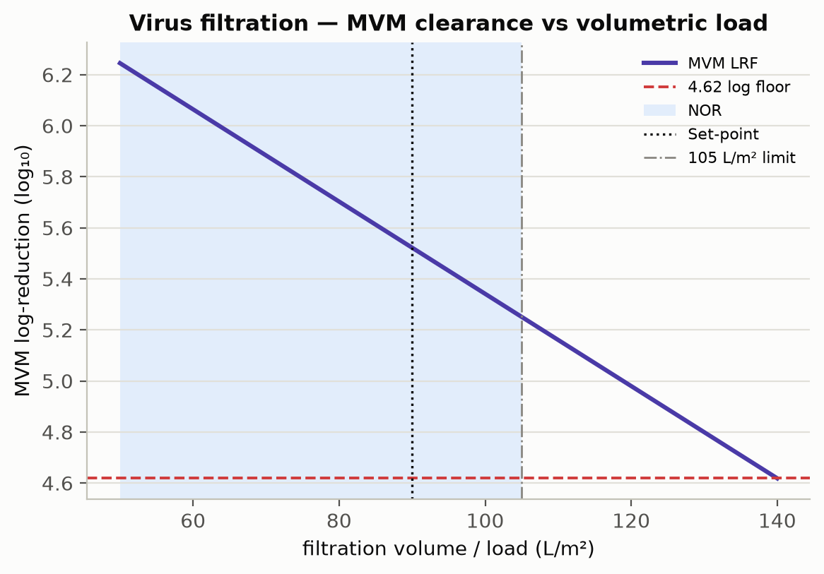
Figure 1: Small-virus filtration MVM (parvovirus) log-reduction versus volumetric load: the log-reduction declines as the membrane is progressively loaded, so the load is capped at the upper normal-operating-range bound to preserve the credited clearance with margin. The normal-operating range and the load limit are marked; the enveloped-virus (XMuLV) is retained essentially completely across the range.
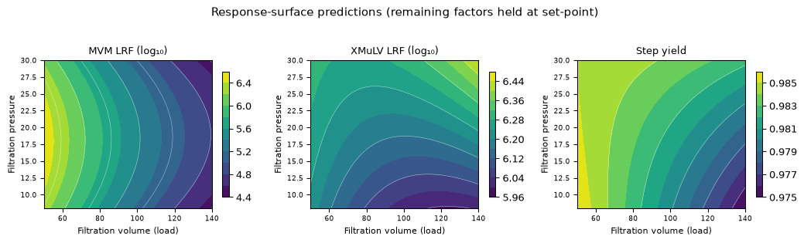
Figure 2: Response-surface predictions for the MVM log-reduction, XMuLV log-reduction and step yield over volumetric load × filtration pressure. The MVM log-reduction falls with volumetric load; the XMuLV log-reduction and the step yield are essentially flat (robust).
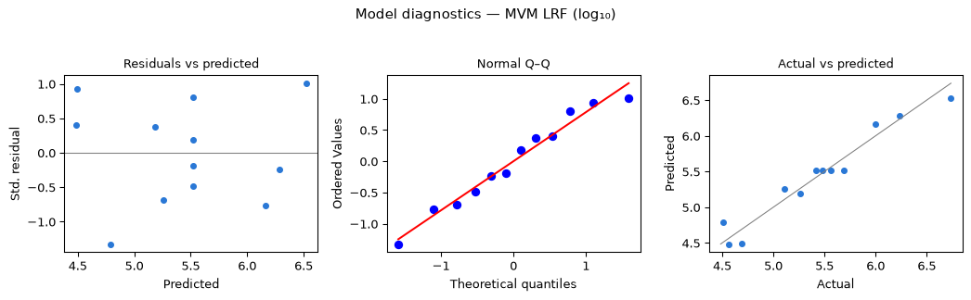
Figure 3: Model diagnostics for the MVM log-reduction response-surface model.

5.4 Mechanistic interpretation
The response-surface model reproduces the established behaviour of small-virus retentive filtration. Removal is governed by size exclusion at the membrane rating. The enveloped retrovirus XMuLV is substantially larger than the membrane rating and is retained essentially completely and independently of load and pressure over the ranges studied, which is why its log-reduction is high and flat. The small non-enveloped parvovirus MVM is closer to the membrane rating, so a small fraction can pass as the membrane is progressively loaded and partially fouled; its log-reduction is therefore highest at low volumetric load and declines as the load increases, which is the single significant relationship in the design and the reason a volumetric-load limit — rather than a pressure limit — defines the operating region. Filtration pressure, within its controlled range, does not materially change retention (the load × pressure interaction is not significant), but it is controlled to preserve filter performance and integrity and is confirmed by the post-use integrity test. The step yield is high and robust because the antibody monomer transmits freely through the membrane at all conditions studied. Because virus filtration removes virus by a size-based mechanism that is independent of the low-pH (Step 6) and charge-based anion-exchange (Step 8) mechanisms, its contribution is credited as orthogonal, modular clearance under ICH Q5A(R2).

6. Design space
The operating region (design space) is defined principally by a volumetric-load limit: the credited MVM log-reduction is preserved with margin when the area-normalized load is held at or below 105 L/m² (the upper NOR bound), with the filtration pressure controlled within its NOR (10–20 psi), over which retention is insensitive to pressure. The NOR of each parameter (Table 4) — volumetric load 50–105 L/m² and filtration pressure 10–20 psi — lies within the characterized region, which in turn lies within the broader knowledge space bounded by the proven acceptable ranges. Because the MVM log-reduction is lowest at the maximum load, the credited clearance is substantiated at that worst-case condition per ICH Q5A(R2); movement within the operating region (below the load limit) is not a change, whereas exceeding the load limit would require assessment under the quality system (CMC Biotech Working Group 2009; International Council for Harmonisation 2009, 2023a). The region is set by the MVM constraint; the XMuLV log-reduction and the step yield are robust across it.

7. Process capability and robustness
Virus filtration is the dedicated small-virus removal step and the principal contributor to the cumulative MVM (parvovirus) clearance. A Monte-Carlo simulation of 2,000 commercial-scale batches, with every parameter varied within its NOR, was used to estimate the commercial-scale distributions and process capability of the cumulative viral-clearance CQAs to which this step contributes (Table 12). Capability is evaluated one-sided against the cumulative lower requirement.
Table 12: Commercial-scale process capability for the cumulative viral-clearance CQAs to which the virus-filtration step contributes.
CQA | Crit. | Spec | Acceptance | Mean ± SD | Cpk
Viral clearance — XMuLV (enveloped) | VH | lower | 16.7–30 | 19.5 ± 0.61 | 1.53
Viral clearance — MVM (parvovirus) | VH | lower | 8.6–20 | 10.4 ± 0.4 | 1.51

The drug-substance MVM clearance meets its ≥ 8.6 log₁₀ cumulative requirement with a capability of Cpk = 1.51 — the process-minimum capability — to which virus filtration is the principal contributor (5.32 of the 10.03 log₁₀ cumulative MVM clearance at the nominal condition). The XMuLV clearance meets its ≥ 16.7 log₁₀ cumulative requirement with a capability of Cpk = 1.53, to which this step contributes a major (5.82 log₁₀) reduction alongside the low-pH inactivation and anion-exchange steps. The capability margins confirm that the NOR-bounded step contributes robustly to the integrated, modular viral clearance of the drug substance at commercial scale.

8. Parameter classification
Each parameter was classified on the A-Mab continuum from the demonstrated effects and the operating-region risk (Table 13). The rationale is as follows.
- Volumetric load (filtration volume) — WC-CPP. The single significant factor for the credited MVM log-reduction (clearance declines with load); it defines the volumetric-load limit that preserves the credited small-virus clearance. It is reliably held at or below the load limit by controlled filter sizing and batch volume, and is therefore a well-controlled CPP.
- Filtration pressure — WC-CPP. No significant effect on retention over the range studied, but it is controlled within a defined range to preserve filter performance and the validated retention and is confirmed by the post-use filter-integrity test; because it is controlled to protect a credited viral-clearance claim it is classified as a well-controlled CPP rather than a general parameter.
Both parameters are well-controlled CPPs; there are no key or general process parameters at this step, because both parameters that affect performance also relate to the credited viral clearance.
Table 13: Post-characterization parameter classification.
Parameter | Class | Study
Filtration volume (load) | WC-CPP | multivariate
Filtration pressure | WC-CPP | multivariate

9. Contribution to the control strategy
The virus-filtration step is the dedicated small-virus removal point of the process and the principal contributor to the cumulative MVM clearance. Its contribution to the overall control strategy comprises: control of the volumetric load at or below the established load limit and of the filtration pressure within its NOR (both WC-CPPs); a validated pre-use membrane flush and lot control; a post-use filter-integrity test (SOP-2012) as a release-linked confirmation of membrane integrity and the credited retention; and the crediting of the step’s MVM and XMuLV log-reduction as orthogonal, modular clearance under ICH Q5A(R2) (International Council for Harmonisation 2023a). Together with the low-pH inactivation (Step 6) and the anion-exchange polish (Step 8), virus filtration completes the modular viral-clearance strategy, whose cumulative log-reductions and capability are consolidated in PCMR-001.

10. Discussion
The characterization quantifies the parameter–response relationships for the small-virus retentive filtration step, establishes a volumetric-load limit that preserves the credited MVM clearance, and classifies both parameters with a data-supported rationale. The MVM log-reduction response-surface model is adequate and behaves as established for size-based virus filtration — a load-dependent decline for the near-rating parvovirus and complete, robust retention of the larger enveloped virus. Consistent with the inherent variability of infectivity assays and the compact two-factor design, the MVM surface is used to set the load limit rather than as a high-precision predictor, and the credited clearance is substantiated conservatively at the worst-case load per ICH Q5A(R2). The principal limitation is inherent to scale-down characterization: absolute log-reduction and throughput may shift modestly at scale and across membrane lots, which is why the operating region is defined on the qualified SDM, confirmed at commercial scale during Stage 2, and carried forward with the load limit, pressure control and the post-use integrity test. The characterization did not identify any parameter requiring the most stringent (CPP, as opposed to WC-CPP) control within the studied ranges.

11. Conclusions
The A-Mab small-virus retentive filtration step is well understood and robust. The relationship between the filtration parameters and the MVM and XMuLV log-reduction and the step yield is quantified by DoE; a volumetric-load limit that preserves the credited MVM clearance is established; both parameter ranges are justified by data; and the cumulative viral-clearance CQAs to which the step contributes meet acceptance at commercial scale, with the step being the principal contributor to the drug-substance MVM-clearance capability of Cpk = 1.51. The load limit, parameter classifications and proven acceptable ranges provide the basis for the Stage 2 operating ranges and the drug-substance viral-safety control strategy. This report rolls up into the Process Characterization Master Report (PCMR-001) and provides the parameter risk basis for the post-characterization process risk assessment.

Deviations from the plan
No deviations from PCP-009 were recorded. All planned runs were executed and all planned responses were measured on the qualified scale-down model.

References
CMC Biotech Working Group. 2009. A-Mab: A Case Study in Bioprocess Development. CASSS.
International Council for Harmonisation. 2009. ICH Q8(R2): Pharmaceutical Development. ICH.
International Council for Harmonisation. 2012. ICH Q11: Development and Manufacture of Drug Substances. ICH.
International Council for Harmonisation. 2023a. ICH Q5A(R2): Viral Safety Evaluation of Biotechnology Products Derived from Cell Lines of Human or Animal Origin. ICH.
International Council for Harmonisation. 2023b. ICH Q9(R1): Quality Risk Management. ICH.
International Society for Pharmaceutical Engineering. 2023. Good Practice Guide: Practical Implementation of the Lifecycle Approach to Process Validation. ISPE.
Parenteral Drug Association. 2013. Technical Report No. 60: Process Validation — a Lifecycle Approach. PDA.
U.S. Food and Drug Administration. 2011. Guidance for Industry: Process Validation — General Principles and Practices. FDA.

Appendix A — Screening design matrix and responses
The coded two-level full-factorial design (factors A–B per Table 5; coded levels −1/0/+1) and the measured responses for each run.
Table 14: Appendix A1 — screening design (coded factor settings).
Run | Type | A | B
1 | factorial | -1 | -1
2 | factorial | -1 | 1
3 | factorial | 1 | -1
4 | factorial | 1 | 1
5 | center | 0 | 0
6 | center | 0 | 0
7 | center | 0 | 0

Table 15: Appendix A2 — screening run responses.
Run | MVM LRF (log₁₀) | XMuLV LRF (log₁₀) | Step yield
1 | 6.341 | 6.331 | 0.9847
2 | 6.076 | 6.406 | 0.9719
3 | 4.708 | 6.061 | 0.9722
4 | 4.481 | 6.511 | 0.9957
5 | 5.328 | 6.459 | 0.9852
6 | 5.01 | 6.167 | 0.9942
7 | 5.969 | 6.282 | 0.9789

Appendix B — Response-surface design matrix and responses
The coded face-centred central-composite design (factors A–B; coded levels −1/0/+1) and the measured responses for each run.
Table 16: Appendix B1 — response-surface design (coded factor settings).
Run | Type | A | B
1 | factorial | -1 | -1
2 | factorial | -1 | 1
3 | factorial | 1 | -1
4 | factorial | 1 | 1
5 | axial | -1 | 0
6 | axial | 1 | 0
7 | axial | 0 | -1
8 | axial | 0 | 1
9 | center | 0 | 0
10 | center | 0 | 0
11 | center | 0 | 0
12 | center | 0 | 0

Table 17: Appendix B2 — response-surface run responses.
Run | MVM LRF (log₁₀) | XMuLV LRF (log₁₀) | Step yield
1 | 6.234 | 6.203 | 0.9895
2 | 5.998 | 6.342 | 0.9854
3 | 4.692 | 5.901 | 0.9767
4 | 4.568 | 6.399 | 0.9806
5 | 6.736 | 6.247 | 0.9811
6 | 4.513 | 6.376 | 0.9785
7 | 5.109 | 6.155 | 0.9754
8 | 5.265 | 6.285 | 0.9852
9 | 5.483 | 5.939 | 0.9899
10 | 5.56 | 6.293 | 0.9887
11 | 5.691 | 6.031 | 0.9716
12 | 5.42 | 6.271 | 0.9823

Appendix C — Full effect and coefficient tables

11.1 Screening effects — all responses
MVM LRF (log₁₀)
Term | Effect | Coef. | Std. err. | t | p-value | Sig.
A | -1.61 | -0.807 | 0.2 | -4.04 | 0.0273 | *
B | -0.246 | -0.123 | 0.2 | -0.617 | 0.581
AB | 0.0192 | 0.00962 | 0.2 | 0.0482 | 0.965
XMuLV LRF (log₁₀)
Term | Effect | Coef. | Std. err. | t | p-value | Sig.
B | 0.262 | 0.131 | 0.0608 | 2.16 | 0.12
AB | 0.188 | 0.0939 | 0.0608 | 1.54 | 0.22
A | -0.0821 | -0.041 | 0.0608 | -0.675 | 0.548
Step yield
Term | Effect | Coef. | Std. err. | t | p-value | Sig.
AB | 0.0181 | 0.00905 | 0.00365 | 2.48 | 0.0892
A | 0.00567 | 0.00283 | 0.00365 | 0.776 | 0.494
B | 0.00539 | 0.00269 | 0.00365 | 0.738 | 0.514

11.2 Response-surface coefficients — XMuLV log-reduction and step yield
XMuLV LRF (log₁₀)
Term | Coef. | Std. err. | t | p-value | Sig.
Intercept | 6.16 | 0.0719 | 85.7 | 1.7e-10 | ***
A | -0.0191 | 0.0643 | -0.297 | 0.776
B | 0.128 | 0.0643 | 1.99 | 0.0943
AB | 0.0896 | 0.0788 | 1.14 | 0.299
A² | 0.0849 | 0.0965 | 0.88 | 0.413
B² | -0.00707 | 0.0965 | -0.0733 | 0.944
Step yield
Term | Coef. | Std. err. | t | p-value | Sig.
Intercept | 0.982 | 0.00313 | 314 | 7.02e-14 | ***
A | -0.00336 | 0.0028 | -1.2 | 0.275
B | 0.0016 | 0.0028 | 0.573 | 0.587
AB | 0.00199 | 0.00342 | 0.58 | 0.583
A² | -0.000294 | 0.00419 | -0.0701 | 0.946
B² | 0.000228 | 0.00419 | 0.0544 | 0.958

Appendix D — Analytical methods summary
Table 18: Analytical methods, techniques and validation references (performance characteristics per the cited method validation reports).
Method | Technique | Analytes / attributes | Validation ref. | Reportable
MVM infectivity | TCID₅₀ / qPCR | MVM (parvovirus) infectious titre | AMV-3018 | log₁₀ reduction
XMuLV infectivity | TCID₅₀ | XMuLV (enveloped) infectious titre | AMV-3017 | log₁₀ reduction

