**CSP2101 Assignment2 Portfolio Task2**

**Semester 1, 2020**

**Morium Mostafa Momo**

**10492778**

Rectangle.sh is a bash script that obtains all the dimensions of rectangles from the text file given on blackboard as rectangle.txt. the code of the script has been done so that the output can come as a formatted file which has named rectangle_f.txt.

The screenshot of the code is given below:

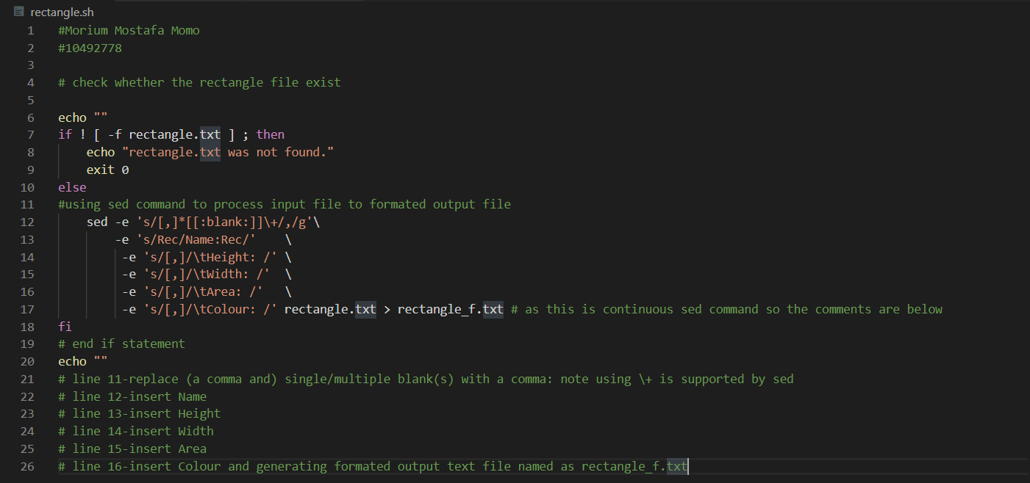

The screenshot of the output when it runs:

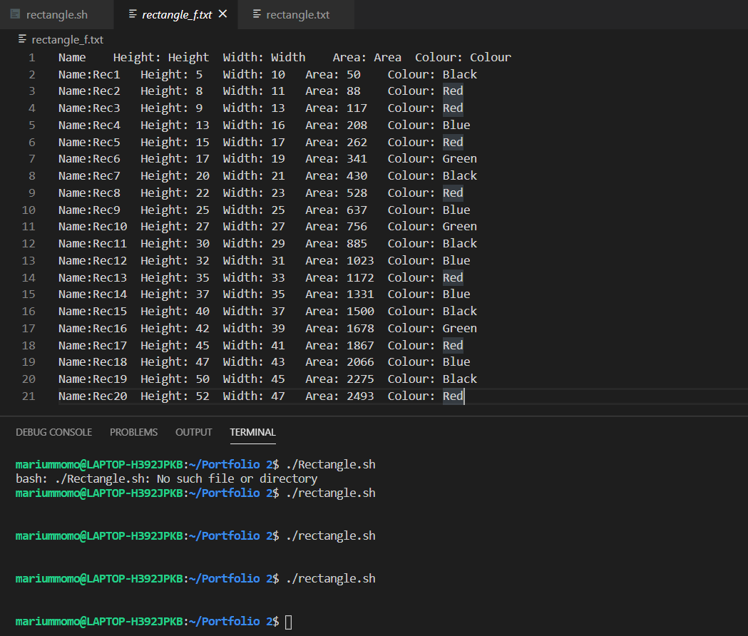

The rectangle.txt file that has been taken from the blackboard and used with the code to get the output is:

