**模块2-2 裁剪算法**

**一 实验目的**

1. 编写直线段、多边形裁剪算法
2. 熟悉逐边裁剪法、Weiler-Atherton裁剪法的使用

**二 实验内容**

4：用逐边裁剪法实现多边形裁剪（代码最上方功能区注明是否处理退化边）

**无退化**实验结果如下图所示：

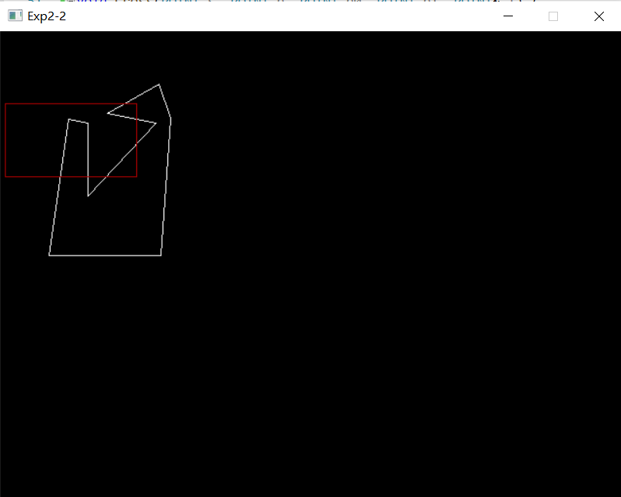图形初始化：（红色部分为裁剪框，白色部分为待裁剪多边形）

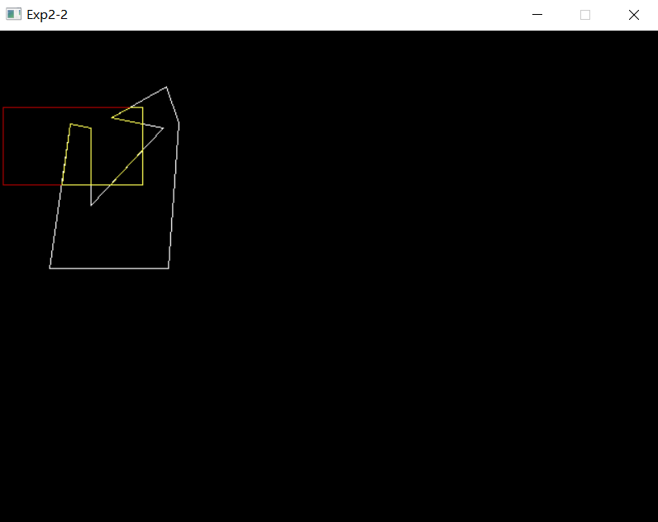点击左键进行裁剪：（黄色部分为裁剪后剩余多边形）

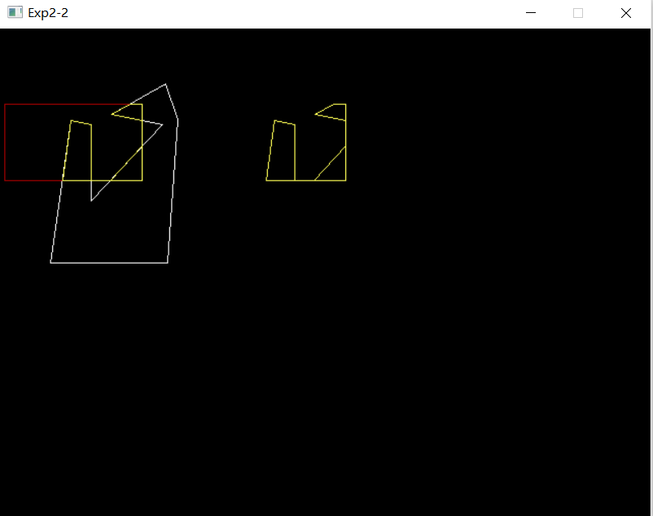点击右键将裁剪图案右移：（黄色部分为裁剪后剩余多边形）

**有退化**实验结果如下图所示：

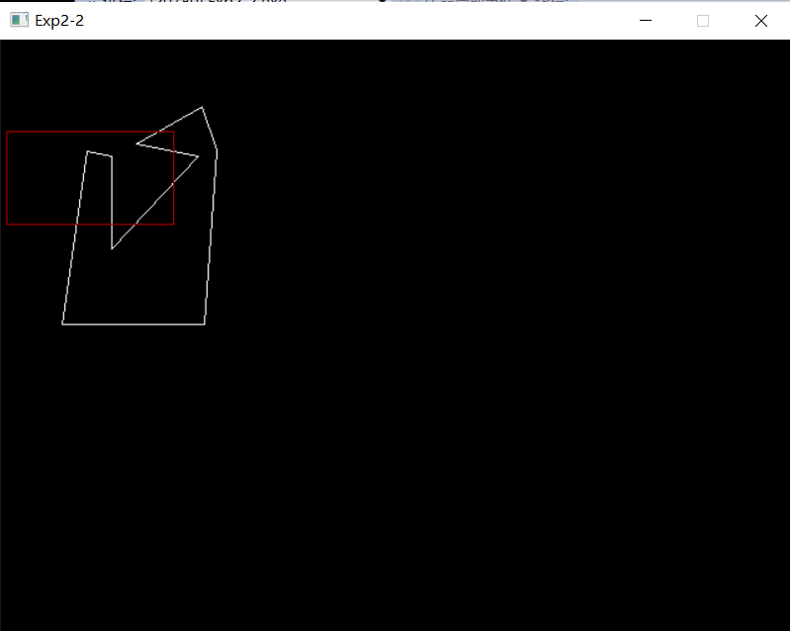图形初始化：（红色部分为裁剪框，白色部分为待裁剪多边形）

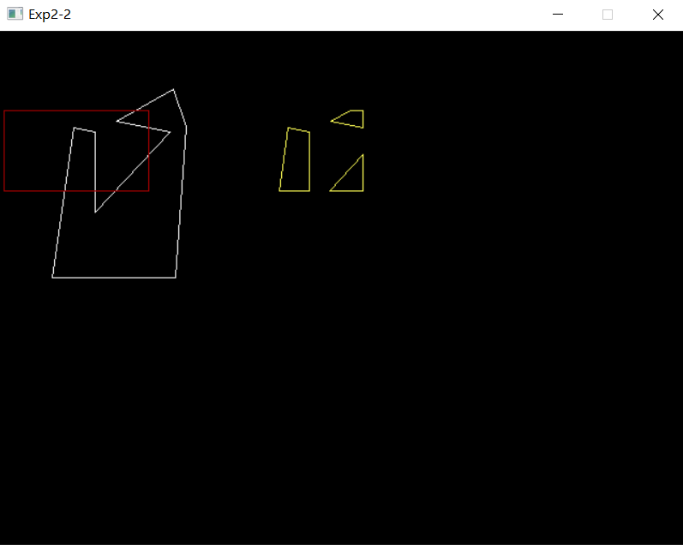点击左键将裁剪图案右移：（黄色部分为裁剪后剩余多边形）

5：用Weiler-Atherton裁剪法实现多边形裁剪

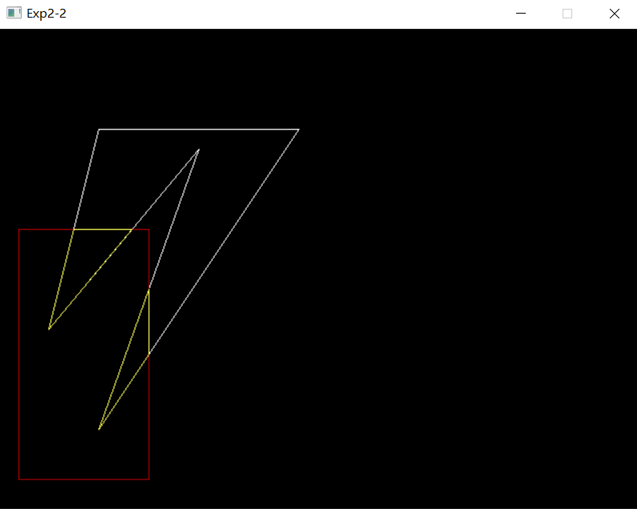实验结果如下图所示：

说明：白色部分为原始多边形，红色部分为裁剪框，黄色部分为通过Weiler-Atherton裁剪法实现的裁剪多边形。

总结：

1. 上述两种裁剪法的代码实现方法，大致是按照PPT上的算法思路构建的。原始多边形是在全局里面预设的，由于时间紧张没有测试过其他多边形（以及水平很菜），可能存在bug没有找到并维护。望谅解。
2. 在实现本实验的过程中，调用了之前实验的函数（CSLineClip等），算是一种学以致用吧。

**三 程序说明**

Project中程序的调用：

将当前cpp文件的属性——常规——从生成中排除中选择否，其他文件选择是，即可运行当前的cpp文件

|  |
| --- |
| 4题：无退化 |
| //////////////////////////////////////////////////////  // 程序名称：多边形裁剪1-1  // 功 能：用逐边裁剪法实现多边形裁剪（无退化）  // 编译环境：VS2019，EasyX_20220116  // 作 者：夏婉可<2020301010225><1597493790@qq.com>  // 最后修改：2022-3-31  #include <graphics.h>  #include <conio.h>  #include <iostream>  using namespace std;  //框的边界  float XL = 5, XR = 140, YB = 74, YT = 149;  POINT Edge[] = { {XR,YB},{XR,YT},{XL,YT},{XL,YB} };  //自定义多边形  POINT Vertex[] = { {110,84},{160,94},{90,169},{90,94},{70,90},{50,230}, {165,230},{175,89},{163,54} };  int inlen = 9;  #define max 100  //判断顶点和裁剪边的内外关系  bool Inside(POINT test, POINT p0, POINT p1) {  if (p1.x > p0.x) {  //裁剪边是窗口的下边  if (test.y >= p0.y) {  return 1;  }  }  else if (p1.x < p0.x) {  //裁剪边是窗口的上边  if (test.y <= p0.y) {  return 1;  }  }  else if (p1.y > p0.y) {  //裁剪边是窗口的右边  if (test.x <= p0.x) {  return 1;  }  }  else if (p1.y < p0.y) {  //裁剪边是窗口的左边  if (test.x >= p0.x) {  return 1;  }  }  return 0;  }  //求多边形的一条边和裁剪边的交点  void Cross(POINT s, POINT p, POINT p0, POINT p1, POINT &i) {  if (p0.y == p1.y) {  //水平裁剪边  i.y = p0.y;  i.x = s.x + (p0.y - s.y) * (p.x - s.x) / (p.y - s.y);  }  else {  //竖直裁剪边  i.x = p0.x;  i.y = s.y + (p0.x - s.x) * (p.y - s.y) / (p.x - s.x);  }  }  //将新的多边形顶点加入原有顶点组  void Insert(POINT newpoint, int &mylen, POINT p[]) {  p[mylen].x = newpoint.x;  p[mylen].y = newpoint.y;  mylen++;  //顶点数+=1  }  //裁剪算法  void SHClip(int mylen, POINT in[], int& outlen, POINT out[], POINT p0, POINT p1) {  POINT s, p, i;  outlen = 0;  s = in[mylen - 1];  for (int j = 0; j < mylen; j++) {  p = in[j];  if (Inside(p, p0, p1)) {  if (Inside(s, p0, p1)) {  Insert(p, outlen, out);  }  else {  Cross(s, p, p0, p1, i);  Insert(i, outlen, out);  Insert(p, outlen, out);  }  }  else if (Inside(s, p0, p1)) {  Cross(s, p, p0, p1, i);  Insert(i, outlen, out);  }  s = p;  }  }  int main() {  //接收框的信息  float x0, y0, x1, y1;  initgraph(640, 480);  //绘制自定的point多边形  setcolor(WHITE);  polygon(Vertex, 9);  //绘制框  setlinecolor(RED);  line(XL, YT, XR, YT);  line(XL, YB, XR, YB);  line(XL, YT, XL, YB);  line(XR, YT, XR, YB);  ExMessage m;  POINT outp1[max], outp2[max], outp3[max], outp4[max];  int len1, len2, len3, len4;  int times = 0;  while (1) {  m = getmessage(EX_MOUSE | EX_KEY);  //用户点击左键后生成裁剪图形  if (m.message == WM_LBUTTONDOWN) {    //裁剪过程  //POINT Edge[] = { {XR,YB},{XR,YT},{XL,YT},{XL,YB} };  //右边窗口裁剪边  SHClip(inlen, Vertex, len1, outp1, Edge[0], Edge[1]);  //上边窗口裁剪边  SHClip(len1, outp1, len2, outp2, Edge[1], Edge[2]);  //左边窗口裁剪边  SHClip(len2, outp2, len3, outp3, Edge[2], Edge[3]);  //下边窗口裁剪边  SHClip(len3, outp3, len4, outp4, Edge[3], Edge[0]);  //连线过程  setcolor(YELLOW);  polygon(outp4, len4);  //原来的位置进行黄色标注裁剪    times++;  }  //用户点击右键后在旁边空白处生成裁剪图形  else if (m.message == WM_RBUTTONDOWN) {  for (int i = 0; i < len4; i++) {  outp4[i].x += 200;  }  setcolor(YELLOW);  polygon(outp4, len4);  times++;  }  if (times == 2) {  break;  }  }  _getch(); // 按任意键继续  closegraph(); // 关闭绘图窗口  return 0;  } |
| 4题：有退化 |
| //////////////////////////////////////////////////////  // 程序名称：多边形裁剪1-2  // 功 能：用逐边裁剪法实现多边形裁剪（有退化）  // 编译环境：VS2019，EasyX_20220116  // 作 者：夏婉可<2020301010225><1597493790@qq.com>  // 最后修改：2022-3-31  #include <graphics.h>  #include <conio.h>  #include <iostream>  #include <stdlib.h>  #include <stdio.h>  using namespace std;  //框的边界  float XL = 5, XR = 140, YB = 74, YT = 149;  POINT Edge[] = { {XR,YB},{XR,YT},{XL,YT},{XL,YB} };  //自定义多边形  POINT Vertex[] = { {110,84},{160,94},{90,169},{90,94},{70,90},{50,230}, {165,230},{175,89},{163,54} };  int inlen = 9;  #define max 100  //判断顶点和裁剪边的内外关系  bool Inside(POINT test, POINT p0, POINT p1) {  if (p1.x > p0.x) {  //裁剪边是窗口的下边  if (test.y >= p0.y) {  return 1;  }  }  else if (p1.x < p0.x) {  //裁剪边是窗口的上边  if (test.y <= p0.y) {  return 1;  }  }  else if (p1.y > p0.y) {  //裁剪边是窗口的右边  if (test.x <= p0.x) {  return 1;  }  }  else if (p1.y < p0.y) {  //裁剪边是窗口的左边  if (test.x >= p0.x) {  return 1;  }  }  return 0;  }  //求多边形的一条边和裁剪边的交点  void Cross(POINT s, POINT p, POINT p0, POINT p1, POINT& i) {  if (p0.y == p1.y) {  //水平裁剪边  i.y = p0.y;  i.x = s.x + (p0.y - s.y) * (p.x - s.x) / (p.y - s.y);  }  else {  //竖直裁剪边  i.x = p0.x;  i.y = s.y + (p0.x - s.x) * (p.y - s.y) / (p.x - s.x);  }  }  //将新的多边形顶点加入原有顶点组  void Insert(POINT newpoint, int& mylen, POINT p[]) {  p[mylen].x = newpoint.x;  p[mylen].y = newpoint.y;  mylen++;  //顶点数+=1  }  //裁剪算法  void SHClip(int mylen, POINT in[], int& outlen, POINT out[], POINT p0, POINT p1) {  POINT s, p, i;  outlen = 0;  s = in[mylen - 1];  for (int j = 0; j < mylen; j++) {  p = in[j];  if (Inside(p, p0, p1)) {  if (Inside(s, p0, p1)) {  Insert(p, outlen, out);  }  else {  Cross(s, p, p0, p1, i);  Insert(i, outlen, out);  Insert(p, outlen, out);  }  }  else if (Inside(s, p0, p1)) {  Cross(s, p, p0, p1, i);  Insert(i, outlen, out);  }  s = p;  }  }  //VS不让用快排啊=。=  int cmp(void* a, void* b) {  return *(int*)a - *(int*)b;  }  int main() {  //接收框的信息  initgraph(640, 480);  //绘制自定的point多边形  setcolor(WHITE);  polygon(Vertex, 9);  //绘制框  setlinecolor(RED);  line(XL, YT, XR, YT);  line(XL, YB, XR, YB);  line(XL, YT, XL, YB);  line(XR, YT, XR, YB);  ExMessage m;  POINT outp1[max], outp2[max], outp3[max], outp4[max];  int len1, len2, len3, len4;  int times = 0;  while (1) {  m = getmessage(EX_MOUSE | EX_KEY);  //用户点击左键后生成裁剪图形  if (m.message == WM_LBUTTONDOWN) {  //裁剪过程  //POINT Edge[] = { {XR,YB},{XR,YT},{XL,YT},{XL,YB} };  //右边窗口裁剪边  SHClip(inlen, Vertex, len1, outp1, Edge[0], Edge[1]);  //上边窗口裁剪边  SHClip(len1, outp1, len2, outp2, Edge[1], Edge[2]);  //左边窗口裁剪边  SHClip(len2, outp2, len3, outp3, Edge[2], Edge[3]);  //下边窗口裁剪边  SHClip(len3, outp3, len4, outp4, Edge[3], Edge[0]);  //连线过程  //setcolor(YELLOW);  //polygon(outp4, len4);  //原来的位置进行黄色标注裁剪  /*closegraph(); // 关闭绘图窗口  for (int t = 0; t < len4; t++) {  cout << outp4[t].x <<" " << outp4[t].y << endl;  }*/  //退化边，根据outp4修改吧  for (int i = 0; i < len4 - 1; i++) {  int flag = 1;  if (outp4[i].x == outp4[i + 1].x) {  if (outp4[i].x == int(XL) || outp4[i].x == int(XR)) {  flag = 0;  }  }  if (outp4[i].y == outp4[i + 1].y) {  if (outp4[i].y == int(YB) || outp4[i].y == int(YT)) {  flag = 0;  }  }  if (flag == 1) {  setcolor(YELLOW);  //+200像素，可能是为了，方便展示orz  line(outp4[i].x + 200, outp4[i].y, outp4[i + 1].x + 200, outp4[i + 1].y);  }  }    //float XL = 5, XR = 140, YB = 74, YT = 149;  //{XR,YB},{XR,YT},{XL,YT},{XL,YB}  //{ {110,84},{160,94},{90,169},{90,94},{70,90},{50,230}, {165,230},{175,89},{163,54} };    //将坐标值按从小到大排序，奇数线段依次连接。  int xl[10], xr[10], yb[10], yt[10];//记录和框重合的点  int cntl = 0, cntr = 0, cntb = 0, cntt = 0;  for (int t = 0; t < len4; t++) {  if (outp4[t].x == int(XL)) {  //有了一个x坐标了我还用啥二维数组存坐标啊，笑  //[XL,y]  xl[cntl++] = outp4[t].y;  }  if (outp4[t].x == int(XR)) {  //[XR,y]  xr[cntr++] = outp4[t].y;  }  if (outp4[t].y == int(YB)) {  //[x,YB]  yb[cntb++] = outp4[t].x;  }  if (outp4[t].y == int(YT)) {  //[x,YB]  yt[cntt++] = outp4[t].x;  }  }  /*void selectSort(int& a, int alen) {  for (int i = 0; i < alen - 1; i++) {  int min = i;  for (int j = i + 1; j < alen; j++) {  if (a[j] < a[min]) {  min = j;  }  }  //swap elements  int temp = a[min];  a[min] = a[i];  a[i] = temp;  }  }*/  //为什么调用sort函数呢，突然的bug猝不及防。还是传统方法改好了。  //排序x,y坐标  //画left边  if (cntl != 0) {  for (int i = 0; i < cntl - 1; i++) {  int min = i;  for (int j = i + 1; j < cntl; j++) {  if (xl[j] < xl[min]) {  min = j;  }  }  int t = xl[min];  xl[min] = xl[i];  xl[i] = t;  }  for (int i = 0; i < cntl; i += 2) {  setcolor(YELLOW);  line(int(XL) + 200, xr[i], int(XL) + 200, xr[i + 1]);  }  }  //画right边  if (cntr != 0) {  for (int i = 0; i < cntr - 1; i++) {  int min = i;  for (int j = i + 1; j < cntr; j++) {  if (xr[j] < xr[min]) {  min = j;  }  }  int t = xr[min];  xr[min] = xr[i];  xr[i] = t;  }  for (int i = 0; i < cntr; i += 2) {  setcolor(YELLOW);  line(int(XR) + 200, xr[i], int(XR) + 200, xr[i + 1]);  }  }  //画bottom边  if (cntb != 0) {  for (int i = 0; i < cntb - 1; i++) {  int min = i;  for (int j = i + 1; j < cntb; j++) {  if (yb[j] < yb[min]) {  min = j;  }  }  int t = yb[min];  yb[min] = yb[i];  yb[i] = t;  }  for (int i = 0; i < cntb; i += 2) {  setcolor(YELLOW);  line(yb[i] + 200, int(YB), yb[i + 1] + 200, int(YB));  }  }  //画top边  if (cntt != 0) {  for (int i = 0; i < cntt - 1; i++) {  int min = i;  for (int j = i + 1; j < cntt; j++) {  if (yt[j] < yt[min]) {  min = j;  }  }  int t = yt[min];  yt[min] = yt[i];  yt[i] = t;  }  for (int i = 0; i < cntt; i += 2) {  setcolor(YELLOW);  line(yt[i] + 200, int(YT), yt[i + 1] + 200, int(YT));  }  }  }  }  _getch(); // 按任意键继续  closegraph(); // 关闭绘图窗口  return 0;  } |
| 5题 |
| //////////////////////////////////////////////////////  // 程序名称：多边形裁剪2  // 功 能：用Weiler-Atherton裁剪法实现多边形裁剪  // 编译环境：VS2019，EasyX_20220116  // 作 者：夏婉可<2020301010225><1597493790@qq.com>  // 最后修改：2022-3-31  #include <graphics.h>  #include <conio.h>  #include <iostream>  using namespace std;  //框的边界  float XL = 20, XR = 150, YB = 200, YT = 450;  POINT Edge[] = { {XR,YB},{XR,YT},{XL,YT},{XL,YB} };  //自定义多边形，顺时针排序点坐标  POINT Vertex[] = { {300,100},{100,400},{200,120},{50,300},{100,100} };  int inlen = 5, outlen = 0;  int keepx[100], keepy[100];  //编码数值  #define LEFT 1  #define RIGHT 2  #define BOTTOM 4  #define TOP 8  //编码函数  int encode(float x, float y, int* code) {  int c = 0;  if (x < XL) {  c = c | LEFT;  }  else if (x > XR) {  c = c | RIGHT;  }  if (y < YB) {  c = c | BOTTOM;;  }  else if (y > YT) {  c = c | TOP;  }  *code = c;  return 0;  }  //CS裁剪  int CSLineClip(float x1, float y1, float x2, float y2) {  //记录原始点  float x10 = x1, y10 = y1, x20 = x2, y20 = y2;  int code1, code2, code;  float x, y;  encode(x1, y1, &code1);  encode(x2, y2, &code2);  while (code1 != 0 || code2 != 0) {  if ((code1 & code2) != 0) {  return 0;  }  code = code1;  if (code1 == 0) {  code = code2;  }  //找交点，通过边界找坐标值  if ((LEFT & code) != 0) {  x = XL;  y = y1 + (y2 - y1) * (XL - x1) / (x2 - x1);  }  else if ((RIGHT & code) != 0) {  x = XR;  y = y1 + (y2 - y1) * (XR - x1) / (x2 - x1);  }  else if ((BOTTOM & code) != 0) {  y = YB;  x = x1 + (x2 - x1) * (YB - y1) / (y2 - y1);  }  else if ((TOP & code) != 0) {  y = YT;  x = x1 + (x2 - x1) * (YT - y1) / (y2 - y1);  }  //更新范围内的交点  if (code == code1) {  x1 = x;  y1 = y;  encode(x, y, &code1);  }  else {  x2 = x;  y2 = y;  encode(x, y, &code2);  }  }  //最终端点是x1 y1, x2 y2  //由于本题的特殊性，一定有一个是原始点，那先在一开始记录下  //把求得的交点push到keep数组中  //记录原始点 float x10 = x1, y10 = y1, x20 = x2, y20 = y2;  if (x10 == x1 && y10 == y1) {  //1点和原始点一样，那2点是交点，存入2点  keepx[outlen] = x2;  keepy[outlen] = y2;  outlen++;//???换个名字就可以全局了  }  else if (x20 == x2 && y20 == y2) {  //2点和原始点一样，那1点是交点，存入1点  keepx[outlen] = x1;  keepy[outlen] = y1;  outlen++;  }  //画线  setlinecolor(YELLOW);  line(x1, y1, x2, y2);  return 0;  }  int main() {  initgraph(640, 480);  //绘制自定的point多边形  setcolor(WHITE);  polygon(Vertex, inlen);  setcolor(RED);  polygon(Edge, 4);  //寻找第一个从外部->内部的边，求交点  int startnum = -1, endnum = -1;  for (int i = 0; i < inlen; i++) {  int code1 = -1, code2 = -1;  //非末尾点判断  if (i < inlen - 1) {  encode(Vertex[i].x, Vertex[i].y, &code1);  encode(Vertex[i + 1].x, Vertex[i + 1].y, &code2);  if (code1 != 0 && code2 == 0) {  //external to internal  startnum = i;  endnum = i + 1;  break;  }  }  //末尾点判断  else {  encode(Vertex[inlen - 1].x, Vertex[inlen - 1].y, &code1);  encode(Vertex[0].x, Vertex[0].y, &code2);  if (code1 != 0 && code2 == 0) {  //external to internal  startnum = i;  endnum = i + 1;  break;  }  }  }  //看看框和多边形是否有交集  if (startnum == -1) {  //没找到交点  return 0;  }  /*else {  cout << startnum << " " << endnum; //输出判断  }*/  //设置全局count不行，给到主函数然后传参进去吧  //int count = 0;  //CSCLIP救我老命啊，直接求内外交点然后clip掉  CSLineClip(Vertex[startnum].x, Vertex[startnum].y, Vertex[endnum].x, Vertex[endnum].y);  int curnum = endnum;  int times = 1;//判断是否循环结束  while (1) {  int code1 = -1, code2 = -1;  int flag = -1;  //给起始点编码，看看是否在框内  if (curnum < inlen - 1) {  encode(Vertex[curnum].x, Vertex[curnum].y, &code1);  encode(Vertex[curnum + 1].x, Vertex[curnum + 1].y, &code2);  flag = 1;  }  else {  encode(Vertex[inlen - 1].x, Vertex[inlen - 1].y, &code1);  encode(Vertex[0].x, Vertex[0].y, &code2);  flag = 0;  }  //两个点都在框内  if (code1 == 0 && code2 == 0) {  setlinecolor(YELLOW);  if (flag == 1) {  line(Vertex[curnum].x, Vertex[curnum].y, Vertex[curnum + 1].x, Vertex[curnum + 1].y);  }  else if (flag == 0) {  line(Vertex[inlen - 1].x, Vertex[inlen - 1].y, Vertex[0].x, Vertex[0].y);  }  }  //起点内，终点外  else if (code1 == 0 && code2 != 0) {  if (flag == 1) {  CSLineClip(Vertex[curnum].x, Vertex[curnum].y, Vertex[curnum + 1].x, Vertex[curnum + 1].y);  }  else if (flag == 0) {  CSLineClip(Vertex[inlen - 1].x, Vertex[inlen - 1].y, Vertex[0].x, Vertex[0].y);  }  }  //起点外，终点内  else if (code1 != 0 && code2 == 0) {  if (flag == 1) {  CSLineClip(Vertex[curnum].x, Vertex[curnum].y, Vertex[curnum + 1].x, Vertex[curnum + 1].y);  }  else if (flag == 0) {  CSLineClip(Vertex[inlen - 1].x, Vertex[inlen - 1].y, Vertex[0].x, Vertex[0].y);  }  }  //起点外，终点外  else {  //不画线  }  //记录入框交点和出框交点，并连结  //当前线段判断完并连线完，给下一轮循环更新curnum  if (curnum == inlen - 1) {  curnum = 0;  times++;  }  else {  curnum++;  times++;  }  //判断循环退出  if (times == inlen) {  break;  }  }  for (int i = 0; i < outlen; i += 2) {  line(keepx[i], keepy[i], keepx[i + 1], keepy[i + 1]);  }  _getch(); // 按任意键继续  closegraph(); // 关闭绘图窗口  //cout << outlen;  /*  //交点判断  for (int i = 0; i < outlen; i++) {  cout << keepx[i] << " " << keepy[i] << endl;  }  */  return 0;  } |