**模块3-2 图形变换**

**一 实验目的**

1. 编写图形各种变换的算法

**二 实验内容**

1：任意直线的对称变换。要求将变换矩阵写在实验报告中，并与代码匹配。求对任意直线Ax+By+C=0的对称变换矩阵。

实验结果如下图所示：

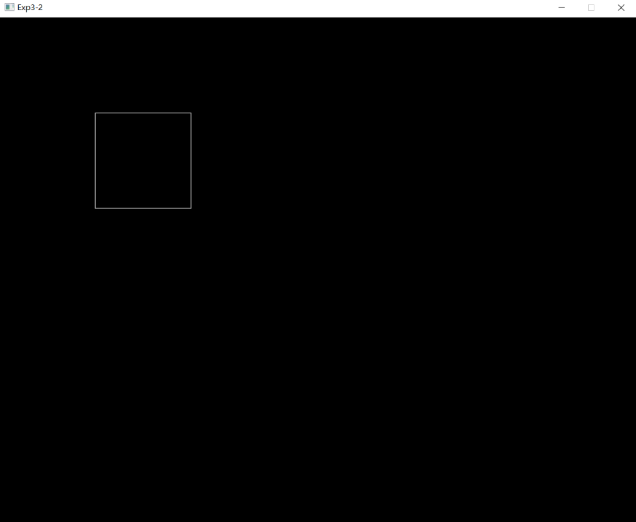预设图形初始化：

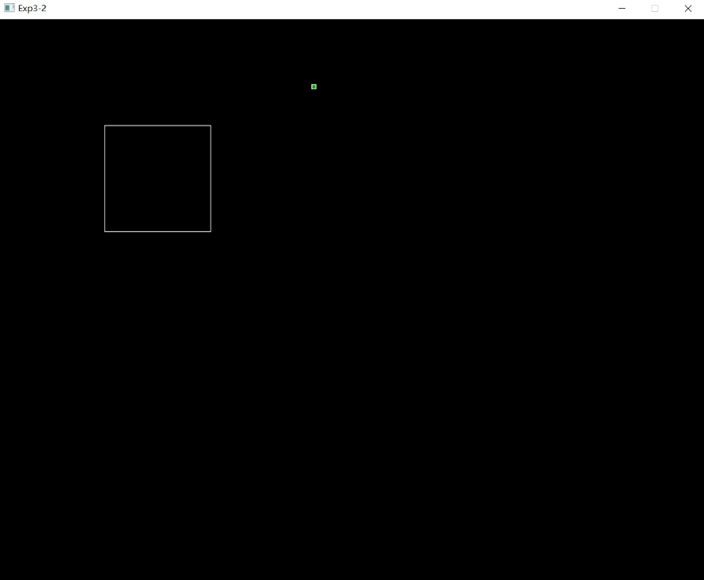鼠标左键点击直线起点：

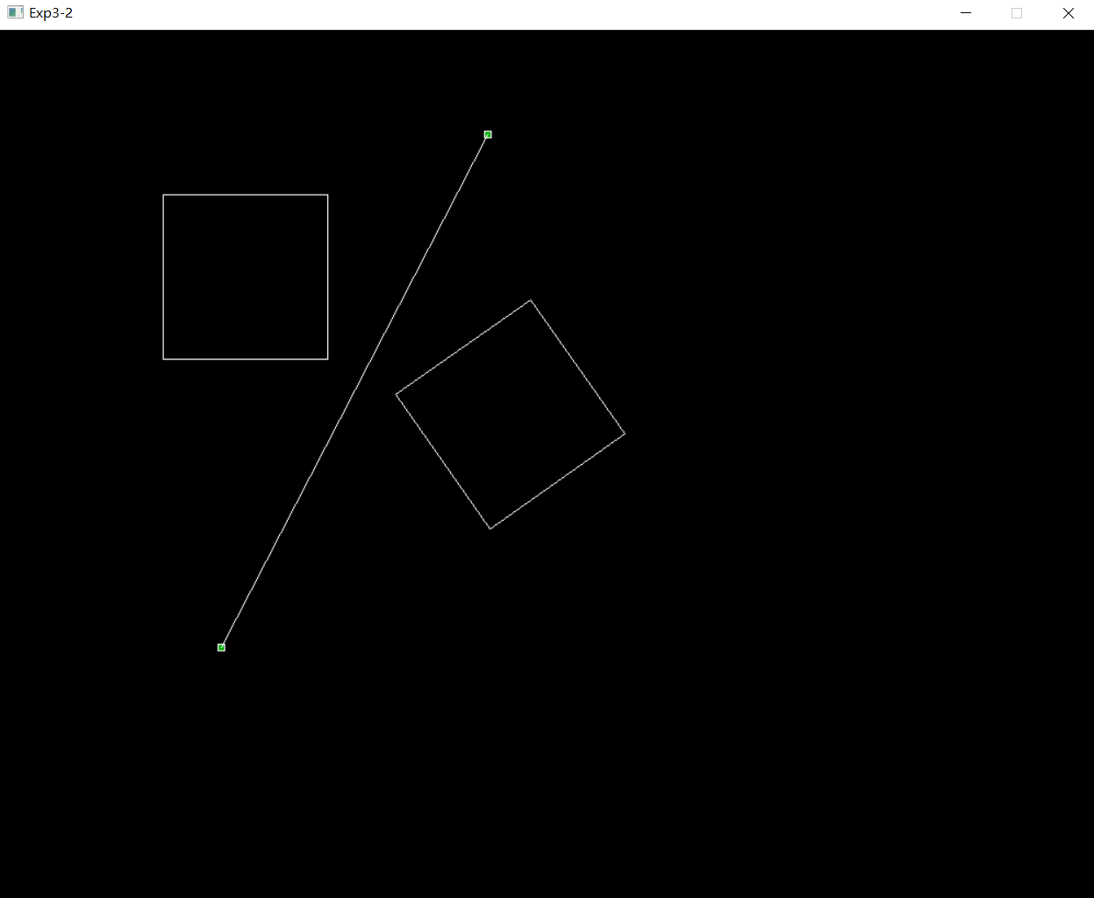鼠标右键点击直线终点：

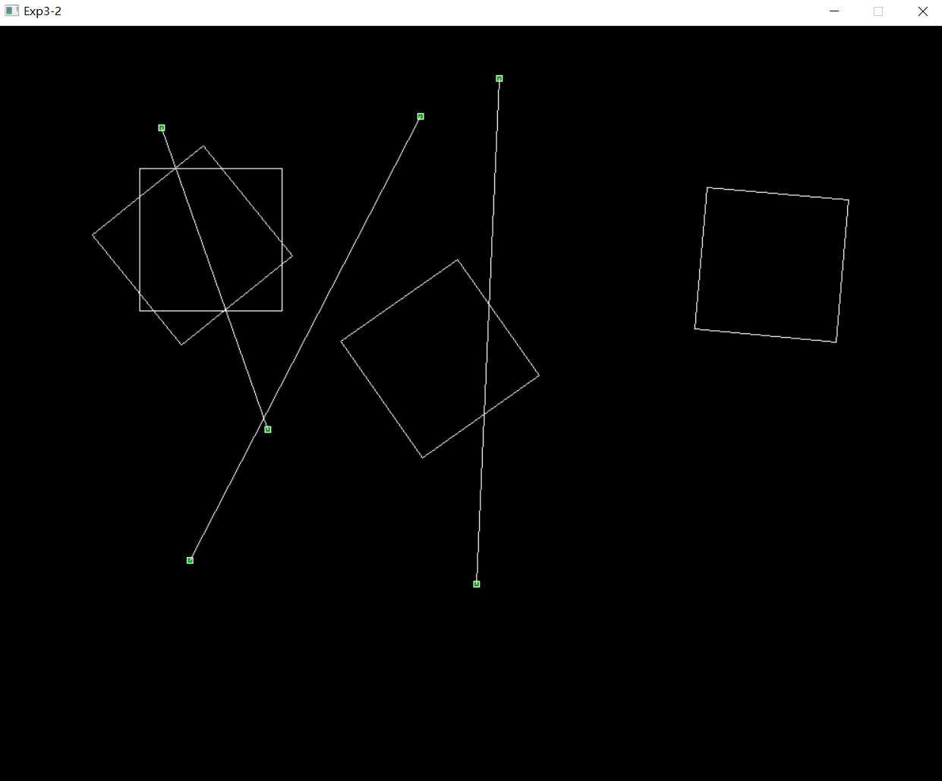继续添加对称情况：

求对任意直线Ax+By+C=0的对称变换矩阵：

对于任意直线Ax + By + C = 0，对称变换矩阵为M = (1-2A^2/(A^2+B^2), -2AB/(A^2+B^2), -2AC/(A^2+B^2); -2AB/(A^2+B^2), 1-2B^2/(A^2+B^2), -2BC/(A^2+B^2); 0, 0, 1)，其中A和B不同时为0。

|  |  |  |
| --- | --- | --- |
| 1-2A^2/(A^2+B^2) | -2AB/(A^2+B^2) | -2AC/(A^2+B^2) |
| -2AB/(A^2+B^2) | 1-2B^2/(A^2+B^2) | -2BC/(A^2+B^2) |
| 0 | 0 | 1 |

**三 程序说明**

最终的实验代码如下表所示：

|  |
| --- |
| 1题 |
| //////////////////////////////////////////////////////  // 程序名称：任意直线对称变换  // 功 能：实现图形以任意直线为基准的对称变换  // 编译环境：VS2019，EasyX_20220116  // 作 者：夏婉可<2020301010225><1597493790@qq.com>  // 最后修改：2022-4-7  #include <graphics.h>  #include <conio.h>  #include <iostream>  #include <math.h>  using namespace std;  double points[4][2] = { {150,150},{150,300},{300,300},{300,150} };  const double newpoints[4][2] = { {150,150},{150,300},{300,300},{300,150} };  int num = 4, dimension = 3;  #define PI 3.1415927  //旋转变换  void rotate(double degree);  //平移变换  void trans(double tx, double ty);  //矩阵乘法  void mutiply(double a[5][5], int ar, int ac, double b[5][5], int br, int bc);  //画图函数  void paint();  //任意对称变换  void anysymmetry(int x1, int y1, int x2, int y2);  //坐标轴对称变换  void symmetry(int flag);  void anysymmetry(int x1, int y1, int x2, int y2) {  double k = 0, b = 0;  if (x1 == x2) {  trans(-x1, 0);  symmetry(1);  trans(x1, 0);  }  else if (y1 == y2) {  trans(0, -y1);  symmetry(0);  trans(0, y1);  }  else {  k = 1.0 * (y1 - y2) / (x1 - x2);  b = y1 - k * x1;  trans(0, -b);  rotate(-atan(k) * 180 * 1.0 / PI);  symmetry(0);  rotate(atan(k) * 180 * 1.0 / PI);  trans(0, b);  }  }  void symmetry(int flag) {  int i;  if (flag == 0) {  for (i = 0; i < num; i++) {  points[i][1] = -points[i][1];  }  }  else if (flag == 1) {  for (i = 0; i < num; i++) {  points[i][0] = -points[i][0];  }  }  else {  return;  }  }  void paint() {  for (int i = 0; i < num; i++) {  if (i == num - 1) {  line(int(points[i][0]), int(points[i][1]), int(points[0][0]), int(points[0][1]));  break;  }  line(int(points[i][0]), int(points[i][1]), int(points[i + 1][0]), int(points[i + 1][1]));  }  }  void rotate(double degree) {  double sita = 1.0 * degree / 180 * PI;  double R[5][5] = { {cos(sita),-sin(sita),0},{sin(sita),cos(sita),0},{0,0,1.0} };  double point[5][5];  int i;  for (i = 0; i < num; i++) {  point[0][0] = 1.0 * points[i][0];  point[1][0] = 1.0 * points[i][1];  point[2][0] = 1;  mutiply(R, dimension, dimension, point, dimension, 1);  points[i][0] = point[0][0];  points[i][1] = point[1][0];  }  }  void trans(double tx, double ty) {  double T[5][5] = { {1,0,tx},{0,1,ty},{0,0,1} };  double point[5][5];  int i;  for (i = 0; i < num; i++) {  point[0][0] = 1.0 * points[i][0];  point[1][0] = 1.0 * points[i][1];  point[2][0] = 1;  mutiply(T, dimension, dimension, point, dimension, 1);  points[i][0] = point[0][0];  points[i][1] = point[1][0];  }  }  void mutiply(double a[5][5], int ar, int ac, double b[5][5], int br, int bc) {  int i, j, k;  double c[5][5];  for (i = 0; i < ar; i++) {  for (j = 0; j < bc; j++) {  c[i][j] = 0;  }  }  for (i = 0; i < ar; i++) {  for (j = 0; j < bc; j++) {  for (k = 0; k < ac; k++) {  c[i][j] += 1.0 * a[i][k] * b[k][j];  }  }  }  for (i = 0; i < ar; i++) {  for (j = 0; j < bc; j++) {  b[i][j] = c[i][j];  }  }  }  int main() {  initgraph(1000, 800);  ExMessage m;  //绘画初始矩形  setcolor(WHITE);  rectangle(points[0][0], points[0][1], points[2][0], points[2][1]);  int x0, y0, x1, y1;  while (1) {  m = getmessage(EX_MOUSE | EX_KEY);  switch (m.message) {  case WM_LBUTTONDOWN:  x0 = m.x;  y0 = m.y;  //画直线起点  setlinecolor(WHITE);  setfillcolor(GREEN);  fillrectangle(m.x - 3, m.y - 3, m.x + 3, m.y + 3);  break;  case WM_RBUTTONDOWN:  x1 = m.x;  y1 = m.y;  //画直线终点  setlinecolor(WHITE);  setfillcolor(GREEN);  fillrectangle(m.x - 3, m.y - 3, m.x + 3, m.y + 3);  //处理直线  line(x0, y0, x1, y1);  anysymmetry(x0, y0, x1, y1);  paint();  for (int i = 0; i < 4; i++) {  points[0][0] = newpoints[0][0];  points[0][1] = newpoints[0][1];  points[1][0] = newpoints[1][0];  points[1][1] = newpoints[1][1];  points[2][0] = newpoints[2][0];  points[2][1] = newpoints[2][1];  points[3][0] = newpoints[3][0];  points[3][1] = newpoints[3][1];  }  break;  case WM_KEYDOWN:  if (m.vkcode == VK_ESCAPE) {  return 0;  }  }  }  _getch();  closegraph();  return 0;  } |