MGT 656 - Class Project

Software Development Project Status Report

Sprint 2

Professor Kyle Jensen



Team: Morning-Leaf

Members:

Raúl Madriz raul.madriz@yale.edu

Ernesto Reyes ernesto.reyes@yale.edu

Ernesto Castillo ernesto.castillo@yale.edu

Carlos Romo carlos.romo@yale.edu

November 2, 2015

**Sprint 2**

Heroku application address: (https://mgt656-morning-leaf.herokuapp.com/)

**Burndown Chart**

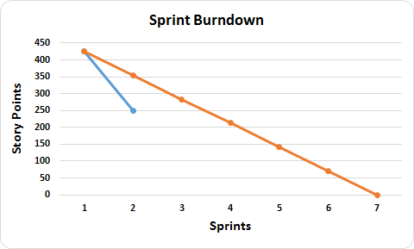

**Sprint Completed Stories**

1. U1 - Task 1 - Bootstrap CSS framework
2. U1 - Task 2 - HTML5 header and footer elements
3. U1 - Task 3 - Every page has a link to the about page and the homepage in the footer element of the page
4. U1 - Task 4 - "Every page" will refer to the following for testing purposes: /, /about, /events/new, /events/0, /events/1, /events/2
5. U2 - Task 1 - Your team Logo
6. U2 - Task 1 - A an unordered list of events, including their details
7. U6 - Task 1 - I can visit your API at /api/events and retrieve an object with key events containing all events in JSON format
8. U7 - Task 1 - Your names, each in a span tag with id attribute set to your class nickname
9. U7 - Task 2 - A headshot of you each in an img tag with id="-headshot". This does not have to actually be a picture of you

During the Sprint 1 we manage to set up all the technical issues that we were going to use to advance on our project. We broke the user stories to specific tasks and we gave them a Fibonacci number to identify the difficulty of each user story and the story points estimates.

In Sprint 2 we understood better the project and we calculated the story points estimates of each user stories and then we broke this story points estimates to the individual tasks that each user story has. This had to be done to create our burndown chart. We estimated 425 story points for the 7 sprints of the final project. This tells us that we have to be able to manage more less 71 story points per sprint, to be able to finish the project on time. During Sprint 2 we finished the user stories 1 and 2 from Sprint 1 and for Sprint 2 we worked and finished the user stories 6 and 7. This led us to a result of 175 story points for this sprint.

An inconvenience that we had during Sprint 2 was a little of trouble getting our logo to show in the page. Until we realize that it had to be placed in the public folder.

**Sprint Backlog**

During Sprint 2 we were able to manage and finished all the tasks that we had in progress from last sprint and the tasks that we had for Sprint 2.

**Product Backlog**



For Sprint 3 we are going to work on the following tasks:

1. U3 - Task 1 - The title for each event is a clickable link to the "detail page" for that event, which should be at /events/, where id refers to the id of the event
2. U4 - Task 1 - Events that are over are not shown
3. U5 - Task 1 - I can click a link to take me to /events/new. The link has id="new"

This will give us a total of 90 points estimates, which will be good to be align with the strategy of the team to fulfill the requirements of the project.