MGT 656 - Class Project

Software Development Project Status Report

Sprint 3

Professor Kyle Jensen



Team: Morning-Leaf

Members:

Raúl Madriz raul.madriz@yale.edu

Ernesto Reyes ernesto.reyes@yale.edu

Ernesto Castillo ernesto.castillo@yale.edu

Carlos Romo carlos.romo@yale.edu

November 9, 2015

**Sprint 3**

Heroku application address: (https://mgt656-morning-leaf.herokuapp.com/)

**Burndown Chart**

**Sprint Completed Stories**

1. U3 - Task 1 - The title for each event is a clickable link to the "detail page" for that event, which should be at /events/, where id refers to the id of the event
2. U4 - Task 1 - Events that are over are not shown
3. U5 - Task 1 – I can click a link to take me to /events/new. The link has id=”new”

During the Sprint 3 the team was very well organized and since the conclusion of sprint 2 we already knew the user stories that were going to be worked and developed for sprint 3. During our meeting we didn’t had any big issue with the user stories that were in progress and conclude. With the upgrade of the commands of GitHub we were able to do the merge in a successful way with the master branch. We were wondering also if the scrum master can supply us the list of commands for each unit test.

During Sprint 3 we finished the user stories 3, 4 and 5. This led us to a result of 90 story points for this sprint. From the 425 story points that we estimated for the 7 sprints of the final project, we have completed 265 story points which lives us with 160 story points to finish. We have been able to manage more than 71 story points per sprint and with this we will have time to concentrate in the designing aspects of the application once we have finish the user stories. At the moment we have not reestimated any task of any user story, because the estimations that we did since the beginning have been very accurate with what we expected. We have been using waffle to distribute the activities and also we have google docs so that all the team members can be informed of the tasks they have to deliver.

**Sprint Backlog**

During Sprint 3 we were able to manage and finished all the tasks that we had planned for Sprint 3.

**Product Backlog**



For Sprint 4 we are going to work on the following tasks:

1. U8 - Task 1 - It should have a form for creating events. The form should have attribute method="POST"
2. U8 - Task 2 - I must specify the following attributes of an event: title, location, image, year, month, day, hour, and minute.
3. U8 - Task 3 - The image URL must begin with ‘http://’ or ‘https://’ and end with ‘.gif’ or ‘.png’.
4. U8 - Task 4 - I can click a input element to submit the event. This element should have id="submit" and type="submit"
5. U8 - Task 5 - If the submitted form is valid, I am redirected to the detail page for that new event. This redirect is accomplished using a "302" HTTP response.
6. U8 - Task 6 - If the form was not valid, I am taken back the form and the errors are shown on the form.
7. U9 - Task 1 - I submit my email address by filling in a form. The form has method="POST" and contains an input element with attributes type, id, and name all set to "email".
8. U9 - Task 2 - If I submit a valid email address, I see the event detail page again and it shows my email address on there along with the other attendees.

This will give us a total of 160 points estimates, which will be good to be align with the strategy of the team to fulfill the requirements of the project.

**What is Morning-Leaf Developing?**

We will also want to remember you our stakeholders that the application that we are developing is an application that allows users to create and RSVP for upcoming events. At the moment the application looks like figure 1, figure 2 and figure 3 .

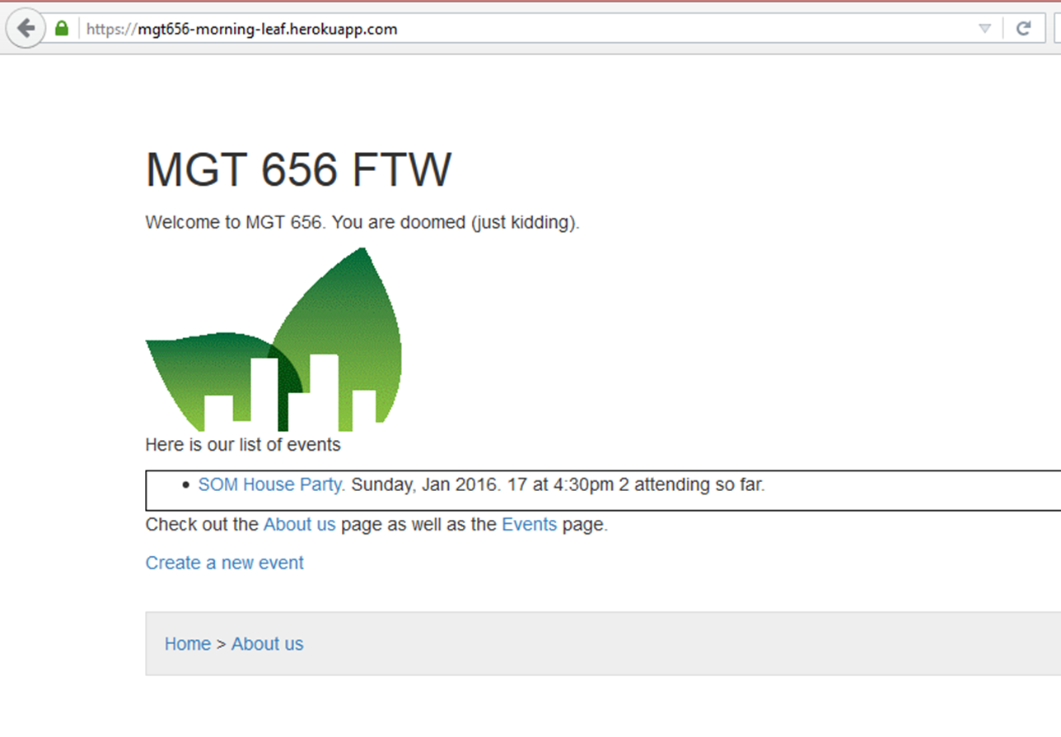

***Figure 1***

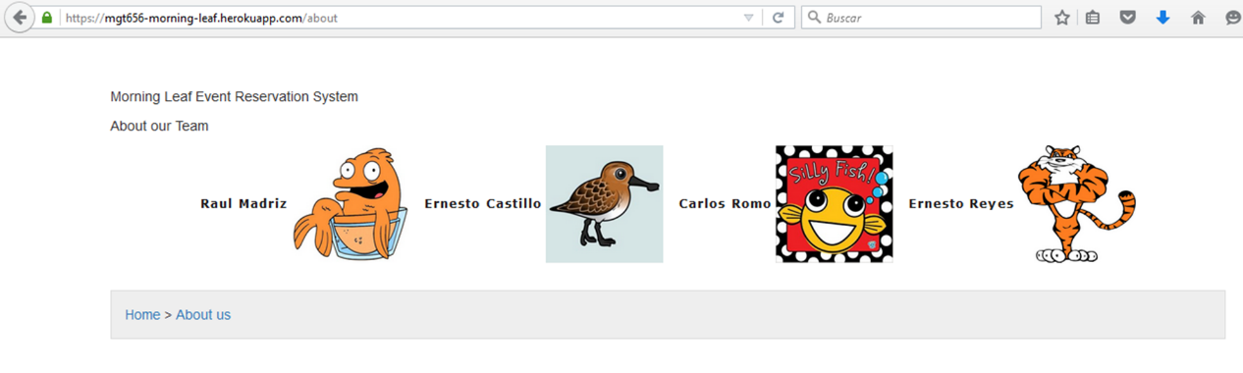

***Figure 2***

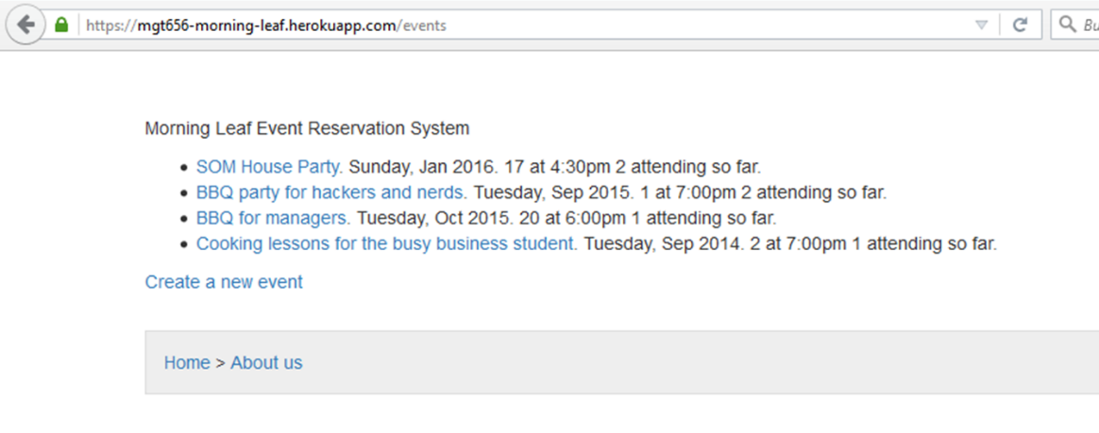

***Figure 3***

We hope that with this information you have a better knowledge of what the team Morning-Leaf has been doing to develop this application and the importance of the team on delivering high quality on the product.