MGT 656 - Class Project

Software Development Project Status Report

Sprint 4

Professor Kyle Jensen



Team: Morning-Leaf

Members:

Raúl Madriz raul.madriz@yale.edu

Ernesto Reyes ernesto.reyes@yale.edu

Ernesto Castillo ernesto.castillo@yale.edu

Carlos Romo carlos.romo@yale.edu

November 16, 2015

**Sprint 4**

Heroku application address: (<https://mgt656-morning-leaf.herokuapp.com/>)

Version control: (<https://github.com/Morning-Leaf/morning-leaf-reporting>)

**Burndown Chart**

**Sprint Completed Stories**

1. U8 - Task 1 - It should have a form for creating events. The form should have attribute method="POST"
2. U8 - Task 2 - I must specify the following attributes of an event: title, location, image, year, month, day, hour, and minute.
3. U8 - Task 3 - The image URL must begin with ‘http://’ or ‘https://’ and end with ‘.gif’ or ‘.png’.
4. U8 - Task 4 - I can click a input element to submit the event. This element should have id="submit" and type="submit"
5. U8 - Task 5 - If the submitted form is valid, I am redirected to the detail page for that new event. This redirect is accomplished using a "302" HTTP response.
6. U8 - Task 6 - If the form was not valid, I am taken back the form and the errors are shown on the form.
7. U9 - Task 1 - I submit my email address by filling in a form. The form has method="POST" and contains an input element with attributes type, id, and name all set to "email".
8. U9 - Task 2 - If I submit a valid email address, I see the event detail page again and it shows my email address on there along with the other attendees.

During the Sprint 4 the team was very well organized, because we already knew the user stories that we were going to work and develop for sprint 4. During our meeting we didn’t had any big issue with the user stories that were in progress and conclude. We only had one question about the names of the tests. We have seen that every user story has a command of mocha and we wanted to know if someone could provide us the list of all the names of the tests. During the Monday class we were able to get that answer from our professor Kyle Jensen, who told us that those tests where in cloud 9 in a folder called Mocha-better spec-reporter and inside that folder in a folder called test.

During Sprint 4 we finished the user stories 8 and 9. This led us to a result of 160 story points for this sprint. From the 425 story points that we estimated for the 7 sprints of the final project, we have completed the 425 story points which lives us with 0 story points at the moment. We have been able to manage more than 71 story points per sprint and now we will concentrate in the designing aspects of the application and extra issues that can appear to have a really great project. At the moment we have not reestimated any task of any user story, because the estimations that we did since the beginning have been very accurate with what we expected. We have been using waffle to distribute the activities and also we have google docs so that all the team members can be informed of the tasks they have to deliver.

**Sprint Backlog**

During Sprint 4 we were able to manage and finished all the tasks that we had planned for the sprint that were user story 8 and user story 9.

**Product Backlog**

At the moment we don’t have any product backlog for user stories. All user stories have been concluded. But now we are going to focus on the design of the application.



For Sprint 5 we are going to work on the following tasks:

1. Improve some elements of design of the application
2. Future user stories that may came from stakeholders

**What is Morning-Leaf Developing?**

We will also want to remember you our stakeholders that the application that we are developing is an application that allows users to create and RSVP for upcoming events. During each sprint our application has been improving. At the moment the application looks like the next figures 1, f 2, 3, 4 and 5

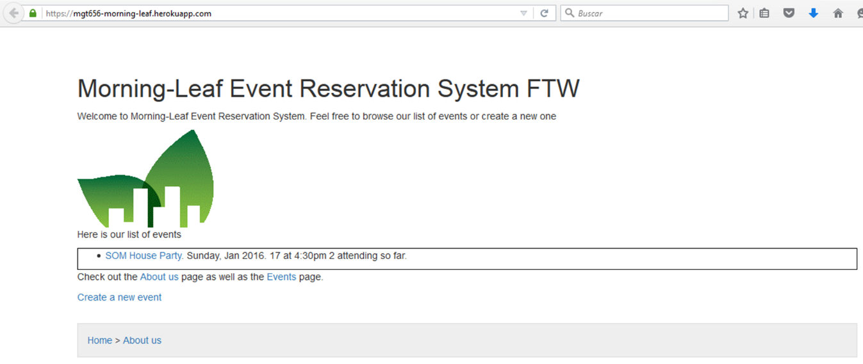

***Figure 1***

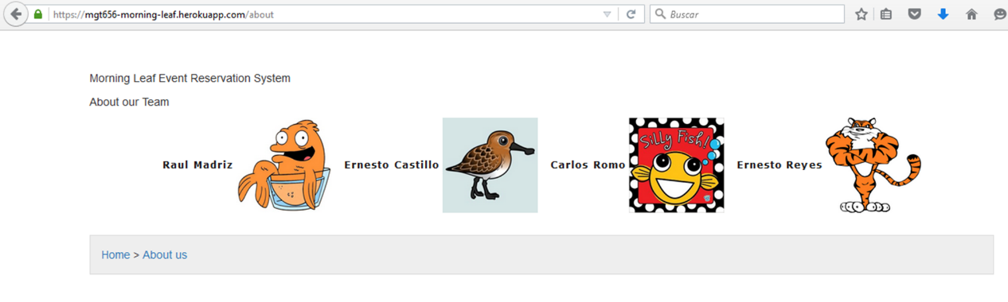

***Figure 2***

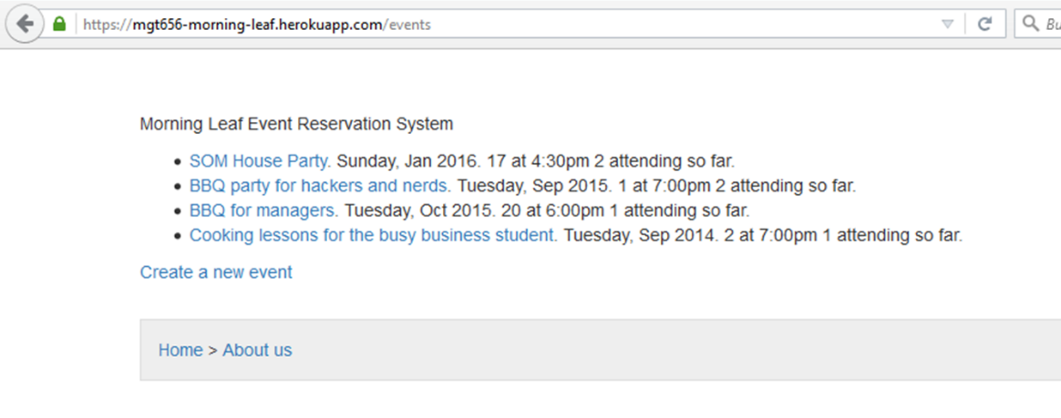

***Figure 3***

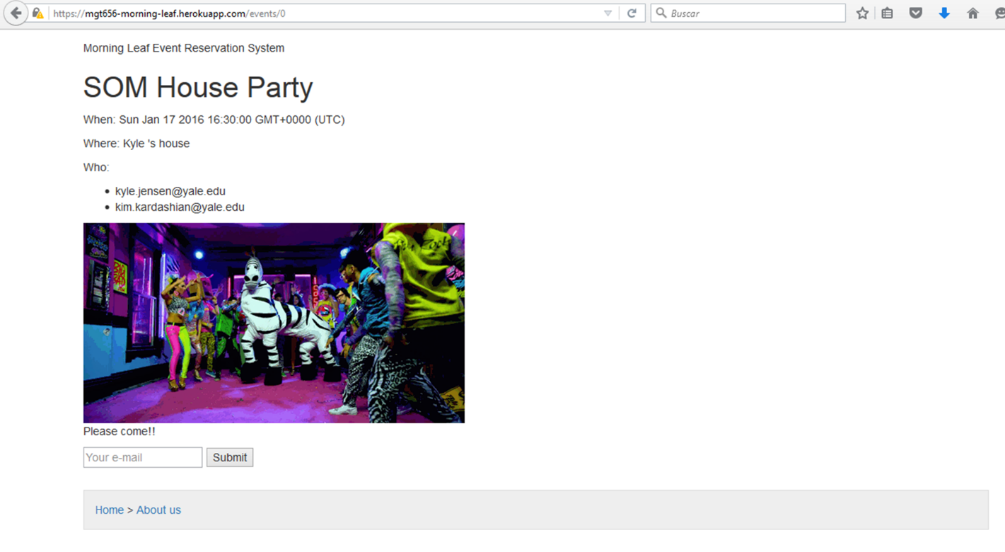

***Figure 4***

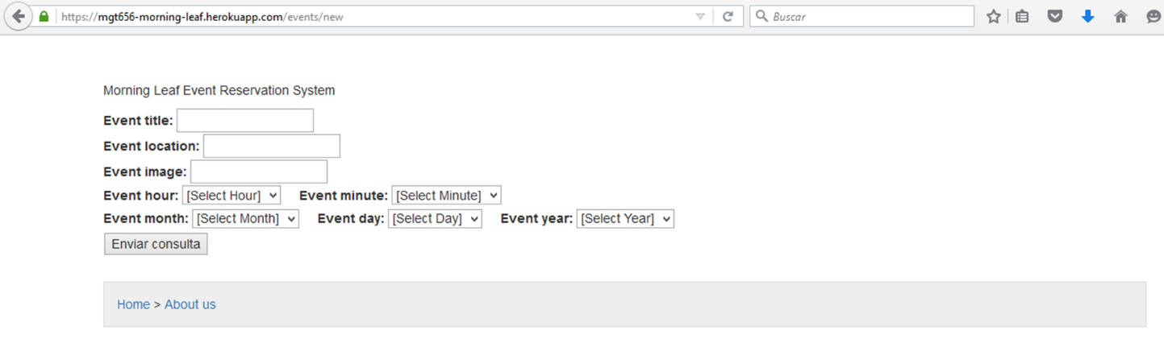

***Figure 5***

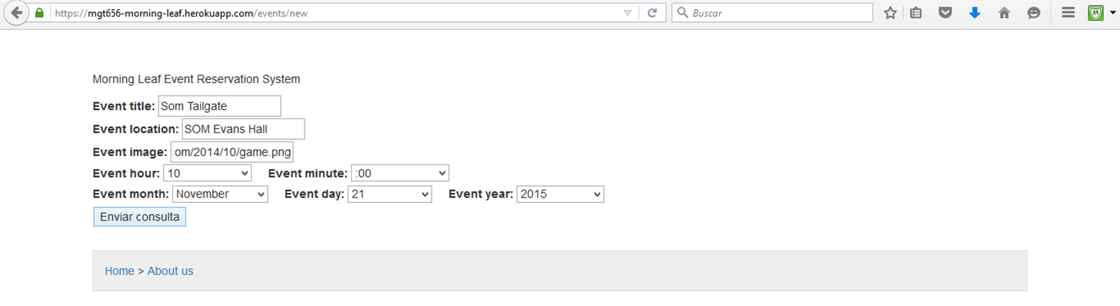

***Figure 6***

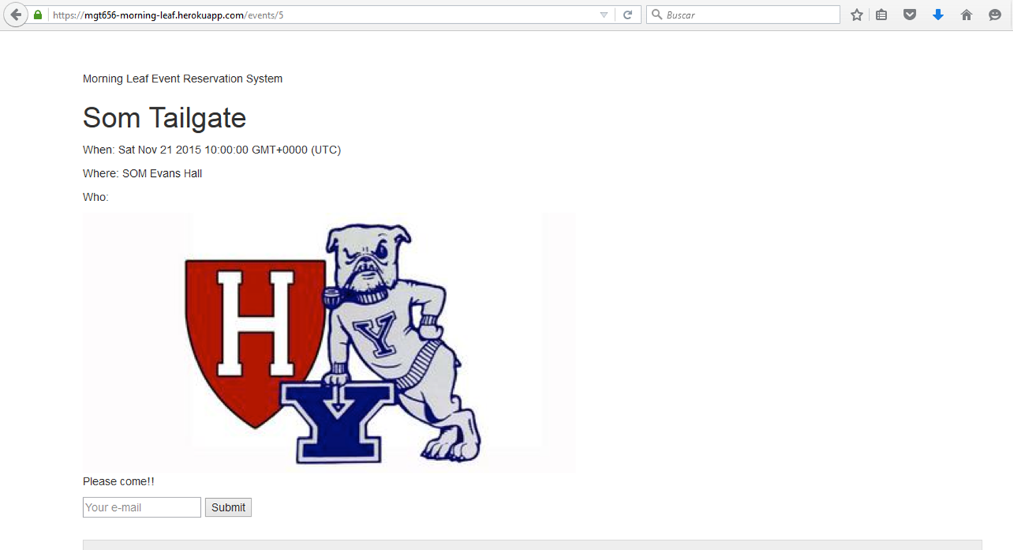

***Figure 7***

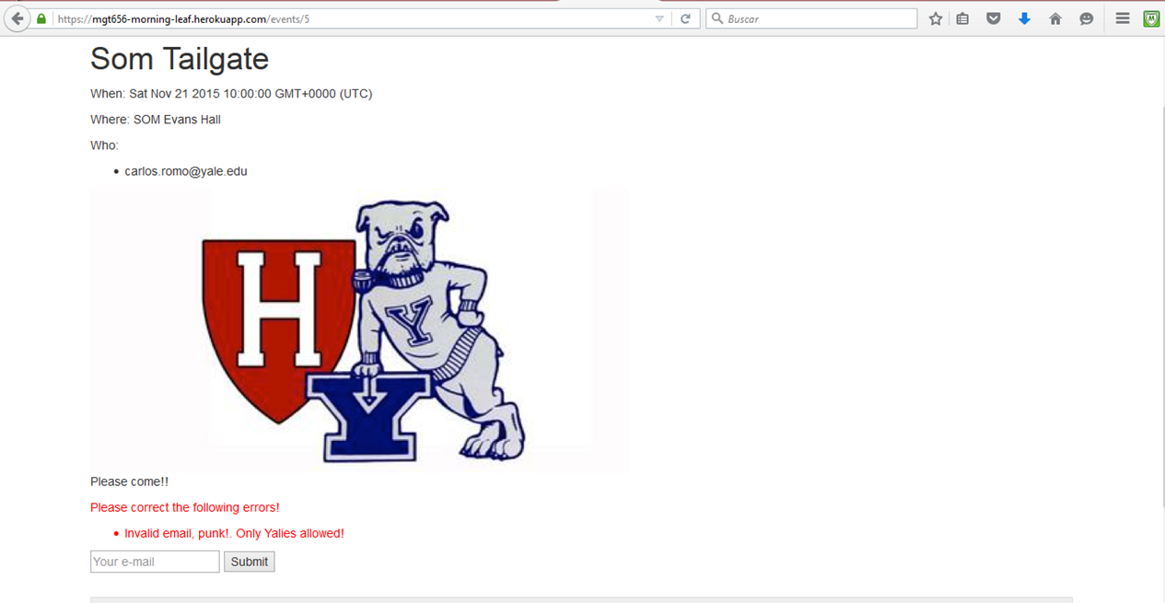

***Figure 8***

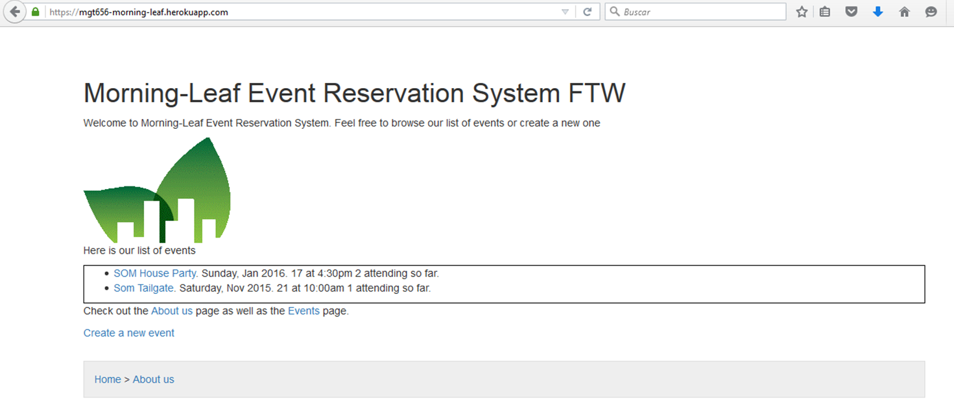

***Figure 9***

We hope that with this information you have a better knowledge of what the team Morning-Leaf has been doing to develop this application and the importance of the team on delivering high quality on the product. In next sprint we hope to give you a good design for the application and we are going to review if there is no possible bugs (errors).