MGT 656 - Class Project

Software Development Project Status Report

Sprint 5

Professor Kyle Jensen



Team: Morning-Leaf

Members:

Raúl Madriz raul.madriz@yale.edu

Ernesto Reyes ernesto.reyes@yale.edu

Ernesto Castillo ernesto.castillo@yale.edu

Carlos Romo carlos.romo@yale.edu

November 30, 2015

**Sprint 5**

Heroku application address: (<https://mgt656-morning-leaf.herokuapp.com/>)

Version control: (<https://github.com/Morning-Leaf/morning-leaf-reporting>)

**Burndown Chart**

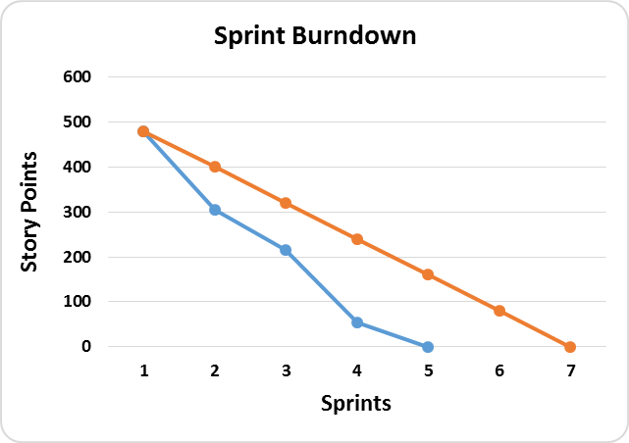

**Labels**

**Ideal Burndown**

**Actual Burndown**

**Sprint Completed Stories**

1. U10 - Task 1 - Design layout for the application
2. U10 - Task 2 - Get images for the application
3. U11 - Task 1 - Google track donations

During the Sprint 5 the team was very well organized, because we already knew the user stories that we were going to work and develop for the sprint. During our meeting we discuss how we were going to include the new user stories 10 and 11 in our project. We analyzed each user story and we developed the tasks that each one was going to have. I as product owner decided who was going to work in each task. We didn’t had any big issue with the user stories that were developed and concluded. But there was an issue that we found that was that every time that we create a new event after several hours it disappears, we asked a TA and it told us that this was due to the fact that there is not enough memory because we are running the application in Heroku.

During Sprint 5 we reestimated our burndown chart, because we integrated two additional user stories (10 and 11) that had a weight of 55 extra points. This integration changed our 425 story point’s estimates that we had developed at the beginning of the project. This change gave us a final 480 story point’s estimate for our project. We finished the user stories 10 and 11. This led us to a result of 55 story points for this sprint. From the 480 story points that we reestimated for the 7 sprints of the final project, we have completed the 480 story points which lives us with 0 story points at the moment. We have been able to manage more than 80 story points per sprint that would have been the ideal burndown chart. Now we will concentrate in extra designing aspects of the application and extra issues that can appear to have a really great project.

The estimations that we did since the beginning have been very accurate with what we expected. We have been using waffle to distribute the activities and also we have google docs so that all the team members can be informed of the tasks they have to deliver. But the most important is the team meetings that we have every week to discuss the important issues of the project.

**Sprint Backlog**

During Sprint 5 we were able to manage and finished all the tasks that we had planned for the sprint that were user story 10 and user story 11.



**Product Backlog**

At the moment we don’t have any product backlog for user stories. All user stories have been concluded. But now we are going to focus on the extras that the application may need to be better. Also we are waiting for future user stories that may come from stakeholders and this will create a change in our burndown chart and in the project, like the one that we experimented in this sprint. In the next chart we show all the user stories that were developed during the 5 sprints of the project.



For Sprint 6 we are going to work on the following tasks:

1. Improve elements needed to have a better application
2. Future user stories that may came from stakeholders
3. Analyze traffic data to our site

**What is Morning-Leaf Developing?**

We will also want to remember you our stakeholders that the application that we are developing is an application that allows users to create and RSVP for upcoming events. During each sprint our application has been improving. At the moment the application looks like the next figures 1, 2, 3, 4, 5, 6, 7, 8 and 9.

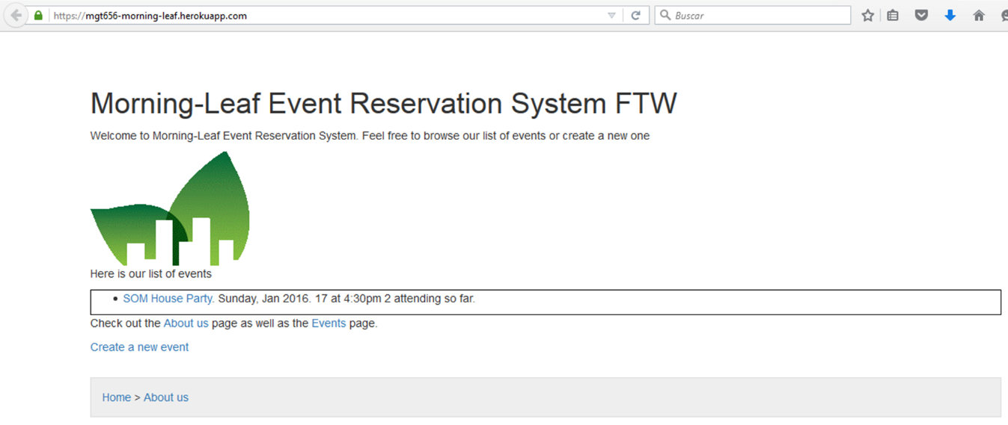

***Figure 1***

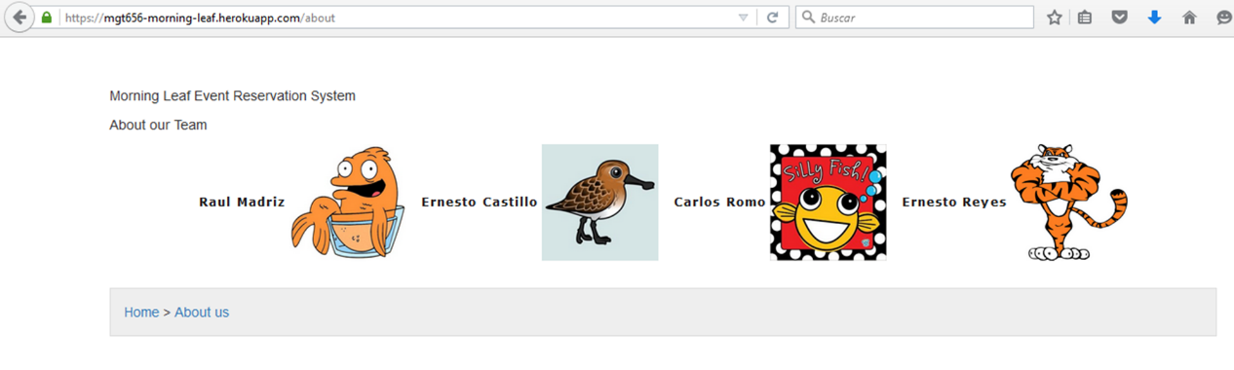

***Figure 2***

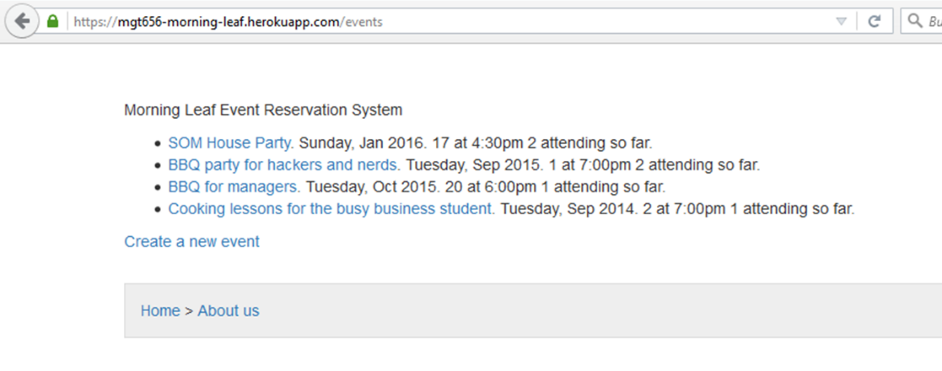

***Figure 3***

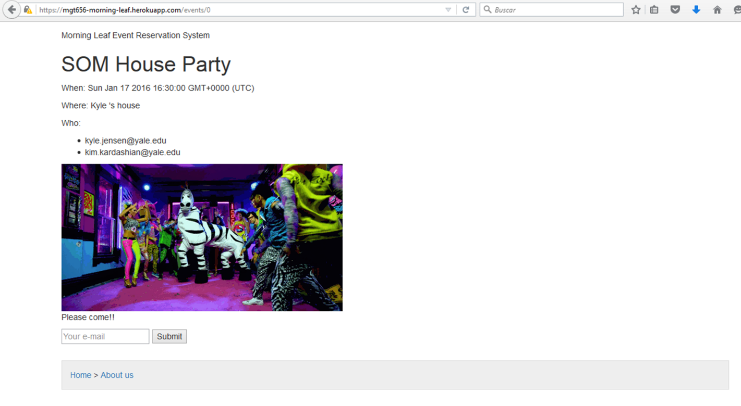

***Figure 4***

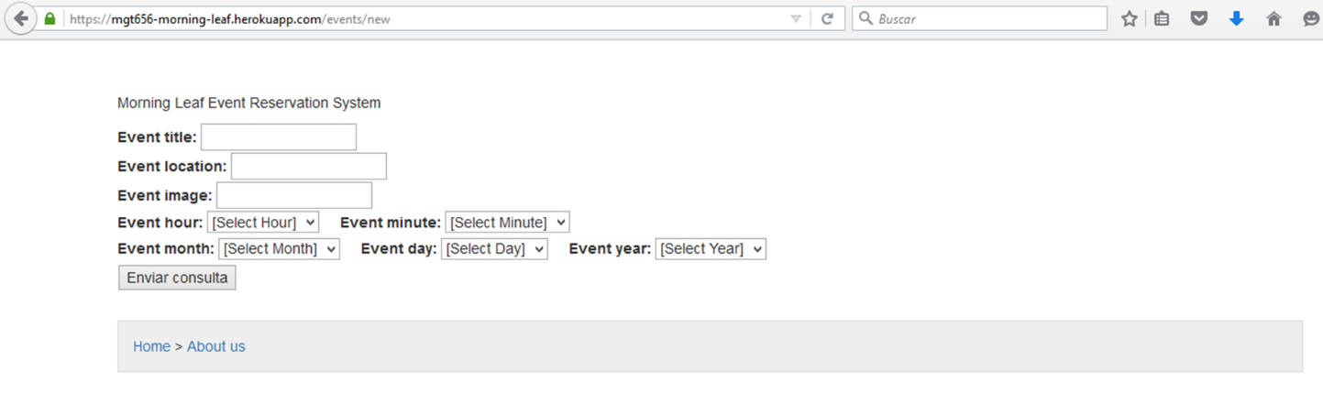

***Figure 5***

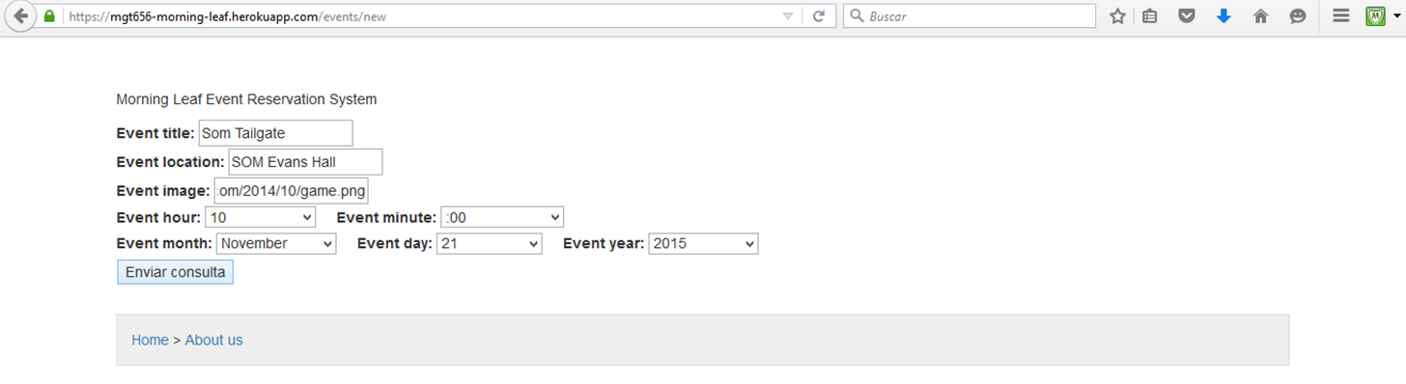

***Figure 6***

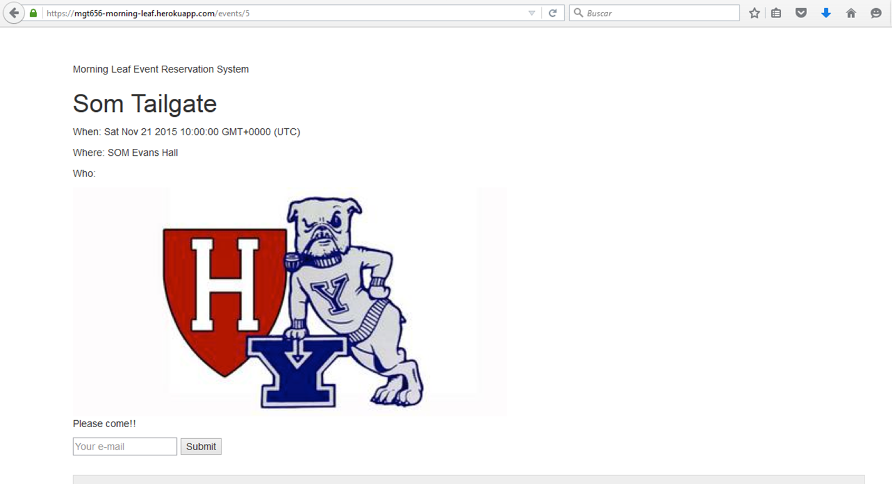

***Figure 7***

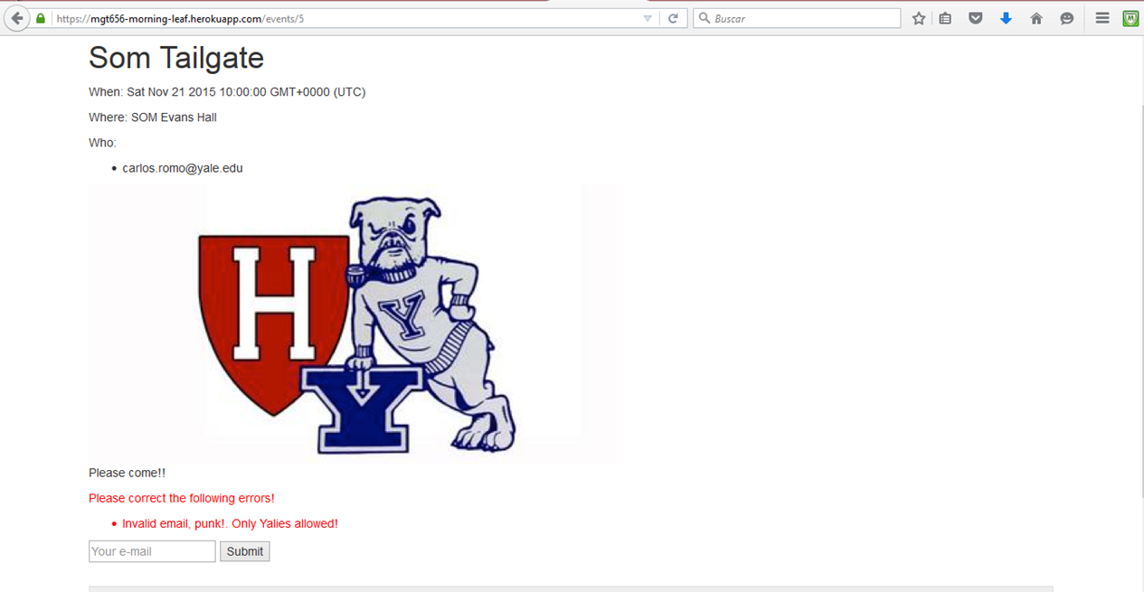

***Figure 8***

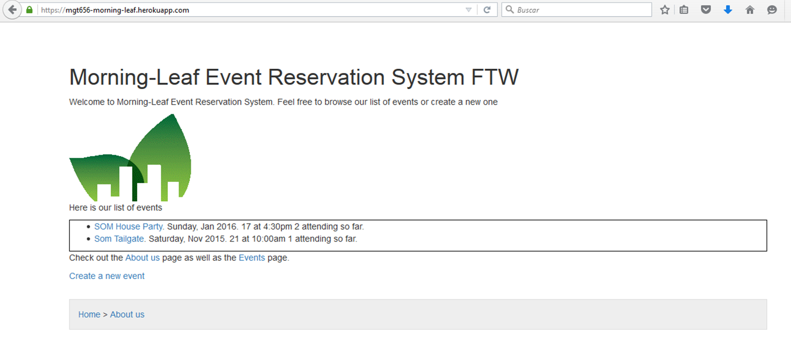

***Figure 9***

We hope that with this information you have a better knowledge of what the team Morning-Leaf has been doing to develop this application and the importance of the team on delivering high quality on the product. In next sprint we hope to give you a good design for the application and we are going to review if there is no possible bugs (errors).