数字逻辑课程设计报告

题目 自动售邮票控制电路

院 、 系 计算机与控制工程学院
专 业 计算机科学与技术
班 级 计221-2
姓 名 赵法科
学 号 202258501216
指导教师 郭强

2023 年 6月 18 日
目录
1 项目描述 1
2 设计方案 1
3 功能模块设计 1
4系统功能实现及调试 1
5 项目的实现结果 1
6 课程设计总结 1
附录：源程序 2

1 项目描述
一、设计要求
设计一个用于自动售邮票的控制电路。
二、系统功能描述
1)用两个发光二极管分别模拟售出面值为6角和8角的邮票，购买者可以通过开关选择一种面值的邮票，
灯亮时表示邮票售出。
2)用开关分别模拟1角、5角和1元硬币投入，用发光二极管分别代表找回剩余的硬币。
要求：
每次只能售出一枚邮票，当所投硬币达到或超过购买者所选面值时，售出一枚邮票，并找回剩余的硬币，
回到初始状态；
当所投硬币值不足面值时，可以通过一个复位键退回所投硬币，回到初始状态。

2 设计方案
设计出输入输出端口，其中输入端口5个，分别为两个邮票选择端口，3个投币端口，用数码管显示找回的钱，用指示灯显示是否可以购买。然后要有一个数据选择器，根据投币的不同输出也不同。

3 功能模块设计
我们采用vhdl代码实现功能
5个输入端口，两个为邮票选择端口，3个为硬币投入端口
LIBRARY IEEE;
USE IEEE.STD_LOGIC_1164.ALL;
USE IEEE.STD_LOGIC_UNSIGNED.ALL;
ENTITY intt IS
PORT ( RESET : IN STD_LOGIC; -- 复位信号
CLK,LIU,BA : IN STD_LOGIC; --BA为8毛邮票输入
INYM,INWM,INYY : IN STD_LOGIC; --钱输入端口
YOU : OUT STD_LOGIC; --邮票出口
ZHAO : OUT STD_LOGIC_VECTOR(3 DOWNTO 0)); --找钱出口
END intt;
ARCHITECTURE BEHAV OF intt IS
TYPE STATES IS (ST0,ST1,ST2,ST3,ST4,ST5,ST6,ST7);
SIGNAL YIMAO,WUMAO,YIKUAI : STD_LOGIC; -- 钱输入信号
SIGNAL SIG_YOU : STD_LOGIC; -- 输出对应信号
SIGNAL SIG_ZHAO : STD_LOGIC_VECTOR(3 DOWNTO 0);-- 找零对应信号
SIGNAL ZHAORE :STD_LOGIC_VECTOR(3 DOWNTO 0);-- 复位时的找零
SIGNAL CURRENT_STATE : STATES; -- 现态
SIGNAL NEXT_STATE : STATES; -- 次态
BEGIN
P1 :PROCESS(CLK) -- 将输入送相应的信号
BEGIN
IF CLK'EVENT AND CLK='1' THEN YIMAO <= INYM;
WUMAO <= INWM; YIKUAI <=INYY; END IF;
END PROCESS P1;

p2 :PROCESS(RESET,CLK)--次态给现态
BEGIN
IF RESET = '1' THEN
CURRENT_STATE <= ST0;
ELSIF CLK'EVENT AND CLK='1' THEN
CURRENT_STATE <= NEXT_STATE;
END IF;
END PROCESS p2;
p3 :PROCESS(CLK,CURRENT_STATE,NEXT_STATE,YIMAO,WUMAO,YIKUAI)-- 状态转换
BEGIN
IF RESET ='1' THEN SIG_ZHAO<=ZHAORE;NEXT_STATE<=ST0;-- 复位找钱
ELSIF LIU='1'THEN
CASE CURRENT_STATE IS
WHEN ST0 => ZHAORE<="0000"; -- 状态 S0
IF YIMAO = '1' THEN -- 输入 1 毛
SIG_YOU <= '0'; -- 不出邮票
SIG_ZHAO <= "0000"; -- 不找钱
NEXT_STATE <= ST1; -- 次态为 ST1
ELSIF WUMAO = '1' THEN -- 输入 5 毛
SIG_YOU <= '1'; -- 出邮票
SIG_ZHAO <= "0000"; -- 不找钱
NEXT_STATE <= ST5; -- 次态为 ST5
ELSIF YIKUAI ='1' THEN -- 输入 1 块
SIG_YOU <= '1'; -- 出邮票
SIG_ZHAO <= "0100"; -- 找 4 毛
NEXT_STATE <= ST0; -- 次态为 ST0
ELSE
SIG_YOU <= '0';
SIG_ZHAO <= "0000"; -- 不输入 都不变
NEXT_STATE <= ST0;
END IF;
WHEN ST1 => ZHAORE<="0001" ; IF YIMAO = '1' THEN SIG_YOU <= '0';
SIG_ZHAO <= "0000"; NEXT_STATE <= ST2;
ELSIF WUMAO = '1' THEN SIG_YOU <= '1';
SIG_ZHAO <= "0000"; NEXT_STATE <= ST0;
ELSIF YIKUAI = '1' THEN
SIG_YOU <= '1';
SIG_ZHAO <= "0101"; NEXT_STATE <= ST0;
ELSE
SIG_YOU <= '0';
SIG_ZHAO <= "0000"; NEXT_STATE <= ST1;
END IF;
WHEN ST2 => ZHAORE<="0010"; IF YIMAO = '1' THEN SIG_YOU <= '0';
SIG_ZHAO <= "0000"; NEXT_STATE <= ST3;
ELSIF WUMAO = '1' THEN SIG_YOU <= '1';
SIG_ZHAO <= "0001"; NEXT_STATE <= ST0;
ELSIF YIKUAI = '1' THEN
SIG_YOU <= '1';
SIG_ZHAO <= "0110"; NEXT_STATE <= ST0;
ELSE
SIG_YOU <= '0';
SIG_ZHAO <= "0000"; NEXT_STATE <= ST2;
END IF;
WHEN ST3 => ZHAORE<="0011"; IF YIMAO = '1' THEN SIG_YOU <= '0';
SIG_ZHAO <= "0000"; NEXT_STATE <= ST4;
ELSIF WUMAO= '1' THEN SIG_YOU <= '1';
SIG_ZHAO <= "0010";
NEXT_STATE <= ST0;
ELSIF YIKUAI= '1' THEN SIG_YOU <= '1';
SIG_ZHAO <= "0111"; NEXT_STATE <= ST0;
ELSE
SIG_YOU <= '0';
SIG_ZHAO <= "0000"; NEXT_STATE <= ST3;
END IF;
WHEN ST4 =>ZHAORE<="0100"; IF YIMAO = '1' THEN SIG_YOU <= '0';
SIG_ZHAO <= "0000";
NEXT_STATE <= ST5;
ELSIF WUMAO= '1' THEN SIG_YOU <= '1';
SIG_ZHAO <= "0011"; NEXT_STATE <= ST0;
ELSIF YIKUAI= '1' THEN SIG_YOU <= '1';
SIG_ZHAO <= "1000"; NEXT_STATE <= ST0;
ELSE
SIG_YOU <= '0';
SIG_ZHAO <= "0000"; NEXT_STATE <= ST4;
END IF;
WHEN ST5 => ZHAORE<="0101"; IF YIMAO = '1' THEN SIG_YOU <= '1';
SIG_ZHAO <= "0000"; NEXT_STATE <= ST0;
ELSIF WUMAO= '1' THEN
SIG_YOU <= '1';
SIG_ZHAO <= "0100"; NEXT_STATE <= ST0;
ELSIF YIKUAI= '1' THEN SIG_YOU <= '1';
SIG_ZHAO <= "1001"; NEXT_STATE <= ST0;
ELSE
SIG_YOU <= '0';
SIG_ZHAO <= "0000"; NEXT_STATE <= ST5; END IF;
WHEN OTHERS => NULL; -- 其他状态 空操作
END CASE;
ELSIF BA='1'THEN -- 挑选 8 毛的邮票
CASE CURRENT_STATE IS
WHEN ST0 => ZHAORE<="0000"; -- 状态 S0
IF YIMAO = '1' THEN -- 输入 1 毛
SIG_YOU <= '0'; -- 不出邮票
SIG_ZHAO <= "0000"; -- 不找钱
NEXT_STATE <= ST1; -- 次态为 ST1
ELSIF WUMAO = '1' THEN -- 输入 5 毛
SIG_YOU <= '0'; -- 不出邮票
SIG_ZHAO <= "0000"; -- 不找钱
NEXT_STATE <= ST5; -- 次态为 ST5
ELSIF YIKUAI ='1' THEN -- 输入 1 块
SIG_YOU <= '1'; -- 出邮票
SIG_ZHAO <= "0010"; -- 找 2 毛
NEXT_STATE <= ST0; -- 次态为 ST0
ELSE
SIG_YOU <= '0';
SIG_ZHAO <= "0000"; -- 不输入 都不变
NEXT_STATE <= ST0; END IF;
WHEN ST1 => ZHAORE<="0001" ; -- 状态1
IF YIMAO = '1' THEN SIG_YOU <= '0'; 投入1毛，
SIG_ZHAO <= "0000"; NEXT_STATE <= ST2;
ELSIF WUMAO = '1' THEN SIG_YOU <= '0';
SIG_ZHAO <= "0000"; NEXT_STATE <= ST6;
ELSIF YIKUAI = '1' THEN
SIG_YOU <= '1';
SIG_ZHAO <= "0011"; NEXT_STATE <= ST0;
ELSE
SIG_YOU <= '0';
SIG_ZHAO <= "0000"; NEXT_STATE <= ST1;
END IF;
WHEN ST2 => ZHAORE<="0010"; IF YIMAO = '1' THEN SIG_YOU <= '0';
SIG_ZHAO <= "0000"; NEXT_STATE <= ST3;
ELSIF WUMAO = '1' THEN SIG_YOU <= '0';
SIG_ZHAO <= "0000";
NEXT_STATE <= ST7;
ELSIF YIKUAI = '1' THEN SIG_YOU <= '1';
SIG_ZHAO <= "0100"; NEXT_STATE <= ST0;
ELSE
SIG_YOU <= '0';
SIG_ZHAO <= "0000"; NEXT_STATE <= ST2;
END IF;
WHEN ST3 => ZHAORE<="0011"; IF YIMAO = '1' THEN SIG_YOU <= '0';
SIG_ZHAO <= "0000";
NEXT_STATE <= ST4;
ELSIF WUMAO= '1' THEN SIG_YOU <= '1';
SIG_ZHAO <= "0000"; NEXT_STATE <= ST0;
ELSIF YIKUAI= '1' THEN SIG_YOU <= '1';
SIG_ZHAO <= "0101"; NEXT_STATE <= ST0;
ELSE
SIG_YOU <= '0';
SIG_ZHAO <= "0000"; NEXT_STATE <= ST3;
END IF;
WHEN ST4 =>ZHAORE<="0100"; IF YIMAO = '1' THEN SIG_YOU <= '0';
SIG_ZHAO <= "0000"; NEXT_STATE <= ST5;
ELSIF WUMAO= '1' THEN
SIG_YOU <= '1';
SIG_ZHAO <= "0001"; NEXT_STATE <= ST0;
ELSIF YIKUAI= '1' THEN SIG_YOU <= '1';
SIG_ZHAO <= "0110"; NEXT_STATE <= ST0;
ELSE
SIG_YOU <= '0';
SIG_ZHAO <= "0000"; NEXT_STATE <= ST4;
END IF;
WHEN ST5 => ZHAORE<="0101"; IF YIMAO = '1' THEN SIG_YOU <= '0';
SIG_ZHAO <= "0000"; NEXT_STATE <= ST6;
ELSIF WUMAO= '1' THEN SIG_YOU <= '1';
SIG_ZHAO <= "0010"; NEXT_STATE <= ST0;
ELSIF YIKUAI= '1' THEN SIG_YOU <= '1';
SIG_ZHAO <= "0111";
NEXT_STATE <= ST0;
ELSE
SIG_YOU <= '0';
SIG_ZHAO <= "0000"; NEXT_STATE <= ST5;
END IF;
WHEN ST6 => ZHAORE<="0110"; IF YIMAO = '1' THEN SIG_YOU <= '0';
SIG_ZHAO <= "0000";
NEXT_STATE <= ST7;
ELSIF WUMAO= '1' THEN SIG_YOU <= '1';
SIG_ZHAO <= "0011"; NEXT_STATE <= ST0;
ELSIF YIKUAI= '1' THEN SIG_YOU <= '1';
SIG_ZHAO <= "1000"; NEXT_STATE <= ST0;
ELSE
SIG_YOU <= '0';
SIG_ZHAO <= "0000"; NEXT_STATE <= ST6;
END IF；

WHEN ST7 => ZHAORE<="0111"; IF YIMAO = '1' THEN SIG_YOU <= '1';
SIG_ZHAO <= "0000"; NEXT_STATE <= ST0;
ELSIF WUMAO= '1' THEN SIG_YOU <= '1';
SIG_ZHAO <= "0100"; NEXT_STATE <= ST0;
ELSIF YIKUAI= '1' THEN
SIG_YOU <= '1';
SIG_ZHAO <= "1001"; NEXT_STATE <= ST0;
ELSE
SIG_YOU <= '0';
SIG_ZHAO <= "0000"; NEXT_STATE <= ST7; END IF;
WHEN OTHERS => NULL; -- 其他状态 空操作
END CASE;
END IF;
END PROCESS p3;
p4 :PROCESS(CLK,SIG_YOU,SIG_ZHAO)-- 将输出信号送输出端
BEGIN
IF CLK'EVENT AND CLK='1' THEN YOU <= SIG_YOU;
ZHAO <= SIG_ZHAO;
END IF;
END PROCESS p4; END BEHAV;

4系统功能实现及调试
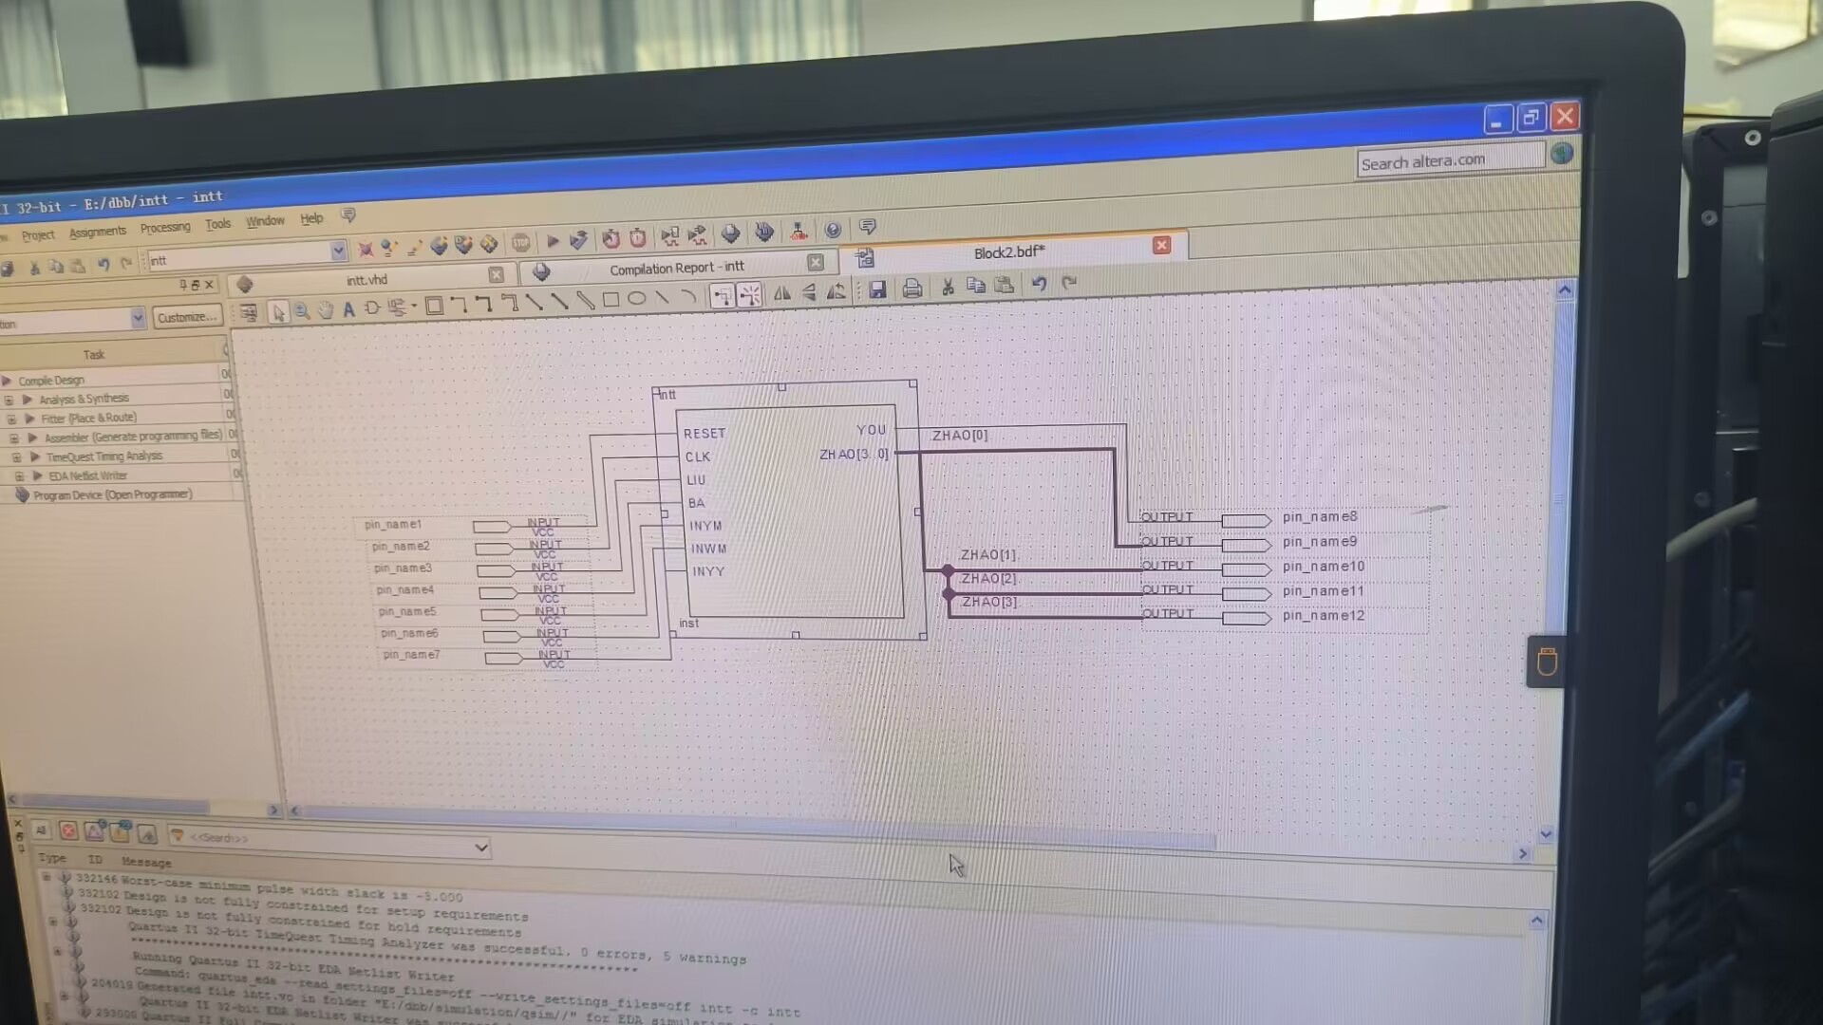
将vhdl代码封装成intt芯片，然后连接对应的输入输出
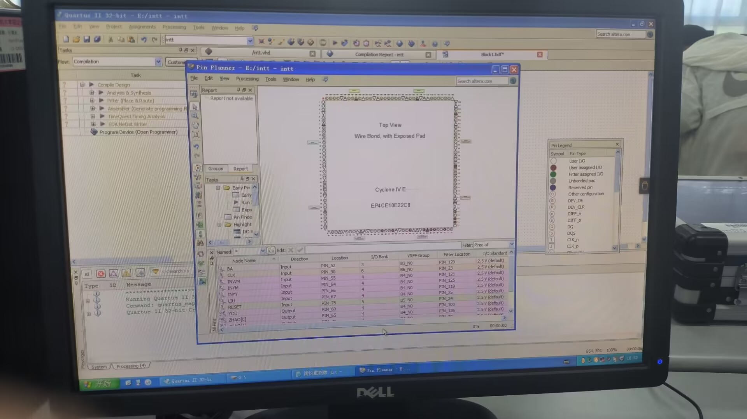
将输入输出连接相应的引脚，引脚连接完成后再进行编译一次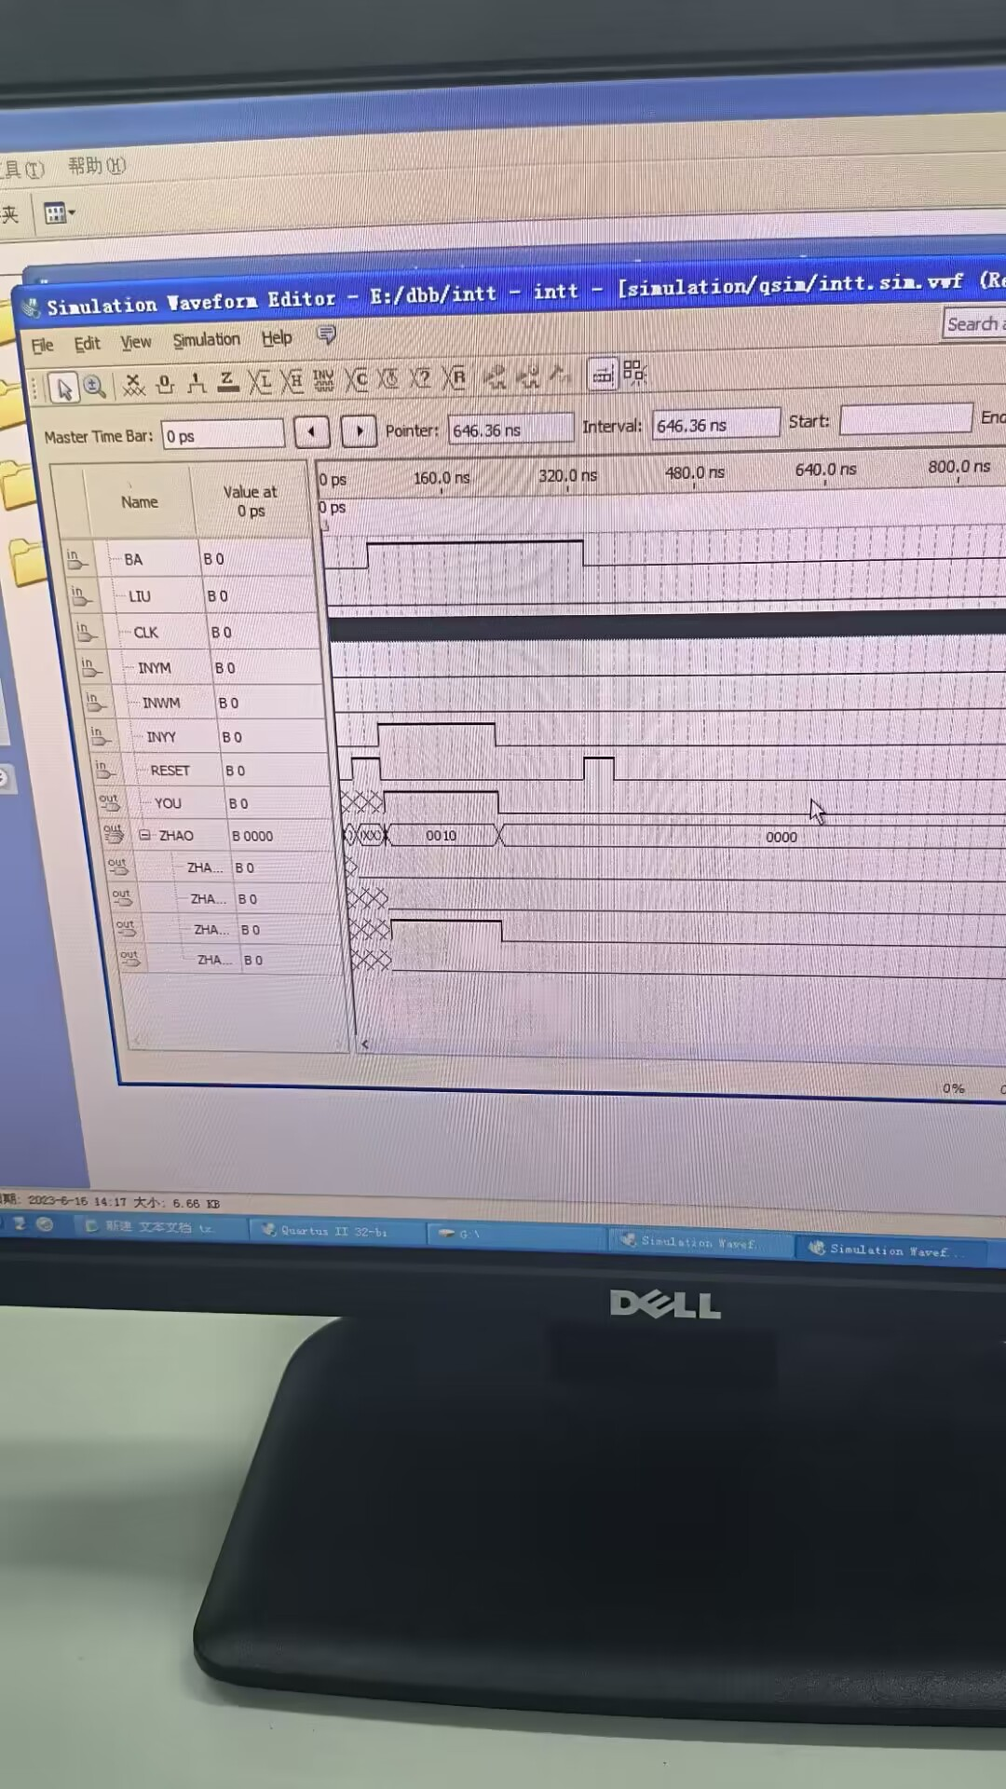
生成波形图进行仿真实验

5 项目的实现结果
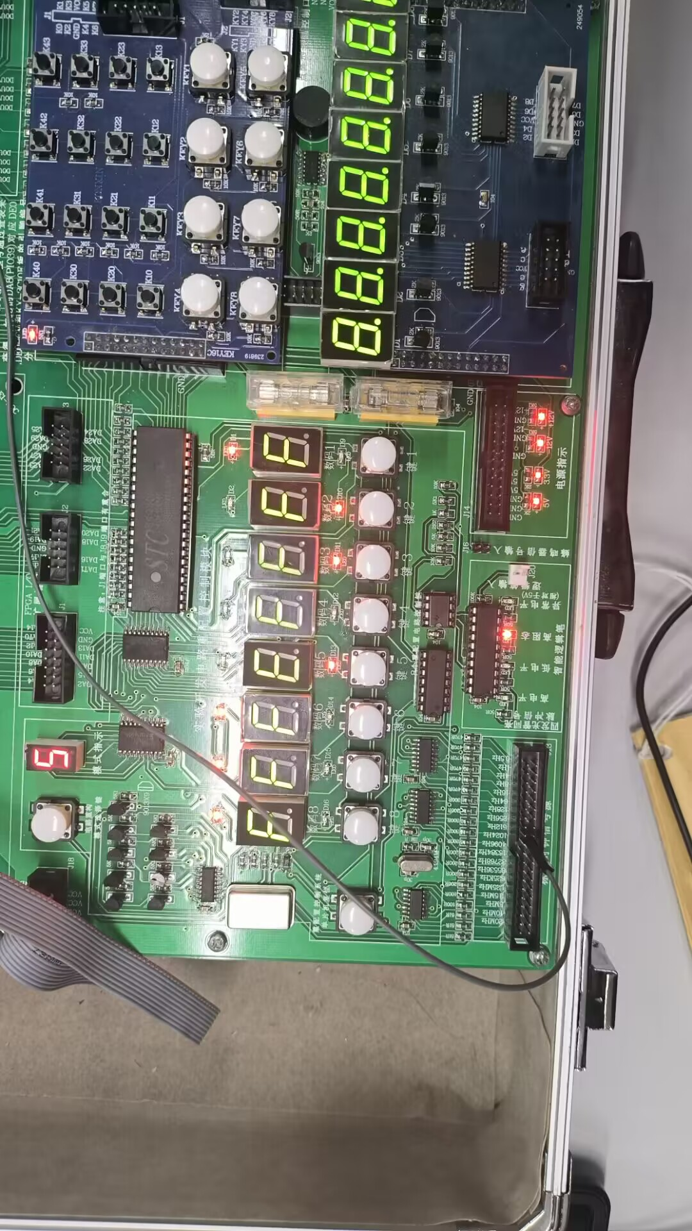
邮票输入六毛，先后投入一毛和五毛的硬币，购买邮票成功
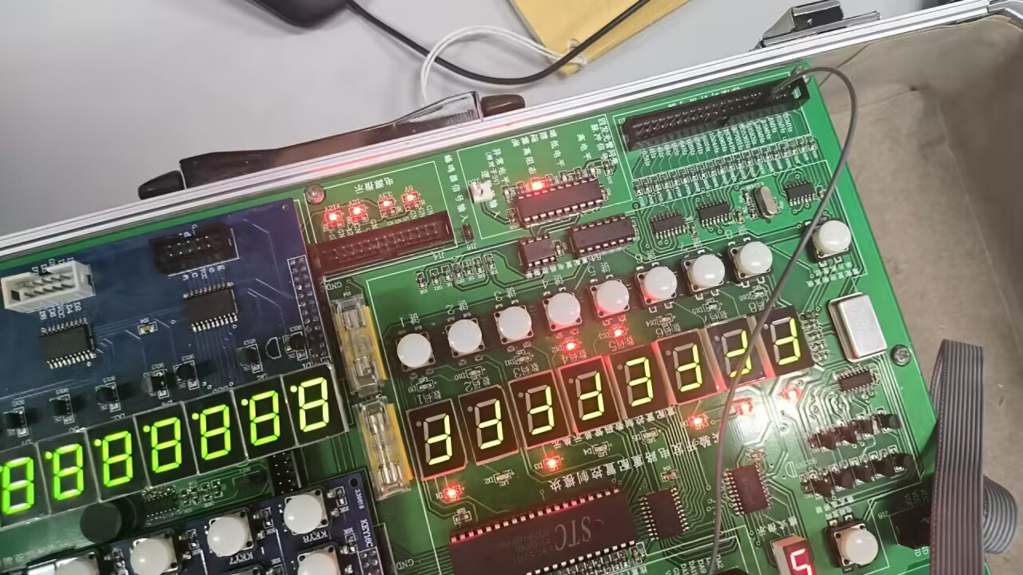
购买六毛的邮票，投入一块的硬币，找钱四毛。

6 课程设计总结
数电的课设从选题开始，找到自己感兴趣的题目，和志同道合的人组成小组。小组内在开始设计前要讨论设计的总体方向，设计的大概模型，明确好个人分工，这样才人多力量大，在设计过程中肯定会遇到这样那样的问题，不要急躁，慢慢改正就行，做程序设计要细心，一个小错误就可以让程序无法运行，而且要有耐心，有耐心去一遍一遍验证程序，去修改程序，没有程序一写出来就是完美的，不断的修改可以让他更完善。

附录：源程序
可以将源代码融入“3 功能模块设计”部分，也可以单独作为附录提供。在文件中需要按有关的规范加入必要的注释。
LIBRARY IEEE;
USE IEEE.STD_LOGIC_1164.ALL;
USE IEEE.STD_LOGIC_UNSIGNED.ALL;
ENTITY intt IS
PORT ( RESET : IN STD_LOGIC;
CLK,LIU,BA : IN STD_LOGIC;
INYM,INWM,INYY : IN STD_LOGIC;
YOU : OUT STD_LOGIC;
ZHAO : OUT STD_LOGIC_VECTOR(3 DOWNTO 0));
END intt;
ARCHITECTURE BEHAV OF intt IS
TYPE STATES IS (ST0,ST1,ST2,ST3,ST4,ST5,ST6,ST7);
SIGNAL YIMAO,WUMAO,YIKUAI : STD_LOGIC;
SIGNAL SIG_YOU : STD_LOGIC;
SIGNAL SIG_ZHAO : STD_LOGIC_VECTOR(3 DOWNTO 0);
SIGNAL ZHAORE :STD_LOGIC_VECTOR(3 DOWNTO 0);
SIGNAL CURRENT_STATE : STATES;
SIGNAL NEXT_STATE : STATES;
BEGIN
P1 :PROCESS(CLK)
BEGIN
IF CLK'EVENT AND CLK='1' THEN YIMAO <= INYM;
WUMAO <= INWM; YIKUAI <=INYY; END IF;
END PROCESS P1;
p2 :PROCESS(RESET,CLK)
BEGIN
IF RESET = '1' THEN
CURRENT_STATE <= ST0;
ELSIF CLK'EVENT AND CLK='1' THEN
CURRENT_STATE <= NEXT_STATE;
END IF;
END PROCESS p2;
p3 :PROCESS(CLK,CURRENT_STATE,NEXT_STATE,YIMAO,WUMAO,YIKUAI)
BEGIN
IF RESET ='1' THEN SIG_ZHAO<=ZHAORE;NEXT_STATE<=ST0;SIG_YOU<='0';
ELSIF LIU='1'THEN
CASE CURRENT_STATE IS
WHEN ST0 => ZHAORE<="0000";
IF YIMAO = '1' THEN
SIG_YOU <= '0';
SIG_ZHAO <= "0000";
NEXT_STATE <= ST1;
ELSIF WUMAO = '1' THEN
SIG_YOU <= '0';
SIG_ZHAO <= "0000";
NEXT_STATE <= ST5;
ELSIF YIKUAI ='1' THEN
SIG_YOU <= '1';
SIG_ZHAO <= "0100";
NEXT_STATE <= ST0;
ELSE
SIG_YOU <= '0';
SIG_ZHAO <= "0000";
NEXT_STATE <= ST0;
END IF;
WHEN ST1 => ZHAORE<="0001" ; IF YIMAO = '1' THEN SIG_YOU <= '0';
SIG_ZHAO <= "0000"; NEXT_STATE <= ST2;
ELSIF WUMAO = '1' THEN SIG_YOU <= '1';
SIG_ZHAO <= "0000"; NEXT_STATE <= ST0;
ELSIF YIKUAI = '1' THEN
SIG_YOU <= '1';
SIG_ZHAO <= "0101"; NEXT_STATE <= ST0;
ELSE
SIG_YOU <= '0';
SIG_ZHAO <= "0000"; NEXT_STATE <= ST1; END IF;
WHEN ST2 => ZHAORE<="0010"; IF YIMAO = '1' THEN SIG_YOU <= '0';
SIG_ZHAO <= "0000"; NEXT_STATE <= ST3;
ELSIF WUMAO = '1' THEN SIG_YOU <= '1';
SIG_ZHAO <= "0001"; NEXT_STATE <= ST0;
ELSIF YIKUAI = '1' THEN
SIG_YOU <= '1';
SIG_ZHAO <= "0110"; NEXT_STATE <= ST0;
ELSE SIG_YOU <= '0'; SIG_ZHAO <= "0000"; NEXT_STATE <= ST2; END IF;
WHEN ST3 => ZHAORE<="0011"; IF YIMAO = '1' THEN SIG_YOU <= '0';
SIG_ZHAO <= "0000"; NEXT_STATE <= ST4;
ELSIF WUMAO= '1' THEN SIG_YOU <= '1';
SIG_ZHAO <= "0010";
NEXT_STATE <= ST0;
ELSIF YIKUAI= '1' THEN SIG_YOU <= '1';
SIG_ZHAO <= "0111"; NEXT_STATE <= ST0;
ELSE SIG_YOU <= '0'; SIG_ZHAO <= "0000"; NEXT_STATE <= ST3;
END IF; WHEN ST4 =>ZHAORE<="0100"; IF YIMAO = '1' THEN SIG_YOU <= '0';
SIG_ZHAO <= "0000";
NEXT_STATE <= ST5;
ELSIF WUMAO= '1' THEN SIG_YOU <= '1';
SIG_ZHAO <= "0011"; NEXT_STATE <= ST0;
ELSIF YIKUAI= '1' THEN SIG_YOU <= '1';
SIG_ZHAO <= "1000"; NEXT_STATE <= ST0;
ELSE SIG_YOU <= '0'; SIG_ZHAO <= "0000"; NEXT_STATE <= ST4; END IF;
WHEN ST5 => ZHAORE<="0101"; IF YIMAO = '1' THEN SIG_YOU <= '1';
SIG_ZHAO <= "0000"; NEXT_STATE <= ST0;
ELSIF WUMAO= '1' THEN
SIG_YOU <= '1';
SIG_ZHAO <= "0100"; NEXT_STATE <= ST0;
ELSIF YIKUAI= '1' THEN SIG_YOU <= '1';
SIG_ZHAO <= "1001"; NEXT_STATE <= ST0;
ELSE SIG_YOU <= '0'; SIG_ZHAO <= "0000"; NEXT_STATE <= ST5; END IF;
WHEN OTHERS => NULL;
END CASE;
ELSIF BA='1'THEN
CASE CURRENT_STATE IS
WHEN ST0 => ZHAORE<="0000";
IF YIMAO = '1' THEN
SIG_YOU <= '0';
SIG_ZHAO <= "0000";
NEXT_STATE <= ST1;
ELSIF WUMAO = '1' THEN
SIG_YOU <= '0';
SIG_ZHAO <= "0000";
NEXT_STATE <= ST5;
ELSIF YIKUAI ='1' THEN
SIG_YOU <= '1';
SIG_ZHAO <= "0010";
NEXT_STATE <= ST0;
ELSE SIG_YOU <= '0'; SIG_ZHAO <= "0000"; NEXT_STATE <= ST0; END IF;
WHEN ST1 => ZHAORE<="0001" ; IF YIMAO = '1' THEN SIG_YOU <= '0';
SIG_ZHAO <= "0000"; NEXT_STATE <= ST2;
ELSIF WUMAO = '1' THEN SIG_YOU <= '0';
SIG_ZHAO <= "0000"; NEXT_STATE <= ST6;
ELSIF YIKUAI = '1' THEN
SIG_YOU <= '1';
SIG_ZHAO <= "0011"; NEXT_STATE <= ST0;
ELSE
SIG_YOU <= '0';
SIG_ZHAO <= "0000"; NEXT_STATE <= ST1; END IF;
WHEN ST2 => ZHAORE<="0010"; IF YIMAO = '1' THEN SIG_YOU <= '0';
SIG_ZHAO <= "0000"; NEXT_STATE <= ST3;
ELSIF WUMAO = '1' THEN SIG_YOU <= '0';
SIG_ZHAO <= "0000";
NEXT_STATE <= ST7;
ELSIF YIKUAI = '1' THEN SIG_YOU <= '1';
SIG_ZHAO <= "0100"; NEXT_STATE <= ST0;
ELSE SIG_YOU <= '0'; SIG_ZHAO <= "0000"; NEXT_STATE <= ST2; END IF;
WHEN ST3 => ZHAORE<="0011"; IF YIMAO = '1' THEN SIG_YOU <= '0';
SIG_ZHAO <= "0000";
NEXT_STATE <= ST4;
ELSIF WUMAO= '1' THEN SIG_YOU <= '1';
SIG_ZHAO <= "0000"; NEXT_STATE <= ST0;
ELSIF YIKUAI= '1' THEN SIG_YOU <= '1';
SIG_ZHAO <= "0101"; NEXT_STATE <= ST0;
ELSE SIG_YOU <= '0'; SIG_ZHAO <= "0000"; NEXT_STATE <= ST3; END IF;
WHEN ST4 =>ZHAORE<="0100"; IF YIMAO = '1' THEN SIG_YOU <= '0';
SIG_ZHAO <= "0000"; NEXT_STATE <= ST5;
ELSIF WUMAO= '1' THEN
SIG_YOU <= '1';
SIG_ZHAO <= "0001"; NEXT_STATE <= ST0;
ELSIF YIKUAI= '1' THEN SIG_YOU <= '1';
SIG_ZHAO <= "0110"; NEXT_STATE <= ST0;
ELSE SIG_YOU <= '0'; SIG_ZHAO <= "0000"; NEXT_STATE <= ST4; END IF;
WHEN ST5 => ZHAORE<="0101"; IF YIMAO = '1' THEN SIG_YOU <= '0';
SIG_ZHAO <= "0000"; NEXT_STATE <= ST6;
ELSIF WUMAO= '1' THEN SIG_YOU <= '1';
SIG_ZHAO <= "0010"; NEXT_STATE <= ST0;
ELSIF YIKUAI= '1' THEN SIG_YOU <= '1';
SIG_ZHAO <= "0111";
NEXT_STATE <= ST0;
ELSE SIG_YOU <= '0'; SIG_ZHAO <= "0000"; NEXT_STATE <= ST5; END IF;
WHEN ST6 => ZHAORE<="0110"; IF YIMAO = '1' THEN SIG_YOU <= '0';
SIG_ZHAO <= "0000";
NEXT_STATE <= ST7;
ELSIF WUMAO= '1' THEN SIG_YOU <= '1';
SIG_ZHAO <= "0011"; NEXT_STATE <= ST0;
ELSIF YIKUAI= '1' THEN SIG_YOU <= '1';
SIG_ZHAO <= "1000"; NEXT_STATE <= ST0;
ELSE SIG_YOU <= '0'; SIG_ZHAO <= "0000"; NEXT_STATE <= ST6; END IF;
WHEN ST7 => ZHAORE<="0111"; IF YIMAO = '1' THEN SIG_YOU <= '1';
SIG_ZHAO <= "0000"; NEXT_STATE <= ST0;
ELSIF WUMAO= '1' THEN SIG_YOU <= '1';
SIG_ZHAO <= "0100"; NEXT_STATE <= ST0;
ELSIF YIKUAI= '1' THEN SIG_YOU <= '1'; SIG_ZHAO <= "1001"; NEXT_STATE <= ST0;
ELSE SIG_YOU <= '0'; SIG_ZHAO <= "0000"; NEXT_STATE <= ST7; END IF;
WHEN OTHERS => NULL;
END CASE;
END IF;
END PROCESS p3;
p4 :PROCESS(CLK,SIG_YOU,SIG_ZHAO)
BEGIN
IF CLK'EVENT AND CLK='1' THEN YOU <= SIG_YOU;
ZHAO <= SIG_ZHAO;
END IF;
END PROCESS p4; END BEHAV;

数字逻辑课程设计成绩评价表
课程目标 | 评价依据 | 评价指标及标准 | 满分 | 学生自评 | 教师确认
课程目标1：针对相对复杂的数字系统，能用自顶向下的形式合理划分能够易于实现且具有一定功能的模块【应用】，能在数字系统的层面上，识别问题中要处理的信息，以及信息之间的关系、在信息的传输、处理的基本操作【分析】。 | 课程设计报告中1 系统功能和2 数字系统结构设计”部分及整体的格式和书写 | 项目描述清晰、功能完整复杂；  系统顶层设计合理，并能很好的进行方案的设计和描述以及子模块的划分；  书写格式包括文字/图表/格式等是否规范，总结是否能够体现最大的收获和对专业学习的激励； | 20 | 19
课程目标2：理解系统设计中技术参数的要求及实现方式，能识别系统中对信号传输复杂度、处理时间、时间复杂度和信号之间的相互干扰等技术参数【评价】，将之用于数字系统子模块的设计中【应用】。 | 课程设计报告其余部分 | 子模块功能明确，能用原理图或语言代码正确的进行设计实现，仿真图正确，完备；报告中能够正确写明模块设计原理/实现过程及仿真结果； | 20 | 19
 | 课程设计报告其余部分 | 答辩：对系统的整体设计清晰明白，讲解清楚；是否能够正确回答老师的提问； | 20 | 19
课程目标3：针对相对复杂的实际的数字系统的应用问题，能综合运用集成芯片、EDA技术、VHDL设计语言、算法等多种知识，在对问题进行分析、模块划分基础上，选择系统顶层模块结构，设计较优的算法，并通过编程与调试，完成应用系统的构建【创造】。 | 验收答辩：  仿真结果及实验箱下载功能实现； | 验收：子模块设计正确，仿真结果正确，系统下载结果正确；设计过程中发现问题解决问题的能力及创新/项目实现功能的难度等； | 40 | 39
合 计 |  |  | 100 | 96
注：请在验收答辩前，对除“答辩”以外的其他项目完成自评。

