Introduction to Image Processing Lab03 Report
EECS26 111060024 蔡孟伶
Project04-01
Implementation
The preprocess before applying discrete Fourier transform includes padding the image, and centering the intensity. Usually, the padded image will be 2 times size of the original image. Then the centered function multiply each element f(x, y) with (-1)^(x + y) to center the spectrum to zero-mean, this helps to control the range of the spectrum.
2-D discrete Fourier transform and inverse Fourier transform follows the formula:
$$F\left(u, v\right)=\sum_{u=0}^{M-1}{\sum_{v=0}^{N-1}{f\left(x, y\right)e^{-j2π(\frac{ux}{M}+\frac{vy}{N})}}}$$
and $f\left(x, y\right)=\frac{1}{MN}\sum_{x=0}^{M-1}{\sum_{y=0}^{N-1}{F\left(u, v\right)e^{j2π(\frac{ux}{M}+\frac{vy}{N})}}}$
I use for loops to implement this 2-dimensional Fourier transform. Calculating the complex number result for each (u, v) or (x, y) directly. After getting the DFT of the image, I take the amplitude of it and processed through log(1 + F), after that, I normalized the result by using mat2gray function. This two process helps to visualize the spectrum better. Then a Gaussian low-pass filter is used. The D0 threshold is chosen as 10 in the following result image, since the image is quite concentrated at the low frequency part, it blurs a lot. I apply the filter by element-wise multiplication on the Fourier spectrum, and transform it back to spatial domain using inverse Fourier Transform. The real part is taken, and the image is centered again. The padding is taken away to get the final result image.
Result Image
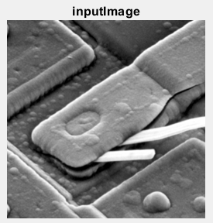 | 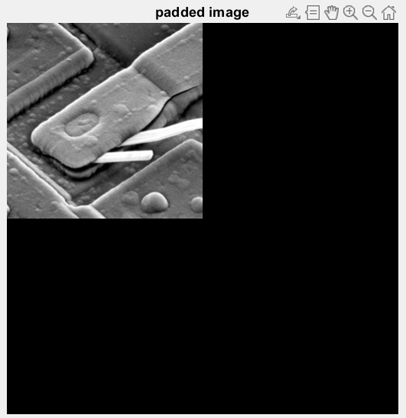
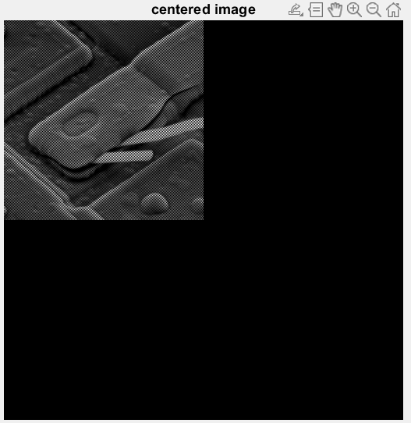 | 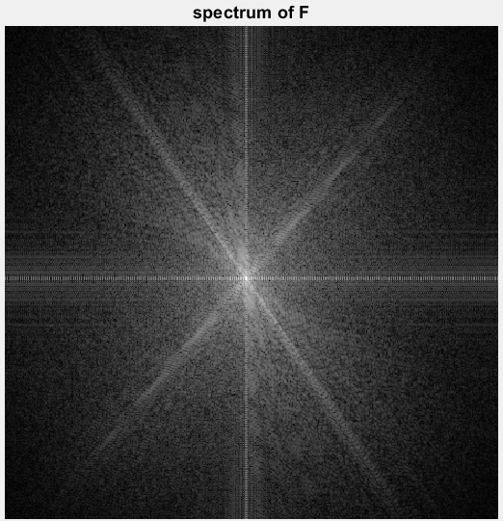
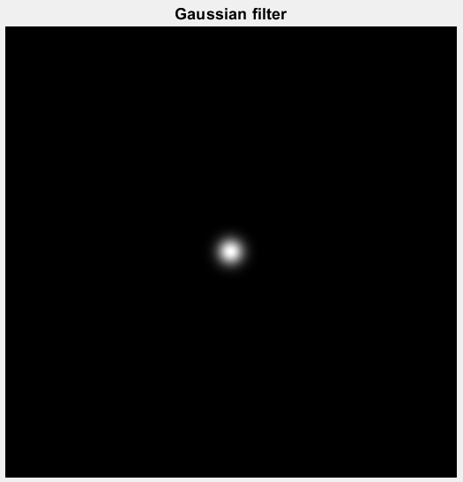 | 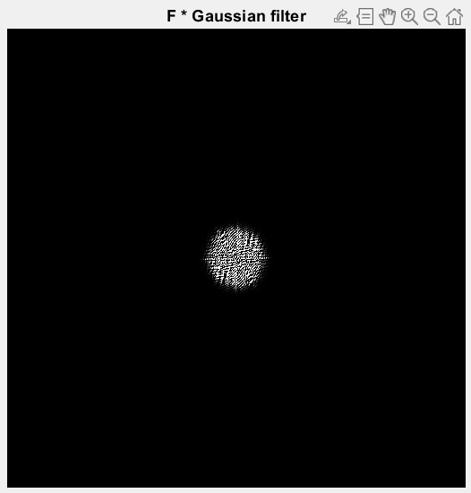
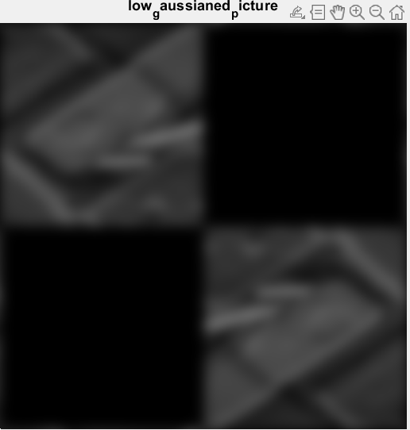 | 
Discussion
During the implementation, I had problem with my IDFT, but I later found out that for each element, a scalar of 1 / (MN) is needed. The problem is then solved.
- Difference between padding and non-padding
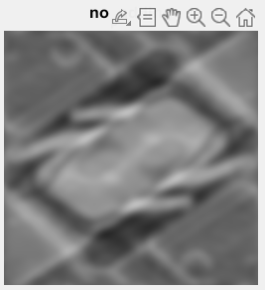
At the side is a result of the input image going through same processing procedure, but the only difference is that the input to the Fourier Transform has not been padded. We can see that although their brightness is a little bit different. The result picture that has not been padded somehow had non-correct, symmetry structure which is not in the original image. I think non-padding makes the dealing of edge / high frequency signal incorrect or came up with results that are not expected. It also had artifacts at the edge, though this is a picture processed by low-pass filter, there are white line at the object’s edge. The image with padding had overall smooth performance.
(2) Faster way of implementing Fourier Transform / FFT
From the class we know that there is a way of implementing 2D-DFT is to implement a 1D-DFT, and apply it on the image two times by different directions(rows and columns). This function also supports with 2D-IDFT, since you can implementing by operation and properties of complex conjugate. It makes the reusability higher. For the time complexity, originally, it takes O(M*M*N*N) = O((MN)^2) to run the for loop, but now it performs in:
rows-direction(橫向): there are N elements each row, for every element, the sigma makes it to calculate N times, therefore it takes O(M * N * N)
columns-direction(直向): there are M elements each column, for every element, the sigma makes it to calculate M times, therefore it takes O(N * M * M)
in total, it takes O(MN^2 + NM^2) = O(MN(M+N)) which is much faster than O((MN)^2), this is one of the approach of FFT.
Project04-02
Implementation
The implementation is based on the built-in function fft2 of Matlab, before that the image is centered by multiplying each element f(x, y) with (-1)^(x + y). After the transformation, I take the amplitude of the complex number and transform it with log(1 + |F|) to make the spectrum visualized better.
Result Image
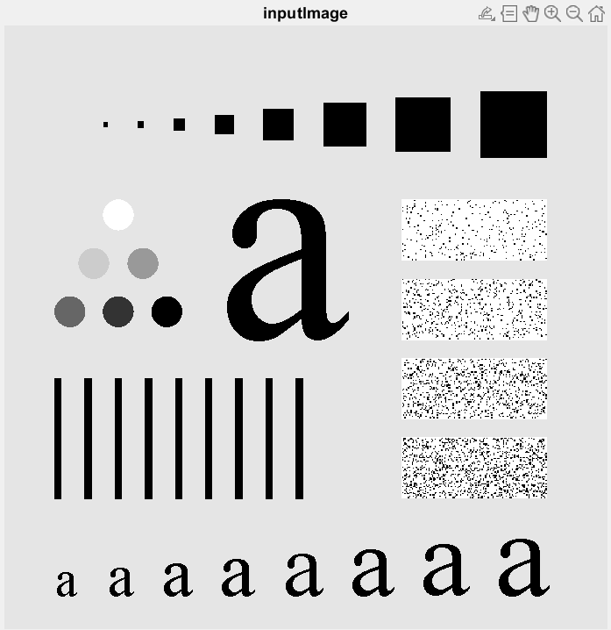 | 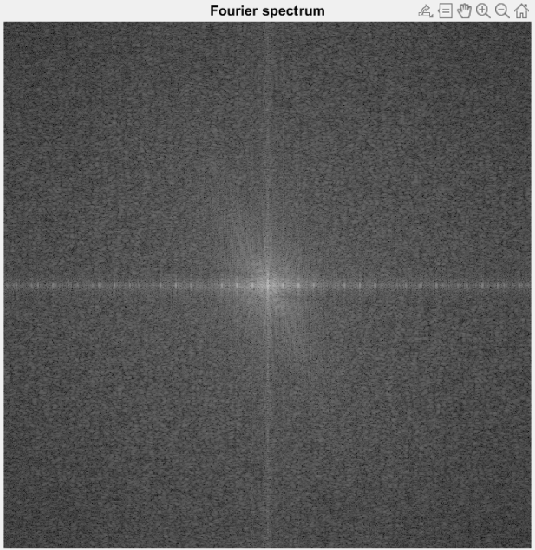

Discussion
Comparison of getting the means directly from the mean and from the center of the spectrum:
If you’re getting the mean directly from the image, the mean you get represents the overall intensity of the image, it is the mean on the spatial domain. But if you’re taking the mean from the center of the Fourier spectrum, this mean not only represents the brightness of the image, but also by how much that low-frequency takes place in this image. If the center of the spectrum has high value, it could be indicating that the image is rather smooth, or are in similar intensity throughout the whole image.
Project04-03
Implementation
In this project, we need to implement a Gaussian lowpass filter whose formula is
$$H\left(u, v\right)=e^{\frac{{-D}^{2}(u, v)}{2{D0}^{2}}}$$
Where D(u, v) is the distance from the (u, v) to the center of the filter. In this project, we assume that the center of the filter is at the middle, which is (M/2, N/2). Therefore, D²(u, v) is (u – M/2)² + (v – N/2)². D0 is the radius of the cutoff that we want to set. Since e^-x is a decreasing function when x is always greater than zero as in this case, the filter passes low-frequency signal of the image and weakens or you could say, filter the high-frequency signal. To make this filter work on an image, we first centered the image by multiplying each element f(x, y) by (-1)^(x + y), then derive the 2D DFT spectrum F of the image by build-in function ftt2. The operation between F and H is element-wise multiplication. I transferred it back to intensity domain by iftt2, take the real part and center again to meet the original brightness.
Result Image
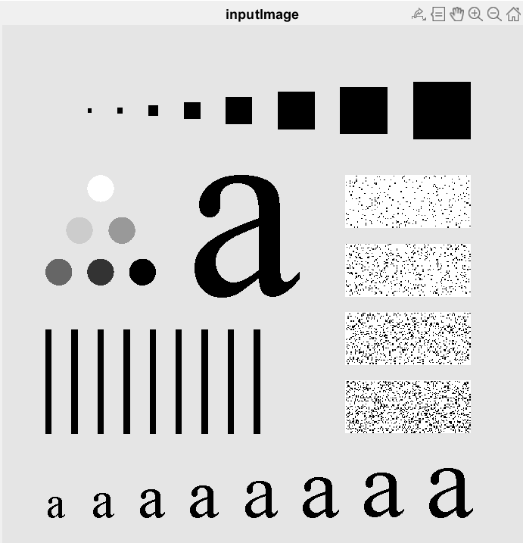 | 
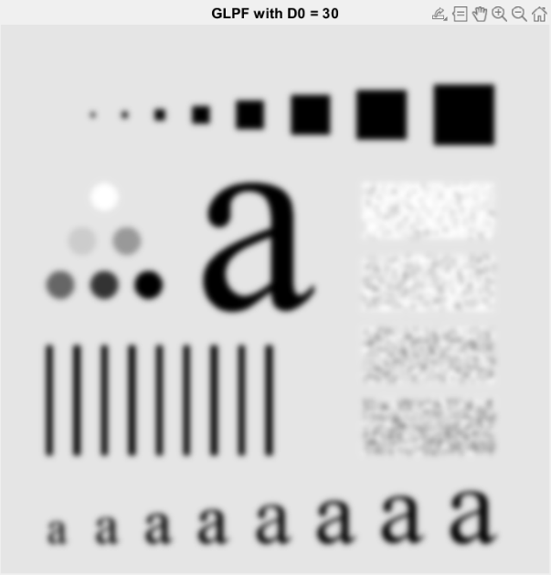 | 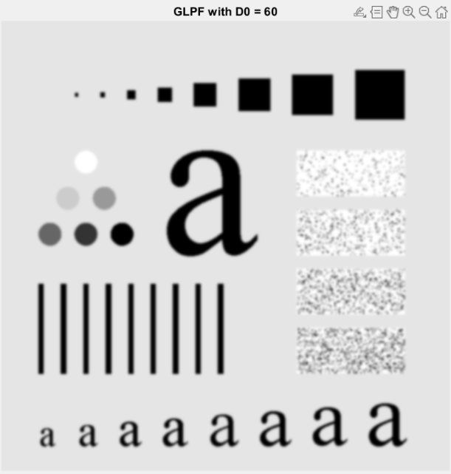
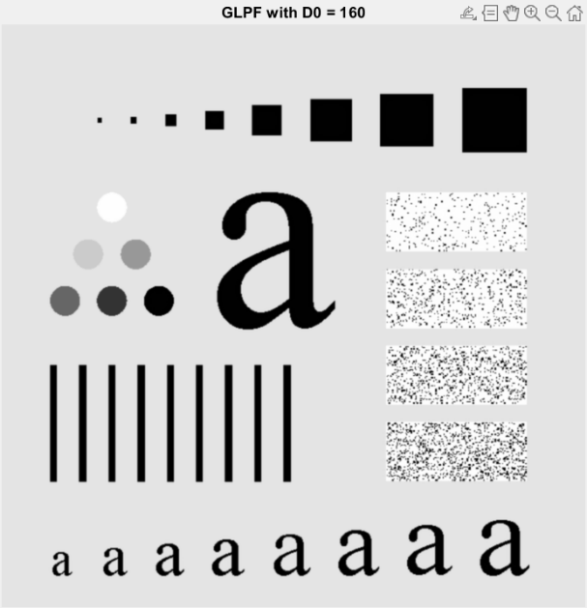 | 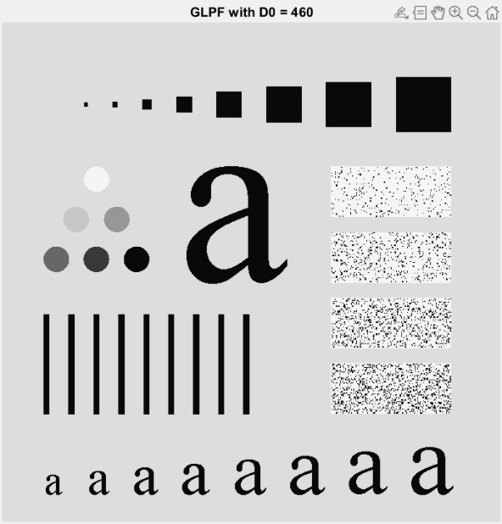
Above are the result image with (a) original image (b) D0 = 10 (c) D0 = 30 (d) D0 = 60 (e) D0 = 160 and (f) D0 = 460
Discussion
Although the original image is different from the image on the textbook, so I’m not sure whether this result image is correct or not, we could still see the tend of the image as D0 gets higher. While the low-frequency corresponds to the blurry part of the image, when a low-pass filter is used and the lower the thresholds are set, the more the blurry part of the image takes place. As D0 is set higher, the result image becomes more like the original image(clearer), is reasonable.
During the implementation, I initially noticed that the filtered image that I’ve reconstructed has different brightness as the original input. Though it doesn’t affect the result’s blurriness, it seems that it needs to be centered again after the inverse discrete Fourier transform. After this adjustment, the reconstructed filter-image makes more sense and they now have the same overall brightness.
Project04-04
Implementation
In this project, we need to implement a Gaussian lowpass filter whose formula is
$$H\left(u, v\right)=1-e^{\frac{{-D}^{2}(u, v)}{2{D0}^{2}}}$$
Where D(u, v) is the distance from the (u, v) to the center of the filter. In this project, we assume that the center of the filter is at the middle, which is (M/2, N/2). Therefore, D²(u, v) is (u – M/2)² + (v – N/2)². D0 is the radius of the cutoff that we want to set. Since 1 - e^-x is a increasing function when x is always greater than zero as in this case, the filter passes high-frequency signal of the image and weakens or you could say, filter the low-frequency signal. To make this filter work on an image, we first centered the image by multiplying each element f(x, y) by (-1)^(x + y), then derive the 2D DFT spectrum F of the image by build-in function ftt2. The operation between F and H is element-wise multiplication. I transferred it back to intensity domain by iftt2, take the real part and center again to meet the original brightness.
Result Image
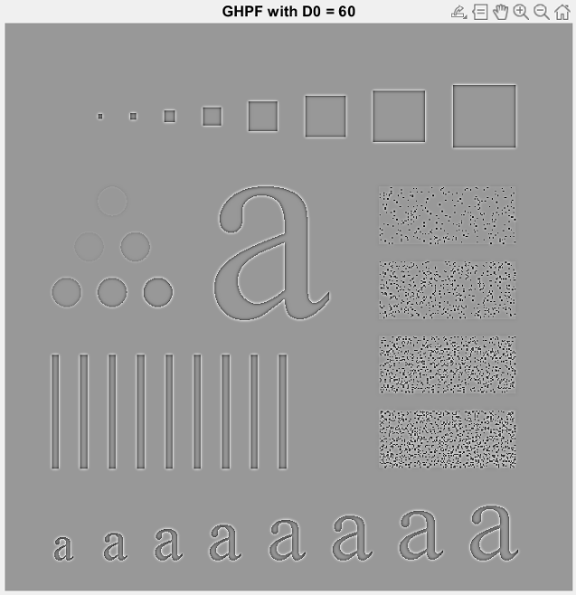 | 

Discussion
This two picture are not as clear as the picture from Fig4.56(b) and (e). They have brighter background than the image on the textbook. I tried centered, log transform, and normalization, but it doesn’t help. However, the behavior of the image is reasonable and similar to the answer image. Highpass filter let the signal with higher frequency pass through, and lowers the weight of the low frequency signal. Therefore, you will see at the edge between black and white dominating the image. A more obvious evidence is at the left of the picture where there are small balls but with different color. Some have similar color with the background(low frequency) are filtered when D0 = 60 and are almost invisible when D0 = 160.

