Introduction to Image Processing Lab04 Report
EECS26 111060024 蔡孟伶
Project05-01
Implementation
This project need two noise generator function known as addGaussianNoise and addImpulseNoise. The first function add noise randomly to the spatial domain of the image by formula
$$p\left(z\right)= \frac{1}{\sqrt{2π}σ}e^{\frac{-(z-\overline{z)}}{2σ^{2}}}$$
Since this is a random distribution noise with default zero mean, the new parameterized Gaussian noise will be randomly created in the space of the picture. These newly created noise will time the variance input and plus the mean input.
Another one is the salt and pepper noise which has dots distributed also in the spatial domain of the image. These dots are either white or black, and the user can input the density argument of them. The program randomly produce some pixel indexes inside the image, and we assign the proportion of salt and pepper by density.
Result Image
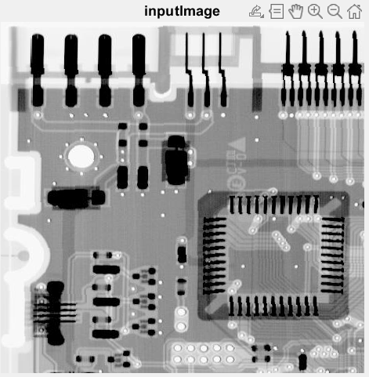 | 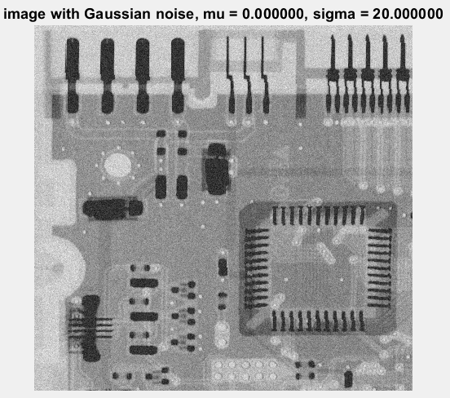
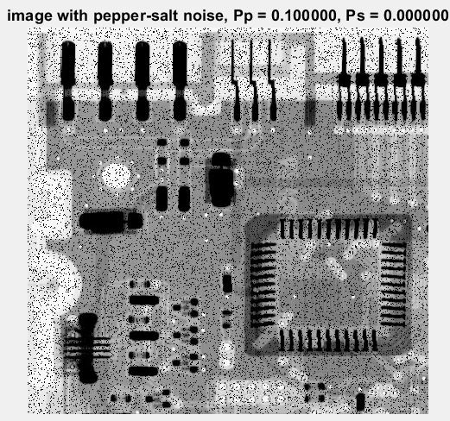 | 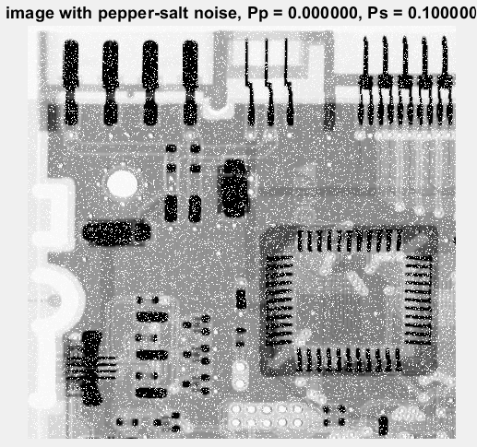
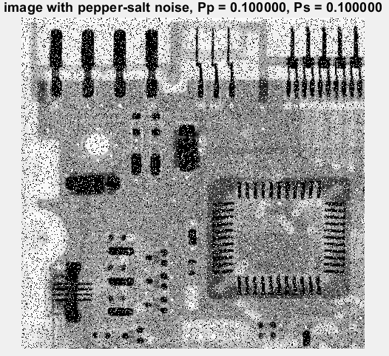 | 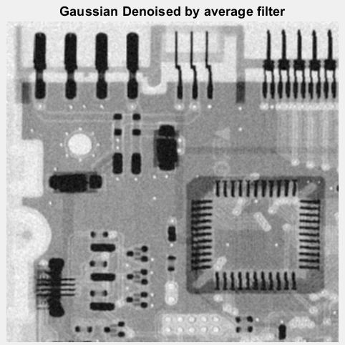
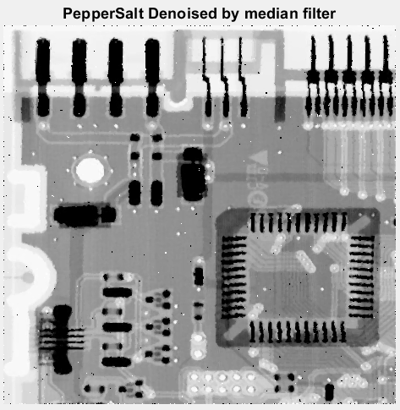
Discussion
Bonus:
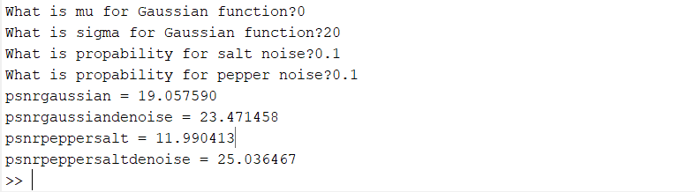
Above is the comparison of the pSNR of the image with noise and the denoised image, we can see that both the denoise function of Gaussian noise and impulse noise have higher pSNR, which mean they’re more like the original input image. For these two different kind of noise, I choose two different denoise model. They are both easy to implement but are affective to denoise. I think the side effects of the average filter is evident. The denoise image, is blurred on the edge, which I want to avoid if there’s another choice. The median filter has great effect on denoising the image.
Project05-03
Implementation
Different from the previous project, the noise that we are making at this project is located at the frequency domain and has some periodic property. Thus a notch filter is used, we want to filter out the exact frequency, but sometimes things don’t go as expected. I first create the periodic noise by the formula
$$η\left(x, y\right)=Asin⁡(2π\left(\frac{u_{0}x}{M}+ \frac{v_{0}y}{N}\right))$$
This is created at spatial domain but you can observe the periodic property by sin function. I add this noise to the image, then change into frequency domain by fast Fourier transform of 2-dimensional. I also centered the spectrum by fftshift. The notch filter is implemented in this domain, and then apply to the image by element multiplication. The formula of the Notch filter is
$$H\left(u, v\right)=\left\{\begin{aligned}0, if D_{1}\left(u, v\right)≤ D_{0} or D_{2}\left(u, v\right)≤ D_{0} \\ 1, otherwise \end{aligned}\right.$$
$$D_{1}\left(u, v\right)={\left[{\left(u-\frac{M}{2}- u_{0}\right)}^{2}+{\left(v-\frac{N}{2}-v_{0}\right)}^{2}\right]}^{\frac{1}{2}}$$
$$D_{2}\left(u, v\right)={\left[{\left(u-\frac{M}{2}+ u_{0}\right)}^{2}+{\left(v-\frac{N}{2}+v_{0}\right)}^{2}\right]}^{\frac{1}{2}}$$
For easy computing and not suffering from rounding, I didn’t take the square root during implementation, instead, I decide whether ${D_{1}}^{2}\left(u, v\right)≤{D_{0}}^{2} or {D_{2}}^{2}\left(u, v\right)≤{D_{0}}^{2}.$ This Notch filter H(u, v) is applied to the spectrum of the input image but with noise by element-wise multiplication.
Result Image
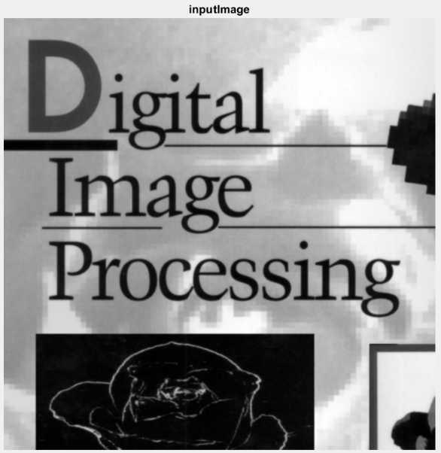 | 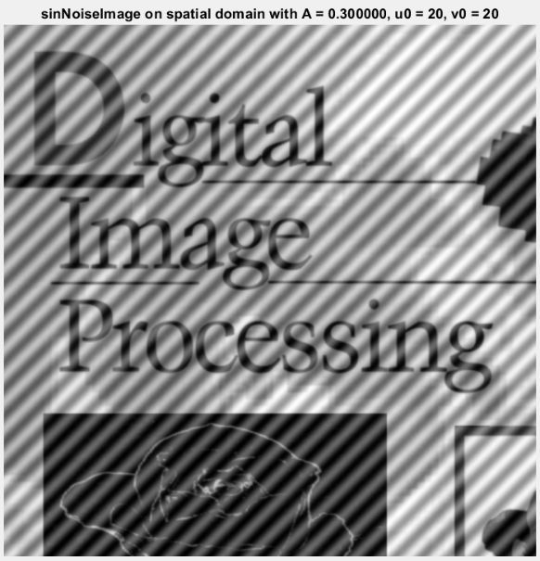
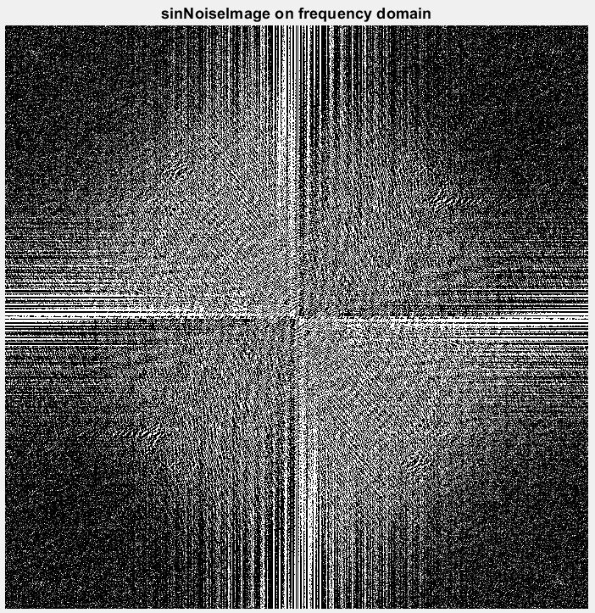 | 
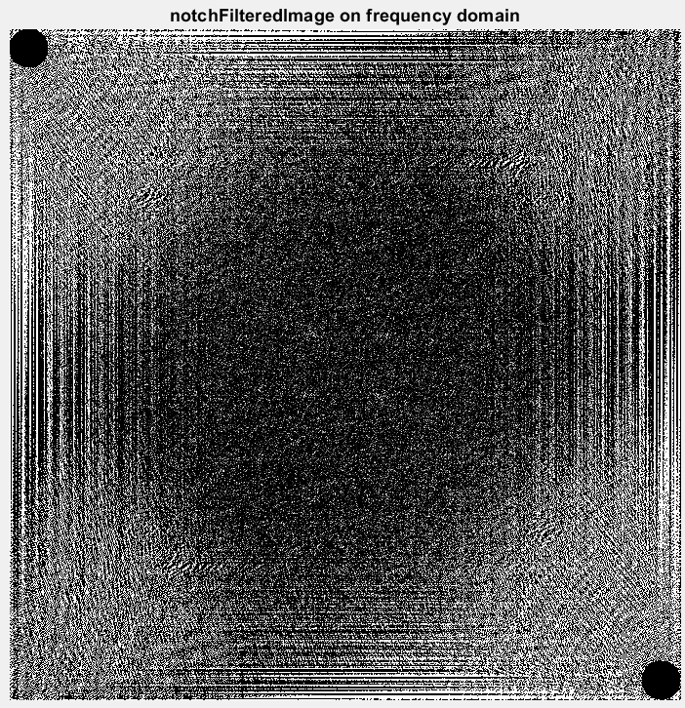 | 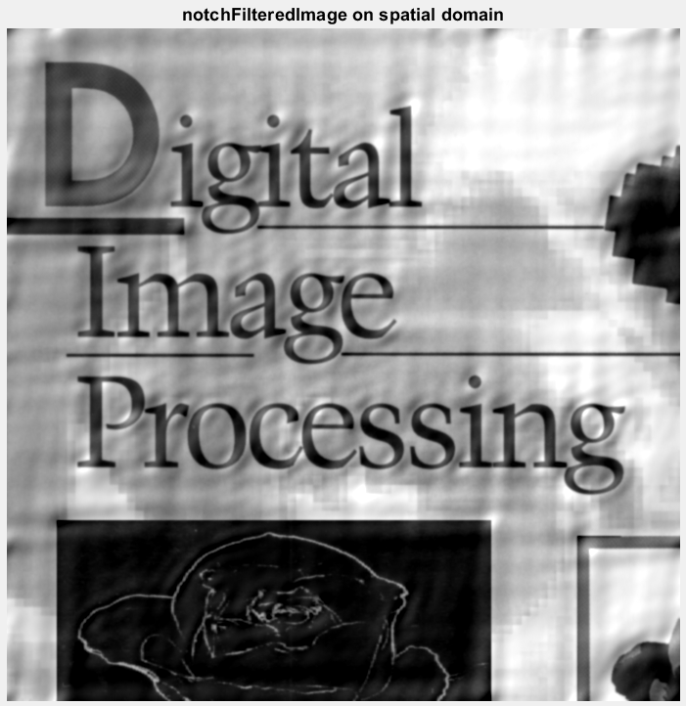
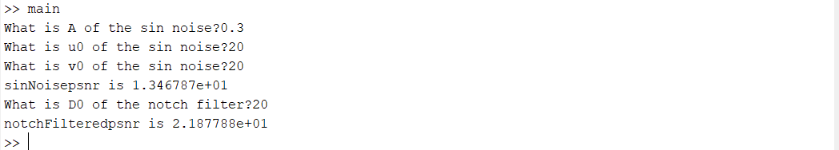
The move of black circle in fifth image is due to the centralization of the spectrum, the operation is actually the same. Just showed differently.
Discussion
During the implementation, I think it’s hard to start to try for the first group of parameter. Although the goal is to try different u0 and v0, A and D0 are also unknown and wait to be set. Since A means the intensity of the noise, it should be between 0 to 1 or else it goes out of bound of single value.
Looking at the pSNR of the image after adding sin noise and denoised by the Notch filter, the pSNR increase after the filter applied is reasonable since the higher pSNR is, the more it is similar to the original image. I also tried different u0 and v0 and D0. The number tried include 50, 75, 100, 300. From the statistic of pSNR, we see that the higher u0 and v0 are, the higher frequency the noise has. And the better the Notch filter works. I think this is because the image include low frequency structure, so it is hard to separate the noise from the image without ruining it. On the other hand, we easily filter out the high frequency and little portion of the image got affected by the filter, leading to higher pSNR.
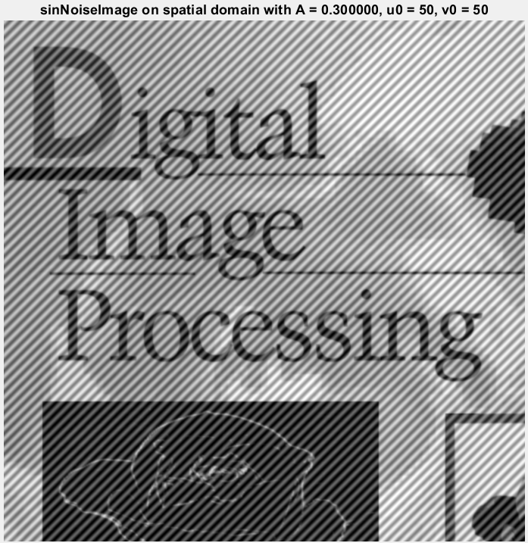 | 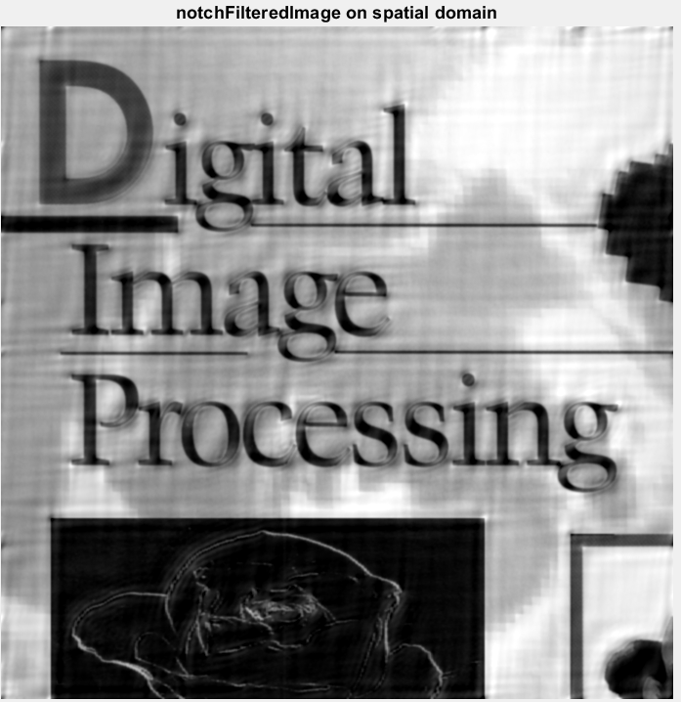
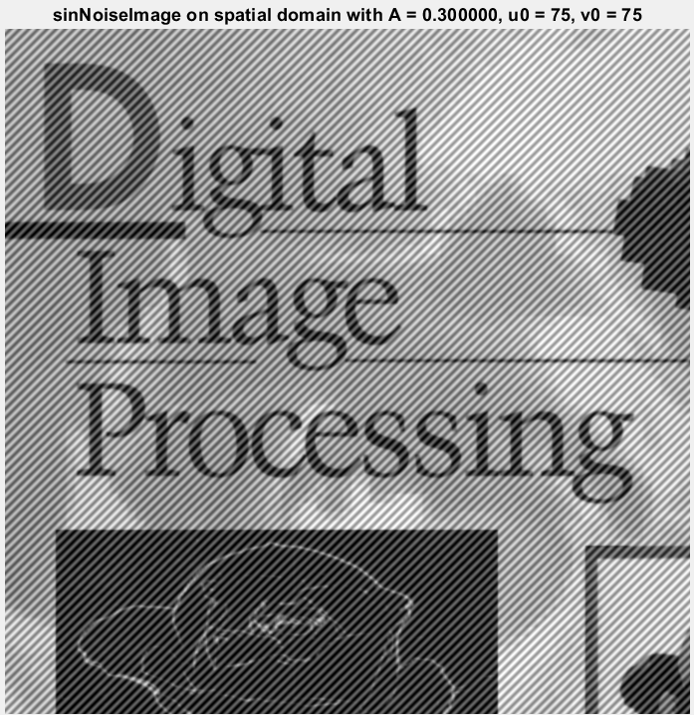 | 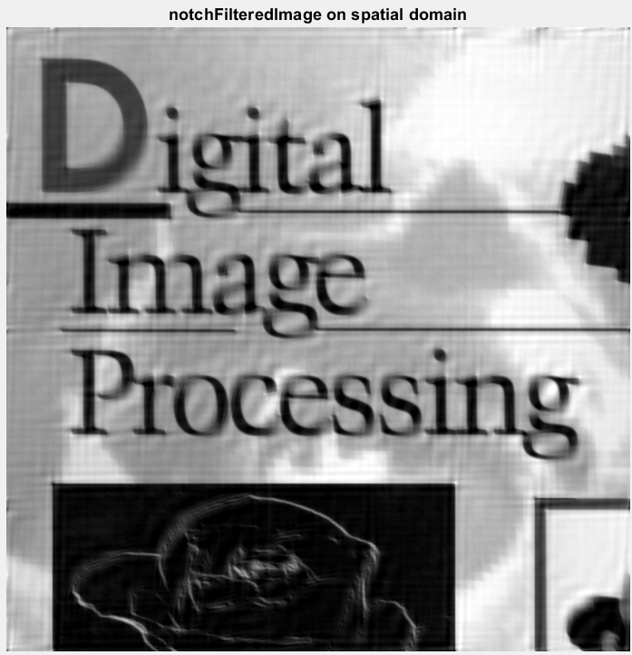
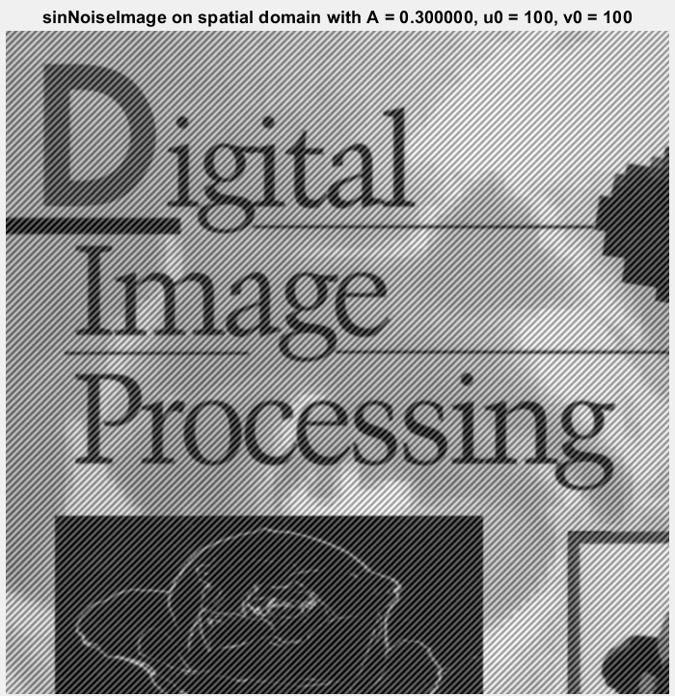 | 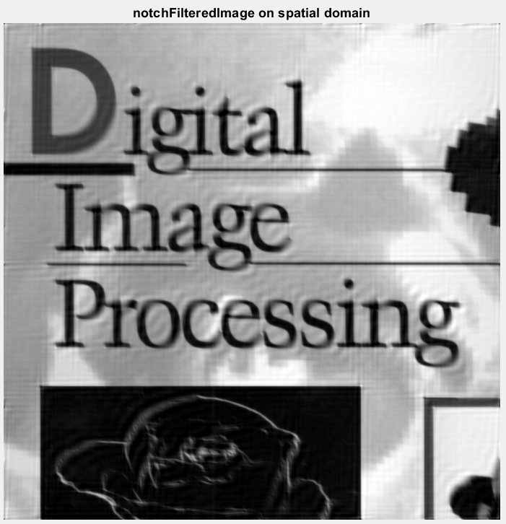
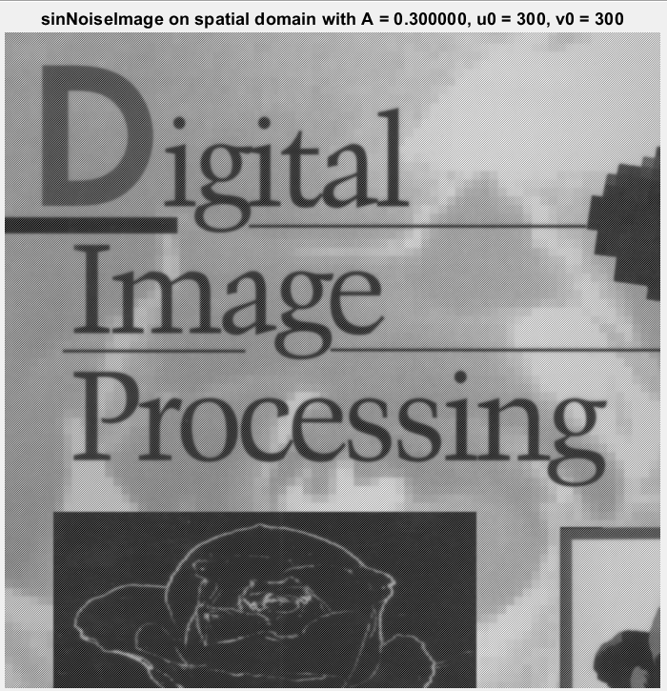 | 
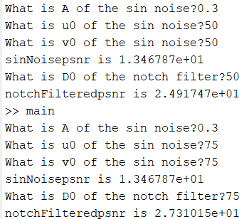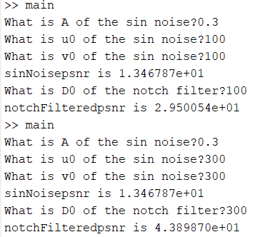
Project05-03
Implementation
This project implement the condition that, the degradation of the image is no longer only noice, but also motion blur. At first, I applied the motion blur to the image by formula
$$H\left(u, v\right)= \frac{1}{π(ua+vb)}\sin\left[π\left(ua+vb\right)\right]e^{-jπ(ua+vb)}$$
Before that, the image is transformed into frequency domain by fft2, then I implement the Wiener filter by the formula shown below. Also, in this implementation, I think that there may be conditions where H(u,v) is too small, and thus, the inverse filter amplifies the dominance of noise in the image as mentioned in class and textbook , so I set a threshold = 0.003 by observing the value in H. One of the reason why the result image didn’t show as expected can also be this.
$$\hat{F}\left(u, v\right)=[\frac{1}{H\left(u, v\right)} \frac{{\left|H\left(u, v\right)\right|}^{2}}{{\left|H\left(u, v\right)\right|}^{2}+K}]G(u,v)$$
Result Image
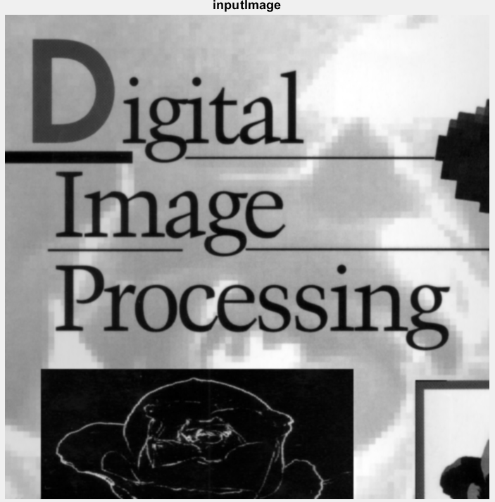 | 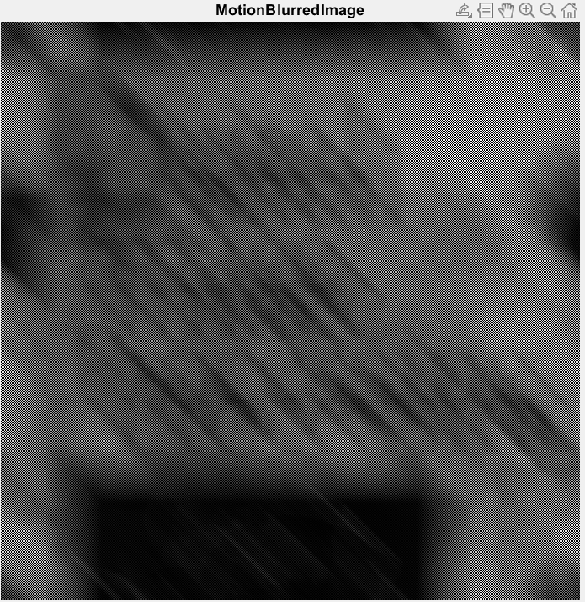
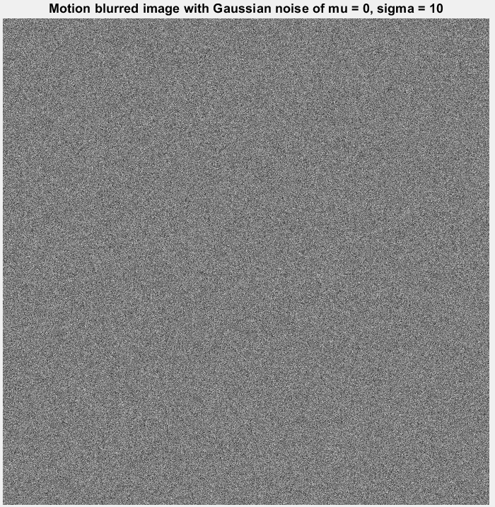 | 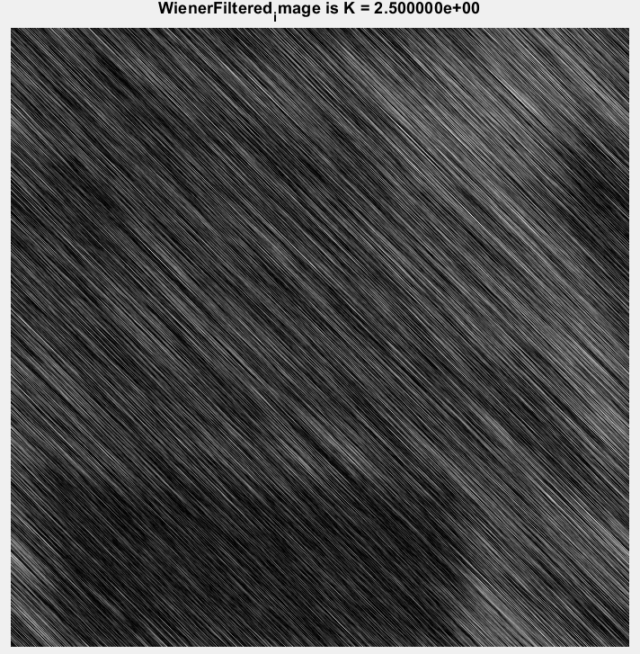
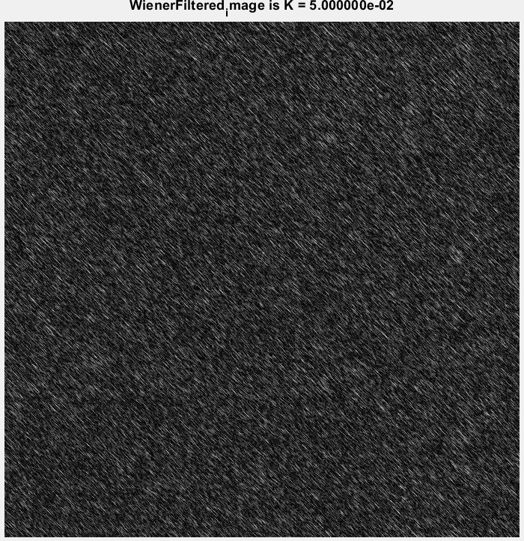 | 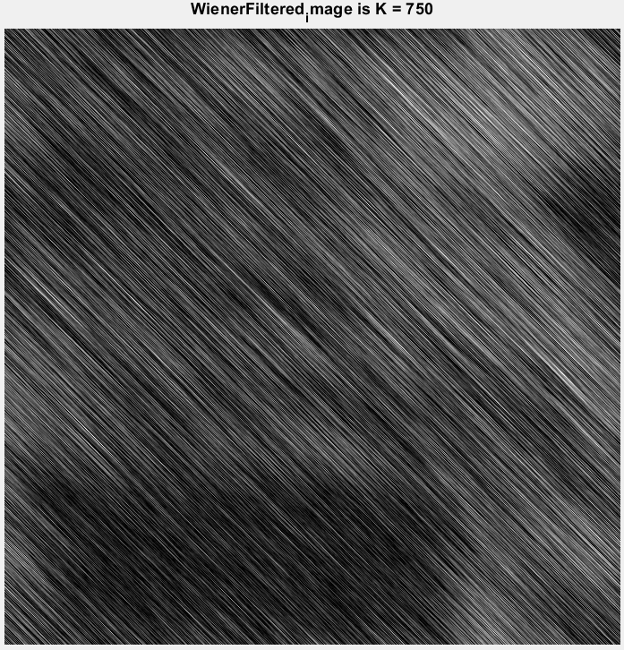
Discussion
The original problem on the website asked to add a Gaussian noise with mean = 0 and sigma = 10 on it, making the motion blurred image even harder to restore. I’ve taken K = 0.05, 2.5 and 750, each representing an order of magnitude. But as the result picture shows, I cannot find the K that restore the image to a basic quality. However, I still have observations on the statistics.
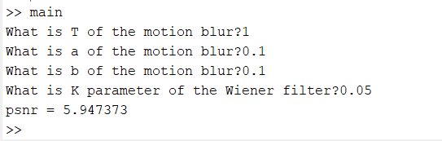
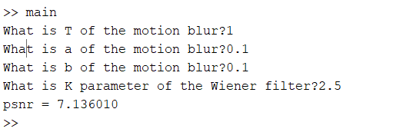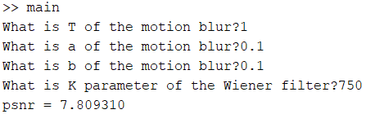
As the psnr shows, the affect of Wiener filter gets better as K increases in this case. If you look at the result picture of K = 750, you see that it actually indicate the spatial distribution of dark and bright park in the input image roughly. Besides, I think the reason that lead to this poor performance is because the Gaussian noise is the critical reason. So I tried to decrease the sigma number and get higher pSNR immediately. This indicates that although Wiener filter can help to restore image, images that has too many noises still can’t better result than image that are cleaner, even with motion blurr degradation. Below are the image restoration result and their pSNR with sigma = 1 (left column)and sigma = 0.1(right column).
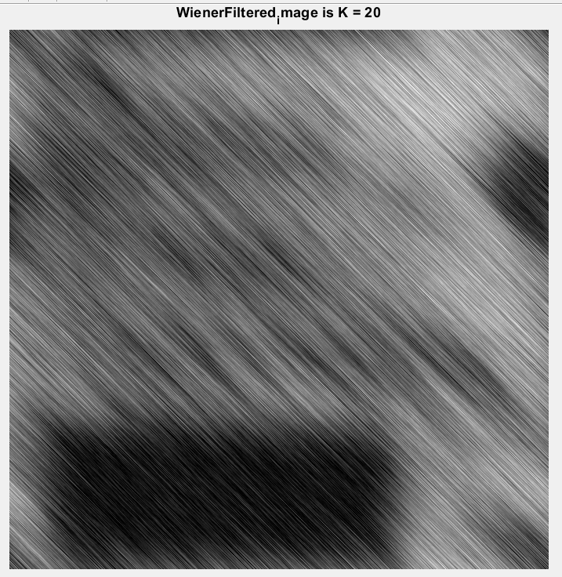 | 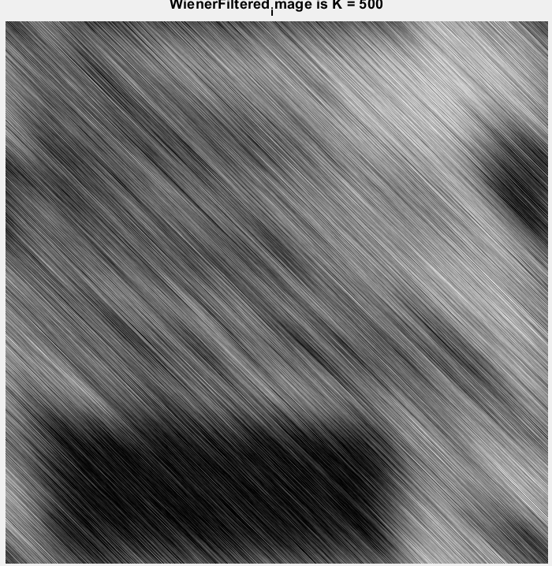
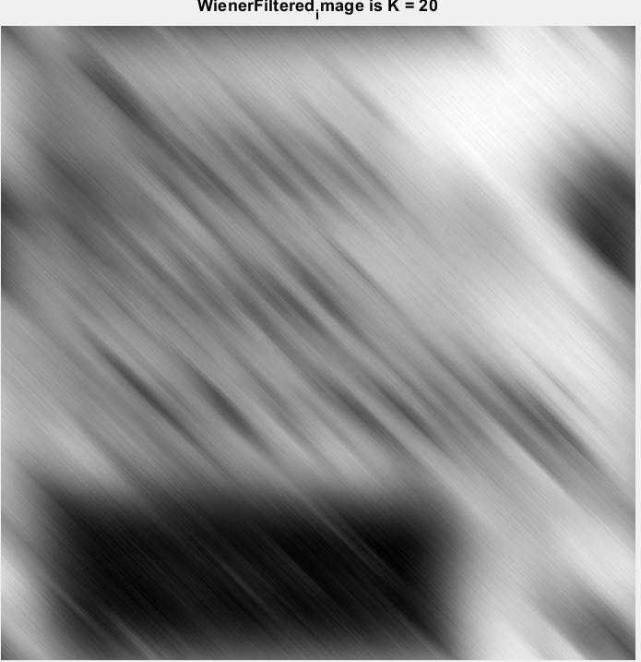 | 