Introduction to Image Processing Final Project Proposal
EECS26 111060024 蔡孟伶
Problem Description
There are many ways to implement image resizing. Content-aware seam carving is one of them. It gained the distribution of the energy of the image, and decided the path of a single seam that doesn’t cut through important content. Removal of seams makes the resized image look more natural than just neighbor sampling or interpolation.
An experiment tried to improve seam carving by preprocessing the image with an edge-aware smoothing-sharpening guided filter. The filter is smoothing or sharpening depends on the parameter tuned. By applying the filter, it smooths contents that are usually taken as less important without losing the edge. Thus, it is helpful to decide the path of seam.
Methods
For an input image, first, denoise image to avoid its distraction. Then, applied the guided smoothing filter to the image to smooth the background but preserve edge at the same time. Then calculate the energy map of the image, finally, design the seam carving dynamic programming algorithm to perform image resizing.
Possible results
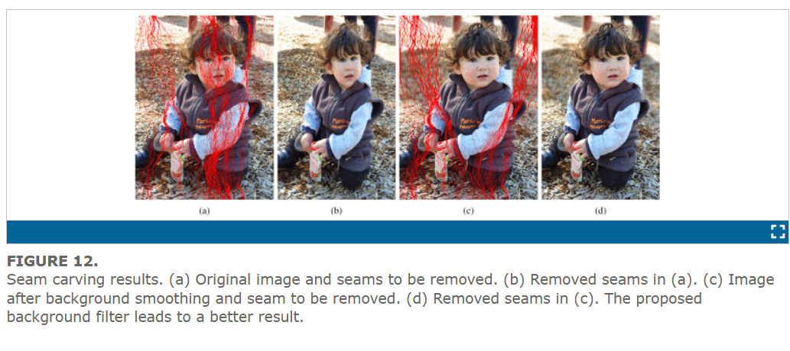
References
G. Deng, F. Galetto, M. Al–nasrawi and W. Waheed, "A Guided Edge-Aware Smoothing-Sharpening Filter Based on Patch Interpolation Model and Generalized Gamma Distribution," in IEEE Open Journal of Signal Processing, vol. 2, pp. 119-135, 2021,

