Introduction to Image Processing Term Project Report
EECS26 111060024 蔡孟伶
Problem Description
There are many ways to implement image resizing. Content-aware seam carving is one of them. It gained the distribution of the energy of the image, and decided the path of a single seam that doesn’t cut through important content. Removal of seams makes the resized image look more natural than just neighbor sampling or interpolation.
An experiment tried to improve seam carving by preprocessing the image with an edge-aware smoothing-sharpening guided filter. The filter is smoothing or sharpening depends on the parameter tuned. By applying the filter, it smooths contents that are usually taken as less important without losing the edge. Thus, it is helpful to decide the path of seam.
Method
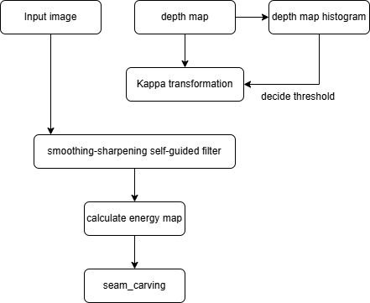
On the left is the flow chart of my processing method. The input includes original image data and its depth map data, below is an example of the input data pair. Generally, there are two main ways to produce a depth map of an image: by camera shooting from multiple angle, or if only two-dimensional single image is accessible, we can try to get a depth map by running a machine-learning model. Since my term project does not focus on generating depth map, the depth map is generated by a deep-learning model online.
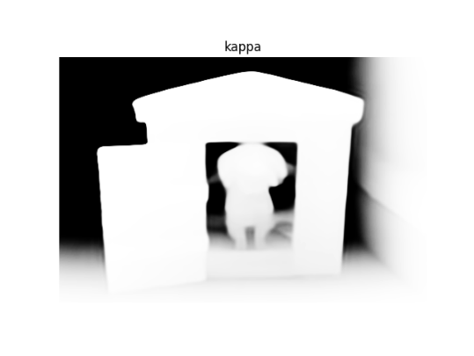
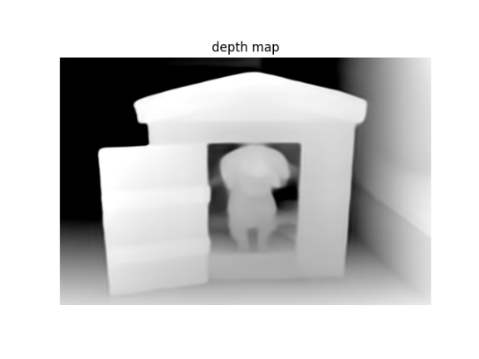
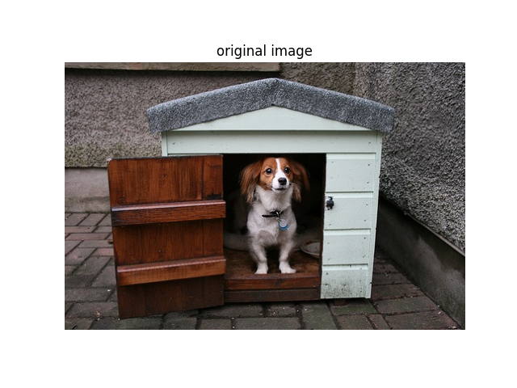
Inside the research paper, it describes a non-linear transformation from a feature map, the value inside resides in range [0, 1], I transform the type of image data from uint8 to single to ensure this property. These value t will be transformed into parameter kappa which controls whether the self-guided filter will have smoothing affect or sharpening affect on the image locally. The transformation formula mentioned is shown below.
$$κ=\left(κ_{max} -κ_{min}\right)e^{-0.69 *e^{-c(t - t_{0})}}+κ_{min}$$
$${,where κ}_{max,} κ_{min, }c, and t_{0} are user defined parameter globally for the image$$
Kappa max and Kappa min will constrain the range of the produced Kappa, having the property that 0 < Kappa < 1 is smoothing, and Kappa > 1 is sharpening. c is the growth rate, and $t_{0}$ is the threshold that we want Kappa to be 1. I want to decide $t_{0}$ dynamically for each image such that it can split the pixel into (will be) smoothing and sharpening two classes. I choose to analyze the histogram of the depth map and decide its threshold $t_{0}$ by Otsu method. Below is the depth map histogram example and the threshold chosen.
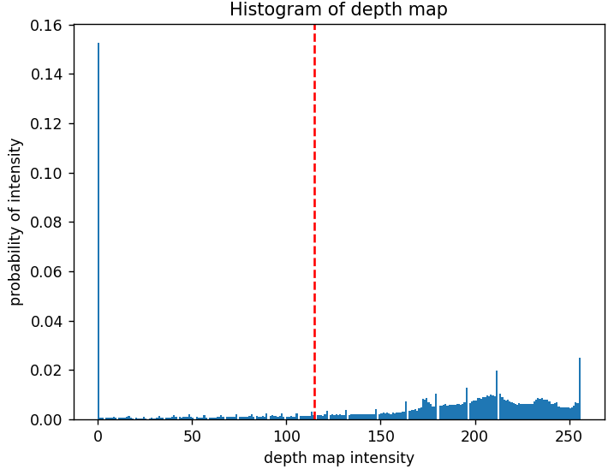
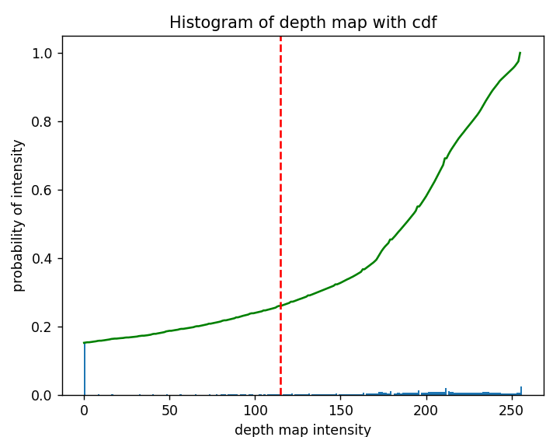

Next, the smoothing-sharpening self-guided filter is applied to the image. It is similar to the classic self-guided filter where a linear relationship is assumed locally, and a parameter decided by how much the output pixel is affected by input pixel or the average around it. To apply this filter, there are four parameters that should be decided: patch radius, Kappa, epsilon, and scale. I reduced it into first three because I want to keep the computation simpler and keep control of my filter, so I take the original self-guided filter approach.
$$J\left(p\right)=I\left(p\right)\sum_{k=1}^{N}{w_{k}α_{k}+\sum_{k=1}^{N}{w_{k}\left({1 - α}_{k}\right)μ_{k}}}, w_{k}= \frac{c_{k}}{1+\frac{σ_{k}^{2}}{scale *{\overline{σ}}^{2}}} in the paper, now reduced to w_{k}=\frac{1}{N}$$
$$J\left(p\right)= I\left(p\right)\frac{1}{N}\sum_{k=1}^{N}{α_{k}}+μ_{k}\frac{1}{N}\sum_{k=1}^{N}{{(1 - α}_{k})}$$
$$α_{k}= \frac{1}{2}\left(a_{k}+ \sqrt{a_{k}^{2}+4κ\left(1 - a_{k}\right)} \right), a_{k}= \frac{σ_{k}^{2}\left(p\right)}{σ_{k}^{2}\left(p\right)+epsilon},$$
$$since I want my α_{k} to depend on Kappa more, I choose big epsilon as my parameter$$
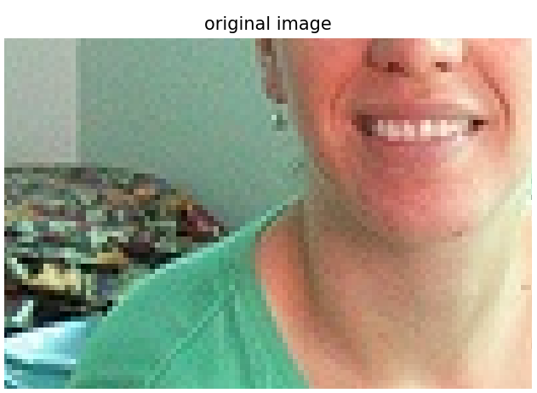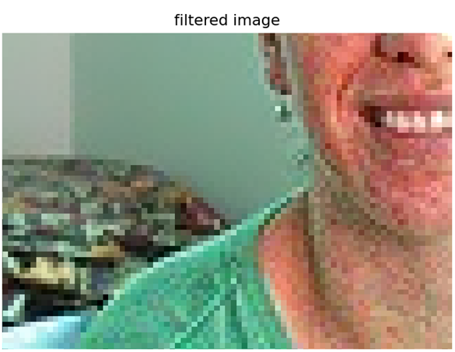
After the image is filtered, I calculate the energy map of the original image and filtered image. The energy map function for RGB color image is defined by
$E\left(x, y\right)=\left|\frac{∂I_{R}}{∂x}\right|+$ $\left|\frac{∂I_{R}}{∂y}\right|$ + $\left|\frac{∂I_{G}}{∂x}\right|+$ $\left|\frac{∂I_{G}}{∂y}\right|$ + $\left|\frac{∂I_{B}}{∂x}\right|+$ $\left|\frac{∂I_{B}}{∂y}\right|$
The implementation is done by Sobel operator of opencv package. Last the image is processed by seam-carving and compare the result. This term project focuses on removing vertical seams from the image, and the test image are actually picked instead of randomly gathering the image. For seam-carving, method of dynamic programming is taken. First for each pixel from the top of the image, it accumulates the energy loss by three candidates of the pixel from top-left, top, and top-right. Then it chooses the seam with least accumulated loss and back trace the path. The seam is then marked and removed.
In the method mentioned above, seam-carving is applied on the filtered image, since depth map actually implies content by its value, there is another approach that I later tried to reference depth map and do seam carving on the original image. This is a slightly different version of code from the original implementation.
Result
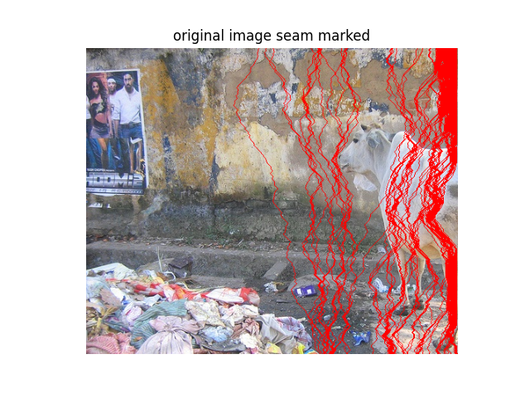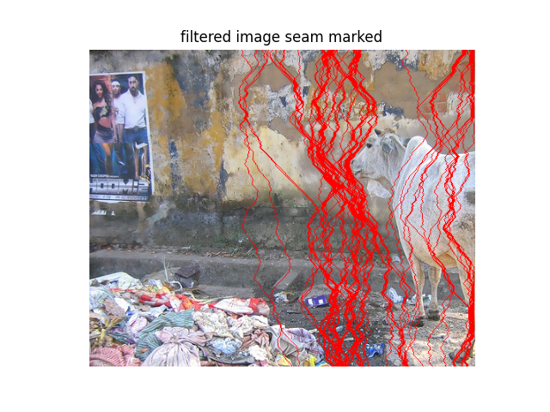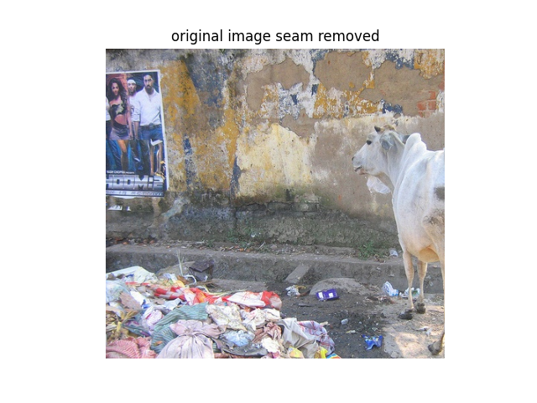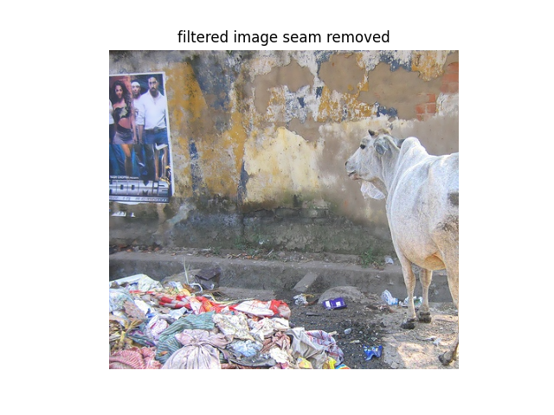
▲These images result are examples of successful processing
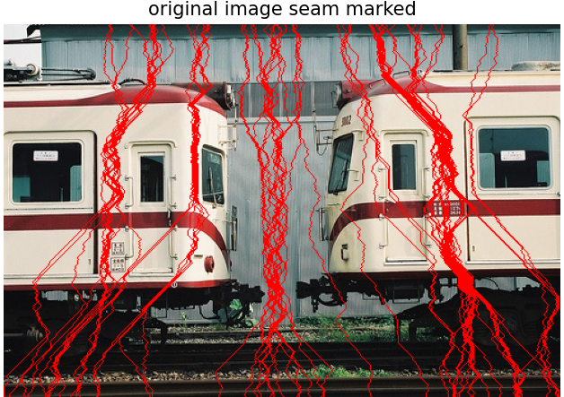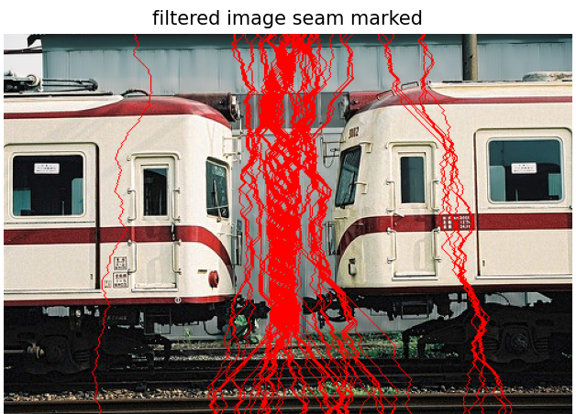
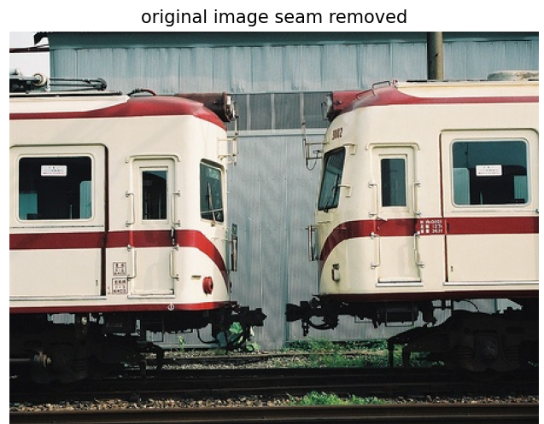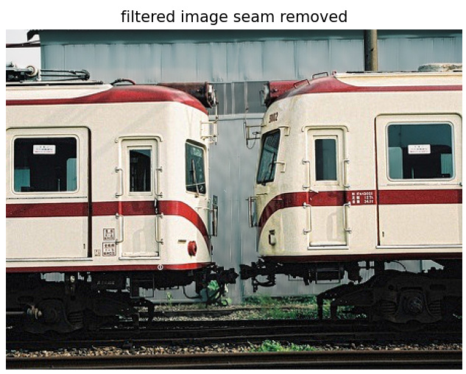
▲These images result are examples of successful processing
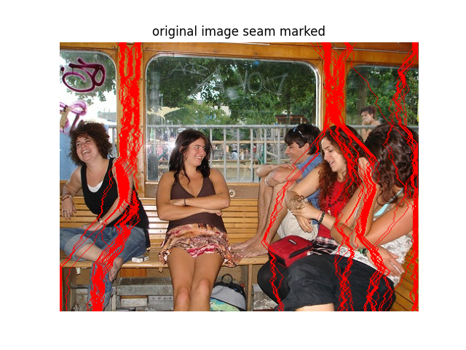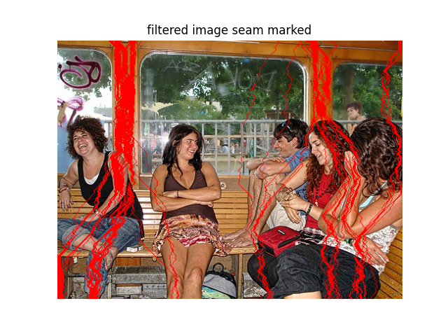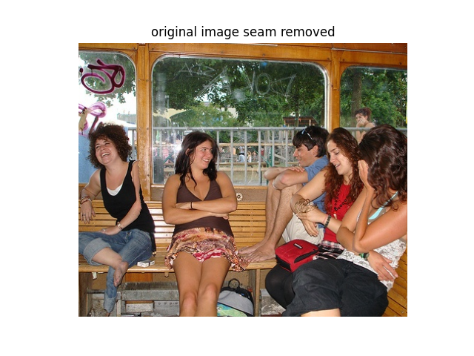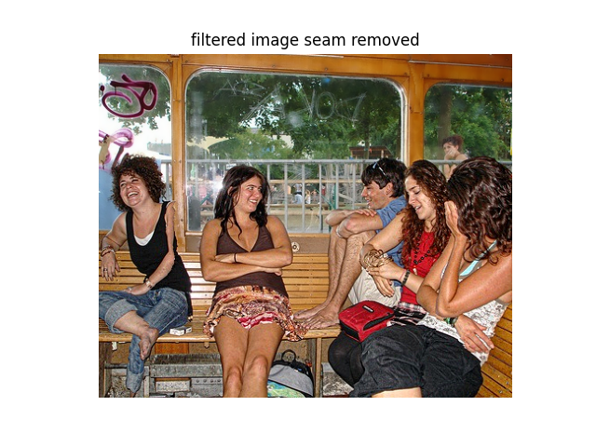
- These are examples where self-guided filter preprocess didn’t make much difference
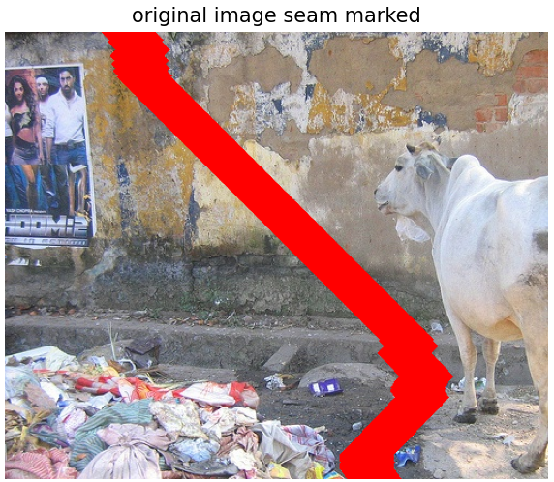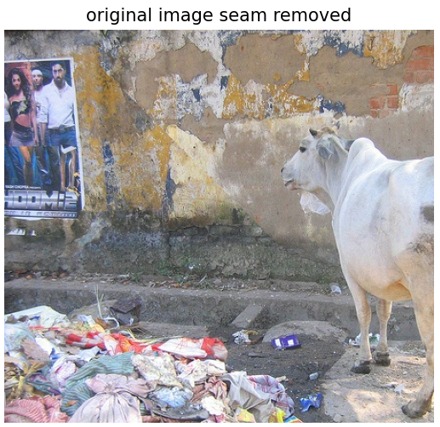
▲These two are result that reference depth map as loss and do seam carving on the original image.
Discussion
- The image data is selected to compare if this form of smoothing-sharpening self-guided filter is a good preprocessing step before seam-carving, therefore, I’ve chose image that has similar color or structure on vertical direction, other images are main content with similar color but with a relatively complicated background. From the result we can see that, this filter though worked well with some input, it cannot guarantee its affect on every image. For image with too complicated background and main-content with color lump, it still fail to preserve the content well.
- I think the transformation of depth map to kappa is still discussable because it mappes a value in range of [0, 1] to value in range of [$κ_{min}, κ_{max}]$, but the range of smoothing is only [0, 1), while range of sharpening is (1, infinity). In other words, $κ_{min}$ could only be small as 0, but $κ_{max}$ could be big as the user want. This could be meaning that most of the pixel in sharpening class is sharpened strongly, but for smoothing, it may no be as obvious as sharpening.
- In this self-guided filter as preprocessed before seam carving, seam carving is performed on the filtered image. I tried another set with performing seam carving on the original image but decide the seam by depth map because it marks different content with different value (even better, lower value is associated with lower importance at the background). But the result turned out that this kind of seam carving neglects the effect from the image’s color and detail itself. From the result you can see that it always chooses seam at some area with as much as background pixel it can cover, but it’s not as fined as seam now, after removing 50 pixels, there’s an artifact on the image’s background, resulting worse than the filtered method.
- Though the usage of self-guided filter is once questioned, but I think the intermediate results with self-guided filter applied to it gives DOF effect, which could be another useful preparation for image edits etc.
- Last, the futher work of this topic could include more complicated seam carving with bidirectional and more optimization, and try to get the depth map or data similar to that when only one 2-D image is shot.

