Pattern Recognition Experiment 2

EECS26 111060024 蔡孟伶

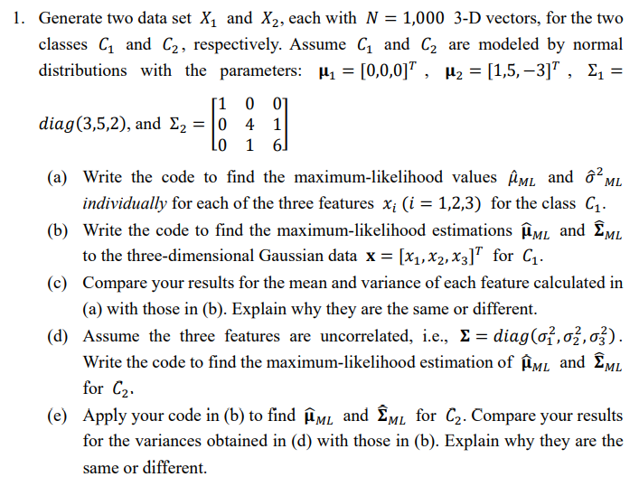

(c) The mean estimator derived in (a) and (b) are the same. Additionally, the variance calculated at (a) is the same as the covariance matrix’s diagonal line. I think it is reasonable that sigma(i, j) means the variance between feature i and feature j. Therefore, the diagonal line is the variance within the individual class. They are both calculated under biased variance.

(e) Inside (d), assuming the features were uncorrelated, then the mean estimator and variance estimator would be the same as (a). Therefore, this is another case of comparing the result derived from (a) and (b). The variance value will be the same, but for the dataset of C2, the covariance matrix of generating the dataset is not like what (d) assume. Therefore, although they have the same value for individual class variance, the covariance matrix is not the same. (d) has 0 on sigma(i, j), i != j. (e) computes the between feature covariance, which is not 0.

一張含有 文字, 字型, 螢幕擷取畫面, 行 的圖片

AI 產生的內容可能不正確。

Conclusion:

Since the p ML estimator is equal to the mean of the sample value, by testing a few times, (b) usually has estimated p ML closer to 0.7 than (a), and the reason is likely because that (b) has more samples, and could generate dataset that fits better to the ground truth we set.

一張含有 文字, 字型, 螢幕擷取畫面, 代數 的圖片

AI 產生的內容可能不正確。

The following is the result figure of (a) and (b) for each dataset, I think usually that taking order = 5 would get low SSE error than other choices inside cross validation.

一張含有 圖表, 文字, 行, 繪圖 的圖片

AI 產生的內容可能不正確。一張含有 圖表, 行, 繪圖, 文字 的圖片

AI 產生的內容可能不正確。一張含有 圖表, 行, 繪圖, 文字 的圖片

AI 產生的內容可能不正確。一張含有 圖表, 行, 繪圖, 文字 的圖片

AI 產生的內容可能不正確。一張含有 圖表, 行, 繪圖, 文字 的圖片

AI 產生的內容可能不正確。一張含有 圖表, 文字, 行, 繪圖 的圖片

AI 產生的內容可能不正確。一張含有 圖表, 行, 文字, 繪圖 的圖片

AI 產生的內容可能不正確。一張含有 圖表, 行, 繪圖, 文字 的圖片

AI 產生的內容可能不正確。一張含有 圖表, 行, 繪圖, 文字 的圖片

AI 產生的內容可能不正確。一張含有 圖表, 行, 繪圖, 文字 的圖片

AI 產生的內容可能不正確。