Ffmpeg.c(FFmpeg\fftools\ffmpeg.c)

int main(int argc, char **argv)
{
int i, ret;

// 基准时间戳
BenchmarkTimeStamps ti;
typedef struct BenchmarkTimeStamps {
int64_t real_usec;
int64_t user_usec;
int64_t sys_usec;
} BenchmarkTimeStamps;
// 初始化动态加载，主要是针对win32系统
init_dynload();
void init_dynload(void)
{
#ifdef _WIN32
在dll的搜索路径中移除当前工作目录，为了安全着想
SetDllDirectory("");
#endif
}
#define SetDllDirectory SetDllDirectoryW
SetDllDirectoryW是一个windows下的函数，作用是在搜索dll的路径中增加一个路径，
当传入参数为“”空字符串时，从dll搜索路径中删除当前目录

注册退出时的清理函数，ffmpeg_cleanup函数里都是释放内存的操作
register_exit(ffmpeg_cleanup);

c里的函数，不设置输出的缓冲
setvbuf(stderr,NULL,_IONBF,0); /* win32 runtime needs this */
设置日志，AV_LOG_SKIP_REPEATED：跳过重复信息
av_log_set_flags(AV_LOG_SKIP_REPEATED);
从输入命令中获取日志级别，参数-loglevel设定
parse_loglevel(argc, argv, options);

如果有-d参数，则设置为守护进程
if(argc>1 && !strcmp(argv[1], "-d")){
run_as_daemon=1;
设置日志的回调，log_callback_null是一个空函数
av_log_set_callback(log_callback_null);
argc--;
argv++;
}

如果申明了设备的宏定义，就注册所有的设备
#if CONFIG_AVDEVICE
avdevice_register_all();
#endif
如果有申明网络设置的宏定义，初始化网络相关的配置
avformat_network_init();
int avformat_network_init(void)
{
#if CONFIG_NETWORK
int ret;
if ((ret = ff_network_init()) < 0)
return ret;
if ((ret = ff_tls_init()) < 0)
return ret;
#endif
return 0;
}

输出相关的程序信息，使用的库信息
show_banner(argc, argv, options);
void show_banner(int argc, char **argv, const OptionDef *options)
{
int idx = locate_option(argc, argv, options, "version");
if (hide_banner || idx)
return;

print_program_info (INDENT|SHOW_COPYRIGHT, AV_LOG_INFO);
print_all_libs_info(INDENT|SHOW_CONFIG, AV_LOG_INFO);
print_all_libs_info(INDENT|SHOW_VERSION, AV_LOG_INFO);
}
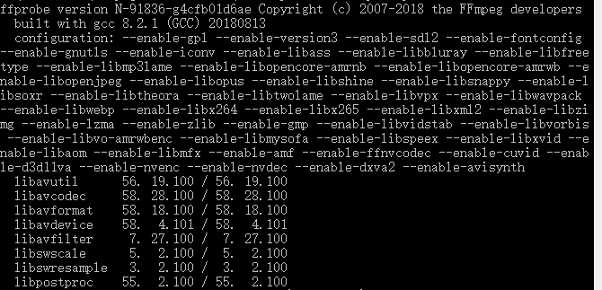
/* parse options and open all input/output files */
获取输入参数并打开所有的输入文件和输出文件
ret = ffmpeg_parse_options(argc, argv);
int ffmpeg_parse_options(int argc, char **argv)
{
OptionParseContext octx;
uint8_t error[128];
int ret;

memset(&octx, 0, sizeof(octx));
/* split the commandline into an internal representation */
ret = split_commandline(&octx, argc, argv, options, groups,
FF_ARRAY_ELEMS(groups));
通过函数split_commandline把所有的输入参数存储在结构体OptionParseContext中，包含了全局的选项，一个选项组的列表，列表大小，以及目前在解析的选项组。
一个选项组OptionGroup 里包含了多个选项，其中每个选项都至少拥有相同的标志flag
typedef struct OptionParseContext {
OptionGroup global_opts;

OptionGroupList *groups;
int nb_groups;
/* parsing state */
OptionGroup cur_group;
} OptionParseContext;
OptionDef结构体，选项的内容存储在这个结构体中。
typedef struct OptionDef {
选项名
const char *name;
选项的类型
int flags;
以下的宏定义都是这个flags的可选值，可以是其中的一个，也可以是多个值做位或操作得到的值。
#define HAS_ARG 0x0001
#define OPT_BOOL 0x0002
#define OPT_EXPERT 0x0004
#define OPT_STRING 0x0008
#define OPT_VIDEO 0x0010
#define OPT_AUDIO 0x0020
#define OPT_INT 0x0080
#define OPT_FLOAT 0x0100
#define OPT_SUBTITLE 0x0200
#define OPT_INT64 0x0400
#define OPT_EXIT 0x0800
#define OPT_DATA 0x1000
#define OPT_PERFILE 0x2000 /* the option is per-file (currently ffmpeg-only).
implied by OPT_OFFSET or OPT_SPEC */
#define OPT_OFFSET 0x4000 /* option is specified as an offset in a passed optctx */
#define OPT_SPEC 0x8000 /* option is to be stored in an array of SpecifierOpt.
Implies OPT_OFFSET. Next element after the offset is
an int containing element count in the array. */
#define OPT_TIME 0x10000
#define OPT_DOUBLE 0x20000
#define OPT_INPUT 0x40000
#define OPT_OUTPUT 0x80000
处理函数，这个选项使用什么函数来处理输入/输出文件
union {
void *dst_ptr;
int (*func_arg)(void *, const char *, const char *);
size_t off;
} u;
选项帮助，通常是这个选项的含义
const char *help;
选项后面接的参数名
const char *argname;
} OptionDef;

有一个常量options数组，存储着所有的输入选项的内容，数组里有一个宏数组，存着一些通用的选项。
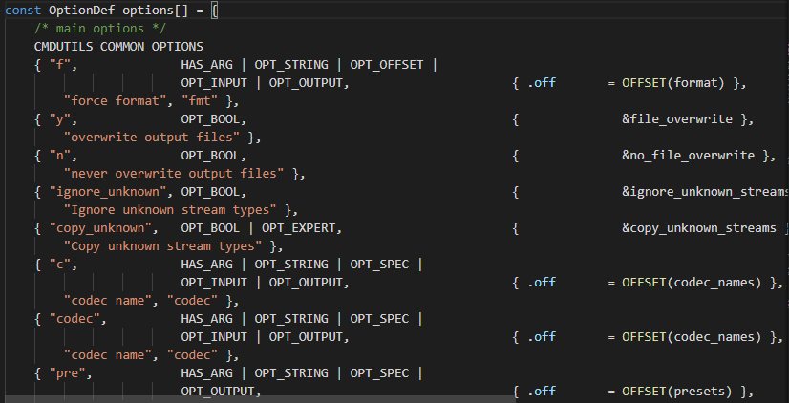
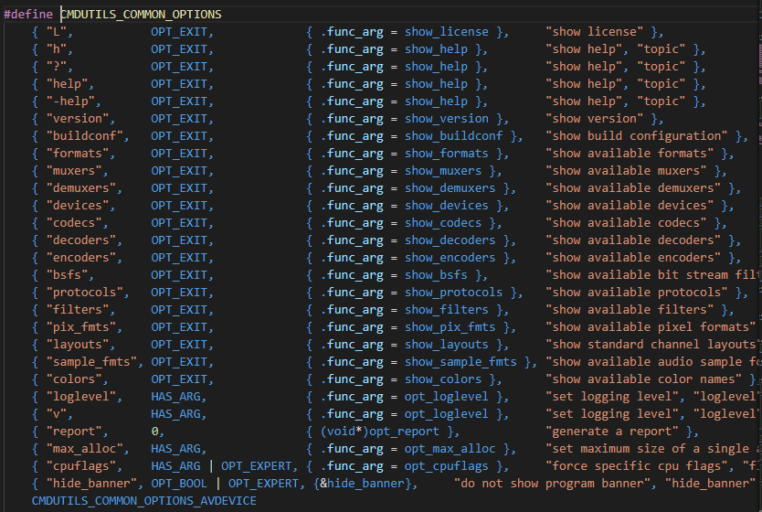

if (ret < 0) {
av_log(NULL, AV_LOG_FATAL, "Error splitting the argument list: ");
goto fail;
}
处理完全部的输入参数后，开始解析全局的选项
/* apply global options */
ret = parse_optgroup(NULL, &octx.global_opts);
int parse_optgroup(void *optctx, OptionGroup *g)
{
int i, ret;

av_log(NULL, AV_LOG_DEBUG, "Parsing a group of options: %s %s.\n",
g->group_def->name, g->arg);
for (i = 0; i < g->nb_opts; i++) {
Option *o = &g->opts[i];
判断选项组里的选项的flags是否至少含有组的flags的其中一个，包含则进行操作，否则报错。因为flag的可能值都是2的次幂，所以两者做位与操作,至少需要有一位都不为0，也就是两者至少有一个flag是相同的。

组的flags
选项的flags
if (g->group_def->flags &&
!(g->group_def->flags & o->opt->flags)) {
av_log(NULL, AV_LOG_ERROR, "Option %s (%s) cannot be applied to "
"%s %s -- you are trying to apply an input option to an "
"output file or vice versa. Move this option before the "
"file it belongs to.\n", o->key, o->opt->help,
g->group_def->name, g->arg);
return AVERROR(EINVAL);
}
av_log(NULL, AV_LOG_DEBUG, "Applying option %s (%s) with argument %s.\n",
o->key, o->opt->help, o->val);
ret = write_option(optctx, o->opt, o->key, o->val);
if (ret < 0)
return ret;
}
av_log(NULL, AV_LOG_DEBUG, "Successfully parsed a group of options.\n");
return 0;
}

if (ret < 0) {
av_log(NULL, AV_LOG_FATAL, "Error parsing global options: ");
goto fail;
}
配置终端并开启信号处理器
/* configure terminal and setup signal handlers */
term_init();
/* open input files */
打开输入文件
ret = open_files(&octx.groups[GROUP_INFILE], "input", open_input_file);
if (ret < 0) {
av_log(NULL, AV_LOG_FATAL, "Error opening input files: ");
goto fail;
}
创建复杂图过滤器
/* create the complex filtergraphs */
ret = init_complex_filters();
if (ret < 0) {
av_log(NULL, AV_LOG_FATAL, "Error initializing complex filters.\n");
goto fail;
}
/* open output files */
打开输出文件
ret = open_files(&octx.groups[GROUP_OUTFILE], "output", open_output_file);
if (ret < 0) {
av_log(NULL, AV_LOG_FATAL, "Error opening output files: ");
goto fail;
}
检查输出文件是否与filter绑定
check_filter_outputs();
失败时的操作
fail:
取消context的初始化
uninit_parse_context(&octx);
if (ret < 0) {
av_strerror(ret, error, sizeof(error));
av_log(NULL, AV_LOG_FATAL, "%s\n", error);
}
return ret;
}

回到ffmpeg.c的main函数
if (ret < 0)
exit_program(1);
检查输入文件和输出文件的数量是否正常，如有错误。输出请示
if (nb_output_files <= 0 && nb_input_files == 0) {
show_usage();
av_log(NULL, AV_LOG_WARNING, "Use -h to get full help or, even better, run 'man %s'\n", program_name);
exit_program(1);
}
/* file converter / grab */
if (nb_output_files <= 0) {
av_log(NULL, AV_LOG_FATAL, "At least one output file must be specified\n");
exit_program(1);
}
判断输出文件中是否有使用rtp协议的，如果有，把使用sdp协议的标志设为0（false）.
for (i = 0; i < nb_output_files; i++) {
if (strcmp(output_files[i]->ctx->oformat->name, "rtp"))
want_sdp = 0;
}
获取目前的时间戳
current_time = ti = get_benchmark_time_stamps();
开始转码
if (transcode() < 0)
exit_program(1);
转码结束后，再次获取时间戳，并输出转码花费的时间。
if (do_benchmark) {
int64_t utime, stime, rtime;
current_time = get_benchmark_time_stamps();
utime = current_time.user_usec - ti.user_usec;
stime = current_time.sys_usec - ti.sys_usec;
rtime = current_time.real_usec - ti.real_usec;
av_log(NULL, AV_LOG_INFO,
"bench: utime=%0.3fs stime=%0.3fs rtime=%0.3fs\n",
utime / 1000000.0, stime / 1000000.0, rtime / 1000000.0);
}
输出日志，并退出程序
av_log(NULL, AV_LOG_DEBUG, "%"PRIu64" frames successfully decoded, %"PRIu64" decoding errors\n",
decode_error_stat[0], decode_error_stat[1]);
if ((decode_error_stat[0] + decode_error_stat[1]) * max_error_rate < decode_error_stat[1])
exit_program(69);
exit_program(received_nb_signals ? 255 : main_return_code);
return main_return_code;
}

Transcode函数，main函数里操作都是在的函数transcode中实现的：
static int transcode(void)
{
int ret, i;
AVFormatContext *os;
OutputStream *ost;
InputStream *ist;
int64_t timer_start;
int64_t total_packets_written = 0;
初始化转码操作
ret = transcode_init();
if (ret < 0)
goto fail;
操作提示
if (stdin_interaction) {
av_log(NULL, AV_LOG_INFO, "Press [q] to stop, [?] for help\n");
}
获取相对时间
timer_start = av_gettime_relative();
如果有多线程的宏定义，初始化输入的多线程
#if HAVE_THREADS
if ((ret = init_input_threads()) < 0)
goto fail;
#endif
循环处理转码操作，每次一步
while (!received_sigterm) {
获取相对时间
int64_t cur_time= av_gettime_relative();
/* if 'q' pressed, exits */
如果按钮q键，则退出循环
if (stdin_interaction)
if (check_keyboard_interaction(cur_time) < 0)
break;
/* check if there's any stream where output is still needed */
如果已经没有更多的输出文件需要处理，结束循环
if (!need_output()) {
av_log(NULL, AV_LOG_VERBOSE, "No more output streams to write to, finishing.\n");
break;
}
转码的一次操作
ret = transcode_step();
检查转码结果是否有错误，有则退出循环
if (ret < 0 && ret != AVERROR_EOF) {
av_log(NULL, AV_LOG_ERROR, "Error while filtering: %s\n", av_err2str(ret));
break;
}
/* dump report by using the output first video and audio streams */
输出报告
print_report(0, timer_start, cur_time);
}
释放输入线程
#if HAVE_THREADS
free_input_threads();
#endif
/* at the end of stream, we must flush the decoder buffers */
处理输入的数据包
for (i = 0; i < nb_input_streams; i++) {
ist = input_streams[i];
if (!input_files[ist->file_index]->eof_reached) {
process_input_packet(ist, NULL, 0);
}
}
强制刷新解码缓冲
flush_encoders();
term_exit();
/* write the trailer if needed and close file */
写入输出文件的文件尾，并关闭输出文件
for (i = 0; i < nb_output_files; i++) {
os = output_files[i]->ctx;
if (!output_files[i]->header_written) {
av_log(NULL, AV_LOG_ERROR,
"Nothing was written into output file %d (%s), because "
"at least one of its streams received no packets.\n",
i, os->url);
continue;
}
if ((ret = av_write_trailer(os)) < 0) {
av_log(NULL, AV_LOG_ERROR, "Error writing trailer of %s: %s\n", os->url, av_err2str(ret));
if (exit_on_error)
exit_program(1);
}
}
/* dump report by using the first video and audio streams */
输出日志
print_report(1, timer_start, av_gettime_relative());
/* close each encoder */
关闭并释放每个编码器
for (i = 0; i < nb_output_streams; i++) {
ost = output_streams[i];
if (ost->encoding_needed) {
av_freep(&ost->enc_ctx->stats_in);
}
total_packets_written += ost->packets_written;
}
if (!total_packets_written && (abort_on_flags & ABORT_ON_FLAG_EMPTY_OUTPUT)) {
av_log(NULL, AV_LOG_FATAL, "Empty output\n");
exit_program(1);
}
关闭每个解码器
/* close each decoder */
for (i = 0; i < nb_input_streams; i++) {
ist = input_streams[i];
if (ist->decoding_needed) {
avcodec_close(ist->dec_ctx);
if (ist->hwaccel_uninit)
ist->hwaccel_uninit(ist->dec_ctx);
}
}
取消缓冲区的引用，可能是便于重复利用
av_buffer_unref(&hw_device_ctx);
释放设备相关的全部内存
hw_device_free_all();
/* finished ! */
ret = 0;
失败时的流程
fail:
释放线程
#if HAVE_THREADS
free_input_threads();
#endif
if (output_streams) {
for (i = 0; i < nb_output_streams; i++) {
ost = output_streams[i];
if (ost) {
if (ost->logfile) {
if (fclose(ost->logfile))
av_log(NULL, AV_LOG_ERROR,
"Error closing logfile, loss of information possible: %s\n",
av_err2str(AVERROR(errno)));
ost->logfile = NULL;
}
释放内存
av_freep(&ost->forced_kf_pts);
av_freep(&ost->apad);
av_freep(&ost->disposition);
av_dict_free(&ost->encoder_opts);
av_dict_free(&ost->sws_dict);
av_dict_free(&ost->swr_opts);
av_dict_free(&ost->resample_opts);
}
}
}
return ret;
}

