
School of Computer Science and Engineering
Department of Internet of Things
Industrial Internship Report
FALL SEMESTER 2025-26
Type of Intern:  Tick the applicable | Industry (offline) | CDC Course |  |  |  | VIT-TBI | VAC
Course Details
Course Code | CSI3903 | Course Name |  | Industrial Internship
Student Details
Name of the Candidate | Utkarsh Gupta |  |  | Reg. No. |  | 22BCT0102
Programme |  | Branch
Email id | guptautkarsh2504@gmail.com |  |  | Mobile |  | 8318738435
Intern Details
Title of Intern / Course Name /VAC name | Backend Engineer
Name of the Company / Platform / School | Paytm
Location (if applicable)  Online platform / VAC location | Noida
Website / Source Link | https://paytm.com/
Duration | From Date | 26-05-25 | To Date |  | 08-07-25
Proof(Certificate) of Completion | https://drive.google.com/file/d/1JcF8yBuc3A-k5sZOSET9q5Tg4NkejKxL/view?usp=sharing
Issuing Authority / Supervisor Details | Shruti Raj
Certificate ID / Number
Date of Issuance | 22-07-2025
Email (Authority) | shruti1.raj@paytm.com |  |  | Mobile |  | 8931009595

Brief About the Internship
During my internship, I worked on developing a Merchant Control Protocol (MCP) Server designed to manage and fetch databases of merchant subscriptions efficiently. The project involved creating a modular system integrating multi-query results, dynamic query generation, and graph-based data relationships, along with a remote client SDK and AI integration with Claude. My key responsibilities included contributing to backend development, database design, query optimization, and testing real-time client interactions.
Throughout the internship, I gained practical knowledge in server architecture design, asynchronous data handling, and graph implementation using modern frameworks and databases. I also developed skills in building scalable APIs, optimizing query performance, and integrating AI-assisted data retrieval.
One major challenge was optimizing multi-query execution for large datasets without impacting response time. This was addressed through caching, query batching, and indexing strategies. Additionally, aligning natural language inputs from Claude with structured database queries required iterative fine-tuning of prompts and query translation logic.
Overall, the internship provided an excellent opportunity to work on a complex, full-stack system combining backend logic, client communication, and AI-driven intelligence. It strengthened my technical, problem-solving, and collaboration skills while deepening my understanding of distributed and intelligent system design.

Skills Obtained During the Internship
During the internship, I developed a strong foundation in backend development, database management, and system design. I gained hands-on experience with server-side frameworks, SQL/NoSQL databases, dynamic query generation, and graph-based data modeling. Working on multi-query optimization enhanced my understanding of asynchronous processing, indexing, and caching techniques to improve system performance.
In addition to technical skills, I strengthened my problem-solving, analytical, and teamwork abilities by collaborating with team members during feedback and testing phases. The project also improved my communication and documentation skills, as I had to translate complex technical processes into clear, actionable reports.
From a domain perspective, I acquired practical knowledge in subscription management systems, client–server communication protocols, and AI-driven data integration, particularly through the integration of the MCP server with Claude for intelligent query handling and reporting.

Feedback and Suggestions:
My internship experience was highly enriching and well-structured, offering a perfect blend of learning and practical implementation. The project on building the MCP server for merchant subscription management allowed me to explore various aspects of software development — from backend design and database optimization to graph-based data handling and AI integration. The mentorship and guidance I received throughout the internship were extremely supportive, ensuring that I could overcome technical challenges with confidence and clarity.
I particularly appreciated the collaborative environment, where regular feedback sessions helped refine the project design and improve overall performance. The balance between independent problem-solving and team discussions enhanced both my technical and interpersonal skills.
Overall, the internship provided a comprehensive understanding of how real-world systems are built, optimized, and integrated with emerging AI technologies. It was a valuable and motivating experience that has significantly contributed to my professional growth and practical knowledge in the field of intelligent system development.

Signature of the Student: ________________ ________
Date: _____________22-07-25___________

Completion Certificate
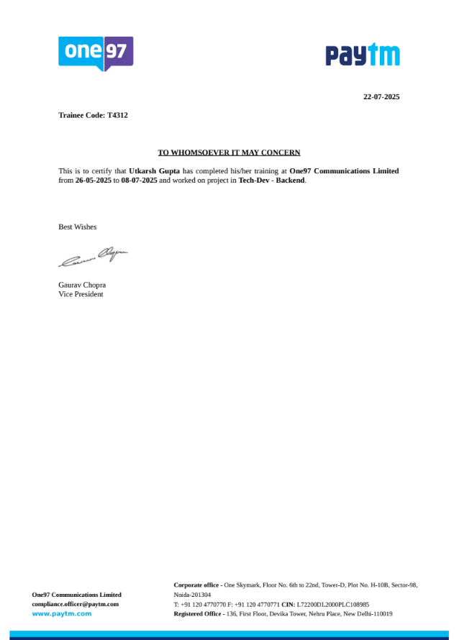

Date | Activity
26 May (Mon) | Internship induction and project overview; understanding MCP (Model Context Protocol) system architecture and objectives.
27 May (Tue) | Set up development environment and tools (Git, DB server, API testing tools).
28 May (Wed) | Design initial database schema for merchants, subscriptions, and products.
29 May (Thu) | Develop basic backend routes for merchant registration and subscription retrieval.
30 May (Fri) | Connect backend to database; implement CRUD operations.
31 May (Sat) | Holiday
1 June (Sun) | Holiday
2 June (Mon) | Begin implementation of dynamic query generation (JSON >SQL).
3 June (Tue) | Integrate multi-query execution logic and test batched queries.
4 June (Wed) | Optimize query responses and add filtering capabilities.
5 June (Thu) | Internal testing of dynamic query results; handle edge cases.
6 June (Fri) | Documentation and feedback review on query engine.
7 June (Sat) | Holiday
8 June (Sun) | Holiday
9 June (Mon) | Design graph model for merchant-subscription relationships.
10 June (Tue) | Implement graph structure using Neo4j or in-memory graph library.
11 June (Wed) | Integrate graph queries into MCP backend.
12 June (Thu) | Test graph traversal and relationship queries.
13 June (Fri) | Optimize graph queries and document results.
14 June (Sat) | Holiday
15 June (Sun) | Holiday
16 June (Mon) | Design client SDK architecture for remote communication.
17 June (Tue) | Implement authentication and secure connection handling in SDK.
18 June (Wed) | Add multi-query and retry logic in SDK.
19 June (Thu) | Conduct end-to-end testing (Client < MCP < Database).
20 June (Fri) | Review and refine SDK usability and documentation.
21 June (Sat) | Holiday
22 June (Sun) | Holiday
23 June (Mon) | Begin integration of Claude for natural language query translation.
24 June (Tue) | Implement middleware to convert AI inputs into structured MCP queries.
25 June (Wed) | Test Claude-to-MCP communication and refine query translation.
26 June (Thu) | Add result summarization and reporting through Claude.
27 June (Fri) | Review integration and record test results.
28 June (Sat) | Holiday
29 June (Sun) | Holiday
30 June (Mon) | Conduct system-level testing for all modules (DB, graph, SDK, AI).
1 July (Tue) | Optimize performance and fix identified bugs.
2 July (Wed) | Implement logging, error handling, and security checks.
3 July (Thu) | Perform load testing and generate analytics reports.
4 July (Fri) | Final review with mentors; prepare presentation/demo.
5 July (Sat) | Holiday
6 July (Sun) | Holiday
7 July (Mon) | Write final project documentation and prepare submission materials.
8 July (Tue) | Final evaluation, feedback session, and internship closure.

