SFWR ENG 3DX4 Summary

Instructor: Dr. Lawford

Course: SFWR ENG 3DX4

*Math objects made using* [*MathType*](http://www.dessci.com/en/products/mathtype/)*; graphs made using* [*Winplot*](http://math.exeter.edu/rparris/winplot.html)*.*

Table of Contents

Introduction to Systems 1

Laplace 1

Transfer Functions 2

Electrical 2

Cramer’s Rule 3

OP-Amps 3

Mechanical 3

Translational Systems 3

Rotational Systems 4

Note: the following summaries may be useful:

* [SFWR ENG 2MX3](https://drive.google.com/open?id=0BxW61uJyyN8TTWx5d0gzQW9ZUzQ&authuser=0)
* [ENGINEER 3N03](https://docs.google.com/document/d/117z1qGbrDJJV9bx57CQ4SxEL8Ws8oL27bM7-NgFHNKU/edit)
* [TRON 3TA4](https://drive.google.com/file/d/0BxW61uJyyN8TLTR4UV9fYVdBeEU/view?usp=sharing)

I may review to clarify or correct, but mostly I will omit those things.

# Introduction to Systems

Systems can be represented by **block diagrams** to make it easier to marginalize the different parts of the systems.

# Laplace

Useful for…

Time begins when your signal begins



Initial conditions:

* *c*(0)

**Time domain** (*t*): variables are lower case, e.g. *f* (*t*)

**Frequency domain** (*s*): variables are upper case, e.g. *F* (*s*)

**Transfer function**:

When doing the inverse Laplace, it’s useful to break your fractions up so that you can

**Strictly Stable**: it will eventually get back to the initial position

**Marginally Stable**:

**Unstable**: it will progressively get worse

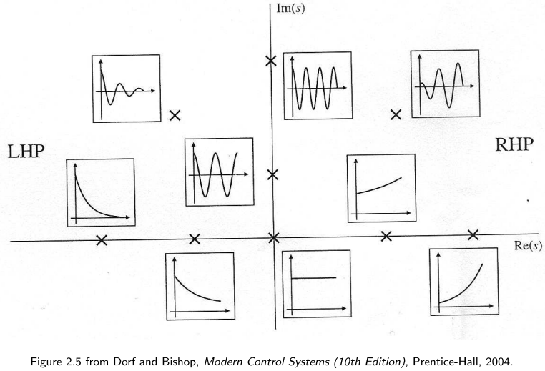

# Transfer Functions

## Electrical

**admittance**:





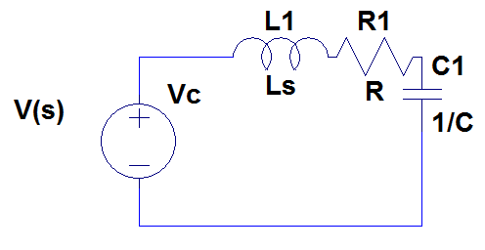

### Cramer’s Rule





### OP-Amps

## Mechanical

**Translational systems**:

**Rotational Systems**:

**Newton’s Second Law of Motion**: Σ *f = Ma*





### Translational Systems

#### Spring

Spring is like a capacitor

**Force displacement**:

#### Viscous Damper

Using viscous fluid to slow something down

Viscous Damper is like a resistor

**Force displacement**:

#### Mass

Mass is like a inductor

**Force displacement**:

### Rotational Systems

**Transducer**: anything that converts energy to electrical energy

**Transmitter**: long distances